Respiratory Diseases Prediction Using Deep Learning and Health Guidance
Vaidehi Chavan, Vaibhavi Dhole, Sanika Patil, Aryan Thosar, Sakshi Singh, Priti V. Matre
Yeshwantrao Chavan College of Engineering, Dept. of Information Technology, Nagpur, India
pritu.777@gmail.com

Abstract—The growing prevalence of respiratory illnesses (Tuberculosis, Pneumonia) where early diagnosis is vital, this study applies deep-learning techniques—CNN paired with Transfer Learning (EfficientNetB3, ResNet50)—to classify chest X-rays for five lung conditions: Normal, Viral Pneumonia, Bacterial Pneumonia, Tuberculosis, and Obstructive Pulmonary Disease. Images were resized to 300×300 px and enhanced with CLAHE. Real-time augmentations were applied to ~3,000 labelled scans. EfficientNetB3 achieved 83% Macro F1 and 83.33% accuracy. The MedScan-AI web platform integrates classification with a Gemini AI advisory module for personalized post-diagnosis health guidance.
Keywords: Deep Learning; CNN; Pneumonia; Tuberculosis; OPD; Transfer Learning; EfficientNetB3; ResNet50; CLAHE; Data Augmentation; Gemini AI.

1 INTRODUCTION
Respiratory diseases are a major contributor to global mortality, with pneumonia, tuberculosis, and obstructive respiratory diseases causing millions of deaths annually, particularly in low- and middle-income countries. Pneumonia alone accounts for over 2.5 million deaths per year. Risk factors including tobacco use, malnutrition, pollution, and immunosuppression raise individual susceptibility. Overlapping clinical symptoms make early diagnosis difficult.
Chest X-ray imaging is the most widely used non-invasive tool for detecting lung disease; however, manual interpretation is labour-intensive and error-prone. Shortage of trained radiologists underscores the urgent need for automated diagnostic support.
This study presents EfficientNetB3 with transfer learning to classify five respiratory conditions, integrated into the MedScan-AI web platform with a Gemini-powered advisory module providing personalized health guidance after diagnosis.
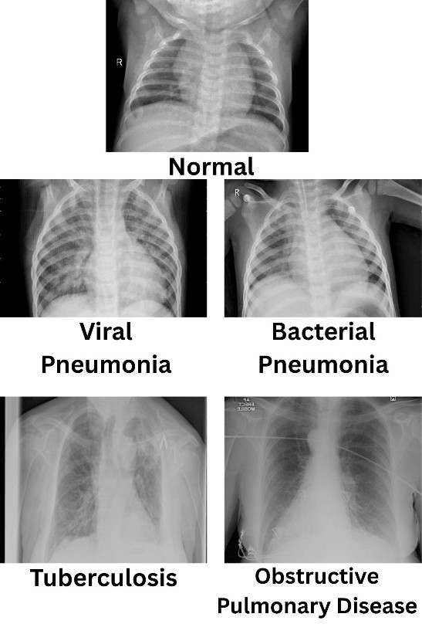
Fig. 1. Sample chest X-ray images across five disease classes
2 PROBLEM STATEMENT
Manual chest X-ray analysis is complex and error-prone, especially in resource-limited settings. Conventional methods are slow, ambiguous, and subject to human bias, causing delayed diagnoses. Most existing automated systems require additional clinical data unavailable in rural areas or classify only a limited set of diseases. This creates a pressing need for an intelligent system capable of classifying Normal, Viral Pneumonia, Bacterial Pneumonia, Tuberculosis, and Obstructive Pulmonary Diseases while delivering safe, accessible healthcare guidance.
3 LITERATURE REVIEW
The respiratory disease crisis has accelerated AI-driven CXR analysis [1]. CNN models are standard for medical image feature extraction [1],[5]. EfficientNetB3 employs compound scaling of depth, width, and resolution, achieving 83.33% accuracy on 5-class classification with efficient parameter use, outperforming ResNet50 [1]. CLAHE preprocessing enhances fine radiographic features under non-uniform lighting, improving model sensitivity in early disease stages [1]. LLMs—especially Gemini, scoring 4.4/5 on TB advisory benchmarks—enable diagnostic platforms to evolve beyond classifiers into actionable patient guidance systems [2],[5].
4 METHODOLOGY
The MedScan-AI system uses a six-step pipeline from raw radiographic data to intelligent diagnostic outputs.
4.1 System Architecture and Workflow
1. Upload chest X-ray (JPG/PNG/PDF) via online application.
2. Preprocess: resize to 300×300 px, normalize pixel values to [0, 1].
3. EfficientNetB3 predicts among five disease classes.
4. Evaluate confidence levels; return predicted class to user.
5. Generate "do's and don'ts" health recommendations via Gemini AI.
6. Authorized personnel record prescriptions on a secure dashboard.
4.2 Data Acquisition and Partitioning
In total, 3,000 chest X-ray images were acquired from Mendeley Data and Kaggle, split equally into five diagnostic categories of 600 images each.
Table 1. Class-wise Data Distribution
Class | Train | Val. | Total
Normal | 480 | 120 | 600
Viral Pneumonia | 480 | 120 | 600
Bacterial Pneumonia | 480 | 120 | 600
Tuberculosis | 480 | 120 | 600
OPD | 480 | 120 | 600
Total | 2400 | 600 | 3000
4.3 Image Pre-processing
Systematic preprocessing: (1) Bicubic Interpolation to 300×300 px; (2) CLAHE for soft-tissue contrast enhancement; (3) Pixel Normalization to [0,1] using factor 1/255; (4) Low-pass filter noise removal preserving edge features.
4.4 Model Development
EfficientNetB3 backbone uses compound scaling for optimal depth/width/resolution balance. Transfer learning from ImageNet initializes convolution layers. Custom head: Global Average Pooling, dense ReLU layers with dropout, 5-class Softmax output. Grad-CAM identifies discriminative regions. Two-stage training: warm-up (frozen base) then full fine-tuning at lower learning rate.
4.5 AI Health Advisory Module
Gemini LLM generates post-diagnosis recommendations. Normal cases return pre-defined lifestyle guidelines without an API call. For abnormal conditions, Gemini generates three concise Do's and Don'ts covering lifestyle, hygiene, rest, and nutrition—without drug names—plus a note to consult a qualified medical professional. Streamlit caching and dictionary fallbacks ensure reliability.
4.6 Deployment
MedScan-AI uses Python Flask and Streamlit for lightweight browser-based interaction. MongoDB stores scan records securely; dotenv manages API keys. Inference completes in seconds: 90.03% training accuracy, 83.33% test accuracy, Macro F1 Score 83%.
5 RESULTS AND DISCUSSIONS
EfficientNetB3 achieved 83.33% accuracy across five lung disease classes, performing best on Normal and Obstructive Pulmonary cases. Minor confusion between Viral and Bacterial Pneumonia arose from similar X-ray patterns. The model proves reliable for real-time prediction.
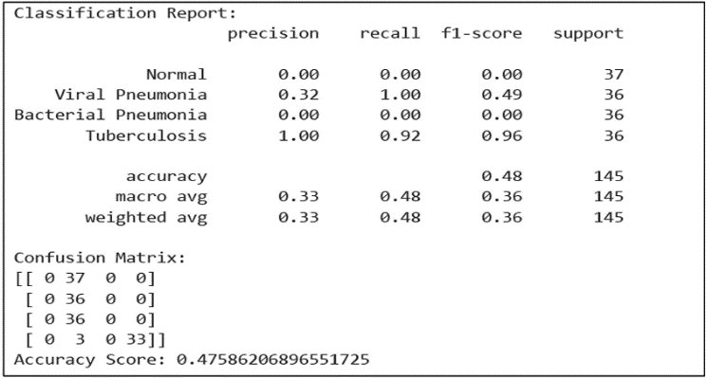
Fig. 2. EfficientNetB3 Classification Report
Final Test Accuracy | 83.33%
Training Accuracy | 90.03%
Validation Accuracy | 81.67%
Training Loss | ~0.27
Validation Loss | ~0.75
Macro F1 Score | 83%
Weighted F1 Score | 83%
Table 2. EfficientNetB3 Evaluation Results
ResNet50 achieved ~47.6% average accuracy. While it excelled at Tuberculosis detection (Precision=1.00, Recall=0.92, F1=0.96), it completely failed on Normal and Bacterial Pneumonia (Precision=Recall=0.00), confirming poor generalization on this multi-class task.
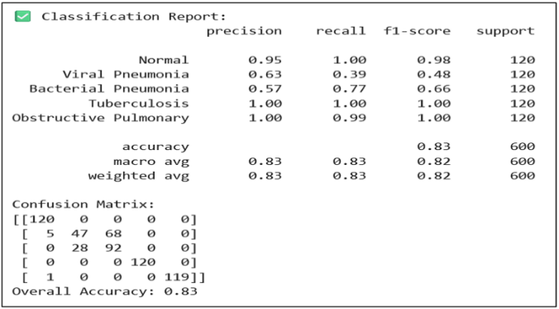
Fig. 3. ResNet50 Classification Report
6 DISCUSSION
6.1 Comparison with Other Architectures
EfficientNetB3 outperforms DenseNet in parameter efficiency via compound scaling. Compared to Vision Transformers, it performs better on smaller medical datasets where transformers require large-scale data, offering strong balance of accuracy and computational cost.
6.2 Class Imbalance and Bias Analysis
The dataset was balanced across five classes; augmentation (rotation, flipping, scaling) ensured uniform representation. Class-wise evaluation confirmed the model did not favour any particular category.
6.3 ResNet50 vs. EfficientNetB3
ResNet50's fixed architecture and higher complexity cause overfitting on limited medical data. EfficientNetB3's optimized compound scaling yields superior feature extraction and generalization.
6.4 Generalization to Real-World Data
The model was evaluated on both Kaggle and Mendeley datasets. Future work will validate it on clinical hospital data to confirm robustness in practical deployment scenarios.
6.5 Confusion Matrix and Class-Wise Performance
Precision, recall, and F1-score were computed per class. Balanced performance was achieved across all five categories, with minor Viral vs. Bacterial Pneumonia confusion due to overlapping X-ray patterns.
6.6 Gemini Advisory: Safety and Reliability
The Gemini advisory system offers supportive health insights and is not intended for direct clinical decision-making. It has not been formally validated by healthcare professionals and should be used solely as an assistive tool.
6.7 Data Privacy and Security
No personally identifiable information (PII) was used. X-ray images were stored securely with encrypted communication and controlled access, following standard data protection practices.
6.8 Inference Time and Scalability
The model achieves near real-time inference. Its lightweight architecture supports web-based deployment, and cloud integration can handle large-scale clinical usage.
7 SUMMARY AND CONCLUSION
This work demonstrates that EfficientNetB3 with transfer learning effectively classifies five respiratory conditions from chest X-rays, achieving 83.33% test accuracy and 83% Macro F1 Score. ResNet50 underperformed, confirming EfficientNetB3 superiority on small-to-medium medical datasets. MedScan-AI integrates classification with Gemini-powered health guidance, creating a comprehensive diagnostic and advisory tool. Limitations include dataset size constraints, potential misclassification between similar disease classes, and absence of clinical validation. Future work will address these through larger datasets, Grad-CAM-assisted physician review, and real-world hospital validation.
8 FUTURE SCOPE
Future directions: (1) expand dataset with diverse X-ray sources; (2) apply Grad-CAM for physician-interpretable outputs; (3) validate on real-world hospital clinical data; (4) integrate into hospital workflows for faster, more accurate pneumonia diagnosis at scale.
REFERENCES
[1] V. Dhole et al., "Respiratory Disease Detection Using Chest X-Ray Images and Deep Learning," 2025 IEEE InCoWoCo, India, pp. 1-7, doi: 10.1109/InCoWoCo68239.2025.11407217.
[2] G. K. Gupta et al., "Digital Diagnostics: The Potential of LLMs in Recognizing Symptoms of Common Illnesses," AI, vol. 6, no. 1, pp. 13-28, Jan. 2025.
[3] K. Sleurs et al., "Mobile health tools for chronic respiratory diseases," Allergy, vol. 74, no. 7, pp. 1292-1306, Jul. 2019.
[4] D. C. C. Canari et al., "Mobile App Design: Logging and Diagnostics of Respiratory Diseases," IJACSA, vol. 13, no. 8, pp. 582-589, 2022.
[5] M. Dastani et al., "LLM capabilities in responding to tuberculosis medical questions," Sci. Reports, vol. 15, no. 18004, 2025.
[6] S. K. H. Bukhari and L. Fahad, "Lung Disease Detection using Deep Learning," 2022 ICET, Swabi, Pakistan, pp. 154-159.
[7] M. V. Sanida et al., "An Advanced DL Framework for Multi-Class Diagnosis from Chest X-ray Images," J, vol. 7, no. 1, pp. 48-71, 2024.
[8] S. Taslimi et al., "SwinCheX: Multilabel Classification on Chest X-ray Images with Transformers," arXiv:2206.04246, 2022.
[9] P. Rajpurkar et al., "CheXNet: Radiologist-Level Pneumonia Detection on Chest X-Rays," arXiv:1711.05225, 2017.
[10] S. Bharati et al., "Hybrid Deep Learning for Detecting Lung Diseases from X-ray Images," arXiv:2003.00682, 2020.

