Engagement Efficiency Segmentation and
Growth Prediction for Twitch Channels
DATA110 Capstone Project Thesis Report
Submitted by: Viven Chavan
Professor: Durga Ma’am

Table of Contents
Table of Contents 2
Abstract 3
1. Introduction and Problem Statement 4
2. Literature Review and Novelty 5
3. Methodology 6
3.1 Overall Pipeline 6
3.2 Data Cleaning 6
3.3 Feature Engineering 6
3.4 Modeling Approach by Project Level 6
4. Data Description 7
4.1 Class Balance Considerations 7
4.2 Correlation Structure 7
5. Model Development 8
5.1 Basic Level: Exploratory Regression 8
5.2 Intermediate Level: Classification 8
5.3 Advanced Level: Clustering and Growth Prediction 8
6. Results and Discussion 11
6.1 What Drives Engagement Efficiency Segmentation 11
6.2 The Efficiency–Growth Paradox 11
6.3 Model Performance in Context 11
6.4 Limitations 11
7. Conclusion and Future Work 12

Abstract
Public analyses of Twitch streaming datasets, including numerous Kaggle notebooks built on this same dataset, overwhelmingly predict raw follower counts from raw size metrics such as watch time and peak viewers. Because these size metrics are highly correlated with one another, such models largely re-learn the trivial fact that bigger channels have bigger numbers, offering little insight into what actually drives audience engagement quality. This project takes a different approach. Working from a dataset of the top 1,000 Twitch channels, six size-independent engagement ratios were engineered — including watch-time-per-follower, viewer retention, and follower growth rate — and combined into a composite Engagement Efficiency Score (EES). This score was used to segment channels via K-Means clustering into High-Efficiency and Standard engagement tiers, and the engineered features were then used to predict absolute Followers Gained across three regression models. Gradient Boosting performed best (R² = 0.337), with viewer density per stream hour and follower growth rate emerging as the strongest predictors. A central finding is that High-Efficiency channels do not necessarily gain the most absolute followers: niche, highly engaged channels average roughly 81,000 followers gained versus roughly 220,000 for Standard-tier channels, indicating that raw growth remains partly a function of channel size rather than engagement quality alone. Alongside this advanced-level study, the project also includes a basic-level exploratory regression and an intermediate-level classification task, completed in line with the project's three-tier structure.

1. Introduction and Problem Statement
Twitch is one of the largest live-streaming platforms in the world, hosting thousands of channels that vary enormously in scale, from casual hobbyist streamers to fully partnered professional broadcasters. Platform-level datasets typically capture channel statistics such as total watch time, peak and average concurrent viewers, follower counts, and follower growth. These raw numbers are useful for understanding the size of a channel, but they conflate two very different things: how large a channel's audience is, and how engaged that audience actually is.
A channel with ten million followers who each watch for a few minutes a month is not the same as a channel with one hundred thousand followers who watch for hours every week, yet raw follower and watch-time figures alone do not distinguish between them. This creates a practical problem: platform recommendation systems, brand sponsorship decisions, and even streamers' own understanding of their audience can be biased toward channel size rather than genuine engagement quality.
The objective of this project is to address this gap using the Top 1000 Twitch Streamers dataset. Specifically, the project asks two research questions:
- Can channels be meaningfully segmented by engagement quality, independent of their size, using engineered ratio-based features?
- Do these engineered engagement features help predict absolute follower growth, and if so, which behavioral patterns matter most?
In line with the capstone's three-tier project structure, this thesis first establishes a basic-level exploratory baseline, then builds an intermediate-level classification model, before addressing the two research questions above as the advanced-level primary research contribution.

2. Literature Review and Novelty
The Top Twitch Streamers dataset is widely used as an introductory dataset for regression and exploratory data analysis exercises, and a large number of publicly shared notebooks on this dataset follow a similar pattern: computing summary statistics and correlations between raw size metrics, then fitting a regression model to predict one raw metric (commonly Followers or Average Viewers) from another (commonly Watch Time or Peak Viewers). Because these raw metrics are strongly correlated with each other by construction — a channel with more watch time will almost mechanically tend to have more followers and higher peak viewership — such models tend to report inflated-looking but conceptually shallow results: they demonstrate that size correlates with size, rather than uncovering anything about audience behaviour.
More broadly, research on streaming and social media platforms has increasingly emphasized the distinction between audience size and audience engagement quality, using engagement ratios and retention metrics rather than absolute counts to compare channels or content fairly across different scales. This project draws on that general principle rather than replicating a specific prior study: instead of predicting one raw metric from another, it constructs a set of scale-independent ratio features intended to capture behavioral engagement patterns, and evaluates whether these patterns — rather than raw size — can explain meaningful variation in channel outcomes.
The novelty of this project is therefore twofold. First, methodologically, it engineers a composite Engagement Efficiency Score from six ratio-based features and uses it both for unsupervised segmentation and as the feature basis for supervised prediction, rather than using raw features directly. Second, empirically, the analysis surfaces a counter-intuitive finding — that higher engagement efficiency does not straightforwardly translate into higher absolute follower growth — which runs contrary to the assumption implicit in most raw-metric regression approaches to this dataset.

3. Methodology

3.1 Overall Pipeline
The project follows a five-stage pipeline implemented in Python using pandas, scikit-learn, and matplotlib: (1) data cleaning and quality validation, (2) feature engineering, (3) a basic-level exploratory regression, (4) an intermediate-level classification task, and (5) the advanced-level clustering and predictive modeling study. Each stage is implemented as a standalone, reproducible script, and the same cleaned and engineered dataset is used consistently across all three project levels.

3.2 Data Cleaning
Column names were standardized to a consistent snake_case format. The dataset was checked for missing values, duplicate channel entries, and non-positive values in fields that should logically be positive (such as watch time and stream time). No missing values or duplicate channels were found. A small number of rows with zero stream time were removed prior to feature engineering, since several engineered ratios divide by stream time and would otherwise be undefined.

3.3 Feature Engineering
Six engagement ratio features were engineered, each designed to be independent of raw channel size:
- Average-to-Peak Ratio — average viewers divided by peak viewers, capturing viewership consistency versus one-off spikes.
- Watch Time per Follower — total watch time divided by follower count, capturing how much cumulative attention each follower represents.
- Views per Follower — views gained divided by follower count, capturing reach efficiency relative to the existing audience.
- Follower Growth Rate — followers gained divided by existing followers, normalizing growth by channel size.
- Viewers per Stream Hour — average viewers divided by hours streamed, capturing audience density relative to time invested.
- Stickiness — watch time divided by the product of stream time and average viewers, capturing whether viewers stay engaged longer than a simple baseline would predict.
A small number of channels exhibited extreme outlier values in these ratios (for example, a handful of channels with very few followers relative to their watch time produced ratio values 5–40 times larger than the rest of the dataset). Left uncapped, these outliers would dominate min-max scaling and any subsequent distance-based clustering. Each ratio was therefore winsorized at the 1st and 99th percentiles before scaling. The six winsorized, min-max scaled features were then averaged into a single equally weighted composite: the Engagement Efficiency Score (EES). Equal weighting was chosen because there is no prior theoretical basis to weight one engagement dimension above another; this is a defensible default, and its limitations are discussed in Section 6.

3.4 Modeling Approach by Project Level
Basic level: a single-feature Linear Regression predicting Average Viewers from Watch Time, evaluated with an 80/20 train-test split.
Intermediate level: a multi-feature Logistic Regression predicting a binary content classification, using standardized features and a stratified 80/20 train-test split, evaluated using accuracy, precision, recall, F1-score, and a confusion matrix.
Advanced level: K-Means clustering (with the number of clusters selected by silhouette score across k = 2 to 6) on the six scaled engagement features, followed by a comparison of Linear Regression, Random Forest, and Gradient Boosting Regressors predicting Followers Gained from the six engineered (unscaled) features, evaluated using R² and Mean Absolute Error on a held-out 20% test set.

4. Data Description
The dataset consists of 1,000 Twitch channels, each described by 11 raw fields: channel name, total watch time (minutes), total stream time (minutes), peak concurrent viewers, average concurrent viewers, current follower count, followers gained over the tracked period, views gained, partnership status, a mature-content flag, and primary broadcast language.

4.1 Class Balance Considerations
Two Boolean fields were considered as potential classification targets for the intermediate-level task. The Partnered field is severely imbalanced, with 978 of 1,000 channels marked True and only 22 marked False; a classifier could trivially achieve 97.8% accuracy by always predicting True without learning anything meaningful. The Mature field is much better balanced, with 770 channels marked False and 230 marked True, and was therefore selected as the classification target instead — a deliberate, data-driven decision documented here and reflected in the accompanying code.

4.2 Correlation Structure
Table 1 shows Pearson correlations among the raw numeric features. Most size-related metrics are moderately-to-strongly correlated with one another (e.g., Followers and Followers Gained at r = 0.72; Peak Viewers and Average Viewers at r = 0.68), which motivates the use of engineered, size-independent ratio features for the advanced-level analysis rather than relying on these raw metrics directly.
Table 1. Correlation matrix of raw numeric features
Feature | Watch Time | Stream Time | Peak Viewers | Avg Viewers | Followers | Followers Gained | Views Gained
Watch Time | 1.00 | 0.15 | 0.58 | 0.48 | 0.62 | 0.51 | 0.53
Stream Time | 0.15 | 1.00 | -0.12 | -0.25 | -0.09 | -0.16 | 0.06
Peak Viewers | 0.58 | -0.12 | 1.00 | 0.68 | 0.53 | 0.47 | 0.30
Avg Viewers | 0.48 | -0.25 | 0.68 | 1.00 | 0.43 | 0.42 | 0.25
Followers | 0.62 | -0.09 | 0.53 | 0.43 | 1.00 | 0.72 | 0.28
Followers Gained | 0.51 | -0.16 | 0.47 | 0.42 | 0.72 | 1.00 | 0.24
Views Gained | 0.53 | 0.06 | 0.30 | 0.25 | 0.28 | 0.24 | 1.00

English is the dominant language in the dataset (485 channels), followed by Korean (77), Russian (74), Spanish (68), and French (66), with the remaining channels spread across a long tail of other languages.

5. Model Development

5.1 Basic Level: Exploratory Regression
A single-feature Linear Regression was fitted to predict Average Viewers from Watch Time. On the held-out test set, the model achieved R² = 0.406 and a Mean Absolute Error of approximately 2,323 viewers. This establishes a baseline: watch time alone explains a moderate but incomplete share of the variance in average viewership, motivating the use of additional and engineered features in the later stages of the project.
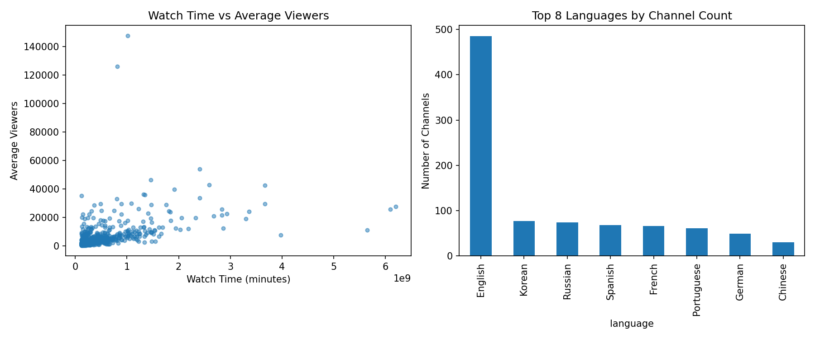
Figure 1. Watch Time vs. Average Viewers (left) and channel counts by top languages (right)

5.2 Intermediate Level: Classification
A multi-feature Logistic Regression was trained to predict the Mature content flag from seven raw channel statistics (watch time, stream time, peak viewers, average viewers, followers, followers gained, and views gained), using class-balanced weighting to account for the residual imbalance. On the held-out test set, the model achieved an accuracy of 0.475, precision of 0.243, recall of 0.609, and an F1-score of 0.348.
This result is modest, and deliberately so: it indicates that raw engagement and size statistics alone carry limited signal about whether a channel is flagged as mature content, which is a content-classification attribute more plausibly driven by genre and streamer choice than by audience statistics. This is a genuine empirical finding rather than a modeling failure, and it is discussed further in Section 6.

5.3 Advanced Level: Clustering and Growth Prediction
K-Means clustering was applied to the six scaled engagement features, testing k = 2 through k = 6. The silhouette score was highest at k = 2 (0.386), clearly outperforming higher values of k (which ranged from 0.208 to 0.299), and k = 2 was therefore selected. The resulting clusters split the dataset into a 105-channel “High-Efficiency” tier (Cluster 0, mean EES = 0.338) and an 895-channel “Standard” tier (Cluster 1, mean EES = 0.209).
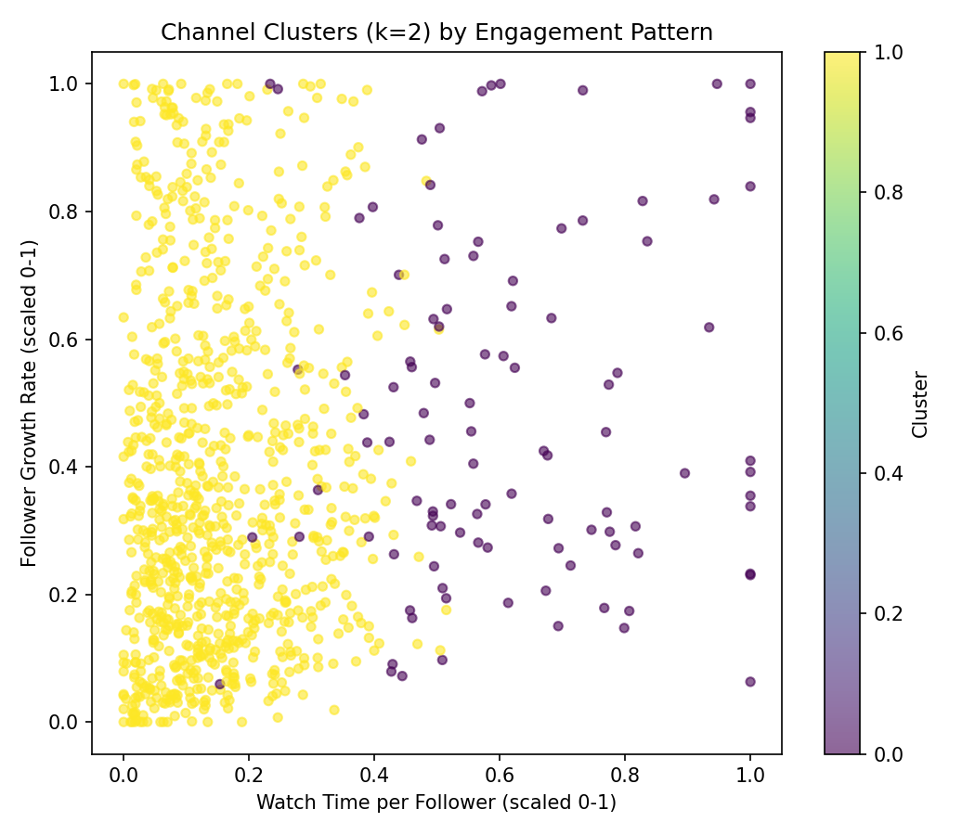
Figure 2. Channel clusters by scaled Watch-Time-per-Follower and Follower Growth Rate
Three regression models were then compared for predicting Followers Gained from the six engineered features. Table 2 summarizes the results.
Table 2. Model comparison for predicting Followers Gained
Model | R² (test set) | MAE (test set)
Linear Regression | 0.171 | 140,135
Random Forest | 0.244 | 123,162
Gradient Boosting | 0.337 | 117,977

Gradient Boosting was the best-performing model. Its feature importances (Figure 3) show that Viewers per Stream Hour (43.5%) and Follower Growth Rate (27.4%) were by far the strongest predictors, together accounting for roughly 71% of the model's total feature importance, while Views per Follower, Watch Time per Follower, Average-to-Peak Ratio, and Stickiness played comparatively minor roles.
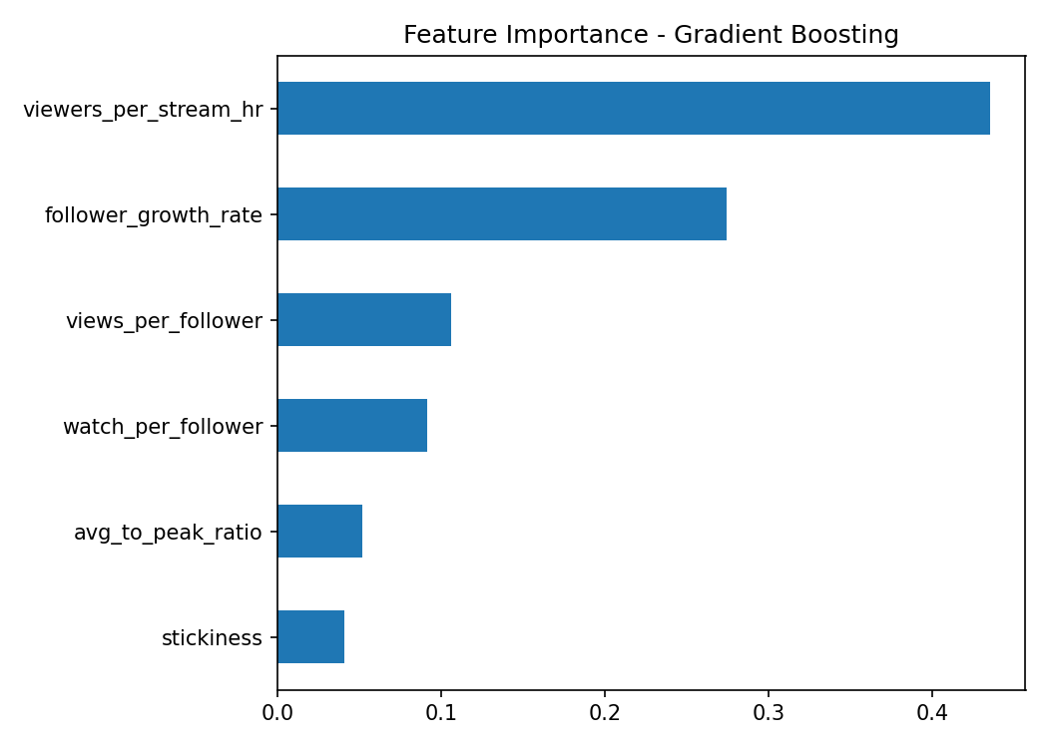
Figure 3. Gradient Boosting feature importances

6. Results and Discussion

6.1 What Drives Engagement Efficiency Segmentation
The clustering results show a clear, statistically preferred two-tier structure (silhouette = 0.386 at k = 2) rather than a finer-grained segmentation. This suggests that, within this dataset, the dominant distinction among channels is a single high-versus-standard engagement-efficiency axis, rather than several qualitatively distinct engagement archetypes.

6.2 The Efficiency–Growth Paradox
The central and most notable finding of this project is that engagement efficiency and absolute follower growth are not aligned. Cluster 0 (High-Efficiency) channels gained an average of approximately 81,000 followers, while Cluster 1 (Standard) channels gained an average of approximately 220,000 followers — nearly three times as many. In other words, the channels with the most engaged, retained audiences (relative to their size) are not the channels growing their follower base the fastest in absolute terms.
This is consistent with the Gradient Boosting feature importance results: Viewers per Stream Hour, the single strongest predictor of Followers Gained, is closely tied to a channel's raw audience density and, indirectly, its size, whereas the more purely “efficiency”-oriented ratios (Stickiness, Average-to-Peak Ratio) contributed comparatively little. Taken together, these results indicate that raw follower growth in this dataset remains substantially a function of existing channel scale and reach, and that engagement efficiency, while a meaningful and interpretable way to segment channels, is not by itself a strong predictor of future growth.

6.3 Model Performance in Context
An R² of 0.337 for the best model (Gradient Boosting) may appear modest in absolute terms, but should be read in context: the model was deliberately restricted to engineered engagement-ratio features rather than raw size features, in order to isolate the predictive contribution of engagement behavior specifically. Given that the correlation analysis in Section 4.2 shows raw size features are themselves only moderately correlated with Followers Gained (e.g., Followers: r = 0.72; Watch Time: r = 0.51), and that this project's regression deliberately excludes those raw size features in favor of derived ratios, an R² of 0.337 represents a meaningful, non-trivial amount of explained variance from behavioral signal alone.

6.4 Limitations
- The dataset is cross-sectional (a single snapshot with cumulative totals), not longitudinal, which limits the ability to draw causal conclusions about what drives growth over time.
- The Engagement Efficiency Score uses equal weighting across its six component ratios; alternative, empirically-derived weightings (e.g., via PCA loadings) might shift cluster boundaries or score interpretation.
- The intermediate-level classification task achieved only modest predictive performance, suggesting that content-type flags such as Mature status are driven by factors not captured in this dataset (e.g., game genre, streamer intent).
- External factors such as sponsorship deals, collaborations, esports event schedules, or platform promotion — all plausible drivers of follower growth — are not present in this dataset and could not be modeled.

7. Conclusion and Future Work
This project set out to move beyond the common practice of predicting raw Twitch channel metrics from other raw metrics, which largely reproduces the trivial observation that larger channels have larger numbers. By engineering six size-independent engagement ratios into a composite Engagement Efficiency Score, this project was able to (1) segment channels into a statistically preferred two-tier engagement structure, and (2) predict absolute follower growth from behavioral signal alone with a Gradient Boosting model achieving R² = 0.337 on held-out data.
The most significant finding is the efficiency–growth paradox: channels with the highest engagement efficiency do not gain the most absolute followers, and in this dataset gain roughly a third as many on average as Standard-tier channels. This nuanced result would not have been visible using only raw size metrics, and demonstrates the value of engineering behavior-aware features when studying platform growth dynamics.
Several directions for future work follow naturally from these limitations. First, incorporating longitudinal, time-series data (rather than cumulative snapshot totals) would allow the causal direction between engagement efficiency and growth to be studied more directly, for example via Granger causality or lagged regression. Second, testing alternative weighting schemes for the Engagement Efficiency Score, such as Principal Component Analysis-derived weights or expert-elicited weights, would test the robustness of the segmentation. Third, enriching the dataset with external variables such as game or content genre, sponsorship activity, and collaboration history could substantially improve both the classification and growth-prediction models, and would help explain the currently under-predicted variance in both tasks. Finally, applying model-agnostic interpretability tools such as SHAP values to the Gradient Boosting model would allow for instance-level explanations of why specific channels are predicted to grow quickly or slowly, which would be valuable for both researchers and streamers themselves.

