Collections

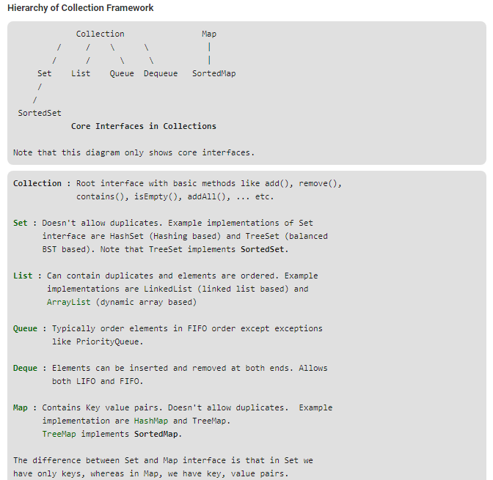

|  |  |  |  |
| --- | --- | --- | --- |
|  | Duplicate | Ordered | Types |
| Set | 🗙 |  | HashSet  LinkedHashSet  TreeSet |
| List | ✔ | ✔ | LinkedList  ArrayList  Stack  Vector |
| Map | 🗙 |  | HashMap  HashLinkedMap  HashTable  TreeMap |
| Queue |  | ✔ | PriorityQueue  ArrayDeque  LinkedListDeque |

