Financial Advisor

In this project you ask us to develop Financial advisor using Lang Chain model but this model is not free of cost and asking registration with Credit Card so we changed model to Google Gemini which is free of cost. This model will fetch live financial stock data of any company like Apple, Amazon, Microsoft or any other company and then analyse last 1 year data to generate suggestion and investment plan.

To implement this project we have designed following model

1. New User Registration: user can sign up with the application
2. User Login: user can login to system
3. Load Financial Model: after login user can run this module to load model
4. Financial Analysis & Investment Suggestions: using this module user can select any stock financial name and then model will generate suggestion and plans.

SCREEN SHOTS

To run project install python 3.10 and then install all packages given in requirements.txt file. Now install MYSQL database and then copy content from ‘database.txt’ file and paste in MYSQL console to create database

Now double click on ‘run.bat’ file to start python server and then will get below page

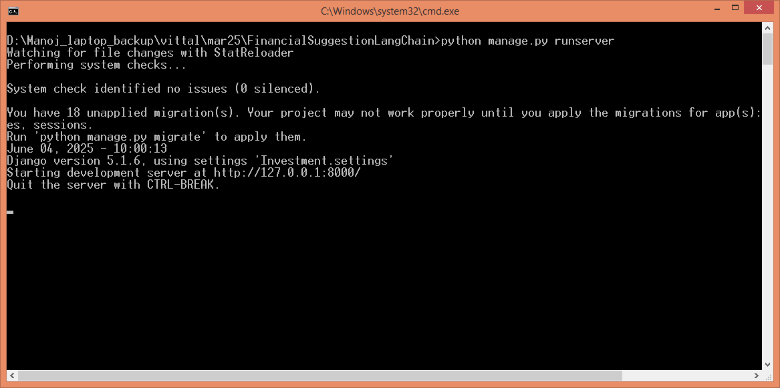

In above screen python server started and now open browser and enter URL as <http://127.0.0.1:8000/index.html> and then press enter key to get below page

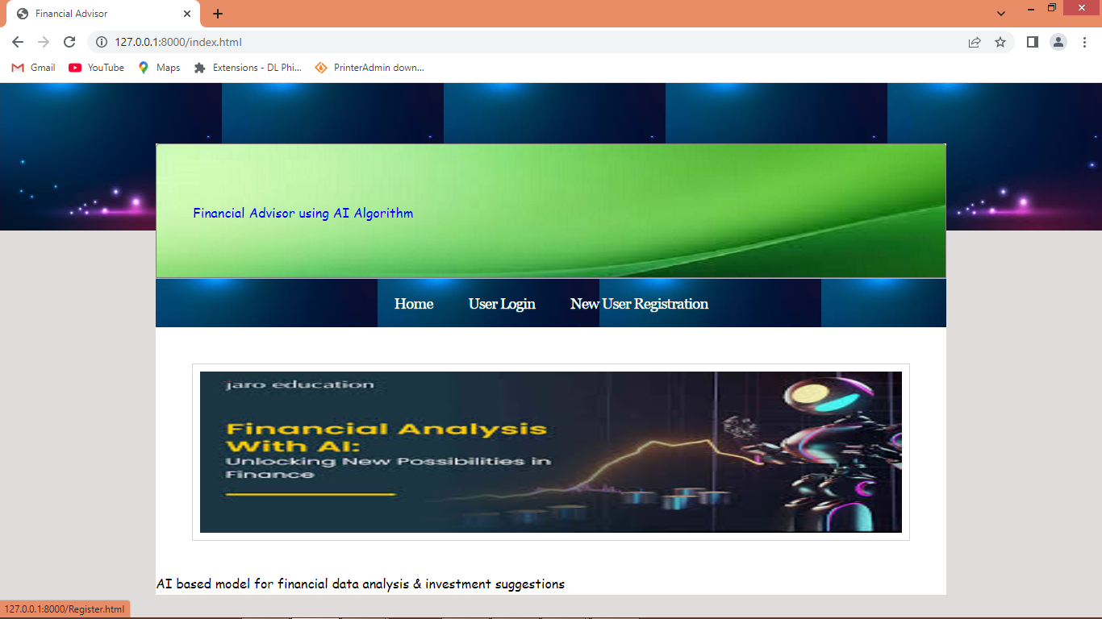

In above screen click on ‘New User Registration’ link to get below page

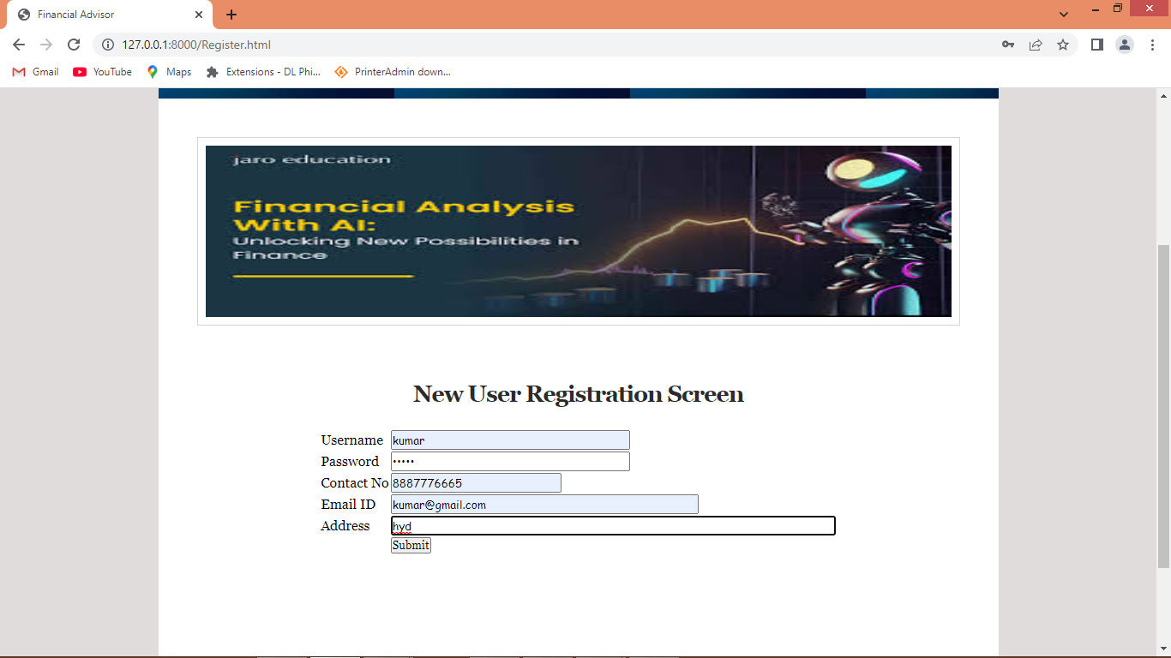

In above screen user is entering sign up details and then press button to get below page

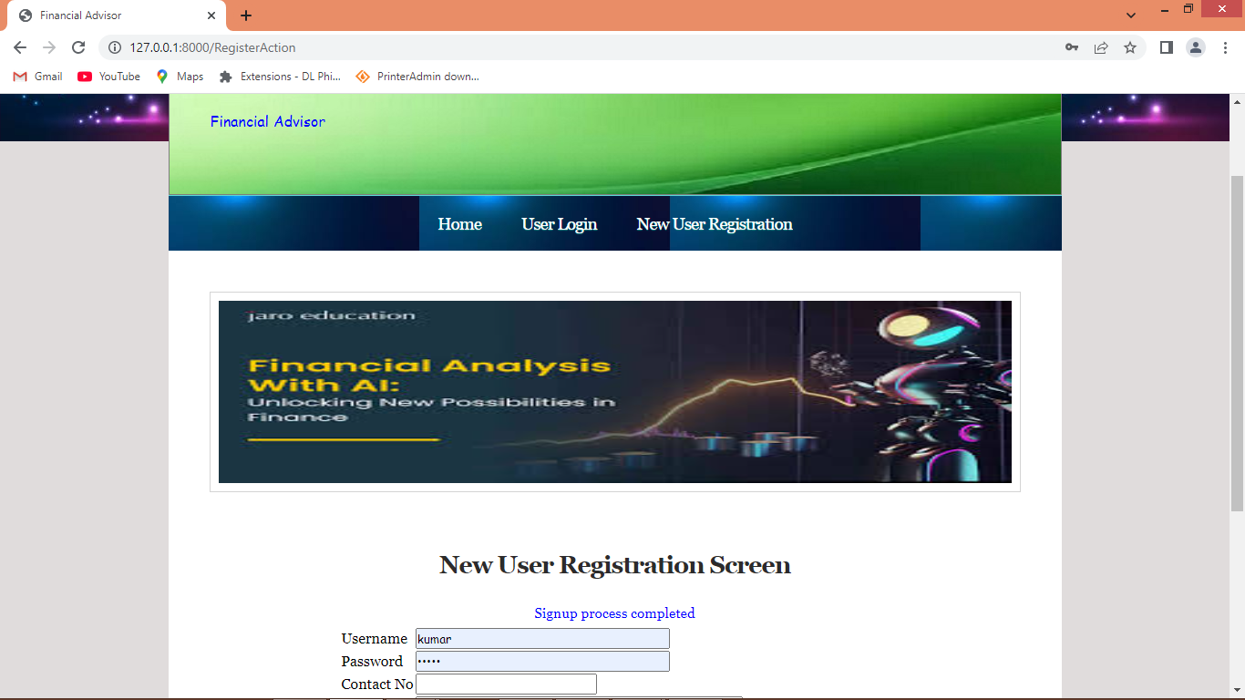

In above screen in blue text can see sign up task completed and now click on ‘User Login’ link to get below page

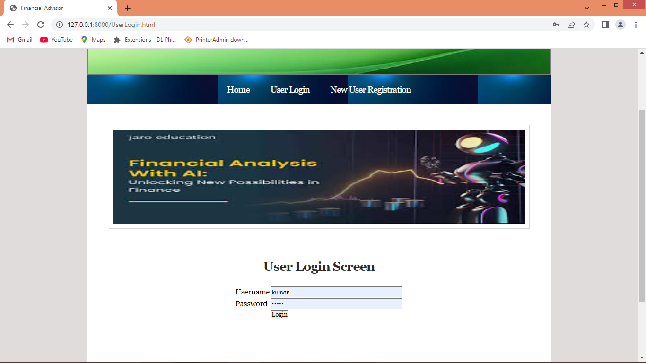

In above screen user is login and after login will get below page

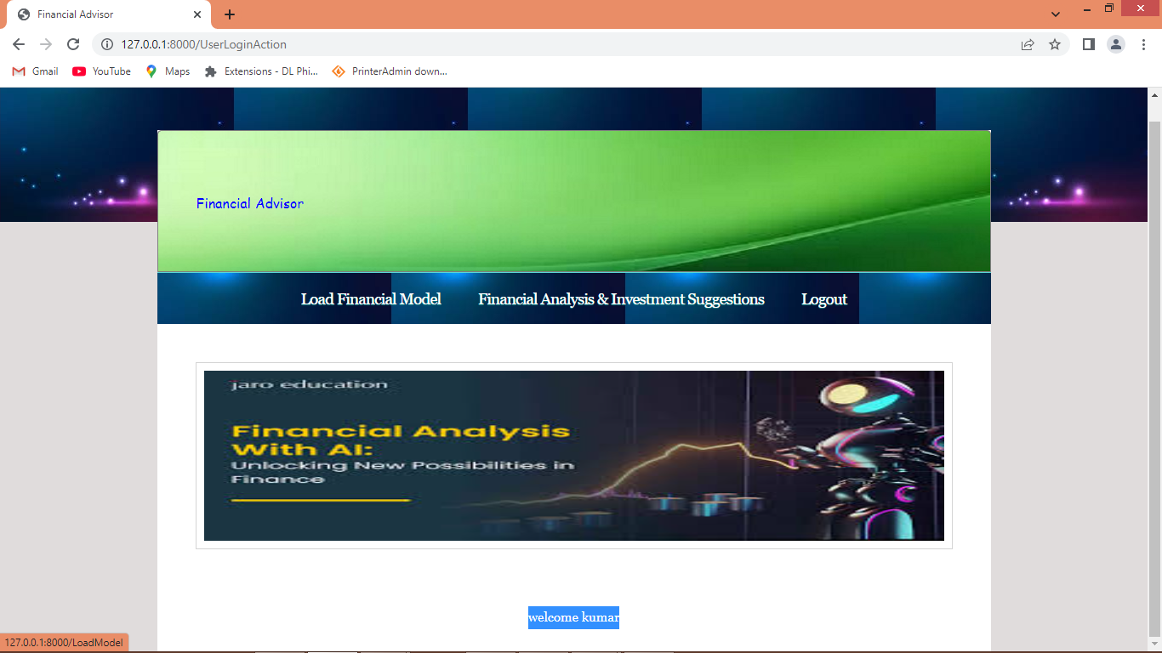

In above screen click on ‘Load Financial Model’ link to get below page

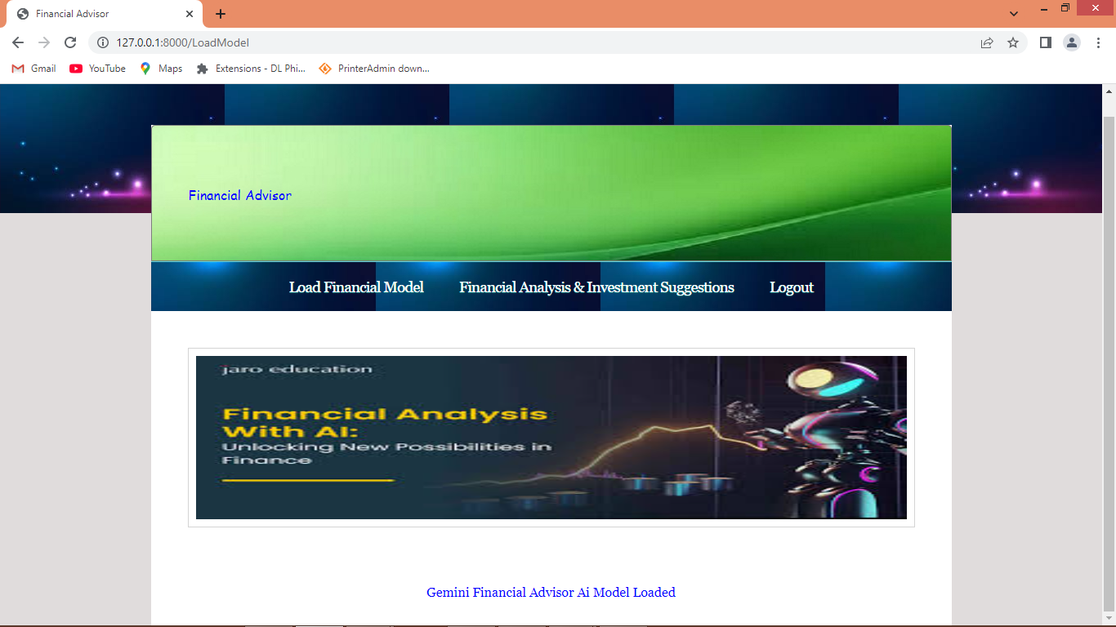

In above screen model loaded displaying blue text and now click on ‘Financial Analysis & Investment Suggestions’ link to get below page

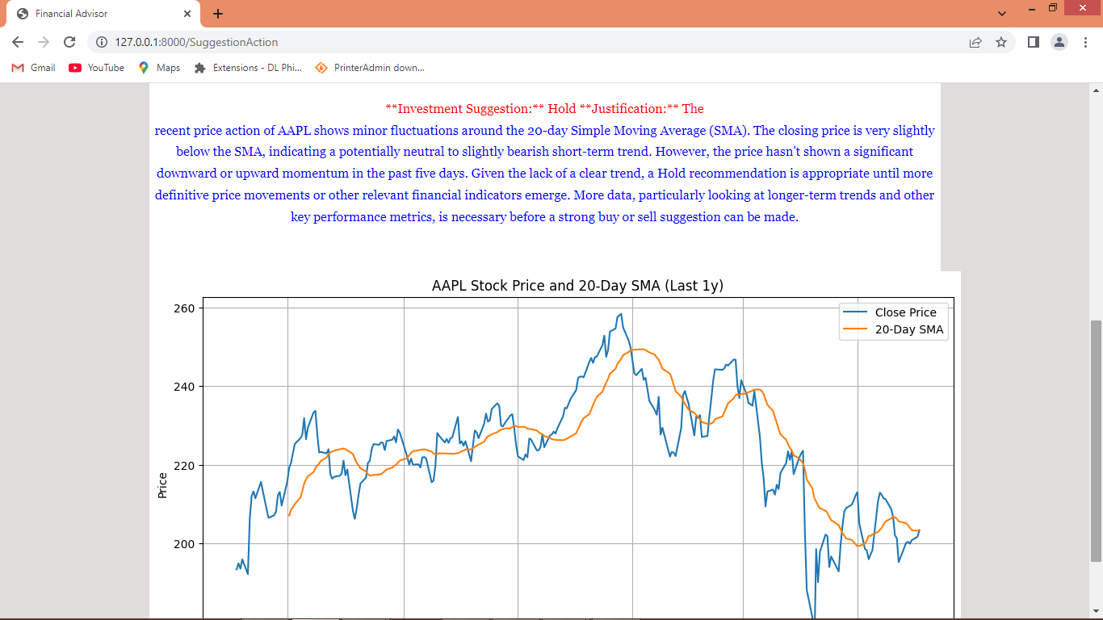

In above screen for selected stock model is saying to ‘Hold’ investment in red colour text and in blue text we can see some suggestion and plan details. In graph we can see closing price in blue line and SMA (Simple Moving Average) in orange line which is lower to blue line so model suggestion is correct. Now test another stock finance data

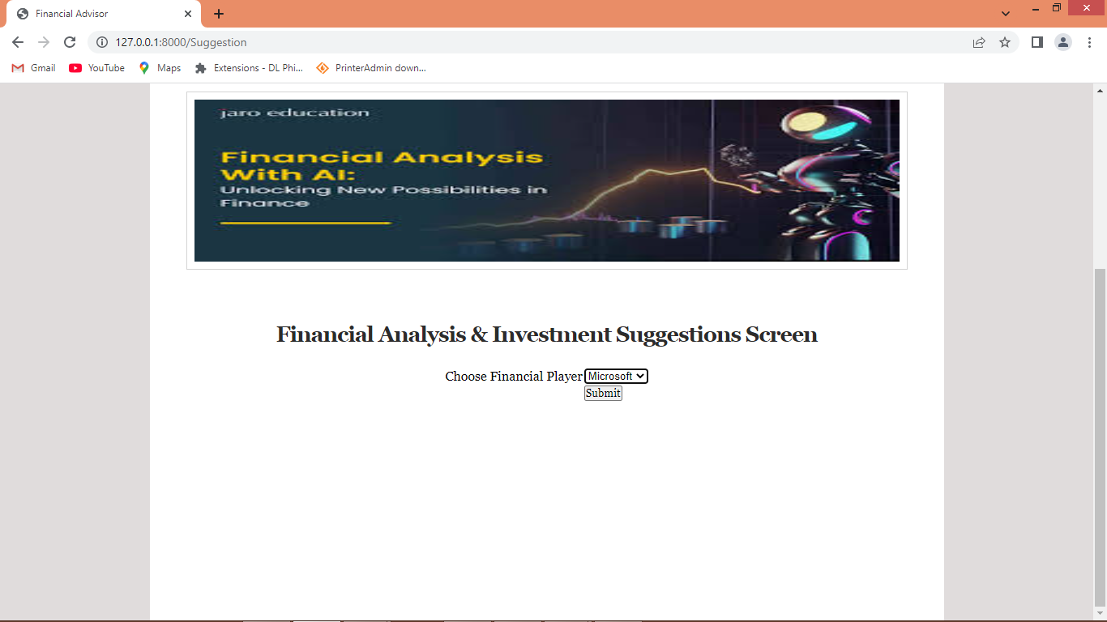

In above screen i am selecting Microsoft stock and below is the suggestion

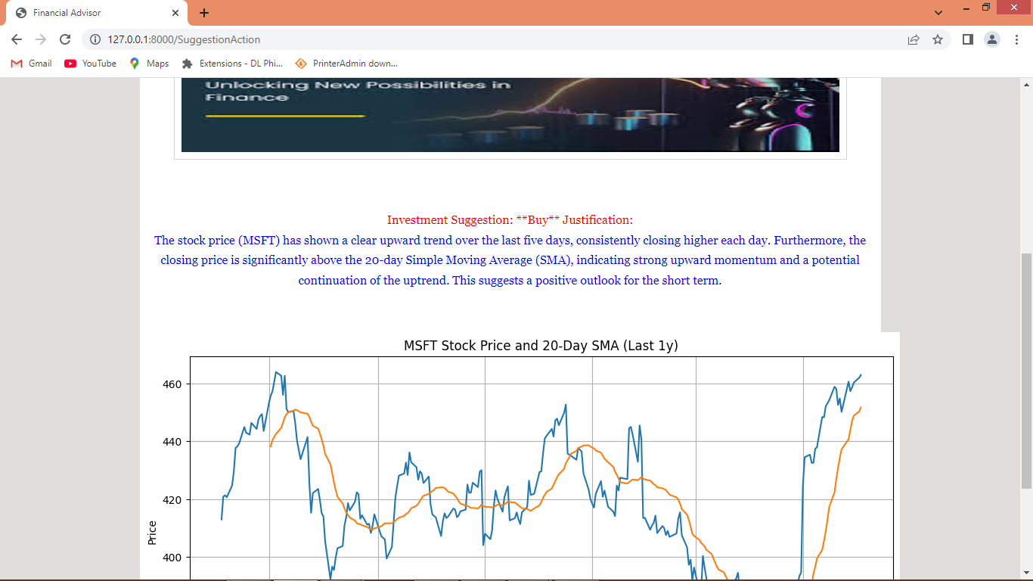

In above screen for selected Microsoft stock model saying to “Buy” means we can invest and the explanation is giving in blue text and in graph also we can see performance

Similarly you can select any other financial institution name and then get investment plans