SRH UNIVERSITY
CAMPUS MUNICH – SUMMER SEMESTER 2026

PROJECT REPORT:
GROCERY MANAGEMENT SYSTEM USING SAP RAP

MODULE: SAP ABAP AND CLOUD
LECTURER:

PREPARED BY:
1.Sandeep Chava - 100007689
2. Nilesh Dokuparthi - 100008372
3. Vikas Vikas- 100008525

DATE OF SUBMISSION: 21.07.2026

Contents
1. Introduction 5
1.1 Background 5
1.2 Purpose of the Project 5
1.3 Objectives 5
2. Project Overview 6
3. Problem Statement 7
4. Scope of the Project 7
5. System Design 7
5.1 System Design 7
5.2 System Workflow 8
System Workflow Diagram 8
5.3 Design Principles 9
6. System Architecture 9
6.1 System Architecture 9
Architecture Diagram 9
Components Description 10
7. Technologies Used 11
SAP ABAP Cloud 11
SAP RESTful ABAP Programming Model (RAP) 12
Core Data Services (CDS) 12
Behavior Definition 12
SAP Fiori Elements 12
SAP HANA Database 12
8. Functional Modules 12
8.1 Product Registration Module 12
8.2 Store Information Module 12
8.3 Category Management Module 13
8.4 Product Update Module 13
8.5 Search Module 14
8.6 Filter and Sorting Module 14
8.7 Draft Management Module 14
8.8 Validation and Business Rules Module ……………………………………………………….14
9. User Guide 15
Step 1: Launch the Application 15
Step 2: View Grocery Records 15
Step 3: Create an Item Record 15
Step 4: Edit an Item Information 16
Step 5: Search, Filter, and Sort 16
Step 6: Delete an UnwantedItem Record 16
10. Validation Rules 16
11. Determinations……………………………………………………………………………………………………………………………...17
12. Value Helps …………………………………………………………………………………………18
13. Draft Management 18
14. Testing 18
15. Error Handling 19
16. Future Enhancements 19
17. Conclusion 19
18. References…………………………………………………………………………………………..20

1. Introduction

1.1 Background
Retail grocery businesses manage hundreds of products belonging to different categories and stores. Maintaining product information manually often leads to duplicate records, inconsistent pricing, missing product details, and inefficient inventory management. Enterprise applications require a secure and standardized approach to manage such business data efficiently.
SAP provides the RESTful ABAP Programming Model (RAP), which enables developers to build cloud-ready enterprise applications using CDS View Entities, Behavior Definitions, OData V4 services, and SAP Fiori Elements. RAP separates the data model, business logic, and service layer while supporting draft handling, validations, determinations, and transactional consistency.
This project implements a Grocery Store Management System that allows users to manage grocery products, stores, and categories through an intuitive SAP Fiori interface. The application demonstrates enterprise features such as CRUD operations, value helps, validations, semantic key checking, draft handling, and business object implementation.

1.2 Purpose of the Project
The primary objective of this project is to demonstrate the implementation of SAP RAP by developing a Grocery Store Management System following SAP Cloud ABAP development standards.
The application provides a centralized platform for maintaining grocery product information while ensuring data accuracy through business validations and draft functionality. It also exposes business data through OData V4 services for SAP Fiori Elements applications.
Beyond academic requirements, this project provides practical experience in enterprise application development using SAP Business Technology Platform and Cloud ABAP.

1.3 Objectives
The objectives of the Grocery Management System are designed to provide a complete enterprise-level solution while demonstrating the capabilities of SAP RAP. The major objectives include:
- Develop a cloud-ready SAP application using the RESTful ABAP Programming Model.
- Implement complete CRUD (Create, Read, Update, Delete) operations for product records.
- Design reusable CDS View Entities that expose business data efficiently.
- Implement RAP Behavior Definitions to control business transactions.
- Enable Draft functionality to improve user experience and prevent accidental data loss.
- Implement business validations to ensure only valid information is stored.
- Prevent duplicate product records using semantic key validation.
- Expose the application through OData V4 services.
- Develop a responsive SAP Fiori Elements user interface.
- Demonstrate best practices in SAP Cloud ABAP development.
These objectives ensure that the application not only satisfies functional requirements but also follows SAP's recommended architecture for enterprise applications.

2. Project Overview
The Grocery Store Management System is an enterprise application developed using SAP RAP within SAP Business Technology Platform. The application manages grocery products across multiple stores and product categories.
Users can create, modify, delete, search, and maintain product records using SAP Fiori Elements. All operations pass through the RAP Business Object where validations and business logic are executed before data is stored in SAP HANA.
The application also supports draft functionality, allowing users to save incomplete work before activation, improving usability and preventing accidental data loss.

3. Problem Statement
Managing grocery product information manually often results in duplicate records, inconsistent pricing, missing category assignments, and inaccurate product details. Traditional systems lack proper validation and transactional processing, increasing the possibility of business errors.
This project addresses these challenges by implementing a cloud-ready Grocery Store Management System using SAP RAP that ensures data consistency, validation, draft management, and centralized product maintenance.

4. Scope of the Project
The project includes:
- Grocery Product Management
- Store Management
- Category Management
- CRUD Operations
- Draft Handling
- Validations
- Determinations
- Semantic Key Checking
- SAP Fiori User Interface
- OData V4 Service Exposure
The project focuses on academic implementation and demonstrates SAP RAP concepts rather than a complete retail ERP solution.

5. System Design

5.1 System Design
The Grocery Store Management System follows SAP RAP's layered architecture consisting of Presentation Layer, Service Layer, Business Logic Layer, CDS Layer, and SAP HANA Database.
Business logic is implemented using Behavior Definitions and Behavior Implementations, while CDS View Entities expose business data for SAP Fiori.

5.2 System Workflow
• User opens the SAP Fiori application.
• User creates or edits a grocery product.
• RAP Behavior validates user input.
• Determinations execute business logic.
• Draft data is temporarily stored.
• Active data is saved in SAP HANA after activation.

• Updated information is displayed back in SAP Fiori.

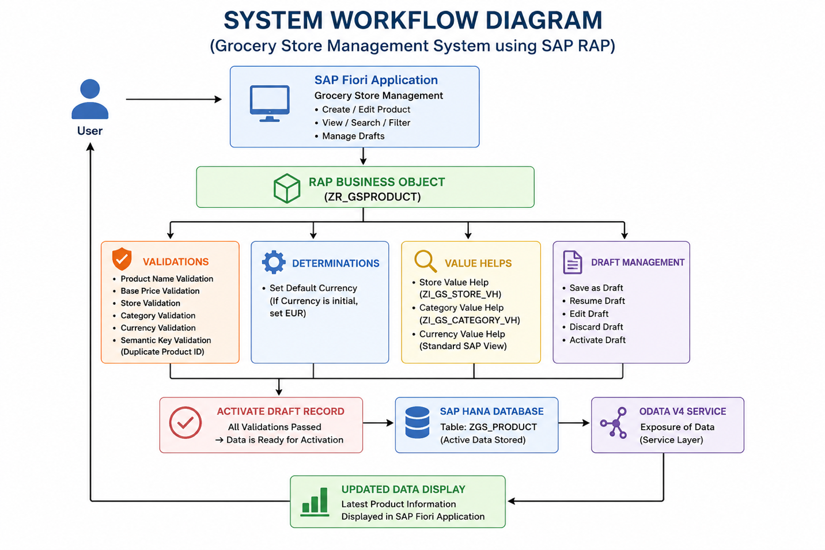

5.3 Design Principles
- Layered Architecture
- Modular Development
- Data Integrity
- Reusability
- Scalability
- Draft Processing
- Enterprise Transaction Management
- User-Friendly SAP Fiori Interface

6. System Architecture

6.1 System Architecture
The Grocery Store Management System consists of:
- SAP Fiori Elements
- OData V4 Service
- RAP Business Object
- CDS View Entities
- Behavior Definition
- Behavior Implementation
- SAP HANA Database
All user requests travel through the RAP Business Object before reaching the database, ensuring validations, determinations, and transaction consistency.
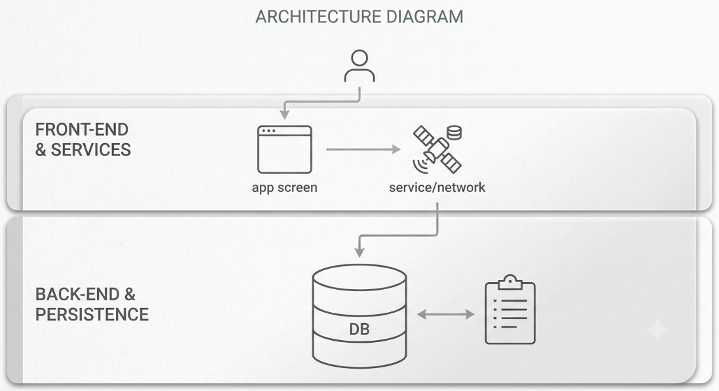
SAP Fiori Elements
Provides a responsive and user-friendly interface where users interact with the application. It automatically generates standard pages such as List Reports and Object Pages based on metadata exposed by the RAP service.
OData V4 Service
Acts as the communication layer between the frontend and backend. It receives requests from the Fiori application and transfers them to the RAP Business Object for processing.
RAP Business Object
Contains the application's business logic. It handles CRUD operations, validations, determinations, draft management, and transaction control before data is committed to the database.
CDS View Entity
Defines the application's data model and exposes database fields to the RAP framework. CDS Views also support annotations that simplify UI generation and improve data readability.
SAP HANA Database
Stores all product information persistently while providing high-performance data processing and transactional consistency.

7. Technologies Used
The Grocery Management System has been developed using modern SAP technologies that support cloud-native enterprise application development. Each technology contributes to a specific layer of the application architecture.
Technology | Purpose
SAP ABAP Cloud | Backend programming language
SAP RAP | Business object development framework
SAP HANA | Database management system
CDS View Entity | Data modeling
Behavior Definition | Business rules and CRUD
Behavior Implementation | Validation and determination logic
OData V4 | Service exposure
SAP Fiori Elements | User Interface
Eclipse ADT | Development environment

SAP ABAP Cloud
SAP ABAP Cloud is the programming environment used to develop the backend logic of the application. It follows clean-core principles and supports cloud-ready application development with secure and maintainable coding standards.

SAP RESTful ABAP Programming Model (RAP)
RAP provides a standardized framework for developing enterprise applications. It simplifies CRUD implementation, transaction handling, draft functionality, validations, and OData service generation while reducing development complexity.

Core Data Services (CDS)
CDS Views define the business data model. They expose database tables in a structured manner and provide annotations that enable automatic UI generation and service exposure.

Behavior Definition
Behavior Definitions specify how business objects behave, including which operations are allowed, validation rules, determinations, draft support, and locking mechanisms.

SAP Fiori Elements
SAP Fiori Elements automatically generates responsive web applications based on metadata annotations, allowing developers to build enterprise-grade applications with minimal frontend coding.

SAP HANA Database
SAP HANA serves as the application's persistent storage layer. Its in-memory architecture provides high performance for reading and writing product records while supporting transactional consistency.

8. Functional Modules
The Grocery Store Management System is organized into multiple functional modules, with each module responsible for handling a specific business process. This modular architecture improves maintainability, scalability, and code reusability while ensuring that each component performs a well-defined function. The system has been developed using SAP RAP Business Objects, CDS View Entities, Behavior Definitions, and SAP Fiori Elements to provide a modern enterprise application for grocery product management.
8.1 Product Management Module
The Product Management Module is the core component of the application. It enables users to create, maintain, update, and delete grocery product records. Each product contains essential information such as Product ID, Product Name, Store ID, Category ID, Base Price, and Currency.
During product creation, the RAP framework validates mandatory fields, prevents duplicate Product IDs using semantic key validation, and ensures that only valid business data is stored in the SAP HANA database. The module provides a simple and user-friendly interface through SAP Fiori Elements, allowing users to efficiently manage grocery products.

8.2 Store Management Module
The Store Management Module maintains the list of grocery stores available within the system. Each store is identified by a unique Store ID and corresponding Store Name.
Products are associated with stores through value help functionality, allowing users to select existing stores instead of manually entering store identifiers. This approach improves data consistency, minimizes typing errors, and simplifies product management.

8.3 Category Management Module
The Category Management Module organizes grocery products into predefined business categories such as Dairy Products, Bakery, Fruits & Vegetables, Beverages, Frozen Foods, Household Items, and Snacks.
Using category value help, users can easily assign products to appropriate categories. Proper categorization improves product organization, simplifies searching and filtering, and supports future reporting and analytics.

8.4 Product Update Module
The Product Update Module enables users to modify existing product information while maintaining transactional consistency through SAP RAP Draft Handling.
Users can edit product details such as Product Name, Store, Category, Base Price, and Currency. Changes are initially stored as draft instances, allowing users to continue editing before activating the final version. This prevents accidental data loss and provides greater flexibility during data maintenance.

8.5 Search Module
The Search Module allows users to quickly locate grocery products using SAP Fiori's built-in search capabilities.
Users can search products based on Product ID, Product Name, Store ID, or Category ID. This functionality significantly reduces the time required to locate specific records, especially when managing many grocery products.

8.6 Filter and Sorting Module
The Filter and Sorting Module enhances data navigation by allowing users to filter grocery products according to business requirements.
Products can be filtered using fields such as Store, Category, Currency, or Product Name. Additionally, users can sort records in ascending or descending order based on Product ID, Product Name, or Base Price. These capabilities improve usability and simplify data analysis.

8.7 Draft Management Module
Draft Management is one of the key features provided by SAP RAP. Instead of immediately saving user changes to the active database, the application temporarily stores modifications as draft records.
Users can save incomplete work, resume editing later, activate completed changes, or discard unwanted drafts. This mechanism improves user experience while ensuring transactional consistency and preventing accidental updates to active business data.

8.8 Validation and Business Rules Module
The Validation and Business Rules Module ensures that only accurate, complete, and meaningful product information is stored in the system. Before any transaction is committed to the SAP HANA database, the RAP Business Object executes multiple business validations to verify the integrity of the entered data.
The implemented validations include checking that the Product Name is not empty, ensuring that the Base Price is greater than zero, verifying that a valid Store and Category have been selected, validating the Currency against the SAP standard currency list, and preventing duplicate Product IDs through semantic key validation. If any validation fails, the transaction is immediately stopped, and an informative error message is displayed to the user through the SAP Fiori interface.
In addition to validations, the module also executes business determinations such as assigning a default currency when required. These business rules ensure consistent data quality, reduce manual errors, and enforce enterprise standards throughout the application's lifecycle.

9. User Guide
The Grocery Management System provides a simple and intuitive SAP Fiori interface that enables users to manage product records efficiently. The following steps describe the typical workflow for using the application.

Step 1: Launch the Application
Users access the Grocery Management System from the SAP Fiori Launchpad. Selecting the application tile opens the List Report page, which displays all available product records.

Step 2: View Grocery Records
The List Report displays all existing product records in a structured table format. Users can scroll through the list, search for specific records, apply filters, or sort the displayed information.

Step 3: Create an Item Record
To create a new product, the user selects the Create button and enters all required information. Mandatory fields are validated before saving. After successful validation, the new record is created and becomes available in the product list.

Step 4: Edit Item Information
Users can select an existing record and choose the Edit option. Changes are initially stored as a draft, allowing users to continue editing before activating the updated information.

Step 5: Search, Filter, and Sort
The application provides built-in SAP Fiori search and filtering capabilities, enabling users to locate records efficiently and organize displayed information according to their requirements.

Step 6: Delete an UnwantedItem Record
Users can delete obsolete records by selecting the required entry and choosing the Delete option. A confirmation dialog ensures that records are not removed accidentally.

10. Validation Rules
Validation is a critical component of the Grocery Management System because it ensures that only accurate and meaningful information is stored in the database. The RAP Business Object performs validations before data is activated, preventing inconsistent or duplicate records.
The implemented validation rules include checking mandatory fields, preventing duplicate product IDs, verifying valid email formats, and ensuring that values satisfy business requirements. If any validation fails, the transaction is stopped, and a descriptive error message is displayed to the user.

Validation | Purpose
Product Name Validation | Product name cannot be empty
Semantic Key Check | Prevents duplicate product ID’s
Store Validation | Store selection is mandatory
Currency Validation | Currency must exist in SAP
Base Price Validation | Price must be greater than zero
Category Validation | Category selection is mandatory

These validations improve data integrity, reduce human errors, and ensure reliable information throughout the application.

11. Determinations
Implemented determinations include:

Default Currency Determination
Automatically assigns EUR if the currency field is left empty during product creation.

Price Category Determination
Automatically classifies products into price ranges such as Budget, Standard, and Premium based on the entered base price.

12. Value Helps
Two value helps have been implemented:
- Store Value Help (ZI_GS_STORE_VH)
- Category Value Help (ZI_GS_CATEGORY_VH)
These enable users to select valid stores and categories directly from SAP Fiori without manually entering IDs.

13. Draft Management
The application uses SAP RAP Draft functionality, allowing users to save incomplete product information temporarily. Draft records can later be edited, activated, resumed, or discarded before updating the active database.

14. Testing
Comprehensive testing was performed to verify that the Grocery Management System satisfies all functional and business requirements. Each feature was tested individually as well as in combination with other modules to ensure consistent system behavior.
The testing process included CRUD operations, draft handling, validations, search functionality, filtering, sorting, and user interface behavior. Test cases were designed to evaluate both successful and unsuccessful scenarios to verify proper error handling.
All identified issues were corrected before the final deployment, and the completed system successfully passed all planned functional and draft-related test cases.
The detailed Functional Testing Report and Draft Testing Report are included as separate project documents.

15. Error Handling
The application displays meaningful error messages whenever business rules are violated. Examples include missing mandatory fields, duplicate Product IDs, invalid currency codes, and invalid base prices. RAP prevents invalid transactions from being committed to the SAP HANA database.

16. Future Enhancements
Possible future improvements include:
- Inventory Management
- Stock Availability Tracking
- Supplier Management
- Barcode Integration
- Product Images
- Discount and Offer Management
- Sales Dashboard
- Purchase Order Management
- Role-Based Authorization
- Analytics and Reporting

17. Conclusion
The Grocery Store Management System successfully demonstrates the implementation of SAP RESTful ABAP Programming Model using SAP ABAP Cloud, CDS View Entities, Behavior Definitions, Behavior Implementations, OData V4 services, and SAP Fiori Elements. The application supports complete CRUD functionality, draft management, semantic key validation, value helps, and business validations while ensuring transactional consistency and data integrity. It provides a scalable and maintainable foundation for future retail management enhancements and effectively showcases modern SAP Cloud development practices.
18. References
SAP. ABAP RESTful Application Programming Model (RAP).
SAP. Core Data Services (CDS) Documentation.
SAP. SAP Fiori Elements Documentation.
SAP. SAP HANA Cloud Documentation.
SAP Community. ABAP Development Resources.

GitHub: Sandeep_Chava_999

