Rodrigo Chavez Mercado

N01510943

Q4

Data

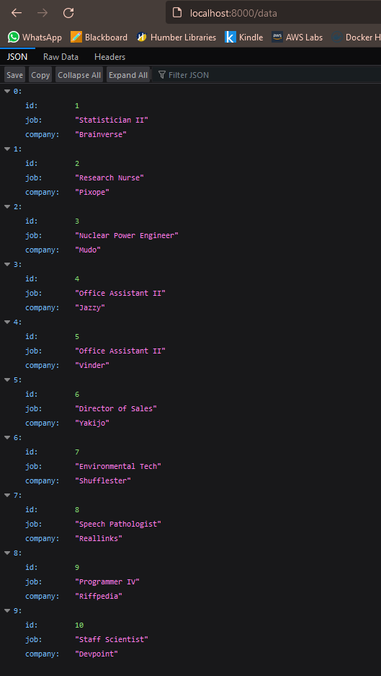

Data/index/:index

/data/search/[c|j]-:name

