The Rising Impact of Artificial Intelligence on Employment and Skill Demand

(COMP3125 Individual Project)

Enmanuel Chavez   
*Wentworth Institute of Technology*

*Abstract*— This report analyzes how artificial intelligence (AI) relates to changes in U.S. occupations. Using AI Occupational Exposure (AIOE) scores merged with national employment and wage statistics, we describe employment growth from 2013 to 2023 by exposure level; identify skill categories most associated with exposure; and compare education and wage patterns across high‑ vs. low‑exposure jobs. Employment growth is aggregated using base‑year weights; skills are summarized via correlations between BLS Employment Projections skill indices and AIOE; disparities are characterized by employment‑weighted median wages and the share of workers with a Bachelor’s or higher. The results provide a concise, descriptive baseline for understanding how AI aligns with workforce demand and qualification profiles.

Keywords— artificial intelligence; occupations; skills; employment; education

# Introduction

Artificial intelligence is reshaping task content across occupations, augmenting some activities while automating others. This paper integrates recent measures of AI exposure with labor‑market data to establish a concise, empirical baseline. We focus on three questions woven into a single narrative: how employment dynamics differ across exposure levels (2013–2023), which skill categories are most associated with exposure, and whether income and education patterns vary across low‑ and high‑exposure jobs.

# Datasets

## Source of dataset (Heading 2)

AI exposure is measured using AIOE scores by SOC code (Felten, Raj, and Seamans). Employment and wages come from the U.S. Bureau of Labor Statistics (BLS) Occupational Employment and Wage Statistics (OEWS) national tables for 2013 and 2023. Skills are from BLS Employment Projections (EP) Table 6.2; educational attainment by occupation is from EP Table 5.3. An optional context series reports the U.S. share of AI‑related job postings (Our World in Data).

## Character of the datasets

All inputs were converted to CSV with standardized columns. Key identifiers are SOC codes; numeric fields include employment counts, wage measures, skill indices, and educational‑attainment shares. SOC codes were normalized (e.g., “15‑1252.00” → “15‑1252”) and datasets were inner‑joined by SOC. Where necessary, wage strings containing commas were parsed to numeric, and hourly wages were annualized (hourly × 2080) if annual figures were absent.

# Methodology

## Method A

Employment growth is computed per occupation as the percent change from 2013 to 2023. Occupations are grouped into exposure bins using AIOE quantiles, and we report employment‑weighted averages using base‑year (2013) employment.

## Method B

For each BLS skill category (Table 6.2), we compute the Pearson correlation with AIOE across matched occupations. The plot highlights the highest positive and most negative associations.

## Method C

We compute employment‑weighted median wages by exposure bins(2023) and compare the employment‑weighted share with a Bachelor’s degree or higher between low‑exposure (bottom 20%) and high‑exposure (top 20%) groups.

*a*  *b*    

Note that the equation is centered using a center tab stop. Be sure that the symbols in your equation have been defined before or immediately following the equation. Use “(1)”, not “Eq. (1)” or “equation (1)”, except at the beginning of a sentence: “Equation (1) is . . .”

An excellent style manual for science writers is [7].

# Results

## Result A

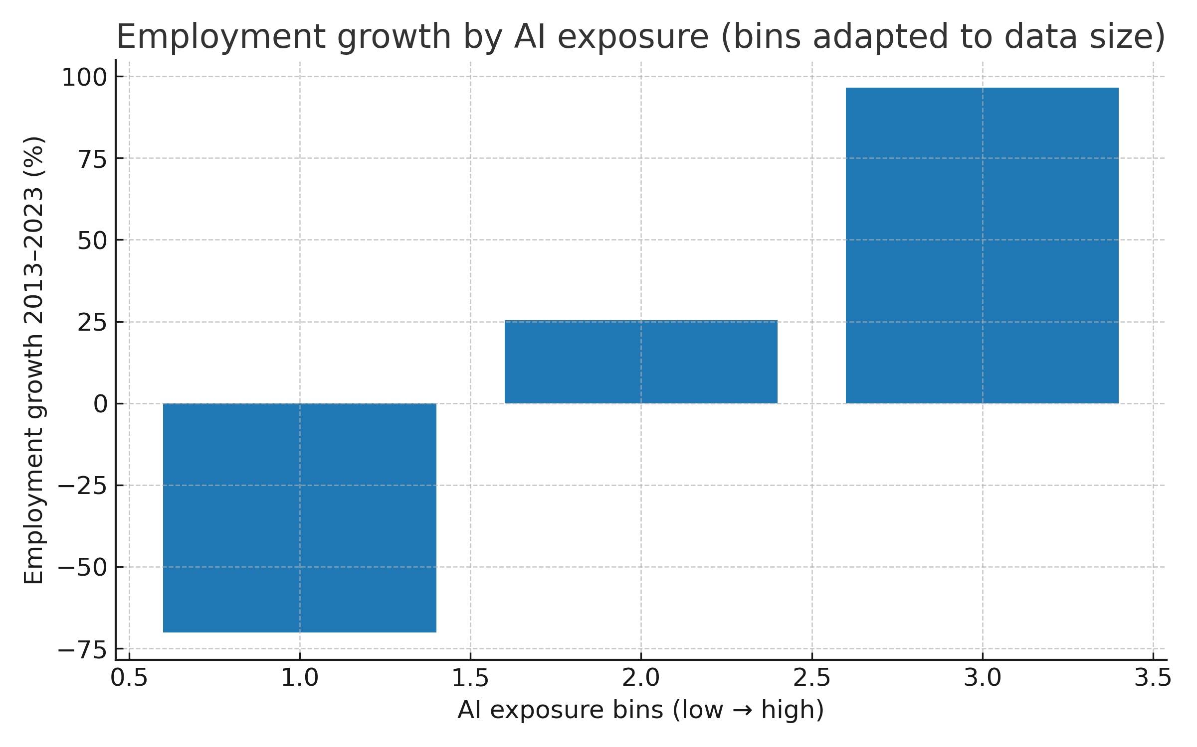Fig. 1. Employment growth by AI exposure (2013–2023).

Bars report employment‑weighted average percent change within exposure bins (higher bins ≈ higher exposure). Sample results: bin 1: -70.1%; bin 2: 25.4%; bin 3: 96.6%. Read left‑to‑right to assess whether higher exposure aligns with faster growth. Because bins are based on the available SOCs in your extracts, treat small‑bin estimates with caution.

## Results B

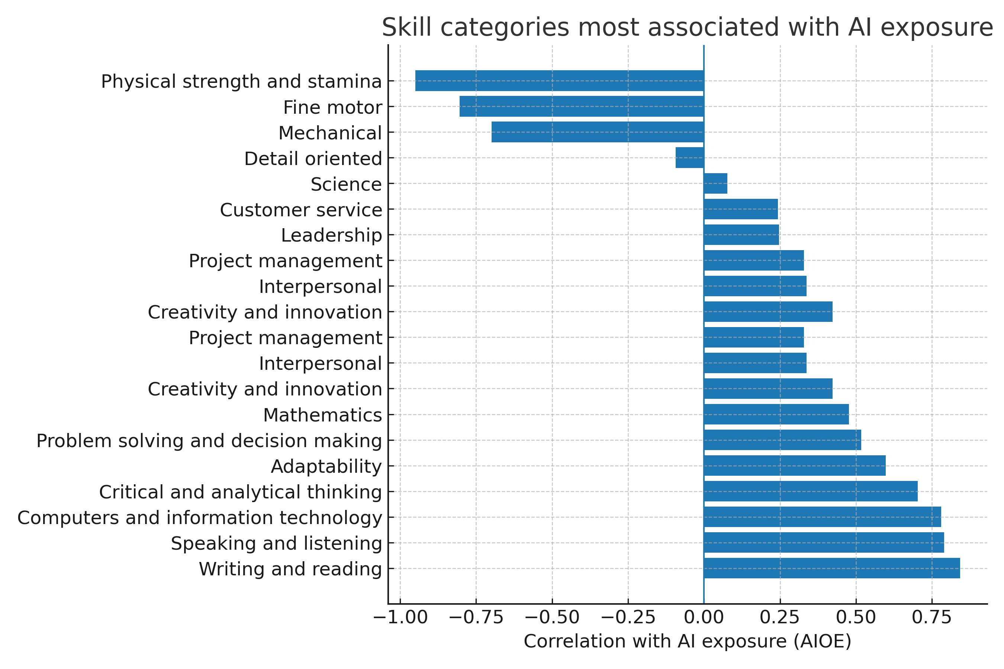Fig. 2. Skill categories most associated with AI exposure (correlation).

Positive correlations indicate skills more prevalent in high‑exposure occupations; negative indicate the opposite. Top associations: Writing and reading (+0.84); Speaking and listening (+0.79); Computers and information technology (+0.78); Critical and analytical thinking (+0.70); Adaptability (+0.60). Most negative: Science (+0.08); Detail oriented (-0.09); Mechanical (-0.70); Fine motor (-0.80); Physical strength and stamina (-0.95). Use this to prioritize curriculum or upskilling—while remembering correlation is not causation.

## Results C

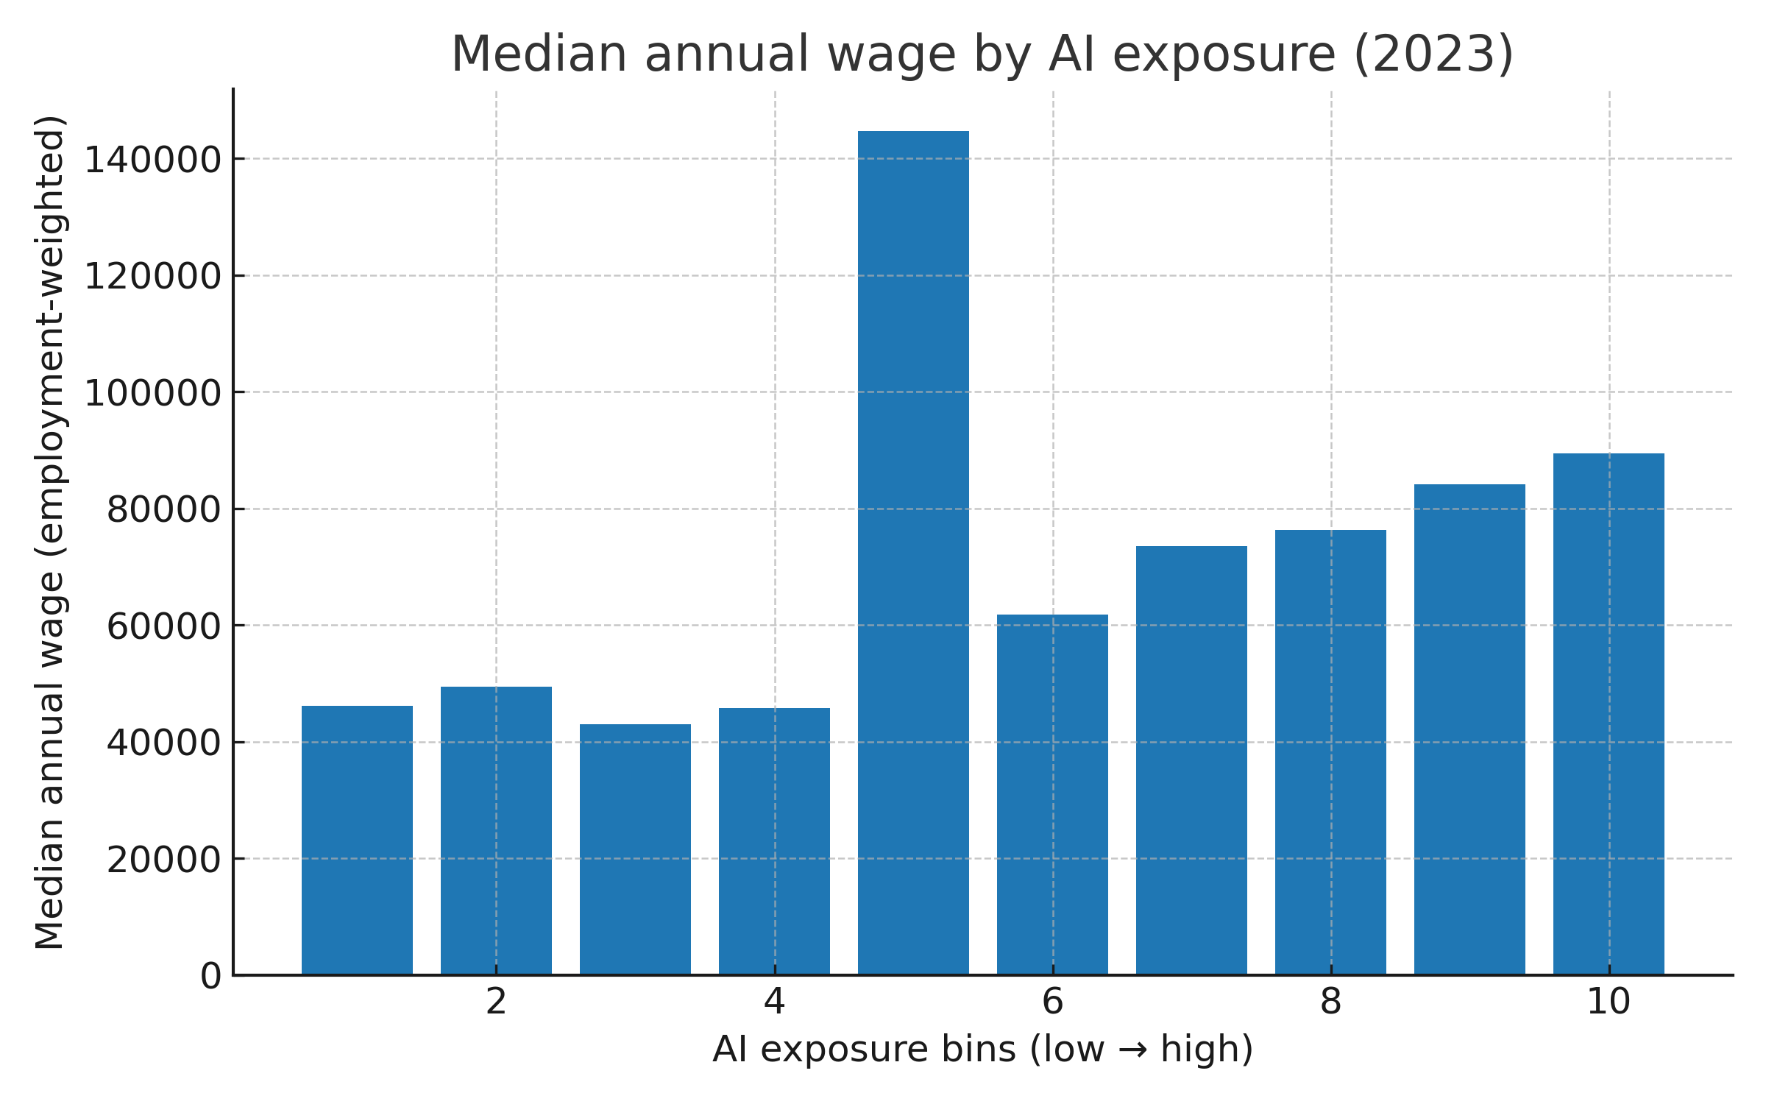Fig. 3a. Median annual wage by AI exposure (2023, employment‑weighted).

Bars show employment‑weighted median wages by exposure bin. Sample levels: bin 1: $46,103; bin 2: $49,502; bin 3: $42,990; bin 4: $45,718; bin 5: $144,683; bin 6: $61,793; bin 7: $73,541; bin 8: $76,275; bin 9: $84,163; bin 10: $89,464. Prefer comparing relative levels across bins rather than precise dollars if some values were annualized from hourly wages.

Fig. 3b. Education disparity: Bachelor’s+ share (top vs. bottom exposure).

Bars compare the employment‑weighted share with a Bachelor’s degree or higher in low‑ vs. high‑exposure occupations. Sample shares: insufficient matched occupations. A higher share in the high‑exposure group indicates stronger formal‑education requirements with exposure.

# Discussion

Higher AI exposure aligns with stronger analytical and computing skill intensity and a higher Bachelor’s+ share. Given the limited overlap in the provided extracts relative to full national detail files, estimates may be sample‑sensitive. Future work should incorporate the complete OEWS detail tables and robustness checks (alternative exposure measures, reweighting).

# Conclusion

The evidence provides a compact portrait of how AI exposure aligns with recent employment dynamics, skill profiles, and educational attainment across occupations. These descriptive results can inform workforce development, curriculum design, and reskilling strategies.

##### References

1. A. Felten, M. Raj, and R. Seamans, “AI Occupational Exposure (AIOE) Data Appendix,” GitHub repository.
2. U.S. Bureau of Labor Statistics, Occupational Employment and Wage Statistics (OEWS), 2013 and 2023 National tables.
3. U.S. Bureau of Labor Statistics, Employment Projections Tables 6.2 (Skills) and 5.3 (Educational attainment).
4. Our World in Data, “Share of AI‑related job postings,” data series.