**Arules observation on Books/Groceries/my_movies dataset**

(1)Books

Observation :-

Test Case -> I have applied support values from .02 to .05 and confidence value from .7 to .9

**.02<= Support <= .05**

**.7<=confidence<=.9**

**Conclusion** ->Out of all combination I would like to consider the rule set where support is **.03 and confidence is .9**. The reason behind it there are **41** rules in amount and where lift ration is very good at 8 which can also I get if we reduce the support and confidence so it will decrease the quality of rule.

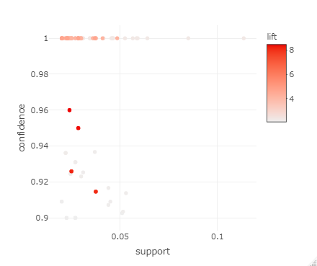

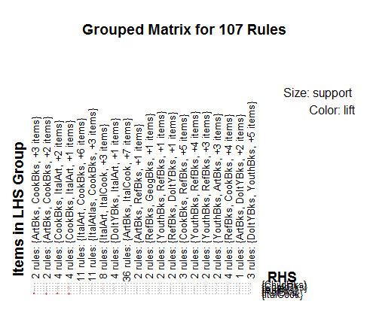

(2)groceries

Observation :-

Test Case -> I have applied support values from .02 to .05 and confidence value from .7 to .9

**.002<= Support <= .005**

**.7<=confidence<=.9**

**Conclusion** ->Out of all combination I would like to consider the rule set where support is **.03 and confidence is .9**. The reason behind it there are **29** rules in amount and where lift ration is very good at 26 same when I get in on support .004 but here I can get the number of attributes more than .004 rules set.

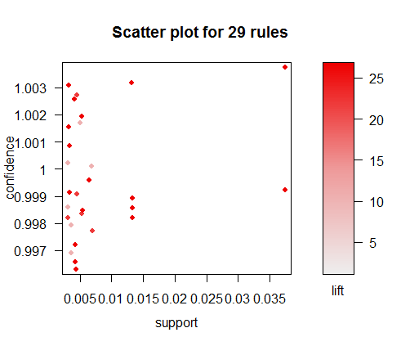

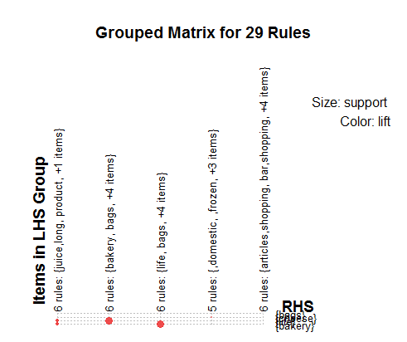

(3)my_movies

Observation :-

Test Case -> I have applied support values from .02 to .05 and confidence value from .7 to .9

**.02<= Support <= .05**

**.7<=confidence<=.9**

**Conclusion** ->There is no point to apply arules on this dataset as observation is very less only 11 and on that data no matter what support and confidence I will apply I am getting same kind of rule in term of count,lift and all rules have only one one element on RHS and LHS.

**Total Result on all three Data Sets**

