**Airline dataset clustering**

Below are the inferences

* Import dataset
* Eliminate the Id column
* Normalized the dataset
* K selection gave me suggestion of 11 clusters
* fviz gave me suggestion of 6 cluster
* Hierarchical Clustering output in aggregate function

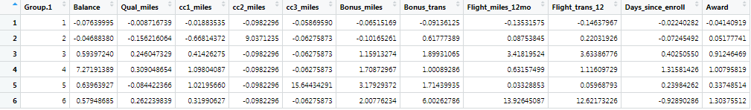

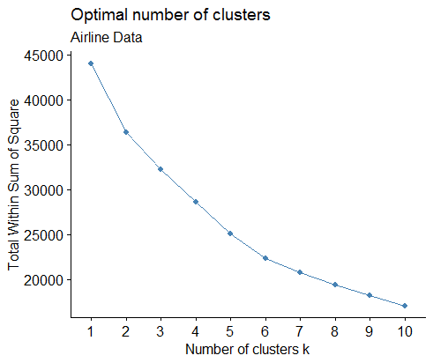

* Kmean Clustering graph

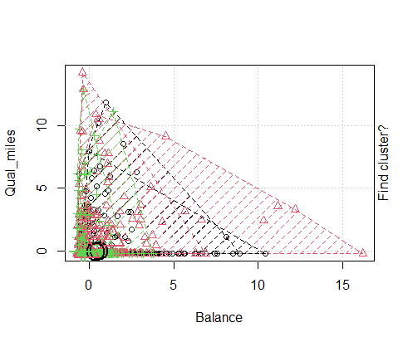

* Aggregate value for Kmean clustering wrt 11 attribute

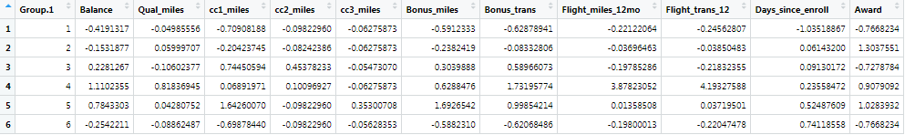

* You have to make you criteria to select the customer to reward and the best suits cluster will the observation to whom you want to give the rewards

Crime Dataset Clustering

Inferences are as below

* This dataset having one categorical column, city.
* Adding one more column named as city id.   
  In applying dataset remove column city and keep only city code.
* crime_data1 <- crime_data[,2:6]
* Normalized the data
* Apply H clustering as data is not so big
* Fviz giving me 10 cluster suggestion

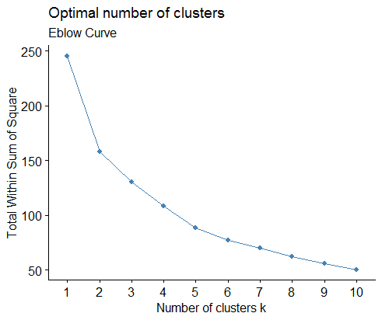

* K selection gave me suggestion of 2 cluster
* n/2 square root suggesting 5 clusters
* After comparing the square root suggestion and Fviz suggestion I decided to make 5 clusters

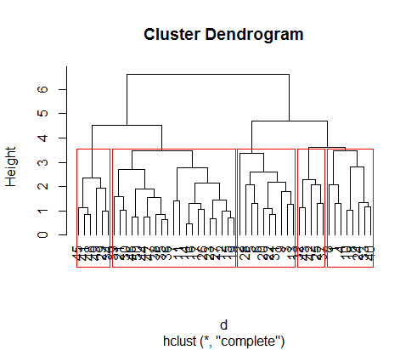

* Below is the aggregate value of clusters wrt attribute

