**Application overview**

**Objective ->** This application has been designed for finding the effectiveness of drug on the basis of user review which they have given for drug or medicine.

**Environment->**

Language -> R 4.0.2

Package -> Shiny

**Prediction computation ->** Application works on four machine learning algorithm

(1) SVM

(2) Multiple Regression

(3) Decision Tree

(4) Random Forest

**Computation Result->** Application generates the output in the form of drug effectiveness with two values Effective or Ineffective. Along with effectiveness, application is also capable to generate below outputs:-

**(1) Effectiveness Result ->** Drug is effective or not on the basis of review.

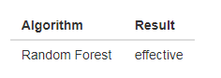

**(2) Sentiments ->** It is the overall positive sentiment percentage of drug which has been entered by end user.

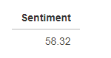

**(3) Conditions->** List of all conditions in which drug can be used.

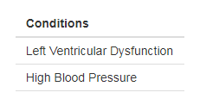

**(4) Word Cloud->** It is the word cloud made by the combine review of entered drug.

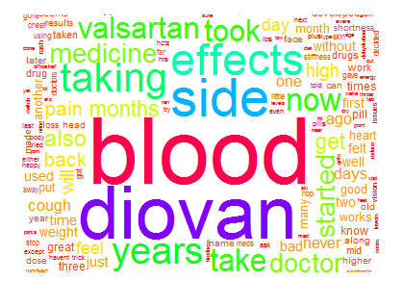

**Application Input Fields ->** Four input fields has been provide to user.

**(1) Drug Name ->** This is auto suggestive fields which takes drug name out of 3669 different drugs.

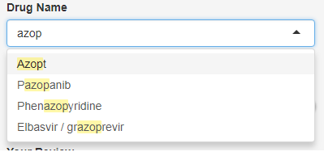

**(2) Drug Rating ->** It is the slider field which takes 0 to 10 drug rating enter by user.

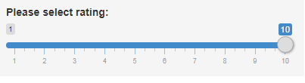

**(3) Drug Review->** This is the text area field where user can share his experience and review about the drug.

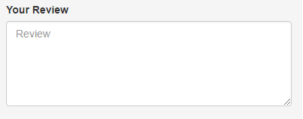

**(4) Drug Method->** It is a drop down input field which accept one of the algorithm out of four which has been mention above.

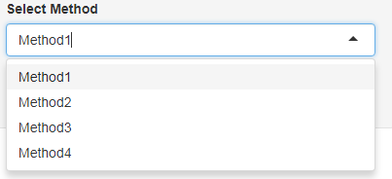

**Input validation->** Application input field validation has been implemented for empty value check.

**Overall Application->**

