Text Mining and Sentiment Analysis

**(1) Word Cloud of Mix words**

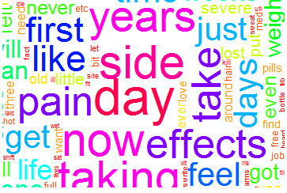

**(2)Term Frequency Graph**

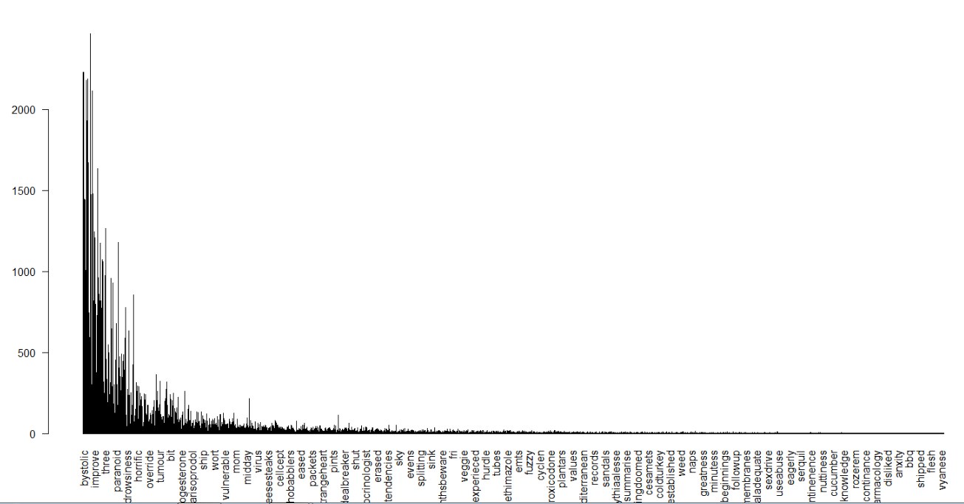

**(3) Top 20 Terms**

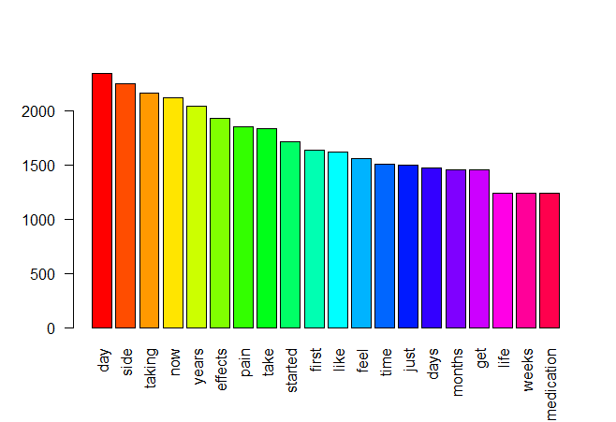

**(4) Ten Topics having 10 term each**

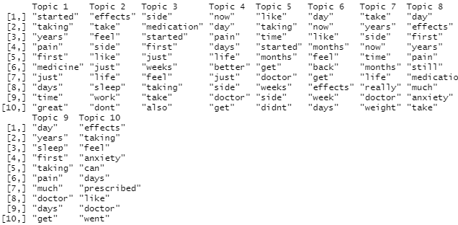

**(5) Positive Word Cloud**

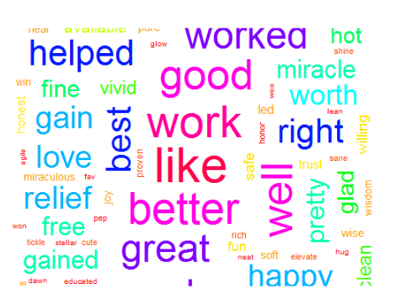

**(6) Top 20 positive word frequency graph**

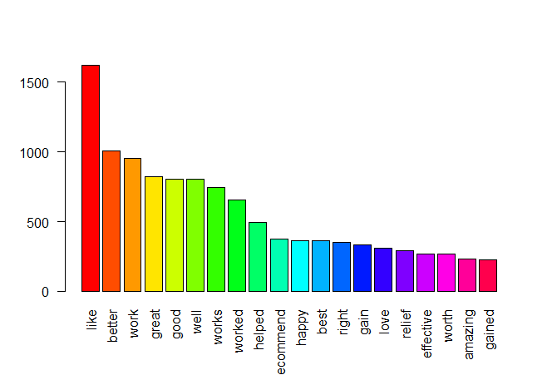

**(7) Negative words cloud**

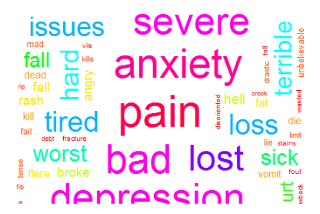

**(8) Top 20 Negative word frequency graph**

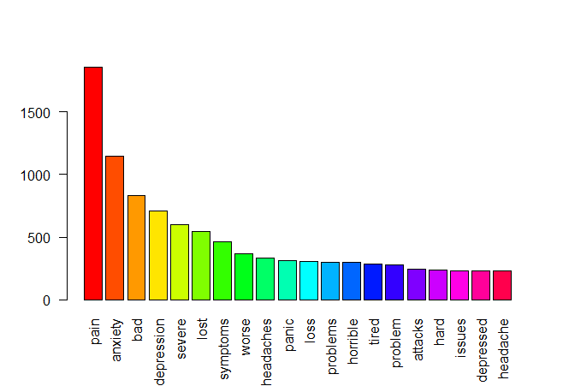

**(9) Sentiment Graph**

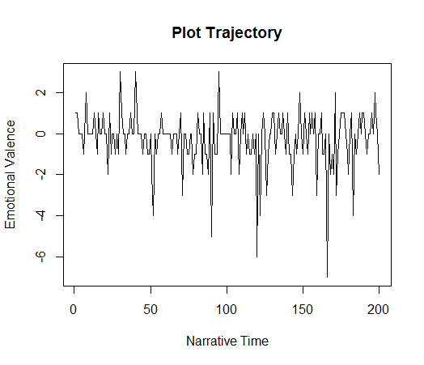

**(10) Percentage base emotion graph**

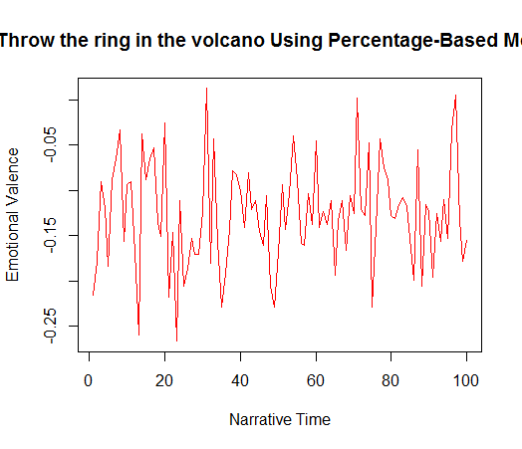

**(11) LOTR Graph (by transform value )**

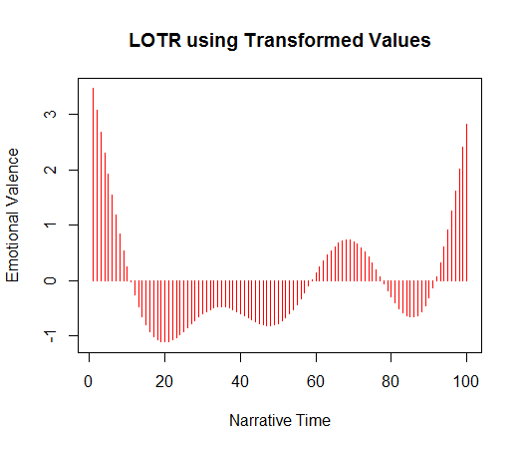

**(12) Emotion percentage Graph**

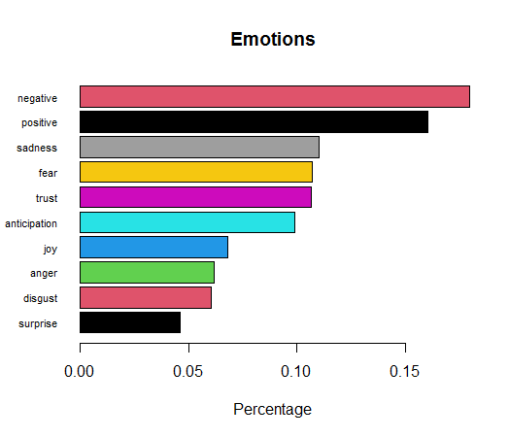

**(13) Top 5 negative sentiments**

[1] "\"In Sept 2012 I was in car wreck that resulted in Several herniated Discs and Bulging discs, as the pain kept on and seemed to increase, I began getting depressed, mix that with trying to plan a wedding, starting a new job, and issues with my oldest child, last week (we are now in Feb 2013) I had 3 bad panic attacks, found myself crying all the time, generally unhappy, snapping at people, and just completely exhausted, stressed out, full of anxiety and depression."

[2] "My symptoms included: Complete exhaustion even though I was getting the same amount of sleep and doing the same things during the day as before, I constantly had a dull ache in my stomach, I had a muscle spasm in my left arm for 2 days straight, constipation, feeling sick and completely unmotivated to do anything, I lost my appetite and hardly ate at all, I was easily hurting myself from barely moving (mostly in my back), extremely weak, headache, and swollen lips\""

[3] "ive suffered from severe depression, anxiety,panic attacks, obsessive compulsive disorder and ive had suicidal thoughts since is was 9 years old."

[4] "My symptoms have been: weight gain, inability to lose weight (very slow loss) despite 6 day workouts and calorie (low carb) control, hot flashes, night sweats, neck pain, headaches, low energy, terrible depression, insane hostile angry mood swings and constant irritability."

[5] "It came after a decade of severe depression, anxiety and panic states, and a multitude of psych issues, and I was like a person on the outside, but inside a disease of agonizing mental anguish and physically I hurt of severe pain but no physical evidence that I was like a 20 year old young man who was only alive because I would not die."

**(14) Top 5 positive sentiments**

[5] "\"Thanks Lamictal, my moods are level (no lows or highs),no more rapid cycling or rapid thoughts, feel confident, happy, more energy, haven&#039;t had one depressive thought since starting this medication and at my correct dose of 200mg (cut in half and take 1/2 tablet twice per day, works out cheaper this way)."

[4] "\"I have had servere psoriasis for 15 years I am now 34 nothing has work apart from u v but the condition soon came back after treatment since being on stelara I have notice a 90% improvement before starting I was 80% covered I could not hardly walk I had thick scales from my neck right down to my ankles since I have been on stelara all I have is a long thin white patch on the inside of my right leg and and I still have some red on both sides of my stomic,i have never felt so healthy or happy blood test always come back clear and I can at last wear shorts and tops with no sleeves with out worrying about what people think\""

[3] "\"I just tried ambien last night for the first time since not getting any more than 2-3 hrs of sleep and I didn&#039;t take the recommended amount of 5mg I took 10mg n it worked perfect for me no side affects of being drowsy in the morning nothing slept right through the night and woke up like a new refreshed woman.\""

[2] "waves of euphoria, pretty dancing rainbows, everything sensory felt incredible BUT I had no emotion or empathy and only cared about feeling good and stopped caring about people in my life or work."

[1] "So I told my psychiatrist and she put me on Wellbutrin XL it took about 3 weeks to start noticing a big improvement I felt energetic I wanted to do things again my mood has been really good I could concentrate it helped me tremendously in my job and I was able to start living life to the fullest and be that fun loving, energetic person I want to be."