**Airline Dataset Description**

[1] "Month" "Passengers" "Jan" "Feb" "Mar" "Apr" "May"

[8] "Jun" "Jul" "Aug" "Sep" "Oct" "Nov" "Dec"

[15] "t" "tsquare" "logPassengers"

Month Passengers Jan Feb Mar Apr May Jun Jul Aug Sep Oct Nov Dec t tsquare logPassengers

1 1995-01-01 112 1 0 0 0 0 0 0 0 0 0 0 0 1 1 4.718499

2 1995-02-01 118 0 1 0 0 0 0 0 0 0 0 0 0 2 4 4.770685

3 1995-03-01 132 0 0 1 0 0 0 0 0 0 0 0 0 3 9 4.882802

4 1995-04-01 129 0 0 0 1 0 0 0 0 0 0 0 0 4 16 4.859812

5 1995-05-01 121 0 0 0 0 1 0 0 0 0 0 0 0 5 25 4.795791

6 1995-06-01 135 0 0 0 0 0 1 0 0 0 0 0 0 6 36 4.905275

All Model Results

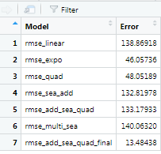

All Graphs

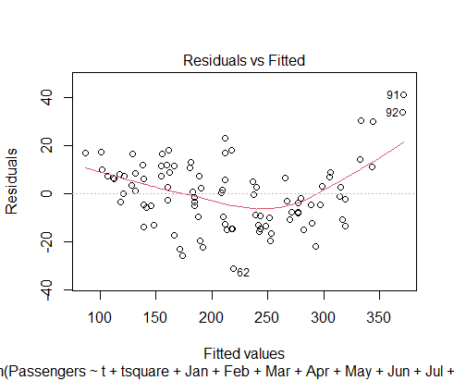

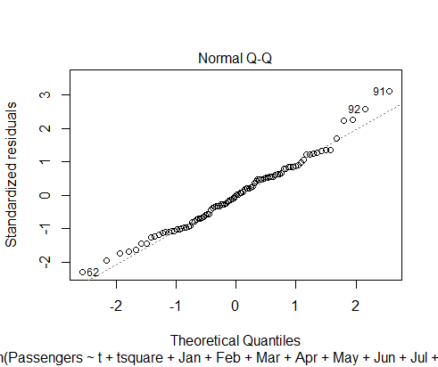

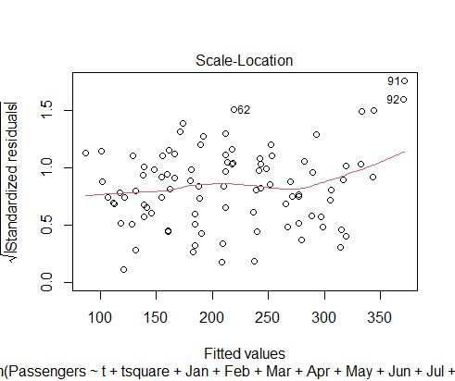

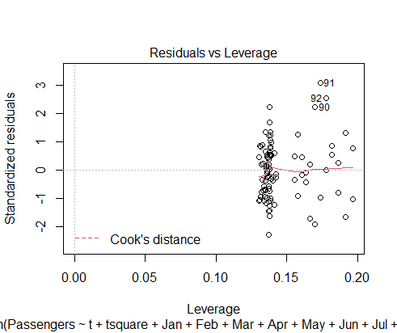

**ACF Plot** :- By the graph we can see some errors are exceeding the margin.

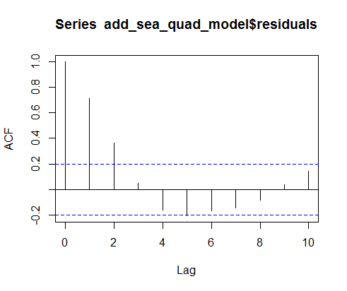

**ArimaOne**:- order with ar value 1 c(1,0,0). 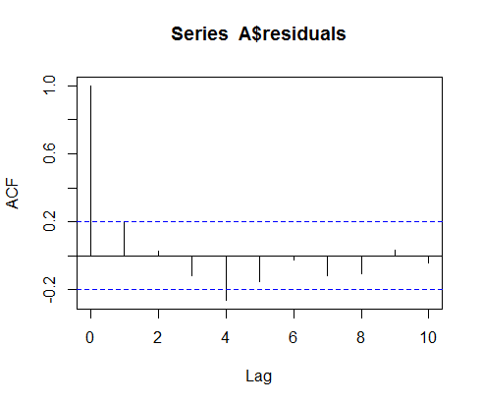

It is showing some errors are still exceeding the margin.

**ArimaTwo**:- with ar value two c(2,0,0)

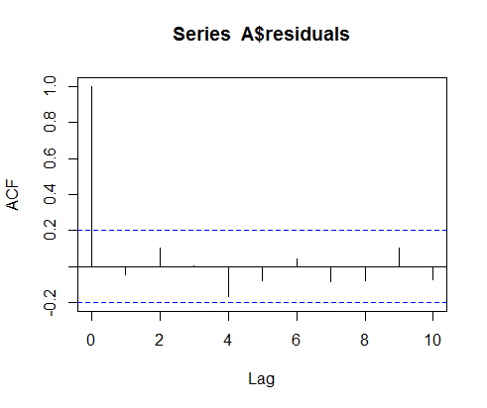

Now all error and inside the margin values.