**Wine Cluster analysis with PCA and without PCA**

Inferences are as below

* Import the data
* Eliminate the first column
* check for colinearity by pairs.panels function 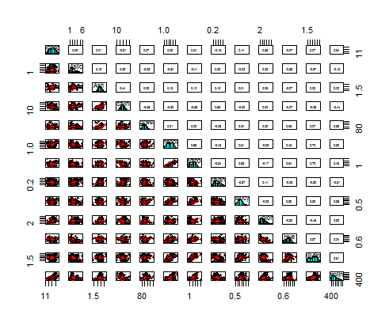
* Apply the princomp function for PCA.
* Three top PCA cover 66% of information.
* Obviously there is no colinearity found in PC1,PC2,PC3

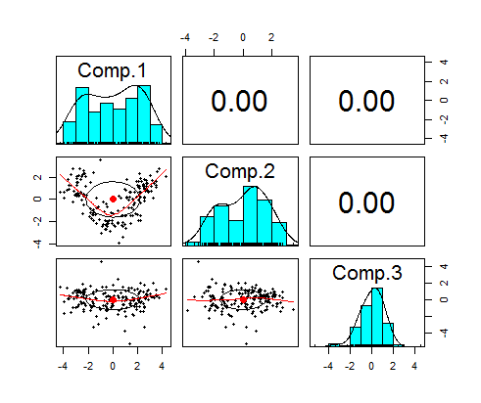

* Pcplot fig

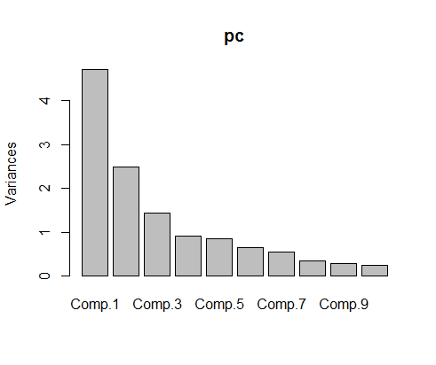

* Fviz suggesting 3 cluster on method silhouette

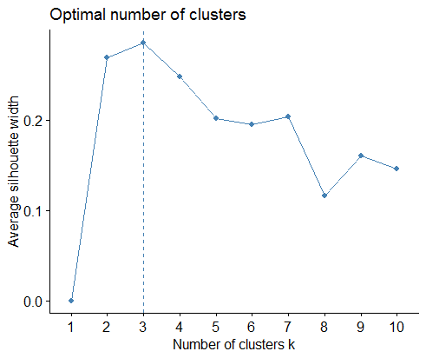

* Fviz suggesting 3 cluster on method gap_stat

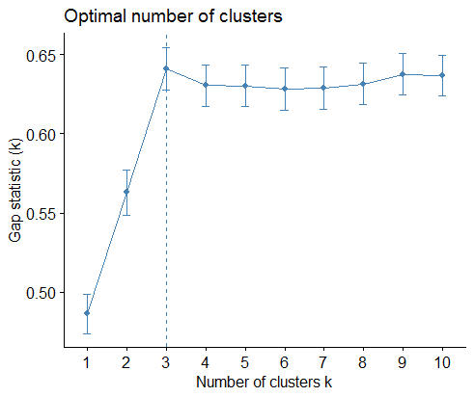

* Kselection suggesting 2 cluster

Dataset looks like below after adding three groups

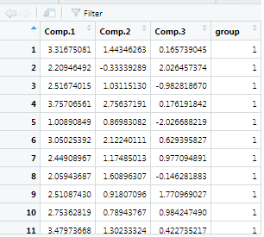

* Hierarchical clustering aggregate values

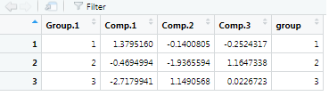

* Kmean plot figure on PC data

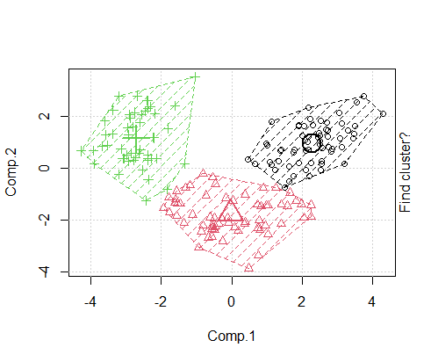

* Kmean Clustering aggregate values

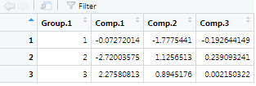

Note:- Yes we get the same cluster count on normal dataset as well.

