# Snake game

**Genre:** Game

**Audience**: Suitable for all ages

**Purpose**: Entertainment

**What is it about?**

The user will control the snake to collect food. The more it eats, the longer it gets and the faster it goes. However, it cannot bump into the wall or touch its parts. That will lead to the death of the snake.

**Tasks**

1. To control the snake by using the arrow buttons because using word input can slow down the game and make the users feel inefficient.
   1. Each arrow will move the snake one unit in the corresponding direction. Nevertheless, the snake cannot make a 180-degree turn because it will touch its body and die.
2. To make the snake grow and go faster every time it eats food.
   1. Eating food is just like increasing the level. As the snake moves more quickly, it would be harder to control and the growing size will raise the probability of running into a wall or its parts.
3. To show the score on the game window.
   1. The score would be demonstrated throughout the game at the top of the window and it will change according to the snake’s food intake.
4. To kill the snake whenever it hits a wall (boundary of the window.) or its own body parts.
   1. Hitting a wall or bumping into its part means “GAME OVER”.
   2. At that time, the game-over statement together with the obtained score will appear on the window.
5. To allow a limited number of inputs. i.e., inputs that do not have any corresponding function would be neglected and they would not cause the abrupt ending of the game.

**Evolution**

(Due to the limited functionality of the word document, some properties could not be demonstrated here. Therefore, it is highly recommended to check the demonstration video.)

1. **Control the snake by using the arrow buttons**.
   * Users can change directions by using the arrow pad on their keyboard. (up, down, left, right )
   * In addition, directions are also bounded to four alphabets (a,w,s,d) to make the game suitable for left-handed users.
2. **To make the snake grow and go faster every time it eats food.**
   * When the user, clicked the “Start” button, the snake will start moving. However, the time it takes to travel from one coordinate to the next one takes 200milliiseconds in the beginning and the time will be reduced, at the rate of 5 milliseconds per food, every time the snake eats food.
   * Eating food will also make the snake longer by a unit.
3. **To show the score on the game window**.

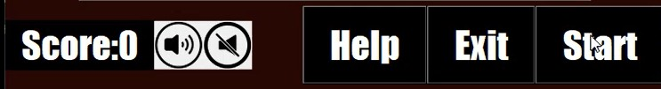

Each food the snake eats accounts for a unit of the score and it would be displayed at the bottom of the game.

1. **To kill the snake whenever it hits a wall(boundary of the window) or its own body part.**

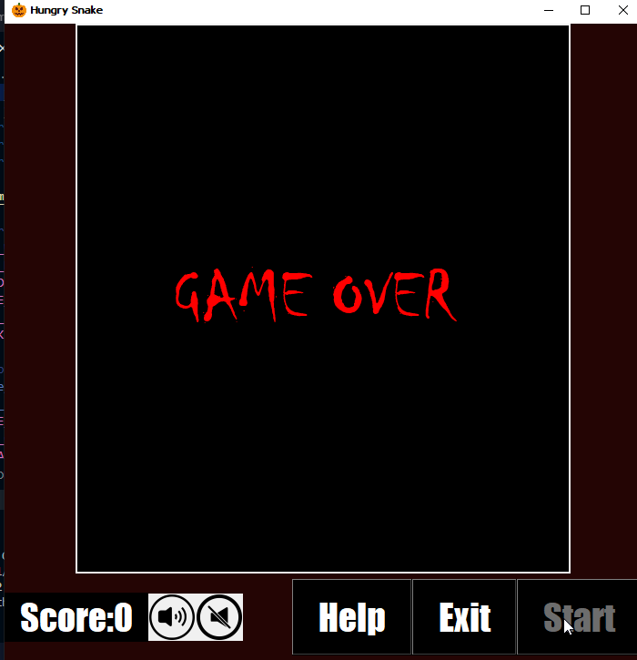

a. The game would be over once the snake head tries to go beyond the boundary or eat its own part.

1. **To allow a limited number of inputs**. i.e. inputs that do not have any corresponding function would be neglected and they would not cause the abrupt ending of the game.

a. The game will not accept any other interventions except the buttons that have functions related to the game.

**Game Features**

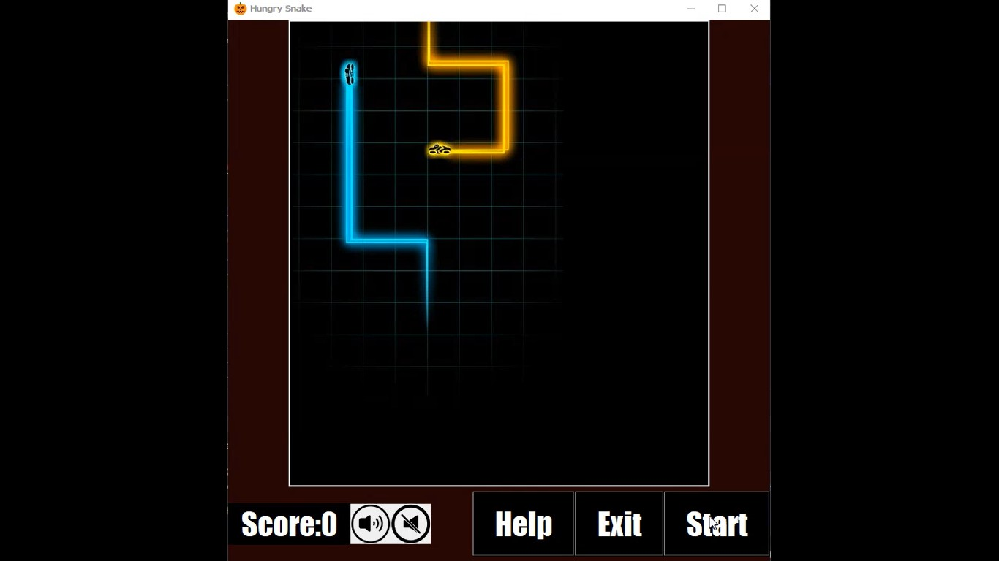

1. **Start button**
   1. The game will not start just by running the codes.
   2. Starting the game just by running the codes causes the snake to bump into the wall since the snake has a certain velocity and new users are not expected of this.
   3. Moreover, it also provides chances for users to control the background sound setting and understand how to play the game by the use of the help button.
2. **Help button**
3. 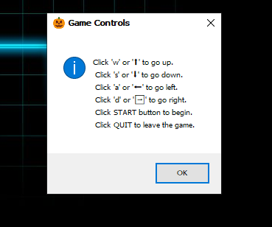

* The information about how to play the game would be shown once the user clicks the start button.

1. **Quit button**
   1. Users have three options to close the game.
      1. Clicking the big, attractive QUIT button on the game.
      2. Clicking the usual close button common to all software.
      3. Using shortcut(Alt+F4)
2. **Sound buttons**
   1. The game comes with background music and the user can turn it on or off with the use of sound buttons.
   2. Sound source: [05 - Double Trouble - Harry Potter and the Prisoner of Azkaban Soundtrack - YouTube](https://www.youtube.com/watch?v=CvnUYeGM3qw)
3. **More color More fun**
   1. The snake and the food will change color randomly every time the user runs the code. There are 9 possible color options for the snakes and 4 for the food.

Figure 1: Snake colors

* 1. 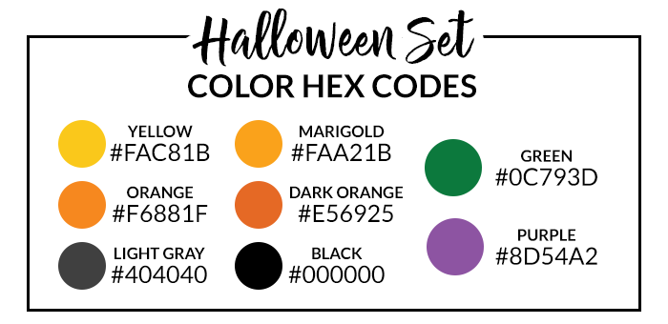

Figure 2: Food colors

* 1. 

**Functionality test and Explanation of the code**

[Functionality test](https://youtu.be/oT9RIQdWOVE)

[Explanation of the code (Detailed)](https://youtu.be/CAOCpaukXAw)