

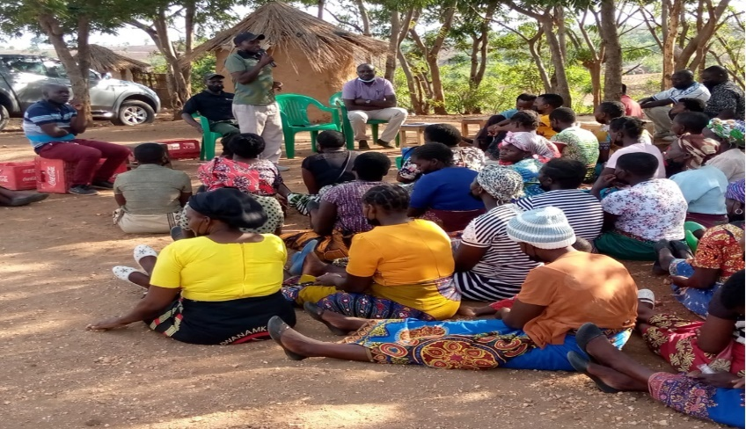

**_____________________**

**FINAL REPORT ON**

**UPSCALING OF RURAL AND FARMER BASED VSLAS TO SACCOS, MZIMBA SOUTH DISTRICTS**

**SEPT 2021 – MARCH, 2022**

**_____________________**

**SUBMITTED BY**

**MALAWI UNION OF SAVINGS AND CREDIT COOPERATIVES (MUSCCO) THROUGH COOPERATIVES DEVELOPMENT INSTITUTE**

**TO**

**GIAE - GREEN INNOVATION CENTRE**