Login-Registration Form

Step 1- click login ig you are alreaddy registered

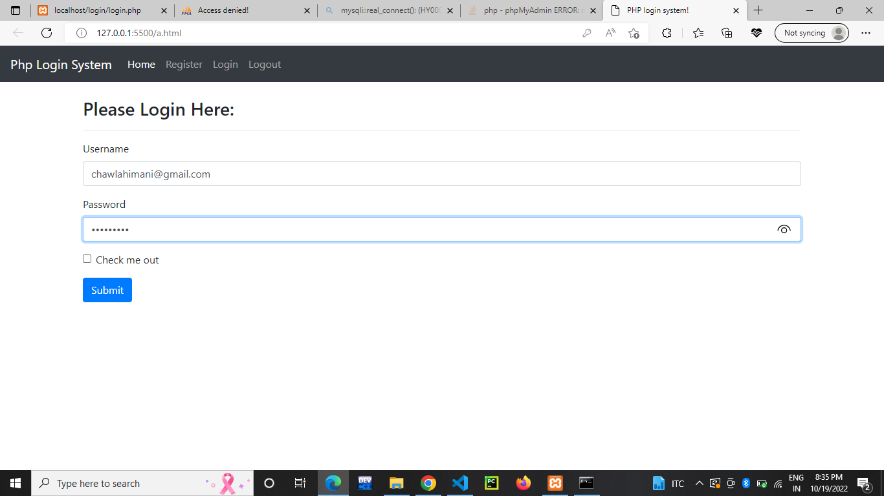

Step 2:- if not register click on register button-

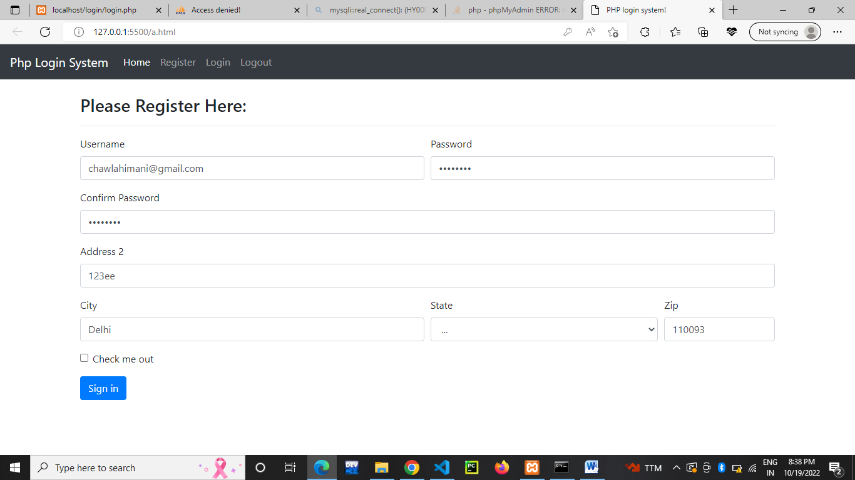

Step 3- after registration again start login the you will logged in

