URL01 – Git hub - <https://github.com/chawlashikha91/Project3>

URL02 - http://udapeople-1b0cd82.s3-website-us-east-1.amazonaws.com/#/employees

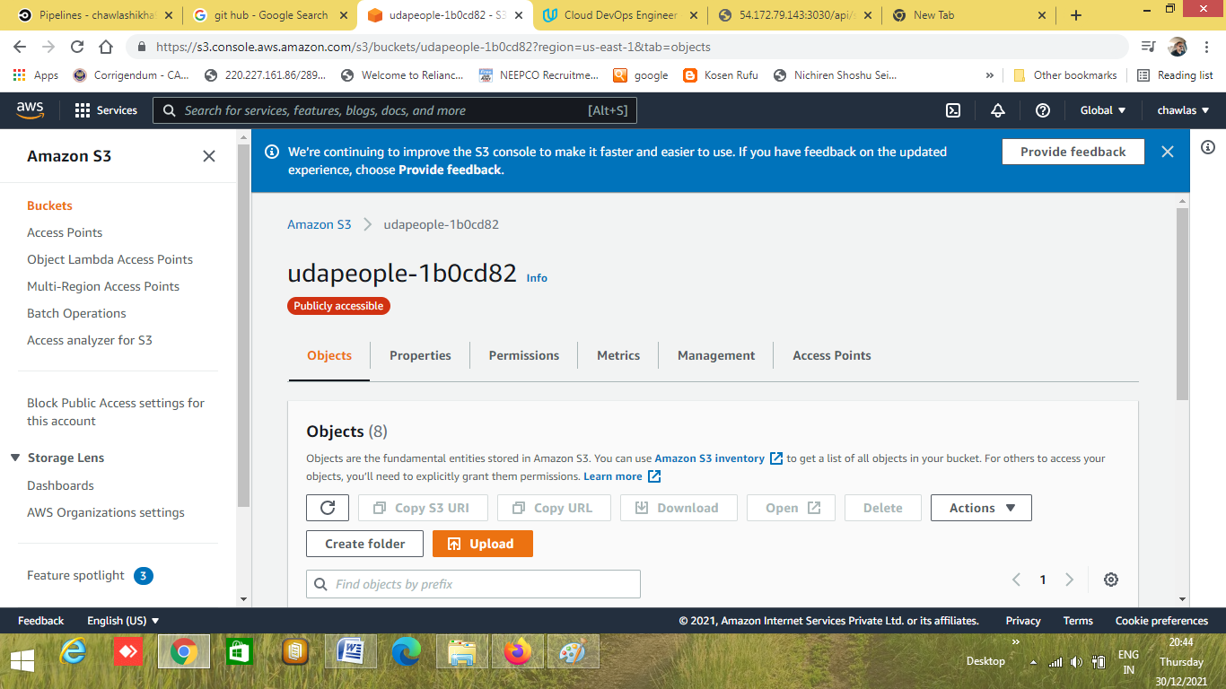

URL03- <http://d2h2x775lhz4dr.cloudfront.net/#/employees>

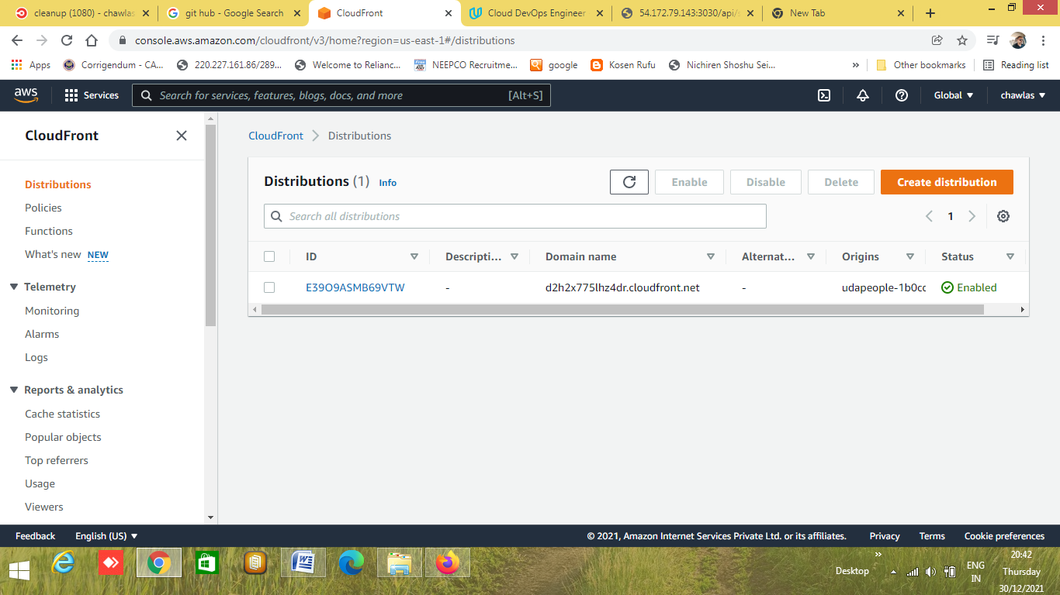

URL04 - <http://54.172.79.143:3030/api/status>

