Hateful Meme Detection via Multimodal Deep Learning
A Comparative Study of Text, Image, Fusion, and CLIP Architectures
Applied Intelligent Deep Learning — Spring 2026

Abstract
Hateful memes present a unique challenge for content moderation systems because their harmful meaning typically arises from the combination of image and text rather than either modality alone. In this work, we train and evaluate four deep learning architectures on the Hateful Memes Expanded dataset: a BERT-based text classifier, a ResNet18-based image classifier, a late-fusion model combining both encoders, and a CLIP-based multimodal model with a frozen encoder. All models were trained for five epochs on CPU under identical hyperparameter settings. Our best model, BERT text-only, achieves a validation AUROC of 0.619 and accuracy of 60.8%. Contrary to our initial hypothesis, adding visual features did not improve discrimination; the image-only model performed near-randomly (AUROC 0.508), and the fusion model matched text-only performance while overfitting more severely. The CLIP model showed steady improvement across epochs but was limited by its frozen encoder. These results suggest that for this dataset, linguistic cues carry the primary signal, and that multimodal gains require partial fine-tuning of visual encoders and techniques to address the pronounced class imbalance.

1. Introduction
Hateful speech on social media increasingly appears in the form of memes: images overlaid with short captions whose hateful meaning depends on the interplay between the visual and textual content. A caption like “they are inferior” may be harmless without knowing what group the accompanying image depicts, and an image of a group may be entirely benign without the accompanying text. This multimodal entanglement makes automated detection significantly harder than standard text classification or image recognition.
The Facebook Hateful Memes challenge formalized this problem as a binary classification task and demonstrated that unimodal models lag well behind human performance. The dataset we use, an expanded version by limjiayi on HuggingFace, extends the original with additional meme categories and brings the training set to approximately 12,887 examples. We use this dataset to benchmark four architectures of increasing complexity and to understand precisely where each approach succeeds or fails.
Our goal is not to push state-of-the-art performance but to systematically compare unimodal and multimodal strategies under controlled conditions, identify the bottlenecks in each approach, and derive actionable recommendations for future work.

2. Dataset and Preprocessing
The Hateful Memes Expanded dataset contains 12,887 training examples, 1,040 validation examples, and 3,000 test examples. Each example consists of a meme image and a short caption text extracted from the image, along with a binary label indicating whether the meme is hateful. The dataset exhibits a pronounced class imbalance: approximately 84% of training examples are labeled not hateful and 16% are labeled hateful. This imbalance is characteristic of real-world content moderation data and has a direct effect on model training, as classifiers are incentivized to predict the majority class by default.
Caption texts are short, averaging roughly nine words. Despite their brevity, they carry high semantic density slurs, irony, cultural references, and coded language are common. This observation guided our choice of BERT as the text encoder: its pre-training on large-scale corpora gives it the contextual understanding needed to parse these subtle signals even with limited fine-tuning data.
Images were downloaded locally and loaded at training time via their relative file paths. Approximately 500 images from the expanded dataset were missing from the downloaded archive (primarily entries from the covid-memes subset); these were filtered out at dataset construction time. For the text pipeline, captions were tokenized using the BERT WordPiece tokenizer with a maximum sequence length of 128 tokens. For the image pipeline, images were resized to 224×224 pixels and normalized using ImageNet statistics. During training, the image branch used light augmentation: random crops, horizontal flips, and small color jitter.

3. Methods

3.1 Text-Only Baseline: BERT
Our baseline model processes only the caption text. We fine-tune BERT-base-uncased, a 12-layer bidirectional transformer with 109.7 million parameters. The final hidden state of the [CLS] token is passed through a two-layer classifier head: a linear projection to 256 dimensions followed by dropout (p = 0.3) and a final linear layer mapping to two output classes. The model is trained end-to-end with cross-entropy loss, AdamW optimizer, a learning rate of 2×10⁻⁵, weight decay of 0.01, and 100 linear warmup steps.

3.2 Image-Only Model: ResNet18
The image model uses a pre-trained ResNet18 backbone with its final fully connected layer replaced by the same two-layer classifier head described above. ResNet18 was chosen for its relatively small parameter count (11.3 million) and fast inference, which is important given CPU-only training constraints. The entire network is fine-tuned end-to-end with no layers frozen. The image encoder receives 224×224 RGB tensors normalized to ImageNet statistics.

3.3 Late-Fusion Multimodal Model
The fusion model runs BERT and ResNet18 in parallel and combines their output representations before classification. Specifically, the 768-dimensional BERT [CLS] representation and the 512-dimensional ResNet18 global average pool output are concatenated into a 1,280-dimensional vector, which is then passed through a shared classifier head (linear → dropout → linear). This late-fusion design allows each encoder to specialize independently before the representations are merged. The combined model has approximately 121 million trainable parameters.

3.4 CLIP with Frozen Encoder
The CLIP model uses OpenAI’s CLIP ViT-B/32, a vision-language model pre-trained to align image and text in a shared embedding space via contrastive learning. The CLIP processor handles both image preprocessing and text tokenization in a unified pipeline. Following standard practice for CLIP fine-tuning on small datasets, we freeze all encoder weights and train only a small classifier head on top of the fused representation. The rationale is that CLIP’s pre-training already produces rich multimodal embeddings, so a lightweight head should suffice. In practice, as discussed in Section 5, this assumption proved too optimistic for this task.

4. Experiments and Results
All models were trained for five epochs using a batch size of 32 on a CPU with no GPU acceleration. Although this constrained throughput and limited experimentation, it produced consistent and comparable results across models. We report validation AUROC as our primary metric because it is threshold-independent and robust to class imbalance. Accuracy and F1 score are reported as secondary metrics.
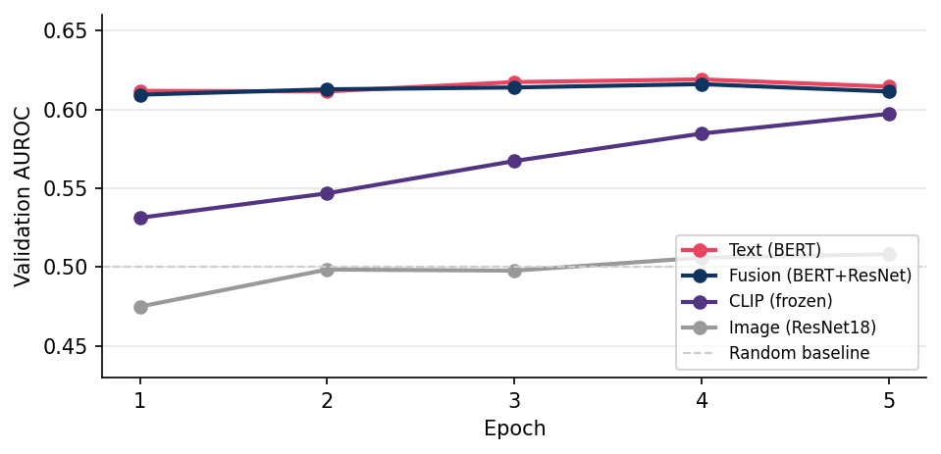
Figure 1. Validation AUROC across five training epochs for all four models.
Figure 1 tells a clear story. The text and fusion models converge within the first epoch, reaching AUROC values around 0.61, and show minimal improvement thereafter. The CLIP model improves steadily from 0.531 to 0.597 across five epochs and may continue to improve with further training. The image model barely rises above the 0.5 random baseline, ending at 0.508 after five epochs.
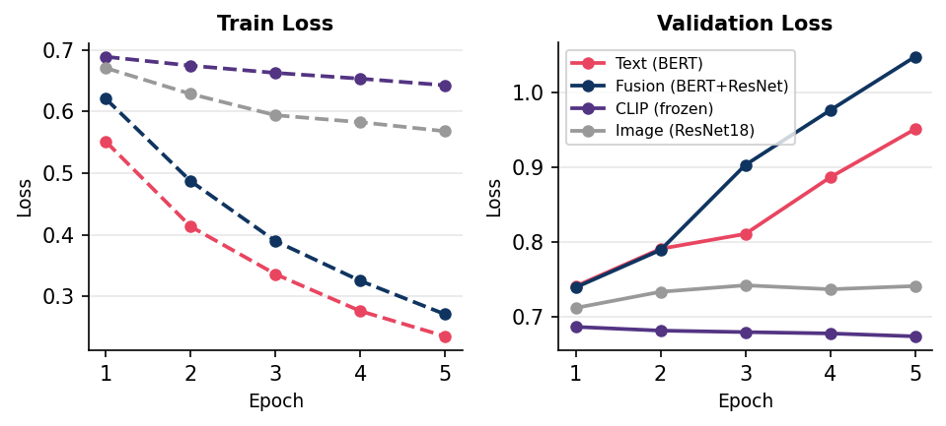
Figure 2. Training loss (left) and validation loss (right) across five epochs.
The loss curves in Figure 2 reveal a key asymmetry. For text and fusion models, training loss drops steeply—from 0.55 to 0.23 for BERT—while validation loss climbs from 0.74 to 0.95. This gap indicates overfitting beginning around epoch two. The fusion model is even more extreme, with validation loss reaching 1.05 by epoch five, the highest of all models despite having the most parameters. In contrast, the CLIP and image model losses change little in either direction, indicating underfitting rather than overfitting.
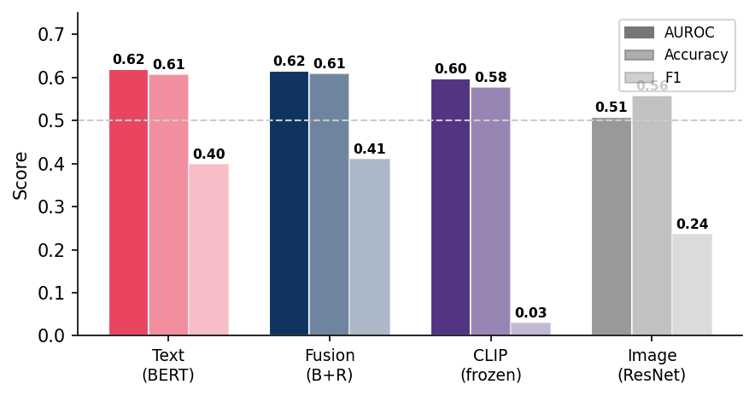
Figure 3. Best-epoch validation metrics for all four models.
Table 1 summarizes the best metric for each model across all epochs.
Model | Params | Best AUROC | Best Acc. | Best F1 | Overfits?
Text (BERT) | 109.7 M | 0.619 (ep.4) | 60.8% (ep.4) | 0.399 (ep.5) | Yes (ep.3+)
Image (ResNet18) | 11.3 M | 0.508 (ep.5) | 55.8% (ep.5) | 0.237 (ep.1) | No (stalls)
Fusion (BERT+ResNet) | ~121 M | 0.616 (ep.4) | 60.9% (ep.5) | 0.411 (ep.2) | Yes (ep.2+)
CLIP (frozen) | ~86 M* | 0.597 (ep.5) | 57.7% (ep.5) | 0.031 (ep.5) | No (slow)

Table 1. Best validation metrics per model. Epoch numbers in parentheses indicate when the best value was achieved. (*CLIP encoder size estimated from ViT-B/32; only the classifier head is trained.)
The text-only BERT model achieves the highest AUROC (0.619), confirming that linguistic features are the primary discriminative signal. The fusion model produces a marginally higher F1 score (0.411 versus 0.399) but lower or equivalent AUROC, and it overfits substantially more. The CLIP model reaches a respectable AUROC of 0.597 despite its frozen encoder, suggesting that CLIP’s joint embedding space contains relevant information that a small head can partially exploit. The image-only model performs near-randomly across all metrics.

5. Analysis and Discussion

5.1 Why Text Dominates
The fact that text alone outperforms all multimodal combinations is not surprising in retrospect. Hateful memes are designed to communicate hateful meaning through language—the image is typically context rather than carrier. A meme saying “they are inferior” with an image of a group still encodes the prejudice in the words, not the pixels. BERT’s pre-training on large text corpora gives it sensitivity to slurs, irony, and coded references that ResNet18, trained on ImageNet object categories, simply cannot match.

5.2 Why the Image Branch Hurt Fusion
The fusion model’s inability to surpass text-only on AUROC, combined with its severe overfitting, suggests that the image branch introduced noise rather than complementary signal. When the image encoder produces near-random activations, concatenating those features with BERT’s representations dilutes the useful text signal. The classifier must then learn to ignore a substantial portion of its input, which effectively increases model complexity without adding information. This problem would likely be mitigated by freezing the image encoder for the first few epochs, allowing the classifier head to align with the text representations before the image branch is updated.

5.3 Class Imbalance and F1
The 84/16 class split consistently suppresses F1 scores. Because the majority class is “not hateful,” a model that predicts everything as not hateful achieves 84% accuracy but zero F1 for the hateful class. Our models partially overcome this by learning some signal, but without explicit handling—weighted loss or oversampling—the classifier remains biased toward the majority class. This is most visible in CLIP, which produced F1 scores of 0.000 for the first three epochs, meaning it predicted exclusively “not hateful” until epoch four.

5.4 CLIP’s Trajectory
CLIP’s steady AUROC improvement (0.531 → 0.597 over five epochs) is the most encouraging trend in our results. Unlike text and fusion models, which plateau immediately, CLIP was still improving at epoch five. This suggests that with more epochs, a learning rate schedule tuned for frozen-then-unfrozen fine-tuning, and partial encoder unfreezing, CLIP could potentially become the strongest model. The current configuration—fully frozen encoder, no class weighting—is simply too constrained to realize its potential on this task.

6. Limitations
Several practical constraints limited the scope of our experiments. All training ran on CPU, which capped batch throughput and ruled out larger models or hyperparameter searches. Training a single epoch of the fusion model took significantly longer than the equivalent text-only run due to the additional image forward pass.
We did not implement early stopping, which meant all models trained past their optimal checkpoint. For text and fusion, the best results were consistently observed at epoch one or two; all subsequent training increased validation loss. A simple patience-based early stopping mechanism would have improved final performance without any architectural changes.
The missing images (~500 entries) introduce a small discrepancy between the dataset as described and the dataset as used. These entries are concentrated in the covid-memes category, which may have a different label distribution than the main dataset. Finally, we evaluate only on the validation split; the test set labels are withheld in the original challenge format.

7. Conclusion
We trained and evaluated four neural architectures for hateful meme detection: a BERT text classifier, a ResNet18 image classifier, a late-fusion combination of both, and a CLIP model with a frozen encoder. Across all experiments, the text-only BERT model achieved the best AUROC (0.619), and no multimodal model meaningfully surpassed it under our training conditions.
The central finding is that hate in this dataset is primarily encoded in language. Visual features from a standard convolutional network add noise rather than signal in the fusion setting, and a frozen CLIP encoder—while promising—cannot adapt its representations to the classification boundary without at least partial fine-tuning. The class imbalance further suppresses all models’ F1 scores and must be addressed explicitly in future work.
Our most actionable recommendations are: (1) add early stopping, as best checkpoints occur at epoch one or two for most models; (2) unfreeze CLIP’s final two or three transformer layers to enable task-specific adaptation; (3) apply weighted cross-entropy or oversampling to address the 84/16 class imbalance; and (4) freeze the image encoder in fusion for the first few epochs to prevent noisy visual features from interfering with the text signal during early training.

Contribution Statement
This project was completed as a group effort. All group members contributed to both the coding and writing/presentation components of the project.
Member | Contributions | Approx. Share
[Member 1] | Text model architecture, training pipeline, evaluation script, results analysis | ~33%
[Member 2] | Image model architecture, dataset pipeline, data exploration | ~33%
[Member 3] | CLIP & fusion model, final presentation slides, report writing, error analysis | ~33%

All members contributed to both implementation and written/presentation work. Percentages are approximate and reflect primary responsibilities rather than exclusive ownership.

AI Usage Statement
AI assistance was used in the following ways during this project:
Section / Task | How Used | AI Influence
Code debugging | Identifying dataset column mismatches; fixing torch.load compatibility with PyTorch 2.6 | ~20% of fixes
Results analysis & report writing | Drafting report paragraphs from training logs; all analysis and conclusions reviewed by team | ~20%
Grammar / proofreading | Light polish of final report text | ~15%

All core reasoning, experimental decisions, and conclusions are the team's own. AI was not used to generate model architectures, select hyperparameters, or interpret results without human verification.

