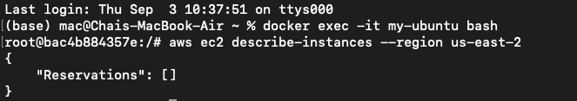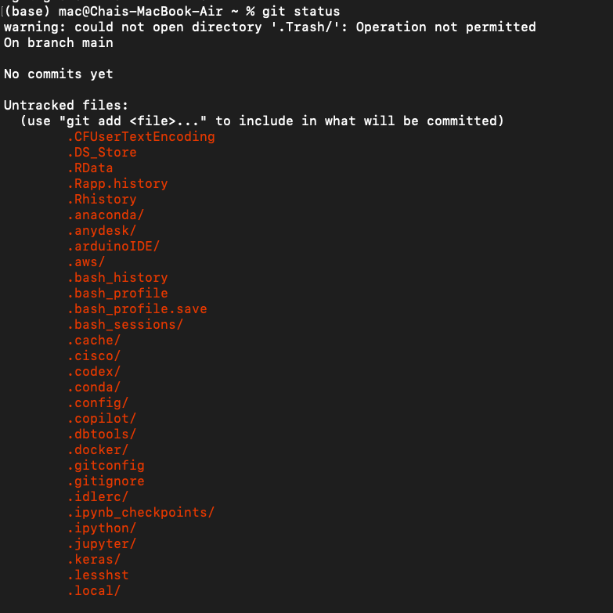

Environment files such as .env are excluded from Git because they often contain sensitive information such as AWS credentials, API keys, passwords, and other configuration values that should not be shared. Even in a private repository, unauthorized access, accidental sharing, or a compromised account could expose these secrets. Using .gitignore to exclude .env files helps prevent sensitive information from being accidentally committed to the repository while allowing configuration values to remain stored securely on the local machine.

