DATABASE MANAGEMENT SYSTEMS
Group Project Report

AMAZON PRIME
Database Design and Implementation
Memberships | Shopping | Prime Video | Prime Music

Item | Details (fill in before submission)
Course / Subject | Database Management Systems [course code]
Submitted to | [Professor name], Department of [department]
Institution | [College / University name]
Semester / Year | [e.g. 5th Semester, 2026-27]
Team member 1 | [Name] - Roll no. [____]
Team member 2 | [Name] - Roll no. [____]
Team member 3 | [Name] - Roll no. [____]
Team member 4 | [Name] - Roll no. [____]
Date of submission | [dd-mm-yyyy]

Contents
1 Abstract
2 Introduction and problem statement
3 Objectives and scope
4 Requirement analysis
5 Entities, attributes and relationships
6 ER diagrams (conceptual and detailed)
7 ER-to-relational mapping
8 Data dictionary (24 tables)
9 Normalization
10 Implementation in SQL
11 Sample data
12 SQL queries with output (25)
13 Transactions and integrity
14 Python application
15 Analytical charts
16 Testing
17 Conclusion, limitations and future scope
18 References
19 Team contribution

1 Abstract
Amazon Prime is a bundled subscription service that combines fast delivery on an online marketplace with video and music streaming. Behind this single membership sit several tightly connected data domains: customers and their payment instruments, membership plans and benefits, a product catalogue with sellers and orders, shipments, reviews, a video library with per-profile viewing history and a music library. This project designs and implements a relational database for such a service. It contains 24 normalized tables, 30 foreign-key relationships, views, triggers and indexes, a deterministic sample data set of about 1,700 rows, 25 analytical SQL queries and a Python console application that performs transactional operations (registration, subscription, ordering, cancellation, viewing). The design was validated with 21 automated tests. The sample data is entirely fictional and the project is an academic model, not Amazon's real schema.

2 Introduction and problem statement
A membership business must answer questions such as: Who is a Prime member today? Which plan earns the most money? Did a Prime customer receive free delivery? Which shows are watched by which profiles? Answering these reliably requires a database that avoids duplicate data, enforces business rules and supports concurrent transactions. Spreadsheets or flat files fail on all three counts.
Problem statement: design and implement a normalized relational database for an Amazon-Prime-like service that (a) stores customers, memberships, payments, shopping and entertainment activity, (b) enforces integrity rules inside the DBMS, and (c) supports operational and analytical queries.

3 Objectives and scope
- Model the real-world domain with an ER diagram that uses 1:1, 1:N, M:N, recursive and exclusive-arc relationships.
- Map the ER model to relational tables in 3NF/BCNF with full key and integrity constraints.
- Implement the schema in MySQL 8 and SQLite using DDL, DML, views, indexes and triggers.
- Write 25 queries covering joins, aggregation, subqueries, CTEs and window functions.
- Build a Python application that uses transactions and demonstrates ACID behaviour.
- Test constraints, triggers and business logic automatically.
In scope: memberships, payments, shopping orders and delivery, reviews, video and music usage. Out of scope: real payment gateways, recommendation algorithms beyond a simple genre rule, a web front-end.

4 Requirement analysis

4.1 Functional requirements
- A customer can register, keep several addresses, and create viewing profiles (including Kids profiles).
- A customer can store payment methods (card, UPI, net banking, wallet).
- A customer can buy one Prime plan (Monthly, Quarterly, Annual, Lite, Shopping Edition, Young Adult) and cancel it.
- Each plan includes a set of benefits (many-to-many).
- Customers browse products from sellers, organised in a category hierarchy, and place orders with several items.
- Prime members receive free delivery and Prime delivery speeds; others pay a fee below Rs 499.
- Every order is paid for and, when dispatched, has one shipment record with tracking and delivery dates.
- Customers who received a product can review it once.
- Profiles watch movies/series (episodes), keep watchlists and play music tracks.
- Management can run reports: revenue, churn, best sellers, late deliveries, popular genres.

4.2 Business rules enforced by the database
# | Rule | Enforced by
1 | Email address is unique per customer | UNIQUE constraint
2 | Prices > 0, stock >= 0, rating 1-5, quantity > 0 | CHECK constraints
3 | A payment pays for exactly one subscription OR one order | CHECK exclusive arc
4 | A customer has at most one ACTIVE subscription | Trigger trg_one_active_sub
5 | Stock reduces when an item is ordered and returns on cancellation | Triggers trg_reduce_stock / trg_restore_stock
6 | Overselling is impossible | CHECK(stock_qty >= 0) aborts the transaction
7 | Every subscription status change is logged | Trigger trg_subscription_audit
8 | A customer reviews a product at most once | UNIQUE(customer_id, product_id)
9 | Kids profiles cannot watch 'A'/'UA 16+' titles | Application service record_watch()
10 | Deleting a customer's profile removes its viewing data | ON DELETE CASCADE

4.3 Non-functional requirements
- Data integrity and consistency (ACID transactions).
- Portability: identical logical design on MySQL and SQLite.
- Performance: indexes on all foreign keys and on frequent filter columns.
- Security: passwords stored only as salted hashes; card/UPI numbers stored masked.

5 Entities, attributes and relationships
The model has five modules. Each coloured group in the detailed ER diagram is one module.
Module | Entities (tables)
Customer & Account | customer, address, profile
Prime Membership | plan, benefit, plan_benefit, subscription, subscription_audit, payment_method, payment
Shopping | seller, category, product, orders, order_item, shipment, review
Prime Video | video_content, episode, watch_history, watchlist
Prime Music | music_artist, music_track, music_play

5.1 Relationships and cardinalities
Entity A | Relationship | Entity B | Cardinality | Implemented as
Customer | has | Address | 1:N | foreign key
Customer | owns | Profile | 1:N | foreign key
Customer | buys | Subscription | 1:N | foreign key
Plan | chosen in | Subscription | 1:N | foreign key
Plan | includes | Benefit | M:N | plan_benefit
Subscription | is logged in | Subscription Audit | 1:N | foreign key
Customer | registers | Payment Method | 1:N | foreign key
Payment Method | is used for | Payment | 1:N | foreign key
Subscription | is paid by | Payment | 1:N | foreign key
Orders | is paid by | Payment | 1:N | foreign key
Customer | places | Orders | 1:N | foreign key
Address | is delivered to | Orders | 1:N | foreign key
Orders | contains | Product | M:N | order_item
Orders | is fulfilled by | Shipment | 1:1 | foreign key
Seller | sells | Product | 1:N | foreign key
Category | classifies | Product | 1:N | foreign key
Category | is parent of | Category | 1:N | recursive FK
Customer | writes | Review | 1:N | foreign key
Product | receives | Review | 1:N | foreign key
Profile | watches | Video Content | M:N | watch_history
Profile | saves to watchlist | Video Content | M:N | watchlist
Video Content | has | Episode | 1:N | foreign key
Music Artist | releases | Music Track | 1:N | foreign key
Profile | plays | Music Track | M:N | music_play

Special relationship types used: M:N (plan-benefit, order-product, profile-video, profile-track), recursive 1:N (category-parent category), 1:1 (order-shipment) and an exclusive arc (payment pays a subscription or an order).

6 ER diagrams

6.1 Conceptual ER diagram
Rectangles are entities, diamonds are relationships, and the letters show cardinality. Associative tables created from M:N relationships are written in square brackets.
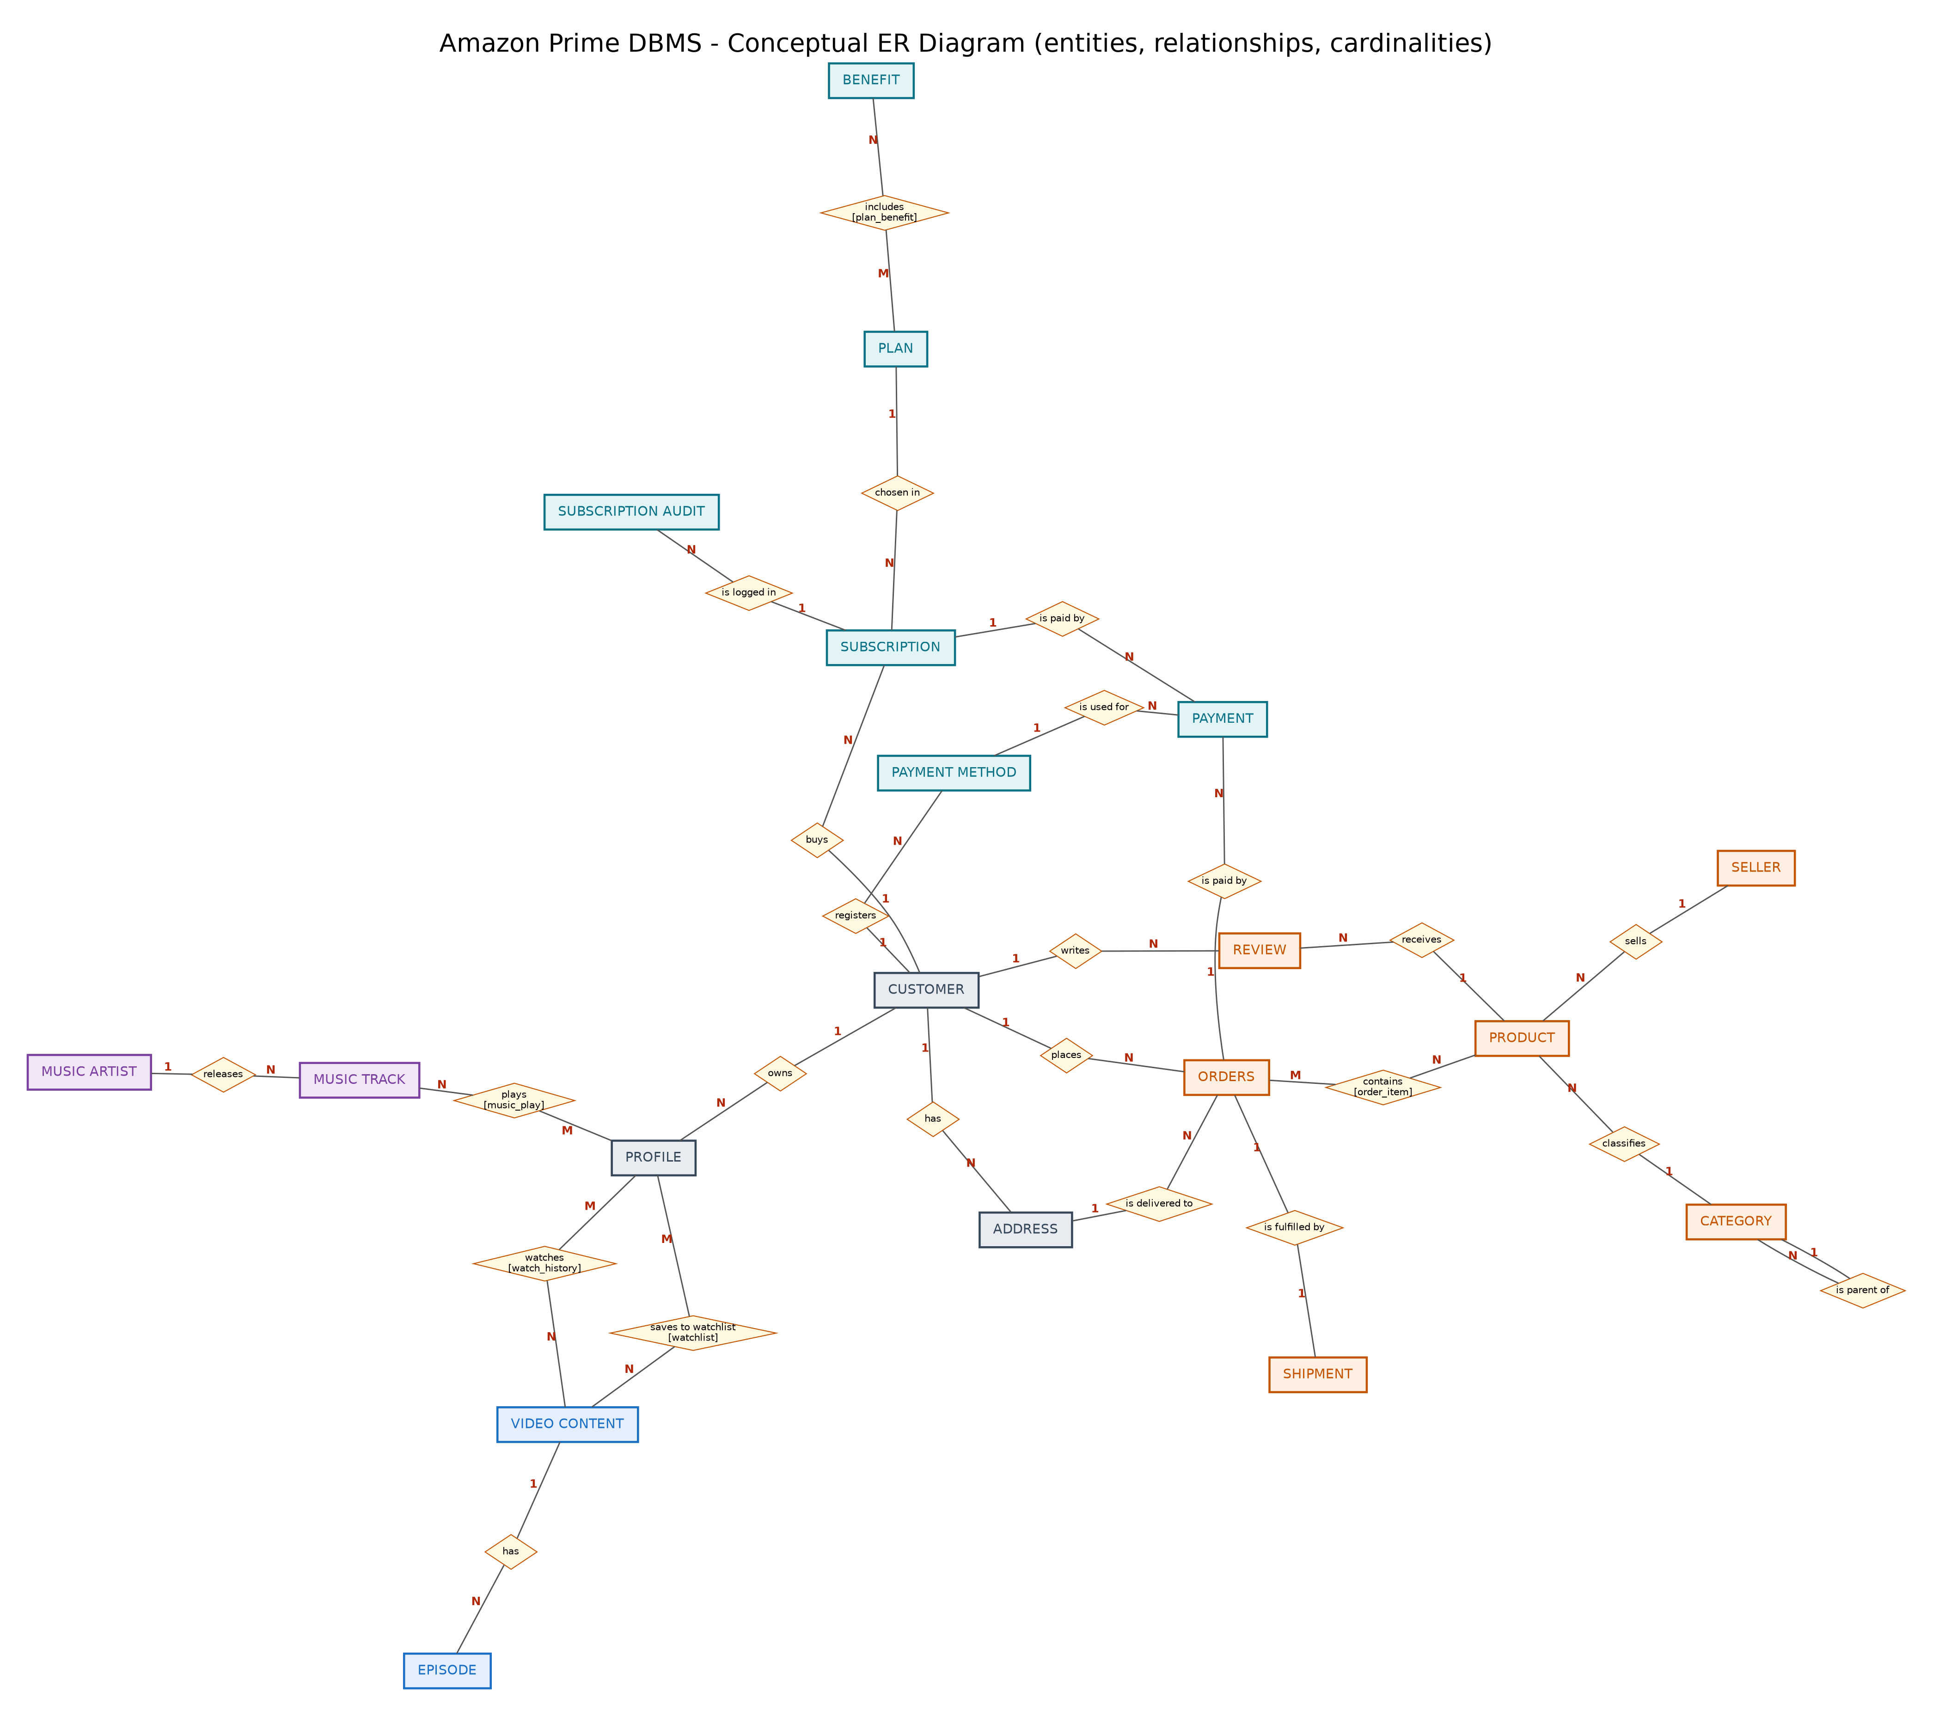
Figure 1 - Conceptual ER diagram

6.2 Detailed ER diagram (crow's-foot)
Every table with all attributes, data types, primary keys (bold, PK), foreign keys (FK), unique columns (U) and nullable columns (?). Vector versions (SVG/PDF) are supplied in the docs folder for zooming.
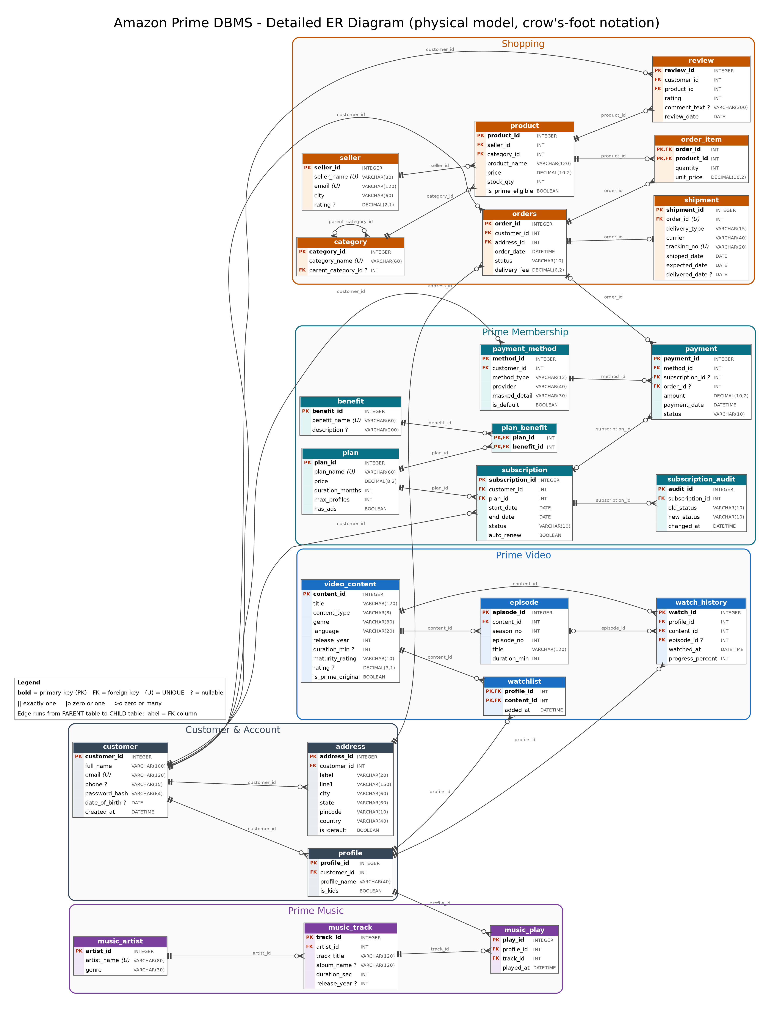
Figure 2 - Detailed ER diagram generated from the actual schema

7 ER-to-relational mapping
ER construct | Mapping rule | Example in this project
Strong entity | Table; key attribute becomes PRIMARY KEY | customer(customer_id, ...)
1:N relationship | Foreign key on the 'N' side | address.customer_id -> customer
M:N relationship | New associative table with composite PK | order_item(order_id, product_id)
M:N with attributes | Attributes go into the associative table | order_item.quantity, unit_price
1:1 relationship | Foreign key + UNIQUE | shipment.order_id UNIQUE
Recursive relationship | Foreign key to the same table | category.parent_category_id
Exclusive arc (OR) | Two nullable FKs + CHECK (exactly one) | payment: subscription_id / order_id
Multivalued attribute | Separate table | Several addresses -> address
Derived attribute | Not stored; computed in a view | Order total -> v_order_totals
Weak/dependent entity | FK + ON DELETE CASCADE | episode depends on video_content

8 Data dictionary
Generated automatically from the live schema. PK = primary key, FK = foreign key, U = unique, NN = NOT NULL.

Customer & Account

8.1 customer
Registered Amazon account holder.
Column | Type | Key | NN | Default
customer_id | INTEGER | PK | Yes
full_name | VARCHAR(100) |  | Yes
email | VARCHAR(120) | U | Yes
phone | VARCHAR(15) |  | No
password_hash | VARCHAR(64) |  | Yes
date_of_birth | DATE |  | No
created_at | DATETIME |  | Yes | CURRENT_TIMESTAMP

8.2 address
Delivery addresses of a customer.
Column | Type | Key | NN | Default
address_id | INTEGER | PK | Yes
customer_id | INT | FK | Yes
label | VARCHAR(20) |  | Yes | 'Home'
line1 | VARCHAR(150) |  | Yes
city | VARCHAR(60) |  | Yes
state | VARCHAR(60) |  | Yes
pincode | VARCHAR(10) |  | Yes
country | VARCHAR(40) |  | Yes | 'India'
is_default | BOOLEAN |  | Yes | 0

8.3 profile
Viewing profile inside an account (adult or kids).
Column | Type | Key | NN | Default
profile_id | INTEGER | PK | Yes
customer_id | INT | FK | Yes
profile_name | VARCHAR(40) |  | Yes
is_kids | BOOLEAN |  | Yes | 0

Prime Membership

8.4 plan
Prime membership plans and prices.
Column | Type | Key | NN | Default
plan_id | INTEGER | PK | Yes
plan_name | VARCHAR(60) | U | Yes
price | DECIMAL(8,2) |  | Yes
duration_months | INT |  | Yes
max_profiles | INT |  | Yes | 6
has_ads | BOOLEAN |  | Yes | 0

8.5 benefit
Individual Prime benefits.
Column | Type | Key | NN | Default
benefit_id | INTEGER | PK | Yes
benefit_name | VARCHAR(60) | U | Yes
description | VARCHAR(200) |  | No

8.6 plan_benefit
Which benefits each plan includes (M:N).
Column | Type | Key | NN | Default
plan_id | INT | PK, FK | Yes
benefit_id | INT | PK, FK | Yes

8.7 subscription
A customer's membership period for a plan.
Column | Type | Key | NN | Default
subscription_id | INTEGER | PK | Yes
customer_id | INT | FK | Yes
plan_id | INT | FK | Yes
start_date | DATE |  | Yes
end_date | DATE |  | Yes
status | VARCHAR(10) |  | Yes | 'ACTIVE'
auto_renew | BOOLEAN |  | Yes | 1

8.8 subscription_audit
Trigger-written log of status changes.
Column | Type | Key | NN | Default
audit_id | INTEGER | PK | Yes
subscription_id | INT | FK | Yes
old_status | VARCHAR(10) |  | Yes
new_status | VARCHAR(10) |  | Yes
changed_at | DATETIME |  | Yes | CURRENT_TIMESTAMP

8.9 payment_method
Stored (masked) payment instruments.
Column | Type | Key | NN | Default
method_id | INTEGER | PK | Yes
customer_id | INT | FK | Yes
method_type | VARCHAR(12) |  | Yes
provider | VARCHAR(40) |  | Yes
masked_detail | VARCHAR(30) |  | Yes
is_default | BOOLEAN |  | Yes | 0

8.10 payment
Money received for a subscription or an order.
Column | Type | Key | NN | Default
payment_id | INTEGER | PK | Yes
method_id | INT | FK | Yes
subscription_id | INT | FK | No
order_id | INT | FK | No
amount | DECIMAL(10,2) |  | Yes
payment_date | DATETIME |  | Yes | CURRENT_TIMESTAMP
status | VARCHAR(10) |  | Yes | 'SUCCESS'

Shopping

8.11 seller
Third-party sellers on the marketplace.
Column | Type | Key | NN | Default
seller_id | INTEGER | PK | Yes
seller_name | VARCHAR(80) | U | Yes
email | VARCHAR(120) | U | Yes
city | VARCHAR(60) |  | Yes
rating | DECIMAL(2,1) |  | No

8.12 category
Product categories (self-referencing hierarchy).
Column | Type | Key | NN | Default
category_id | INTEGER | PK | Yes
category_name | VARCHAR(60) | U | Yes
parent_category_id | INT | FK | No

8.13 product
Items for sale.
Column | Type | Key | NN | Default
product_id | INTEGER | PK | Yes
seller_id | INT | FK | Yes
category_id | INT | FK | Yes
product_name | VARCHAR(120) |  | Yes
price | DECIMAL(10,2) |  | Yes
stock_qty | INT |  | Yes | 0
is_prime_eligible | BOOLEAN |  | Yes | 1

8.14 orders
Customer orders (header).
Column | Type | Key | NN | Default
order_id | INTEGER | PK | Yes
customer_id | INT | FK | Yes
address_id | INT | FK | Yes
order_date | DATETIME |  | Yes | CURRENT_TIMESTAMP
status | VARCHAR(10) |  | Yes | 'PLACED'
delivery_fee | DECIMAL(6,2) |  | Yes | 0

8.15 order_item
Order lines with price at purchase time.
Column | Type | Key | NN | Default
order_id | INT | PK, FK | Yes
product_id | INT | PK, FK | Yes
quantity | INT |  | Yes
unit_price | DECIMAL(10,2) |  | Yes

8.16 shipment
Dispatch and delivery details (1:1 with order).
Column | Type | Key | NN | Default
shipment_id | INTEGER | PK | Yes
order_id | INT | FK, U | Yes
delivery_type | VARCHAR(15) |  | Yes
carrier | VARCHAR(40) |  | Yes
tracking_no | VARCHAR(20) | U | Yes
shipped_date | DATE |  | Yes
expected_date | DATE |  | Yes
delivered_date | DATE |  | No

8.17 review
Product reviews.
Column | Type | Key | NN | Default
review_id | INTEGER | PK | Yes
customer_id | INT | FK | Yes
product_id | INT | FK | Yes
rating | INT |  | Yes
comment_text | VARCHAR(300) |  | No
review_date | DATE |  | Yes

Prime Video

8.18 video_content
Movies and series on Prime Video.
Column | Type | Key | NN | Default
content_id | INTEGER | PK | Yes
title | VARCHAR(120) |  | Yes
content_type | VARCHAR(8) |  | Yes
genre | VARCHAR(30) |  | Yes
language | VARCHAR(20) |  | Yes
release_year | INT |  | Yes
duration_min | INT |  | No
maturity_rating | VARCHAR(10) |  | Yes
rating | DECIMAL(3,1) |  | No
is_prime_original | BOOLEAN |  | Yes | 0

8.19 episode
Episodes of a series.
Column | Type | Key | NN | Default
episode_id | INTEGER | PK | Yes
content_id | INT | FK | Yes
season_no | INT |  | Yes
episode_no | INT |  | Yes
title | VARCHAR(120) |  | Yes
duration_min | INT |  | Yes

8.20 watch_history
Which profile watched what and when.
Column | Type | Key | NN | Default
watch_id | INTEGER | PK | Yes
profile_id | INT | FK | Yes
content_id | INT | FK | Yes
episode_id | INT | FK | No
watched_at | DATETIME |  | Yes
progress_percent | INT |  | Yes | 0

8.21 watchlist
Titles saved by a profile (M:N).
Column | Type | Key | NN | Default
profile_id | INT | PK, FK | Yes
content_id | INT | PK, FK | Yes
added_at | DATETIME |  | Yes | CURRENT_TIMESTAMP

Prime Music

8.22 music_artist
Music artists.
Column | Type | Key | NN | Default
artist_id | INTEGER | PK | Yes
artist_name | VARCHAR(80) | U | Yes
genre | VARCHAR(30) |  | Yes

8.23 music_track
Songs.
Column | Type | Key | NN | Default
track_id | INTEGER | PK | Yes
artist_id | INT | FK | Yes
track_title | VARCHAR(120) |  | Yes
album_name | VARCHAR(120) |  | No
duration_sec | INT |  | Yes
release_year | INT |  | No

8.24 music_play
Play events per profile.
Column | Type | Key | NN | Default
play_id | INTEGER | PK | Yes
profile_id | INT | FK | Yes
track_id | INT | FK | Yes
played_at | DATETIME |  | Yes

9 Normalization
All tables were normalized to at least Third Normal Form (most are in BCNF). The reasoning is below.

9.1 Starting point: an un-normalized order sheet
ORDER_SHEET(order_id, order_date, customer_name, customer_email, customer_phone,
delivery_address, product_ids, product_names, seller_names, quantities,
prices, payment_type, tracking_no, plan_name, plan_price, plan_benefits)

Problems: repeating groups (several products and benefits in one row), partial and transitive dependencies, and insert/update/delete anomalies.

9.2 Steps
Normal form | Problem removed | Result
1NF | Repeating groups (products, benefits) and multivalued data (addresses) removed; every column atomic. | order_item, plan_benefit, address
2NF | Partial dependencies on part of a composite key removed. In (order_id, product_id) the product name depends only on product_id. | product separated from order_item
3NF | Transitive dependencies removed: product -> seller -> seller_city; plan_id -> price; customer_id -> email. | seller, plan, customer separated
BCNF | Every determinant is a candidate key. Check: in subscription, subscription_id -> all; (customer_id,start_date) is a candidate key as well, no other determinants. | No further split needed

9.3 Functional dependencies (examples)
customer_id -> full_name, email, phone, password_hash, date_of_birth, created_at
email -> customer_id (candidate key)
plan_id -> plan_name, price, duration_months, max_profiles, has_ads
(order_id, product_id) -> quantity, unit_price
order_id -> customer_id, address_id, order_date, status, delivery_fee
product_id -> seller_id, category_id, product_name, price, stock_qty
category_id -> category_name, parent_category_id
subscription_id -> customer_id, plan_id, start_date, end_date, status, auto_renew
(profile_id, content_id) -> added_at (watchlist)

9.4 Deliberate design decisions
- unit_price in order_item: looks redundant with product.price but is NOT - it records the price at purchase time, which changes later. It is history, not duplication.
- No stored order total: it is a derived value, so it lives in the view v_order_totals (avoids update anomalies).
- Selective denormalization avoided: no counters or totals are stored in base tables.

10 Implementation in SQL
Two equivalent script sets are supplied: sql/mysql (MySQL 8.0+) and sql/sqlite (SQLite 3.35+). They are generated from one template, so the logical design is identical. Order of execution: 01_schema.sql, 02_sample_data.sql, 03_views_triggers.sql, 04_queries.sql.

10.1 Example DDL
CREATE TABLE subscription (
subscription_id INT AUTO_INCREMENT PRIMARY KEY,
customer_id INT NOT NULL,
plan_id INT NOT NULL,
start_date DATE NOT NULL,
end_date DATE NOT NULL,
status VARCHAR(10) NOT NULL DEFAULT 'ACTIVE'
CHECK (status IN ('ACTIVE','EXPIRED','CANCELLED')),
auto_renew BOOLEAN NOT NULL DEFAULT 1,
CHECK (end_date > start_date),
FOREIGN KEY (customer_id) REFERENCES customer(customer_id),
FOREIGN KEY (plan_id) REFERENCES plan(plan_id)
) ENGINE=InnoDB;

10.2 Constraint summary
Object | Count
Tables | 24
Foreign keys | 30
UNIQUE columns/sets | 14
CHECK constraints | 29
Indexes (explicit) | 14
Views | 3
Triggers | 4

10.2 Views
- v_order_totals - items total + delivery fee = grand total per order.
- v_active_subscribers - customers whose membership is currently ACTIVE.
- v_product_ratings - review count and average rating per product.

10.3 Triggers (MySQL version shown)
CREATE TRIGGER trg_one_active_sub BEFORE INSERT ON subscription
FOR EACH ROW
BEGIN
IF NEW.status = 'ACTIVE' AND EXISTS (SELECT 1 FROM subscription
WHERE customer_id = NEW.customer_id
AND status = 'ACTIVE') THEN
SIGNAL SQLSTATE '45000'
SET MESSAGE_TEXT = 'Customer already has an ACTIVE subscription';
END IF;
END

CREATE TRIGGER trg_reduce_stock AFTER INSERT ON order_item
FOR EACH ROW
BEGIN
UPDATE product SET stock_qty = stock_qty - NEW.quantity
WHERE product_id = NEW.product_id;
END

10.4 Indexing
Indexes were added on every foreign key used in joins (e.g. orders.customer_id, order_item.product_id, watch_history.profile_id) and on columns used in filters (subscription(status, end_date), orders.order_date). Primary and UNIQUE keys are indexed automatically.

11 Sample data
Data is generated by scripts/generate_data.py with a fixed random seed, so the same rows are produced on every run. All names, e-mails, ratings and activity are fictional. Two products are intentionally never ordered and two kids profiles intentionally watched adult titles, so that queries Q19 and Q14 have something to find.
Table | Rows
customer | 40
address | 50
profile | 71
plan | 6
benefit | 7
plan_benefit | 34
subscription | 72
subscription_audit | 4
payment_method | 78
payment | 162
seller | 8
category | 19
product | 36
orders | 90
order_item | 199
shipment | 83
review | 97
video_content | 20
episode | 72
watch_history | 336
watchlist | 70
music_artist | 7
music_track | 17
music_play | 160
TOTAL | 1738

12 SQL queries with output
All queries are in sql/<flavour>/04_queries.sql. Outputs below were produced by running them on the sample data (first 6 rows shown). Sample 'today' is 2026-10-05.

Q1 Active Prime members with their plan and renewal date (JOIN via view)
Concepts: view, JOIN
SELECT full_name, plan_name, start_date, end_date, auto_renew
FROM v_active_subscribers
ORDER BY end_date;

full_name | plan_name | start_date | end_date | auto_renew
Sneha Kulkarni | Prime Annual | 2025-10-17 | 2026-10-17 | 0
Pooja Gupta | Prime Young Adult Annual | 2025-11-01 | 2026-11-01 | 0
Aditya Das | Prime Young Adult Annual | 2025-11-07 | 2026-11-07 | 1
Isha Roy | Prime Annual | 2025-11-29 | 2026-11-29 | 0
Sourav Joshi | Prime Annual | 2025-12-03 | 2026-12-03 | 1
Priya Mukherjee | Prime Young Adult Annual | 2026-01-04 | 2027-01-04 | 1

... 17 rows in total

Q2 Number of subscriptions per plan (GROUP BY)
Concepts: GROUP BY
SELECT p.plan_name, COUNT(*) AS total_subscriptions
FROM subscription s
JOIN plan p ON p.plan_id = s.plan_id
GROUP BY p.plan_name
ORDER BY total_subscriptions DESC;

plan_name | total_subscriptions
Prime Annual | 24
Prime Monthly | 16
Prime Young Adult Annual | 10
Prime Lite Annual | 8
Prime Shopping Edition | 7
Prime Quarterly | 7

Q3 Net subscription revenue per plan (refunded payments excluded)
Concepts: multi-table JOIN, SUM
SELECT p.plan_name, SUM(pay.amount) AS net_revenue
FROM payment pay
JOIN subscription s ON s.subscription_id = pay.subscription_id
JOIN plan p ON p.plan_id = s.plan_id
WHERE pay.status = 'SUCCESS'
GROUP BY p.plan_name
ORDER BY net_revenue DESC;

plan_name | net_revenue
Prime Annual | 31479
Prime Young Adult Annual | 6741
Prime Lite Annual | 6392
Prime Monthly | 4784
Prime Quarterly | 4193
Prime Shopping Edition | 2793

Q4 Customers who have NEVER subscribed to Prime (anti-join with NOT EXISTS)
Concepts: NOT EXISTS
SELECT c.customer_id, c.full_name, c.email
FROM customer c
WHERE NOT EXISTS (SELECT 1 FROM subscription s WHERE s.customer_id = c.customer_id)
ORDER BY c.customer_id;

customer_id | full_name | email
33 | Tushar Chatterjee | tushar.chatterjee33@example.com
34 | Ishaan Kulkarni | ishaan.kulkarni34@example.com
35 | Lakshmi Singh | lakshmi.singh35@example.com
36 | Farhan Patel | farhan.patel36@example.com
37 | Zoya Nair | zoya.nair37@example.com
38 | Harsh Nair | harsh.nair38@example.com

... 8 rows in total

Q5 Active subscriptions expiring in the next 30 days (renewal campaign list)
Concepts: date range
SELECT c.full_name, c.phone, p.plan_name, s.end_date, s.auto_renew
FROM subscription s
JOIN customer c ON c.customer_id = s.customer_id
JOIN plan p ON p.plan_id = s.plan_id
WHERE s.status = 'ACTIVE'
AND s.end_date BETWEEN '2026-10-05' AND '2026-11-04'
ORDER BY s.end_date;

full_name | phone | plan_name | end_date | auto_renew
Sneha Kulkarni | 9196277024 | Prime Annual | 2026-10-17 | 0
Pooja Gupta | 9229728319 | Prime Young Adult Annual | 2026-11-01 | 0

Q6 Top 5 best-selling products by units sold (cancelled/returned excluded)
Concepts: JOIN, ORDER BY, LIMIT
SELECT pr.product_name, SUM(oi.quantity) AS units_sold
FROM order_item oi
JOIN orders o ON o.order_id = oi.order_id
JOIN product pr ON pr.product_id = oi.product_id
WHERE o.status NOT IN ('CANCELLED','RETURNED')
GROUP BY pr.product_id, pr.product_name
ORDER BY units_sold DESC, pr.product_name
LIMIT 5;

product_name | units_sold
Non-stick Cookware Set (5 pcs) | 16
Electric Kettle 1.5L | 13
Women's Printed Kurti | 13
Wireless Mouse | 12
Laptop Backpack 30L | 11

Q7 Revenue per top-level category (self-join on the category hierarchy)
Concepts: self-join hierarchy
SELECT COALESCE(par.category_name, cat.category_name) AS top_category,
SUM(oi.quantity * oi.unit_price) AS revenue
FROM order_item oi
JOIN orders o ON o.order_id = oi.order_id
JOIN product pr ON pr.product_id = oi.product_id
JOIN category cat ON cat.category_id = pr.category_id
LEFT JOIN category par ON par.category_id = cat.parent_category_id
WHERE o.status NOT IN ('CANCELLED','RETURNED')
GROUP BY COALESCE(par.category_name, cat.category_name)
ORDER BY revenue DESC;

top_category | revenue
Electronics | 1135749
Home & Kitchen | 72855
Fashion | 60157
Books | 27911
Grocery | 19426
Sports & Fitness | 1797

Q8 Products with at least 3 reviews, ranked by average rating (HAVING)
Concepts: HAVING
SELECT pr.product_name, COUNT(r.review_id) AS reviews, ROUND(AVG(r.rating), 2) AS avg_rating
FROM product pr
JOIN review r ON r.product_id = pr.product_id
GROUP BY pr.product_id, pr.product_name
HAVING COUNT(r.review_id) >= 3
ORDER BY avg_rating DESC, reviews DESC;

product_name | reviews | avg_rating
Stainless Steel Lunch Box | 3 | 4.67
Fundamentals of Database Systems (7th Ed.) | 3 | 4.33
Women's Printed Kurti | 4 | 4.25
Running Shoes | 6 | 4.17
Casual Sneakers | 4 | 4.00
Electric Kettle 1.5L | 3 | 4.00

... 17 rows in total

Q9 Average order value - Prime delivery vs standard delivery (CASE + view)
Concepts: CASE, view
SELECT CASE WHEN sh.delivery_type = 'STANDARD' THEN 'Standard delivery'
ELSE 'Prime delivery' END AS delivery_group,
COUNT(*) AS orders,
ROUND(AVG(t.grand_total), 2) AS avg_order_value
FROM v_order_totals t
JOIN shipment sh ON sh.order_id = t.order_id
GROUP BY CASE WHEN sh.delivery_type = 'STANDARD' THEN 'Standard delivery'
ELSE 'Prime delivery' END;

delivery_group | orders | avg_order_value
Prime delivery | 39 | 24,799.21
Standard delivery | 44 | 16,358.45

Q10 Late deliveries and how many days late
Concepts: date arithmetic
SELECT o.order_id, c.full_name, sh.delivery_type, sh.expected_date, sh.delivered_date,
CAST(julianday(sh.delivered_date) - julianday(sh.expected_date) AS INTEGER) AS days_late
FROM shipment sh
JOIN orders o ON o.order_id = sh.order_id
JOIN customer c ON c.customer_id = o.customer_id
WHERE sh.delivered_date > sh.expected_date
ORDER BY days_late DESC, o.order_id;

order_id | full_name | delivery_type | expected_date | delivered_date | days_late
7 | Arjun Reddy | PRIME_ONE_DAY | 2026-09-04 | 2026-09-06 | 2
20 | Aditya Das | PRIME_ONE_DAY | 2025-07-23 | 2025-07-25 | 2
21 | Sourav Joshi | PRIME_ONE_DAY | 2026-04-30 | 2026-05-02 | 2
22 | Sneha Kulkarni | STANDARD | 2025-05-27 | 2025-05-29 | 2
32 | Nikhil Chatterjee | STANDARD | 2025-06-10 | 2025-06-12 | 2
34 | Siddharth Joshi | STANDARD | 2025-08-27 | 2025-08-29 | 2

... 25 rows in total

Q11 Customers who spent more than the average customer (scalar subquery)
Concepts: scalar subquery
SELECT c.full_name, ROUND(SUM(t.grand_total), 2) AS total_spent
FROM v_order_totals t
JOIN customer c ON c.customer_id = t.customer_id
WHERE t.status NOT IN ('CANCELLED','RETURNED')
GROUP BY c.customer_id, c.full_name
HAVING SUM(t.grand_total) > (SELECT AVG(x.s) FROM
(SELECT SUM(grand_total) AS s FROM v_order_totals
WHERE status NOT IN ('CANCELLED','RETURNED') GROUP BY customer_id) x)
ORDER BY total_spent DESC;

full_name | total_spent
Arjun Reddy | 220,451.00
Mitali Roy | 158,705.00
Ananya Malhotra | 131,015.00
Tushar Chatterjee | 113,074.00
Neha Patel | 92,375.00
Anjali Banerjee | 86,278.00

... 10 rows in total

Q12 Ten most-watched titles (distinct profiles that watched them)
Concepts: COUNT DISTINCT
SELECT v.title, v.content_type, COUNT(*) AS views, COUNT(DISTINCT w.profile_id) AS unique_viewers
FROM watch_history w
JOIN video_content v ON v.content_id = w.content_id
GROUP BY v.content_id, v.title, v.content_type
ORDER BY views DESC, v.title
LIMIT 10;

title | content_type | views | unique_viewers
Mirzapur | SERIES | 34 | 22
Panchayat | SERIES | 34 | 25
Gulabo Sitabo | MOVIE | 30 | 21
Jai Bhim | MOVIE | 28 | 21
The Family Man | SERIES | 24 | 17
The Marvelous Mrs. Maisel | SERIES | 22 | 20

... 10 rows in total

Q13 Genre popularity on Prime Video
Concepts: AVG
SELECT v.genre, COUNT(*) AS views, ROUND(AVG(w.progress_percent), 1) AS avg_completion_pct
FROM watch_history w
JOIN video_content v ON v.content_id = w.content_id
GROUP BY v.genre
ORDER BY views DESC;

genre | views | avg_completion_pct
Comedy | 105 | 69.40
Drama | 65 | 65.40
Crime | 39 | 69.40
Animation | 35 | 69.90
Action | 30 | 67.80
Thriller | 24 | 86.70

... 9 rows in total

Q14 Parental-control audit - kids profiles that watched 'A' (adult) content
Concepts: multi-join audit
SELECT c.full_name AS account_holder, pf.profile_name, v.title, v.maturity_rating, w.watched_at
FROM watch_history w
JOIN profile pf ON pf.profile_id = w.profile_id
JOIN customer c ON c.customer_id = pf.customer_id
JOIN video_content v ON v.content_id = w.content_id
WHERE pf.is_kids = 1 AND v.maturity_rating = 'A';

account_holder | profile_name | title | maturity_rating | watched_at
Tanvi Joshi | Kids | Paatal Lok | A | 2026-09-15 21:40:14
Aarav Mukherjee | Kids | Mirzapur | A | 2026-09-15 08:56:05

Q15 Each profile's most-watched title (window function RANK)
Concepts: window RANK
SELECT profile_name, title, views FROM (
SELECT pf.profile_name, v.title, COUNT(*) AS views,
RANK() OVER (PARTITION BY pf.profile_id ORDER BY COUNT(*) DESC) AS rnk
FROM watch_history w
JOIN profile pf ON pf.profile_id = w.profile_id
JOIN video_content v ON v.content_id = w.content_id
GROUP BY pf.profile_id, pf.profile_name, v.content_id, v.title
) ranked
WHERE rnk = 1 AND views >= 3
ORDER BY views DESC, profile_name;

profile_name | title | views
Kids | Gulabo Sitabo | 4
Family | Jai Bhim | 3
Family | The Boys | 3
Kids | Kids Cartoon Carnival | 3
Kids | Little Explorers | 3
Kids | Kids Cartoon Carnival | 3

... 13 rows in total

Q16 Monthly revenue and running total (CTE + window SUM OVER)
Concepts: CTE + running SUM
WITH monthly AS (
SELECT strftime('%Y-%m', order_date) AS month, SUM(grand_total) AS revenue
FROM v_order_totals
WHERE status NOT IN ('CANCELLED','RETURNED')
GROUP BY strftime('%Y-%m', order_date)
)
SELECT month, ROUND(revenue, 2) AS revenue,
ROUND(SUM(revenue) OVER (ORDER BY month), 2) AS running_total
FROM monthly
ORDER BY month;

month | revenue | running_total
2025-01 | 79,212.00 | 79,212.00
2025-02 | 6,193.00 | 85,405.00
2025-03 | 17,841.00 | 103,246.00
2025-04 | 202,804.00 | 306,050.00
2025-05 | 55,836.00 | 361,886.00
2025-06 | 90,075.00 | 451,961.00

... 21 rows in total

Q17 Rank customers by spend inside each city (PARTITION BY)
Concepts: RANK PARTITION BY
SELECT city, full_name, total_spent, city_rank FROM (
SELECT a.city, c.full_name, ROUND(SUM(t.grand_total), 2) AS total_spent,
RANK() OVER (PARTITION BY a.city ORDER BY SUM(t.grand_total) DESC) AS city_rank
FROM v_order_totals t
JOIN orders o ON o.order_id = t.order_id
JOIN address a ON a.address_id = o.address_id
JOIN customer c ON c.customer_id = t.customer_id
WHERE t.status NOT IN ('CANCELLED','RETURNED')
GROUP BY a.city, c.customer_id, c.full_name
) r
WHERE city_rank <= 2
ORDER BY city, city_rank;

city | full_name | total_spent | city_rank
Ahmedabad | Rohan Sen | 72,878.00 | 1
Ahmedabad | Amit Mehta | 2,348.00 | 2
Bengaluru | Ananya Malhotra | 131,015.00 | 1
Bengaluru | Meera Sharma | 32,088.00 | 2
Chennai | Vikram Banerjee | 13,493.00 | 1
Chennai | Tanvi Joshi | 9,541.00 | 2

... 18 rows in total

Q18 Active Prime members who placed 3 or more orders (CTE + join)
Concepts: CTE
WITH order_counts AS (
SELECT customer_id, COUNT(*) AS n_orders FROM orders GROUP BY customer_id
)
SELECT v.full_name, v.plan_name, oc.n_orders
FROM v_active_subscribers v
JOIN order_counts oc ON oc.customer_id = v.customer_id
WHERE oc.n_orders >= 3
ORDER BY oc.n_orders DESC, v.full_name;

full_name | plan_name | n_orders
Mitali Roy | Prime Lite Annual | 5
Sourav Joshi | Prime Annual | 5
Tanvi Joshi | Prime Annual | 5
Sneha Kulkarni | Prime Annual | 4
Anjali Banerjee | Prime Annual | 3
Meera Sharma | Prime Young Adult Annual | 3

... 7 rows in total

Q19 Products that were never ordered (LEFT JOIN ... IS NULL)
Concepts: LEFT JOIN IS NULL
SELECT pr.product_id, pr.product_name, pr.stock_qty
FROM product pr
LEFT JOIN order_item oi ON oi.product_id = pr.product_id
WHERE oi.product_id IS NULL;

product_id | product_name | stock_qty
34 | Adjustable Dumbbell Set 20kg | 70
35 | Skipping Rope | 450

Q20 Seller scorecard - revenue and average customer rating
Concepts: derived tables
SELECT s.seller_name,
COALESCE(rev.revenue, 0) AS revenue,
COALESCE(rat.avg_rating, 0) AS avg_product_rating
FROM seller s
LEFT JOIN (SELECT pr.seller_id, SUM(oi.quantity * oi.unit_price) AS revenue
FROM order_item oi
JOIN orders o ON o.order_id = oi.order_id
JOIN product pr ON pr.product_id = oi.product_id
WHERE o.status NOT IN ('CANCELLED','RETURNED')
GROUP BY pr.seller_id) rev ON rev.seller_id = s.seller_id
LEFT JOIN (SELECT pr.seller_id, ROUND(AVG(r.rating), 2) AS avg_rating
FROM review r JOIN product pr ON pr.product_id = r.product_id
GROUP BY pr.seller_id) rat ON rat.seller_id = s.seller_id
ORDER BY revenue DESC;

seller_name | revenue | avg_product_rating
TechZone Traders | 981885 | 3.55
Prime Retail Pvt Ltd | 89185 | 3.67
HomeEssentials Co | 72855 | 3.87
GadgetGalaxy | 64679 | 2.80
StyleHub Fashions | 60157 | 3.95
BookNest Publishers | 27911 | 3.40

... 8 rows in total

Q21 Most played Prime Music artists
Concepts: JOIN, GROUP BY
SELECT ar.artist_name, COUNT(*) AS plays
FROM music_play mp
JOIN music_track t ON t.track_id = mp.track_id
JOIN music_artist ar ON ar.artist_id = t.artist_id
GROUP BY ar.artist_id, ar.artist_name
ORDER BY plays DESC, ar.artist_name;

artist_name | plays
Arijit Singh | 46
Taylor Swift | 28
A. R. Rahman | 26
Ed Sheeran | 22
Coldplay | 20
Queen | 17

... 7 rows in total

Q22 Customers who use more than one type of payment method
Concepts: GROUP_CONCAT
SELECT c.full_name, COUNT(DISTINCT pm.method_type) AS method_types,
GROUP_CONCAT(pm.provider, ', ') AS providers
FROM customer c
JOIN payment_method pm ON pm.customer_id = c.customer_id
GROUP BY c.customer_id, c.full_name
HAVING COUNT(DISTINCT pm.method_type) > 1
ORDER BY method_types DESC, c.full_name
LIMIT 10;

full_name | method_types | providers
Aditya Das | 3 | SBI Mastercard, Amazon Pay Balance, State Bank of India
Debashis Gupta | 3 | Amazon Pay Balance, Axis RuPay, Google Pay
Vikram Banerjee | 3 | SBI Mastercard, Amazon Pay Balance, State Bank of India
Aarav Mukherjee | 2 | Amazon Pay Balance, SBI Mastercard
Amit Mehta | 2 | Google Pay, Amazon Pay Balance, PhonePe
Anjali Banerjee | 2 | Paytm, Amazon Pay Balance

... 10 rows in total

Q23 Subscription churn - share of subscriptions cancelled, per plan
Concepts: conditional aggregation
SELECT p.plan_name,
COUNT(*) AS subscriptions,
SUM(CASE WHEN s.status = 'CANCELLED' THEN 1 ELSE 0 END) AS cancelled,
ROUND(100.0 * SUM(CASE WHEN s.status = 'CANCELLED' THEN 1 ELSE 0 END) / COUNT(*), 1) AS churn_pct
FROM subscription s
JOIN plan p ON p.plan_id = s.plan_id
GROUP BY p.plan_name
ORDER BY churn_pct DESC, p.plan_name;

plan_name | subscriptions | cancelled | churn_pct
Prime Annual | 24 | 3 | 12.50
Prime Young Adult Annual | 10 | 1 | 10.00
Prime Lite Annual | 8 | 0 | 0.00
Prime Monthly | 16 | 0 | 0.00
Prime Quarterly | 7 | 0 | 0.00
Prime Shopping Edition | 7 | 0 | 0.00

Q24 Benefits included in each plan (M:N resolved with GROUP_CONCAT)
Concepts: M:N + GROUP_CONCAT
SELECT p.plan_name, p.price, COUNT(b.benefit_id) AS benefit_count,
GROUP_CONCAT(b.benefit_name, ', ') AS benefits
FROM plan p
JOIN plan_benefit pb ON pb.plan_id = p.plan_id
JOIN benefit b ON b.benefit_id = pb.benefit_id
GROUP BY p.plan_id, p.plan_name, p.price
ORDER BY p.price DESC;

plan_name | price | benefit_count | benefits
Prime Annual | 1499 | 7 | Free & Fast Delivery, Prime Video, Prime Music, Prime Reading, Early Access to Deals, Ad-free Streaming, Prime Gaming
Prime Lite Annual | 799 | 4 | Free & Fast Delivery, Prime Video, Prime Music, Early Access to Deals
Prime Young Adult Annual | 749 | 7 | Free & Fast Delivery, Prime Video, Prime Music, Prime Reading, Early Access to Deals, Ad-free Streaming, Prime Gaming
Prime Quarterly | 599 | 7 | Free & Fast Delivery, Prime Video, Prime Music, Prime Reading, Early Access to Deals, Ad-free Streaming, Prime Gaming
Prime Shopping Edition | 399 | 2 | Free & Fast Delivery, Early Access to Deals
Prime Monthly | 299 | 7 | Free & Fast Delivery, Prime Video, Prime Music, Prime Reading, Early Access to Deals, Ad-free Streaming, Prime Gaming

Q25 Engagement score per account = video views + music plays (UNION ALL)
Concepts: UNION ALL
SELECT c.full_name, SUM(a.events) AS engagement_score
FROM (
SELECT pf.customer_id, COUNT(*) AS events
FROM watch_history w JOIN profile pf ON pf.profile_id = w.profile_id GROUP BY pf.customer_id
UNION ALL
SELECT pf.customer_id, COUNT(*) AS events
FROM music_play m JOIN profile pf ON pf.profile_id = m.profile_id GROUP BY pf.customer_id
) a
JOIN customer c ON c.customer_id = a.customer_id
GROUP BY c.customer_id, c.full_name
ORDER BY engagement_score DESC
LIMIT 10;

full_name | engagement_score
Manish Mukherjee | 28
Meera Sharma | 25
Vikram Banerjee | 24
Shreya Roy | 24
Tanvi Joshi | 23
Isha Roy | 22

... 10 rows in total

13 Transactions and integrity
Operations that touch several tables run inside a single transaction so that the database never shows a half-finished business action (atomicity) and always moves from one valid state to another (consistency).
Operation | Tables changed in ONE transaction | Failure behaviour
Register customer | customer, address, profile | Duplicate e-mail -> nothing saved
Subscribe to Prime | subscription, payment (+ audit via trigger) | Second ACTIVE plan -> rollback
Place order | orders, order_item (+ stock trigger), payment | Insufficient stock -> whole order rolled back
Cancel order | orders (+ stock restore trigger), payment | Only PLACED orders can be cancelled
Cancel membership | subscription (+ audit), payment | No active plan -> error

Isolation and durability are provided by the DBMS (InnoDB / SQLite journal). A real deployment would use SELECT ... FOR UPDATE on product rows when many users order the same item concurrently.

14 Python application
The console application (app/) uses only the Python standard library.
File | Role
db.py | Connection, foreign-key enforcement, database (re)creation, table printer
services.py | Business logic: register, subscribe, cancel, order, ship, review, watch, recommend
prime_cli.py | Interactive menu and a scripted --demo walkthrough
reports.py | Row counts and matplotlib charts

Run: python app/prime_cli.py --reset then python app/prime_cli.py --demo

14.1 Demo output (extract)
3. Order BEFORE Prime: delivery fee applies below Rs 499
{'order_id': 91, 'items_total': 249.0, 'delivery_fee': 40.0, 'grand_total': 289.0, 'prime_member': False}
5. Business rule: a second ACTIVE plan is rejected by a TRIGGER
Rejected -> Customer already has an ACTIVE subscription
6. Order AFTER Prime: free delivery
{'order_id': 92, 'items_total': 2248.0, 'delivery_fee': 0.0, 'grand_total': 2248.0, 'prime_member': True}
7. Overselling is blocked and the whole order is rolled back
Rejected -> Only 70 unit(s) of 'Adjustable Dumbbell Set 20kg' in stock.
8. Cancel the order -> trigger restores stock, payment refunded
9. Kids profile cannot watch adult content
Rejected -> 'The Boys' is rated A - blocked on a Kids profile.

15 Analytical charts
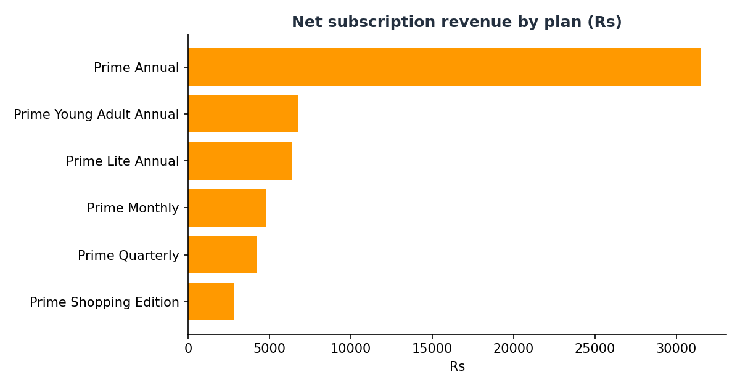
Figure 3 - Net subscription revenue by plan
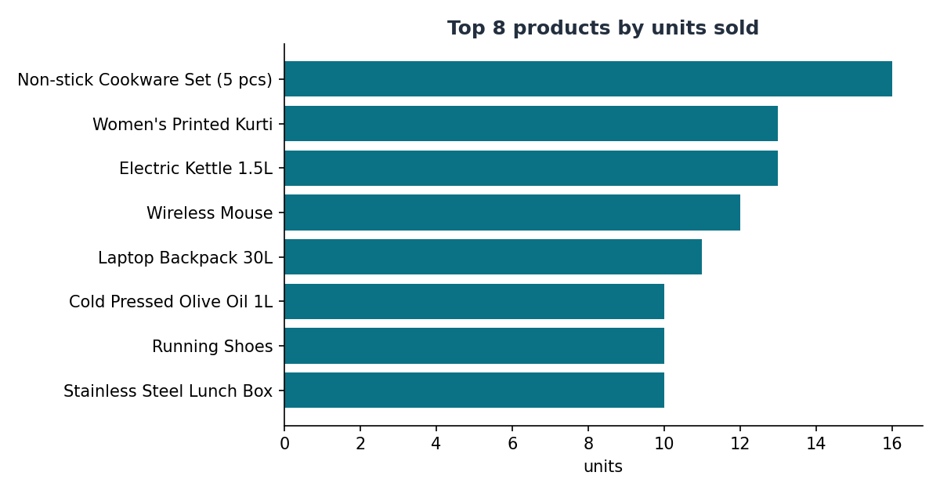
Figure 4 - Best-selling products
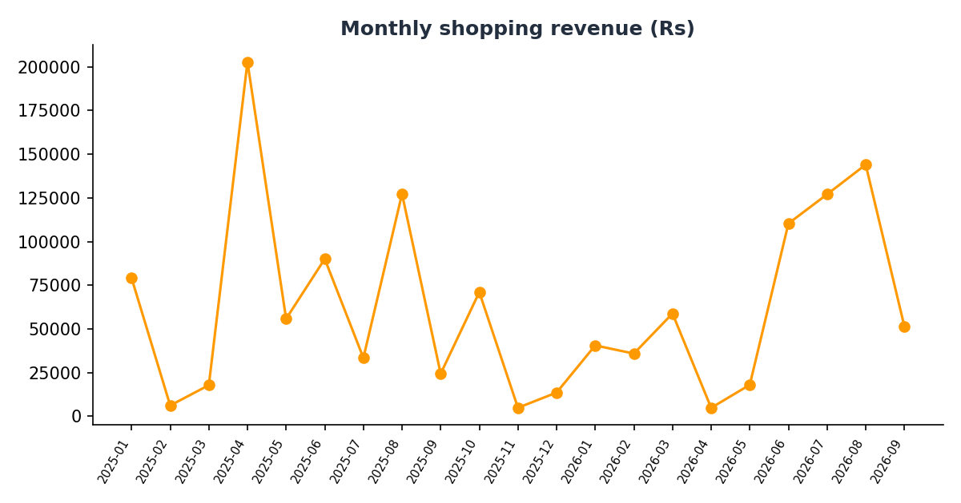
Figure 5 - Monthly shopping revenue
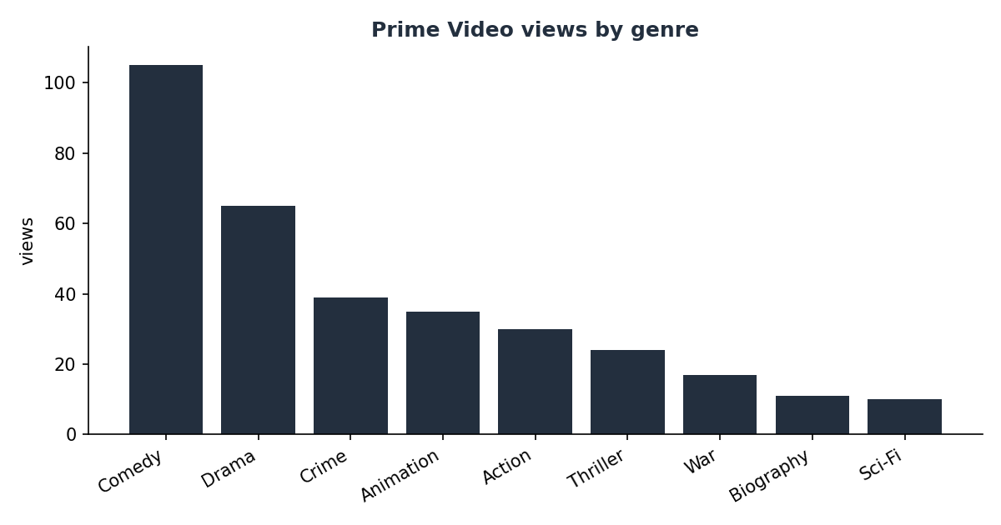
Figure 6 - Prime Video views by genre
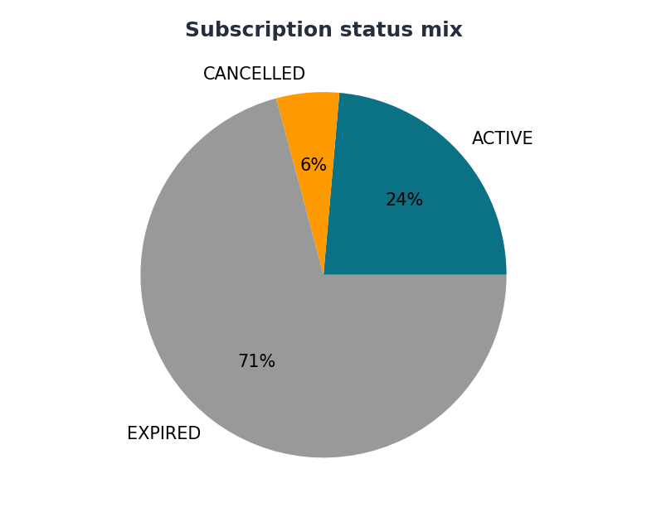
Figure 7 - Subscription status mix

16 Testing
tests/test_database.py contains 21 automated tests (python -m unittest discover -s tests -v). All pass.
Group | What is verified
Schema (9) | 24 tables exist; no FK violations in data; UNIQUE e-mail; CHECK on price, rating, dates; FK enforcement; payment exclusive arc; cascade delete
Views & triggers (5) | Order-total view equals manual sum; one-ACTIVE-subscription rule; audit trigger; stock reduce/restore; overselling blocked
Services (7) | Duplicate registration; delivery fee vs Prime; double subscription rejected; failed order rolled back; cancel restores stock and refunds; kids-profile block; review only after delivery

17 Conclusion, limitations and future scope
The project delivers a complete, normalized, constraint-driven database for an Amazon-Prime-like service, together with views, triggers, 25 queries, a transactional Python application and automated tests. It shows how the DBMS itself - not only application code - can guarantee data quality.
Limitations
- Sample data is small and fictional; no real payment gateway; passwords hashed with SHA-256 for demonstration (use bcrypt/argon2 in production).
- No concurrency stress testing; no partitioning or replication.
Future scope
- Web front-end (Flask/Django) over the same services layer.
- Coupons, wishlists, returns and refunds workflow tables.
- Recommendation engine, full-text product search, data warehouse star schema for reporting.
- Role-based access control (GRANT/REVOKE) and encryption of personal data.

18 References
- A. Silberschatz, H. Korth, S. Sudarshan - Database System Concepts, 7th ed., McGraw-Hill.
- R. Elmasri, S. Navathe - Fundamentals of Database Systems, 7th ed., Pearson.
- MySQL 8.0 Reference Manual - https://dev.mysql.com/doc/
- SQLite documentation - https://www.sqlite.org/docs.html
- Graphviz documentation - https://graphviz.org/documentation/
- Python sqlite3 module - https://docs.python.org/3/library/sqlite3.html

19 Team contribution
Member | Roll no. | Contribution
[Name 1] |  | Requirement analysis, ER design
[Name 2] |  | Schema / DDL, normalization
[Name 3] |  | Sample data, SQL queries, triggers
[Name 4] |  | Python application, testing, report

