

DS 633- Research Paper

Predicting S&P 500 Index



BY: Chayan Gujral

Contents

Introduction 2

Previous Research 2

Methodology 2

Results 3

Histograms 3

Time Series Plots. 4

Scatter Plots 6

Descriptive statistics 7

Correlation Matrix 8

Linear Regression Model. 8

Residuals Analysis 9

GAM regression model 11

Regression Analysis for Gam. 13

Conclusion: 14

Appendix I 15

Appendix- II 22

# Introduction

This paper constructs a statistical model to determine what economic factors effects the price of S&P 500. This paper tries to construct linear parametric and nonlinear non Parametric regression models and analyze different statistical parameters on how and why this paper holds accurate hypothesis.

# Previous Research

No previous research is conducted and my paper conduct no citations from any other research paper.

# Methodology

This research paper is based on Time-Series data having 171 monthly observations. Statistical software R is used to perform the analysis.

Functional Specification: -

The S&P 500 index is hypothesized to be a negative function of unemployment rate, positive function of Consumer price percentage change, positive function of United States Imports, negative function of Global energy price Index and negative function of federal fund rate.

- + + - -

……………………………………………………………. (1)

Population Regression Line: -

………… ..………………..(2)

Sample Regression Line: -

………..…………………..(3)

# Results

## Histograms

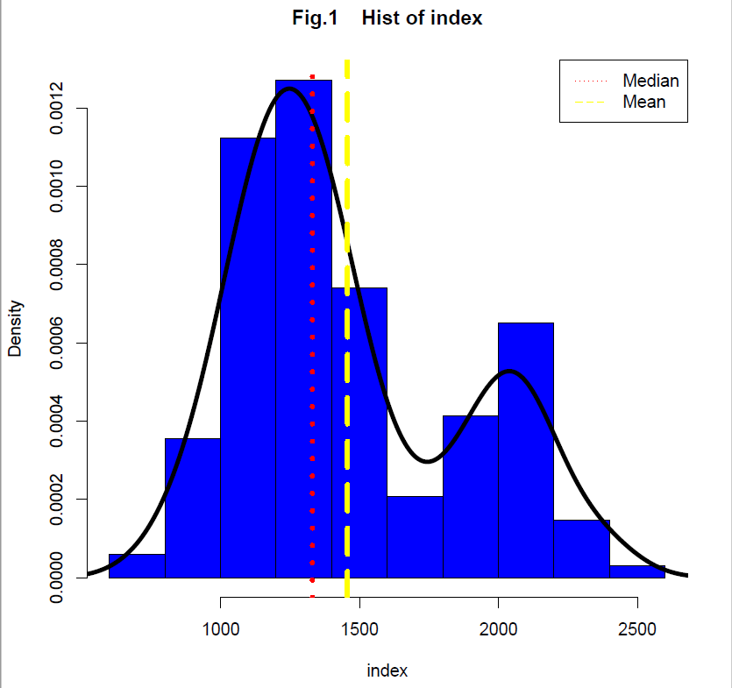 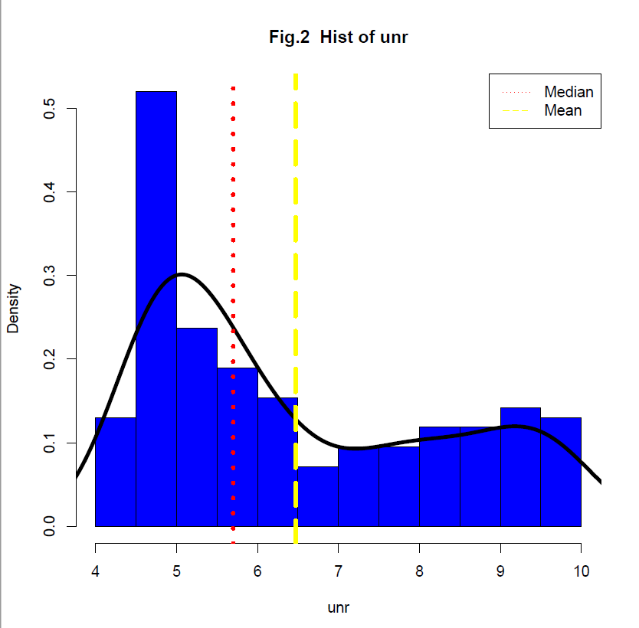

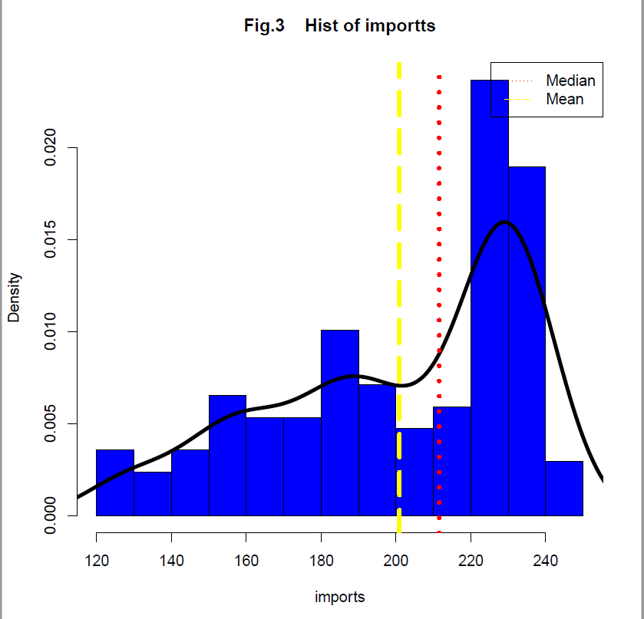 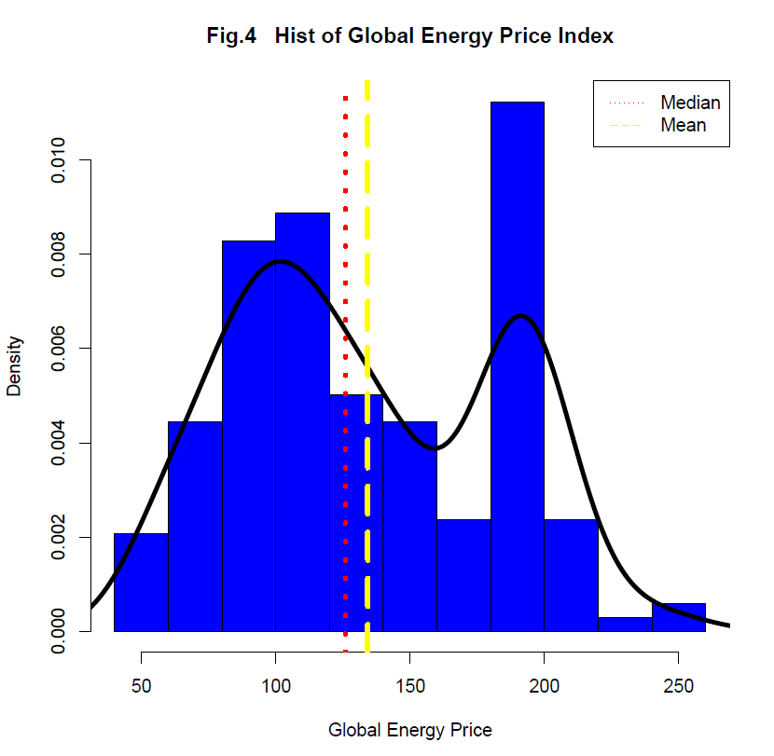

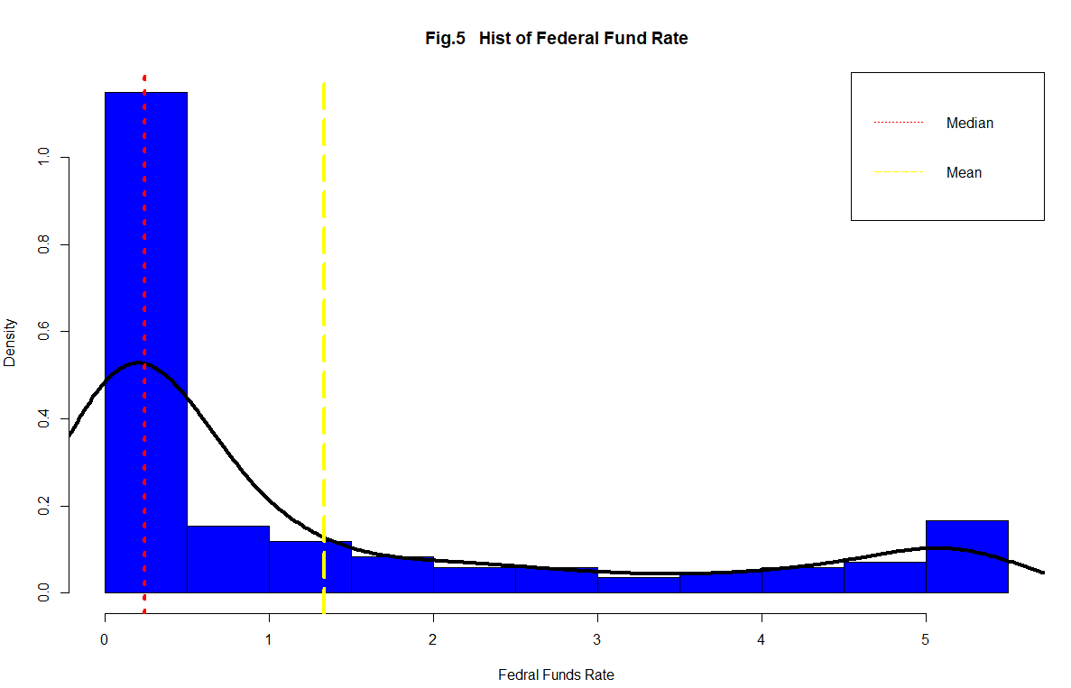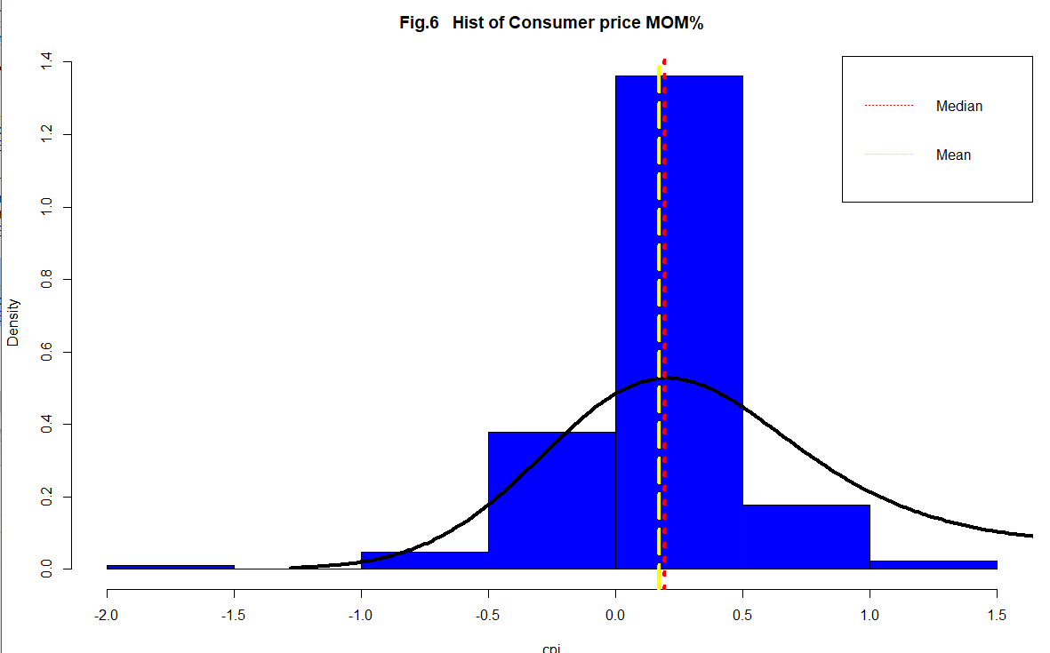

Fig.1 to Fig. 6 shows histograms for our data, the only data which is very skewed is Federal Funds rate and the least skewed is the consumer price percent change every month. The vertical lines show the Median and mean and we can see in Fig 6 they are almost coinciding with one another showing a perfect bell curve

The dependent variable is skewed to the right but the mean and median are pretty much close which shows low level of skewness altogether which will come handy while forming the regression model

## Time Series Plots.

Fig.7 through Fig. 12 shows time series plot for all the data.

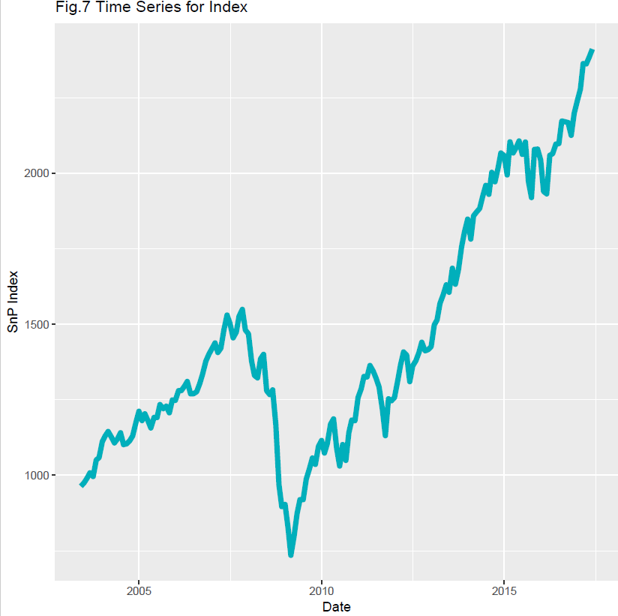 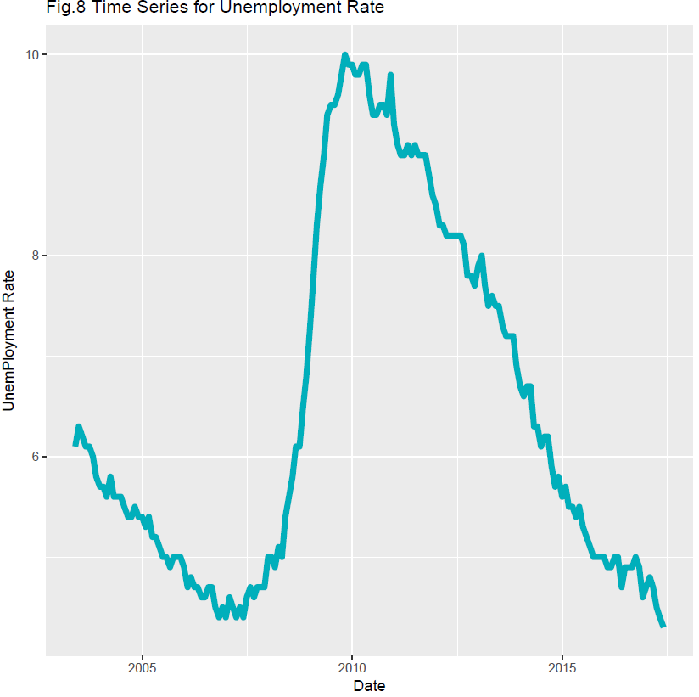

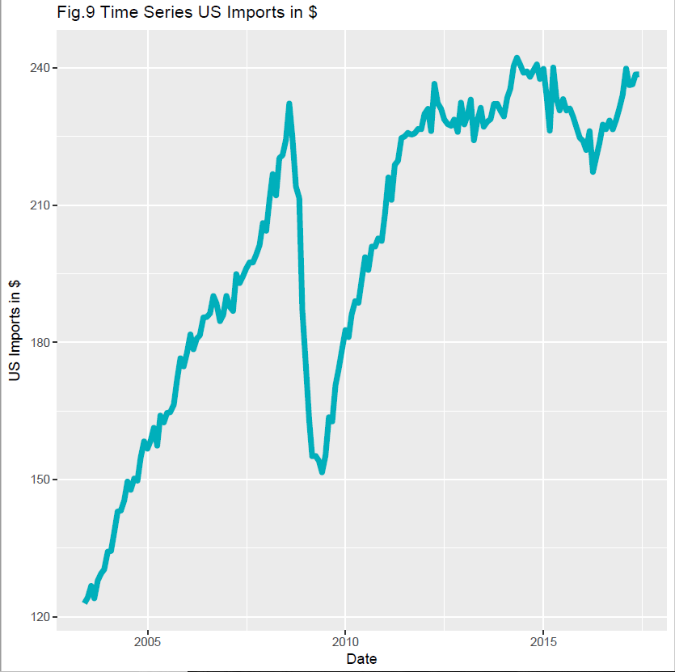 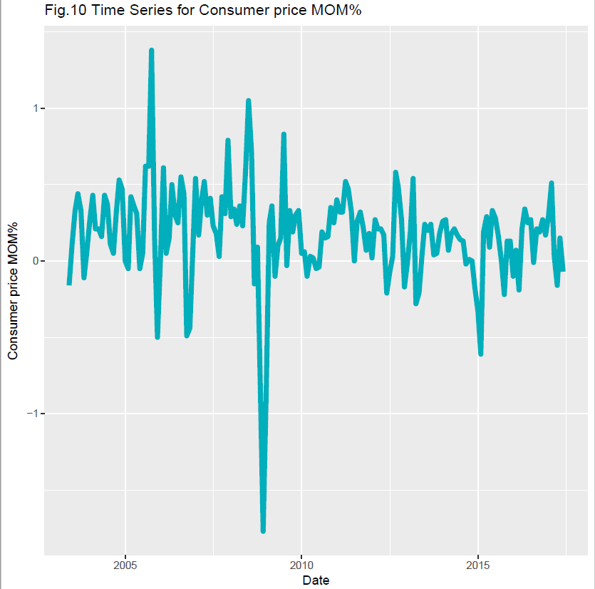

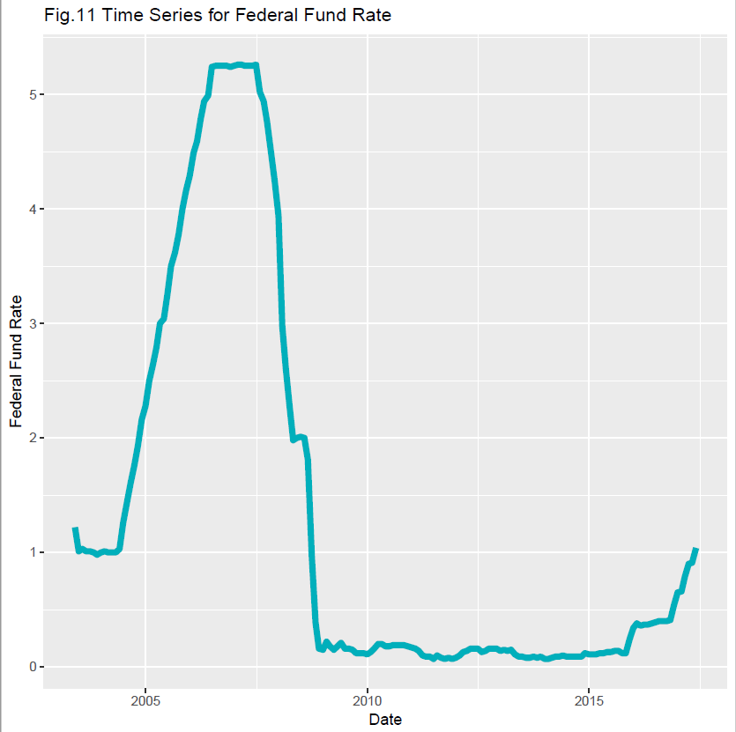 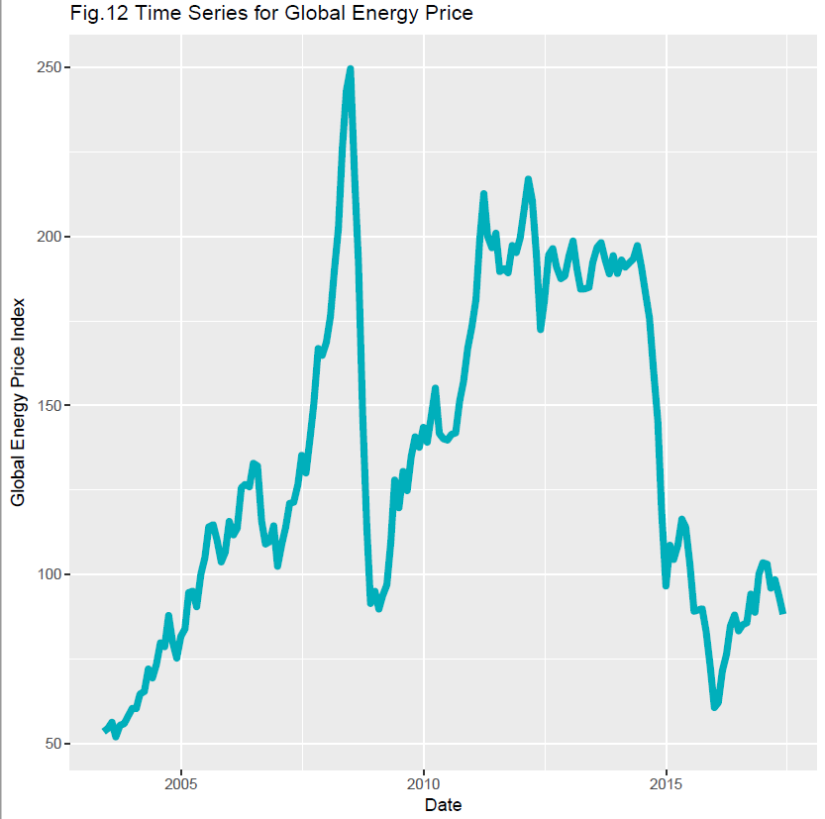

# Scatter Plots

Fig .13 to Fig.17 shows Scatter Plots of S&P Index with all the independent variables and we should see how it lined up with our hypothesis.

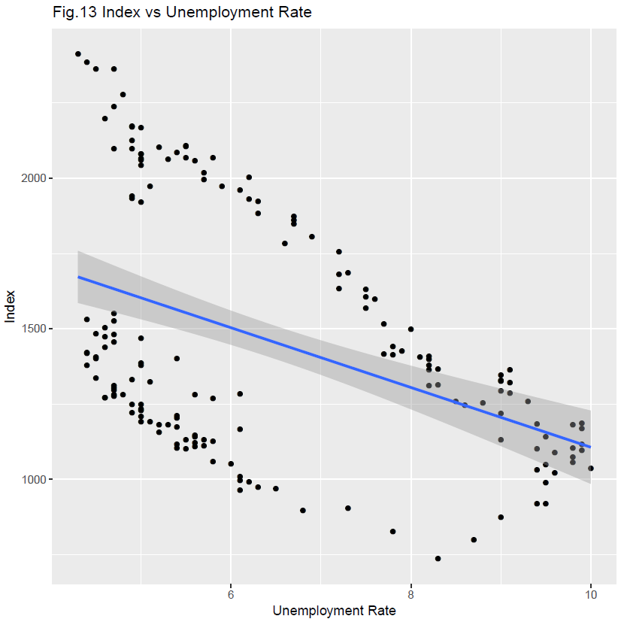 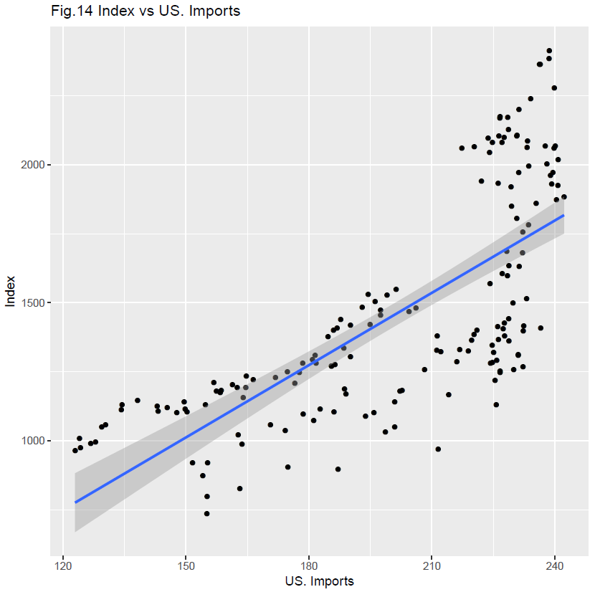

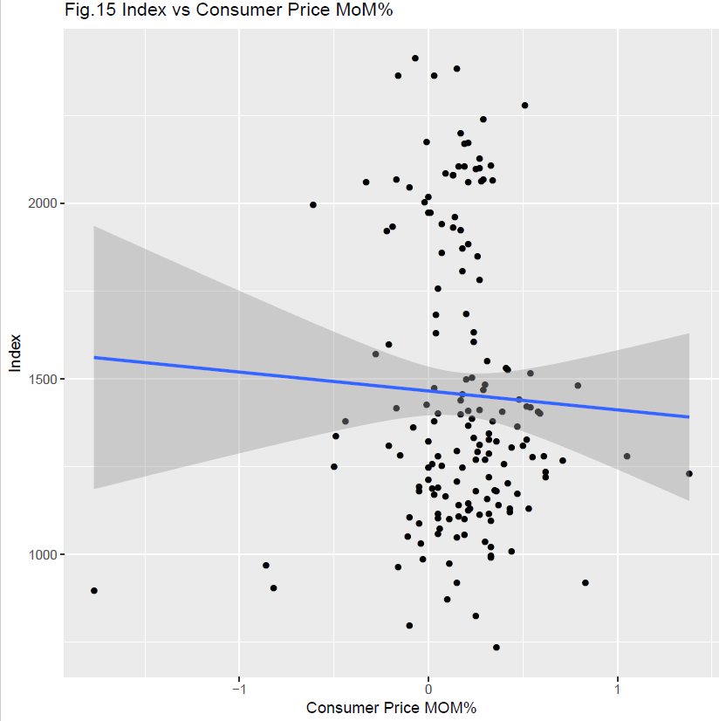 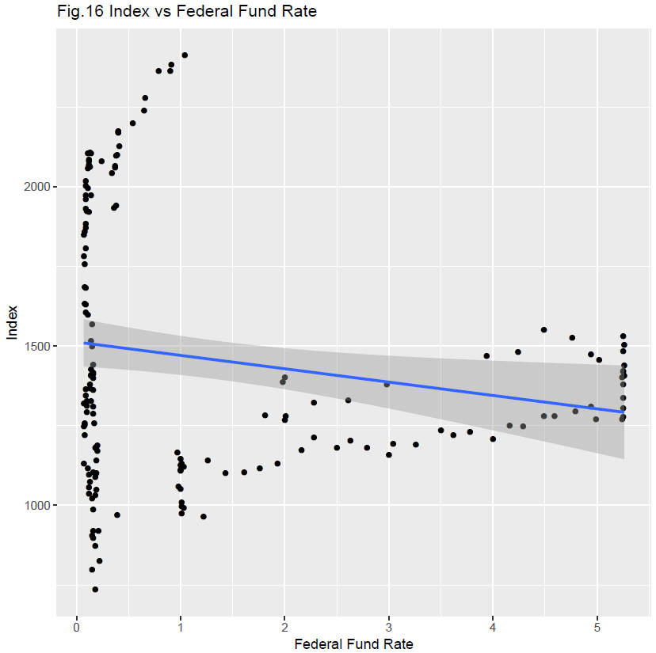

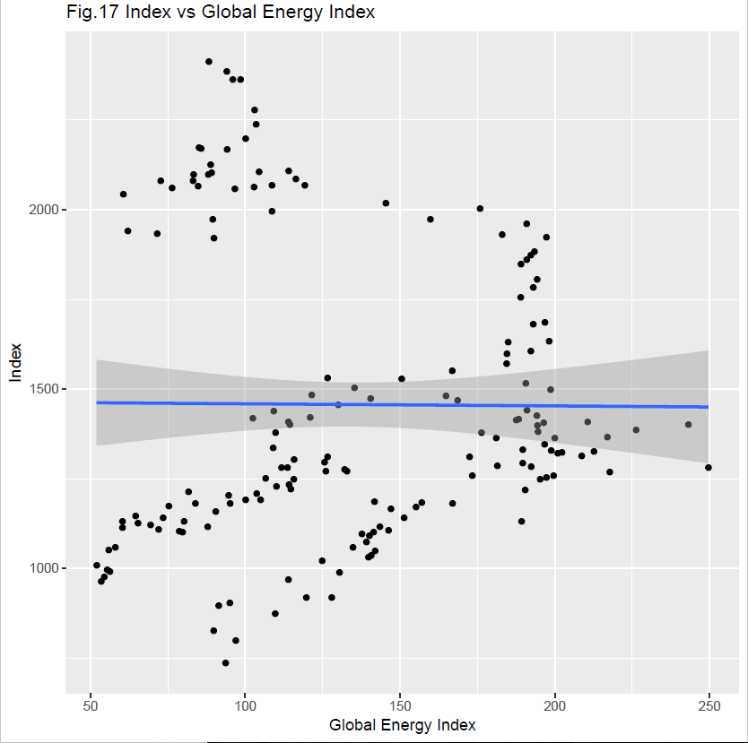

From Fig.13, Fig.15 and Fig. 17 we can see that it is a negative trending and which clearly state that our hypothesis in relation with unemployment rate, Global energy index and Federal Funds rates are true.

Fig 14. Clearly shows an increasing trend.

Fig. 16 is unclear due to very less correlation among variables, it will become more clear using the correlation matrix and more solid by linear regression model.

## Descriptive statistics

Below table shows descriptive statistics for our data.

Table 1

|  |  |  |  |  |  |  |  |  |  |  |
| --- | --- | --- | --- | --- | --- | --- | --- | --- | --- | --- |
|  | n | mean | sd | median | min | max | range | skew | kurtosis | se |
|  |  |  |  |  |  |  |  |  |  |  |
| index | 169 | 1456.839 | 401.551 | 319.545 | 735.09 | 2411.8 | 1676.71 | 0.659 | -0.677 | 30.889 |
| unr | 169 | 6.471 | 1.786 | 1.483 | 4.3 | 10 | 5.7 | 0.625 | -1.09 | 0.137 |
| importts | 169 | 200.919 | 33.474 | 32.069 | 122.95 | 242.24 | 119.29 | -0.662 | -0.786 | 2.575 |
| cpi | 169 | 0.17 | 0.322 | 0.208 | -1.77 | 1.38 | 3.15 | -1.289 | 8.571 | 0.025 |
| Int_rate | 169 | 1.334 | 1.765 | 0.237 | 0.07 | 5.26 | 5.19 | 1.26 | 0.038 | 0.136 |
| Epi | 169 | 134.258 | 48.877 | 60.603 | 51.976 | 249.607 | 197.631 | 0.205 | -1.153 | 3.76 |

Global energy index is statistically normally distributed and Federal Funds rate does not have any peakedness.

## Correlation Matrix

Table 2

|  |  |  |  |  |  |  |
| --- | --- | --- | --- | --- | --- | --- |
|  | index | unr | importts | Epi | Int_rate | cpi |
|  |  |  |  |  |  |  |
| index | 1 | -0.442 | 0.728 | -0.007 | -0.184 | -0.043 |
| unr | -0.442 | 1 | 0.035 | 0.463 | -0.607 | -0.061 |
| importts | 0.728 | 0.035 | 1 | 0.59 | -0.336 | -0.088 |
| Epi | -0.007 | 0.463 | 0.59 | 1 | -0.183 | 0.152 |
| Int_rate | -0.184 | -0.607 | -0.336 | -0.183 | 1 | 0.21 |
| cpi | -0.043 | -0.061 | -0.088 | 0.152 | 0.21 | 1 |

Looking at the table 2 and our hypothesis, most of the variables turn out to be accurate accept cpi mom%, which here shows very marginal negative function of S&P 500 index if this is significant or not further in our regression model.

There is none autocorrelation since the collinearity merely crossing the value of .6 which is very less.

## Linear Regression Model.

According to our linear model hypothesized we run the linear fit model and form the following equation.

Table 3

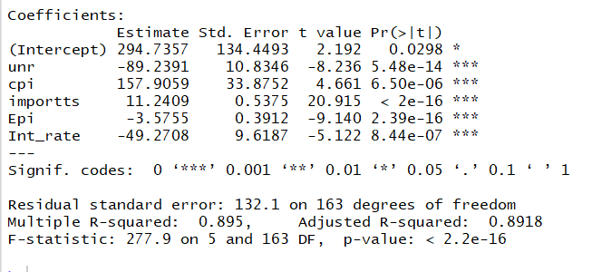

According to linear model all of our coefficients are statistically highly significant and the whole equation supports the alternate hypothesis to be true since F-Statistics is 277.9.

We form the linear equation as:

With coefficient of determination as 89%.

### Residuals Analysis

Below is the residual analysis of our linear model

#### Histograms for residuals.

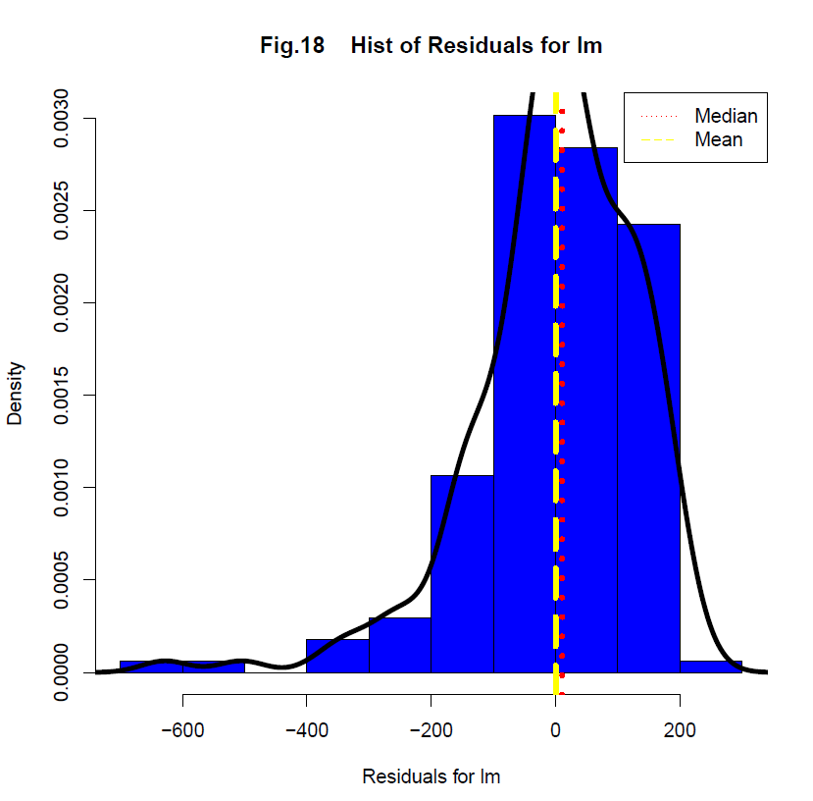

Thing worth noting is that The median and mode are almost coinciding and even though it is negatively skewed it is close to normally distributed. Which shows that the model is capable of predicting accurately.

#### Scatter plots for residuals

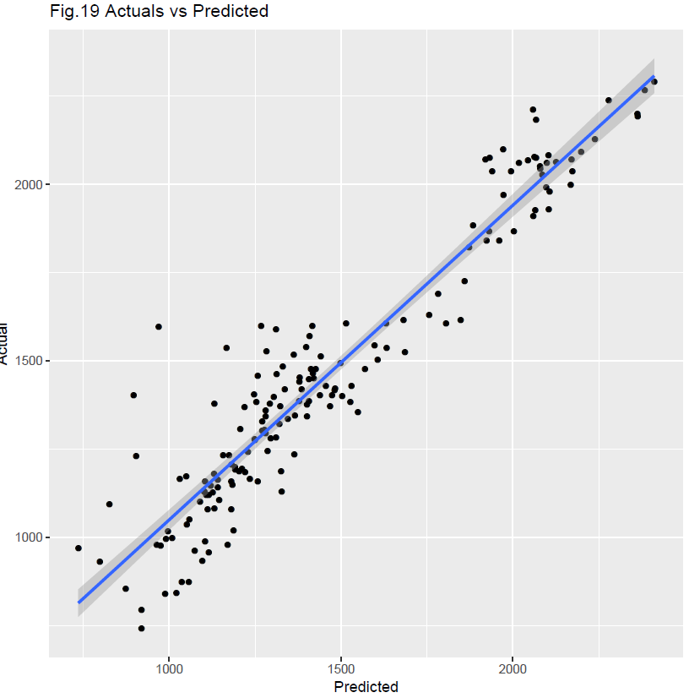 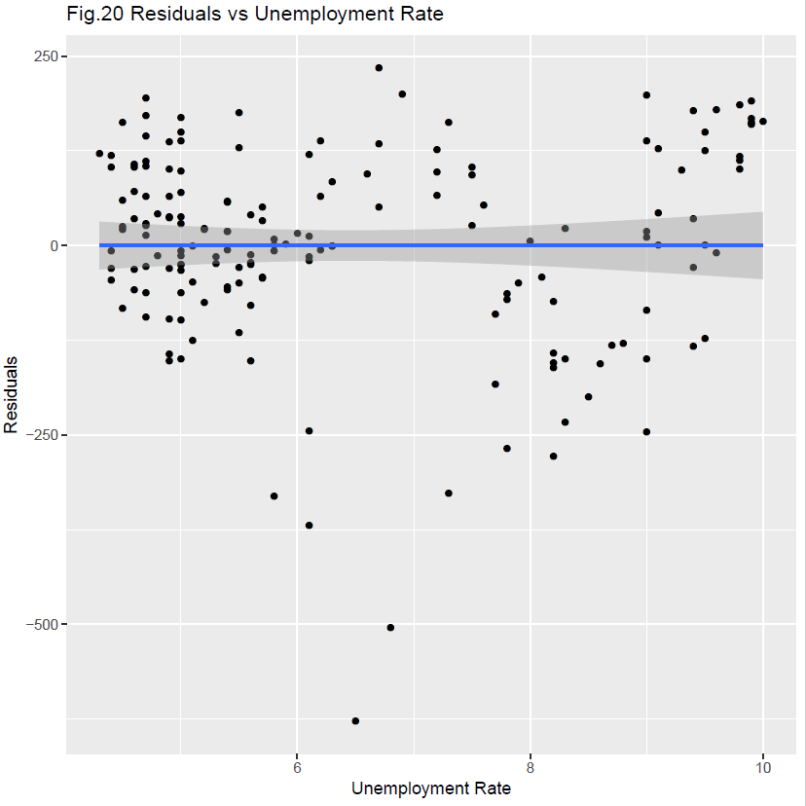

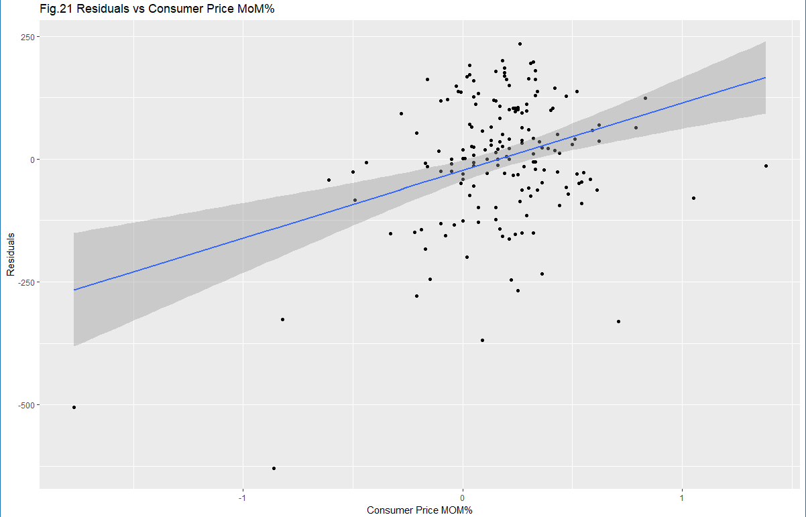 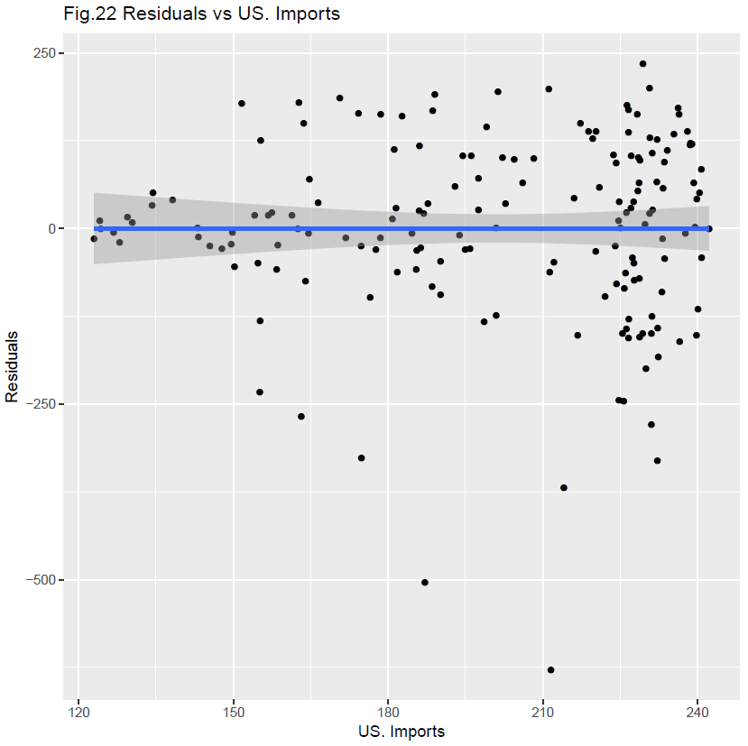

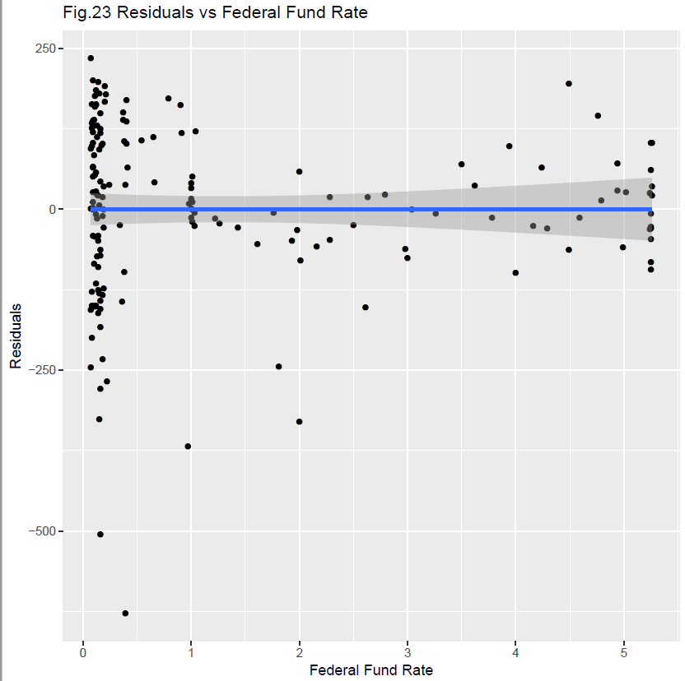 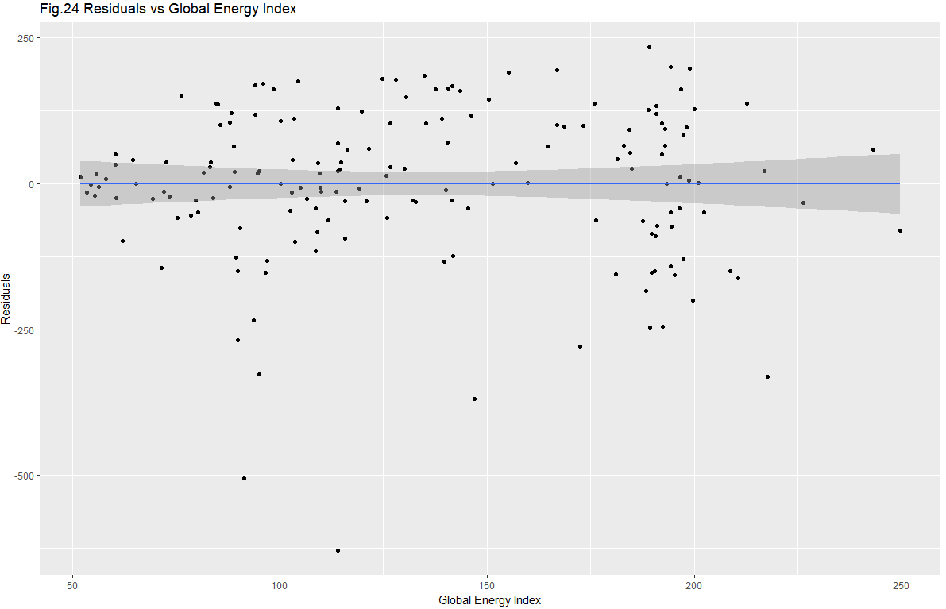

Fig. 19 shows the linear and strong relation between actual and predicited which shows the accuracy of the predicited model.

Fig 20- Fig 24 shows scatter plot of residuals and all independent variables and according to the non existent trend line exept cpi it shows no correlation whatsoever which also shows high accuracy of the model.

## GAM regression model

Gam is the nonlinear non parametric models. There is no equation but shows the trend using graphs.

Fig 25. Show a combined output of GAM analysis for our data with degree of freedom of 1.

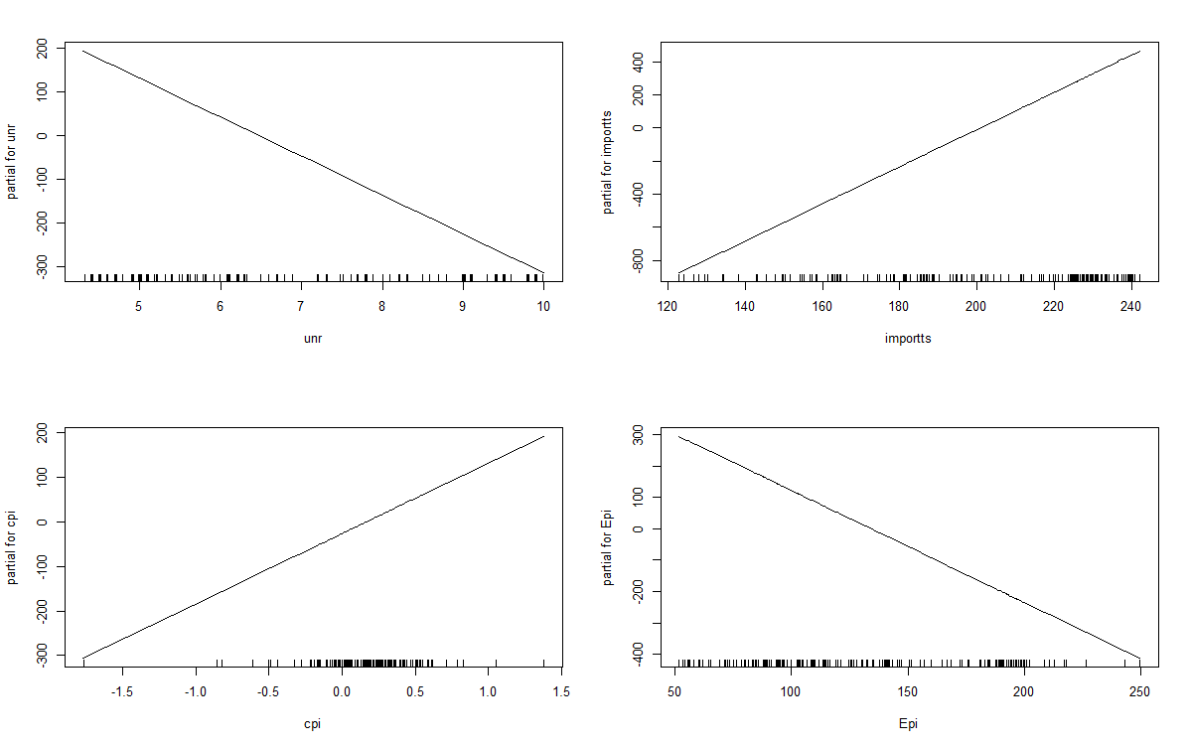

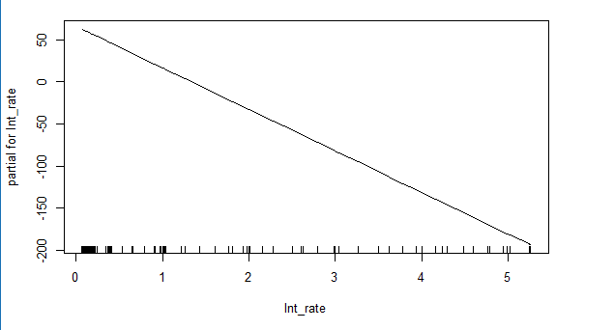

Looking at the plots our hypothesis stands true as we can see the unemployment Energy index consumer price and Federal Funds has negative impact on SnP index and rest have positive impact.

R-Square: - comes out to be .89 which is similar to linear model which suggest linear association of dependent and independent variables.

### Regression Analysis for Gam.

#### Histogram for residuals.

#### 

IT is very much similar to linear model, almost normally distributed showing accuracy of the model.

Skewness is -1.12 but since median and mean are closely located, which is good thing for any model on any given day.

#### Scatter Plots with residuals.

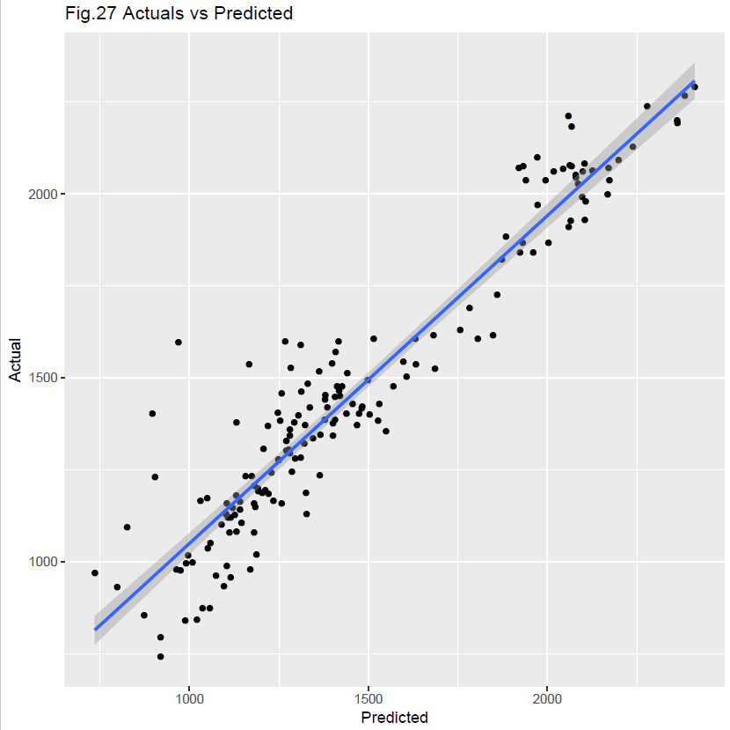 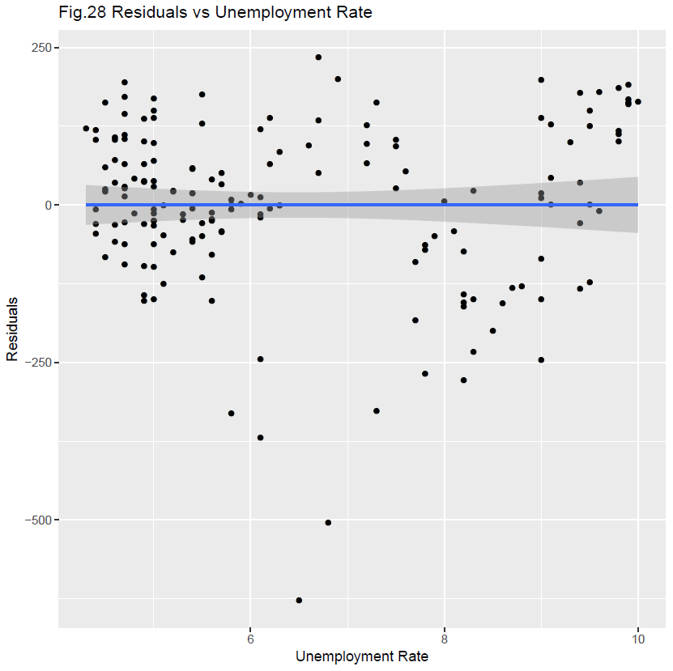

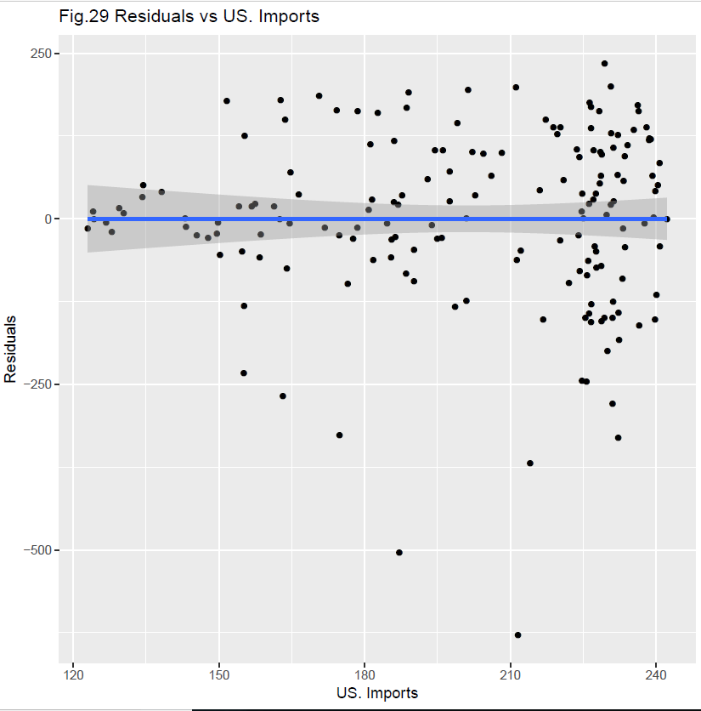 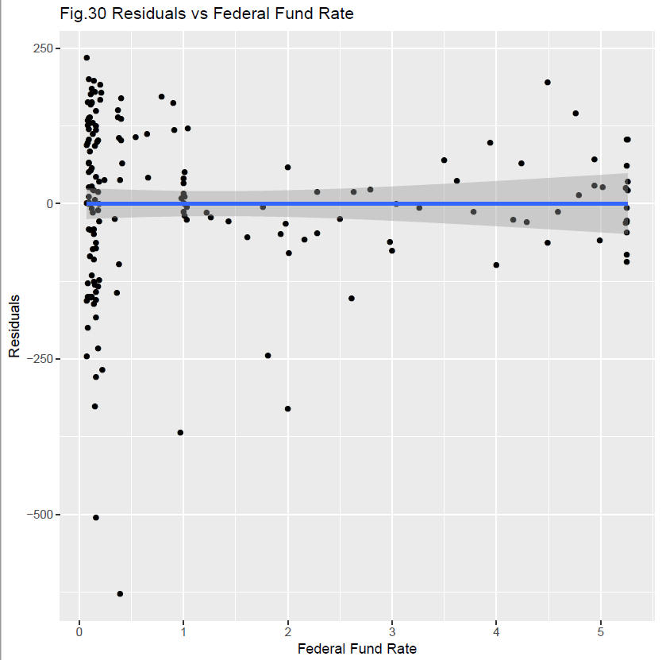

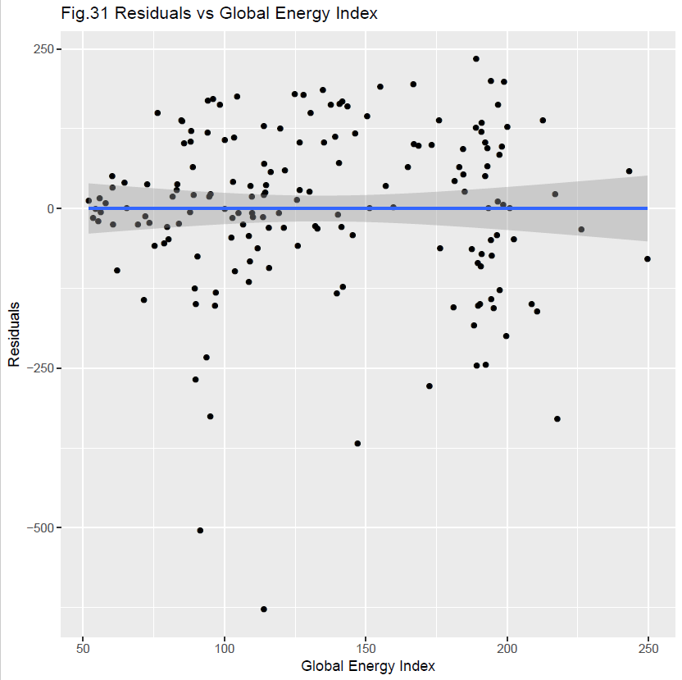 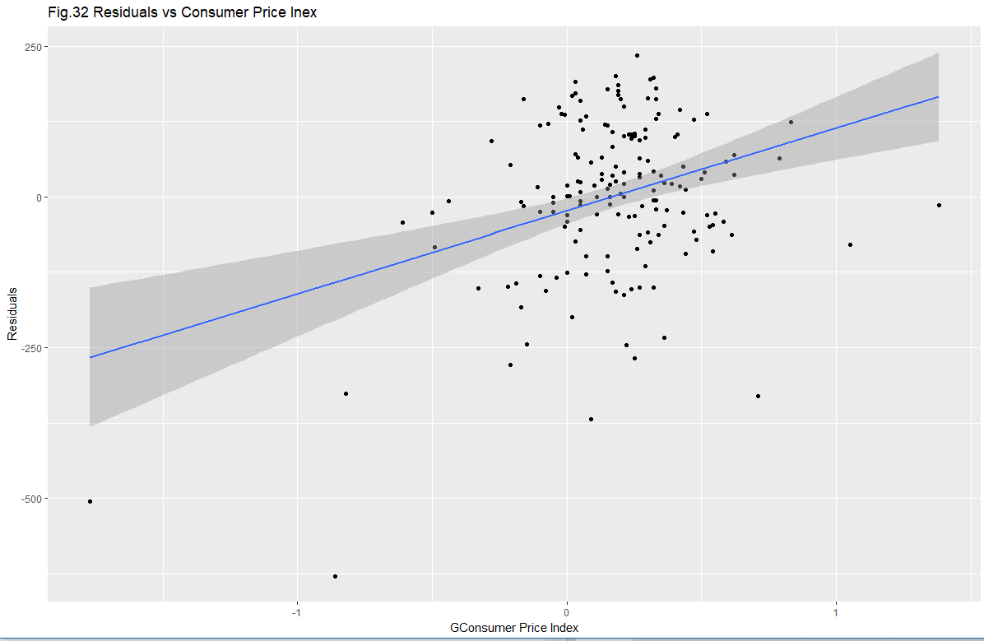

Fig 27 shows the scatter plot of actual vs predicited and by looking at it we can see a strong positive trend line which shows the accuracy of the prediction.

Fig 28-Fig32 shows the scatter plot of residuals vs all the independent variables and the trend line is non existant other than cpi which shows the quality of independent variable chosed to predict the values.

# Conclusion:

This model has accurately predicted the value of S&P 500 index up to 89% of coefficient of determination. Both linear and GAM model has the same explanatory power showing the linear association of independent and dependent variables.

All assumptions were coming out to be true and our hypothesis was accurately proved in the results.

# Appendix I

R- Script Used is pasted below.

library(readxl)

library(ggplot2)

library(psych)

library(lmtest)

library(gam)

snp_500_index <- read_excel("~/Spring 2018/DS 633/Final/snp 500 index.xlsx",

sheet = "Sheet1")

View(snp_500_index)

spDF<- snp_500_index

spDF<- as.data.frame(spDF)

spDF<- na.omit(spDF)

dim(spDF)

#histograms

par(mfcol=c(1,1))

pdf(file= "hist3.pdf")

par(mfcol=c(1,1))

hist(spDF$index,main ="Fig.1 Hist of index", prob =1, xlab = "index", col = "blue"); lines(density(spDF$index),lwd = 4)

abline(v = median(spDF$index),col = "Red",lty = 3,lwd = 4)

abline(v = mean(spDF$index),col = "yellow",lty = 5,lwd = 4)

legend("topright", lty = c(3, 5), col = c("red","yellow"), legend = c("Median","Mean"))

hist(spDF$unr,main ="Fig.2 Hist of unr", prob =1, xlab = "unr", col = "blue"); lines(density(spDF$unr),lwd = 4)

abline(v = median(spDF$unr),col = "Red",lty = 3,lwd = 4)

abline(v = mean(spDF$unr),col = "yellow",lty = 5,lwd = 4)

legend("topright", lty = c(3, 5), col = c("red","yellow"), legend = c("Median","Mean"))

hist(spDF$importts,main ="Fig.3 Hist of importts", prob =1, xlab = "imports", col = "blue"); lines(density(spDF$importts),lwd = 4)

abline(v = median(spDF$importts),col = "Red",lty = 3,lwd = 4)

abline(v = mean(spDF$importts),col = "yellow",lty = 5,lwd = 4)

legend("topright", lty = c(3, 5), col = c("red","yellow"), legend = c("Median","Mean"))

hist(spDF$Epi,main ="Fig.4 Hist of Global Energy Price Index", prob =1, xlab = "Global Energy Price", col = "blue"); lines(density(spDF$Epi),lwd = 4)

abline(v = median(spDF$Epi),col = "Red",lty = 3,lwd = 4)

abline(v = mean(spDF$Epi),col = "yellow",lty = 5,lwd = 4)

legend("topright", lty = c(3, 5), col = c("red","yellow"), legend = c("Median","Mean"))

hist(spDF$Int_rate,main ="Fig.5 Hist of Federal Fund Rate", prob =1, xlab = "Fedral Funds Rate", col = "blue"); lines(density(spDF$Int_rate),lwd = 4)

abline(v = median(spDF$Int_rate),col = "Red",lty = 3,lwd = 4)

abline(v = mean(spDF$Int_rate),col = "yellow",lty = 5,lwd = 4)

legend("topright", lty = c(3, 5), col = c("red","yellow"), legend = c("Median","Mean"))

hist(spDF$cpi,main ="Fig.6 Hist of Consumer price MOM%", prob =1, xlab = "cpi", col = "blue"); lines(density(spDF$Int_rate),lwd = 4)

abline(v = median(spDF$cpi),col = "Red",lty = 3,lwd = 4)

abline(v = mean(spDF$cpi),col = "yellow",lty = 5,lwd = 4)

legend("topright", lty = c(3, 5), col = c("red","yellow"), legend = c("Median","Mean"))

dev.off()

graphics.off()

#Time-Series Plot

pdf(file = "tsplot5.pdf")

par(mfcol = c(2,2))

ggplot(data = spDF, aes(x = Date, y = index)) + labs(y = "SnP Index")+ggtitle("Fig.7 Time Series for Index") +

geom_line(color = "#00AFBB", size = 2)

ggplot(data = spDF, aes(x = Date, y = unr))+ labs(y = "UnemPloyment Rate")+ggtitle("Fig.8 Time Series for Unemployment Rate") +

geom_line(color = "#00AFBB", size = 2)

ggplot(data = spDF, aes(x = Date, y = importts)) + labs(y = "US Imports in $")+ggtitle("Fig.9 Time Series US Imports in $") +

geom_line(color = "#00AFBB", size = 2)

ggplot(data = spDF, aes(x = Date, y = cpi))+ labs(y = "Consumer price MOM%")+ggtitle("Fig.10 Time Series for Consumer price MOM%") +

geom_line(color = "#00AFBB", size = 2)

ggplot(data = spDF, aes(x = Date, y = Int_rate))+ labs(y = "Federal Fund Rate")+ggtitle("Fig.11 Time Series for Federal Fund Rate") +

geom_line(color = "#00AFBB", size = 2)

ggplot(data = spDF, aes(x = Date, y = Epi))+ labs(y = "Global Energy Price Index")+ggtitle("Fig.12 Time Series for Global Energy Price") +

geom_line(color = "#00AFBB", size = 2)

dev.off()

graphics.off()

#scatterplots

pdf(file = "scatterplots3.pdf")

par(mfcol = c(1,1))

ggplot(data=spDF, aes(unr,index)) + labs(x="Unemployment Rate", y="Index") +

geom_point() +stat_smooth(method = "lm") +ggtitle("Fig.13 Index vs Unemployment Rate")

ggplot(data=spDF, aes(importts,index)) + labs(x="US. Imports", y="Index") +

geom_point() +stat_smooth(method = "lm") +ggtitle("Fig.14 Index vs US. Imports")

ggplot(data=spDF, aes(cpi,index)) + labs(x="Consumer Price MOM%", y="Index") +

geom_point() +stat_smooth(method = "lm") +ggtitle("Fig.15 Index vs Consumer Price MoM%")

ggplot(data=spDF, aes(Int_rate,index)) + labs(x="Federal Fund Rate", y="Index") +

geom_point() +stat_smooth(method = "lm") +ggtitle("Fig.16 Index vs Federal Fund Rate")

ggplot(data=spDF, aes(Epi,index)) + labs(x="Global Energy Index", y="Index") +

geom_point() +stat_smooth(method = "lm") +ggtitle("Fig.17 Index vs Global Energy Index")

dev.off()

graphics.off()

#descriptive statistics

names(spDF)

desc<- round(describe(spDF[,c("index","unr","importts","cpi","Int_rate","Epi")]),3)

#correlation matrix

cor<- round(cor(spDF[,c("index","unr","importts","Epi","Int_rate","cpi")],use="na.or.complete"),3)

# linear regression

names(spDF)

fit<-lm(index~unr+cpi+importts+Epi+Int_rate,data=spDF,na.action=na.omit)

summary(fit)

dwtest(fit)

#Linear residual dataframe

rdf<-data.frame(spDF,r=fit$residuals,p=fit$fitted.values)

pdf(file = "linearresid2.pdf")

par(mfcol=c(1,1))

hist(rdf$r,main ="Fig.18 Hist of Residuals for lm", prob =1,

xlab = "Residuals for lm", col = "blue");

lines(density(rdf$r),lwd = 4)

abline(v = median(rdf$r),col = "Red",lty = 3,lwd = 4)

abline(v = mean(rdf$r),col = "yellow",lty = 5,lwd = 4)

legend("topright", lty = c(3, 5), col = c("red","yellow"), legend = c("Median","Mean"))

dev.off()

graphics.off()

skew(rdf$r)

pdf(file = "Scatter_Res_LM2.pdf")

ggplot(data=rdf, aes(index,p)) + labs(x="Predicted", y="Actual") +

geom_point() +stat_smooth(method = "lm") +ggtitle("Fig.19 Actuals vs Predicted")

ggplot(data=rdf, aes(unr,r)) + labs(x="Unemployment Rate", y="Residuals") +

geom_point() +stat_smooth(method = "lm") +ggtitle("Fig.20 Residuals vs Unemployment Rate")

ggplot(data=rdf, aes(cpi,r)) + labs(x="Consumer Price MOM%", y="Residuals") +

geom_point() +stat_smooth(method = "lm") +ggtitle("Fig.21 Residuals vs Consumer Price MoM%");

ggplot(data=rdf, aes(importts,r)) + labs(x="US. Imports", y="Residuals") +

geom_point() +stat_smooth(method = "lm") +ggtitle("Fig.22 Residuals vs US. Imports")

ggplot(data=rdf, aes(Int_rate,r)) + labs(x="Federal Fund Rate", y="Residuals") +

geom_point() +stat_smooth(method = "lm") +ggtitle("Fig.23 Residuals vs Federal Fund Rate")

ggplot(data=rdf, aes(Epi,r)) + labs(x="Global Energy Index", y="Residuals") +

geom_point() +stat_smooth(method = "lm") +ggtitle("Fig.24 Residuals vs Global Energy Index")

dev.off()

graphics.off()

# gam regression

library(gam)

fit<-gam(index~s(unr,1)+s(importts)+s(Epi,1)+s(Int_rate,1),na.action=na.omit,data=spDF)

par(mfcol=c(2,2)); plot.gam(fit)

dwtest(fit)

#residual dataframe

rdf<-data.frame(spDF,r=fit$residuals,p=fit$fitted.values)

pdf(file = "Gamresid1.pdf")

par(mfcol=c(1,1))

hist(rdf$r,main ="Fig.26 Hist of Residuals for GAM", prob =1,

xlab = "Residuals for lm", col = "blue");

lines(density(rdf$r),lwd = 4)

abline(v = median(rdf$r),col = "Red",lty = 3,lwd = 4)

abline(v = mean(rdf$r),col = "yellow",lty = 5,lwd = 4)

legend("topright", lty = c(3, 5), col = c("red","yellow"), legend = c("Median","Mean"))

skew(rdf$r)

dev.off()

graphics.off()

pdf(file = "Scatter_Res_GAM1.pdf")

ggplot(data=rdf, aes(index,p)) + labs(x="Predicted", y="Actual") +

geom_point() +stat_smooth(method = "lm") +ggtitle("Fig.27 Actuals vs Predicted")

ggplot(data=rdf, aes(unr,r)) + labs(x="Unemployment Rate", y="Residuals") +

geom_point() +stat_smooth(method = "lm") +ggtitle("Fig.28 Residuals vs Unemployment Rate")

ggplot(data=rdf, aes(importts,r)) + labs(x="US. Imports", y="Residuals") +

geom_point() +stat_smooth(method = "lm") +ggtitle("Fig.29 Residuals vs US. Imports")

ggplot(data=rdf, aes(Int_rate,r)) + labs(x="Federal Fund Rate", y="Residuals") +

geom_point() +stat_smooth(method = "lm") +ggtitle("Fig.30 Residuals vs Federal Fund Rate")

ggplot(data=rdf, aes(Epi,r)) + labs(x="Global Energy Index", y="Residuals") +

geom_point() +stat_smooth(method = "lm") +ggtitle("Fig.31 Residuals vs Global Energy Index")

ggplot(data=rdf, aes(cpi,r)) + labs(x="GConsumer Price Index", y="Residuals") +

geom_point() +stat_smooth(method = "lm") +ggtitle("Fig.32 Residuals vs Consumer Price Inex")

dev.off()

graphics.off()

R_Square_GAM<- cor(rdf$index,rdf$p)^2

# Appendix- II

Data set is pasted below.

|  |  |  |  |  |  |  |
| --- | --- | --- | --- | --- | --- | --- |
| Date | index | unr | importts | cpi | Int_rate | Epi |
| 5/30/2003 | 963.59 | 6.1 | 122.95 | -0.16 | 1.22 | 53.5160045392877 |
| 6/30/2003 | 974.5 | 6.3 | 124.25 | 0.11 | 1.01 | 54.4496980493557 |
| 7/31/2003 | 990.31 | 6.2 | 126.74 | 0.33 | 1.03 | 56.2795226259468 |
| 8/29/2003 | 1,008.01 | 6.1 | 124.05 | 0.44 | 1.01 | 51.9759621560102 |
| 9/30/2003 | 995.97 | 6.1 | 127.93 | 0.33 | 1.01 | 55.4145747828168 |
| 10/31/2003 | 1,050.71 | 6 | 129.47 | -0.11 | 1.00 | 55.8511720577312 |
| 11/28/2003 | 1,058.20 | 5.8 | 130.36 | 0.05 | 0.98 | 57.9759663303543 |
| 12/31/2003 | 1,111.92 | 5.7 | 134.23 | 0.27 | 1.00 | 60.3632704688512 |
| 1/30/2004 | 1,131.13 | 5.7 | 134.41 | 0.43 | 1.01 | 60.3536832163409 |
| 2/27/2004 | 1,144.94 | 5.6 | 138.2 | 0.21 | 1.00 | 64.6196793676070 |
| 3/31/2004 | 1,126.21 | 5.8 | 143 | 0.21 | 1.00 | 65.3970341546718 |
| 4/30/2004 | 1,107.30 | 5.6 | 143.23 | 0.16 | 1.00 | 72.0266612208297 |
| 5/31/2004 | 1,120.68 | 5.6 | 145.43 | 0.43 | 1.03 | 69.4128768008489 |
| 6/30/2004 | 1,140.84 | 5.6 | 149.56 | 0.37 | 1.26 | 73.4224155352312 |
| 7/30/2004 | 1,101.72 | 5.5 | 147.77 | 0.11 | 1.43 | 79.7559473729571 |
| 8/31/2004 | 1,104.24 | 5.4 | 150.23 | 0.05 | 1.61 | 78.6488491371294 |
| 9/30/2004 | 1,114.58 | 5.4 | 149.77 | 0.32 | 1.76 | 87.8599807163819 |
| 10/29/2004 | 1,130.20 | 5.5 | 154.73 | 0.53 | 1.93 | 80.2123443022663 |
| 11/30/2004 | 1,173.82 | 5.4 | 158.35 | 0.47 | 2.16 | 75.2784924792806 |
| 12/31/2004 | 1,211.92 | 5.4 | 156.76 | 0 | 2.28 | 81.6983403037208 |
| 1/31/2005 | 1,181.27 | 5.3 | 158.62 | -0.05 | 2.50 | 83.8966198842217 |
| 2/28/2005 | 1,203.60 | 5.4 | 161.32 | 0.42 | 2.63 | 94.6023465719798 |
| 3/31/2005 | 1,180.59 | 5.2 | 157.42 | 0.36 | 2.79 | 95.0774188133122 |
| 4/29/2005 | 1,156.85 | 5.2 | 163.98 | 0.31 | 3.00 | 90.4714284751115 |
| 5/31/2005 | 1,191.50 | 5.1 | 162.5 | -0.05 | 3.04 | 100.1332089348930 |
| 6/30/2005 | 1,191.33 | 5 | 164.57 | 0.05 | 3.26 | 104.9792612026520 |
| 7/29/2005 | 1,234.18 | 5 | 164.74 | 0.62 | 3.50 | 114.0727614743140 |
| 8/31/2005 | 1,220.33 | 4.9 | 166.39 | 0.62 | 3.62 | 114.7182860535600 |
| 9/30/2005 | 1,228.81 | 5 | 171.81 | 1.38 | 3.78 | 110.0648916816440 |
| 10/31/2005 | 1,207.01 | 5 | 176.53 | 0.15 | 4.00 | 103.7223523711020 |
| 11/30/2005 | 1,249.48 | 5 | 174.75 | -0.5 | 4.16 | 106.5630842334890 |
| 12/30/2005 | 1,248.29 | 4.9 | 177.64 | 0 | 4.29 | 115.6918150595120 |
| 1/31/2006 | 1,280.08 | 4.7 | 181.74 | 0.61 | 4.49 | 111.7260108875300 |
| 2/28/2006 | 1,280.66 | 4.8 | 178.5 | 0.05 | 4.59 | 113.6571155786470 |
| 3/31/2006 | 1,294.83 | 4.7 | 180.85 | 0.15 | 4.79 | 125.6262831059150 |
| 4/28/2006 | 1,310.61 | 4.7 | 181.52 | 0.5 | 4.94 | 126.6024258257330 |
| 5/31/2006 | 1,270.09 | 4.6 | 185.44 | 0.3 | 4.99 | 125.9529720131990 |
| 6/30/2006 | 1,270.20 | 4.6 | 185.53 | 0.25 | 5.24 | 132.8852097061250 |
| 7/31/2006 | 1,276.66 | 4.7 | 186.33 | 0.55 | 5.25 | 132.1038792216490 |
| 8/31/2006 | 1,303.82 | 4.7 | 190.14 | 0.44 | 5.25 | 115.7770908381160 |
| 9/29/2006 | 1,335.85 | 4.5 | 188.5 | -0.49 | 5.25 | 109.0181383009440 |
| 10/31/2006 | 1,377.94 | 4.4 | 184.64 | -0.44 | 5.25 | 109.7413023162270 |
| 11/30/2006 | 1,400.63 | 4.5 | 186.02 | 0.05 | 5.24 | 114.3799057476970 |
| 12/29/2006 | 1,418.30 | 4.4 | 190.15 | 0.54 | 5.25 | 102.4380345932540 |
| 1/31/2007 | 1,438.24 | 4.6 | 187.73 | 0.17 | 5.26 | 109.1802445944580 |
| 2/28/2007 | 1,406.82 | 4.5 | 186.88 | 0.39 | 5.26 | 113.9503676458560 |
| 3/30/2007 | 1,420.86 | 4.4 | 194.93 | 0.52 | 5.25 | 121.0001842704140 |
| 4/30/2007 | 1,482.37 | 4.5 | 192.97 | 0.3 | 5.25 | 121.4138958616890 |
| 5/31/2007 | 1,530.62 | 4.4 | 194.47 | 0.41 | 5.25 | 126.5693685500610 |
| 6/29/2007 | 1,503.35 | 4.6 | 196.11 | 0.23 | 5.26 | 135.2418119343170 |
| 7/31/2007 | 1,455.28 | 4.7 | 197.48 | 0.18 | 5.02 | 130.0600196396120 |
| 8/31/2007 | 1,473.99 | 4.6 | 197.49 | 0.03 | 4.94 | 140.4766650230900 |
| 9/28/2007 | 1,526.75 | 4.7 | 199.07 | 0.42 | 4.76 | 150.4860505047210 |
| 10/31/2007 | 1,549.38 | 4.7 | 201.27 | 0.31 | 4.49 | 166.8288780708030 |
| 11/30/2007 | 1,481.14 | 4.7 | 206.09 | 0.79 | 4.24 | 164.8368757230160 |
| 12/31/2007 | 1,468.36 | 5 | 204.42 | 0.29 | 3.94 | 168.6108497793390 |
| 1/31/2008 | 1,378.55 | 5 | 211.31 | 0.34 | 2.98 | 176.3136954545210 |
| 2/29/2008 | 1,330.63 | 4.9 | 216.78 | 0.24 | 2.61 | 189.6560353981990 |
| 3/31/2008 | 1,322.70 | 5.1 | 212.15 | 0.36 | 2.28 | 202.3254576311770 |
| 4/30/2008 | 1,385.59 | 5 | 220.28 | 0.23 | 1.98 | 226.2416486940100 |
| 5/30/2008 | 1,400.38 | 5.4 | 220.95 | 0.59 | 2.00 | 243.1130028742220 |
| 6/30/2008 | 1,280.00 | 5.6 | 224.28 | 1.05 | 2.01 | 249.6072413484830 |
| 7/31/2008 | 1,267.38 | 5.8 | 232.22 | 0.71 | 2.00 | 217.7497813170250 |
| 8/29/2008 | 1,282.83 | 6.1 | 224.77 | -0.15 | 1.81 | 192.3890718446350 |
| 9/30/2008 | 1,166.36 | 6.1 | 214.09 | 0.09 | 0.97 | 147.0562188612560 |
| 10/31/2008 | 968.75 | 6.5 | 211.55 | -0.86 | 0.39 | 113.9698565746290 |
| 11/28/2008 | 896.24 | 6.8 | 187.12 | -1.77 | 0.16 | 91.4407533468280 |
| 12/31/2008 | 903.25 | 7.3 | 174.84 | -0.82 | 0.15 | 95.0127950023346 |
| 1/30/2009 | 825.88 | 7.8 | 163.14 | 0.25 | 0.22 | 89.7827897470873 |
| 2/27/2009 | 735.09 | 8.3 | 155.11 | 0.36 | 0.18 | 93.6706388904760 |
| 3/31/2009 | 797.87 | 8.7 | 155.16 | -0.1 | 0.15 | 96.9448832786502 |
| 4/30/2009 | 872.81 | 9 | 154.1 | 0.1 | 0.18 | 109.6615846458320 |
| 5/29/2009 | 919.14 | 9.4 | 151.59 | 0.15 | 0.21 | 127.9246121242680 |
| 6/30/2009 | 919.32 | 9.5 | 155.26 | 0.83 | 0.16 | 119.7492463565400 |
| 7/31/2009 | 987.48 | 9.5 | 163.64 | -0.03 | 0.16 | 130.4771498170070 |
| 8/31/2009 | 1,020.62 | 9.6 | 162.71 | 0.33 | 0.15 | 124.8160051574080 |
| 9/30/2009 | 1,057.08 | 9.8 | 170.63 | 0.19 | 0.12 | 134.8037340969940 |
| 10/30/2009 | 1,036.19 | 10 | 174.23 | 0.3 | 0.12 | 140.6999813513270 |
| 11/30/2009 | 1,095.63 | 9.9 | 178.57 | 0.33 | 0.12 | 137.6457559441470 |
| 12/31/2009 | 1,115.10 | 9.9 | 182.7 | 0.05 | 0.11 | 143.5118316047230 |
| 1/29/2010 | 1,073.87 | 9.8 | 181.17 | 0.06 | 0.13 | 139.1409846849860 |
| 2/26/2010 | 1,104.49 | 9.8 | 186.09 | -0.1 | 0.16 | 146.2551618810020 |
| 3/31/2010 | 1,169.43 | 9.9 | 189.03 | 0.03 | 0.20 | 155.1216114373380 |
| 4/30/2010 | 1,186.69 | 9.9 | 188.66 | 0.02 | 0.20 | 141.6982245924480 |
| 5/31/2010 | 1,089.41 | 9.6 | 193.83 | -0.05 | 0.18 | 140.1231834463220 |
| 6/30/2010 | 1,030.71 | 9.4 | 198.63 | -0.04 | 0.18 | 139.7800681288380 |
| 7/30/2010 | 1,101.60 | 9.4 | 195.85 | 0.19 | 0.19 | 141.4237458046950 |
| 8/31/2010 | 1,049.33 | 9.5 | 200.94 | 0.15 | 0.19 | 141.8889377639180 |
| 9/30/2010 | 1,141.20 | 9.5 | 200.94 | 0.16 | 0.19 | 151.3006224267820 |
| 10/29/2010 | 1,183.26 | 9.4 | 202.73 | 0.35 | 0.19 | 157.0154625606970 |
| 11/30/2010 | 1,180.55 | 9.8 | 202.18 | 0.25 | 0.18 | 166.9805860363650 |
| 12/31/2010 | 1,257.64 | 9.3 | 208.22 | 0.4 | 0.17 | 173.2875282612190 |
| 1/31/2011 | 1,286.12 | 9.1 | 216.06 | 0.32 | 0.16 | 181.3860697945880 |
| 2/28/2011 | 1,327.22 | 9 | 211.16 | 0.32 | 0.14 | 198.8520640563510 |
| 3/31/2011 | 1,325.83 | 9 | 218.85 | 0.52 | 0.10 | 212.6387114919030 |
| 4/29/2011 | 1,363.61 | 9.1 | 219.68 | 0.47 | 0.09 | 200.0139083817750 |
| 5/31/2011 | 1,345.20 | 9 | 224.67 | 0.32 | 0.09 | 196.6659466925660 |
| 6/30/2011 | 1,320.64 | 9.1 | 225.04 | 0 | 0.07 | 200.9392414756520 |
| 7/29/2011 | 1,292.28 | 9 | 225.81 | 0.26 | 0.10 | 189.6101023531370 |
| 8/31/2011 | 1,218.89 | 9 | 225.42 | 0.32 | 0.08 | 190.4055234825620 |
| 9/30/2011 | 1,131.42 | 9 | 225.7 | 0.22 | 0.07 | 189.2553226380070 |
| 10/31/2011 | 1,253.30 | 8.8 | 226.65 | 0.07 | 0.08 | 197.3016080235540 |
| 11/30/2011 | 1,246.96 | 8.6 | 226.63 | 0.18 | 0.07 | 195.2277782824870 |
| 12/30/2011 | 1,257.60 | 8.5 | 229.97 | 0.02 | 0.08 | 199.6190660897260 |
| 1/31/2012 | 1,312.41 | 8.3 | 231.06 | 0.27 | 0.10 | 208.6622786301820 |
| 2/29/2012 | 1,365.68 | 8.3 | 226.21 | 0.21 | 0.13 | 216.9519674640840 |
| 3/30/2012 | 1,408.47 | 8.2 | 236.53 | 0.21 | 0.14 | 210.6160888906380 |
| 4/30/2012 | 1,397.91 | 8.2 | 232.28 | 0.17 | 0.16 | 194.3473545838220 |
| 5/31/2012 | 1,310.33 | 8.2 | 231.04 | -0.21 | 0.16 | 172.4508871981510 |
| 6/29/2012 | 1,362.16 | 8.2 | 228.75 | -0.08 | 0.16 | 181.0117357009230 |
| 7/31/2012 | 1,379.32 | 8.2 | 227.71 | 0.03 | 0.13 | 194.5565262684300 |
| 8/31/2012 | 1,406.58 | 8.1 | 227.37 | 0.58 | 0.14 | 196.3770709237250 |
| 9/28/2012 | 1,440.67 | 7.8 | 228.71 | 0.48 | 0.16 | 190.9941746659090 |
| 10/31/2012 | 1,412.16 | 7.8 | 226.03 | 0.27 | 0.16 | 187.5229777752370 |
| 11/30/2012 | 1,416.18 | 7.7 | 232.41 | -0.17 | 0.16 | 188.2774221332630 |
| 12/31/2012 | 1,426.19 | 7.9 | 227.66 | -0.01 | 0.14 | 194.2096611742360 |
| 1/31/2013 | 1,498.11 | 8 | 229.79 | 0.2 | 0.15 | 198.6291059511610 |
| 2/28/2013 | 1,514.68 | 7.7 | 233.07 | 0.54 | 0.14 | 190.6463737981830 |
| 3/29/2013 | 1,569.19 | 7.5 | 224.2 | -0.28 | 0.15 | 184.4144687472970 |
| 4/30/2013 | 1,597.57 | 7.6 | 228.41 | -0.21 | 0.11 | 184.4915309682110 |
| 5/31/2013 | 1,630.74 | 7.5 | 231.28 | 0.04 | 0.09 | 184.9503705262390 |
| 6/28/2013 | 1,606.28 | 7.5 | 227.16 | 0.24 | 0.09 | 192.2515868508360 |
| 7/31/2013 | 1,685.73 | 7.3 | 228.28 | 0.2 | 0.08 | 196.7799009275180 |
| 8/30/2013 | 1,632.97 | 7.2 | 228.8 | 0.24 | 0.08 | 198.1404904044810 |
| 9/30/2013 | 1,681.55 | 7.2 | 232.11 | 0.04 | 0.09 | 193.0255177512710 |
| 10/31/2013 | 1,756.54 | 7.2 | 232.14 | 0.05 | 0.08 | 188.9509115030700 |
| 11/29/2013 | 1,805.81 | 6.9 | 230.68 | 0.18 | 0.09 | 194.2844368128350 |
| 12/31/2013 | 1,848.36 | 6.7 | 229.41 | 0.26 | 0.07 | 189.0425053035380 |
| 1/31/2014 | 1,782.59 | 6.6 | 233.54 | 0.27 | 0.07 | 193.0144926613900 |
| 2/28/2014 | 1,859.45 | 6.7 | 235.44 | 0.07 | 0.08 | 190.9420579362180 |
| 3/31/2014 | 1,872.34 | 6.7 | 240.4 | 0.18 | 0.09 | 192.2312405650640 |
| 4/30/2014 | 1,883.95 | 6.3 | 242.24 | 0.21 | 0.09 | 193.3848813821230 |
| 5/30/2014 | 1,923.57 | 6.3 | 240.72 | 0.17 | 0.10 | 197.2812772014240 |
| 6/30/2014 | 1,960.23 | 6.1 | 238.92 | 0.14 | 0.09 | 190.8476071977270 |
| 7/31/2014 | 1,930.67 | 6.2 | 239.24 | 0.13 | 0.09 | 182.9861345833440 |
| 8/29/2014 | 2,003.37 | 6.2 | 238.07 | -0.02 | 0.09 | 175.8467996479830 |
| 9/30/2014 | 1,972.29 | 5.9 | 239.49 | 0.01 | 0.09 | 159.7739303765550 |
| 10/31/2014 | 2,018.05 | 5.7 | 240.77 | 0 | 0.09 | 145.3711724379850 |
| 11/28/2014 | 2,067.56 | 5.8 | 237.61 | -0.17 | 0.12 | 119.2717997686810 |
| 12/31/2014 | 2,058.90 | 5.6 | 239.81 | -0.33 | 0.11 | 96.6051946978652 |
| 1/30/2015 | 1,994.99 | 5.7 | 233.59 | -0.61 | 0.11 | 108.6390143471280 |
| 2/27/2015 | 2,104.50 | 5.5 | 226.31 | 0.19 | 0.11 | 104.4447921866520 |
| 3/31/2015 | 2,067.89 | 5.5 | 240.09 | 0.29 | 0.12 | 108.6599026190740 |
| 4/30/2015 | 2,085.51 | 5.4 | 233.32 | 0.09 | 0.12 | 116.3616998867430 |
| 5/29/2015 | 2,107.39 | 5.5 | 230.73 | 0.33 | 0.13 | 113.9818427445880 |
| 6/30/2015 | 2,063.11 | 5.3 | 233.18 | 0.28 | 0.13 | 102.8575084315000 |
| 7/31/2015 | 2,103.84 | 5.2 | 230.71 | 0.16 | 0.14 | 89.1214805309233 |
| 8/31/2015 | 1,972.18 | 5.1 | 231.17 | 0 | 0.14 | 89.4902778586684 |
| 9/30/2015 | 1,920.03 | 5 | 229.33 | -0.22 | 0.12 | 89.8564831181309 |
| 10/30/2015 | 2,079.36 | 5 | 227.1 | 0.13 | 0.12 | 83.1032708327139 |
| 11/30/2015 | 2,080.41 | 5 | 224.78 | 0.13 | 0.24 | 72.6554182443465 |
| 12/31/2015 | 2,043.94 | 5 | 224.04 | -0.1 | 0.34 | 60.6438988664809 |
| 1/29/2016 | 1,940.24 | 4.9 | 222.07 | 0.07 | 0.38 | 62.0660772713202 |
| 2/29/2016 | 1,932.23 | 4.9 | 226.18 | -0.19 | 0.36 | 71.4963350727842 |
| 3/31/2016 | 2,059.74 | 5 | 217.28 | 0.21 | 0.37 | 76.3547216400077 |
| 4/29/2016 | 2,065.30 | 5 | 220.32 | 0.34 | 0.37 | 84.7141337726937 |
| 5/31/2016 | 2,096.96 | 4.7 | 223.69 | 0.25 | 0.38 | 88.0085716209441 |
| 6/30/2016 | 2,098.86 | 4.9 | 227.61 | 0.27 | 0.39 | 83.3262506209829 |
| 7/29/2016 | 2,173.60 | 4.9 | 226.62 | -0.01 | 0.40 | 85.0563544760001 |
| 8/31/2016 | 2,170.95 | 4.9 | 228.51 | 0.21 | 0.40 | 85.7209435220218 |
| 9/30/2016 | 2,168.27 | 5 | 226.59 | 0.19 | 0.40 | 94.1758411453731 |
| 10/31/2016 | 2,126.15 | 4.9 | 228.67 | 0.27 | 0.41 | 88.8286260937682 |
| 11/30/2016 | 2,198.81 | 4.6 | 231.22 | 0.17 | 0.54 | 100.1245306943480 |
| 12/30/2016 | 2,238.83 | 4.7 | 234.11 | 0.29 | 0.65 | 103.4575229900210 |
| 1/31/2017 | 2,278.87 | 4.8 | 239.87 | 0.51 | 0.66 | 103.0442089448710 |
| 2/28/2017 | 2,363.64 | 4.7 | 236.22 | 0.03 | 0.79 | 95.9832181797422 |
| 3/31/2017 | 2,362.72 | 4.5 | 236.43 | -0.16 | 0.90 | 98.4248337508023 |
| 4/28/2017 | 2,384.20 | 4.4 | 238.59 | 0.15 | 0.91 | 94.0471938153037 |
| 5/31/2017 | 2,411.80 | 4.3 | 238.63 | -0.07 | 1.04 | 88.2479073499946 |
| 6/30/2017 | 2,423.41 | 4.3 | 238.65 | 0.05 | 1.15 |  |
| 7/31/2017 | 2,470.30 | 4.3 | 238.71 | 0.08 | 1.16 |  |
| 8/31/2017 | 2,471.65 | 4.4 | 238.3 | 0.42 | 1.15 |  |
| 9/29/2017 | 2,519.36 | 4.2 | 241.24 | 0.46 | 1.15 |  |
| 10/31/2017 | 2,575.26 | 4.1 | 244.8 | 0.08 | 1.16 |  |
| 11/30/2017 | 2,647.58 | 4.1 | 251.09 | 0.34 | 1.30 |  |
| 12/29/2017 | 2,673.61 | 4.1 | 257.51 | 0.2 | 1.41 |  |
| 1/31/2018 | 2,823.81 | 4.1 | 257.61 | 0.54 | 1.42 |  |
| 2/28/2018 | 2,713.83 | 4.1 | 262.09 | 0.15 | 1.51 |  |
| 3/30/2018 | 2,640.87 | 4.1 | 257.48 | -0.06 | 1.69 |  |