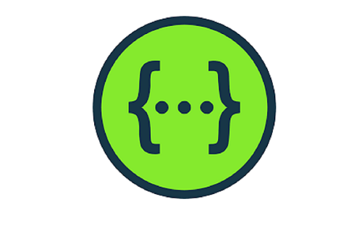

Swagger
It is an open source API documentation framework used for documenting the rest APIs. It provides the HTML view of the API documentation with JSON support and detailed information on the HTTP methods.

Management Service

<!-- https://mvnrepository.com/artifact/org.springdoc/springdoc-openapi-starter-webmvc-ui -->
<dependency>
<groupId>org.springdoc</groupId>
<artifactId>springdoc-openapi-starter-webmvc-ui</artifactId>
<version>2.8.5</version>
</dependency>

Application property
springdoc.api-docs.enabled=true
springdoc.api-docs.path=/v3/api-docs
springdoc.swagger-ui.path=/swagger-ui.html

• Swagger UI: 👉 http://localhost:8002/swagger-ui.html
• OpenAPI JSON: 👉 http://localhost:8002/v3/api-docs

http://localhost:8002/swagger-ui/index.html
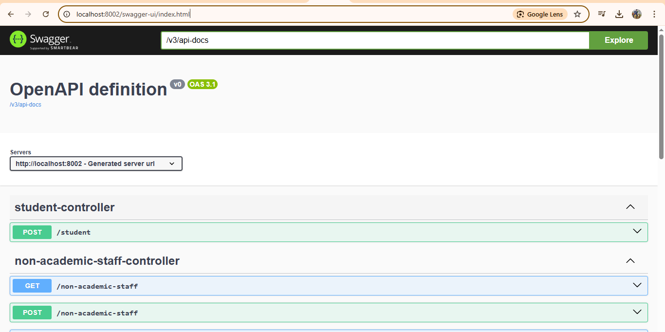

http://localhost:8002/v3/api-docs
