**CASE STUDY-01 ER Diagram**

**NAME: CHAITY RANI MONDOL**

**ID: 22-48731-3**

* **LIST OF ENTITY SET :**
* Member
* Book
* Category
* Author
* **LIST OF RELATIONSHIPS:**
* Rent
* Reserve
* Writes
* Belongs
* **ATTRIBUTES OF BOOK:**
* Book ID (Primary Key)
* Book Name
* Edition
* ISBN
* **ATTRIBUTES OF MEMBER:**
* Member Number (Primary Key)
* Member Name
* Member Address
* House Number
* Street Name
* City
* **ATTRIBUTES OF AUTHOR:**
* Author Id
* Author Name
* **ATTRIBUTES OF CATEGORY:**
* Name
* Category Number (Primary Key)

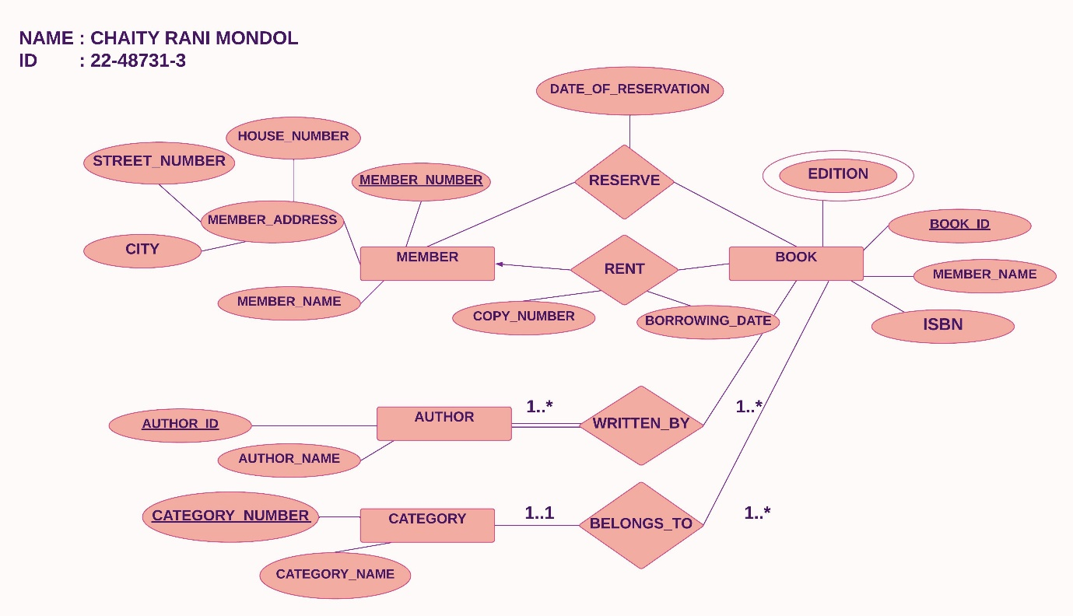**ER DIAGRAM:**