This document contains information proprietary to CTC Global Sdn Bhd (CTC-G) and is provided upon the condition that the information contained herein shall be held in confidence, and the intended recipient shall not disclose to others or utilize the information in whole or in part for purposed other than that intended for under this document without the prior written permission from CTC Global Sdn Bhd.
ICN Maintenance Services at
The Exchange TRX – LQ Retail Sdn Bhd

Preventive Maintenance for Trend Micro Deep Security Report





PM DATE : 20/05/2026
FSMS ID : 02892342
Contract No : ISS/2025/M4170
Contract Period : 01/04/2026 - 31/03/2027

Document Authorization
Author’s Details
Name | Loh Zi Xin
Designation | Associate Technical Engineer
Date | 20th May 2026
Signature | ZiXin
Verified
Name | Fatin Amirah Binti Che A Latif
Designation | Senior Technical Engineer
Date |     20th May 2026
Signature
Reviewed and Acknowledged by LQ Retail Sdn Bhd Representative
Name | :
Designation | :
Date | :
Signature | :
Quick Customer Satisfaction Survey
How satisfied are you with the level of the CTC Preventive Maintenance service?
Rating: (1) | Rating: (2) | Rating: (3) | Rating: (4) | Rating: (5)
- Very Poor | - Poor | - Satisfied | - Very Good | - Excellent

Table of Content

Appliance Information 2
Findings and Recommendation 2
Dashboard and Widgets 3
Alerts 3
Events and Reports 3
License Status 4
Agent Inventory Management 4
Deep Security Server Updates Status 4
Deep Security Manager System Information 4
Deep Security Agent Software Update 4
Deep Security Manager and Database Server Health Check 5
Appendix: 6
1.1 Appendix 1 – Dashboard 6
1.2 Appendix 2 – Alerts 7
1.3 Appendix 3 – Events & Reports 7
1.4 Appendix 4 – License Status 8
1.5 Appendix 5 – Agent Inventory Management 9
1.6 Appendix 6 – Deep Security Server Updates Status 9
1.7 Appendix 7 – Deep Security Manager System Information 10
1.8 Appendix 8 – Deep Security Agent Software Update 11
1.9 Appendix 9 – Deep Security Manager and Database Server Health Check 12
Acknowledgement 14

Appliance Information
Model | Deep Security
Hostname | DSM-GF-MSER-01

Executive Summary

Key Highlight

Based on our comprehensive monitoring and analysis, we are pleased to report that all systems are operating normally and functioning as expected.
- Alerts & Events: No critical or notable alerts were detected during the maintenance period. No malware detections were recorded; therefore, no event logs or log exports were generated.
- License & System Updates: Deep Security licenses are active, and the server components are up to date with the latest security updates.
- Server Health: CPU usage is within normal operating ranges, memory usage is stable and within acceptable limits, and disk usage is optimal, with sufficient available space and no signs of disk-related issues or performance degradation.

Recommendation
- Deep Security Manager Version
- Current manager version is 20.0.844. Recommended to upgrade to the latest Deep Security Manager software version 20.0.1160 (Released: 22 April 2026) as the current version is old.
- Deep Security 20 Administration Guide:
https://help.deepsecurity.trendmicro.com/20_0/onpremise/Deep_Security_20_Administration_Guide.pdf
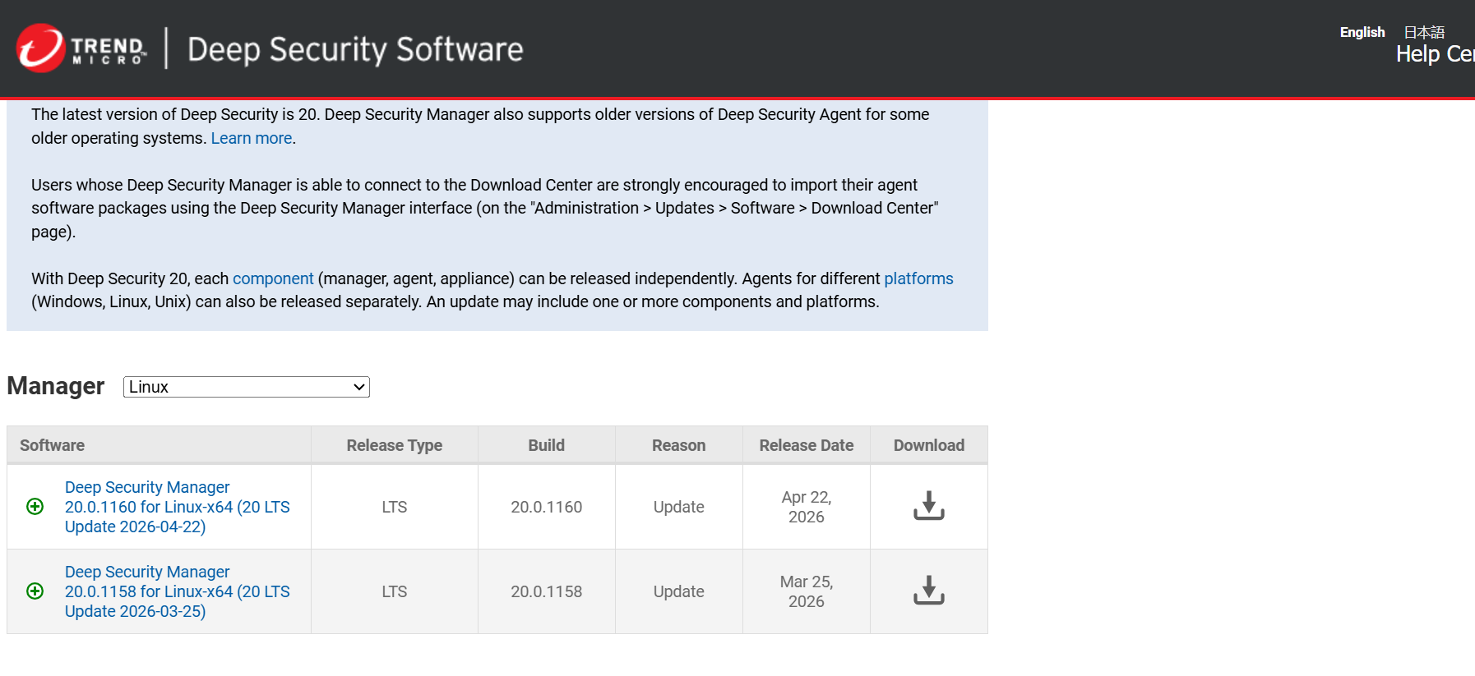

- Deep Security Agent Version
- Curren agent version is 20.0.0.8137. Recommended to upgrade to the latest Deep Security Agent version 20.0.3.8610 (Released: 15 April 2026) once Deep Security Manager has been upgraded.
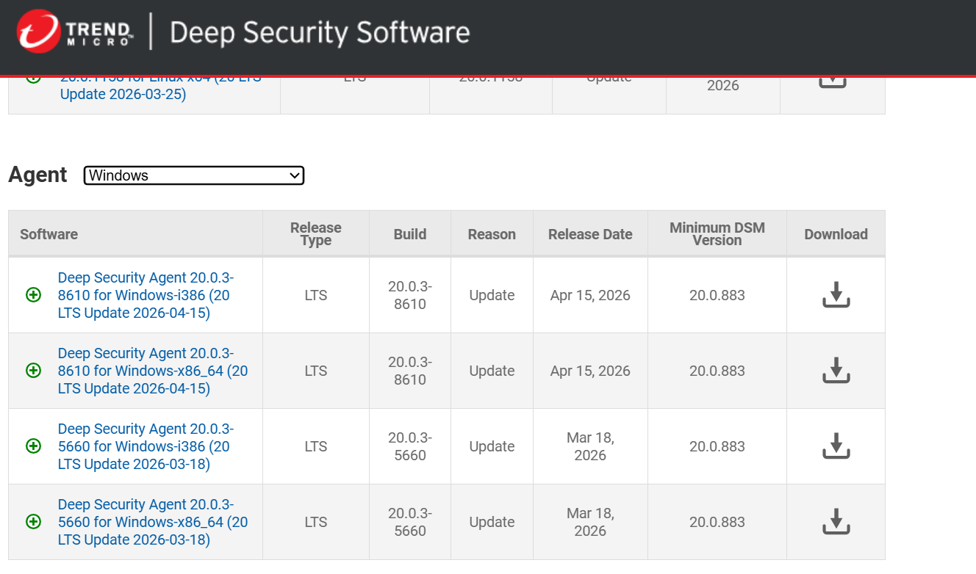

Item | Task | Description
1 | Version | Version/build: 20.0.844

# | Task | EXPECTED INPUT | EXPECTED OUTPUT | RESULT | REMARKS
1 | Dashboard and Widgets
 | Verify that the dashboard is working | Login to the Deep Security web console | The Deep Security web console content should appear starting with the Dashboard and its Widgets | Yes  No | Dashboard and widgets load successfully  Refer to Appendix 1
 | Verify that the widgets are working | Refresh any widget on the dashboard page | Individual widgets should the relevant contents based on the information from Deep Security | Yes  No | Able to refresh widgets
 | Verify that new widgets can be added | Click "Add Widgets" on the upper right portion of the dashboard  Check a widget and click Add | The new selected Widgets should appear on the dashboard currently being displayed | Yes  No | Able to add/remove widgets
2 | Alerts
 | Check for notable alerts | Go to Alert tab and check for any notable alerts | Check for any notable alerts, and provide feedback and best practice. | Yes  No | Refer to Appendix 2
3 | Events and Reports
 | Verify Logging functionality | Go to Event & Reports > Anti-Malware Event > Select Computer and time period > click Display Logs | Selected logs should show up on a window as per criteria selected by admin | Yes  No | No detection  Thus, no log generated  Refer to Appendix 3
 | Verify Log Export capability | Perform above steps to View Logs and click Export All to CSV  Select the directory and filename, then save the export | Selected logs as per criteria selected by admin should be exported to a csv file on the directory selected during export | Yes  No | No detection.  Thus, no log generated
4 | License Status
 | Verify that Deep Security license is active and updated | Go to Administration > License in Deep Security web console | Deep Security License Status for each relevant module should show as "Activated" | Yes  No | Refer to Appendix 4
5 | Agent Inventory Management
 | Verify that the Agent Inventory is properly populated | Go to Computers > All Computers in Deep Security web console and click on domain group in the computer hierarchy | Computers with Deep Security Agent installed should appear in the right pane of the Agent Management page | Yes  No | Refer to Appendix 5
6 | Deep Security Server Updates Status
 | Verify that Server Components are up to date | Go to Administration > Updates > Security  Summary in Deep Security web console will show the last updates | The page should show the last Update time and the current versions that are loaded on the Deep Security server | Yes  No | Refer to Appendix 6
7 | Deep Security Manager System Information
 | Verify connectivity between Deep Security Manager Nodes and Database | Go to Administration > System Information in Deep Security web console and make sure that Deep Security Manager Nodes connect with Database | The page should show the Deep Security Manager Nodes connect with the Database. | Yes  No | Refer to Appendix 7
8 | Deep Security Agent Software Update
 | Verify that latest Deep Security Agent application | Go to Administrator > Software. Summary pages will show the last check update time and prompt alert for latest agent software release | The page should show the last check update time and latest agent software version if have new release. | Yes  No | Refer to Appendix 8

9 | Deep Security Manager and Database Server Health Check
 | Verify that Server are running in good health state. | Login to Deep Security Manager Server and Deep Security Database Server. Check the Hard Disk Available Space and Server Performance | Deep Security Manager Server and Deep Security Database Server need have 30% available Hard Disk Space from total Hard Disk Space.  Server Performance will be in healthy state. | Yes  No | Refer Appendix 9

Appendix:

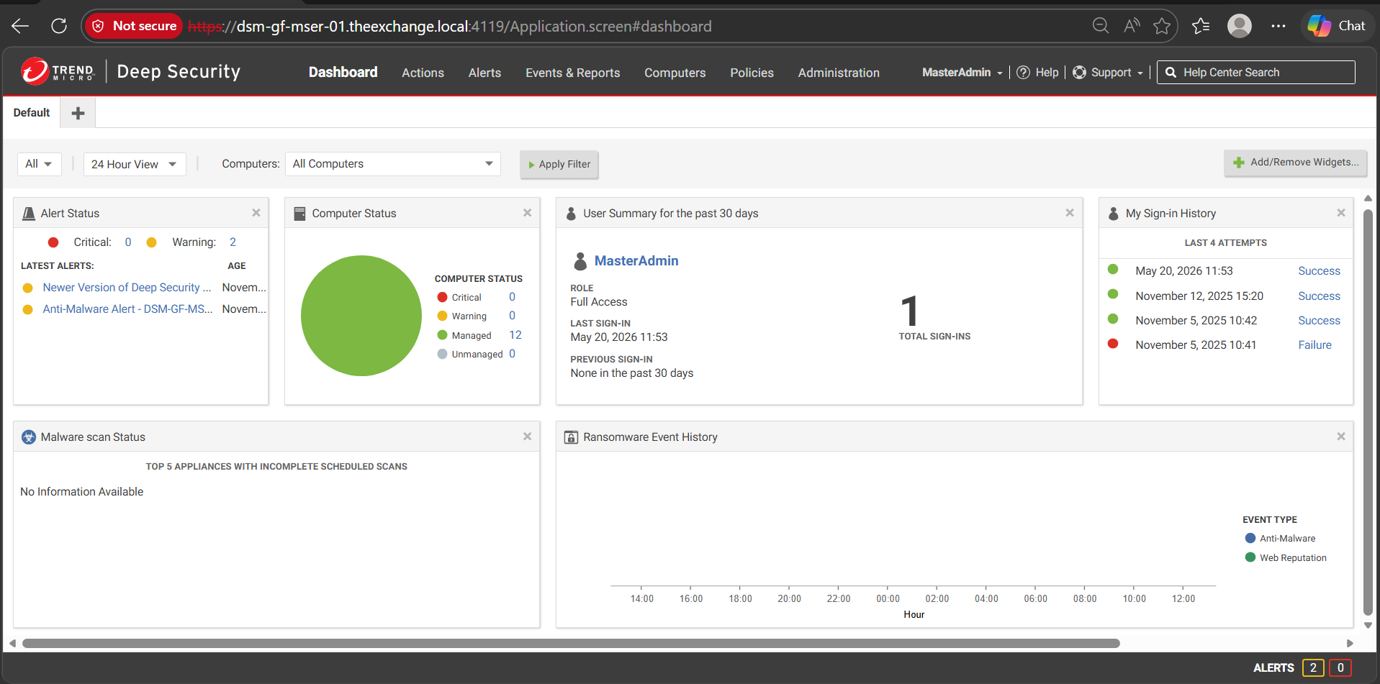

Appendix 1 – Dashboard
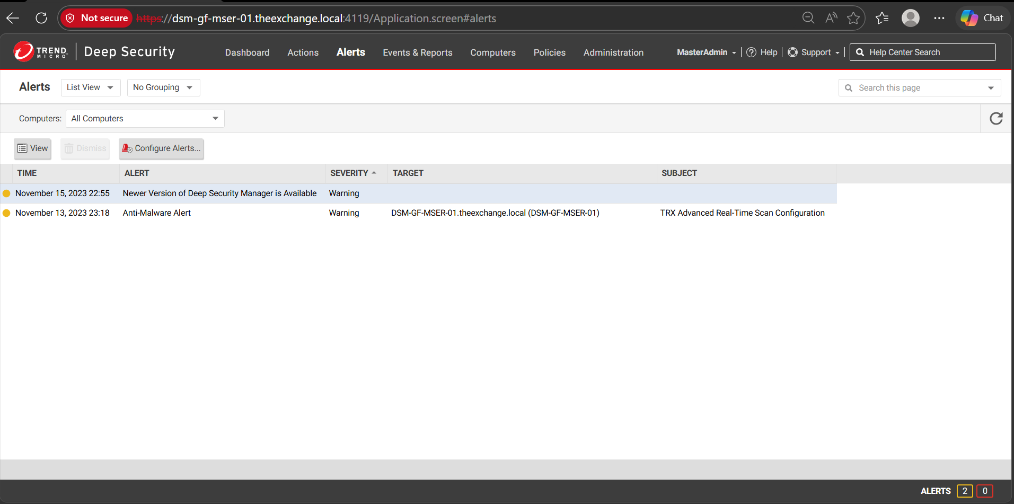

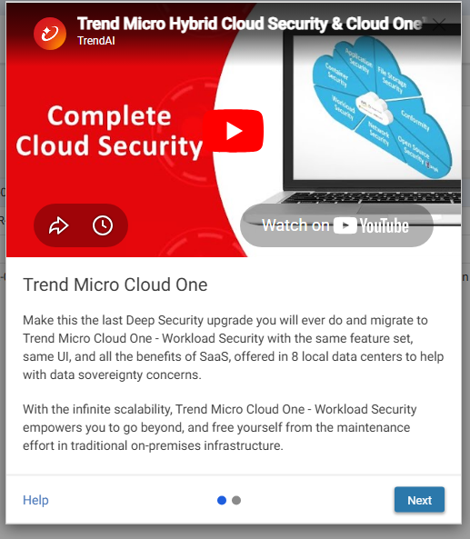
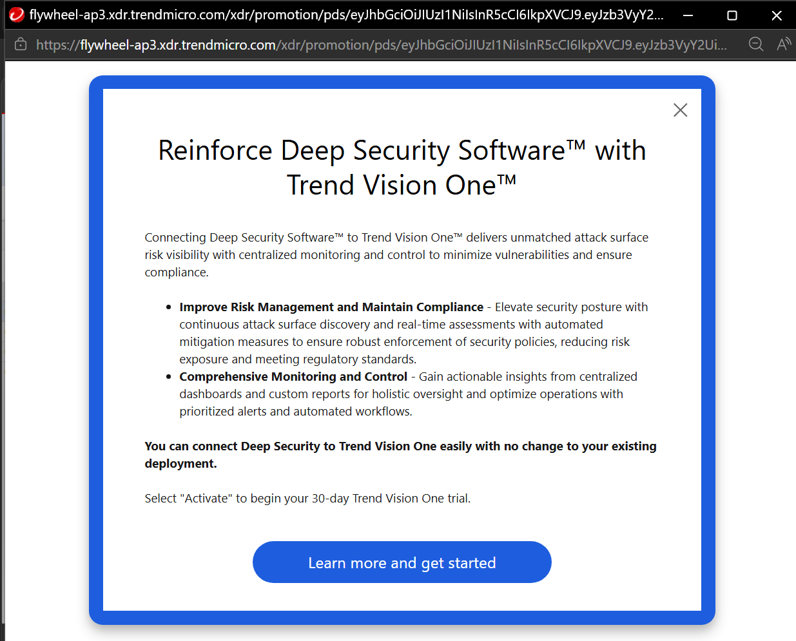

Appendix 2 – Alerts
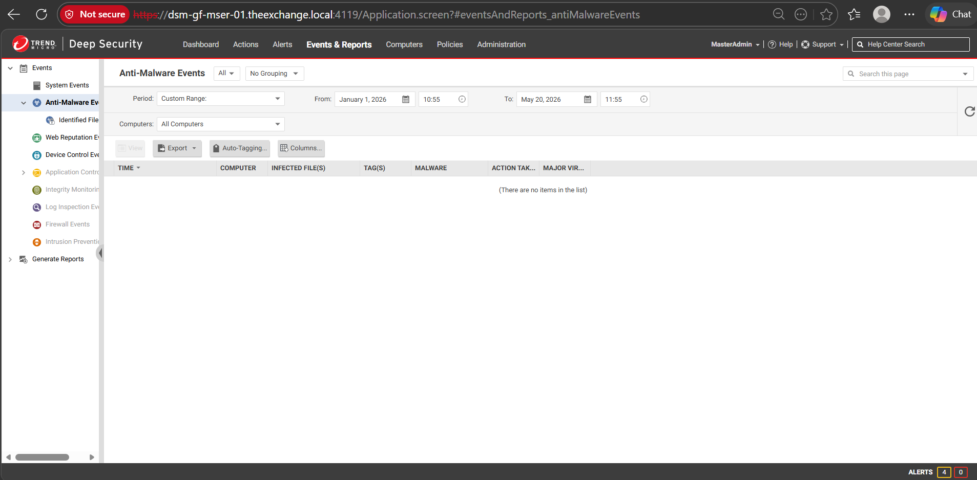

Appendix 3 – Events & Reports

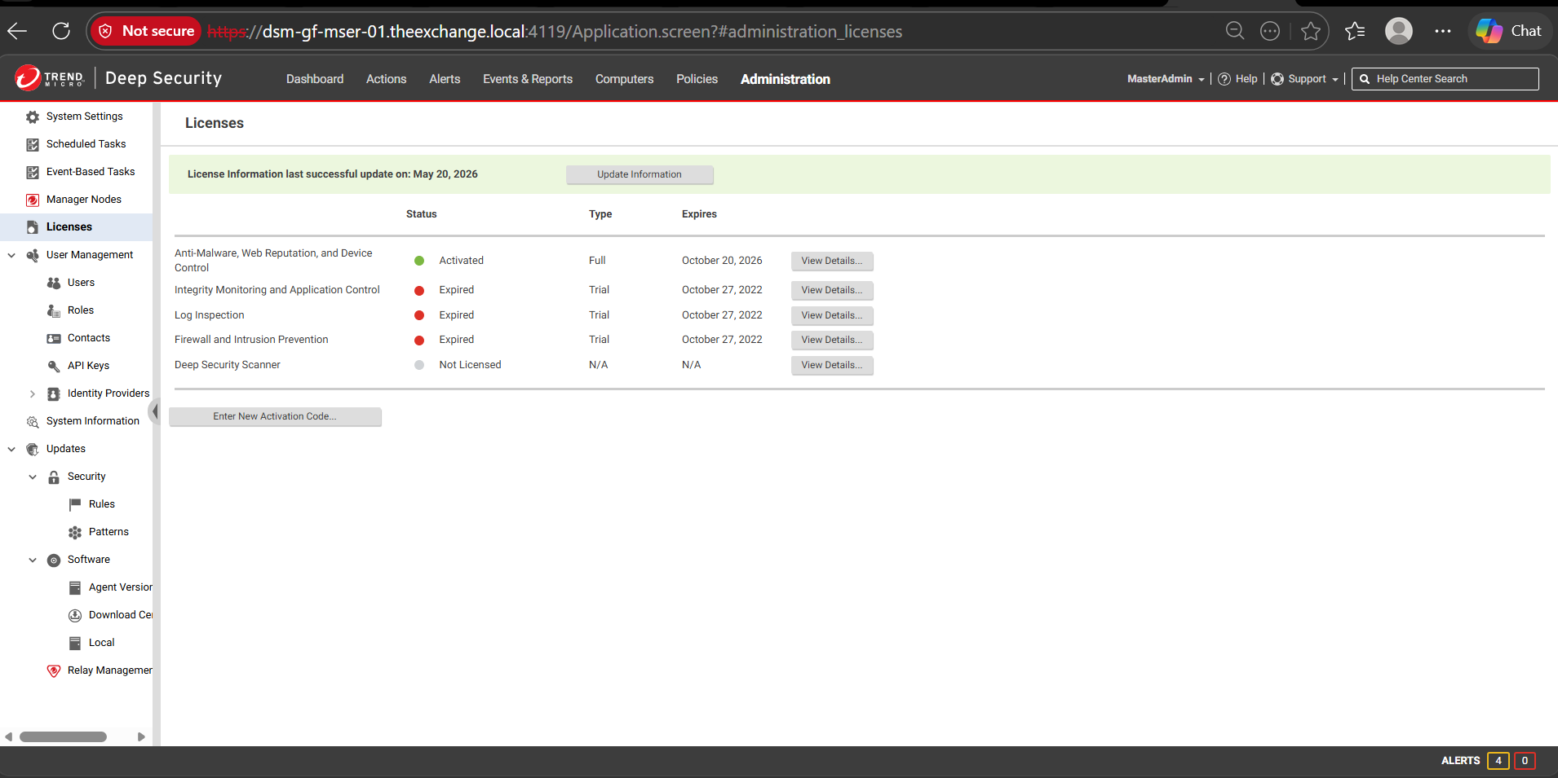
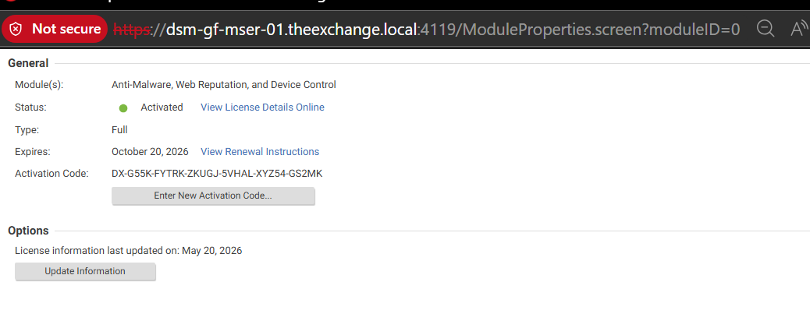

Appendix 4 – License Status

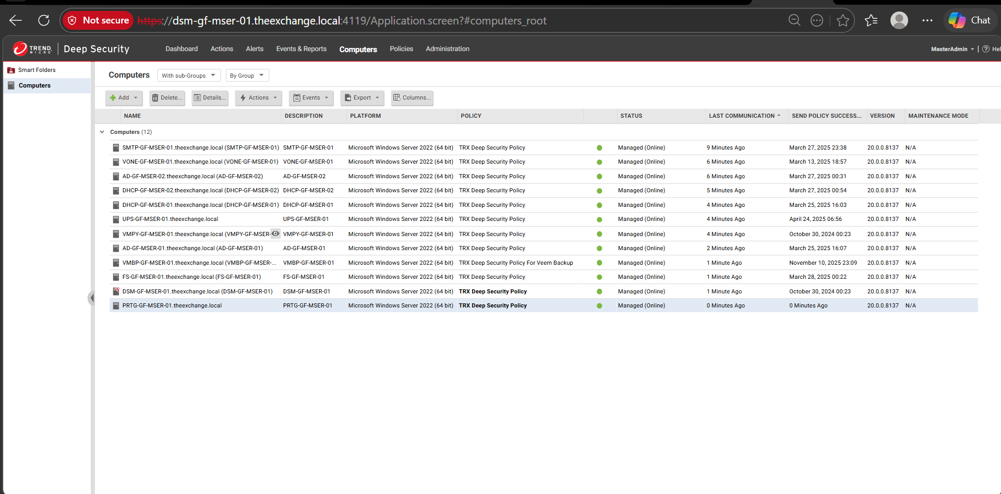

Appendix 5 – Agent Inventory Management
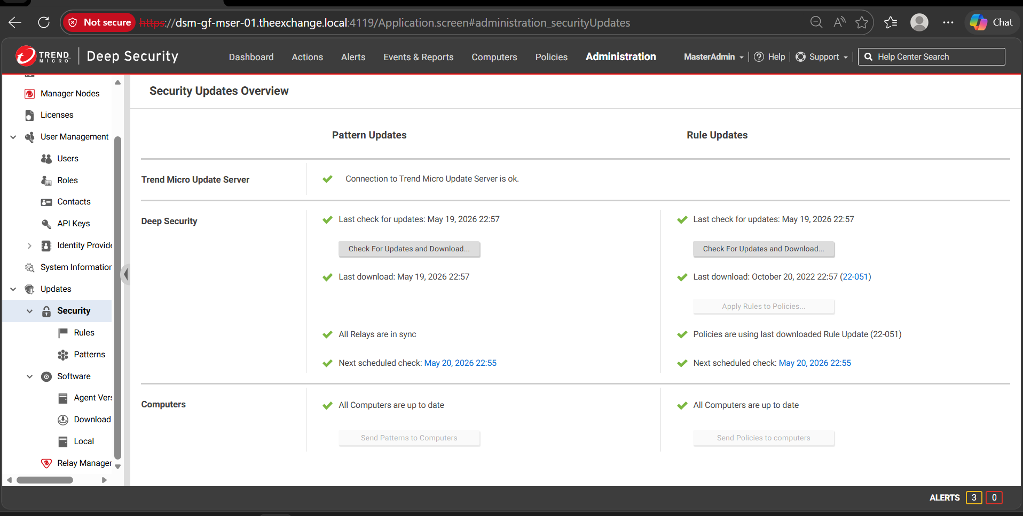

Appendix 6 – Deep Security Server Updates Status

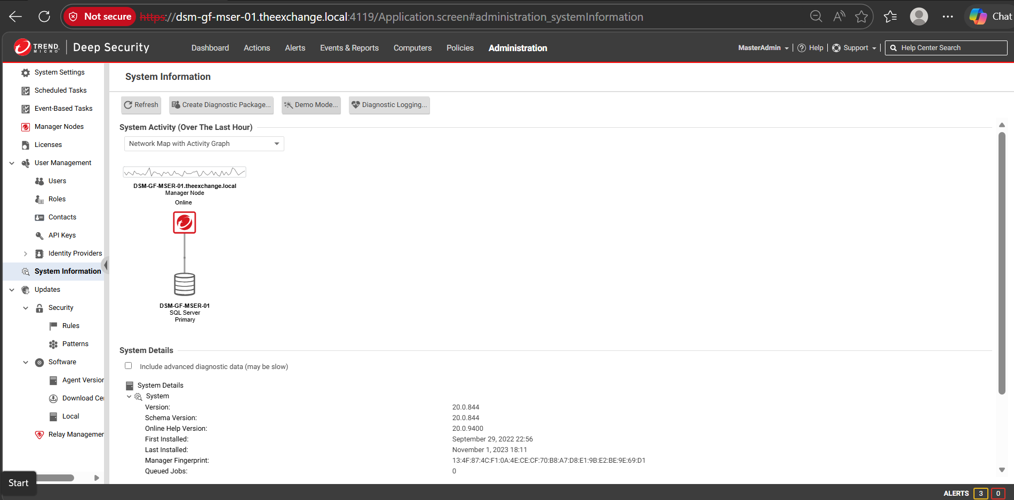
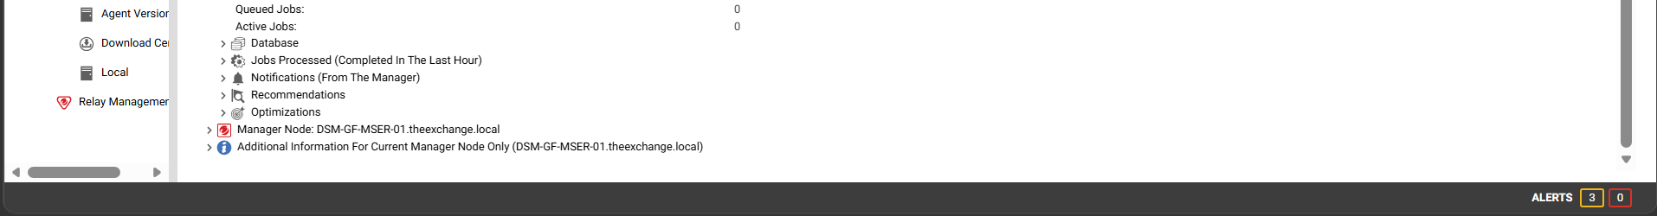

Appendix 7 – Deep Security Manager System Information

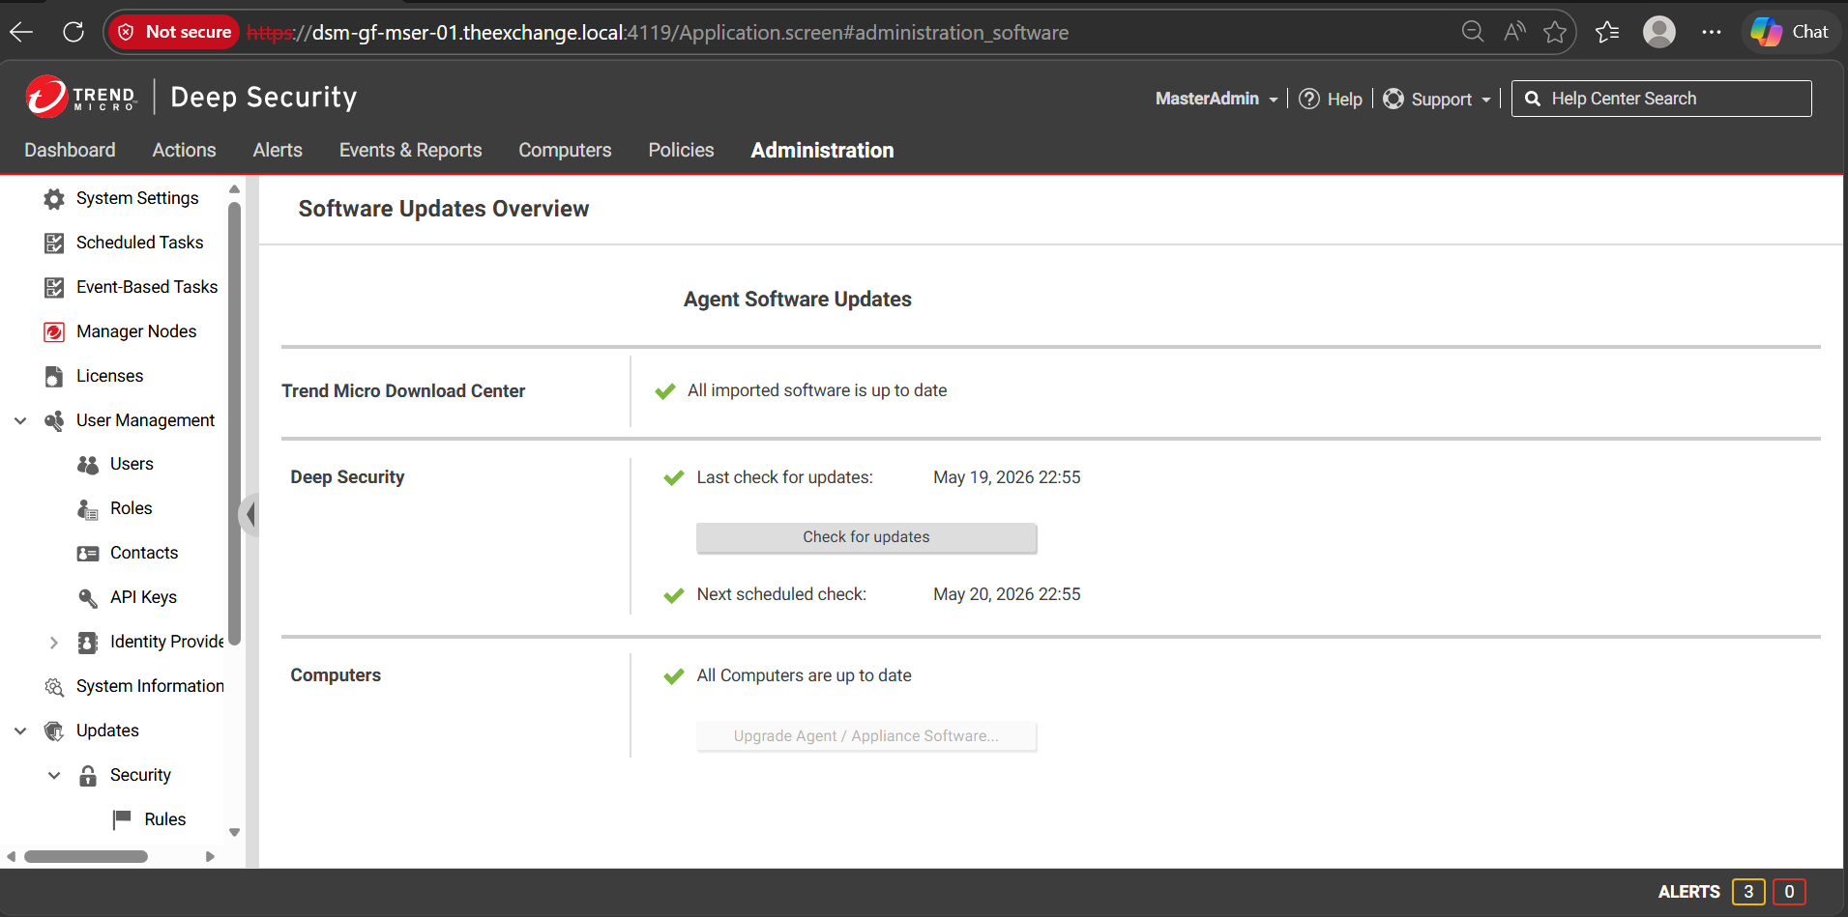

Appendix 8 – Deep Security Agent Software Update
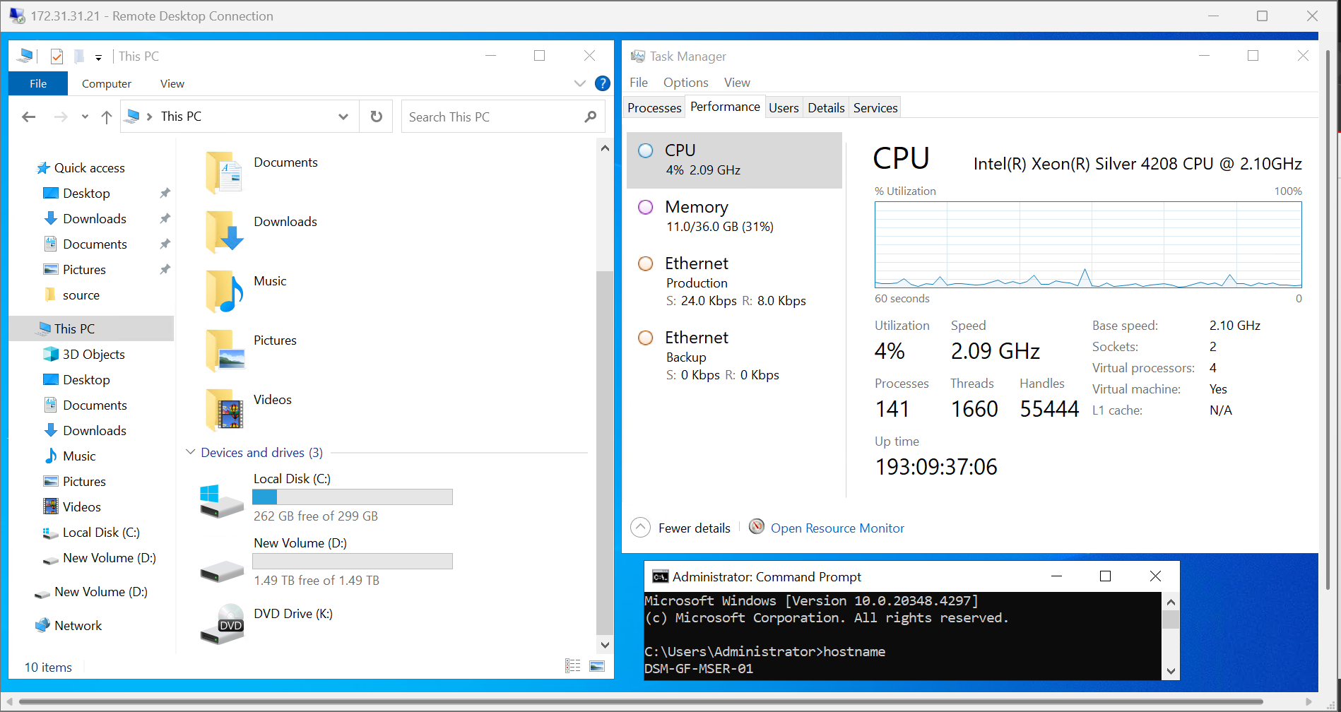
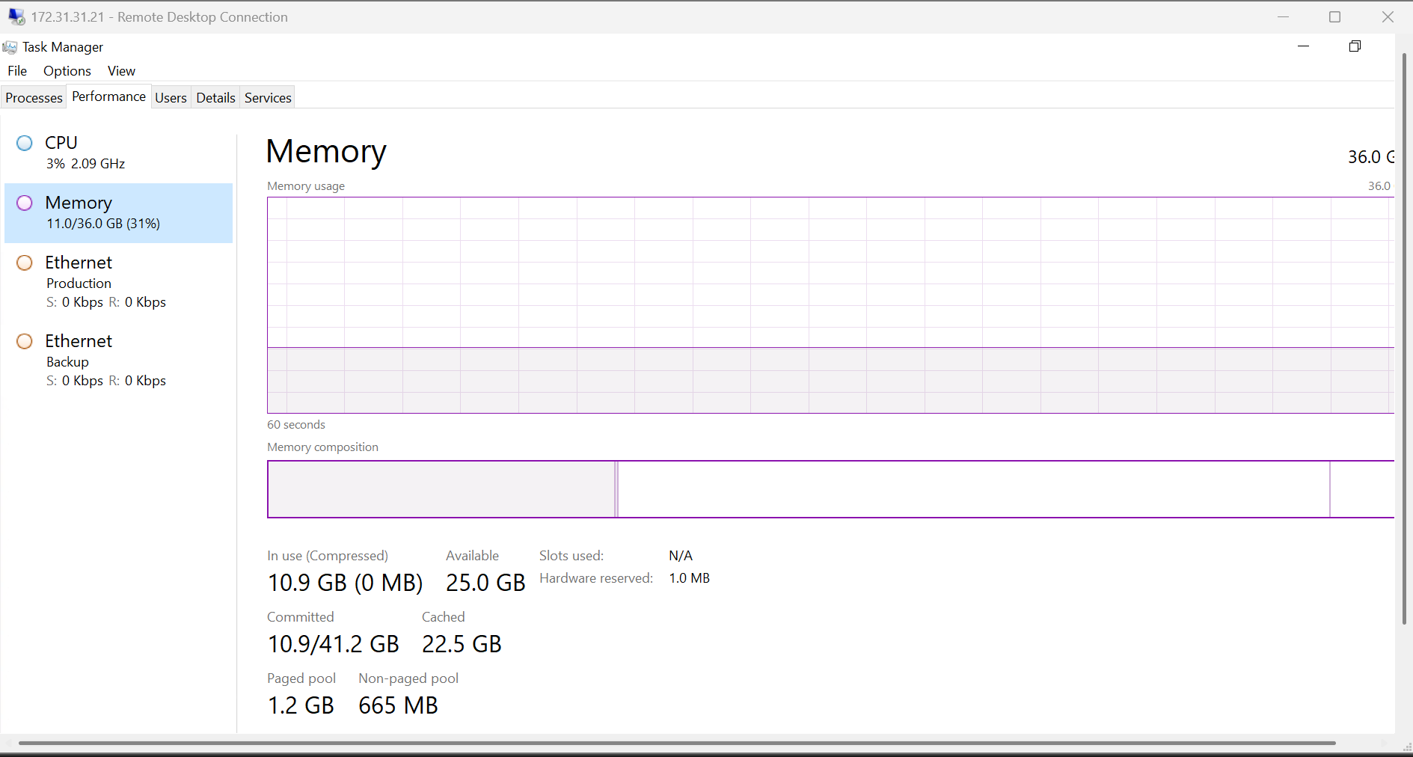
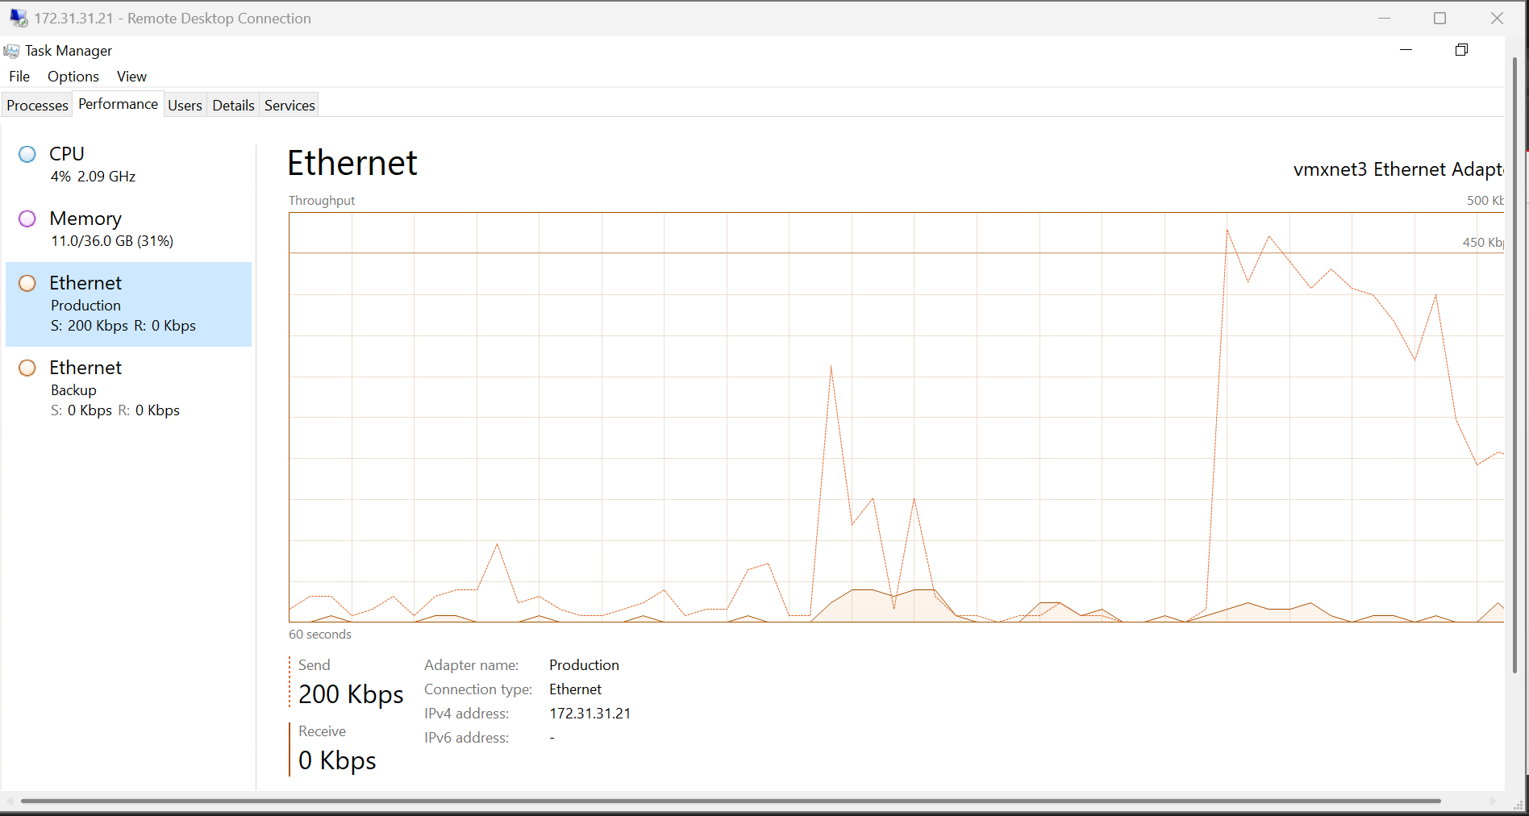

Appendix 9 – Deep Security Manager and Database Server Health Check

Deep Security Manager Version
