2nd Half of 2026 Preventive Maintenance Report for FortiGate Firewall
This document contains information proprietary to CTC Global Sdn Bhd (CTC-G) and is provided upon the condition that the information contained herein shall be held in confidence, and the intended recipient shall not disclose to others or utilize the information in whole or in part for purposed other than that intended for under this document without the prior written permission from CTC Global Sdn Bhd.
Aeon Credit Services (M) BErhad





PM DATE: 09/09/2026
FSMS ID: 02936855
CONTRACT NO: ISS/2021/X2242
CONTRACT PERIOD: 27/12/2021 - 26/12/2026

Document Authorization
Author’s Details
Name | : | Cha Zi Yu
Designation | : | Associate Technical Engineer
Date | : | 09/09/2026
Signature | : | 
Verified by
Name | :
Designation | :
Date | :
Signature | :
Reviewed and acknowledged by Aeon Credit Services (M) Berhad Representative
Name | :
Staff ID | :
Designation | :
Date | :
Signature | :
Quick Customer Satisfaction Survey
How satisfied are you with the level of the CTC Preventive Maintenance service?
Rating: (1) | Rating: (2) | Rating: (3) | Rating: (4) | Rating: (5)
☐ Very Poor | ☐ Poor | ☐ Satisfied | ☐ Very Good | ☐ Excellent

Table of Content
A. Application Information 4
B. Executive Summary 4
Key Highlight 4
Recommendation 4
1. Hardware Status 5
2. Product Licensing 5
3. Fortinet Product Life Cycle Information 6
4. Virtual Private Network (VPN) 6
5. Routing Table 7
6. Configuration 7
7. Appendix (Screen Capture) 8
Appendix 1 - CPU Usage 8
Appendix 2 – Memory Usage 8
Appendix 3 – Interface 9
Appendix 4 – License Info 10
Appendix 5 – Firmware Version 10
Appendix 6 – VPN Tunnels 10
Appendix 7 – Static Routes & Routing Table 11
Appendix 8 – Firewall System Uptime 12
Appendix 9 – Accessed via GUI 12
Appendix 10 – Accessed via CLI/SSH 13
Appendix 11 – Signatures Version 14
Appendix 12 – Firewall Date & Time 15
Appendix 13 – HA Status 15
Appendix 14 - System Event 16
Appendix 15 – Log Manager Setting 16
Appendix 16 – Backup Configuration 17

Application Information
Model | FortiGate 200F
Hostname | HQ_T2_FG200F_Primary
Serial Number | FG200FT921916632 (Primary), FG200FT921914957 (Secondary)

Executive Summary

Key Highlight
Item | Task | Description | Status | Remarks
3.1 | Firewall Firmware Version | Check the Firewall firmware version | ☐ Up-to-Date  ☒ Out-of-Date | Current Firmware Version: v7.4.11 build2878 (Mature)  Latest Firmware Version: v7.4.12  Refer Appendix 5

Recommendation
Recommend to upgrade FortiOS to the stable preferred version 7.4.12.
- Release Note: https://docs.fortinet.com/document/fortigate/7.4.12/fortios-release-notes

Hardware Status
Item | Task | Description | Status | Remarks
1.1 | Hard disk space (If any) | Hard disk space should not be more than 80%. | ☐ Healthy  ☐ Unhealthy  ☒ N/A | Device does not have hard disk.
1.2 | CPU Usage | CPU should within average below 80% for the past 1 hour. | ☒ Healthy  ☐ Unhealthy  ☐ N/A | CPU usage: 0%  Refer Appendix 1
1.3 | Memory Usage | Memory should keep below 80% for the past 1 hour. | ☒ Healthy  ☐ Unhealthy  ☐ N/A | Memory usage: 33%  Refer Appendix 2
1.4 | Interface Monitoring | Physical Connection to be cross check with the Firewall interface. | ☒ Healthy  ☐ Unhealthy  ☐ N/A | Ports in-used: 10  Refer Appendix 3

Product Licensing
Item | Task | Description | Status | Remarks
2.1 | FortiCare Support | Check the License Validity | ☒ Valid  ☐ Expired  ☐ N/A | FortiCare Support license is valid. FortiGuard server connectivity was unavailable during the assessment.  Expiration Date: 28/12/2026  Refer Appendix 4
2.2 | UTM Bundle Update:  - Antivirus  - IPS  - Web Filtering  - Anti-Spam  - Etc. | Check AV, IPS, Web Filtering, Anti-Spam and etc license features validity. | ☒ Valid  ☐ Expired  ☐ N/A | ☒ Antivirus: Valid ☒ | Expired ☐ | NA ☐  ☒ IPS: Valid ☒ | Expired ☐ | NA ☐  ☒ Web Filtering: Valid ☒ | Expired ☐ | NA ☐  ☐Anti-Spam: Valid ☐ | Expired ☐ | NA ☒  ☒ Others: Valid ☒ | Expired ☐ | NA ☐

Fortinet Product Life Cycle Information
Item | Task | Description | Status | Remarks
3.1 | Firewall Firmware Version | Check the Firewall firmware version | ☐ Up-to-Date  ☒ Out-of-Date | Current Firmware Version: v7.4.11 build2878 (Mature)  Latest Firmware Version: v7.4.12  Refer Appendix 5
3.2 | Final Firmware Release (FFR) | The last release of firmware operationally supported on a specific hardware product. FFR firmware is in a must-fix support phase until the EOS date of the applicable hardware product.  https://support.fortinet.com/Information/ProductLifeCycle.aspx | ☐ Valid  ☐ Expired  ☒ N/A | The Final Firmware Release (FFR) for FortiGate-200F has not yet been designated by Fortinet.  Release Note
3.3 | End of Support Date (EOS) | The final milestone in the product lifecycle is the End of Support date. After this date, which Fortinet, will not sell, manufacture, or improve the product and is under no obligation to provide support services. In general, the EOS for hardware takes place 60 months after the End of Order Date.  https://endoflife.date/fortios | ☒ Valid  ☐ Expired  ☐ N/A | The EOS for model 200F 03 January 2031.

Virtual Private Network (VPN)
Item | Task | Description | Status | Remarks
4.1 | Check Number Of tunnel | To check total number of VPN Tunnel(s). Along with the number of active and inactive VPN tunnel(s). | Total VPN Tunnel(s): 0  Active VPN Tunnel(s): 0  Inactive VPN Tunnel(s): 0 | Refer Appendix 6

Routing Table
Item | Task | Description | Status | Remarks
5.1 | Firewall Routing Table | To capture the Routing Table Information. And to ensure the next hop reachable. | Static route and routing monitor information | Refer Appendix 7

Configuration
Item | Task | Description | Status | Remarks
6.1 | Firewall System Uptime | Firewall system uptime | Uptime: 51 day(s) 3 hour(s) 44 min(s) | Refer Appendix 8
6.2 | Accessibility of FortiGate via GUI | Check the accessibility of the firewall via web browser | ☒ Pass  ☐ Failed  ☐ N/A | Refer Appendix 9
6.3 | Accessibility of FortiGate via CLI | Check the accessibility of the firewall via SSH | ☒ Pass  ☐ Failed  ☐ N/A | Refer Appendix 10
6.4 | Signatures version | Check the signatures version | ☒ Up-to-Date  ☐ Out-of-Date | Refer Appendix 11
6.5 | Firewall Date & Time | Date and time should be sync with NTP Server and correct for reviewing logs. Time zone should select or set as GMT +8 or Asia/ Kuala Lumpur | ☒ Pass  ☐ Failed  ☐ N/A | Time zone is set as GMT +8  Refer Appendix 12
6.6 | Firewall Internet Access | Check the internet connection for the Firewall | ☐ Pass  ☐ Failed  ☒ N/A | Device is not connected to internet
6.7 | High Availability (if any) | Check the status of the HA cluster | ☒ Pass  ☐ Failed  ☐ N/A | Refer Appendix 13
6.8 | Logging  (Event Log) | Check the logging for any critical error / warning within the past 3 months. | ☒ Available  ☐ Un-available | Refer Appendix 14
6.9 | Log Manager (if any) | Check the connectivity of the FortiGate to FortiAnalyzer / FortiCloud | ☒ Healthy  ☐ Unhealthy  ☐ N/A | Refer Appendix 15
6.10 | Backup Configurations | Check the backup function for the configuration | ☒ Passed  ☐ Failed | Refer Appendix 16

Appendix (Screen Capture)
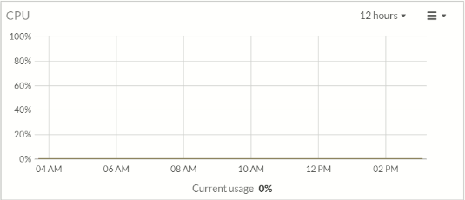

Appendix 1-CPU Usage
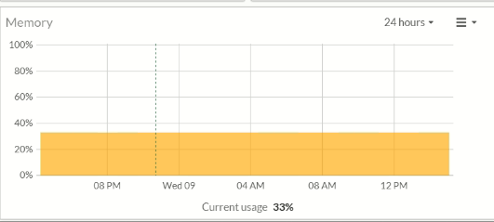

Appendix 2 – Memory Usage

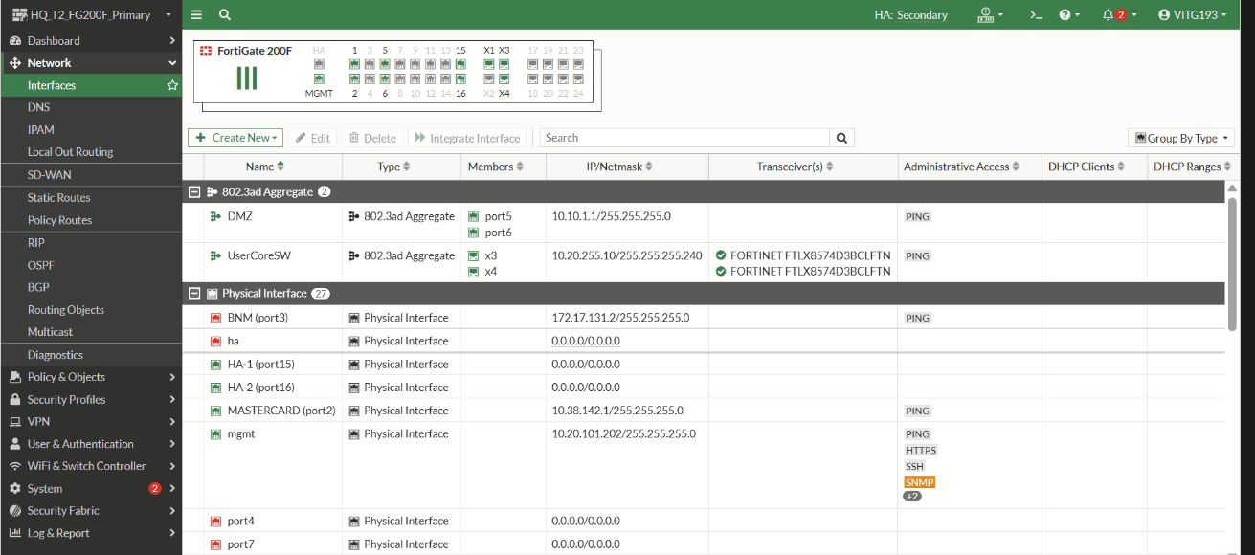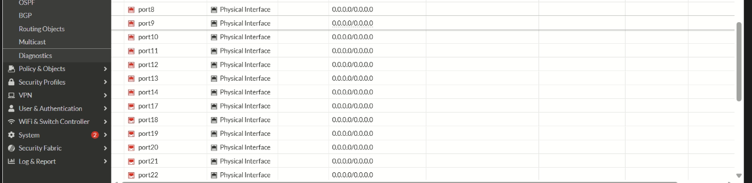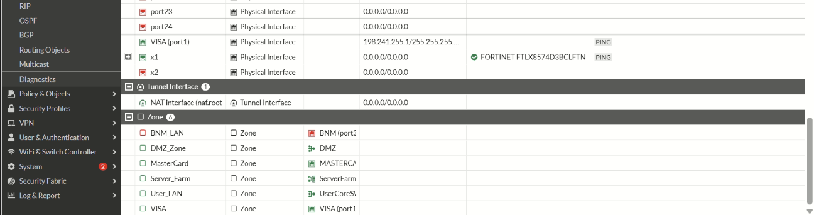
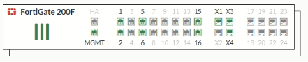

Appendix 3 – Interface

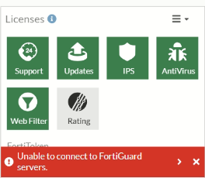

Appendix 4 – License Info
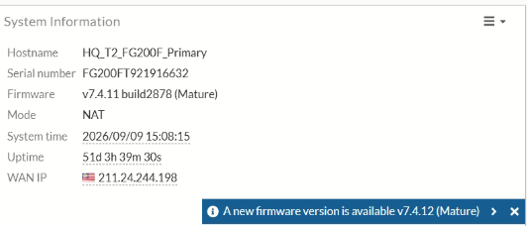

Appendix 5 – Firmware Version
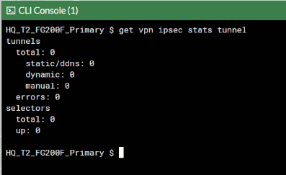

Appendix 6 – VPN Tunnels

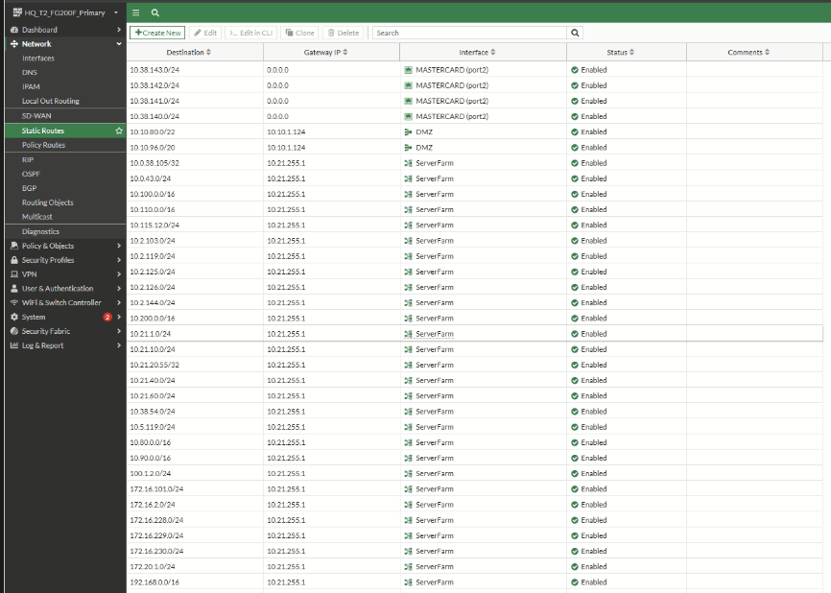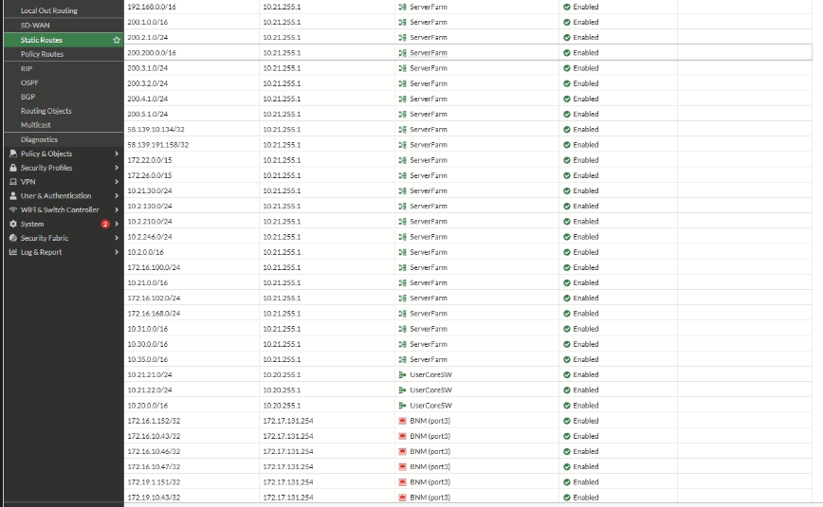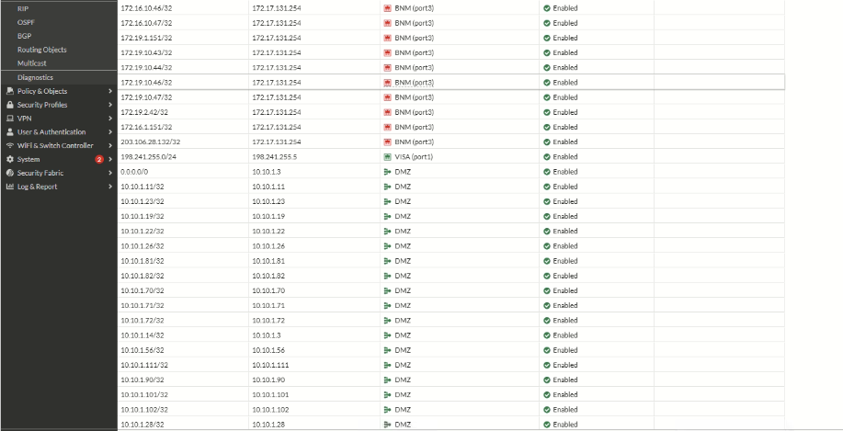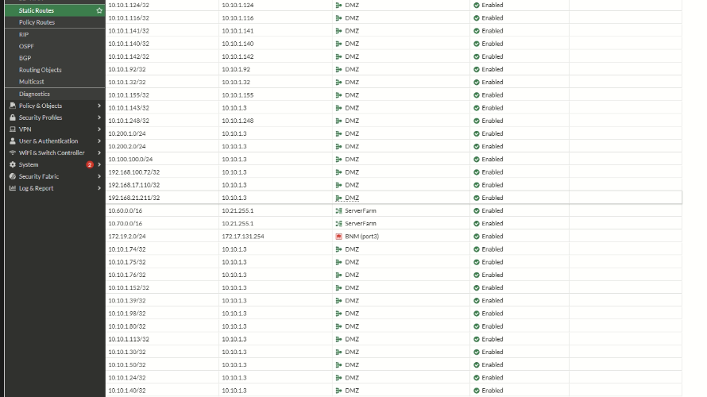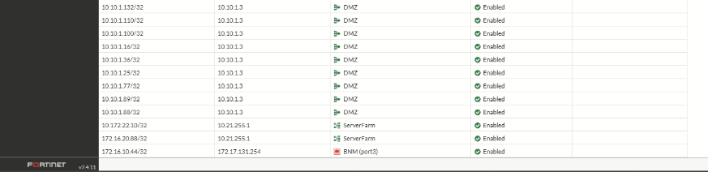

Appendix 7 – Static Routes & Routing Table

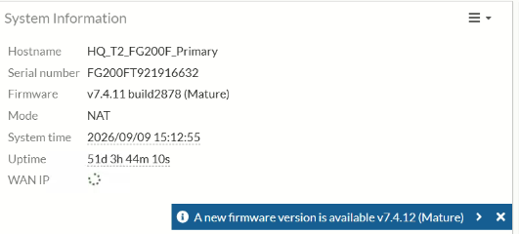

Appendix 8 – Firewall System Uptime

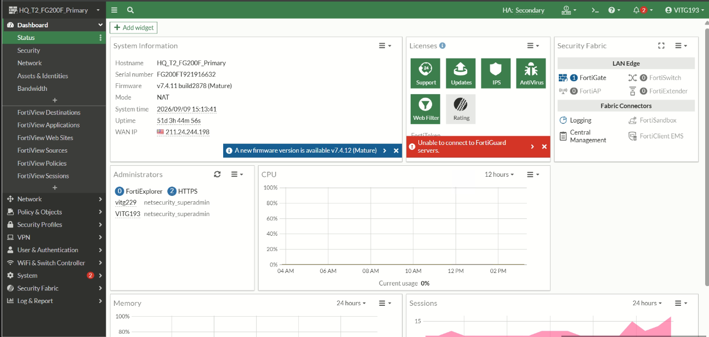

Appendix 9 – Accessed via GUI

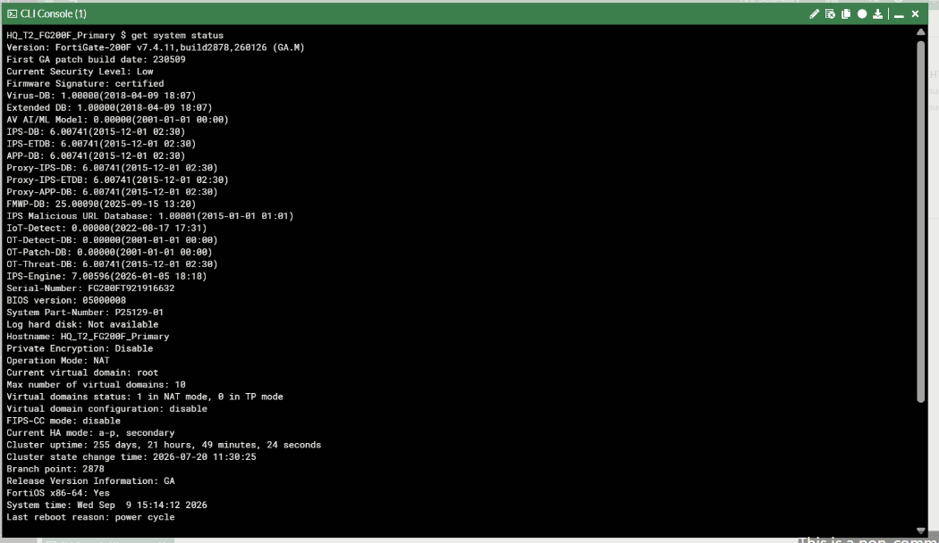

Appendix 10 – Accessed via CLI/SSH

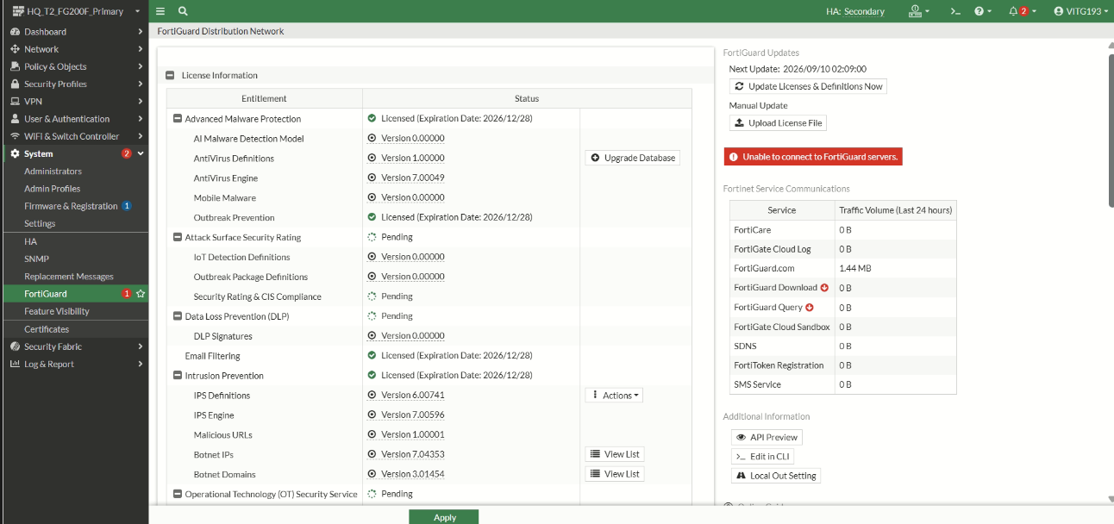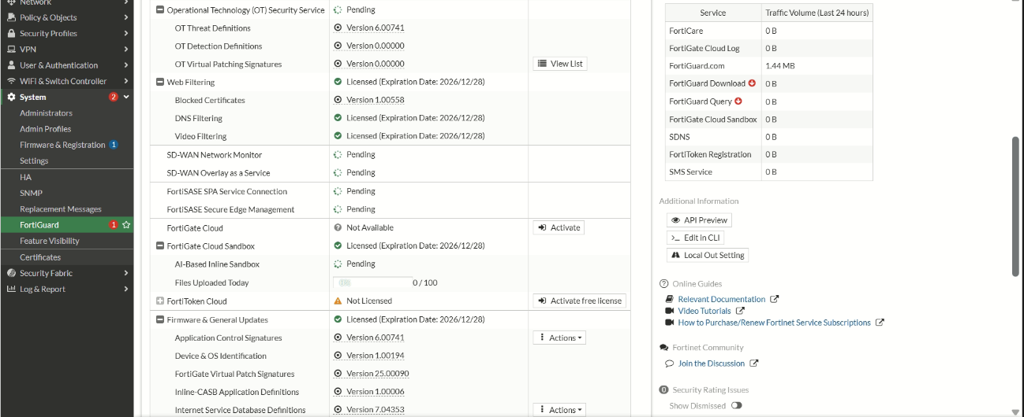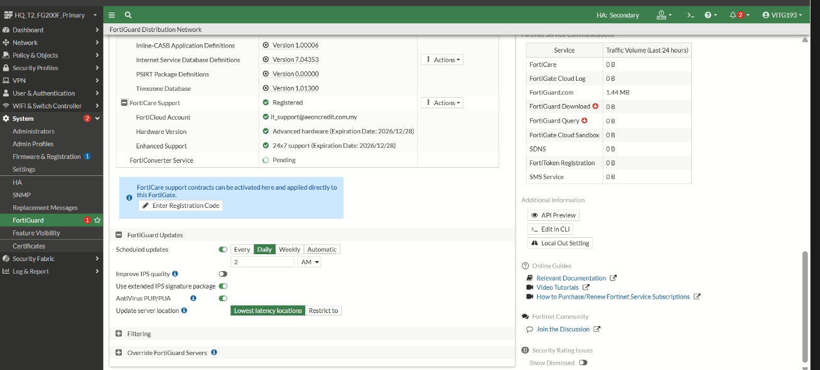

Appendix 11 – Signatures Version

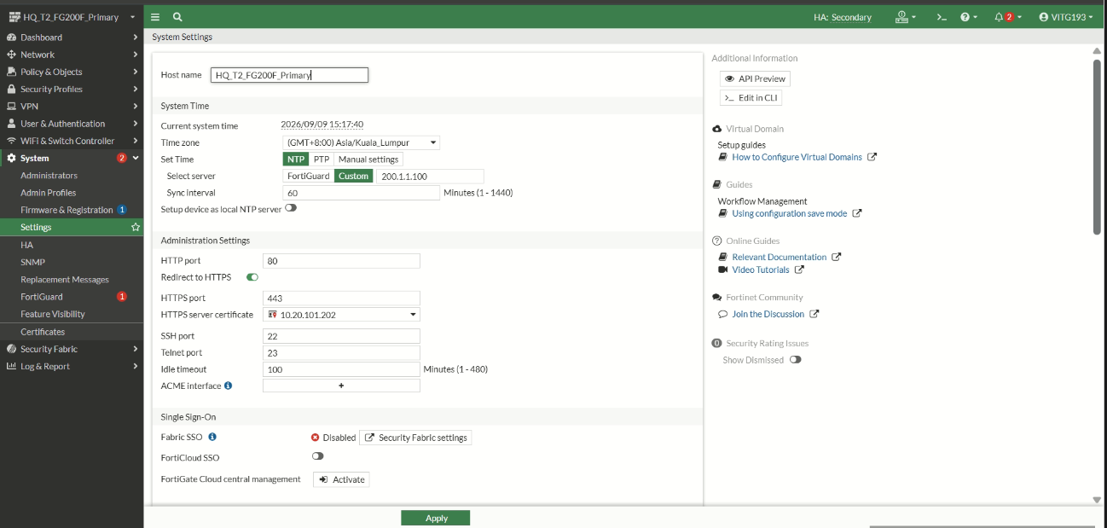

Appendix 12 – Firewall Date & Time

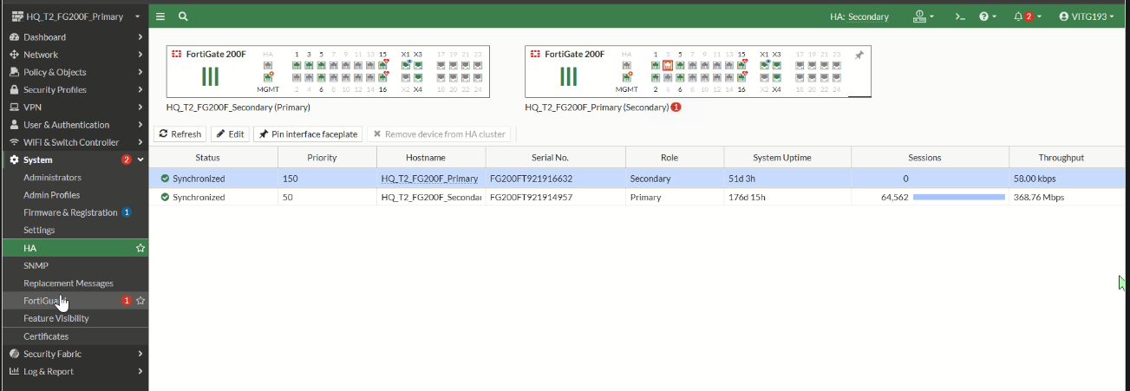

Appendix 13 – HA Status

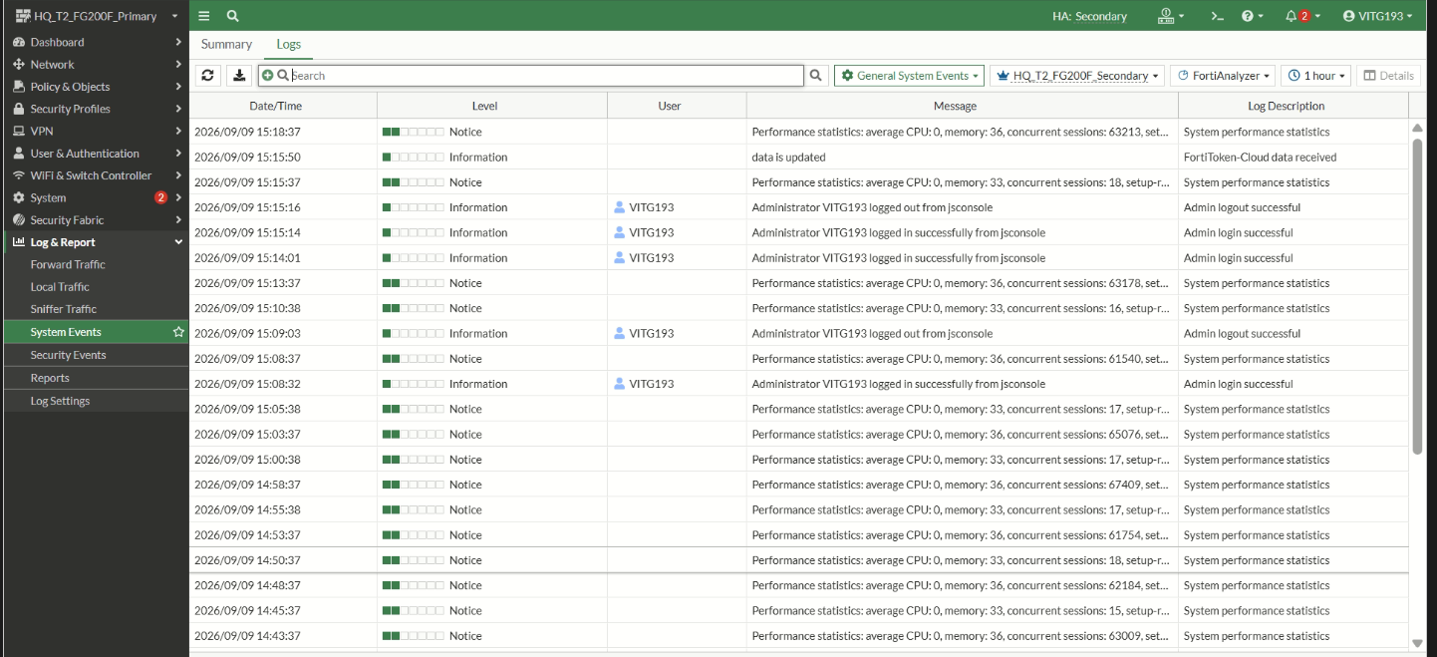

Appendix 14 - System Event
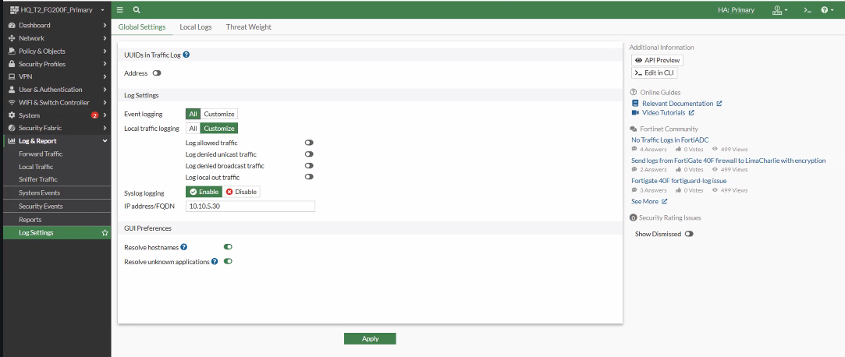

Appendix 15 – Log Manager Setting
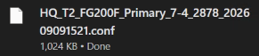

Appendix 16 – Backup Configuration

