**Examiner**

The goal of the project is to provide easy and convenient way for teacher/lecturer to test their students and for student to pass their tests. System allows to create and update tests, unite students to groups, estimate student work and pass tests.

**Roles:** Guest, Student, Teacher, Admin

|  |  |
| --- | --- |
| Role | Description |
| Guest | User that isn’t logged in. Can sign up and log in. |
| Student | Pass tests, joins to group, see group results, appeals question/result, get reminder about near test. Also can get info about his/her account, change password or delete his/her account. |
| Teacher | Create/update/delete tests, create group of students or using existed, get detailed results of passed test, accepts or rejects appeals. Also can get info about his/her account, change password or delete his/her account. |
| Admin | Can view info about users. Has ability to lock/unlock users with option to notify them via email. |

**Account Management System**

|  |  |  |  |  |
| --- | --- | --- | --- | --- |
| **№** | Role | Use case | Description | Action name |
| **1** | Guest | Sign up | Sign up in system | SignUp |
| **2** | User | Log in | Log in to the system | LogIn |
| **3** | Log out | Log out from the system | LogOut |

**User Management System**

|  |  |  |  |  |
| --- | --- | --- | --- | --- |
| **№** | Role | Use case | Description | Action name |
| **1** | Teacher | Create group | Unite students to group seen only by herself/himself | CreateGroup |
| **2** | Admin | Lock user | Make user temporary unavailable to login | Ban |
| **3** | Unlock user | Restore user availability to login | UnBan |
| **4** | View statistics about users accounts | View all the details about users accounts | ViewUserInfo |

**Test Management System**

|  |  |  |  |  |
| --- | --- | --- | --- | --- |
| **№** | Role | Use case | Description | Action name |
| **1** | Student | Join group | Join to group with code given by teacher | JoinGroup |
| **2** | Pass test | Pass test created by teacher | PassTest |
| **3** | See test result | See result of passing test for each group member | SeeResult |
| **4** | View history | See results of passed test | ViewHistory |
| **5** | Appeals question | Appeals question from test to teacher, describing reason | AppealQuestion |
| **6** | Appeals result | Appeals result of test to teacher, describing reason | AppealTestResult |
| **7** | Teacher | Create test | Create test in system | CreateTest |
| **8** | Update test | Update test in system | UpdateTest |
| **9** | Delete test | Delete test from system | DeleteTest |
| **10** | Get test result | Gets the result of the test passed by the selected group | GetTestResult |
| **11** | Create group | Create group of students by itself or giving joining code | CreateGroup |
| **12** | Accept appeal | Accept appeal of student | AcceptAppeal |
| **13** | Reject appeal | Reject appeal of student | RejectAppeal |

**Use case diagrams**

Guest role use case diagram:

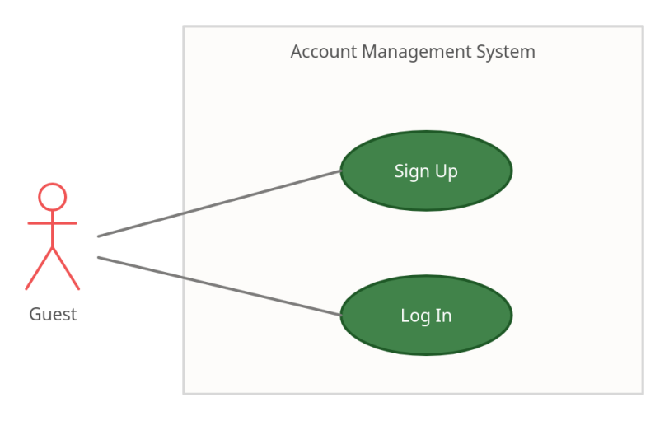

Student role use case diagram:

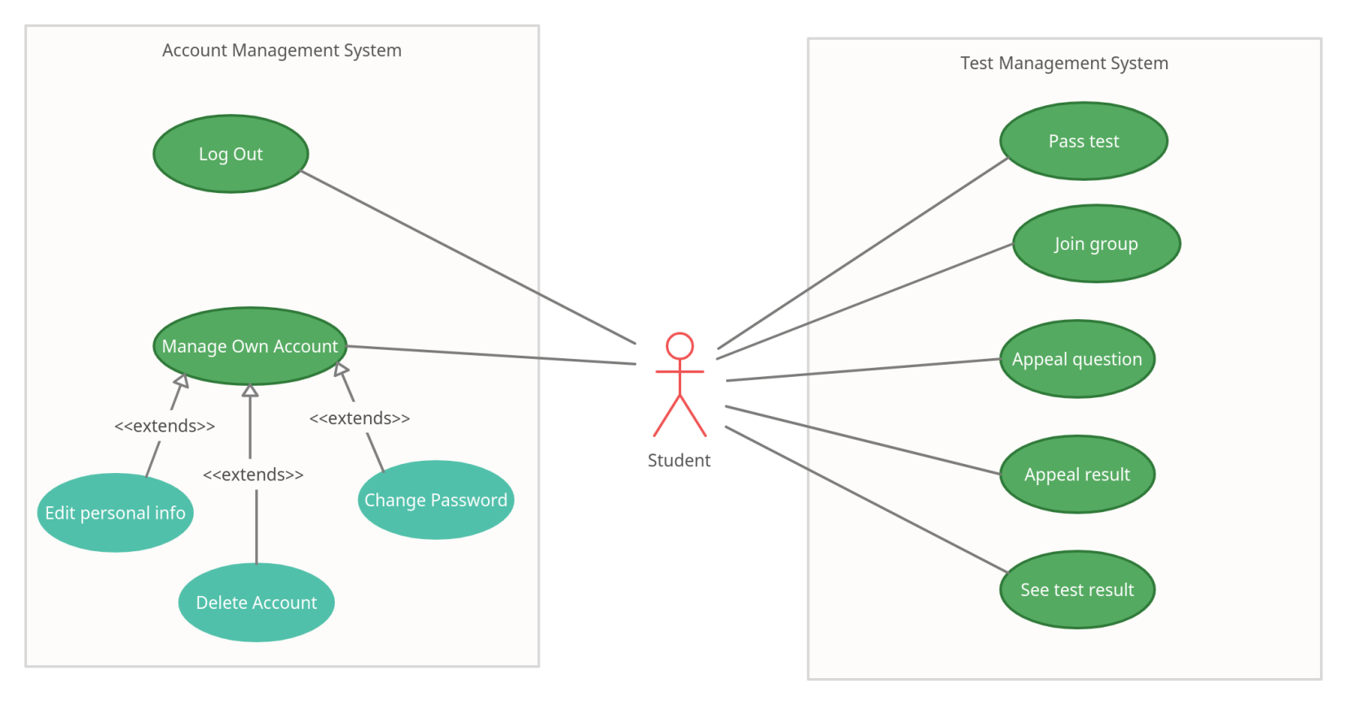

Teacher role use case diagram:

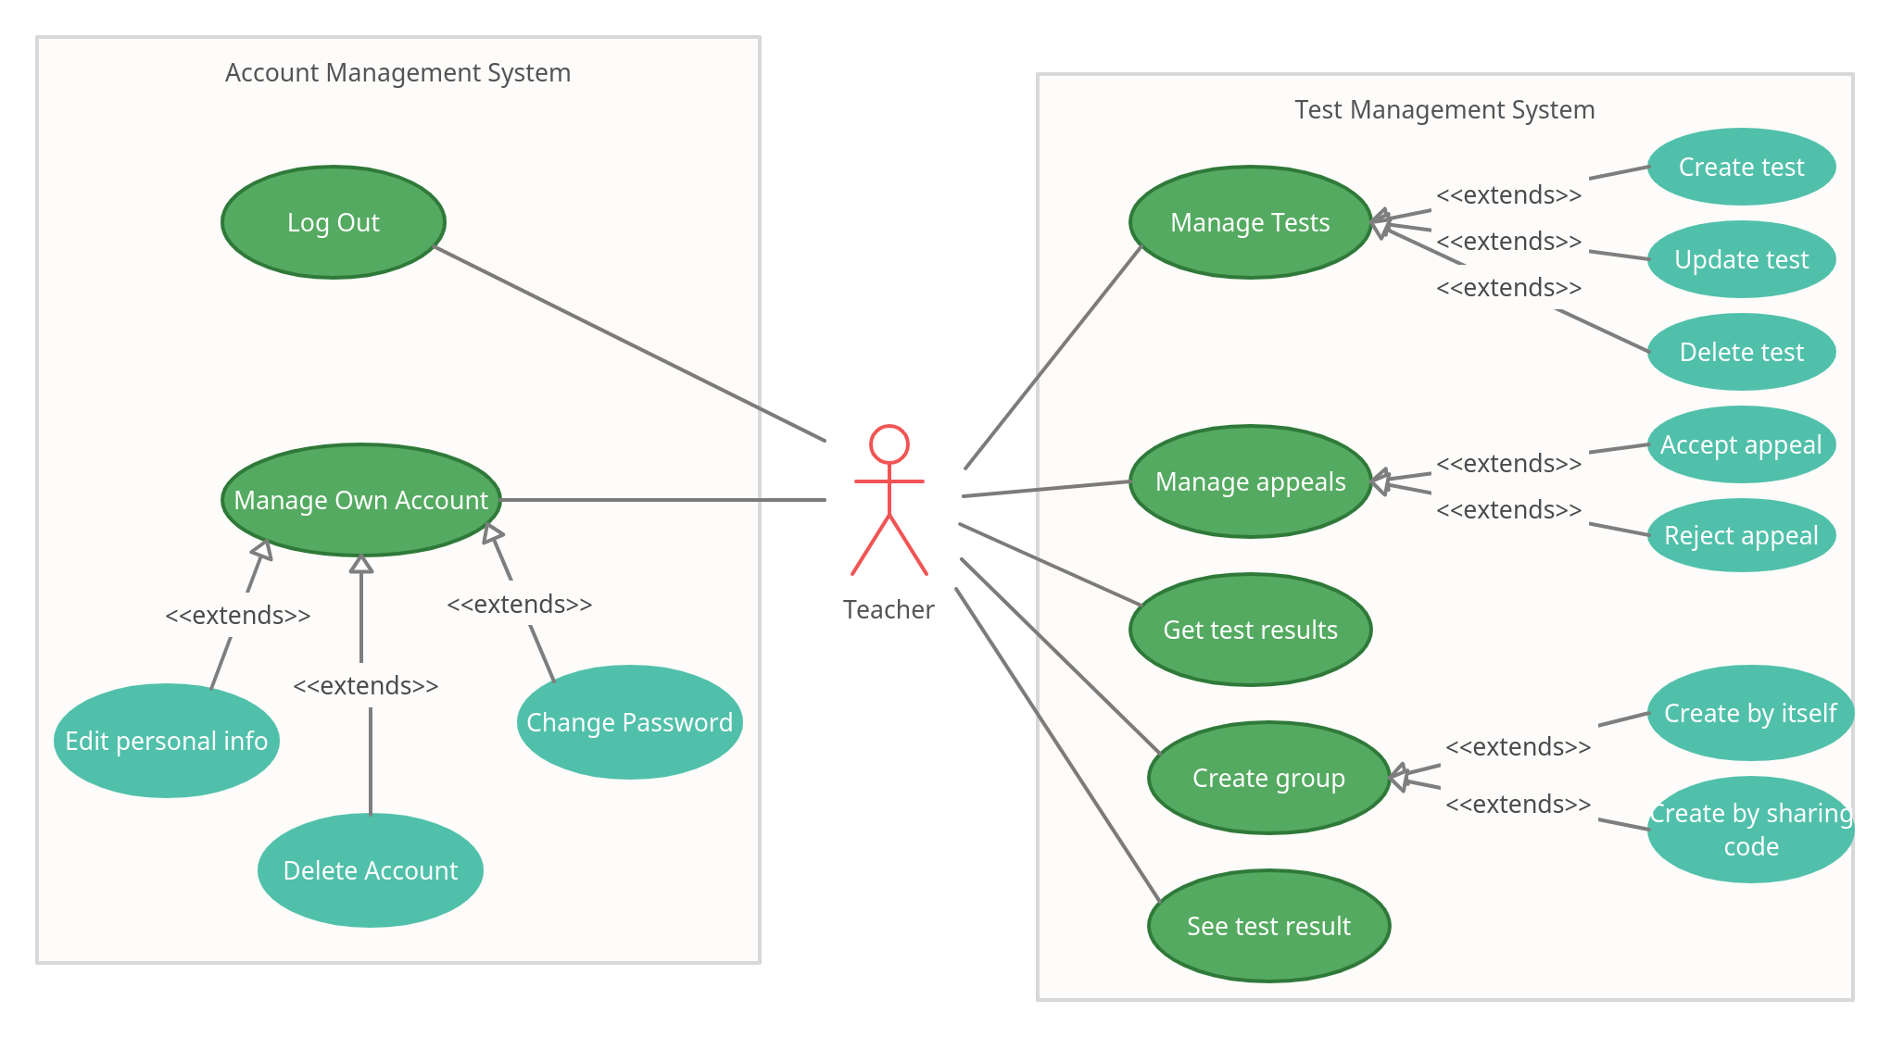

Admin role use case diagram:

