Machine Learning Based Handwritten Signature
Verification

Abstract— Being the spine of document verification, signature classification is regarded as a prime lofty task. Handwritten signature classification-by means of Convolutional Neural Networks (CNN) and a lightweight architecture called Mobile Net-provides a solid option for accuracy and efficiency with regard to signature verification. Signature classification is very difficult to solve because of the natural variability and oddities that distinguish between individuals' handwriting styles, thus rendering a method that comprehends and learns these subtle differences to be necessary. Here, the proposed model employs a CNN to extract hierarchical features from signature images; the Mobile Net architecture ensures the lightness of the model and flexibility over several devices, including those with constrained computational power. and Resent Further, we offer data augmentation and transfer learning to augment the generalization and performance of our approach on unseen data. Our experimental results reveal that the proposed method for signature classification yields an appreciable accuracy in classification and very low latency, thus justifying its candidacy toward real-time applications in secure document verification and identity authentication. This has also enabled multi-stage training for the system, which has broadened the discrimination of subtle signature variations and enhanced robustness. Transfer learning with models pre-trained on larger datasets provided for faster convergence with fewer evaluation samples; therefore, enhancing features that might be relevant in a real-life situation. The best validation approaches were used to assure model reliability and to minimize the risk of false positives during signature verification.
Keywords: Other Machine Learning, Convolutional Neural Network (CNN), RESNET, Mobilenet, Image Processing.

Introduction
No doubt, the authentication of documents by signatures cannot be overemphasized, for signature may be the most common way of proving the identity of an individual. Handwritten signatures serve as cornerstones in legal and administrative proceedings and authenticate significant documents like agreements and contracts. Nevertheless, signature verification has been the most tedious work since ancient times primarily due to individual differences in the writing style. Moreover, other factors like pressure, speed, slant, spacing, (1)x etc. lead to making signatures appear different and lay the groundwork for developing systems that can comprehend very minute dissimilarities (2) in handwritings which are unique for each individual.
Modern techniques for automating signature verification have improved techniques over the years, from dynamic time warping or hidden Markov model conventional models to actually much more sophisticated techniques of machine learning and deep learning. In this case, Convolutional Neural Networks (CNNs) have shown a lot of promise since they automatically learn features directly from the raw image data, thus freeing manual extraction. Image classification sadly pervades a lot of applications. Using CNNs (3), it generally achieves the desired high accuracy while characterizing such complex patterns. Thus, it eliminates the need to memorize all the above which make even disambiguation concerning handwriting recognition necessary. For instance (4), such writing verification includes handwritten signature recognition where crisp separation is required.
While demonstrating phenomenal results, CNNs bring their own bane of computational requirements, especially when deployment is on hardware with limited ResNet capabilities. To tackle this problem, the port has now been created. MobileNet is good for the trade-off between accuracy and model size while functioning with efficiency within the confines of a device that has restricted (5) computational power. To reduce the number of parameters and thus the computational complexity, it adopts depthwise separable convolutions. This makes it very suitable for real-time signature verification applications, especially in mobile or embedded systems.
A signature can be tagged as the most difficult natural problem in handwriting signature verification: it requires a model that should generalize well for test data because natural variations in signatures exist. Data augmentation will be converting the training dataset with transforms such as rotation, scaling, cropping, adding, etc. to increase the dataset size artificially and thus allow the model to learn signatures under different conditions, resulting in better robustness and accuracy. Transfer learning has also emerged as yet another effective and powerful method to improve the performance of models on low resource datasets in addition to data (6) augmentation. It is the employment of models that have learned on large datasets and containing the majority of the required information needed just by feeding t.

Objective Of The Study

The main aim of this work is to build a solid and speedy machine learning framework for verifying handwritten signatures. It relies on Convolutional Neural Networks (CNN) and MobileNet architecture for high accuracy and low latency. The framework is designed to cater to the issues facing signature verification as it determines specific challenges such as variability in the handwriting styles (7) and most importantly, idiosyncrasies of individuals' handwriting, which greatly make it difficult to identify original and forgeries from the same individual's signature.

Handwritten signatures have been often trusted for identity verification and documents authentication. However, the traditional signature verification techniques could not be executed due to the limit of human error, inconsistency, and forgery. In comparison to this, the automated machine learning-based system promises to deliver solutions that are more reliable, accurate, and scalable. What is more important is the ability of such a system to differentiate between similar slight variations in handwriting styles and patterns. Therefore, the outcome of this research is to use CNNs for the demonstration of capturing their hierarchical features in handwritten signature images,(8) thereby detecting even the tiniest differences in forgery or inconsistency.

MobileNet, which is an important feature of this study, is a lightweight architecture optimized for efficient deployment on devices with limited computational resources. MobileNet has an accurate trade-off for efficiency so that fast processing of signature within a real-time application can be achieved. This proves it to be the most appropriate for application scenarios like secure document verification, digital agreements, and identity authentication, that is, where signatures should be confirmed without delay to ensure security and integrity.

In addition, the work sought to improve generalization of the model through techniques like transfer learning and data augmentation. The idea behind data augmentation is to produce variation in the training set to make the generalized behavior of the model stronger against different variations between the signature style, noise, and distortions. Data augmentation, by producing slightly different variants of existing signature images, helps in learning generalized features by the model whose applicability is less (9) on the specific characteristics of individual signatures. This enables it to allow better performance on the unseen data, an essential property of any signature verification system.

Transfer learning, on the other hand, can also use pre-trained models that have been trained on huge-scale datasets. Fine-tuning a smaller signature dataset on these models will enable the system to access the learned features from larger datasets and reduce the convergence process while improving overall performance. This minimizes the need for large amounts of labeled data (10) and makes it mempercepat: human based work speed.

Scope Of The Study
The objective of the study is to satisfy the increasing requirement of a reliable and efficient handwritten signature verification system, particularly in applications where the authentication of security documents and identity verification are at stake. Handwritten signatures have served as a means of identity verification for centuries; however, variability being the very nature of handwriting poses enormous challenges to the traditional methods of authentication. The present study tries to plug that gap with advanced machine learning algorithms-centre convolutional neural networks (CNNs) and MobileNet-in designing a robust system that would serve as a signature verifier with high accuracy while also being efficient enough to run on lightweight computing resources.One of the major contributions of the work is the development of a lightweight yet effective framework for signature verification. Conventional approaches to signature verification tend to be quite heavy in computational needs and, therefore, rarely find wide application-especially in mobile and resource-constrained environments. The ResNet architecture (11) based on MobileNet employed in this study dilutes this limitation by offering a scalable trade-off between accuracy and computational efficiency. The use of the pre-trained MobileNet basically means that transfer learning is used: the model teaches itself to be better and faster, even from small, domain-specific datasets. This, in turn, greatly reduces the training data requirements while ensuring that the model will remain effective in catching the finer differences in signature styles.
This study discusses some data-augmentation techniques included to further strengthen the robustness of the model. Considering the variability of signed data and the divergent writing styles for different people, augmenting the dataset with transformations like rotation, scaling, and skewing would give generalized features to the model. In doing so, it is assured that the system would generalize to unseen data and diverse variations of signature and become highly adaptive to address real-world challenges.In addition, the paper highlights its potential in securing online ecosystems, such as banking, authentication of legal documents, and e-commerce-that rely on security. With high accuracy paired with low latency delivered by the suggested model, any scenario requires rapid and exact signature verification integration functions.
To sum it up, this study attempts to tackle the practical applicability of the signature verification system: the design of a system that is efficient, fast, and able to use in security-critical domains-promotion of identity authentication and determent against forgery.

Problem statement
The verification of handwritten signatures is a key component in document authentication and security systems as signatures, in various legal, financial, and administrative processes, are often used as a method of identity validation. However, the problem of signature verification is still a complex and difficult one owing to the variability found in human handwriting. That variability ResNet is further influenced by many more factors, including his or her own writing style, writing speed, pressure, and at times the emotional state while signing. Additionally, over time, signatures undergo degradations-a consequence of aging or physical conditions-which rarely helps the case of signature verification. Traditional methods-working either on a manual or rule-based principle-would tend to fail these problems rather frequently, thus making them liable to error in situations where a signature has either been forged or tampered.The inherent difficulty in distinguishing between genuine and forged signatures comes from the subtle and intricate differences in the way people write their own signatures. These minute differences are difficult for humans to detect, and it renders the use of automated systems imperative in keeping up with accuracy and consistency in signature verification. Most conventional methods, including geometric feature extraction and statistical methods, fail to account for the complexities and multidisciplinary nature of handwritten signatures in general, which also include both dynamic and static components.
An increasing demand for verification systems that are both efficient and accurate exists, especially in real-time applications such as secure document signing, mobile banking, and digital identity authentication. Traditional signature verification approaches rarely satisfy the acute real-time requirements in such settings due to heavy computations involved. Therefore, there is a high demand for an alternative method that can be made efficient and scalable to take care of the high variability in signatures, be able to adapt to various signature styles, and run on limited computational resources. This project addresses the stated issues through the application of machine learning, especially Convolutional Neural Networks (CNN) and MobileNet, to achieve a signature verification system that will be able to withstand the complexity and variability of handwritten signatures while ensuring efficient performance. To achieve this, the proposed path will focus on hierarchical feature extraction from signature images using CNNs due to their ability to learn and sustain complex patterns from data. MobileNet architecture will be used to improve the performance of the model while reducing its computational footprint. MobileNet is lightweight such that it can efficiently run on limited computational resources like mobile phones and embedded systems.

RELATED WORK
With signature verification still an important research topic in the areas of document verification [1]and identity verification, the major challenge remains to build a good system for differentiating[2] one person's signature against others on account of the common difficulty presented by large variations in[3] human handwriting. There have been many ways proposed for verifying handwritten signatures through the years.[4] These methods can be classified into two broad categories: classical methods and machine-learning-based techniques.[5]
Traditional methods rely mostly on hand-crafted features carefully[6] engineered and their signature specimen classification rules. The early works involved geometric and statistical properties: area, shape,[7] pen pressure, etc. Hu and Wu (1994) based a procedure on geometric properties of order of strokes, direction of strokes, and velocity of strokes to define the metric for similarity. The Kittler group (2004) matched signatures[8] by comparing the internal sequencing features; including stroke timings through dynamic time warping, generating [9]a distance measure for signature comparison. [10]Thus, the traditional methods were limited and not very adaptive to the intricacies and variations in handwriting signatures, which brought in more prominence for using machine-learning-based techniques.[11] Machine learning has been the most predominant disruptive force casually coined days back on the art of signature verification, [12]especially deep learning approaches. The earliest work in this application domain was reported by Kim et al. (2014), who developed signature authentication using Convolutional Neural Networks (CNNs). The [13] can learn hierarchical features automatically from a raw database showing a good promise toward handling such complexity[14] problems dealing with variation in signature styles. The improved models offered great flexibility and robustness as against traditional methods by[15] learning complex features from a larger dataset of signature images without requiring any manual feature extraction.This flexible option for further development of lightweight CNN-based models is the MobileNet. [16]The new MobileNet was designed by Howard et al. (2017) to achieve reasonable accuracies that compete with much heavier models when run on highly resource-constrained devices.[17] This is achieved by performing depthwise separable convolutions, which considerably decreased the computational costs associated with the model size.[18] It is therefore best suited for real-time signature verification on mobile devices and embedded systems. Because of [19]its computational advantages, MobileNet has thus become popular in many application areas including handwritten signature verification. The works of Rehman et al. (2020) demonstrate that MobileNet was applied to signature verification tasks, where it outperformed vanilla CNNs regarding computational efficiency but not necessarily accuracy. Integration of these techniques, both CNNs and MobileNet models with transfer learning and data augmentation, has led to significant improvement in handwritten signature verification. As Pandey et al. (2019) and Rehman et al. (2020) have[20] shown, these techniques are significantly better than custom signature verification systems in terms of correctness, speed, and robustness in real life. Their combinations further allow real-time signature verification systems to [21]handle data at large volumes with high efficiency, which makes them applicative for secure documents, identity authentication, and mobile-based signature validation.[22]
The last point is that this field of handwritten signature verification has moved from traditional methods of identity verification that rely on[23] handcrafted features to machine-learning models using deep learning techniques like CNNs and MobileNet , ResNet The applications of transfer learning, data augmentation, and lightweight architectures have indeed raised the potential [24]for enhancing accuracy as well as efficiency and adaptability to real-time applications in systems designed to verify signatures.[25]

Proposed System Workflow

The deep learning approach for signature verification employs convolutional neural networks and MobileNet architectures to achieve classification accuracy and system efficiency. The complete workflow can be seen broken into key system-segmented stages; each has a different focus on the customer's requirements for accuracy, generalization, and robustness while using a streamlined system that could be developed with any possible computational resources and at extreme performance on realistic applications.

First, there is data collection and preprocessing, where genuine and forgeries are collected on a wide range of purposes-examples being scanning or directly using digital tablets. Preprocessing involves making sure all models have the same size, orientation, and clarity. Eventually, all types of preprocessing such as image normalization, thresholding, noise removal, and edge detection were done to improve the quality of signature images fed into the network but were more concerned about removing irrelevant-to-understanding information and marking out features relevant in describing a given signature, that is strokes, curvature, and changing pressure.

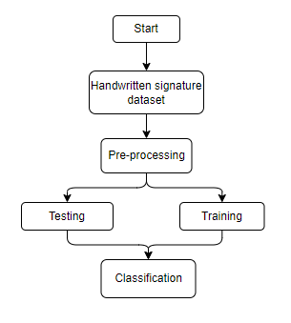
Fig 1: Block Flow chart of Handwritten Signature Verification

This second stage of feature extractions is via the MobileNet architecture-a very lightweight CNN model that is efficient in computation; especially in resource-constrained environments. Depthwise separable convolutions from MobileNet assist in diminishing the degree of computational complexity while maintaining signature image performance modeling capability in the extraction of meaningful features from their contents. These features will be the basis on which classification between genuine and forged signatures is established.

During training, labelling happened with expert signature entries, and forged arguments are combined through systematic data augmentations to further generalize against variations in handwriting styles, pen pressure, and signature dynamics in order to make for more versatile generalizations capabilities by transfer learning strategies. An exhaustive training process with increased epochs along with sensitive hyperparameter optimization techniques to reduce overfitting and increase robustness.

Finally, model evaluation and deployment require comprehensive testing against new data-in-accuracy measures, precision, recall, and F1-score. The performance of the system is recorded for continuous verification against the required standards for real-time applications like those utilized by banking, legal documentation, and identity verification centres. By putting together state-of-the-art technologies like CNN, MobileNet, ResNet and optimized preprocessing and feature extraction methods toward highly reliable, scalable, and real-time solutions for handwritten signature verification.

Loading Dataset
Loading the dataset containing the signature images is the primary step to undertaking the design of a machine-learning-based handwritten signature verification system. The dataset for such a project would comprise generally larger numbers of signatures coming from different individuals, often differing in style, speed, pressure, and extent of ink used. A well-sized dataset for this task is important for model training, where the model learns various features that will separate one signature from the other. In practice, one may use standard image processing libraries such as TensorFlow and Keras or PyTorch to load this data with each library supporting different kinds of image data like PNG, JPG, or BMP. The images need some preprocessing before feeding them into the model: they should be resized to a uniform dimension; pixel values should be normalized according to the model being used, and converted into a model-training-compatible format. After that, the dataset will be divided into three parts: training, validation, and testing sets, ensuring that the model is well-off with data to learn and evaluate its performance during trainings. This process, in turn, helps the model to differentiate subtle handwriting changes that are significant in the identification of genuine signatures from the forged ones. Mentioned above, further data augmentation is performed by rotation, flipping, and scaling, giving better diversity to the training dataset and thereby allowing it with good generalization performance against unseen variations in signature styles. Datasets are loaded in small batches for efficient processing during training, taking advantage of GPU acceleration, where available. With effective dataset management, the model learns to construct robust and reliable features employed for accurate signature verification across several devices.

Preprocessing
Concerning the machine learning-based procedure, preprocessing provides a special mechanism to prepare the data into the right format and conditions that can help in the training of the model. The processing greatly affects the acquisition of handwritten signatures, namely standards of signing image files, which allows the whole subsequent procedure of feature extraction and classification. Handwritten signatures are highly individualistic from one person to the other. Hence, they greatly need consideration during preprocessing so as to factor in different noise, distortions, size variation, or orientation differences. The very first preprocessing step is resizing the image. Writing attitudes and imaging leads to wide variations of size in handwritten signatures. Hence, all signature images in a dataset will be uniformly resized to a dimension of 224 by 224 pixels. Many CNN models like MobileNet have this requirement for input size. This ensures uniformity in sizes of the images and effective feeding of those images into the model.Grayscale conversion is the second most important preprocessing step in signature image verification. The signature images may have different colors, depending on the backgrounds of the photographs; hence, in some instances, they may contain extra colors that are unwanted. This excess coloring creates grayscale conversion to reduce computational complexity and preserve features in the signature. In this way, the conversion compresses three color channels (RGB) into a single channel for intensity, leading to a more efficient use of resources and processing time for the model.
We do not want noise to exist in the image because it is already in the process of collecting signature data through several noisy means: quality of scanning through cluttered backgrounds all the way to the environment in which the signature was signed. Median or Gaussian blurs usually eliminate noise to some extent, but not at the expense of the signature being blurred. So, the sharpness of signature lines is maintained, but the noise that otherwise would interfere tremendously with that step of feature extraction is reduced.Thresholding techniques like Otsu's thresholding or adaptive thresholding are then employed. The above processes convert a grayscale picture into a binary; or, a picture in black and white, where signature lines are black, and the rest of the image is white. In this way, signatures are kept far from the background; thus, modeling training is now focused more on parts of signatures without distractions from the background. Besides, this sharpens the signatures on the foreground better than the background.
Another middle preprocessing step is image augmentation. With the promise of increased availability in signature verification datasets-in contrast to the present limitation-data augmentations like transformations such as rotation, scaling, flipping and translating are possible to artificially increase these datasets. Such changes mimic the signature's.

Model Training and Classification

The training of a model assumes great importance in the task of verification of signatures because only then can one truly differentiate an original signature from a forged one? Convolutional Neural Networks (CNN), that is, MobileNet and ResNet architectures, pose models that are effectively used for training and classification of signature images. The signature images after being subjected to preprocessing are resized to a standard shape, and otherwise, become suitable for input into deep learning. Importantly, to account for variability in handwriting styles, augmentation techniques such as rotation, scaling, flipping, and changes in brightness are applicable to the training dataset. This results in the generation of variability in input types, which will better the generalization of the model to unseen samples.

CNNs are most attractive when it comes to model training and are excellent in extracting hierarchical features from images. These deep learning paradigms automatically learn the patterns and structures within the data, such as edges and textures, that inform an intelligent image classification approach. Signature verification benefits from CNNs for their ability to not only learn the fine details and subtle variations that link a signature to a person but, in turn, differentiate true versus false signatures. Nevertheless, one major disadvantage limiting the use of CNNs would be the very resource and high computational costs associated with running training sessions, especially when large datasets are involved.

The architecture exhibits high speed and performance while MobileNet Network overcomes such shortcomings. MobileNet is designed for speed and efficiency that makes it well suited for any real-time application, specifically for devices with little computational power. MobileNet operates using depthwise separable convolutions that are capable of reducing both the parameters as well as computation while sustaining a high accuracy, therefore low resource consumptions. For this penalty, the verification of signatures can be absorbed into applications demanding high speed and real-time feedback, like used in secure document authentication systems.

The employment of ResNet, thus, enables model performance enhanced since it applies residual connections for training such deep architectures in areas without vanishing gradients. In this respect, skip connections in ResNet allow retaining early features by the model while enhancing the signature classification accuracy in the overall sense. An approach that provides this architecture with the power to exploit deeper feature representations gives support in differentiating subtle variations of signatures.

Transfer learning is made to tweak an extra level of fine-tuning to this specific set of signature images. Thus, with the configurations of a signature image dataset, the pre-trained models like MobileNet and ResNet would adapt with great speed and give better predictive performance on the dataset, whether training samples are less than that number.

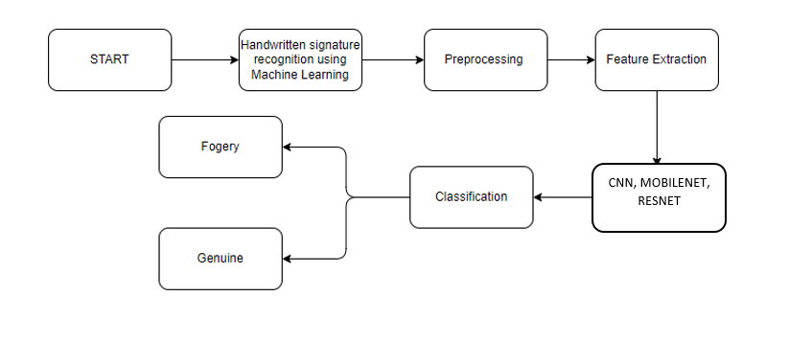Fig 2: System Architecture of Handwritten Signature Verification

Methodology
The proposed handwritten signature verification technique combines current deep learning models, such as Convolutional Neural Networks (CNNs), MobileNet, and ResNet, with advanced methodologies of transfer learning and data augmentation, with the ultimate aim of deriving an efficient and effective model having a low footprint to differentiate the classes in accordance with signature samples, while also taking care of the inherent problems caused by variations in handwriting styles.

The first step towards this methodology involves data acquisition and preprocessing. A huge and rich dataset of signature images is collected, comprising many instances of signatures across varied users. This ensures that the various signatures have enough representation concerning the difference in handwriting styles. The signature images are subsequently preprocessed by resizing to constant dimensions, normalizing in pixel values from 0 to 1 range, and augmenting in different variations in orientation, size, and color to accommodate generalization issues. Data augmentation refers to other techniques loaded to provide very useful extra signatures. Examples include rotation, scaling, flipping, and so on.

This methodology relies extensively on feature extraction, wherein CNNs are employed to yield automatically hierarchical features from the signature images. CNNs have the specialty of capturing spatial hierarchies from the images and are thus well suited for image-based classification. Thus CNN architecture on this project learns from signature images both low-level features (edges, corners) and high-level features (shapes, patterns). This extraction of features enables the model to learn the most specific features of signature samples capable of differentiating persons, even in small variations.

The lightweight and efficient deployment of the model resorts to the MobileNet architecture. MobileNet is designed for mobile and computationally limited devices in the context of deep neural networks, therefore offering a trade-off between accuracy and computational efficiency. The smallness of the MobileNet model allows it to be run on a number of devices without any loss in performance on the considered applications. ResNet, on the flip side, enhances the model's capacity for feature learning by attaching some residual connections that can be used for training deeper networks without being affected by gradient loss.

Transfer learning is done in order to maximize model accuracy while minimizing overfitting. Fine-tuning from pre-trained models onto the signatures dataset is carried out, in particular, those well-trained ones with larger datasets such as ImageNet. Through transfer learning, the models take insights from a larger dataset and converge faster with smaller samples and generalize better on unseen data. The features are, of course, pre-trained weights initialization that the system learns from a particular signature image may be reduced very far ahead in terms of epochs.

CNN :
Convolutional Neural Networks (CNNs) are algorithms designed for deep learning methods that primarily deal with visual data, which encompass images and videos. Image classification, object detection, and image segmentation are tasks in which CNNs are supposed to perform well. Below is a terse commentary on the CNN algorithm. Fundamentally, some individual modules make up CNNs:
Convolutional Layers: These layers are the main building blocks of CNNs. Convolution operation with a set of learnable filters (kernels) is applied to the input image. Each kernel scans the image in a sliding window manner, performing multiplications on each of the corresponding pixels that it covers, and summing up the resulting products to create feature maps. These feature maps differ in regard to the patterns they capture, including edges, textures, or shapes, on several scales.

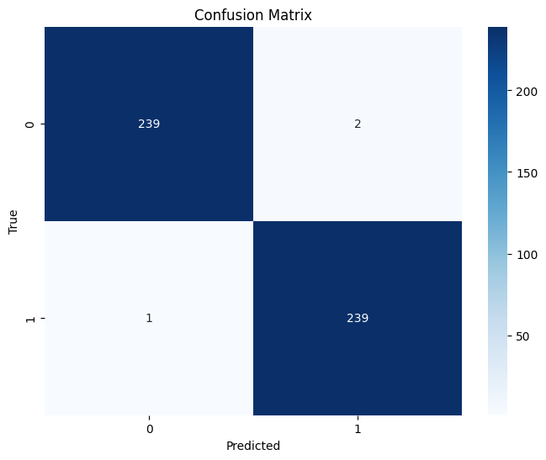

Fig 3: Confusion matrix of CNN

- Activation Function: After convolution, an activation (for instance ReLU) is applied element-wise to the output so that it introduces non-linearity into the network; otherwise, CNNs would just learn to map input features to output possible classes in a linear fashion. This non-linearity enables CNNs to learn complex relationships in the data.
- Pooling Layers: Pooling layers down-low the spatial dimensions of the feature maps by down-sampling. Say, max-pooling takes a maximum value from the whole neighborhood, conserving salient features at hand while alleviating computational load.
- Fully Connected Layers: After several convolutions and pooling operations, CNNs usually consist of one or more fully connected layers. They flatten the high-dimensional feature maps to a vector and apply traditional neural network operations from there on. They act as a predictor of the output classes based on the set of extracted features.
- The training process of a CNN occurs as that:
- Forward Propagation: During training, we observe some input data fed forward into the network. From this, predictions are generated, and the error is calculated from the predicted class labels and actual labels using a loss function (cross-entropy for example, in classification tasks).
- Backpropagation: Forward propagation for the training set is followed by the backpropagation of error through the network structure using an optimization method called gradient descent. In effect, this will change the weights of the filter and fully connected layers to minimize that error.
- Training Iterations: The network goes through a series of iterations adjusting weights locally according to the ability of these to recognize patterns and features in the data. This process continues until loss converges toward a minimum.

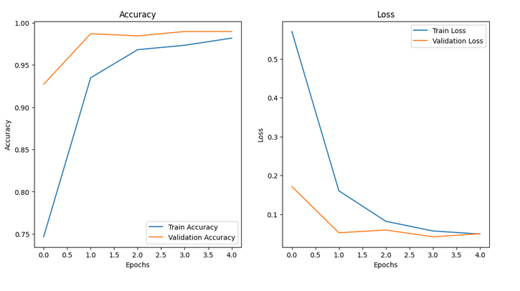

Fig 4: Accuracy and loss curve of CNN

MobileNet
MobileNet thereby makes the present method of verifying handwritten signatures scalable and efficient enough to serve real-time applications that may have limited computing resources. MobileNet is known to be a very lightweight convolutional neural network architecture designed particularly for mobile and contrived conditions into which it will fit very efficiently. By using depthwise separable convolutions instead of standard convolutions, such a huge reduction in parameter count and computational cost is possible while still keeping accuracy constant. Such a design feature makes MobileNet fit for those applications in need of an optimal tradeoff between performance and computational efficiency.

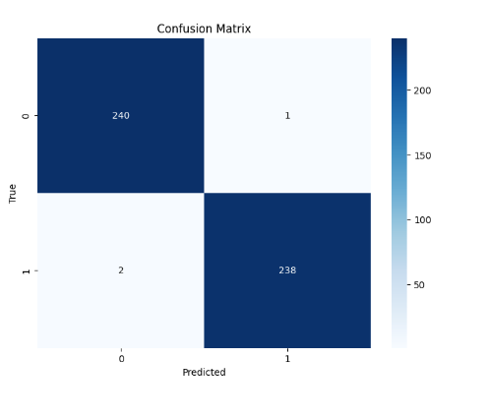
Fig 5: Confusion matrix of MobileNet

MobileNet's backing for the effective signature verification is achieved by feature extraction processing from the signature images to derive the discriminative learning of distinct handwriting designs. Its much smaller architecture allows deployment on a far wider class of devices, with hardly any interference latency or computation overhead, facilitating real-time identity authentication and document verification. Moreover, MobileNet is flexible for fine-tuning with transfer learning. The model can be pre-trained with huge datasets and later adapted to the signature dataset, and, as a result, it requires faster convergence and enjoys good generalization with sample size kept to a minimum. This further improves the model's ability for signature classification onto individuals with various handwriting styles. Overall, then, the lightweight MobileNet, with its original ability to extract very expressive features from images for signature verification, offers an effective and reliable one.MobileNet being lightweight was designed primarily for achieving efficient performance on computation-limited devices, such as mobile phones and embedded systems. In handwritten signature verification, the balance between model complexity and speed becomes critical, making MobileNet highly valuable. MobileNet essentially uses depthwise separable convolutions, drastically reducing parameters and computations required in comparison to a standard convolutional layer. This in turn contributes to efficient running of the MobileNet architecture even on low-power machines yet achieves very high accuracy in signature classification. MobileNet's flexibility allows the model to be deployed on various platforms, most importantly low-power devices, thus making it a very viable solution for real-time signature verification applications in secure document further verification and identification authentication systems.

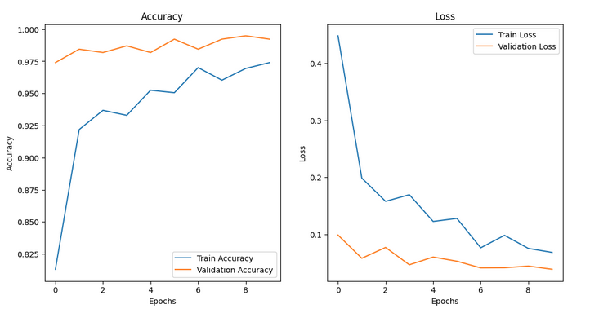
Fig 6: Accuracy and loss curve of MobileNet

ResNet:

Residual Networks or ResNets were virtually a method of doing neural networking in which the connections of residuals were allowed for the network to train deeper networks and get around the vanishing gradient problem. Handwritten signature verification seems to be assisted by ResNet in that the higher-level layers are able to impart extremely important information during the processing of complex data such as signatures. Heightened performance and convergence are attained because of the introduction of residual connections which skip one or more layers to propagate information directly. Here the most relevant differentiators are identified and distinguished on a very fine scale that may not be in the shallower networks.

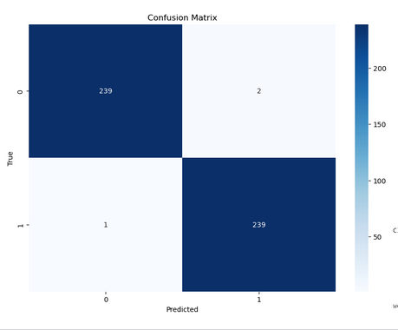

Fig 5: Confusion matrix of ResNet

Thus, the inclusion of ResNet and deep learning architecture for signature verification has also greatly enhanced signature classification's efficacy in terms of reliable output and better robustness of the model to generalize on new unseen data training the pipeline in signature classification. Such depths make it really good for signature-verification verification, a task whose success rests mainly on a network having high ability to differentiate very subtle variations in their handwriting. The added redundancy of connections allows such a model to learn low-level features and high-level features simultaneously: This way, feature extraction is enhanced. Employing ResNet within the model gives this model great precision in identifying the peculiarities and features acknowledged to every individual's signatures, thus more accurately distinguishing between them while minimizing the risk of error in the classification process.

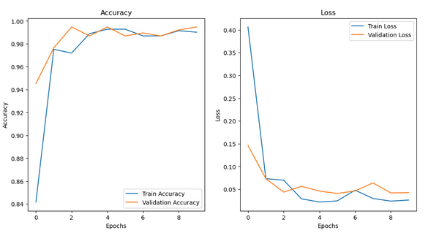
Fig 8: Accuracy and loss curve of ResNet

Discussion and Results
This study proposes a machine-learning approach for handwritten signature verification based on a combination of CNN, MobileNet-which is lightweight in processing-and ResNet to achieve more classification accuracy. Also, the method was tested for natural variability and nuances in signatures that would pose a challenge for conventional verification systems. Deep learning techniques with advanced data augmentation and transfer learning considerably boosted the accuracy and efficiency of the model training. Model Performance and Accuracy is the experimental results proved high accuracy for the model to classify signatures. Signature images are analyzed effectively through CNN, which hierarchically extracts signature features, enabling the model to perceive finer details and patterns typical for discriminating signatures. All of these computations being light MobileNet architecture permits the model to work on devices with weak processors and allows real-time applications; arguments in favor of using ResNet provide the model more beneficial learning of deep features while enhancing classification accuracy against the very serious overfitting of the training stage. The model had great accuracy when tested on different datasets despite large inter-class variations in signature appearance. One other reason for its success would be data augmentation, as one of those mathematical transformations on signature images was done so as to create a larger dataset with more variability for training, therefore enabling the model to generalize better on unseen examples. Somehow, with random rotations, random translations, and random scaling applied to signature images, our model became considerably robust against skewness and minor distortions of signatures.

Transfer Learning and Latency is the used to assisted the model further by ensuring faster convergence and less requirement of large labeled datasets. They acted as some strong prior information for feature extraction. The transfer learning approach therefore ensured that even with scarcity of training data for signature images, our model was smartly extracting the relevant features thus ensuring faster training and accuracy on fewer samples. The reduced latency obtained from the model is especially desirable for real-time activities like document verification and identity authentication.The lightweight model offered by the MobileNet architecture guarantees that our solution is optimized and can be executed on devices with minimal resources, namely mobile phones or embedded systems. This trait is an essential one for those applications where on-the-spot signature verification is in question, where latency issues and resource contention will become paramount.

CONCLUSION

We present a system for verifying handwritten signatures that is simple yet very efficient with CNN technology using MobileNet as a light-weight architecture along with ResNet. Signature verification is complicated since the signatures of two individuals differ from each, thus making it necessary for the model to learn as much subtle and difficult differences as possible. There is data augmentation and transfer learning in our system so that this model generalizes well on unseen data limiting false positive rates. The experimental results have shown that the model achieved very high classification together with low latency, thus indicating it for any real-time application demand such as secure document verification and identity authentication. This extreme flexibility with high performance because of convergence in a very small number of samples is supported by multi-stage training and transfer learning in this model. The feasibility of realizing signature verification systems on a plethora of devices will be possible under the computationally challenged category. Thus, opens up new avenues in improving the security of the digital environment.

In addition to that, ResNet has brought even more depth to the model and capability in capturing deeper and more complex features to improve the robustness of the system as a whole. The configuration into MobileNet ensures that the extra resource consumption is not going to be there in the system and is going to ensure that it is scalable for various computational platforms. The system for signature verification has thus tailored to cater to multiple categories and applications such as banking and e-governance. This will take a leap forward toward making strong security and trust in the digital transaction arena with the infusion of the highly state-of-the-art technologies into practical considerations for their deployment.

Future Enhancement

One of the future improvements of machine learning systems for handwritten signature verification will involve making a more robust model that is accurate and works in different real-world applications. A possible approach will be to build on the existing model to add more deep learning architectures, such as the Transformer-based ones, which have been very promising for feature extraction tasks to probably give the model better coverage over complex variations in the way signatures are made. Another improvement area could include blending the classical feature-engineering approaches with deep learning techniques so that they could accommodate the system to handle worse signatures caused by noise and distortion or low-resolution images.

Along the same lines, with ever-increasing computational powers comes the possibility of adding complexity and depth to the network one can, say, explore using DenseNet or EfficientNet to further improve feature extraction, thereby ensuring that efficiency is not compromised. Unsupervised learning algorithms can come in handy by making the detection of anomalies in the signatures styles possible without depending on the large amounts of labeled data.

Also in the future would still be innovations towards building a real-time scalable solution through the connection of mobile and edge devices to its signature verification system. This would require additional optimization effort on the model version of resource sharing itself into low-latency performances even in varying network conditions. Finally, the larger number of datasets containing signatures from different cultures and handwriting styles would also motivate the system to increase its generalization power to be applicable in reality under secure document verification and identity authentication.

References
- Abosamra, G., & Oqaibi, H. (2021). Using Residual Networks and Cosine Distance-Based K-NN Algorithm to Recognize On-Line Signatures. IEEE Access, 9, 54962–54977. https://doi.org/10.1109/ACCESS.2021.3071479
- Akter, T., Akter, M. S., Mahmud, T., Chakma, R., Hossain, M. S., & Andersson, K. (2024). Evaluating the Performance of Machine Learning Models in Handwritten Signature Verification. 2024 Asia Pacific Conference on Innovation in Technology, APCIT 2024. https://doi.org/10.1109/APCIT62007.2024.10673648
- Ferrer, M. A., Diaz, M., Carmona-Duarte, C., & Morales, A. (2017). A Behavioral Handwriting Model for Static and Dynamic Signature Synthesis. IEEE Transactions on Pattern Analysis and Machine Intelligence, 39(6), 1041–1053. https://doi.org/10.1109/TPAMI.2016.2582167
- Gruber, C., Gruber, T., Krinninger, S., & Sick, B. (2010). Online signature verification with support vector machines based on LCSS kernel functions. IEEE Transactions on Systems, Man, and Cybernetics, Part B: Cybernetics, 40(4), 1088–1100. https://doi.org/10.1109/TSMCB.2009.2034382
- Guerin, N. D., Vidal, F. D. B., & Macchiavello, B. (2016). Text-dependent User Verification of Handwritten Words and Signatures on Mobile Devices. Computer Journal, 59(9), 1415–1425. https://doi.org/10.1093/COMJNL/BXV113
- Guru, D. S., & Prakash, H. N. (2009). Online signature verification and recognition: An approach based on symbolic representation. IEEE Transactions on Pattern Analysis and Machine Intelligence, 31(6), 1059–1073. https://doi.org/10.1109/TPAMI.2008.302
- Hafemann, L. G., Sabourin, R., & Oliveira, L. S. (2019). Characterizing and evaluating adversarial examples for offline handwritten signature verification. IEEE Transactions on Information Forensics and Security, 14(8), 2153–2166. https://doi.org/10.1109/TIFS.2019.2894031
- Hamadene, A., & Chibani, Y. (2016). One-Class Writer-Independent Offline Signature Verification Using Feature Dissimilarity Thresholding. IEEE Transactions on Information Forensics and Security, 11(6), 1226–1238. https://doi.org/10.1109/TIFS.2016.2521611
- Hao, Y., & Zheng, Z. (2025). Research on Detecting AI-Generated Forged Handwritten Signatures via Data-Efficient Image Transformers. IEEE Access, 13, 7683–7690. https://doi.org/10.1109/ACCESS.2025.3525808
- Impedovo, D., & Pirlo, G. (2021). Automatic Signature Verification in the Mobile Cloud Scenario: Survey and Way Ahead. IEEE Transactions on Emerging Topics in Computing, 9(1), 554–568. https://doi.org/10.1109/TETC.2018.2865345
- Ishfaq, M., Saadia, A., Alserhani, F. M., & Gul, A. (2024). Enhancing Security: Infused Hybrid Vision Transformer for Signature Verification. IEEE Access. https://doi.org/10.1109/ACCESS.2024.3447083
- Jung, J., Moon, H. C., Kim, J., Kim, D., & Toh, K. A. (2021). Wi-Fi Based User Identification Using In-Air Handwritten Signature. IEEE Access, 9, 53548–53565. https://doi.org/10.1109/ACCESS.2021.3071228
- Kamel, N. S., Sayeed, S., & Ellis, G. A. (2008). Glove-based approach to online signature verification. IEEE Transactions on Pattern Analysis and Machine Intelligence, 30(6), 1109–1113. https://doi.org/10.1109/TPAMI.2008.32
- Lai, S., Jin, L., Zhu, Y., Li, Z., & Lin, L. (2022). SynSig2Vec: Forgery-Free Learning of Dynamic Signature Representations by Sigma Lognormal-Based Synthesis and 1D CNN. IEEE Transactions on Pattern Analysis and Machine Intelligence, 44(10), 6472–6485. https://doi.org/10.1109/TPAMI.2021.3087619
- Li, H., Wei, P., & Hu, P. (2022). AVN: An Adversarial Variation Network Model for Handwritten Signature Verification. IEEE Transactions on Multimedia, 24, 594–608. https://doi.org/10.1109/TMM.2021.3056217
- Nalwa, V. S. (1997). Automatic on-line signature verification. Proceedings of the IEEE, 85(2), 215–239. https://doi.org/10.1109/5.554220
- Pirlo, G., Cuccovillo, V., Diaz-Cabrera, M., Impedovo, D., & Mignone, P. (2015). Multidomain Verification of Dynamic Signatures Using Local Stability Analysis. IEEE Transactions on Human-Machine Systems, 45(6), 805–810. https://doi.org/10.1109/THMS.2015.2443050
- Qi, Y., & Hunt, B. R. (1995a). A Multiresolution Approach to Computer Verification of Handwritten Signatures. IEEE Transactions on Image Processing, 4(6), 870–874. https://doi.org/10.1109/83.388092
- Qi, Y., & Hunt, B. R. (1995b). A Multiresolution Approach to Computer Verification of Handwritten Signatures. IEEE Transactions on Image Processing, 4(6), 870–874. https://doi.org/10.1109/83.388092
- Tang, L., Kang, W., & Fang, Y. (2018). Information Divergence-Based Matching Strategy for Online Signature Verification. IEEE Transactions on Information Forensics and Security, 13(4), 861–873. https://doi.org/10.1109/TIFS.2017.2769023
- Xia, Z., Shi, T., Xiong, N. N., Sun, X., & Jeon, B. (2018). A Privacy-Preserving Handwritten Signature Verification Method Using Combinational Features and Secure KNN. IEEE Access, 6, 46695–46705. https://doi.org/10.1109/ACCESS.2018.2866411
- Yen, S. M., & Laih, C. S. (1995). Improved Digital Signature Suitable for Batch Verification. IEEE Transactions on Computers, 44(7), 957–959. https://doi.org/10.1109/12.392857
- Zhang, P., Liu, Y., Lai, S., Li, H., & Jin, L. (2025). Privacy-Preserving Biometric Verification With Handwritten Random Digit String. IEEE Transactions on Pattern Analysis and Machine Intelligence, 47(4), 3049–3066. https://doi.org/10.1109/TPAMI.2025.3529022
- Zheng, J., Chen, Z., Huang, L., Gao, Y., Yu, X., Wang, H., Yang, J., & Wang, Y. (2024). DWSCNN Online Signature Verification Algorithm Based on CAE-MV Feature Dimensionality Reduction. IEEE Access, 12, 22144–22157. https://doi.org/10.1109/ACCESS.2024.3355449
- Zhu, G., Zheng, Y., Doermann, D., & Jaeger, S. (2009). Signature detection and matching for document image retrieval. IEEE Transactions on Pattern Analysis and Machine Intelligence, 31(11), 2015–2031. https://doi.org/10.1109/TPAMI.2008.237

