TradingIntelligence
Intelligence Hierarchy Thesis
How evidence becomes a decision, a trade expression, and ultimately a governed action
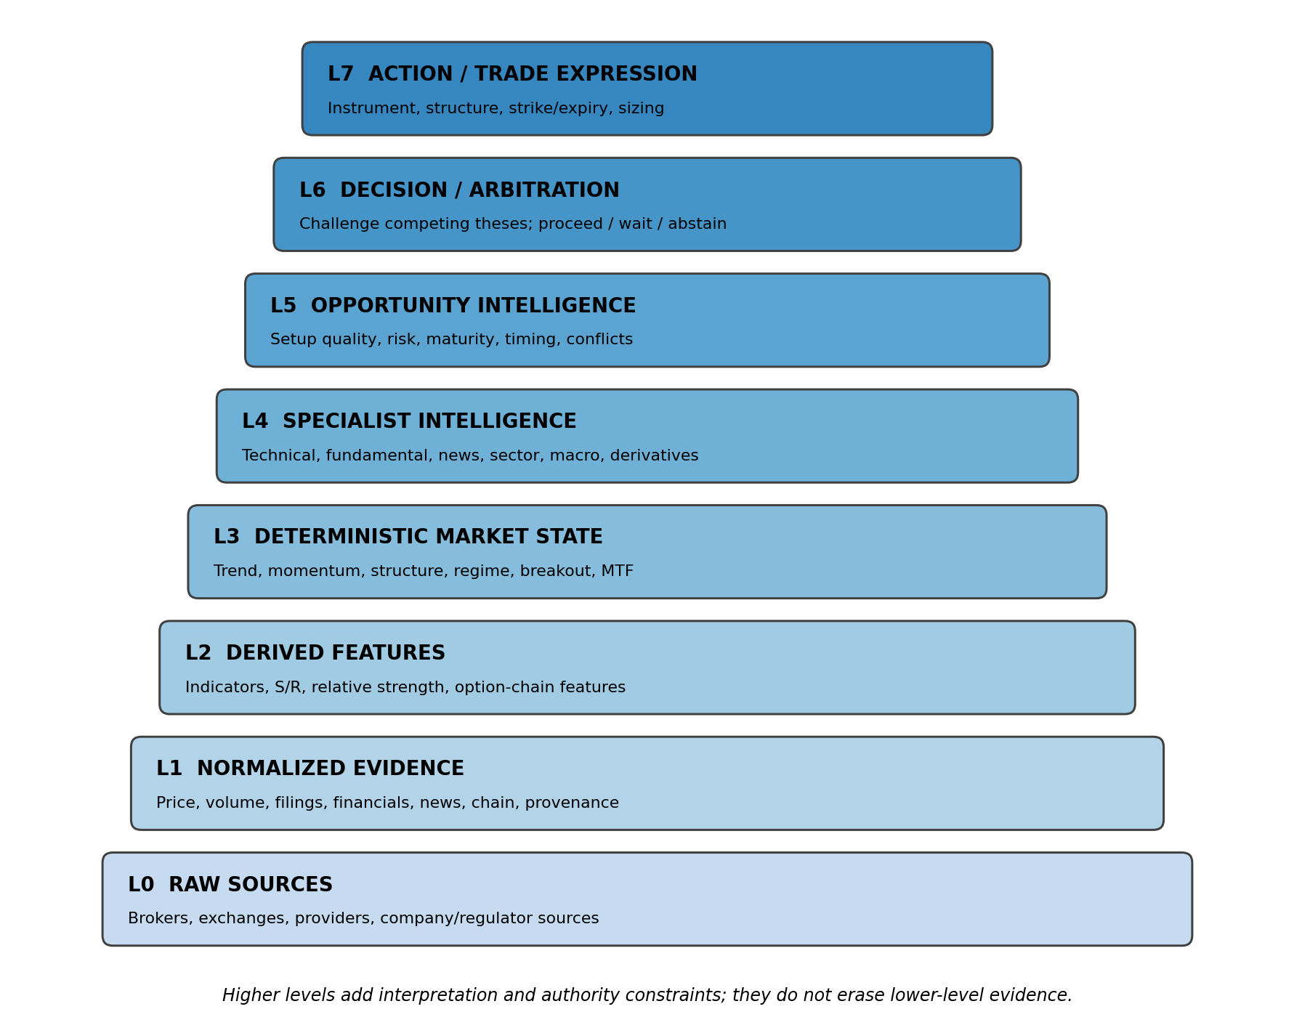
Concept thesis for TradingIntelligence (TI)
September 2026

Executive thesis
A trading decision should be understood as a sequence of transformations, not as a single signal. Raw observations are normalized into evidence, evidence becomes deterministic market state, independent specialists interpret that state, opportunity intelligence asks whether a setup is actually attractive now, challenge and arbitration test competing theses, and only then may TI express the conclusion as a possible trade. TradeMonitor and the broker remain outside the intelligence hierarchy as the operational authority and execution truth.
The hierarchy exists for one reason: to make it possible for a user to ask “why did TI reach this conclusion?” and trace the answer all the way down to the evidence.

1. The hierarchy at a glance

Figure 1. The eight conceptual intelligence levels. Higher levels add interpretation, challenge and decision context; they do not erase lower-level facts.

L0 — Raw sources
Broker/exchange feeds, structured providers, official filings, company IR, regulators and other approved sources. At this level there is no “trade idea”; there are observations.

L1 — Normalized evidence
Provider-specific payloads are converted into canonical TI evidence with identity, timestamps, freshness, point-in-time meaning, provenance and quality.

L2 — Derived features
Deterministic calculations convert evidence into indicators and features such as RSI, MACD, ADX, SuperTrend, support/resistance, relative strength and option-chain features.

L3 — Deterministic market state
TI describes trend, momentum, structure, volatility, breakout state, participation, multi-timeframe alignment, extension and room. This is the A2-style baseline layer.

L4 — Specialist intelligence
Domain specialists interpret the evidence from different viewpoints: technical, fundamental, news/event, relative/sector, macro and derivatives.

L5 — Opportunity intelligence
The specialist views are assembled into setup quality, opportunity state, timing, risk, maturity, contradictions and missing evidence.

L6 — Challenge and arbitration
A4 will deliberately ask what could be wrong, construct or inspect counter-theses, test source quality and unresolved contradictions, and decide which conclusion survives.

L7 — Action / trade expression
Later TI layers translate an arbitrated thesis into position-management advice or a possible instrument expression: stock, future or option, with explicit boundaries. TradeMonitor still governs operational authority.

2. What a candidate passes through before it becomes a trade
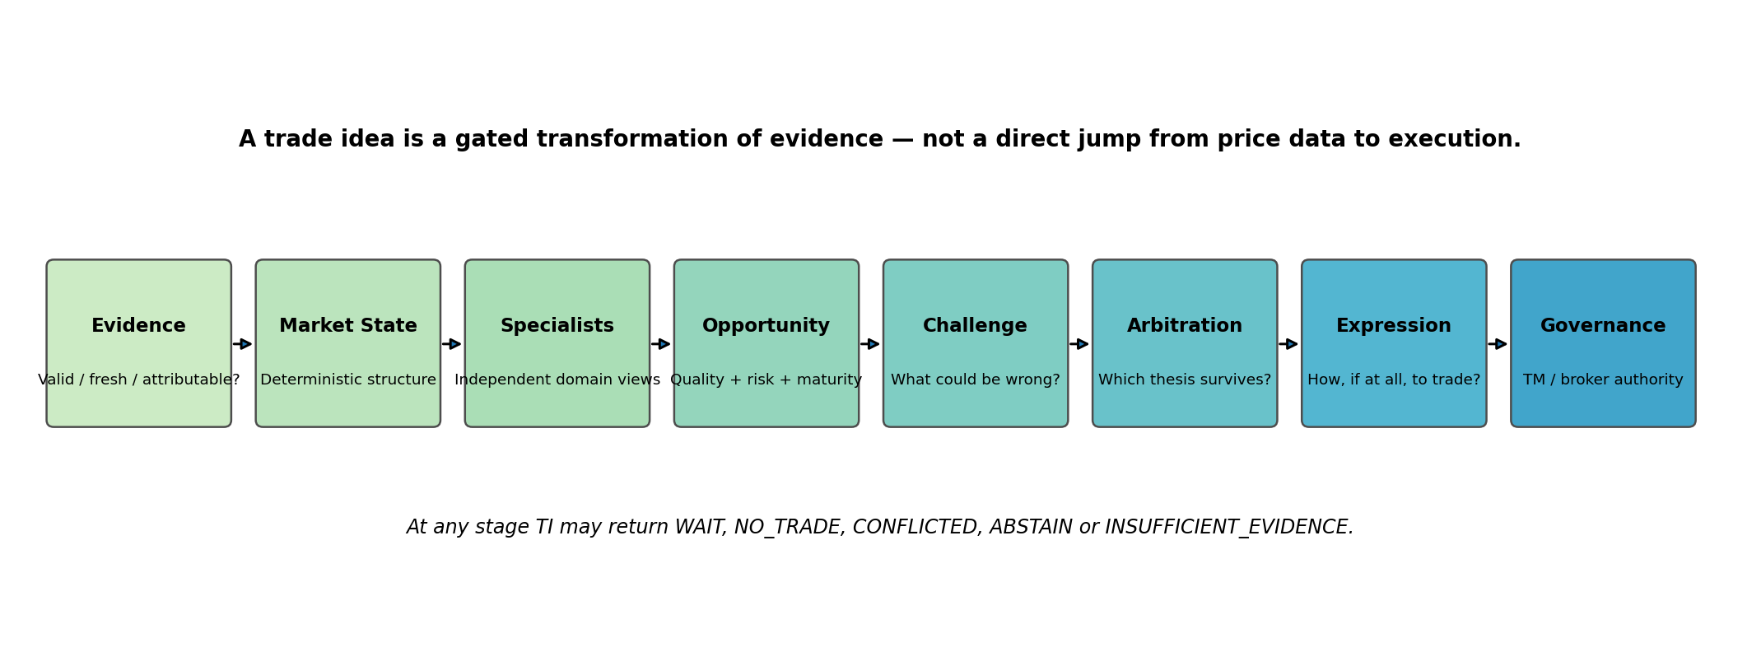
A candidate does not “pass” merely by being bullish or by generating a technical signal. Each stage answers a different question: Is the evidence valid? What is the market state? What do independent specialists think? Is the setup attractive now? What could invalidate the thesis? Does the thesis survive arbitration? If yes, how should it be expressed? Finally, may it be acted upon under operational risk authority?
Gate | Question | Possible positive result | Possible stop result
Evidence | Can TI trust and interpret the inputs? | Admitted evidence | STALE / UNAVAILABLE / INSUFFICIENT_EVIDENCE
Deterministic | What does the price/market structure say? | Qualified market state | NO_TRADE / weak structure
Specialists | What do independent domains say? | Support with explicit dissent | CONFLICTED / missing evidence
Opportunity | Is this setup attractive now? | OPPORTUNITY / WATCH | WAIT / AVOID / NO_TRADE
Challenge | What could be wrong? | Thesis survives criticism | Material unresolved contradiction
Arbitration | Which thesis is best supported? | Proceed conditionally | ABSTAIN / WAIT / CONFLICTED
Expression | How should it be expressed? | Stock/future/option candidate | No suitable expression
Governance | May it be acted upon? | Authorized by TM policy | Rejected / deferred / risk-blocked

3. Three broad layers: foundation, interpretation and decision
Foundation layers (L0–L3). These should be as deterministic, reproducible and evidence-grounded as possible. They establish what TI knows and what the market structure objectively looks like under the chosen rules.
Interpretation layers (L4–L5). These bring multiple specialist viewpoints together without forcing consensus. A strong technical setup can coexist with weak fundamentals or a negative event catalyst.
Decision layers (L6–L7). These ask whether the combined thesis survives challenge and, only if it does, what practical expression is appropriate. These layers carry the greatest reasoning burden and therefore require the strongest audit and authority boundaries.

4. Mapping the hierarchy to the TI roadmap
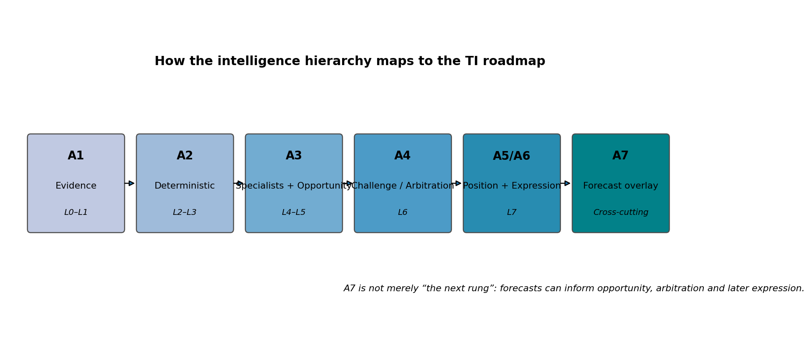
The mapping is approximate because the roadmap is organized by engineering milestones while the hierarchy is organized by intelligence depth. A1 provides evidence; A2 provides deterministic state; A3 supplies specialists and opportunity intelligence; A4 adds challenge/arbitration; A5/A6 turn intelligence into position and trade-expression advice; A7 adds empirically calibrated forecasting and learning.
Important: A7 is an overlay, not merely a final rung. A forecast can influence opportunity assessment, arbitration and trade expression, but it must remain distinguishable from A3 confidence and from deterministic evidence.

5. Why one hierarchy is not enough: depth × horizon × instrument
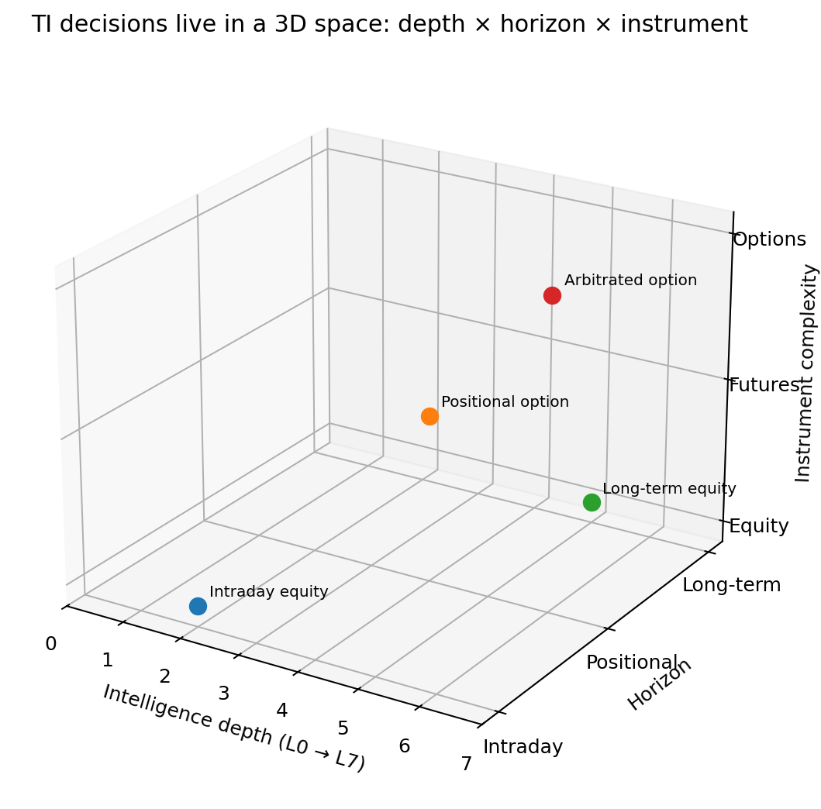
Figure 3. Conceptual 3D view. A TI request exists at a point defined by intelligence depth, time horizon and instrument complexity. The plotted points are illustrative, not measured data.
A five-minute intraday equity trade and a one-year investment in the same company should not invoke the same reasoning mix. The underlying evidence may overlap, but freshness, specialist emphasis, risk interpretation and expression logic differ materially. Likewise, an options trade needs derivatives and expiry-aware reasoning that a delivery-equity thesis may not need.

6. Specialist depth should change with the horizon
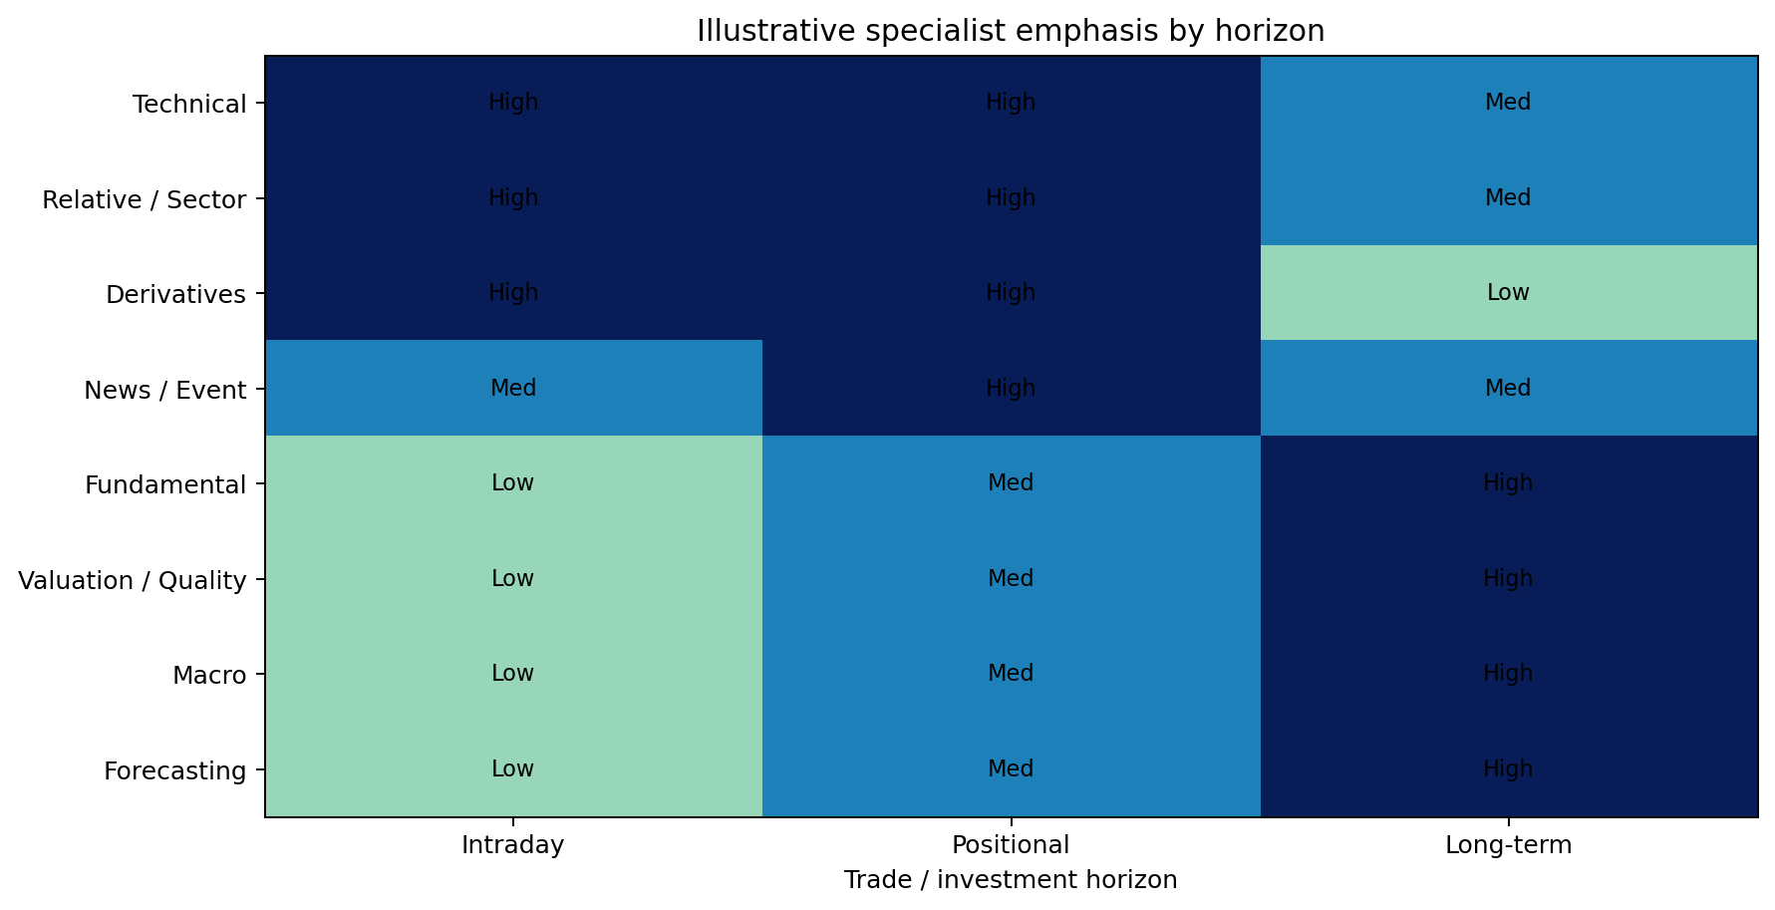
Figure 4. Illustrative emphasis, not a frozen TI policy. It shows the principle that specialist activation should be conditional on the request rather than mechanically running every specialist every time.

7. What each intelligence family contributes
Technical / market structure: Answers where price is, how it is moving, whether structure is healthy, whether the move is early or extended, and what invalidates the setup.
Fundamental / company quality: Answers whether the underlying business quality, financial health, growth, valuation context and sector-specific economics support the thesis.
News / catalyst / event: Answers what changed, whether the event is material, novel and relevant, and whether the market may be repricing new information.
Relative / sector / macro: Answers whether the stock is strong relative to its benchmark/peers and whether sector or macro context supports or opposes the thesis.
Derivatives context: Answers whether options/futures evidence supports, conflicts with or makes the underlying opportunity too risky or expensive.
Forecasting / learning: Later A7 asks not simply “what looks good?” but “what outcomes are empirically likely and how well calibrated has TI been for this task/horizon/regime?”

8. Worked example: a bullish positional candidate
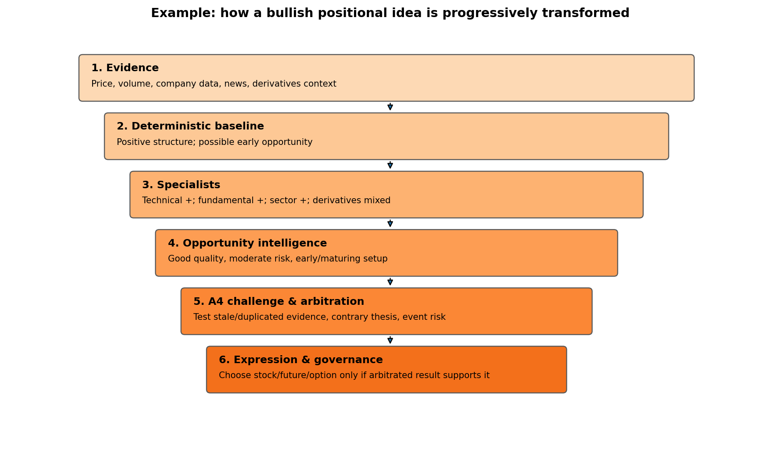

Step 1 — Evidence
TI receives current OHLCV, company fundamentals, recent events/news, benchmark/sector context and derivatives evidence where applicable. It checks identity, timestamps, freshness, provenance and missingness before reasoning over them.

Step 2 — Deterministic baseline
The deterministic engine may conclude that the stock has positive structure and resembles an early opportunity. That is not yet a recommendation; it is a benchmark state that remains visible throughout later reasoning.

Step 3 — Specialist interpretation
Technical may be positive, fundamentals supportive, sector relative strength positive, while derivatives context remains mixed. TI preserves the disagreement instead of averaging it away.

Step 4 — Opportunity intelligence
A3-level assembly asks whether the setup is early, mature or extended; whether risk is acceptable; what evidence is missing; and whether the correct state is OPPORTUNITY, WATCH, WAIT, AVOID, NO_TRADE, CONFLICTED or INSUFFICIENT_EVIDENCE.

Step 5 — Challenge and arbitration
A4 will ask adversarial questions: Is the bullish case relying on duplicated news? Is a provider metric semantically ambiguous? Is event risk being underweighted? Is the apparently negative evidence actually a different time horizon rather than a contradiction? The purpose is not to be pessimistic; it is to prevent fragile conclusions from passing unchallenged.

Step 6 — Expression and governance
Only after the thesis survives arbitration should later TI decide whether the idea is best expressed as delivery equity, futures or an option structure. Operational permission, portfolio risk and broker execution remain governed by TradeMonitor and broker truth.

9. What the user should be able to see behind every decision
- What evidence was used and as of when?
- What did the deterministic baseline say?
- Which specialists supported or opposed the thesis?
- What evidence was missing, stale or ambiguous?
- What contradictions were real, and which were only scope/time differences?
- What challenge changed—or failed to change—the conclusion?
- Why was the result OPPORTUNITY, WAIT, NO_TRADE, ABSTAIN or CONFLICTED?
- If a trade expression was proposed, why was that instrument selected?
- What part of the conclusion came from deterministic rules, model reasoning or future calibrated forecasting?
The audit chain should work downward as well as upward. A user should be able to start from the final decision, drill into the arbitration, inspect specialist opinions, inspect deterministic state, and ultimately reach the exact evidence and source lineage.

10. The hierarchy must not become bureaucracy
The hierarchy is conceptual. It does not mean every request must run every layer, every specialist or every model. The Planner should activate only the evidence and reasoning needed for the objective, horizon, instrument, materiality, budget and uncertainty.
Request | Likely emphasis | What may be skipped or reduced
Intraday stock trade | Technical, relative/sector, liquidity, event risk, derivatives when relevant | Deep valuation or long-horizon forecasting unless a material event requires it
2–6 week positional trade | Technical + fundamental + event + relative + derivatives + A4 challenge | Some very long-term strategic analysis
1-year delivery investment | Fundamental, valuation, industry, macro, governance, longer-horizon forecast | Fine-grained intraday execution intelligence until entry timing is needed

11. A mature intelligence system must be allowed to say “do nothing”
A hierarchy is useful only if every stage is allowed to stop the pipeline honestly. The strongest design is not the one that generates the most trades; it is the one that distinguishes opportunity from uncertainty and poor timing.
WAIT: Potentially valid thesis, but timing or evidence conditions are not yet satisfied.
NO_TRADE: Current evidence does not support a sufficiently attractive setup.
CONFLICTED: Material evidence or specialist conclusions remain unresolved.
ABSTAIN: TI intentionally declines to form a conclusion under the available constraints.
INSUFFICIENT_EVIDENCE: Required evidence is missing, stale, unsupported or unusable.

12. Final thesis
The essence of TradingIntelligence is not a collection of indicators or Agents. It is a controlled hierarchy that transforms attributable evidence into progressively higher-order judgment while preserving the ability to explain, replay and challenge every transformation.
The hierarchy should therefore remain visible in future TI_SHELL and TI_WEB experiences. A concise answer may show only the final state, but the system should always retain a drill-down path from decision → arbitration → opportunity → specialists → deterministic state → evidence → source.
A useful mental model is: pyramid for depth, pipeline for decision flow, and cube for context. Together they explain not only what TI decided, but how deeply it reasoned, for what horizon, and for which instrument.

Appendix A — Conceptual glossary
Term | Meaning in this thesis
Evidence | An attributable observation admitted into TI with identity, time, provenance and quality semantics.
Feature | A deterministic transformation of evidence.
Market state | A deterministic description of current structure under defined policy.
Specialist opinion | A bounded domain interpretation with evidence references, stance, confidence basis and missing evidence.
Opportunity intelligence | A structured description of whether a setup is attractive now, including quality, risk, maturity and conflict.
Challenge | An adversarial examination of assumptions, evidence quality and alternative explanations.
Arbitration | A governed conclusion over competing supported theses without erasing dissent.
Trade expression | The translation of an arbitrated thesis into a candidate instrument/structure, without taking broker authority.
Forecast | A future A7 empirically evaluated estimate of future outcomes; distinct from A3 confidence.
Governance | Operational risk and authority controls, principally TradeMonitor and broker truth.

