TradingIntelligence
Monitoring Architecture Thesis
Subscriber-driven, mandate-centric intelligence that keeps thinking over time
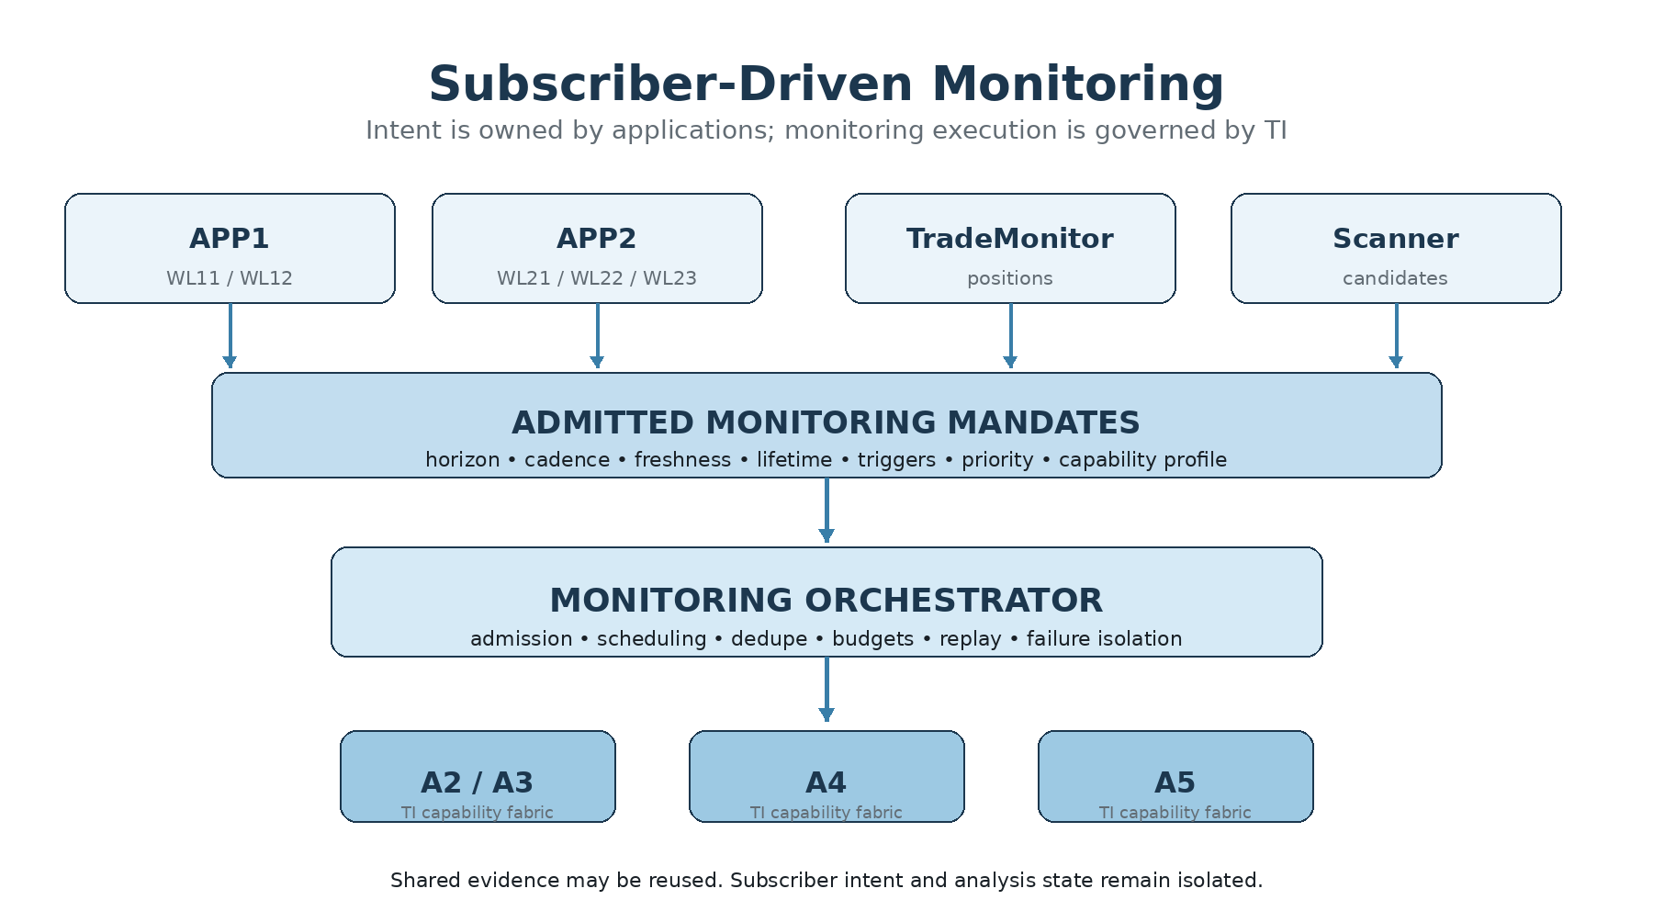
Figure 1. Subscriber intent flows through admitted mandates and a governed monitoring orchestrator into the TI capability fabric.
Concept thesis for TradingIntelligence (TI) • September 2026
Architecture status: monitoring design promoted; recurring runtime not yet implemented.

Executive thesis
TradingIntelligence should not be a watchlist product. It should be a governed intelligence platform that can keep evaluating questions over time on behalf of many authorized subscriber applications. The subscriber owns the business intent. TI owns the disciplined execution of that intent. TradeMonitor owns operational position truth and action governance.
Watchlist is organization; mandate is semantics.
The fundamental future monitoring object is an admitted, immutable, versioned MonitoringMandate for one principal instrument, purpose and horizon. A subscriber may group mandates through its own watchlists—or use no watchlist at all. TI accepts or rejects each mandate under authority, capability, budget, freshness and lifetime constraints.
Deduplicate evidence acquisition, not subscriber intent.
A single stock may be monitored simultaneously by an intraday options app, a positional equity app and TradeMonitor. Compatible market evidence can be fetched once, but each mandate keeps its own horizon, policy, lifecycle, analytical state and result. This is the monitoring form of a core TI principle: Shared Evidence does not imply Shared Analysis State.
Monitoring is intelligence orchestration, not execution.
The monitoring runtime schedules or triggers curated TI capabilities. It does not reproduce technical analysis, sector analysis, A4 arbitration or A5 position intelligence inside a scheduler. It invokes those capabilities under governed composition. Monitoring results remain advice. TM or another authorized consumer decides what to do with them.
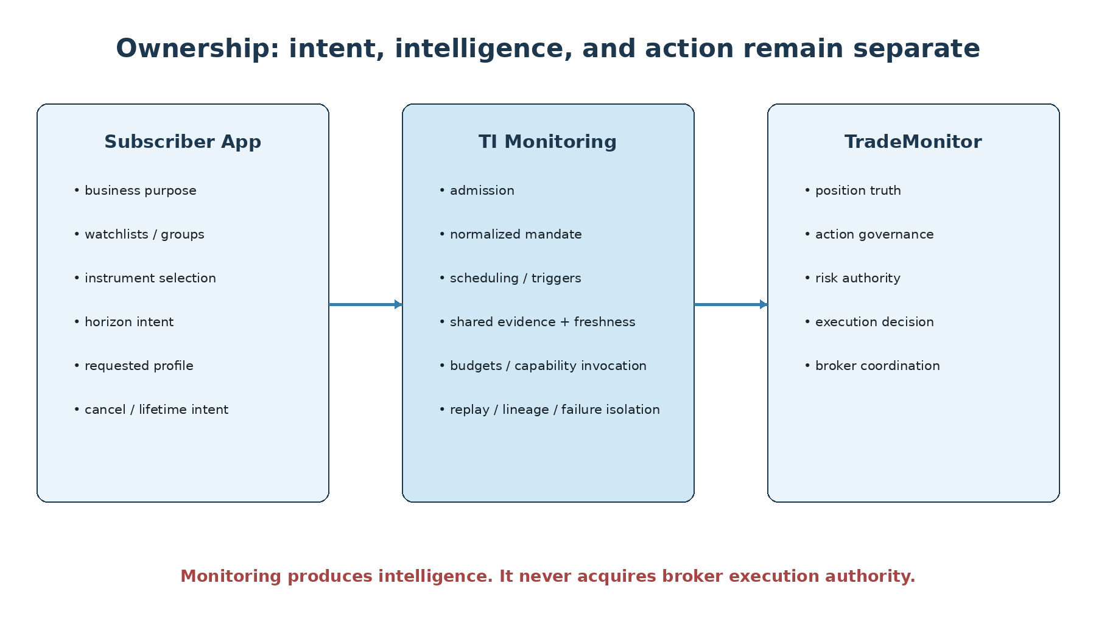
Figure 2. Ownership separation is the safety foundation: the app owns intent, TI owns governed monitoring intelligence, and TM owns position action.

What this thesis is—and is not
This document explains the promoted monitoring architecture, the reasoning behind it, and the implications for future implementation. It intentionally goes beyond a terse engineering specification: it preserves the mental model, examples, diagrams and trade-offs needed to understand why the architecture is shaped this way.
The monitoring architecture was promoted on 12 September 2026, but the recurring runtime is not implemented. The current A5 baseline emits immutable MonitoringNeed and WatchMandate advice and exposes captured position.assess; it does not schedule work. Likewise, no scheduler, queue, persistent monitoring store, remote monitoring API, event bus, lease engine, Sector Rotation runtime or Signal Qualification runtime is implied by this thesis.

1. The problem: intelligence that must remain alive
A one-shot intelligence result answers a question at one evidence cutoff. Markets do not stop at that cutoff. Prices move, positions change, new evidence arrives, sector leadership rotates, option structures decay, and an application’s business purpose may require repeated reassessment. Monitoring exists to bridge that gap without turning TI into an execution engine or an unbounded polling service.
The design challenge is not merely “run this analysis every N minutes.” A useful monitoring architecture must preserve authority, point-in-time integrity, evidence provenance, pluggability, replay, cost accounting, multi-subscriber isolation, failure semantics and the distinction between operational truth and analytical advice.

1.1 Why a TI-owned global watchlist is the wrong center
A global TI watchlist sounds convenient but conflates organization with semantics. It would force TI to own CRUD, synchronization, deletion semantics and the business meaning of lists created by TradeMonitor, scanners, user interfaces and external applications. Yet a list name cannot grant authority, define a horizon precisely, or determine which capabilities are required.
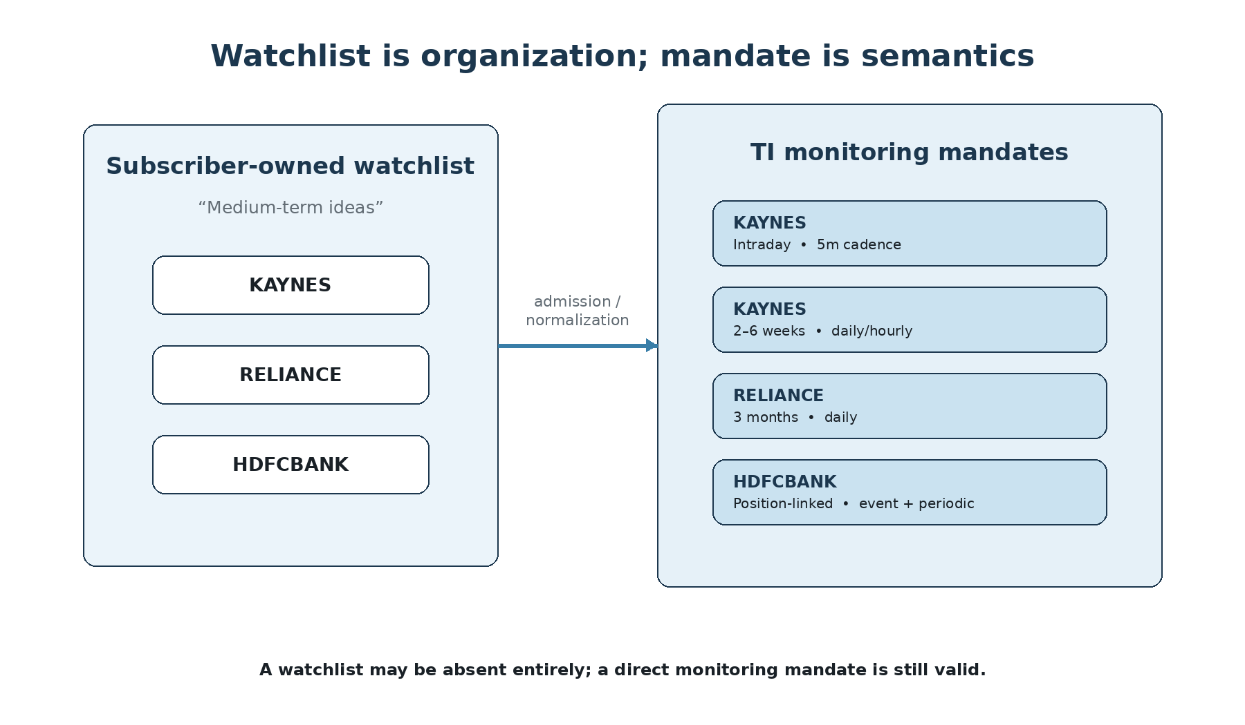
Figure 3. A subscriber-owned watchlist may organize instruments, while TI receives one or more mandates that carry the actual monitoring semantics.
The promoted architecture therefore selects subscriber-owned optional group references and admitted mandates. A future TI-hosted watchlist UI can still exist—but as a separately governed subscriber application, not as a second core monitoring model.

1.2 Why monitoring is a platform capability
Different applications need different horizons, cadences and intelligence depth. A day-trading app may care about the next two hours. A positional app may care about six weeks. TM may care about immediate position protection. A scanner may care only until a breakout either confirms or expires. The architecture must allow all of these without creating separate monitoring subsystems.

2. Subscriber-driven monitoring

Figure 4. The subscriber-driven model: multiple apps express intent; TI admits mandates and executes them through one governed monitoring fabric.
The root of monitoring is the subscriber’s intent, not the symbol. Internal tools and external apps should use the same conceptual admission contract where practical. Their authority profiles may differ, but they do not get architectural bypasses simply because they are “inside TI.”

2.1 Example subscriber applications
Subscriber | Typical purpose | Illustrative horizon | Monitoring style
Equity positional app | Find and hold medium-term opportunities | 2–8 weeks | hourly / daily
Long-term investment app | Structural holdings and thesis health | 6–18 months | daily / weekly / event-driven
Options day-trading app | Short-lived directional candidates | minutes to hours | 1m / 5m / 15m
TradeMonitor | Active-position protection | position-dependent | event + periodic
Scanner | Candidate follow-up | minutes to days | temporary / trigger-driven
TI_WEB / TI_SHELL | User-driven monitoring | varies | subscriber-defined

2.2 No special native monitoring path
If TI_WEB eventually offers watchlists, TI_WEB itself should act as a subscriber. If a scanner discovers a candidate, the scanner may submit a temporary mandate. If TM opens a position, TM may submit or cause admission of a position-linked mandate. One architecture is easier to reason about, secure and replay than separate “native” and “external” monitoring stacks.

3. The fundamental object: MonitoringMandate
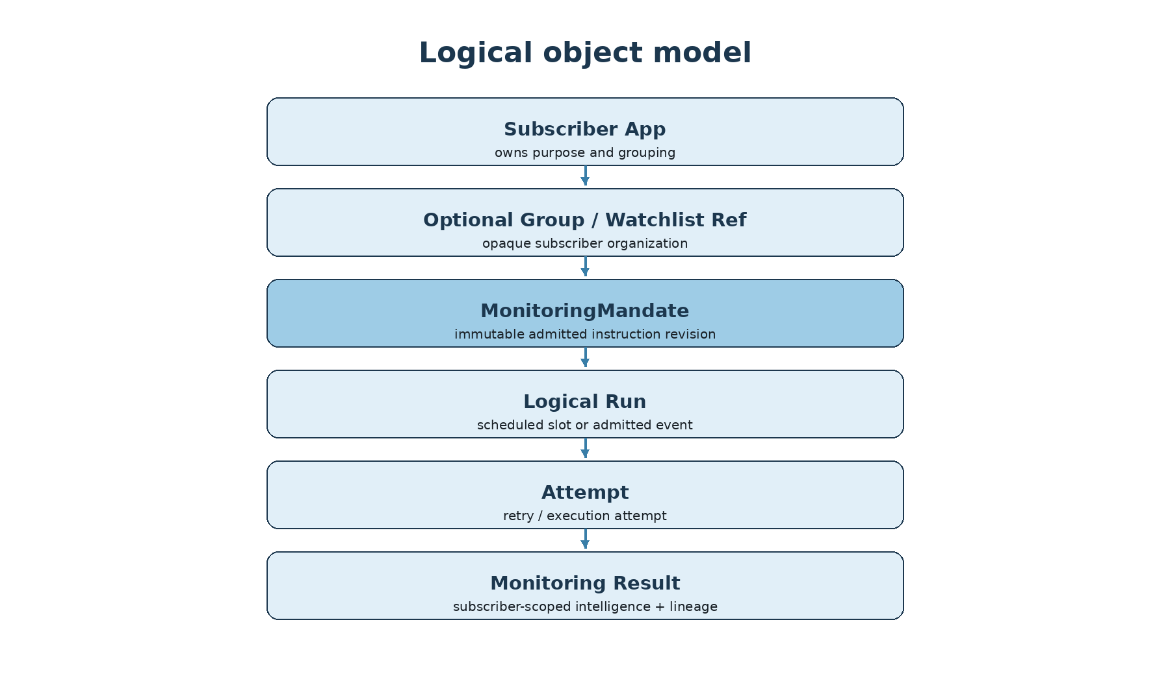
Figure 5. Logical identity flows from subscriber intent to immutable mandate revisions, logical runs, attempts and subscriber-scoped results.
The promoted architecture defines MonitoringMandate as the fundamental future runtime object: an immutable normalized instruction revision for one principal instrument, purpose and horizon scope. A scheduled invocation is not the mandate; it is one run. A watchlist item is not the mandate; it is subscriber organization. An A5 WatchMandate is not automatically an admitted runtime mandate; it is source advice that must later be normalized and admitted.

3.1 Why immutability matters
If an app changes cadence, lifetime, required capabilities or purpose, historical runs should not silently inherit the new meaning. The change should create a new admitted revision linked to its predecessor. This allows replay to answer the question that was actually asked at the time.

3.2 Identity and lineage
Minimum logical identity includes subscriber/caller authority binding, optional group/item references, mandate ID/revision/predecessor, instrument, purpose, canonical horizon, profile provenance, logical run ID, attempt ID and decision as_of. The same symbol can legitimately appear in many mandates simultaneously.

4. Time semantics: five clocks, not one duration
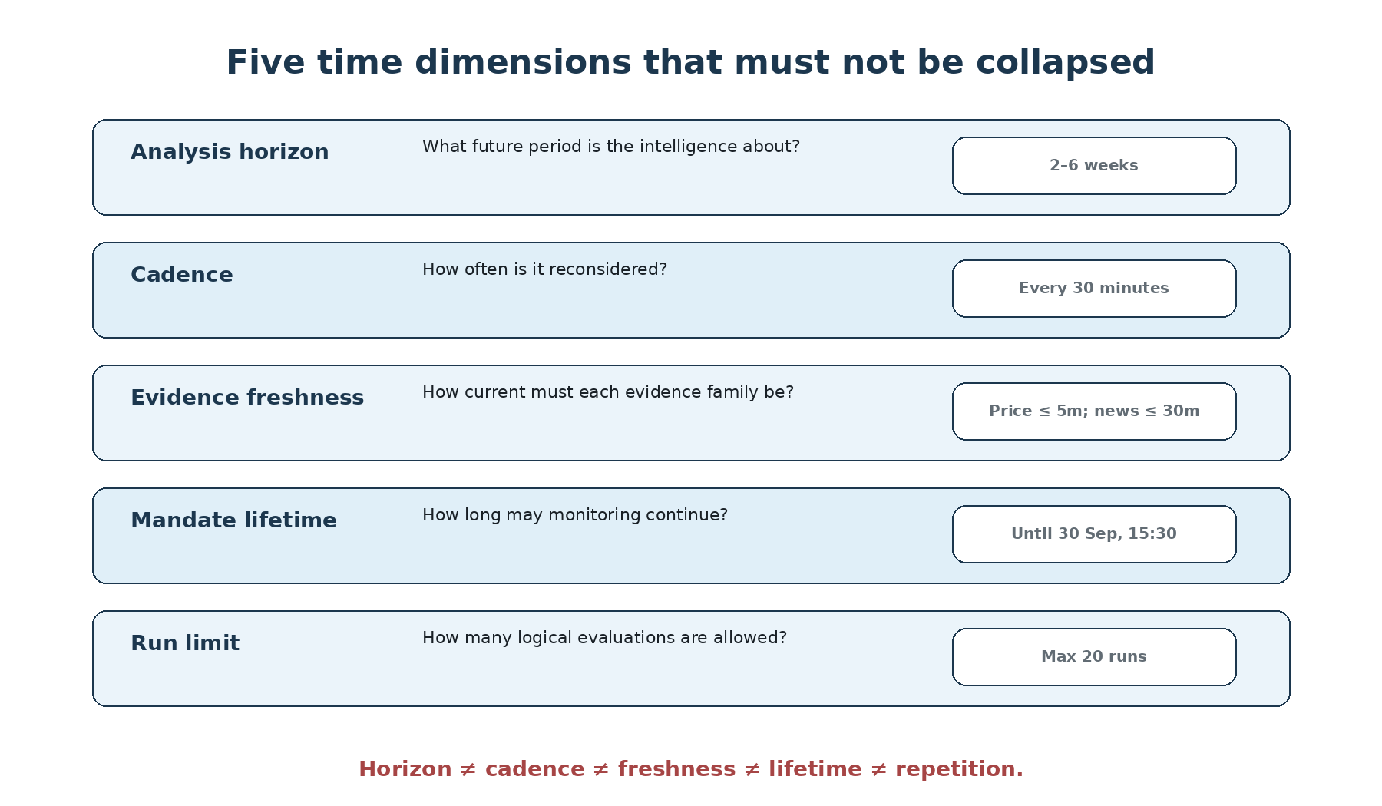
Figure 6. Horizon, cadence, freshness, lifetime and run limits answer different questions and must remain separate.
A common monitoring mistake is to overload “duration.” The architecture instead separates analytical horizon, evaluation cadence, evidence freshness, mandate lifetime and maximum evaluations. This is essential because an investment thesis can have a three-month horizon while being checked hourly, and an intraday strategy can require a two-hour horizon with five-minute reevaluation.

4.1 Canonical horizon
Subscriber labels such as SHORT, SWING or MEDIUM may be preserved for UI and lineage, but TI should not guess their meaning. The admitted mandate should include a canonical duration or explicit target interval under a versioned mapping. Trading-session semantics require an approved calendar contract; wall-clock intervals must not pretend to understand exchange holidays.

4.2 Lifetime and termination
The normalized mandate has finite valid_from and valid_until bounds in the promoted architecture. New dispatch is refused outside the interval. Additional terminal conditions can include run limits, explicit cancel, admitted termination events, verified position closure for position-linked monitoring, or authority termination.

4.3 No universal max_runs=1
One-shot evaluation and recurring monitoring are distinct workflows. A mandate may explicitly allow a single run, but “monitoring” does not silently default to one evaluation. Existing typed capability requests remain the natural one-shot path.

5. One instrument, many intentions
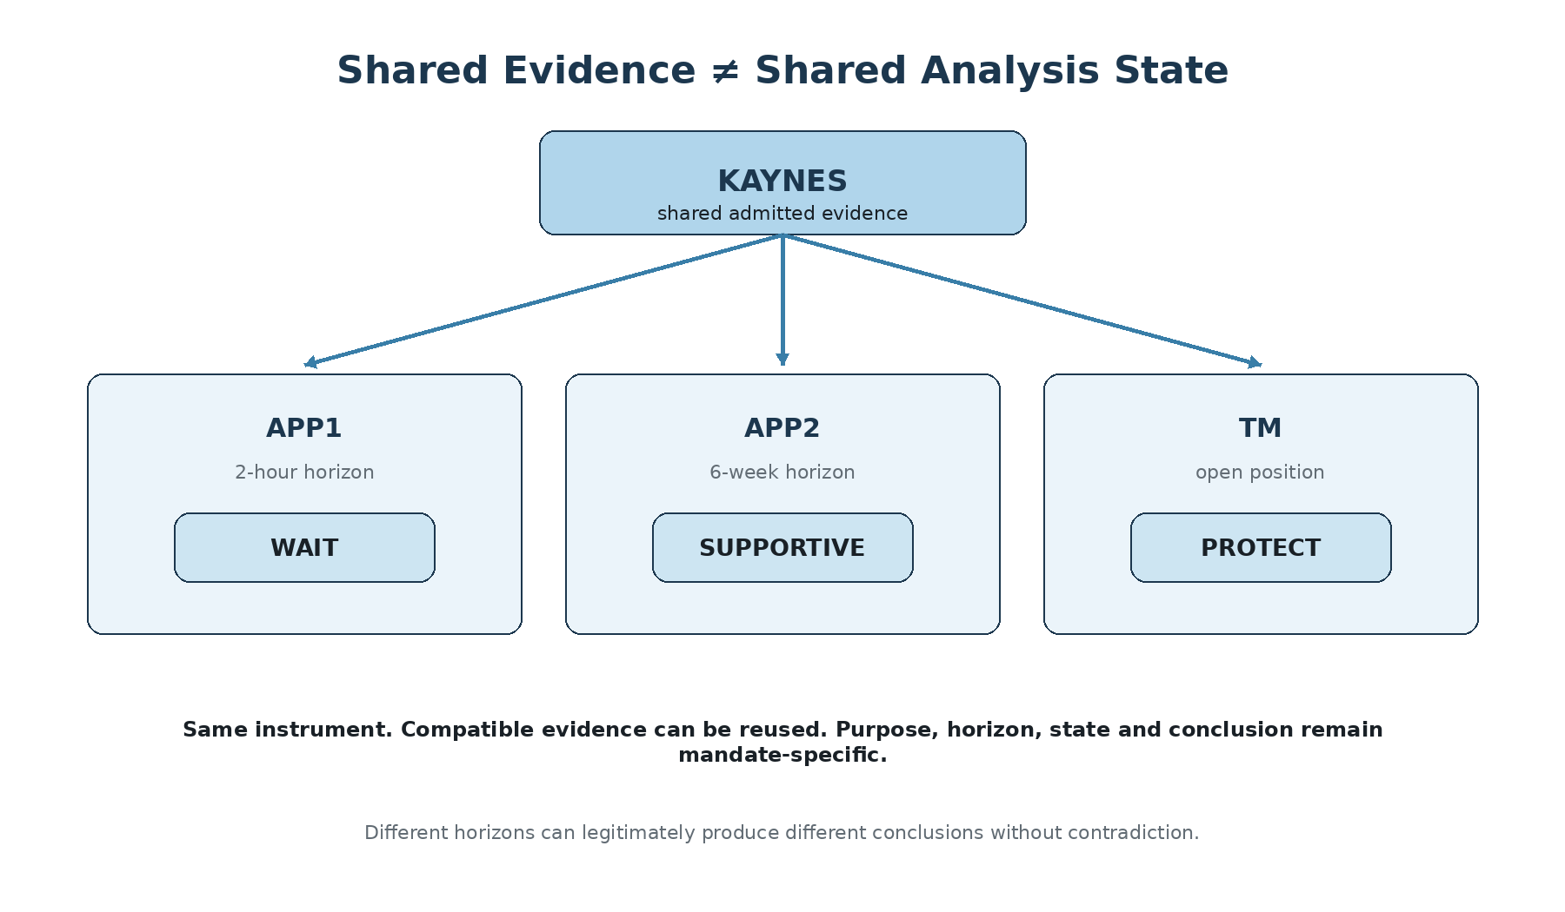
Figure 7. The same evidence can support different valid conclusions because mandate horizon, purpose and policy differ.
The architecture explicitly permits multiple mandates for the same instrument. A short-horizon app may decide WAIT while a long-horizon app remains SUPPORTIVE and TM recommends PROTECT on an open position. That is not necessarily inconsistency. It may simply reflect different proposition scope.

5.1 Contradiction requires comparability
Before calling two monitoring results contradictory, TI must compare proposition identity, effective interval, horizon, basis and admitted availability. “Bullish over six months” and “weak for the next two hours” are different propositions. This aligns monitoring with the Source Authority, Provenance and Contradiction architecture rather than creating a simplistic symbol-level conflict detector.

5.2 Why subscriber state remains isolated
Even when evidence is shared, one subscriber’s purpose, budget, priority, lifecycle and analysis state cannot leak into another subscriber’s result without an explicit shared context. Logical isolation matters even in a single local process; it does not require a distributed multi-tenant deployment.

6. Shared Evidence != Shared Analysis State

Figure 8. Shared evidence can be reused; the three mandate interpretations remain independent.
The optimization target is compatible acquisition and computation—not semantic merger.
If seven mandates need the same five-minute candle and compatible entitlements, TI should not fetch it seven times. If several mandates need the same admitted news document and their freshness requirements are compatible, TI may reuse it. But the fact that evidence was shared does not permit TI to merge the mandates, average their conclusions, or erase horizon differences.

6.1 Dedupe boundaries
A safe dedupe decision must consider provider/account/data entitlements, authorization, instrument and venue, requested fields, adapter/schema/policy versions, PIT cutoff, actual availability and each consumer’s freshness need. Unknown dimensions are not wildcards. Rights should be rechecked on cache return.

6.2 Evidence refresh is not automatic full reanalysis
The architecture keeps evidence acquisition, analytical evaluation and notification as separate activities. A fresh price update may not require every expensive specialist to rerun. Conversely, a material event may require deeper reassessment. Full dependency-aware incremental recalculation remains future work; the scheduler must not quietly become a second Planner.

7. Capability-oriented monitoring and pluggability
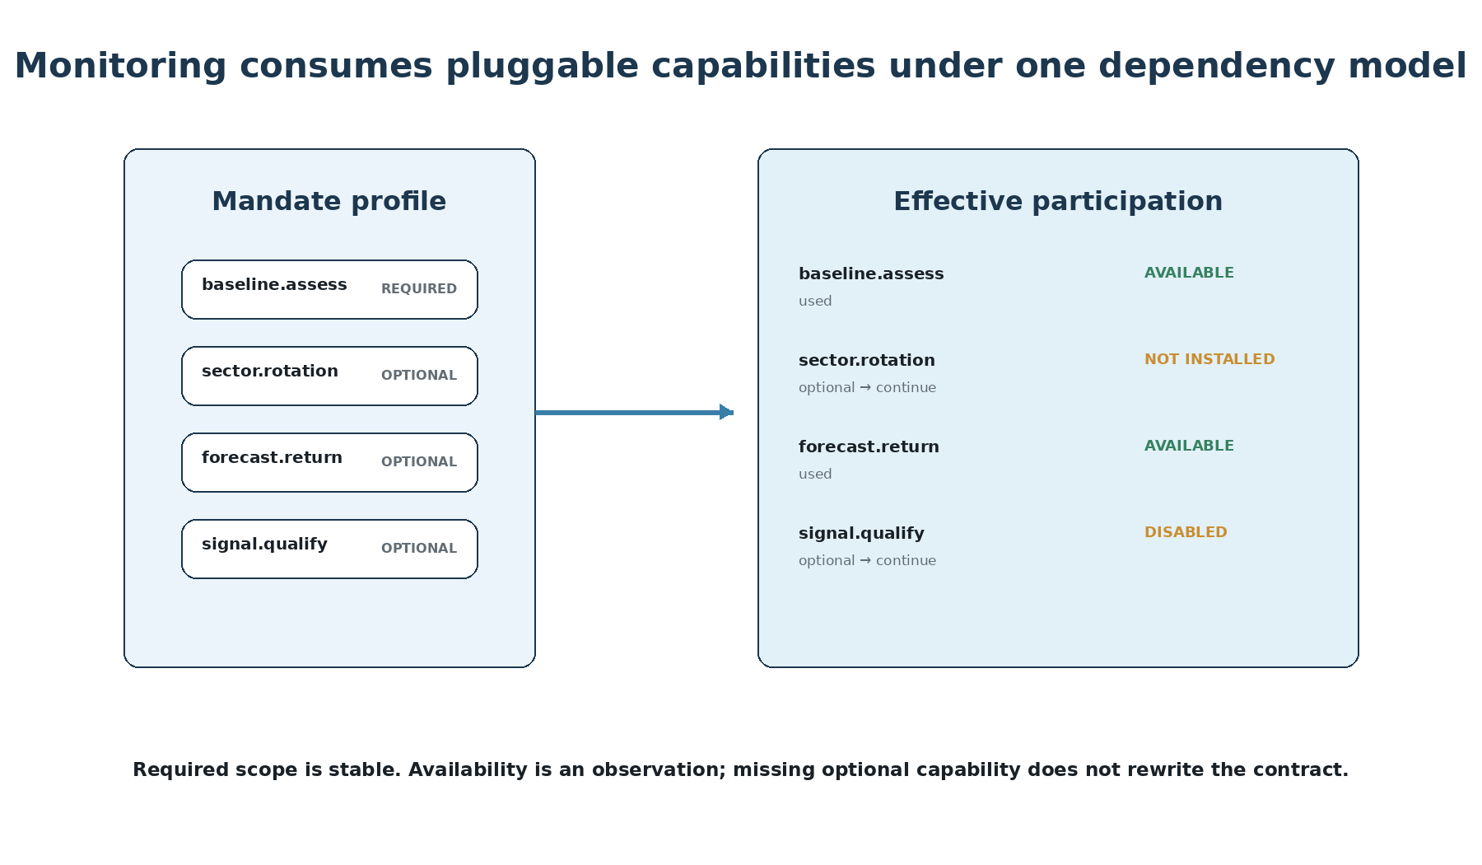
Figure 9. A monitoring profile uses the same required/optional dependency semantics as the rest of TI.
Monitoring should invoke governed capabilities, not specialist or provider internals. Existing public capabilities include position.assess, opportunity.assemble and a4.evaluate, although their current paths operate on captured reads rather than live refresh. A future useful monitor therefore needs separately accepted input acquisition/admission and input-binding semantics—it must not relabel a captured replay as live monitoring.

7.1 One dependency model, not two
A monitoring intelligence profile declares required and optional capabilities/evidence using the same first-order pluggability model as the rest of TI. Required scope is stable. Availability is an observation. requested ∩ available must never silently erase required obligations; this is the lesson formalized by accepted pluggability R1.

7.2 Pluggability classification
Component | Expected pluggability | Reason
Mandate / run / lineage contracts | STRUCTURAL | versioned semantics; compatibility required
Scheduler | COLD + replaceable | startup composition is sufficient initially
Persistence adapter | COLD + replaceable | durability implementation may change behind contract
Event ingress | COLD + optional | not required for periodic first slice
Notification adapter | COLD + optional | delivery transport is separate from intelligence
Adaptive cadence policy | Optional / deferred | should not become hidden mutable learning
Telemetry backend | COLD / optional exporter | minimum audit remains required
HOT loading | Not required | runtime mutation adds lifecycle complexity without current value

7.3 Monitoring profiles
Profiles are versioned trusted COLD configuration. They may define cadence and freshness bounds, depth, triggers, lifetime/run ceilings, priorities, budgets and missed-run policy. Subscriber preferences are intersected with grants and ceilings; a profile never confers authority.

8. Admission: the boundary between intent and authorized work
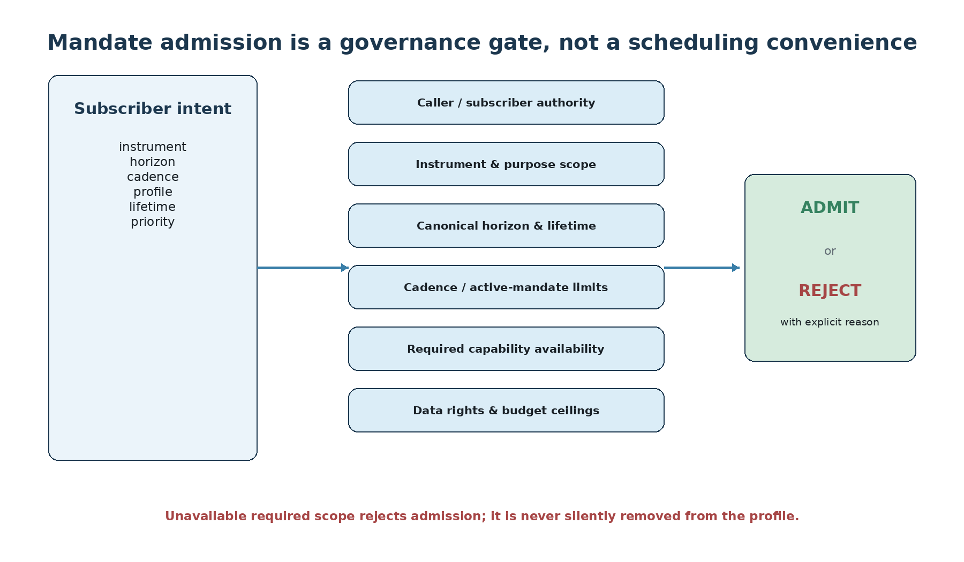
Figure 10. Admission stabilizes scope before scheduling begins.
An app can ask TI to monitor almost anything; TI is not obligated to accept it. Admission validates authority, instrument universe, purpose, horizon, lifetime/run bounds, cadence floor, capacity, profile compatibility, required capability availability, data rights and budget ceilings.

8.1 Atomic admission in the first version
The promoted design chooses atomic admission per mandate, not a batch partial-acceptance protocol. Optional gaps may be disclosed on an accepted mandate; unavailable required capability rejects admission without shrinking the profile. Later required loss becomes an explicit blocked/degraded obligation, never completeness-by-omission.

8.2 Idempotency and immutable amendment
External callers may retry after timeout. Idempotency is therefore scoped by subscriber, operation and client key with a canonical request digest. Same key and same intent returns the same admitted record; same key with different intent conflicts. Amendments create immutable successor revisions. Cancellation is idempotent and leaves an auditable terminal record.

8.3 Why there is no mandatory lease initially
Finite validity plus explicit cancellation is enough for the first version. A disconnected remote subscriber may justify a lease/heartbeat protocol later, but absence of heartbeat must never be mistaken for operational position closure.

9. Scheduling and execution guarantees
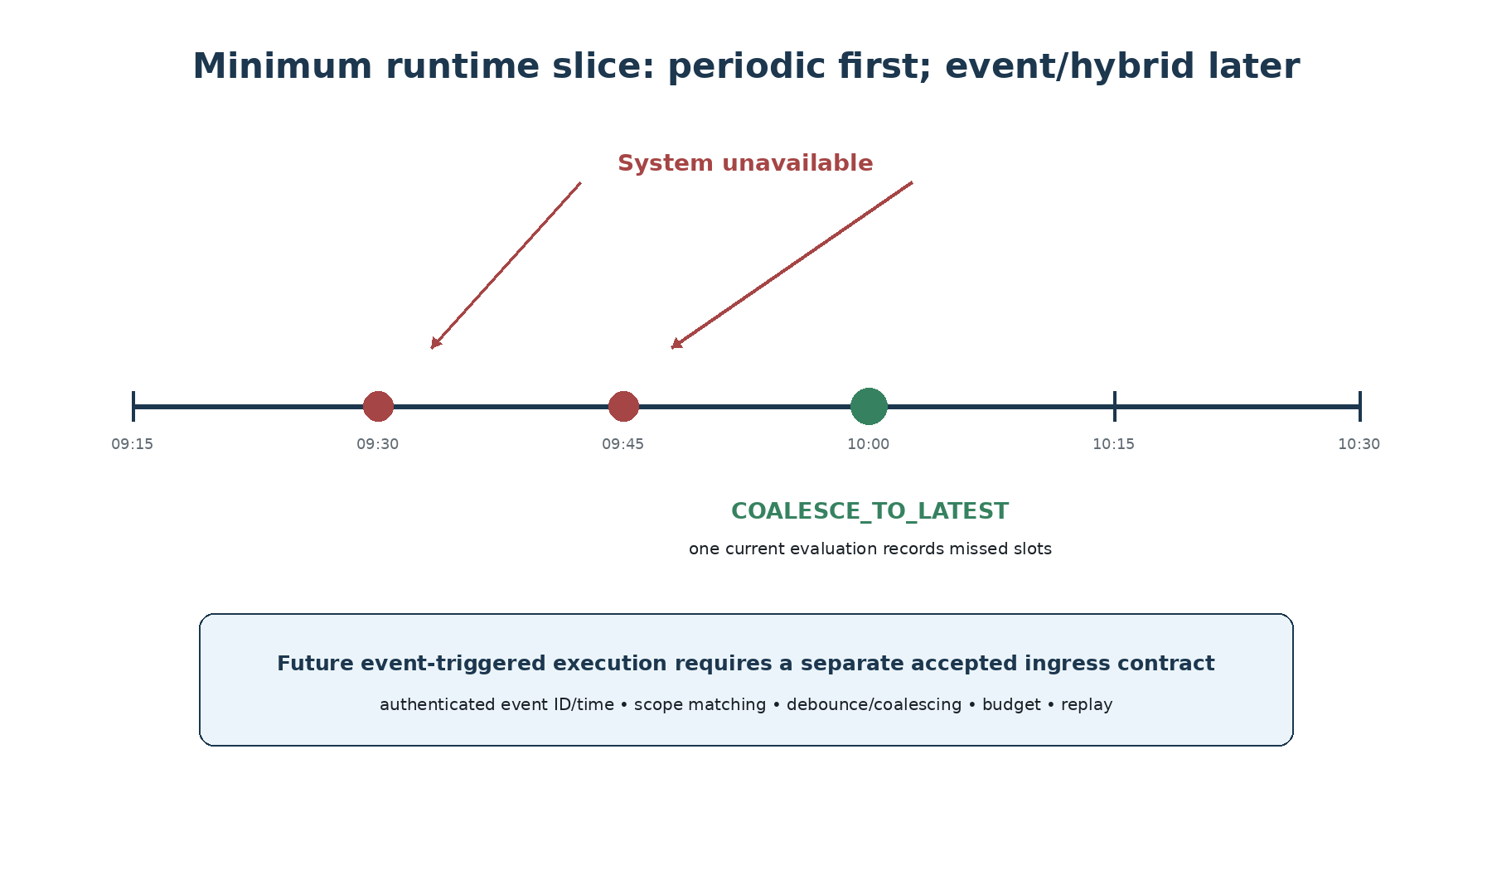
Figure 11. Periodic scheduling is the minimum accepted slice; event-driven monitoring is a later gate.
The minimum future runtime is deliberately conservative: fixed periodic scheduling with bounded due scans, concurrency, attempts and backoff. The default missed-run policy is COALESCE_TO_LATEST: evaluate the current eligible state once and record the missed slots. SKIP_MISSED may be explicitly selected. REPLAY_MISSED is deferred until historical inputs, PIT rights, budgets and evaluation semantics are proven.

9.1 Event-driven monitoring is allowed, not assumed
The architecture permits event/hybrid execution, but only behind a separately accepted typed ingress with authenticated event identity/time, scope matching, debounce/coalescing rules and budget controls. A5 trigger hints are not event detectors, and specialists must not hide their own polling loops.

9.2 At-least-once with idempotent run identity
The runtime should guarantee at-least-once due delivery with idempotent logical run identity, not exactly-once execution. A logical run binds the mandate revision plus scheduled slot or admitted event identity; retries receive separate attempt IDs. Ambiguous provider/model timeouts are recorded as outcome-unknown rather than assumed free failures.

10. A5, Monitoring Runtime and TradeMonitor
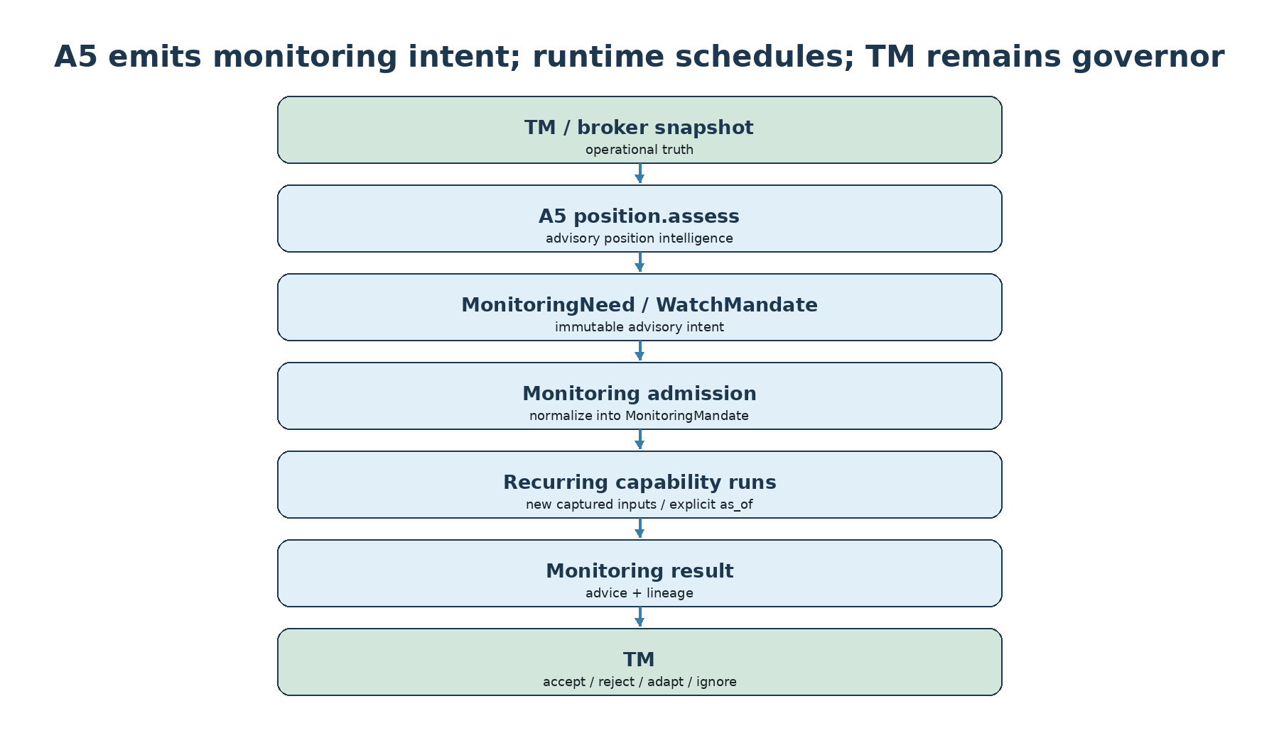
Figure 12. A5 generates advisory monitoring intent; future runtime normalizes it into admitted work; TM keeps action authority.
A5 already owns position-aware interpretation and emits MonitoringNeed / WatchMandate advice. Those accepted A5 values remain unchanged. They are not jobs, grants or guarantees. Future monitoring admission must normalize source advice into a distinct MonitoringMandate while retaining lineage to the source capture, position, needs, policy and budget references.

10.1 No self-expanding feedback loop
An A5 assessment never auto-registers or auto-renews work. A later A5 result may recommend new refresh needs, but changing normalized scope requires a new admitted revision. Intelligence cannot expand its own authority merely because it generated a recommendation.

10.2 Position closure semantics
External authoritative position closure may end a position-linked mandate under an admitted rule. Stale or unknown position state is not closure. EXIT_RECOMMENDED is not a close event. A cancelled position mandate can coexist with a separate authorized candidate mandate for the same stock.

11. Lifecycle is orthogonal
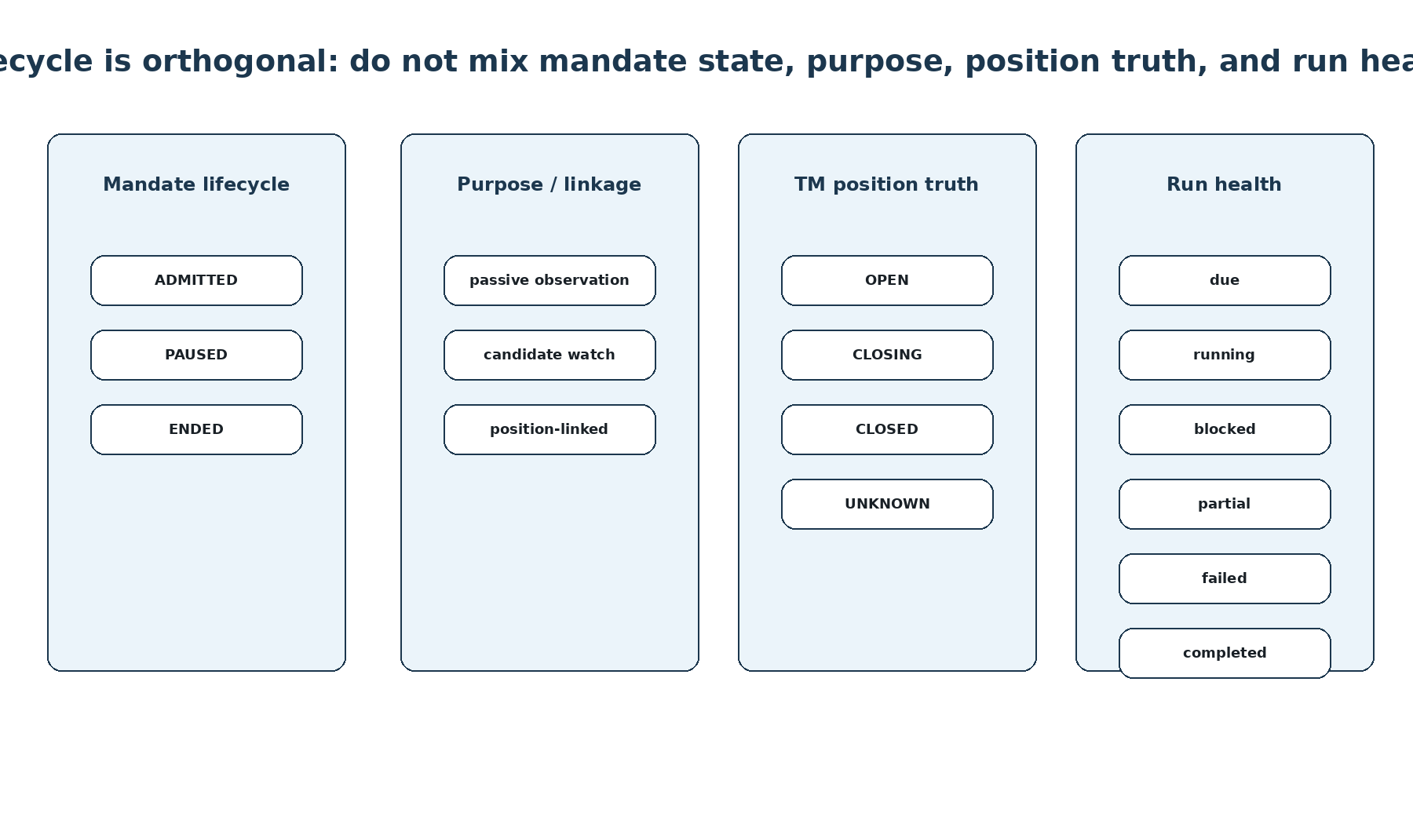
Figure 13. Mandate lifecycle, business purpose, TM position truth and run health are different dimensions.
Older monitoring ideas used PASSIVE, ACTIVE_WATCH, ACTIVE_POSITION and INACTIVE as if they formed one lifecycle. The promoted architecture separates them. Runtime mandate lifecycle is ADMITTED, PAUSED or ENDED. Purpose/linkage describes passive observation, candidate watch or position-linked intent. TM position truth is external. Run health belongs to execution records.

11.1 Why this separation matters
If these dimensions were collapsed, an UI color or A5 advisory label could accidentally be interpreted as operational truth. The separation prevents statements such as “ACTIVE_POSITION means TI owns the position” or “INACTIVE means the broker position is closed.” Neither is valid.

12. Persistence, restart and replay
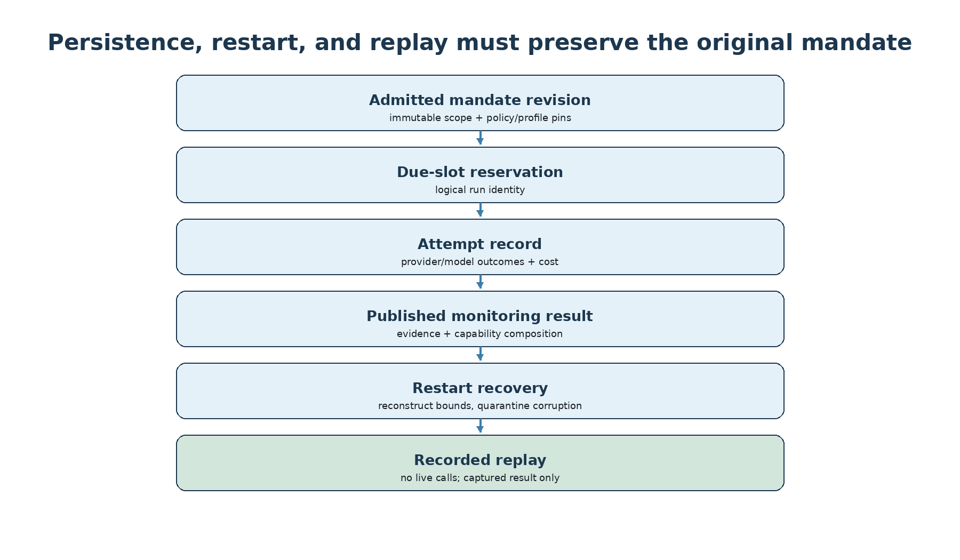
Figure 14. Durable monitoring requires persisted intent, run reservation, attempt outcomes and result lineage before restart safety can be claimed.
Monitoring cannot be called durable merely because the repository can store JSON artifacts. Before claiming restart-safe monitoring, the runtime must persist admitted revisions and idempotency results, lifecycle changes, due-slot reservations, attempts and unknown outcomes, budget references and published result references under a recoverable journal/state protocol.

12.1 Filesystem first, database only when justified
Deployment architecture remains conservative: local single-writer first. Filesystem storage is acceptable only if atomic publication, collision handling, interrupted-write recovery and backup/restore are proven. SQLite or another database should be selected only when demonstrated transactional requirements warrant it.

12.2 Replay is not re-monitoring
Recorded replay returns the captured result without live calls. Verification uses captured inputs and exact compatible bindings. Newly installed capabilities do not enter old runs. If historical code is unavailable, the result is explicitly unverifiable rather than silently reconstructed with current policies.

13. Cost, priority and failure isolation
Monitoring turns one-shot cost control into an ongoing resource-allocation problem. The design therefore reuses existing run, attempt, reservation and usage ledgers rather than inventing a monitoring-only accounting system. Limits may apply at operator, subscriber, mandate and run levels.

13.1 Shared work has one physical cost
If one provider call serves multiple compatible mandates, TI should record one actual usage identity with explicit beneficiaries/allocation. It must not double-count physical cost, but it also must not pretend shared work is free to every subscriber. Unknown monetary cost remains unknown until reconciled.

13.2 Priority is not authority
A position-linked mandate may receive approved high priority, but priority cannot bypass required scope, exceed budget, reveal another subscriber’s data, or turn a recommendation into execution. Backpressure and per-mandate failure isolation remain mandatory.

13.3 Notification failure is not analytical failure
Delivery transport is separate. If a callback fails, the analytical result remains a valid captured result. Future notification transports need their own idempotent delivery attempts rather than triggering a fresh intelligence run merely because delivery failed.

14. Worked scenario: the same stock across three applications
Consider KAYNES appearing simultaneously in three contexts. The purpose of this example is not to recommend a trade; it is to show why mandate scope must be explicit and why evidence sharing cannot imply shared conclusions.
Dimension | Options day app | Positional equity app | TradeMonitor
Purpose | entry discovery | medium-term opportunity | position protection
Horizon | 2 hours | 2–6 weeks | while position open
Cadence | 5 minutes | hourly / daily | 15m + approved events
Required capability | baseline / qualifier profile | opportunity / A4 profile | position.assess / A5
Sector Rotation | optional | optional / valuable | optional context
Priority | normal/high during session | normal | high under risk policy
Possible result | WAIT | SUPPORTIVE | PROTECT

Compatible quotes, candles and admitted news may be reused across these mandates. Yet the three results are not votes on one proposition. They answer different questions. This is why the system must preserve mandate purpose, horizon and profile all the way into result identity and replay.

15. Worked scenario: an options app for one market session
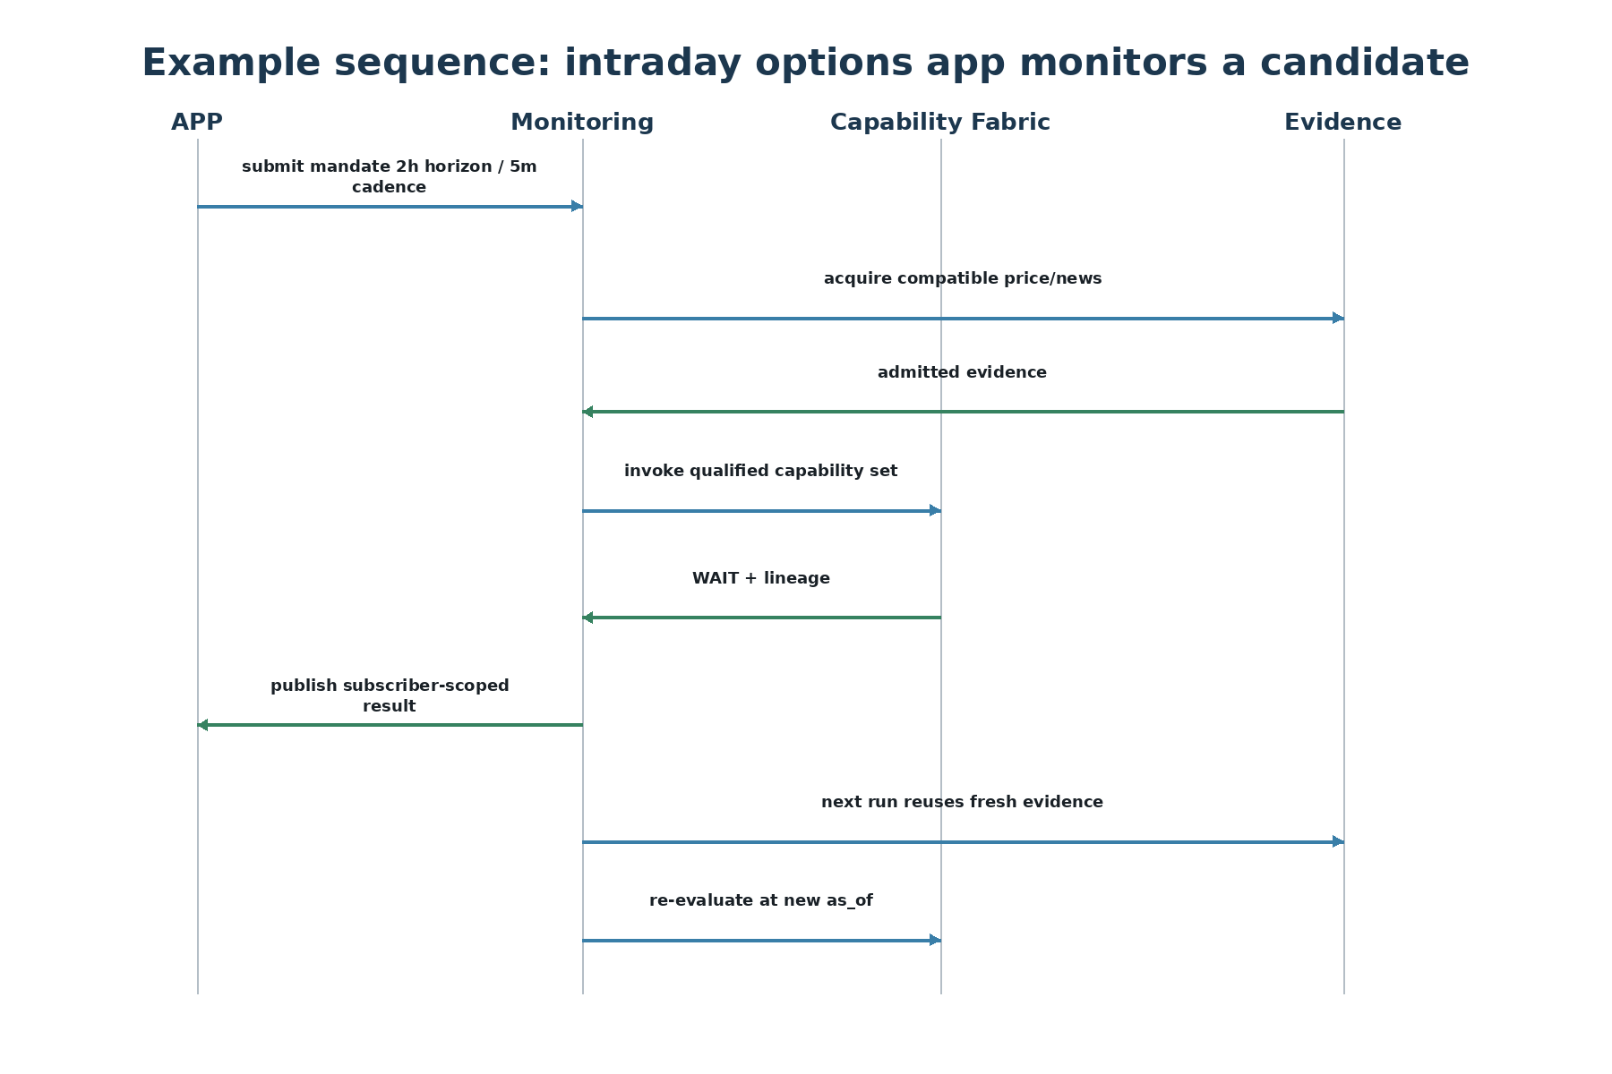
Figure 15. Example interaction sequence for a short-lived subscriber mandate.
An options app may submit a set of underlyings valid only for the current trading session. TI admits individual mandates under bounded cadence and lifetime. Each logical run captures a new as_of and exact input references. Shared evidence may reduce acquisition cost, while the mandate-specific qualifier or A4 context remains separate.

15.1 End-of-session behavior
When valid_until is reached, no new dispatch is allowed. Already admitted in-flight work may complete and be recorded according to policy, but it does not create another eligible run. The app does not need to delete a global TI watchlist; the mandate simply ends with explicit reason.

16. Worked scenario: long-term monitoring with low-frequency evidence
A long-term investment app might track a stock for six months with daily price context, event-driven material news and quarterly fundamentals. The mandate horizon is long, but evidence-family freshness is heterogeneous. The runtime should not fetch or recompute everything at the fastest clock merely because price updates are frequent.
This example shows why freshness policies belong to evidence families and why monitoring profiles should translate subscriber intent into bounded internal clocks. It also shows why the scheduler should not become a second dependency engine: the Planner and capability semantics remain authoritative for intelligence composition.

17. “Day in the life” of centralized monitoring
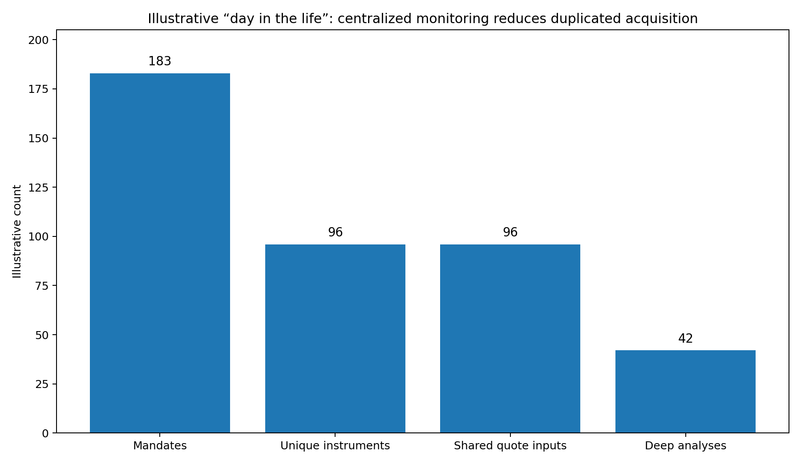
Figure 16. Illustrative—not measured—load example showing why mandate count and unique acquisition work can differ.
Imagine, purely illustratively, seven subscriber applications producing 183 active mandates across 96 unique instruments. The monitoring orchestrator may still need 183 mandate-specific interpretations, yet compatible quote acquisition can often be reduced toward the number of unique instruments. Expensive deeper analysis can be limited further through profiles, materiality and freshness.
183 mandates do not imply 183 independent market-data acquisitions.
This is the economic reason centralized monitoring can be valuable. It creates a place to enforce evidence reuse, budgets, authority and replay while preserving subscriber intent. The numbers in Figure 16 are illustrative only; production capacity planning must be measured empirically.

18. Failure modes the architecture is designed to prevent
Failure mode | Why dangerous | Architectural protection
Required capability silently missing | false completeness | stable required scope + explicit absence
Watchlist deletion rewrites history | audit loss | immutable admitted mandate revisions
Same symbol mandates merged | intent/horizon loss | dedupe evidence, not mandate state
A5 advice treated as job | authority confusion | future admission required
Stale position interpreted as closed | incorrect lifecycle | TM remains operational truth
Retry creates duplicate mandate | runaway monitoring | idempotent admission key/digest
Crash causes blind re-execution | duplicate cost / ambiguity | run reservation + attempt lineage + unknown outcome
Notification failure triggers reanalysis | unnecessary cost | delivery attempts separate from analysis
Latest plugins enter old replay | historical rewrite | pinned composition / recorded result replay

19. What is implemented today versus future architecture
Area | Status as of Sep 2026
A5 MonitoringNeed / WatchMandate advisory values | Implemented and accepted
position.assess over captured complete request | Implemented and accepted
Authoritative Monitoring Architecture | Promoted
Recurring scheduler | Not implemented
Durable monitoring persistence | Not implemented
Remote subscriber API | Not implemented
Event/hybrid ingress | Not implemented
Sector Rotation runtime | Not implemented
Signal Qualification runtime | Not implemented
HOT plugin loading | Not required / not implemented

This distinction is deliberate. Architecture promotion means the design is coherent enough to guide future work. It does not grant runtime authority or imply that deployment acceptance has occurred.

20. Relationship to pluggability R2–R5
The monitoring architecture deliberately depends on the first-order pluggability model rather than creating its own plugin system. Several later pluggability remediations strengthen monitoring, but none is an A5 freeze blocker.
Work | Monitoring relevance
R2 — descriptors/dependencies | monitor compatibility and dependency metadata for generic admission
R3 — composition envelope/pinned verifier | exact run composition and replay truth
R4 — optional adapter import isolation | operate safely when optional SDKs are not installed
R5 — COLD ownership/configuration | reproducible startup bindings for scheduler, persistence and profiles

A bounded static allowlist could support an early runtime slice before a complete discovery fabric exists, but required/optional scope and composition must never be inferred from what happens to be installed.

21. Roadmap and staged implementation
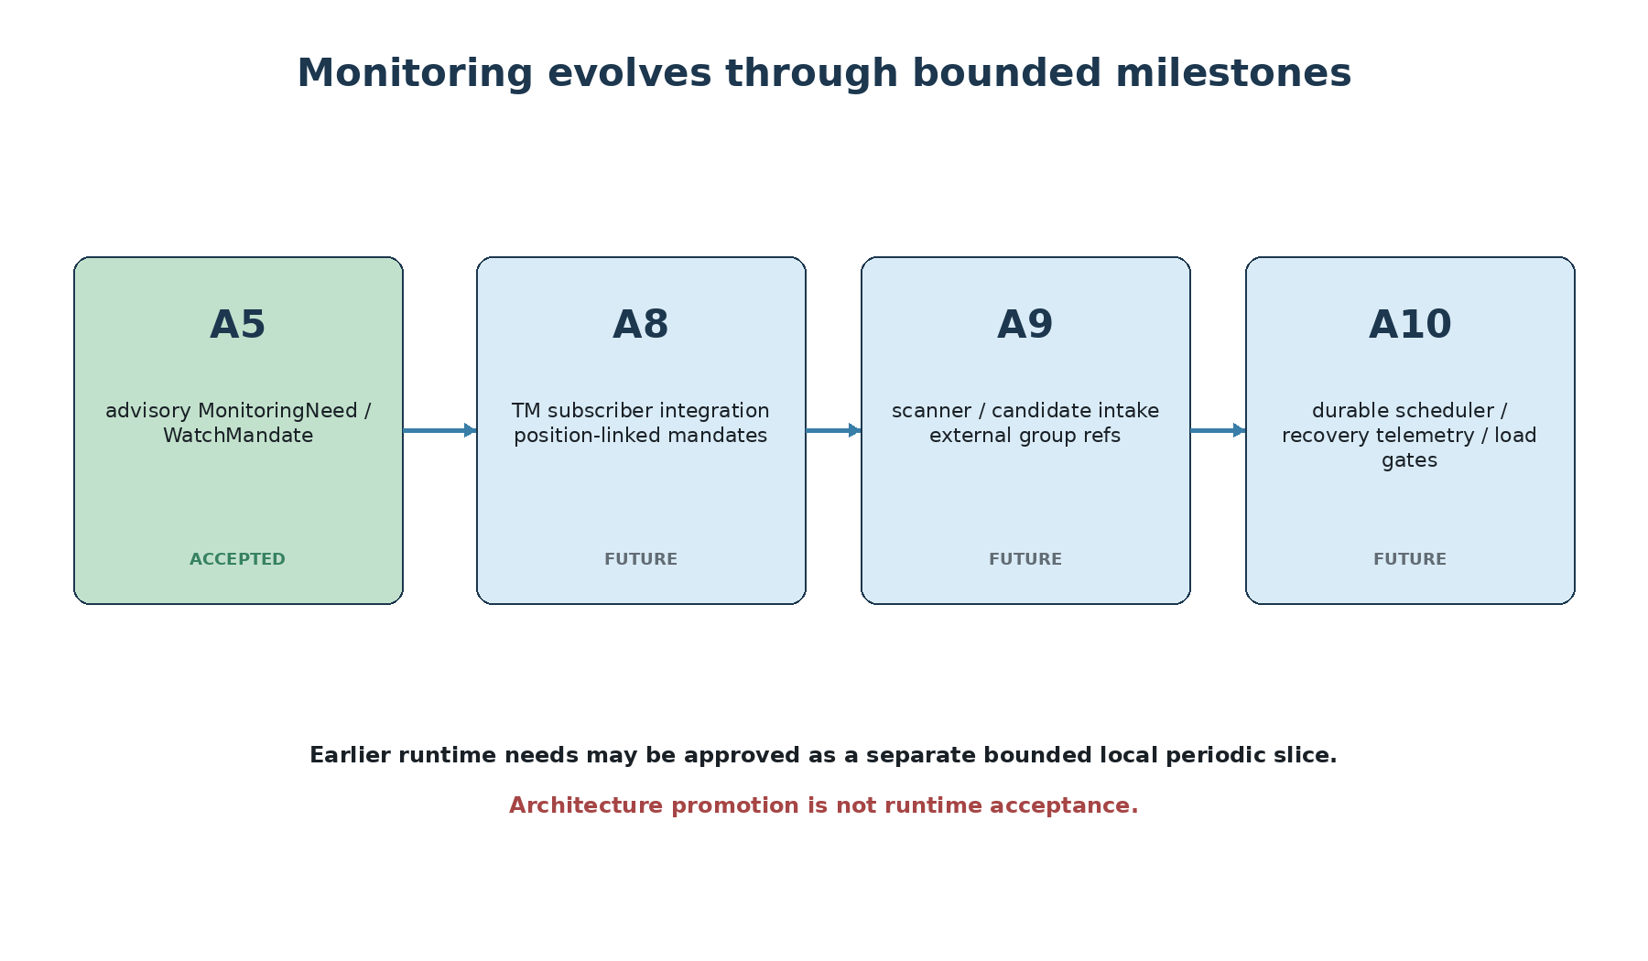
Figure 17. Monitoring responsibilities are intentionally distributed across later milestones.
A8 owns TM subscriber integration and authoritative position lifecycle linkage without transferring execution authority. A9 owns scanner/candidate intake as another subscriber. A10 owns durable recurring runtime, scheduling/recovery, operational telemetry and approved delivery. If earlier milestones genuinely need recurrence, a separate bounded local periodic slice may be accepted without pretending A10 is complete.

21.1 Why staged delivery matters
Monitoring is easy to overbuild. A scheduler, queue, database, event bus and remote service can consume substantial engineering effort before the semantic contract is stable. The promoted architecture therefore starts with contracts, authority and replay; operational machinery appears only when a concrete milestone proves the need.

22. Design principles to remember
1. Watchlist is organization; mandate is semantics.
2. Deduplicate evidence acquisition, not subscriber intent.
3. Shared Evidence does not imply Shared Analysis State.
4. Horizon, cadence, freshness, lifetime and repetition are different dimensions.
5. Monitoring invokes TI capabilities; it does not duplicate intelligence.
6. Required scope is stable; availability is an observation.
7. Optional capability failure may degrade; required absence remains explicit.
8. A5 monitoring advice is not a scheduler job.
9. TM remains operational position truth and action authority.
10. Priority is not authority.
11. Replay is not re-monitoring.
12. Architecture promotion is not runtime acceptance.
13. Prefer STRUCTURAL and COLD pluggability; HOT requires demonstrated need.
14. Persist enough state before claiming restart-safe monitoring.
15. Optimize for risk-adjusted economic utility, not for maximum polling activity.

23. Long-term vision
The monitoring fabric is intended to remain stable while intelligence evolves. Today, monitoring can conceptually target A2/A3/A4/A5 capabilities. Later, Sector Rotation can become an optional context contributor, calibrated forecasting can enrich selected mandates, Signal Qualification can filter candidate signals, and scanners can create short-lived mandates. None of those should require a new monitoring architecture.
A mature TI should be able to add intelligence without redesigning how intent is admitted, scheduled, audited and replayed.
This is why monitoring and pluggability reinforce each other. Monitoring gives optional intelligence a disciplined recurring execution context; pluggability prevents monitoring from becoming permanently coupled to every future feature.

24. Open questions intentionally left for implementation passes
• What is the smallest accepted runtime storage protocol that proves crash-safe durability?
• Which monitor-compatible capability metadata belongs in R2 versus a bounded monitoring allowlist?
• How should calendar-aware trading-session cadence be represented once DEF-007 is resolved?
• Which event ingress types are valuable enough to justify event/hybrid monitoring?
• When should evidence acquisition be shared across subscribers with different provider entitlements?
• How should subscriber-level and mandate-level budgets be allocated when one provider call benefits many mandates?
• What load and latency targets justify moving from a local single-writer runtime to a dedicated service?
• Which monitoring outcomes should feed later A7 evaluation and learning?
These questions are deliberately unresolved. The architecture narrows the space of safe answers without pretending that implementation evidence already exists.

25. Source basis and authority
This thesis synthesizes the following project sources. Authoritative architecture takes precedence over historical TBD notes where they differ; TBD material is used to preserve rationale and examples, not to override promoted decisions.
Source | Role in this thesis
TIAF_MONITORING_ARCHITECTURE.md | primary authoritative monitoring design
TBD_TI_MONITORING_ARCHITECTURE.md | historical watch-mandate ideas and lifecycle/freshness reasoning
TBD_TI_MONITORING_ARCHITECTURE_V2.md | subscriber-driven design evolution and examples
TIAF_A5_POSITION_INTELLIGENCE_ARCHITECTURE.md | A5/TM authority and monitoring-intent boundary
TIAF_PLUGGABILITY_ARCHITECTURE.md | required/optional dependency and COLD/STRUCTURAL semantics
TIAF_PLUGGABILITY_R1_* | stable required scope and explicit absence
TIAF_SYSTEM_ARCHITECTURE.md | capability boundary and shared-evidence/isolated-analysis principle
TIAF_DEPLOYMENT_ARCHITECTURE.md | local single-writer first; no premature service/database
TIAF_SOURCE_AUTHORITY_PROVENANCE_CONTRADICTION_ARCHITECTURE.md | proposition scope/comparability and PIT reasoning
TRADINGINTELLIGENCE_ROADMAP.md | A8/A9/A10 placement
TI_Intelligence_Hierarchy_Thesis.docx | visual/reference style and intelligence-hierarchy context

Appendix A — Glossary
Term | Meaning
Subscriber application | An authorized internal or external consumer that expresses monitoring intent.
Watchlist / group reference | Optional subscriber-owned organization; not the fundamental TI monitoring object.
MonitoringMandate | Immutable admitted instruction revision for one principal instrument, purpose and horizon.
Logical run | One scheduled slot or admitted event evaluation under a mandate revision.
Attempt | One execution attempt for a logical run; retries do not create new logical intent.
Analysis horizon | Future/decision interval about which intelligence is formed.
Cadence | How often reevaluation becomes due.
Freshness | Maximum acceptable age/availability policy for an evidence family.
Lifetime | Interval during which new dispatch is permitted.
Monitoring profile | Versioned trusted policy for cadence/freshness bounds, depth, triggers, budgets and dependencies.
Captured read | Existing facade behavior over a previously admitted complete artifact; not live refresh.
Shared Evidence | Admitted evidence that may be reused when scope, rights, PIT and freshness are compatible.
Shared Analysis State | Not assumed; mandate-specific interpretation remains isolated.
Recorded replay | Return of captured result without live acquisition or newly installed capabilities.
TradeMonitor | Operational position truth and action/execution governor.

Appendix B — Final conceptual model

Figure 18. Final conceptual model: subscriber-owned intent, admitted mandates, centralized orchestration, shared evidence, governed capability execution and subscriber-scoped results.
The monitoring architecture is the mechanism by which TI keeps thinking over time—without confusing intelligence with authority, organization with semantics, or evidence reuse with shared state.

