TRADINGINTELLIGENCE × TRADEMONITOR / ILLUSTRATED ARCHITECTURE HANDBOOK

The Trading
Ecosystem
From discovery to evidence, authority, execution and reevaluation
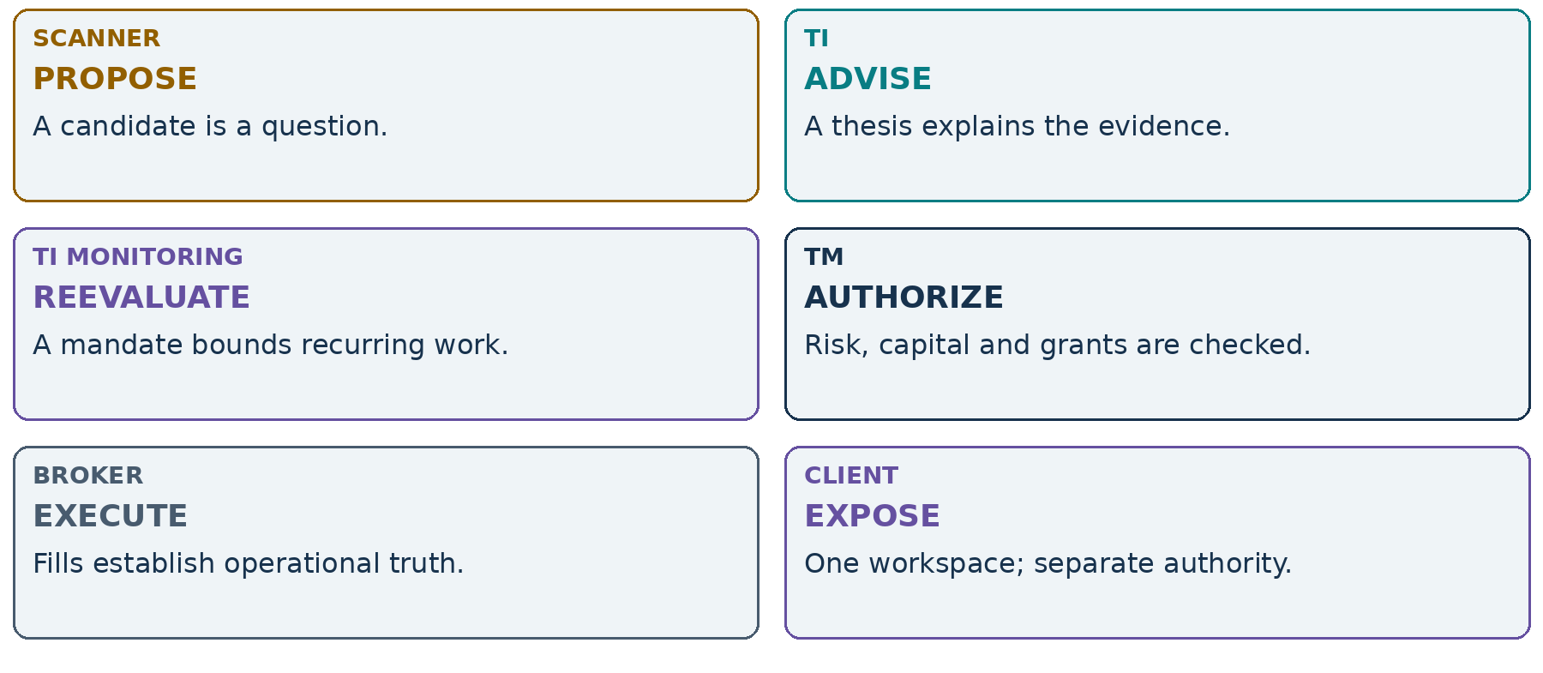
Figure 01. Six roles. One traceable workflow. No merged authority.
Scanners propose. TI advises. TI Monitoring reevaluates. TM authorizes and coordinates. Brokers execute. Human-facing clients expose and control the workflow without merging authority.
A human-readable companion to the authoritative Markdown architecture. All scenario trades, IDs, prices and charts are illustrative—not live validation, forecasts, recommendations or evidence of deployed integration.
READ WITH Architecture baseline: 12 September 2026 • Handbook: 13 September 2026 • Asia/Kolkata
ORIENTATION / READING GUIDE

What this handbook promises
This handbook teaches how an idea can become an accountable operational position without turning every component into a trading engine. Follow the objects, not just the arrows: each handoff changes who may decide, which evidence is required and what must be preserved for replay.
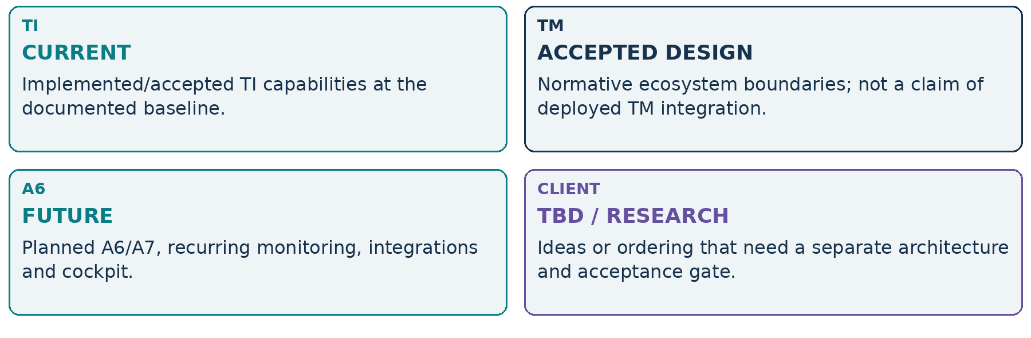
Figure 02. Read status words as well as owner colours.

Implementation truth
A1–A4 are frozen. A5.1/A5.2 and pluggability R1 are accepted; A5 freeze/tag readiness remains a separate gate. Public TI operations are local PURE/CAPTURED_READ capabilities. Replaying an input is not a fresh live evaluation. This thesis does not certify another TM repository or broker implementation.
A supportive thesis is not execution authority. Absence of required intelligence cannot silently become permission.
READ WITH TIAF_TRADING_ECOSYSTEM_ARCHITECTURE.md §1; TIAF_CAPABILITY_MAP.md
ORIENTATION / REFERENCE MAP

Contents & reading routes
Four chapters move from the mental model to safe handoffs, operator surfaces and concrete scenarios. Each teaching spread can also be read independently; owner labels and status labels travel with the visual.
Page | Chapter / reference | Focus
4 | Chapter I | A map of responsibility
16 | Chapter II | Handoffs that preserve authority
26 | Chapter III | Surfaces, observability and resilience
36 | Chapter IV | Follow the objects through a day
46 | Reference | Boundaries to carry into implementation
47 | Reference | Source map & compact glossary

Choose a route
Reader | Start here | Then inspect
New to the ecosystem | Chapter I: map, planes and state | Chapter IV: KAYNES and outage examples
Operator / product designer | Chapter III: tables and cockpit | Chapter II: authority and unknown outcomes
Implementer / reviewer | Chapter I: object ownership | Chapter II: admission; audit; pluggability
Architecture maintainer | Chapter IV: evolution and boundaries | Source map and normative Markdown

Solid arrows show information or governed requests—not automatic permission. Mockups are future concepts. “Illustrative” labels mean constructed teaching examples, never measured performance.
The handbook uses native Word headings, searchable text, editable tables and descriptive image alt text. Wide operational tables are split into linked column groups so their meaning remains readable on a page.
CHAPTER I / CHAPTER DIVIDER

A map of responsibility
Understand the ecosystem before following a trade.
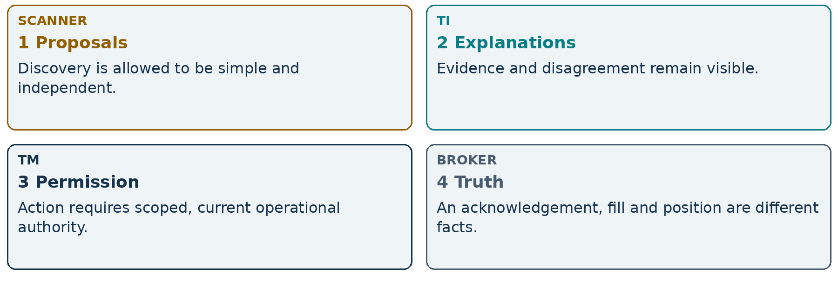
Figure 03. The four questions behind every handoff.
Do not ask one status light to explain discovery, intelligence and execution.
A system can correctly show an active bullish discovery, TI WAIT, TM BLOCKED and no broker exposure at the same time. The architecture preserves that combination rather than forcing a single flattering label.
I • THE ECOSYSTEM / ACCEPTED DESIGN

The full ecosystem
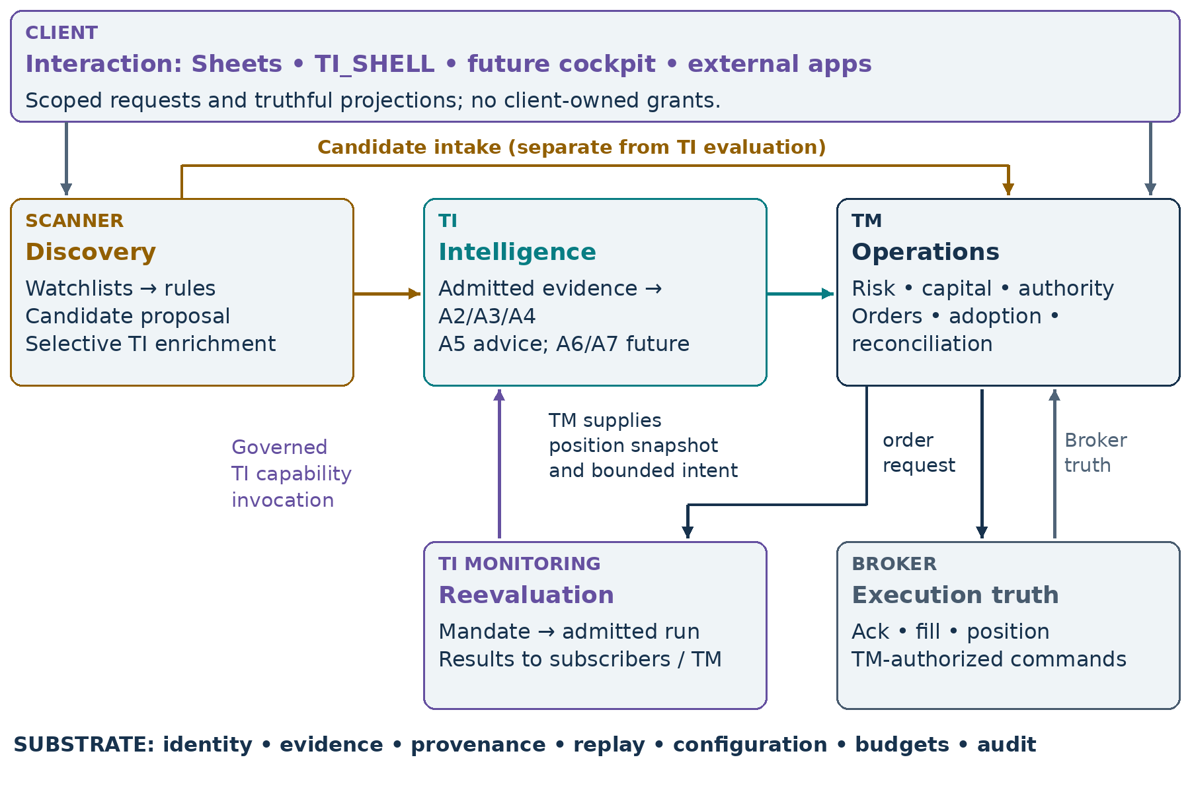
Figure 04. The ecosystem separates discovery, advice, operations and reevaluation.
The horizontal discovery-to-action path is only one route. TI may serve a research app without TM. A manual broker position enters through explicit TM adoption. A candidate can stop at WAIT or NO_TRADE. A monitoring mandate can reevaluate an opportunity even when there is no position.
The TI side may acquire authorized factual market data through adapters. That does not grant submit/modify/cancel authority. The broker box represents external execution and observed order/fill/position truth; TM reconciles it rather than creating truth from a cached display.
READ WITH TIAF_TRADING_ECOSYSTEM_ARCHITECTURE.md §§2,5,7–8
I • THE ECOSYSTEM / ACCEPTED DESIGN

Five planes, not five services
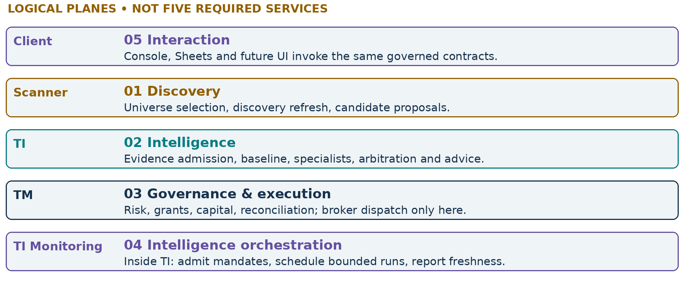
Figure 05. Logical separation does not prescribe a deployment topology.
Cross-cutting substrate | What it preserves
Identity + authorization | Caller, source, tenant/account/environment, rights and grants
Evidence + provenance + replay | Decision-time facts, source meaning, lineage and captured inputs
Configuration + pluggability | Exact policy/capability bindings; explicit required absence
Budgets + audit | Bounded work, attempts, unknown usage, traceable decisions

One local process may implement several logical planes behind explicit contracts. A future remote deployment adds authentication, persistence and operational guarantees; it does not dissolve the same boundaries. TM operational monitoring belongs in governance/execution, not inside TI Monitoring.
READ WITH Ecosystem §2; TIAF_DEPLOYMENT_ARCHITECTURE.md
I • THE ECOSYSTEM / ACCEPTED DESIGN

Three kinds of monitoring
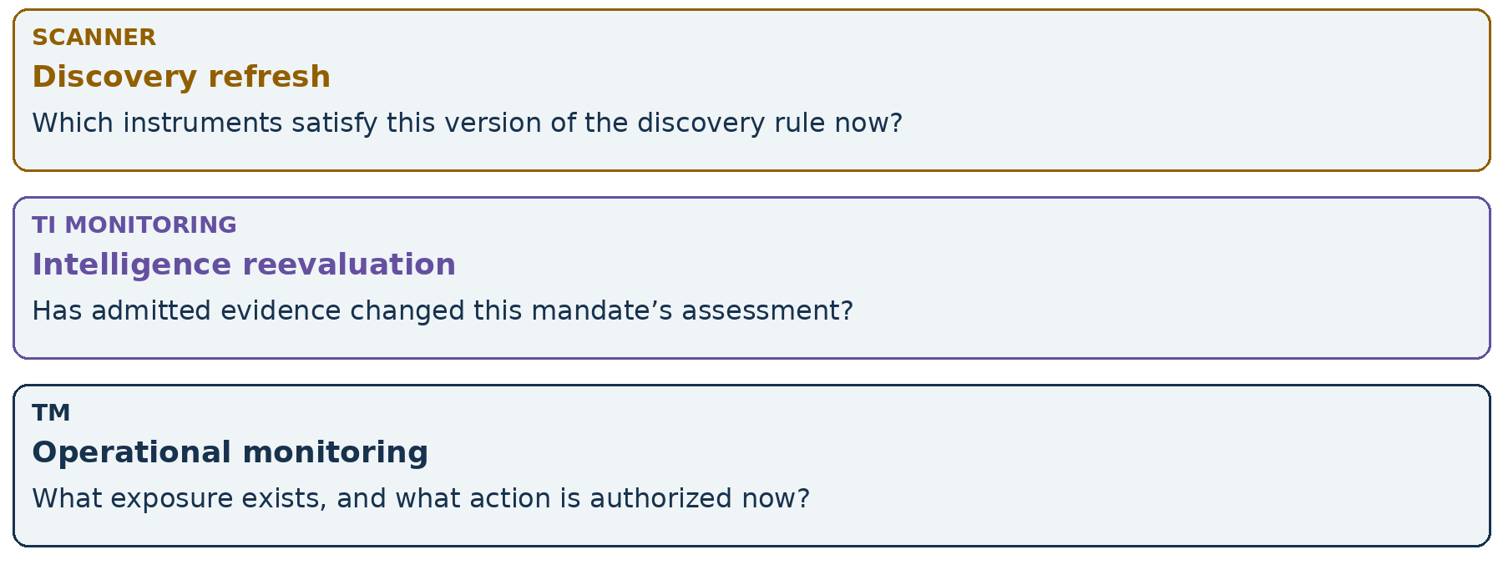
Figure 06. Similar clocks do not imply the same responsibility.
A scanner refresh can create, revise or expire candidates. A TI run can revise an explanation without creating any order. TM must still reconcile fills and exposure if the scanner or TI is unavailable. Operational continuity is bounded by available broker truth and existing authority—not a guarantee that every protective action will succeed.
Watchlist is organization; mandate is semantics. Monitoring is intelligence orchestration, not execution.
Current A5 WatchMandate/MonitoringNeed outputs are advisory intent. They do not create a scheduled job. The recurring TI Monitoring Runtime and its admission/budget/lifecycle guarantees remain future implementation work.
READ WITH Ecosystem §8; TIAF_MONITORING_ARCHITECTURE.md §§1–8
I • THE ECOSYSTEM / CURRENT + FUTURE

The TI intelligence hierarchy
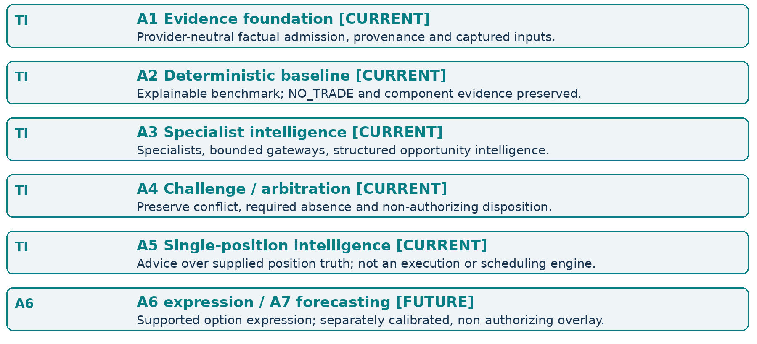
Figure 07. Capability roles, not a compulsory run of every layer for every request.
A3/A4 enrichment does not rewrite the accepted A2 record. The baseline remains an independently replayable comparison point. A5 interprets a single supplied open equity, future, call or put position; multi-leg shapes remain unsupported. Missing thesis or stale operational truth must not become a reassuring default recommendation.
READ WITH TIAF_CAPABILITY_MAP.md; A4/A5 architecture; TI_Intelligence_Hierarchy_Thesis.docx
I • DISCOVERY / ACCEPTED DESIGN

Basic scanner vs TI-enriched scanner
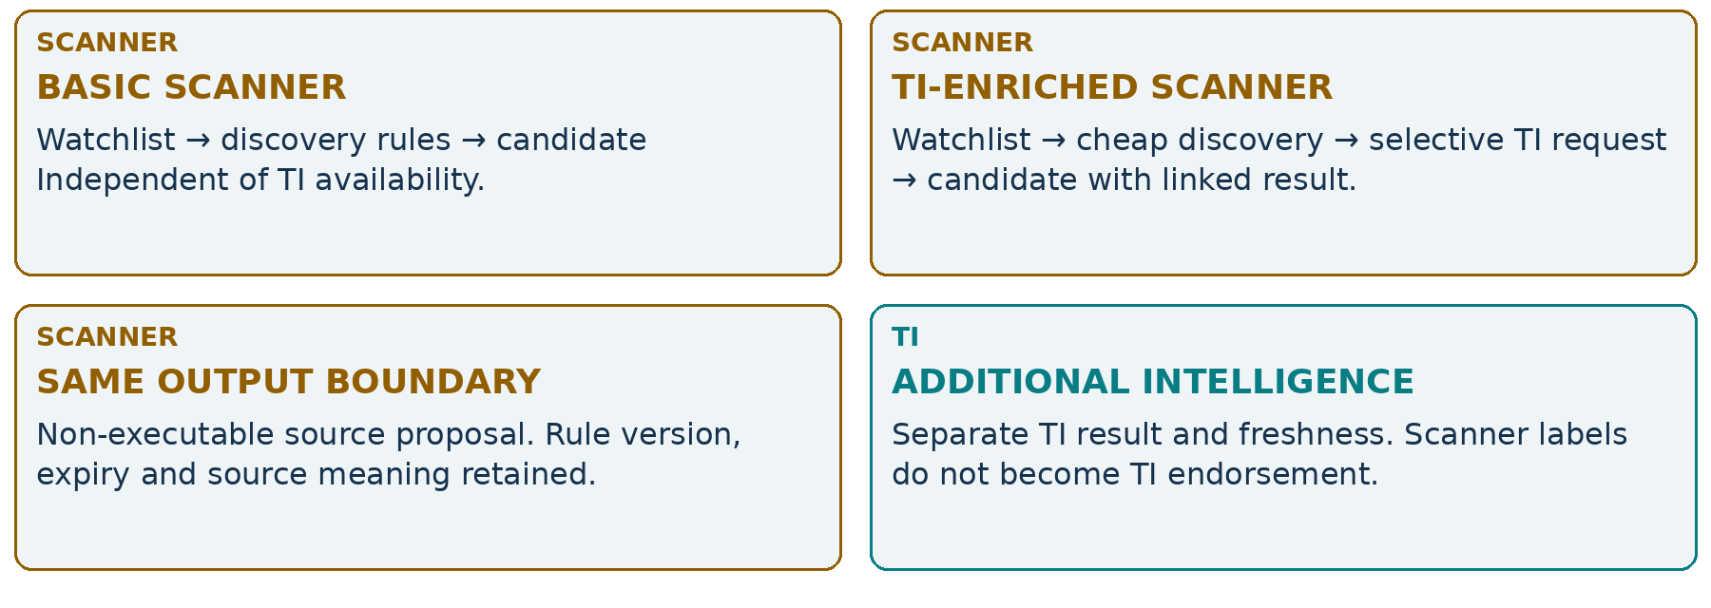
Figure 08. Enrichment adds a linked explanation, not a new source of authority.
TradingView, Chartink, Python, manual and future ML scanners can sit behind one candidate-source interface. A TI-native scanner is also a consumer application; it does not acquire extra Core privileges. Cheap screening followed by selective bounded enrichment avoids requiring deep research across an entire universe.
The subscriber owns watchlist membership and optional group labels. A candidate records the relevant group revision rather than consulting today’s watchlist during replay. Discovery refresh and candidate expiry remain source responsibilities; neither implies an admitted recurring TI mandate.
READ WITH Ecosystem §3
I • DISCOVERY / ACCEPTED DESIGN

Candidate: a versioned question
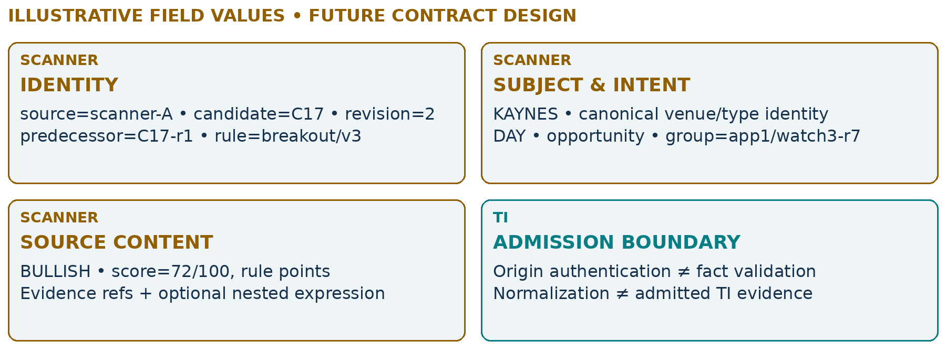
Figure 09. Readable field groups; not a published wire schema or a live KAYNES signal.
Required record groups | Meaning
Schema / event / correlation | Supported schema version, stable originating event, mapped trace context
signal_at / received_at / valid_until | Source time, receiver time and finite validity; late receipt does not reset expiry
Provenance + evidence references | Empty collections require explicit absence; raw source assertions remain attributable
Optional score / confidence / expression | Declared basis and scale; unknown semantics stay unknown; zero is valid

All timestamps are aware, normalized with zoneinfo.ZoneInfo("Asia/Kolkata") and serialized with +05:30. Naive inputs are rejected. Semantic collections remain immutable tuples with JSON arrays; extensible metadata is not promised deep immutability.
READ WITH Ecosystem §3; package version 0.1.0 is separate from A0 contract schema version 1.0
I • STATE / ACCEPTED DESIGN

Discovery and intelligence stay separate
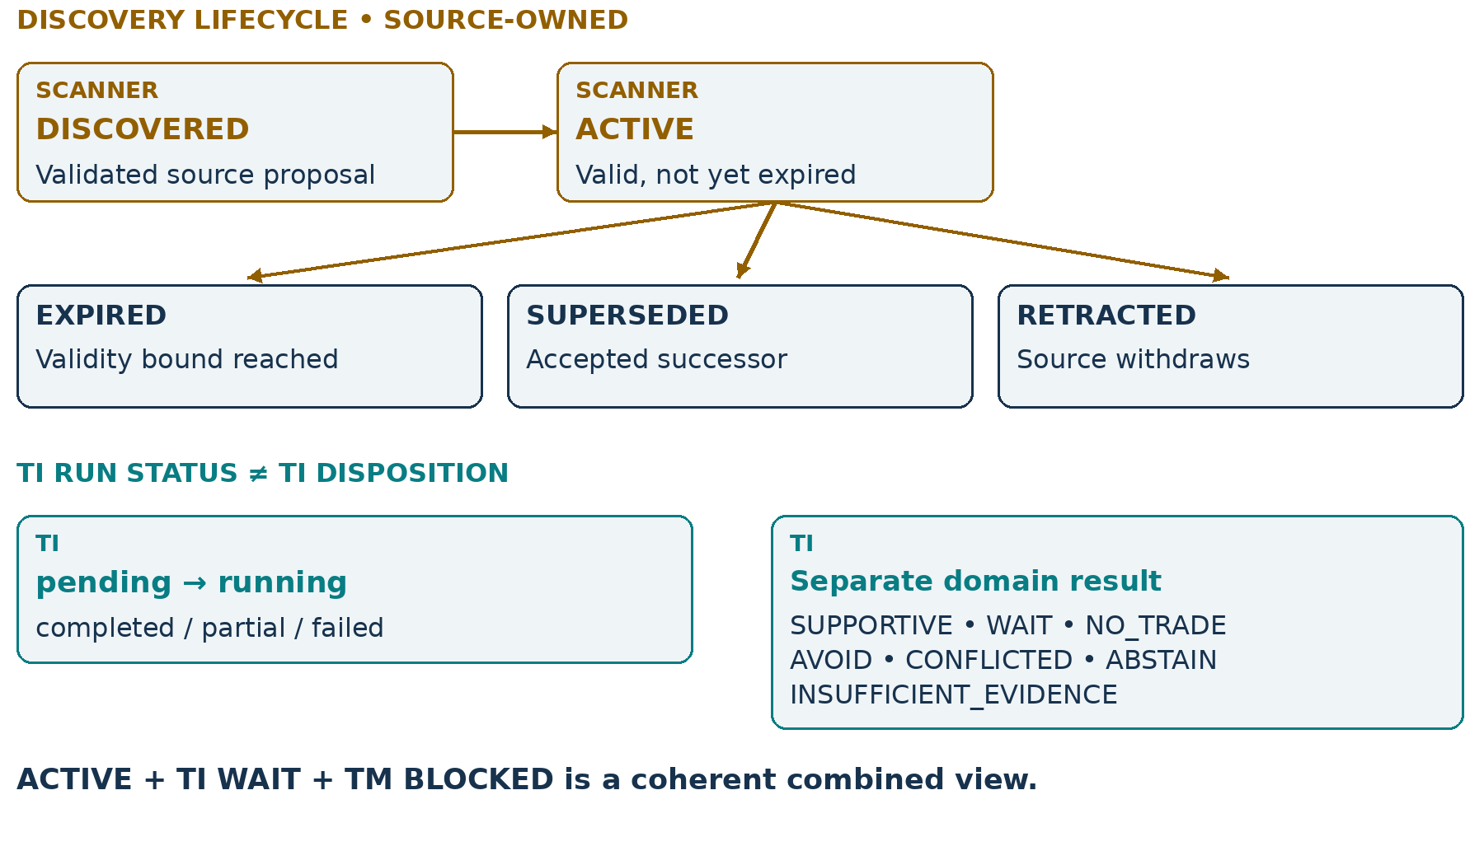
Figure 10. Run completion is not a market opinion; an opinion is not an order.
A failed evaluation records a failed run. It cannot invent WAIT, SUPPORTIVE or NO_TRADE as if evidence supported that disposition. Conversely, a successfully completed A4 run may legitimately conclude ABSTAIN or INSUFFICIENT_EVIDENCE. UI status and domain meaning must both remain visible.
A source correction creates a successor revision. Retraction and expiry are retained events, not deletion. A superseded candidate invalidates linkage to old approval inputs, but does not silently cancel an already submitted broker order. TM reconciles that independent operational lifecycle.
READ WITH Ecosystem §§3–4
I • STATE / ACCEPTED DESIGN

Approval, submission and fill are different
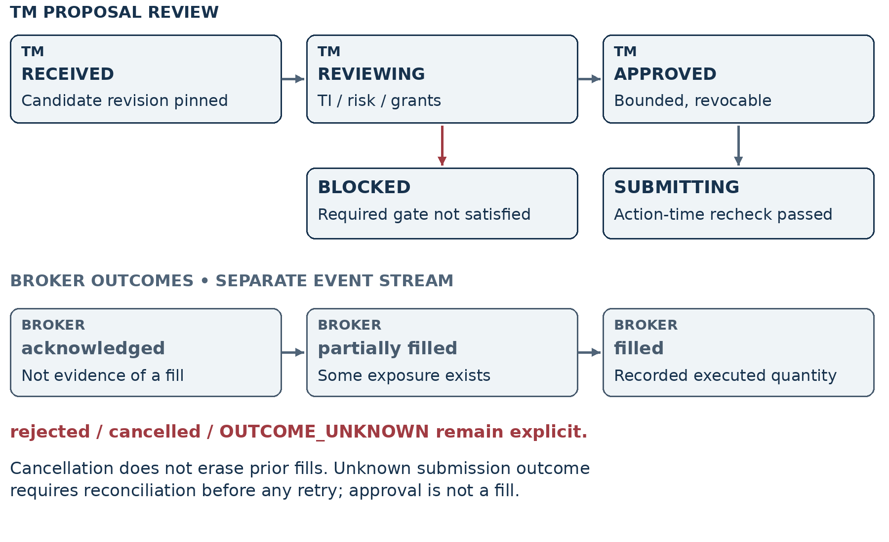
Figure 11. The broker stream is not a continuation of a TI opinion enum.
An APPROVED UI row means a bounded TM decision existed—not that the action remains valid now. New exposure, revocation, expired evidence or a revised expression can invalidate dispatch. An acknowledged order is not yet a fill; a partial fill creates real exposure even if the remainder is cancelled.
Broker truth outranks cached assumptions. OUTCOME_UNKNOWN is not permission to submit a second order.
READ WITH Ecosystem §§4,7
I • OBJECTS / ACCEPTED DESIGN

The semantic object chain
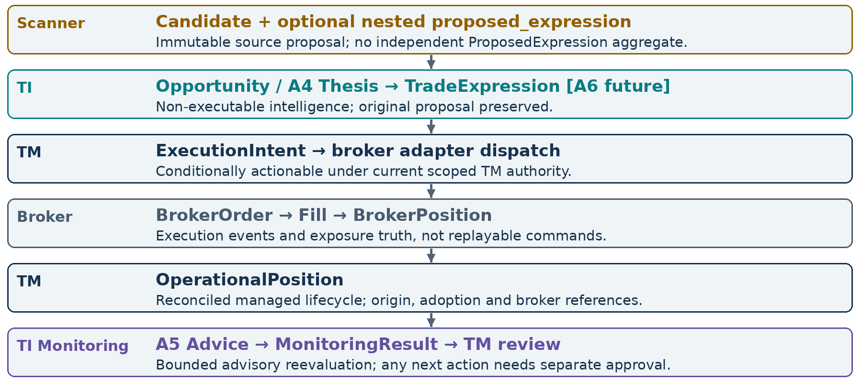
Figure 12. Different objects answer different questions; no mandatory TradeIntent is introduced.
This is a semantic map, not a compulsory pipeline. A NO_TRADE candidate stops. Equity need not pass through an options-only A6. Manual exposure enters through adoption. A broker position may aggregate several fills/orders; TM must preserve that mapping instead of assuming one candidate equals one position.
READ WITH Ecosystem §§4–5
I • OWNERSHIP REFERENCE / ACCEPTED DESIGN

Who owns discovery and advice?
The compact matrix separates the object owner from its producer and consumer. “No” in the authority column means the object cannot itself authorize execution. Immutable results may link to successors; a new interpretation never rewrites the earlier one.
Object / owner | Producer → consumer | Executable / authority | Persistence & replay
Watchlist  Subscriber app | User/app → scanner / TI client | No; organization only | Version membership; retain admitted group context, no live membership lookup.
Candidate  Source app | Authenticated source adapter → TI / TM | No; source proposal | Immutable revision + receipts/events; replay without rescanning.
Nested proposed expression  Source app | Source within Candidate → A6 / TM | No; untrusted proposal | Version with Candidate; preserve original content and digest.
Opportunity / Thesis  TI | A2/A3/A3.9/A4 → apps / A6 / TM / A5 | No; evidence-based advice | Preserve child schemas, policy and captures; successors link to parents.
TradeExpression  TI / future A6 | Supported evaluator → TM | No; suitability ≠ permission | Pin candidate/input/alternatives; new result on reassessment.
A5Advice  TI | A5 → subscriber / TM | No; protection/exit intent is advisory | Accepted capture/replay + policy identity; do not rename the runtime schema.

An object can be authoritative about its own meaning without being authorized to cause a broker action.
For example, TI owns the exact A4 conclusion and its evidence lineage. TM cannot relabel WAIT as SUPPORTIVE. But only TM can decide whether a separately specified policy permits an operational action, using current grants, account state and risk constraints.
READ WITH Ecosystem §5
I • OWNERSHIP REFERENCE / ACCEPTED DESIGN

Who owns action and reevaluation?
Object / owner | Producer → consumer | Executable / authority | Persistence & replay
ExecutionIntent  TM | Authorized TM workflow → TM broker adapter | Conditional; current TM gate required | Durable action ID, pinned approval and attempts; amendments reauthorized; replay never dispatches.
BrokerOrder  Broker | Broker → TM / projections | Actual order state; not client-authored truth | Broker IDs, updates, acknowledgements and unknowns retained; no replay submission.
Fill  Broker | Broker → reconciliation | Executed fact, not reusable permission | Observed ID/account/qty/price/time; append attributable corrections.
BrokerPosition  Broker | Snapshots/events → TM | Exposure truth, not command | Version observations and acquisition times; preserve uncertainty.
OperationalPosition  TM | Reconcile/adopt → risk / TI / clients | Managed lifecycle under scoped grants | Stable account/position ID, origin and revisions; no live broker call in replay.
MonitoringMandate  TI after admission | Subscriber intent → TI runtime | Bounded intelligence only | Admitted revisions + lifecycle; retain original A5 intent if supplied.
MonitoringResult  TI | Capability run → subscribers / TM | Advisory, never permission | Mandate/run/attempt/input/policy/usage links; offline replay, no reacquisition.

Each owner persists its records and cross-links; a shared database is not required. Retention must respect rights and safety. Active actions, unknown outcomes and unresolved usage cannot disappear before reconciliation. Exact durations, storage engine and export protocols remain implementation gates.
READ WITH Ecosystem §5; Monitoring §§10–11
CHAPTER II / CHAPTER DIVIDER

Handoffs that preserve authority
An end-to-end sequence is a chain of checks—not a green-light cascade.
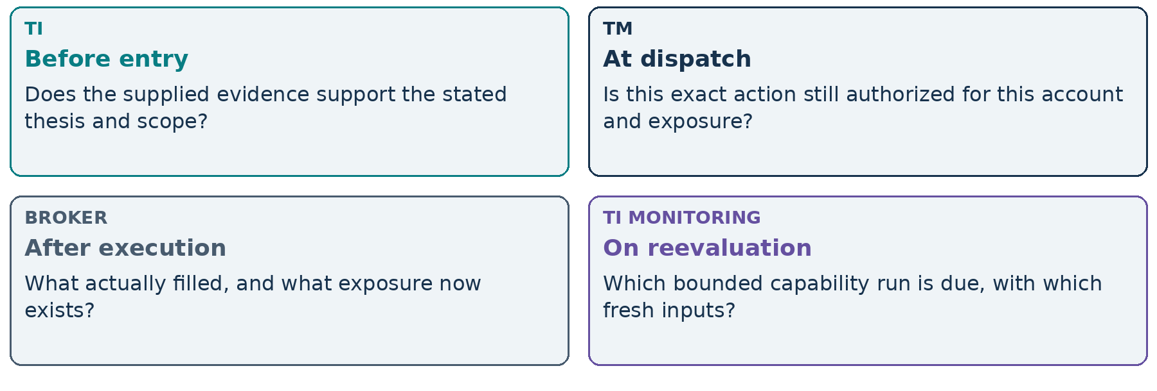
Figure 13. The question changes at every handoff.
TI advises on meaning. TM decides under authority. A6 expression quality cannot replace TM’s capital, quantity or account checks.
Future integration must demonstrate the complete trace, including blocked, partial and unknown outcomes. Successful-looking examples are insufficient if the same path becomes permissive under timeout or stale evidence.
II • BEFORE ENTRY / ACCEPTED DESIGN

Scanner → TI → A6 → TM → Broker
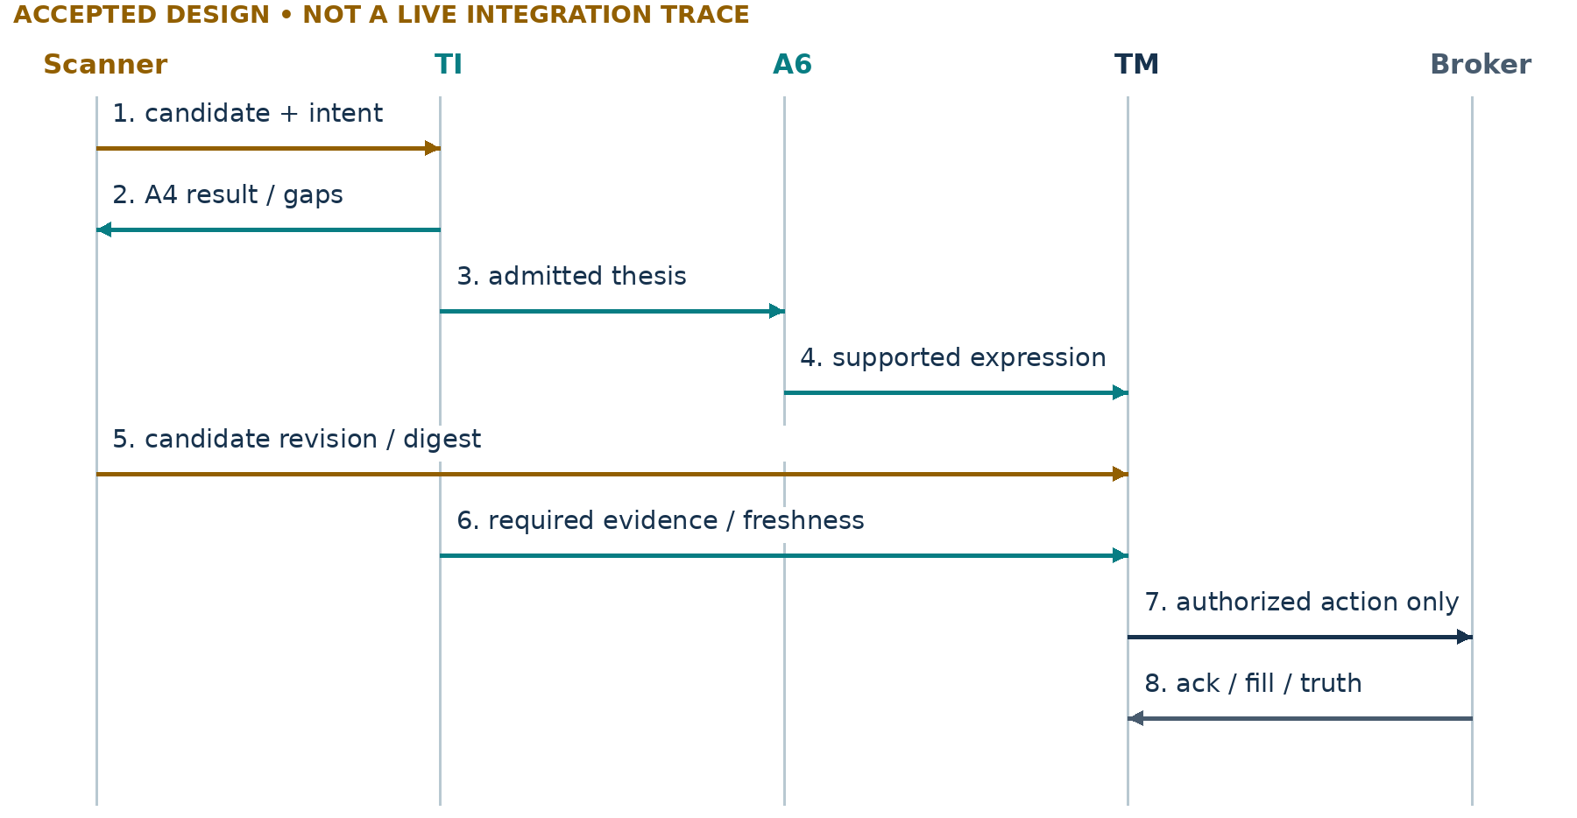
Figure 14. A6 is future; TI and source artifacts remain separately pinned.
TM may intake a candidate before evaluation finishes. What matters is the approval boundary: required intelligence must satisfy the exact declared policy before entry. The sequence does not imply every source invokes A6 directly, nor does it publish a remote API. Today’s captured-read facade cannot serve as proof of fresh live validation.
SUPPORTIVE → expression consideration. Not SUPPORTIVE → order.
READ WITH Ecosystem §§6–7; current facade boundary in §1
II • BEFORE ENTRY / FUTURE

The A6 boundary
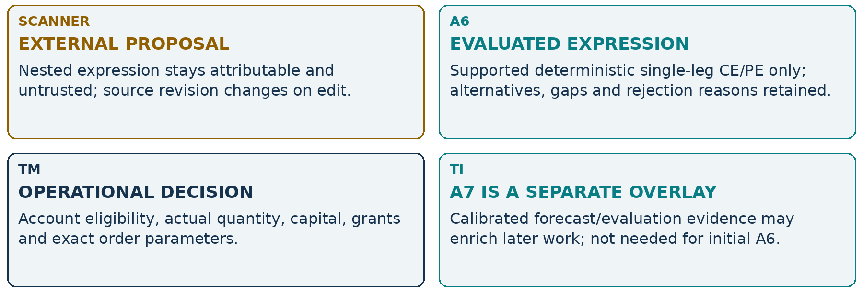
Figure 15. A6 answers “which supported expression?”, not “may this account trade?”.
A6 may compare admitted expiry/strike/moneyness, liquidity, IV/Greeks and accepted constraints. It may return NO_OPTION_TRADE. Exact eligible instruments, exposure side permissions, orderability rules and thresholds require separate acceptance. No spread optimizer, hedge/roll engine or naked-short permission is implied.
A cash or future proposal can use an independently approved TI/TM path; it must not pretend options-only A6 endorsed it. No probability-of-profit or expected-move forecast is fabricated to fill missing evidence.
READ WITH Ecosystem §6; authoritative roadmap A6/A7
II • BEFORE ENTRY / ACCEPTED DESIGN

Required scope cannot disappear
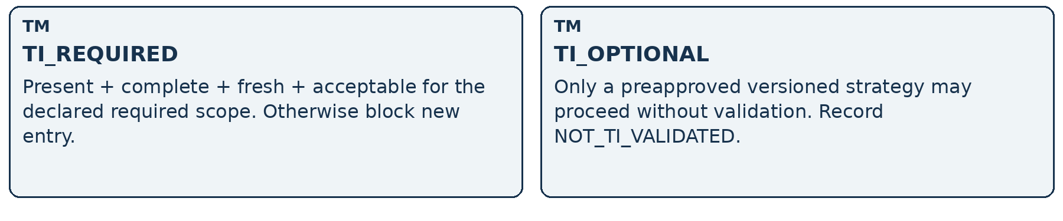
Figure 16. Policy selects the mode before the request; an outage cannot select a weaker mode.
Approval binds | Action-time recheck
Candidate revision / semantic digest; selected expression | Same proposal and approved parameter envelope; changed input requires revalidation
TI result/A4 IDs, hashes, evidence cutoff and expiry | Freshness and required completeness still acceptable; recorded veto not hidden
Actor / account / environment / grants / policy versions | Grant still valid; risk, capital and broker exposure/open orders current
Captured composition where available; parent links | COMPOSITION_UNAVAILABLE stays explicit; a strict composition requirement blocks

Missing optional enrichment need not block a complete required scope. Missing required capability remains part of completeness under R1. An unfavorable answer is not an outage; TI_OPTIONAL cannot relabel a known applicable veto as missing data.
READ WITH Ecosystem §7; TIAF_PLUGGABILITY_ARCHITECTURE.md; R1 accepted behavior
II • AFTER EXECUTION / ACCEPTED DESIGN + CURRENT A5

The post-fill A5 monitoring loop
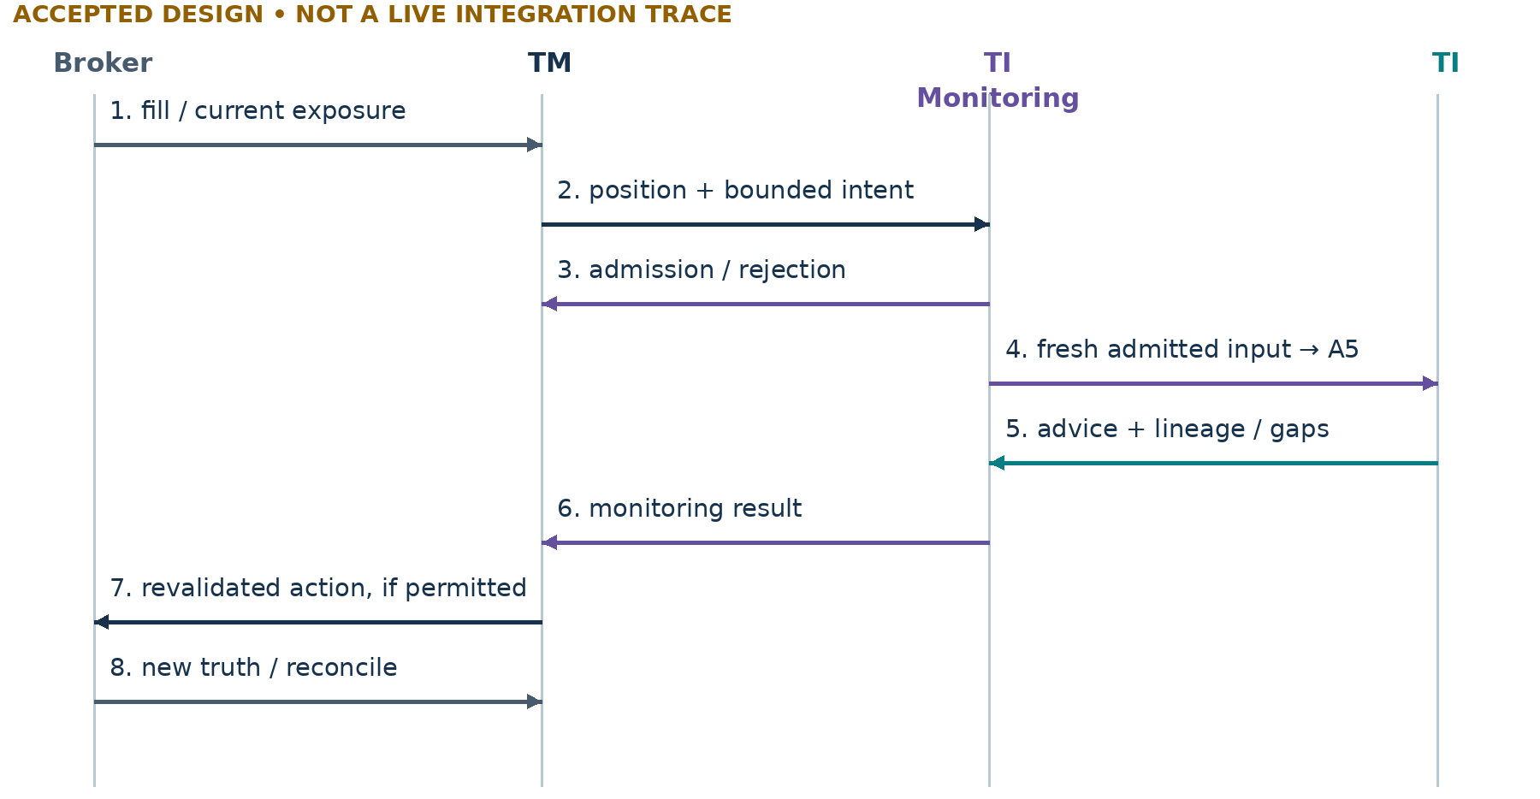
Figure 17. Recurring dispatch is future; A5 advice is already a bounded, non-executable capability.
A5 can emit MAINTAIN, WATCH_CLOSELY, PROTECT, REDUCE_RISK, TRAIL_PROTECTION, EXIT_RECOMMENDED, WAIT_FOR_CONFIRMATION, ABSTAIN or INSUFFICIENT_EVIDENCE. These are recommendations, not order types. A stop/protection intention does not prove a protective broker order exists.
TM tracks what actually executed, including partial reductions and failures. A later A5 run consumes a new supplied operational snapshot; it does not mutate TM state or assume the earlier recommendation was implemented.
READ WITH Ecosystem §8; A5 architecture §§4–7; Monitoring §§5–8
II • RECURRING WORK / ACCEPTED DESIGN • RUNTIME FUTURE

One mandate, five distinct clocks
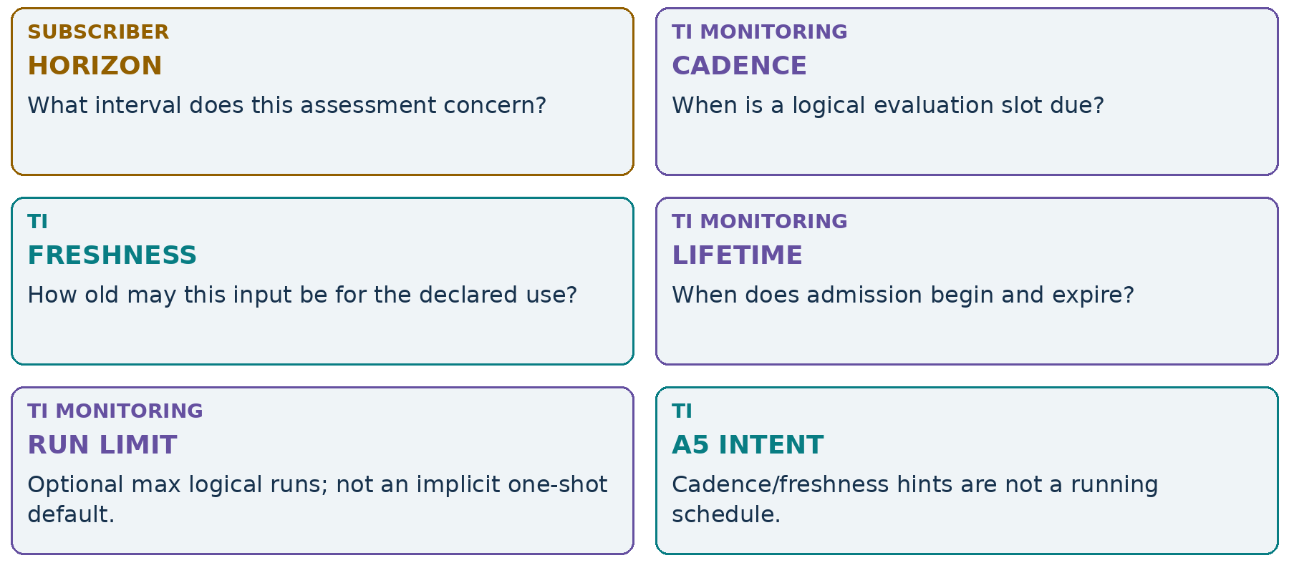
Figure 18. Horizon is not cadence; a finite lifetime does not specify a run count.
A subscriber submits intent; TI admits or rejects a bounded mandate against identity, rights, profile, capabilities, budgets and capacity. A watchlist is optional organization. One instrument may carry multiple mandates with different purposes, horizons and rights.
The planned local runtime uses bounded due slots and a single writer, with at-least-once delivery and idempotent logical run IDs. Retries retain separate attempts. Missed slots may be coalesced under accepted policy; no backdated “fresh” result or silent lifetime renewal is allowed. Unknown attempt cost remains unknown and conservatively reserved.
READ WITH TIAF_MONITORING_ARCHITECTURE.md §§3–8,10–11
II • REUSE / ACCEPTED DESIGN

Shared evidence, separate analysis
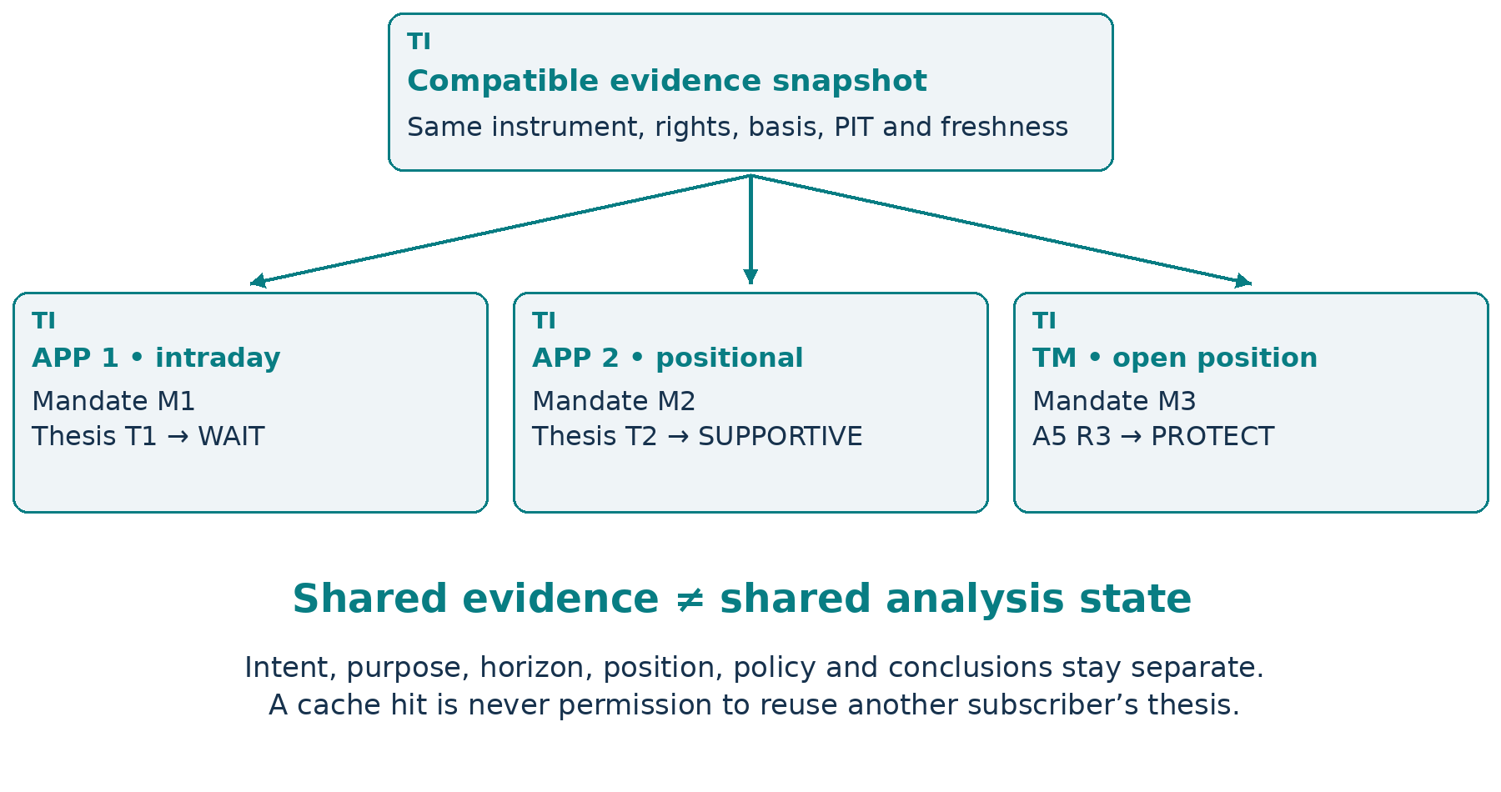
Figure 19. The same KAYNES evidence can support different scoped conclusions.
A safe evidence reuse key includes instrument/venue, provider and account entitlements, requested fields, basis, adapter/schema/policy versions, point-in-time cutoff, availability and each consumer’s freshness. Unknown dimensions are not wildcards. Access rights must still hold when returning a cached item.
Analysis state also depends on purpose, horizon, position, policy and subscriber intent. It is not safe to copy APP 2’s supportive thesis into APP 1’s intraday request merely because the instrument matches. Nor should shared source material be counted twice as independent corroboration.
Deduplicate evidence, not intent. Reuse is an optimization of compatible work—not a merge of meaning.
READ WITH Monitoring §9; source-authority architecture; ecosystem §§3,8
II • WORKLOAD / ILLUSTRATIVE CHART

A day in the life of shared evidence
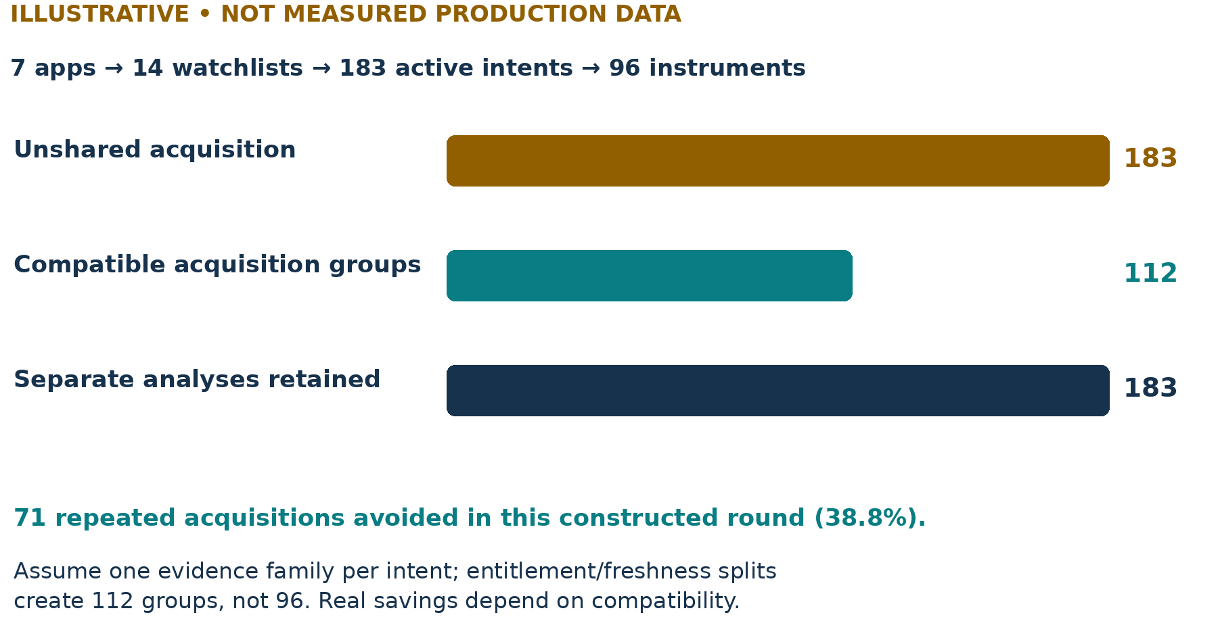
Figure 20. A constructed one-round workload; acquisition savings do not reduce intent count.
Assume all 183 active intents require one comparable evidence family in this round. Ninety-six instruments do not guarantee ninety-six safe acquisitions: entitlement and freshness boundaries split some instruments into multiple groups. For teaching, suppose this produces 112 compatible groups. Then 183 − 112 = 71 repeated acquisitions can be avoided.
This arithmetic does not measure deployment throughput, latency, cost or provider savings. A real workload contains multiple evidence families, cache misses, changing rights and refresh windows. The 183 purpose-specific analyses remain separate even when they share an admitted input snapshot.
Fewer fetches does not mean fewer responsibilities.
READ WITH Monitoring §§9,11; ecosystem profiles and budgets
II • BOUNDED WORK / ILLUSTRATIVE CHART + ACCEPTED DESIGN

Latency and cost are policy dimensions
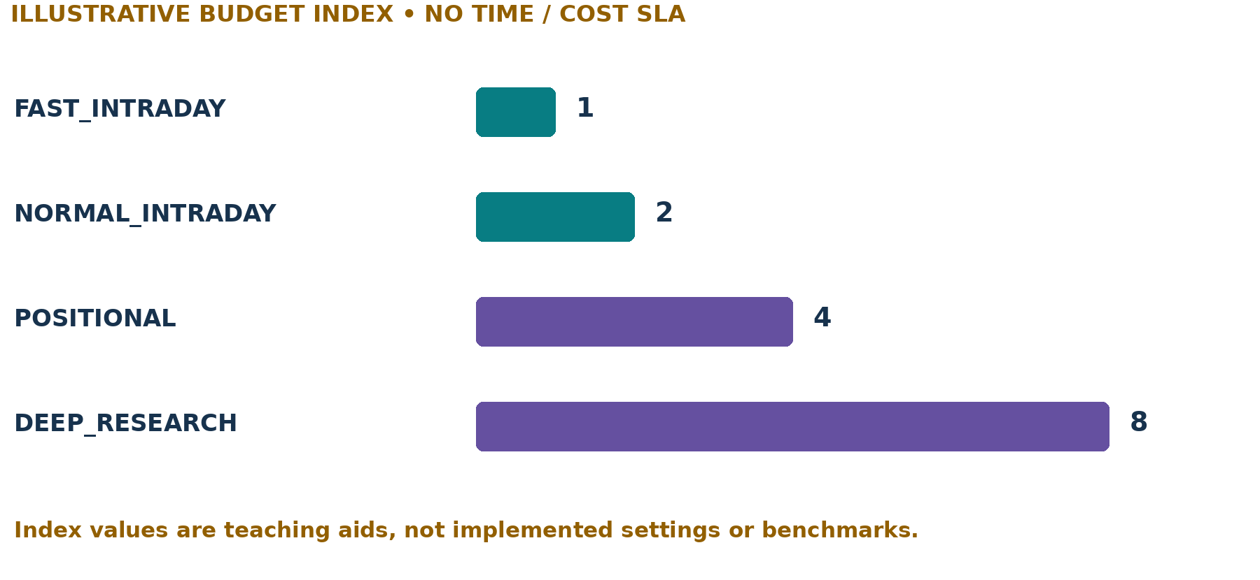
Figure 21. Conceptual resource envelopes, not runtime defaults or measured performance.
Each versioned profile declares | Why it matters
Required / optional intelligence | A deadline can drop optional work only under policy; required scope is never silently shrunk.
Freshness + deadline | Input age and completion time are different constraints; stale success is not fresh success.
Budget + failure behavior | Bound acquisition/model/attempt costs; return explicit partial/blocked outcomes.

FAST_INTRADAY, NORMAL_INTRADAY, POSITIONAL and DEEP_RESEARCH name conceptual usage profiles. No numeric SLA is promised here. Real latency would include acquisition, queueing, execution and retries; real cost needs observable usage. Unknown usage is not zero, and a budget exhaustion cannot be made invisible by excluding an attempted call.
READ WITH Ecosystem §12; Monitoring §11
II • ADOPTION / ACCEPTED DESIGN

A broker position is not yet a managed position
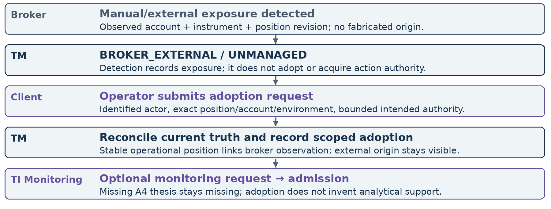
Figure 22. Detection ≠ adoption ≠ thesis creation ≠ execution permission.
A stale UI row is not enough to adopt the latest position revision. TM checks the exact account, current quantity and authority scope, then records who adopted what under which policy. An already managed position must not be adopted twice through duplicate client retries.
If a valid A4 thesis is absent, current A5 may return INSUFFICIENT_EVIDENCE. If current operational truth is stale or unknown, ABSTAIN is the safe intelligence outcome. TM still owns whatever operational controls its existing grants and available truth permit.
READ WITH Ecosystem §8; A5 architecture §§3,11
CHAPTER III / CHAPTER DIVIDER

Surfaces, observability and resilience
Make the workflow legible without relocating its authority into the screen.
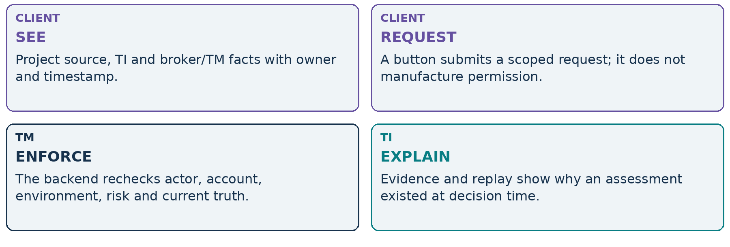
Figure 23. The interface is a lens and a request surface, not a parallel backend.
One cockpit must not mean one undifferentiated “approved” state.
The next pages deliberately split wide tables into linked bands. A compact daily-use grid needs concise defaults and expandable evidence, not dozens of unreadable columns or a single green traffic light that conceals conflicts.
III • CLIENTS / FUTURE MOCK LAYOUT

Google Sheets: replaceable client
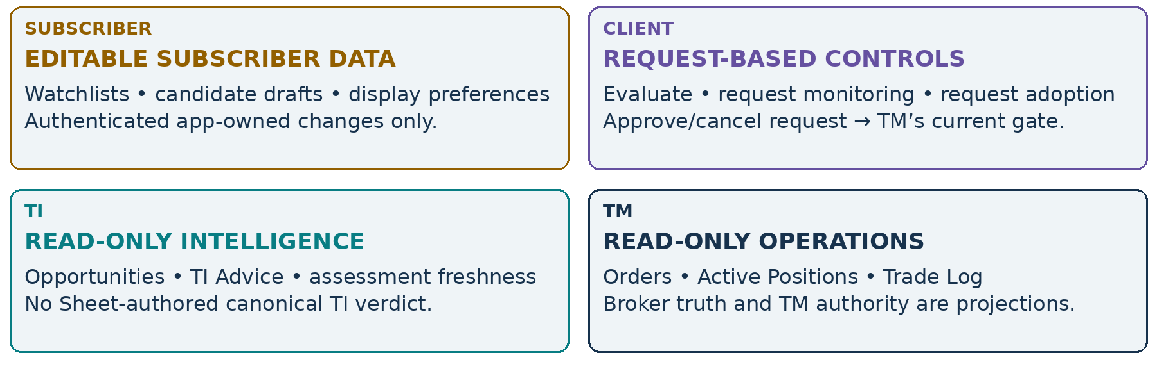
Figure 24. A Sheet edit changes allowed subscriber data; an action cell sends a request.
Example tabs | Role / write boundary
Dashboard • Alerts | Read-only aggregates and freshness/health; acknowledge only through scoped request
Watchlists • Candidates | Subscriber membership / drafts editable; accepted revisions and TI/TM columns read-only
Opportunities • TI Advice | TI explanation, gaps, sources and timestamps; read-only
Active Positions • Orders • Trade Log | Reconciled broker/TM records; read-only
Config | Permitted preferences or change requests—not raw grants, risk bypasses or credentials

READ WITH Ecosystem §9; no broker keys/tokens in Sheets; no automatic replay of stale approvals
III • CANDIDATE MOCKUP / ILLUSTRATIVE FUTURE UI

One candidate row, several truths
These are two horizontally linked bands of the same conceptual grid. The row key pins source/candidate/revision. Detailed raw-score basis, sector context, qualification and forecast fields expand on demand; the compact view never blends them into one status.
Key / source / group | Instrument / horizon / source direction | Discovery / age / expiry | TI disposition / freshness
C17-r2  Python-A / Day-1 | KAYNES / DAY  BULLISH | ACTIVE  2m / 10:20+05:30 | SUPPORTIVE  as_of 10:02+05:30; fresh for demo scope
C22-r1  Chartink-B / Day-2 | KAYNES / DAY  BULLISH | ACTIVE  1m / 10:18+05:30 | WAIT  same-round admitted assessment
C31-r1  Manual / Swing | RELIANCE / POSITIONAL  unspecified | ACTIVE  1d / explicit validity | NOT_EVALUATED  no TI freshness claim

Same row key | Expression / owner | TM risk / authority / execution | Request actions
C17-r2 | CE-demo-01  future A6 result | PASS / pending approval / not submitted | Inspect evidence; request review
C22-r1 | Not evaluated | BLOCKED under TI_REQUIRED / no grant / none | Inspect WAIT reasons
C31-r1 | Source equity proposal; not A6 | Not reviewed / none / none | Request TI evaluation

The same symbol can appear twice because the sources and candidate identities differ. “TI fresh” is a scope-specific check, not a permanent badge.
Every time above is on the same hypothetical session date, 2026-09-14, and in Asia/Kolkata; dates must be retained in persisted records. These examples do not assert market prices, current instrument eligibility, or existing operational grants. Production controls must bind exact revision and current actor/account/environment.
READ WITH Ecosystem §§3–4,9
III • POSITION MOCKUP / ILLUSTRATIVE FUTURE UI

Operational truth beside TI advice
The row key joins these mock bands; the real UI can use expandable panels. All quantities, prices and P&L below are constructed examples for display semantics—not observed data. “Broker B / DEMO” is a fictional context. The position is a simple equity example, not an A6 options claim.
Position / owner | Exposure / source | Origin / adoption / as_of
Broker B / DEMO  BP-EQ7 → P-EQ42-r3 | RELIANCE equity  Qty 10; entry ₹1,000; mark ₹1,010 | BROKER_EXTERNAL; adopted by TM  2026-09-14T11:00:00+05:30
P&L / TM-derived display | ₹100 unrealized = 10 × (1,010 − 1,000) | Fees excluded; mark timestamp retained  Not a broker-confirmed realized return

TI-owned intelligence | TM-owned operations | TI-runtime health
A5 posture: CAPITAL_AT_RISK  Thesis: INTACT  Advice: MAINTAIN | Risk: within demo envelope  Authority: scoped, expires  Protective order: NOT_CONFIRMED | Runtime: NOT_ACTIVE  Last captured A5: 11:00+05:30  Next due: unavailable
Protection intent: none newly supplied  Evidence/gaps: expandable | Broker/account context pinned  Actions: request review / reconcile | Cadence hint, if present: advisory  Not proof of scheduled work

An analytical protection posture is not a protective broker order. “Last captured evaluation” is not a live monitoring heartbeat.
A5 recommendation, thesis health and analytical risk posture remain distinct fields. TM owns quantity, risk and action grants; broker observations anchor live exposure. If monitoring later exists, display last evaluation, next admitted due slot, expiry and overdue status independently of a stale cached recommendation.
READ WITH Ecosystem §9; A5 architecture §4; Monitoring §5
III • WORKSPACES / FUTURE UI • CURRENT CONTRACT BOUNDARIES

TI workspace vs TM workspace
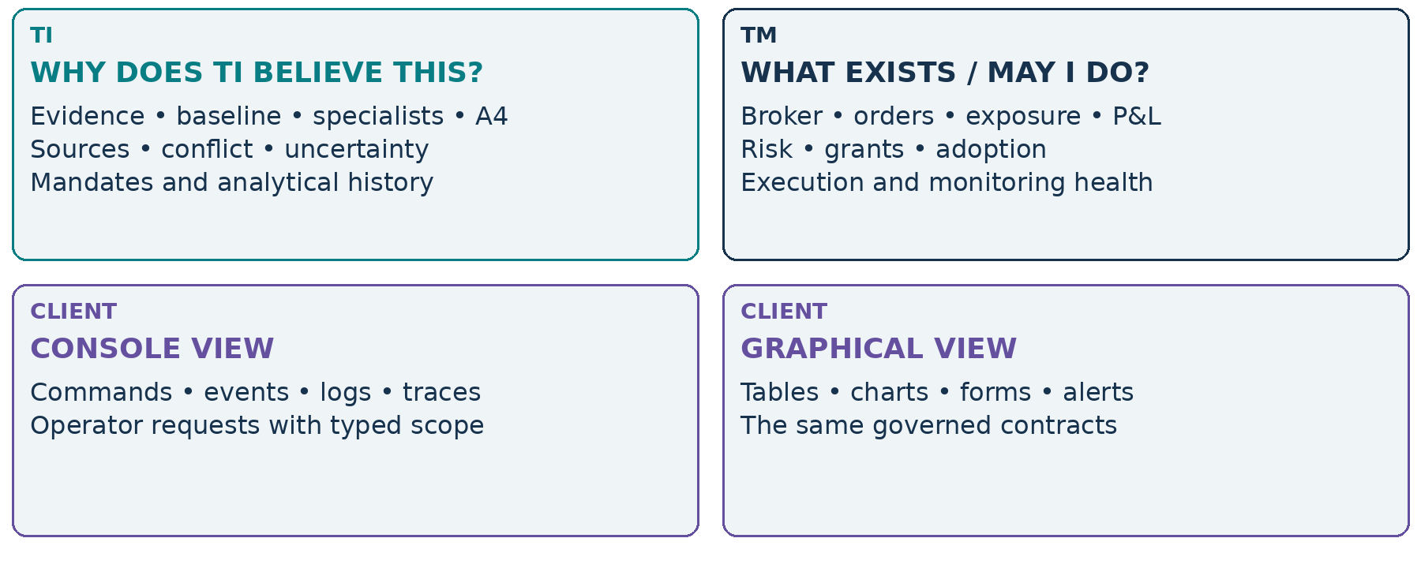
Figure 25. A console and a UI are two views of the same boundaries.
Current TI_SHELL is a local client of curated PURE/CAPTURED_READ operations. A future Web client or Sheets connector must not expand capability authority just because it has a convenient button. It also cannot infer successful adoption or order state from a submitted request.
A shared selection can synchronize KAYNES and a chosen candidate/position across both workspaces. Identity, permissions, provider rights and backend ownership still remain explicit. One panel’s successful request is not another panel’s permission grant.
READ WITH Ecosystem §9; deployment architecture; TBD CLI/Web UI ideas remain future
III • TRADING COCKPIT / FUTURE MOCK ARCHITECTURE

A multi-console daily workstation
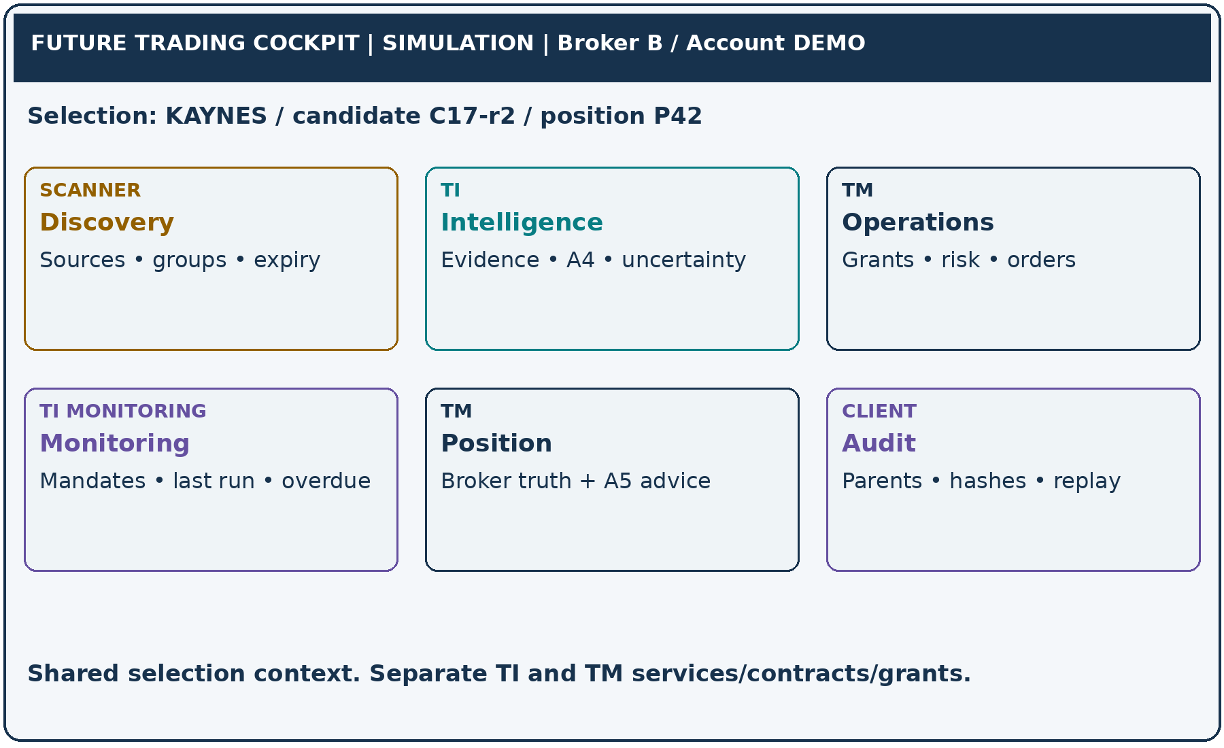
Figure 26. A cohesive workspace built from separate governed panels.
The selection context may carry canonical instrument, candidate revision, thesis/result ID and operational position ID. It is navigation state—not shared mutable analysis or a common authority token. Each panel requests only the scopes its backend and acting principal permit.
A role-limited research workspace may omit order controls entirely. An operations workspace must make broker/account/environment impossible to confuse and recheck authority server-side. UI outage must not freeze otherwise authorized backend reconciliation; stale reconnect requests must not auto-execute.
Unified experience. Separate ownership. Explicit account and environment.
READ WITH Ecosystem §9; future interaction technology and session design remain gated
III • AUDIT / ACCEPTED DESIGN

Why was this trade taken?
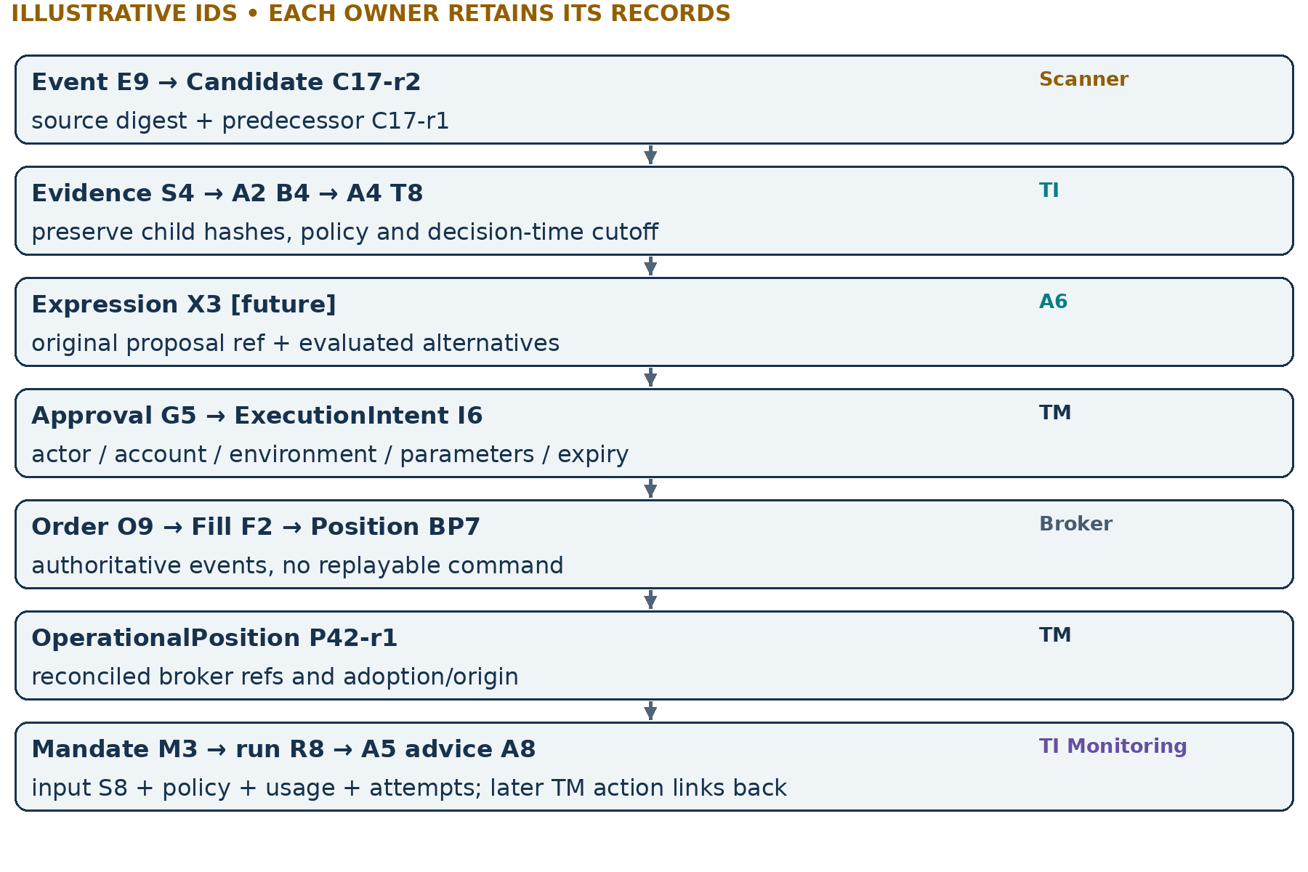
Figure 27. One correlation context links immutable local objects; it does not replace their IDs.
Keep event time, availability time, acquisition time and decision as_of distinct. Child evidence fingerprints, baseline and A4 outputs remain unchanged; later comparison runs are separate artifacts. One event may fan out to multiple candidates, subscribers, fills or mandates, so lineage is a graph, not one mutable “trade row”.
READ WITH Ecosystem §§5,10; A4/A5 replay; source-authority architecture
III • REPLAY / ACCEPTED DESIGN

Replay explains; replay never executes
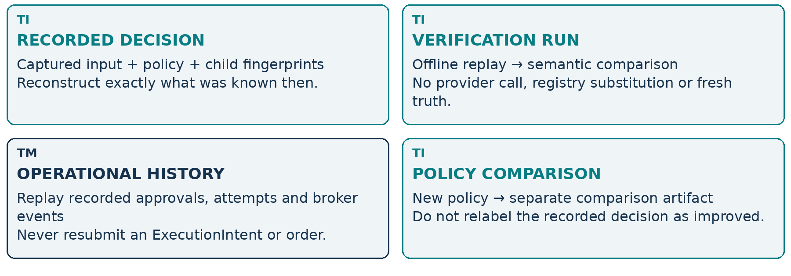
Figure 28. Captured reconstruction and new-policy comparison are different products.
A lineage bundle should retain the decision-time required scope, missing evidence, contradiction findings, source rights and usage observations alongside the successful outputs. A future full composition manifest cannot be reconstructed by consulting today’s registry; absent identity remains COMPOSITION_UNAVAILABLE.
Current captured replay is an implemented TI capability. Durable cross-system export, exact retention and TM replay integration still require their own acceptance. A saved research result is not automatically a current approval, and a successful replay says nothing about today’s broker exposure.
READ WITH Ecosystem §10; pluggability §§9–10; A3.10/A4/A5 captured replay
III • RESILIENCE / ACCEPTED DESIGN

Failure and degradation matrix
Failure | New-entry behavior | Existing work / position | Truth that must remain visible
Scanner unavailable | No fabricated new candidates; existing validity still expires | TM reconciles existing exposure; admitted TI work may continue within bounds | Source outage, candidate age and expiry
TI unavailable | TI_REQUIRED blocks; TI_OPTIONAL only under preapproved policy | TM’s independent controls continue within existing authority and available truth | NOT_TI_VALIDATED if permitted; last TI as_of and gaps
Required capability absent | Block / explicit incomplete result; do not shrink required scope | Other safe, independent work can continue | Required absence and exact profile/version
Broker unavailable / timeout | Block uncertain new exposure; reconcile before retry | Do not promise protection can execute; preserve open/unknown states | OUTCOME_UNKNOWN; attempts and last broker truth
Sheets / UI unavailable | No unverified queued approvals on reconnect | Backend may continue admitted bounded work and reconciliation | Client stale/disconnected; backend status separately
TI Monitoring unavailable | No claim of fresh recurring validation | TM operational controls remain independent; advice can become overdue | Last actual evaluation, expiry, overdue / NOT_ACTIVE
Budget exhausted / unknown usage | Explicit partial/blocked result per policy; required work not silently removed | Keep reservations and attempt lineage for reconciliation | Observed vs unknown usage; remaining admissible budget

Failure isolation is not fail-open permission. “Continue managing” means within current rights and observable truth—not guaranteed execution.
READ WITH Ecosystem §11; Monitoring §§8,11; pluggability §11
III • PLUGGABILITY / ACCEPTED DESIGN

Replace components, preserve meaning
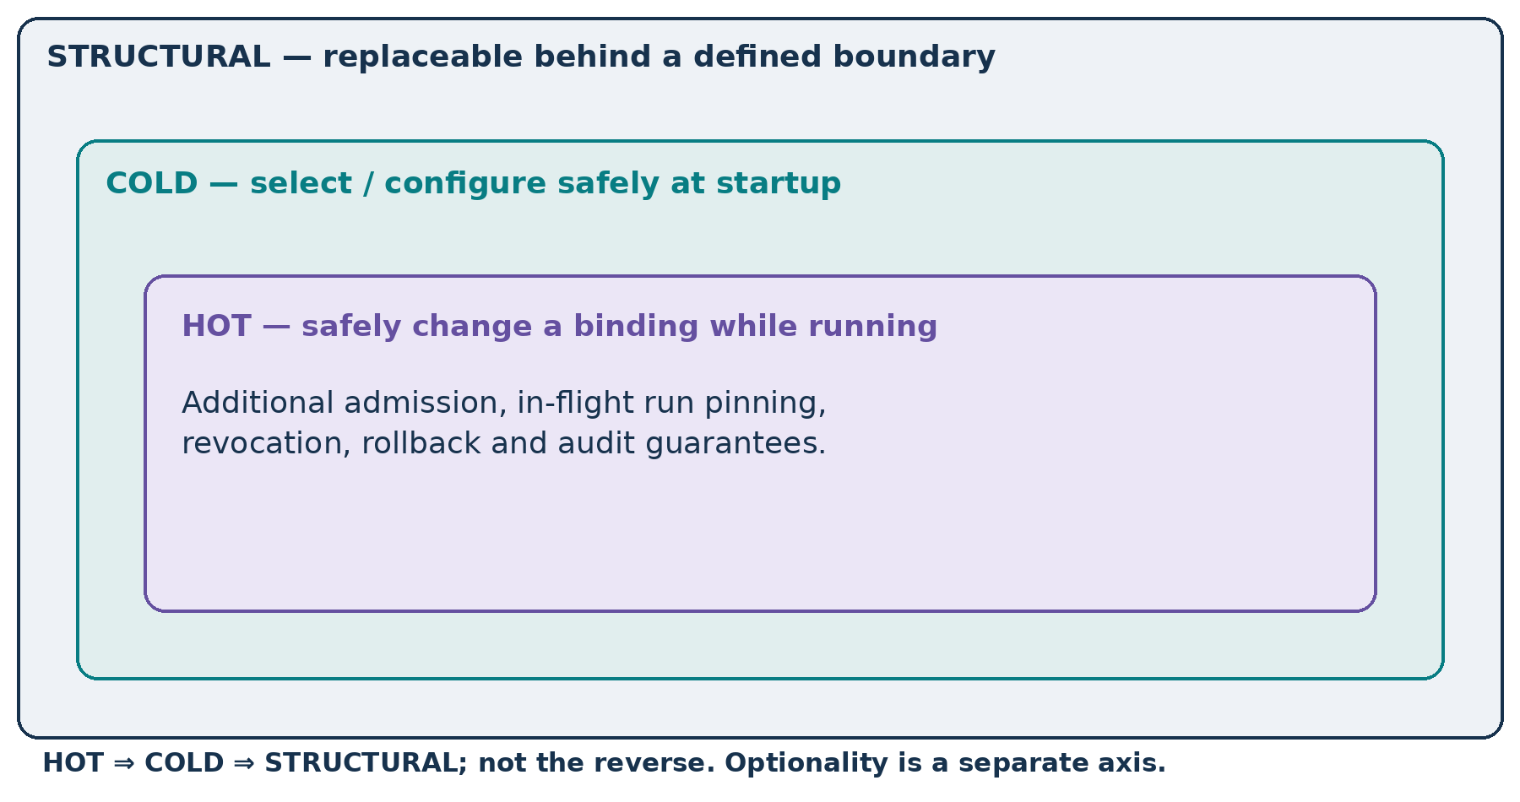
Figure 29. Stronger replacement guarantees contain weaker ones; requiredness is separate.
Component family | Boundary to preserve
Scanner / broker adapters | Source normalization vs TM execution adapter authority
TI capability / model provider | Declared scope, evidence semantics, bounded usage and replay identity
Scheduler / Sheets connector / UI panels | Admitted mandate semantics, scoped requests and faithful projections

No HOT requirement is imposed merely because a component is pluggable. R1 preserves required-scope absence today; broader R2–R5 work is still pending. A configured-but-unready component and an unavailable required capability are not equivalent to an optional component that was never requested.
READ WITH TIAF_PLUGGABILITY_ARCHITECTURE.md §§2–6,13–17
CHAPTER IV / CHAPTER DIVIDER

Follow the objects through a day
Six constructed scenarios test the mental model—including stops and failures.
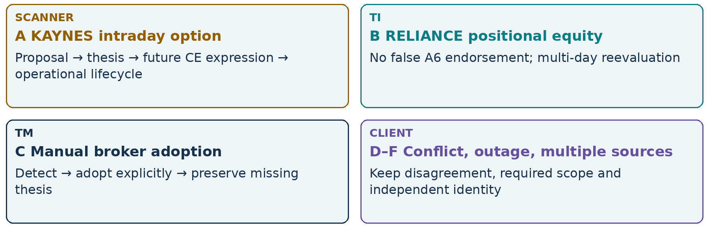
Figure 30. Worked cases explain the architecture; they are not market recommendations.
All case IDs, session times, market facts and quantities are illustrative. A named stock does not assert current eligibility, liquidity, listing availability or a live assessment.
The cases assume future integrations have passed their own acceptance gates. Current A5 advice and captured replay boundaries remain unchanged. Dates use a hypothetical session and Asia/Kolkata; no P&L trajectory or probability is forecast.
IV • CASE A / 1 / ILLUSTRATIVE FUTURE WORKFLOW

KAYNES: from proposal to filled exposure
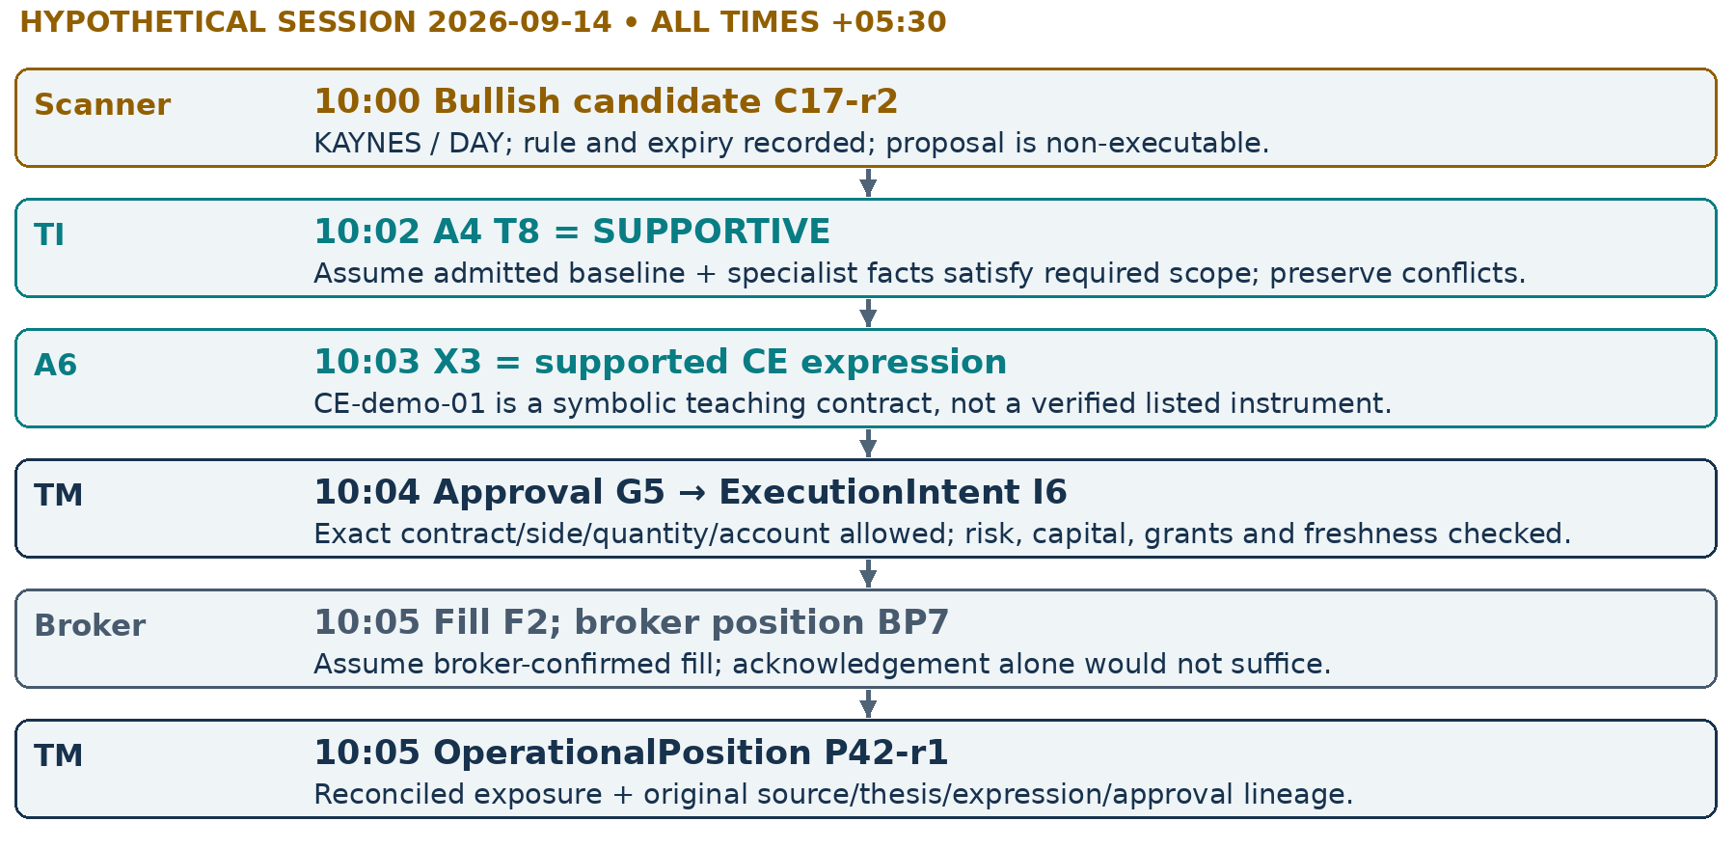
Figure 31. Every step names both the owning component and the object it produces.
Assume a future accepted A6 policy supports this exact instrument and exposure side; the thesis does not choose a strike, expiry, lot size or current long/short permission. TM remains responsible for actual quantity and account eligibility. Any failed required check stops entry even when the underlying thesis is SUPPORTIVE.
READ WITH Case continues on next page; ecosystem §§6–8
IV • CASE A / 2 / ILLUSTRATIVE FUTURE WORKFLOW

KAYNES: MAINTAIN → PROTECT → exit advice
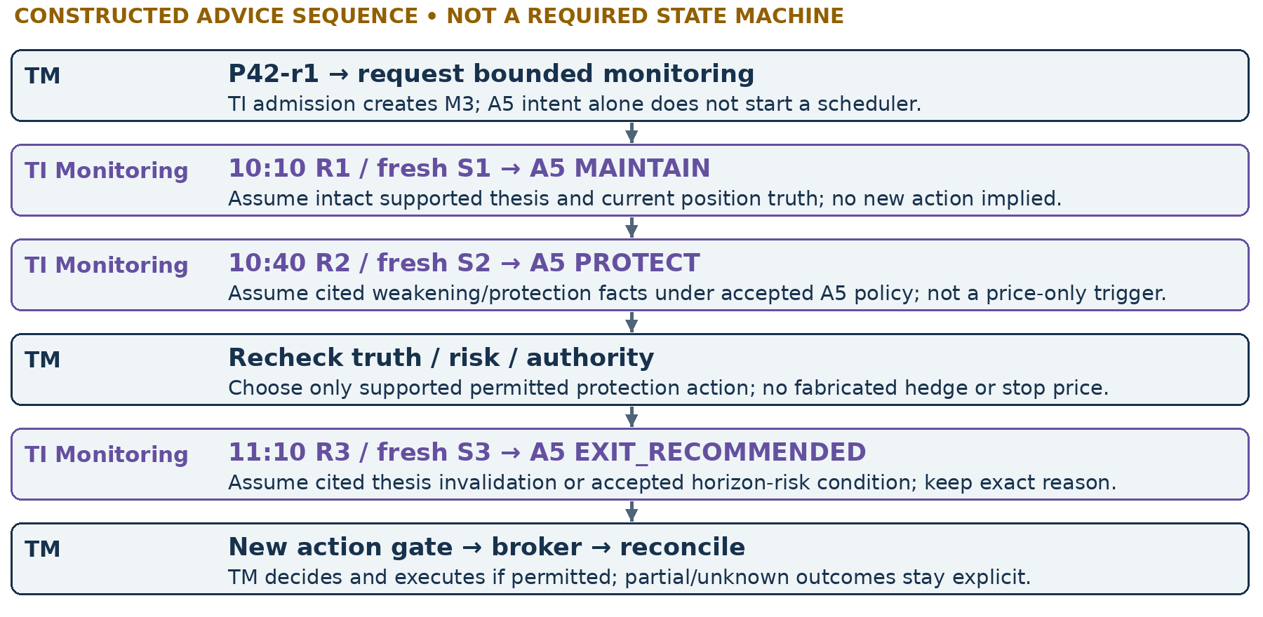
Figure 32. Each advice result is a new A5 run over new supplied truth, not an automatic transition.
At any evaluation, stale/unknown truth can produce ABSTAIN; missing thesis can produce INSUFFICIENT_EVIDENCE; confirmation needs can produce WAIT_FOR_CONFIRMATION. PROTECT does not certify a stop is installed. EXIT_RECOMMENDED does not close P42: TM must receive and reconcile actual broker fills, then terminate or revise the relevant monitoring intent.
Illustrative record | Evidence / ownership to inspect
S1 → Advice-1 / MAINTAIN | TI: intact supported thesis; TM: current position snapshot. Both references remain in the A5 capture.
S2 → Advice-2 / PROTECT | TI: cited weakening/protection basis. TM: separate protection decision and observed broker-order status—not an inferred stop.
S3 → Advice-3 / EXIT_RECOMMENDED | TI: cited invalidation/horizon-risk reason. TM: new authorized exit intent. Broker: actual exit fill before closed exposure is recorded.

READ WITH A5 architecture §§3–7,11; Monitoring §§5,7–8
IV • CASE B / ILLUSTRATIVE FUTURE INTEGRATION

RELIANCE: positional equity without false A6
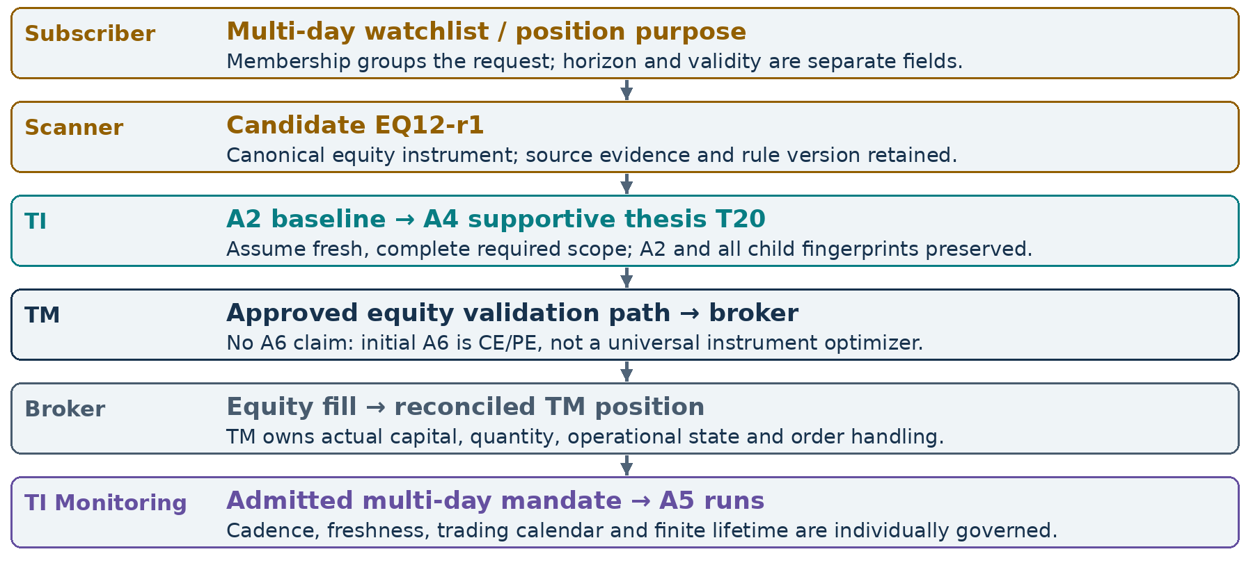
Figure 33. A valid equity path need not masquerade as an option-expression result.
Suppose the first A5 result is MAINTAIN and later evidence weakens the thesis. TI produces a new attributed recommendation, not a rewritten original thesis. An overnight gap or stale mark cannot be treated as fresh just because the mandate horizon spans several days. TM rechecks current broker truth and authority before responding.
READ WITH Ecosystem §§5–8; Monitoring clocks and calendar gate
IV • CASE C / ILLUSTRATIVE FUTURE INTEGRATION

HDFCBANK: adopting a manual broker position
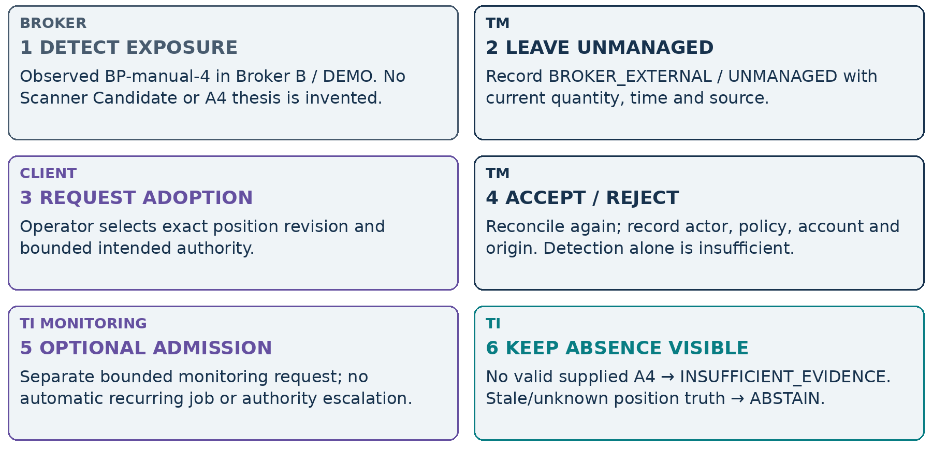
Figure 34. The lineage starts with an external broker observation, not a fictional scanner event.
A later independently admitted TI evaluation may supply thesis evidence for a successor A5 run. That analytical work does not retroactively make the original manual trade TI-validated. TM’s adoption log records what was known and permitted at adoption time.
READ WITH Ecosystem §8; A5 insufficient-evidence and freshness rules
IV • CASE D / ILLUSTRATIVE CONFLICT

Scanner BUY, TI WAIT
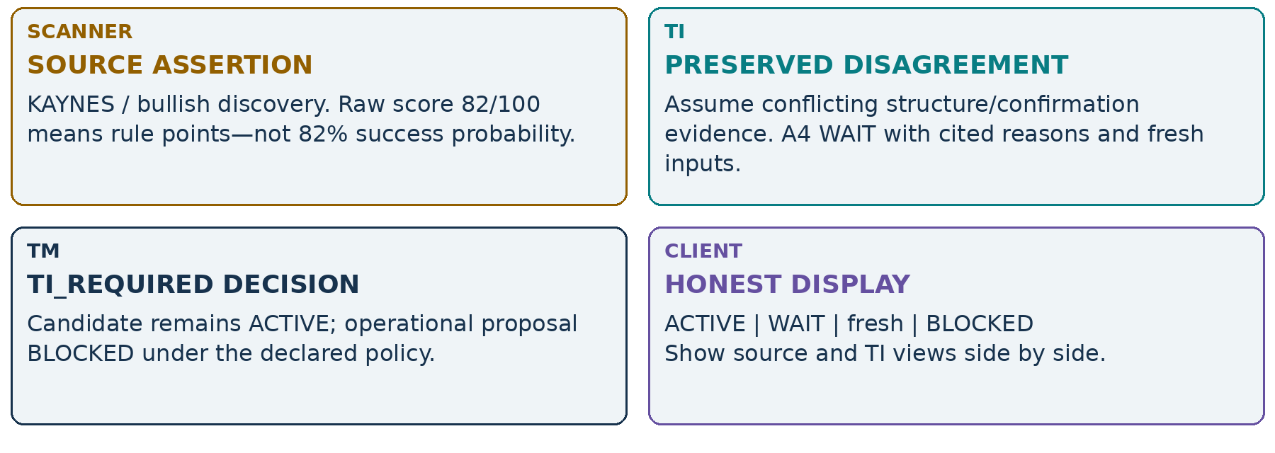
Figure 35. A disagreement is useful information, not a defect to tune away.
Do not average source score and TI confidence, call WAIT a provider outage, or rerun specialists until one produces SUPPORTIVE. A successor evaluation needs a bounded new trigger or changed admitted evidence and retains the prior disagreement. A2 NO_TRADE gates and declared blocking dispositions remain intact.
The future Signal Qualification layer must also preserve this acyclic discipline. Its output, if later implemented, names policy, scope and validity; it is not an unconditional “qualified to trade” badge.
Transparency is more valuable than making a live example look attractive.
READ WITH Ecosystem §§3,6–7; A2 benchmark and A4 preservation principles
IV • CASE E / ILLUSTRATIVE FAILURE SCENARIO

TI outage: stop entry, preserve operations
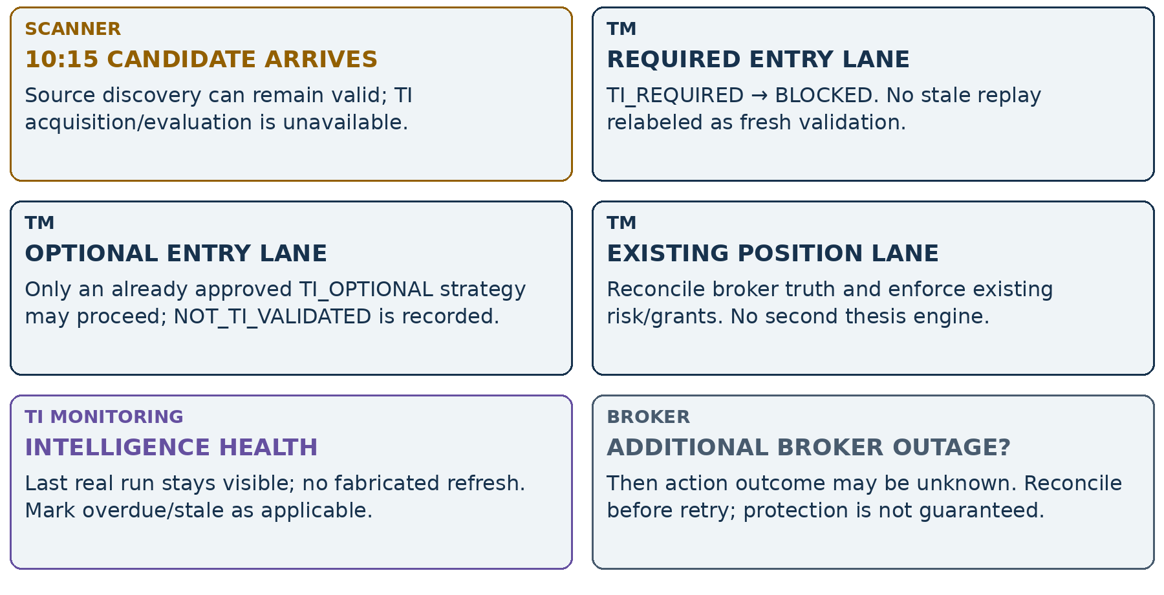
Figure 36. An outage changes availability, not the meaning of required scope or authority.
Recovery creates newly admitted evaluations and current TM reviews. It does not replay queued client approvals automatically. A prior unfavorable TI result stays recorded; optional missing-data handling cannot hide a known policy veto by treating it as unavailability.
READ WITH Ecosystem §§7,11; Monitoring failure isolation
IV • CASE F / ILLUSTRATIVE DEDUPLICATION

Two scanners, one symbol, distinct claims
Incoming event | Receiver treatment | Meaning preserved
A / C17 / r2 / digest H2  first receipt | Accept immutable candidate revision | Source A’s KAYNES assertion
A / C17 / r2 / digest H2  repeated delivery | Idempotent duplicate; retain receipt record | One candidate, not a second signal
A / C17 / r2 / digest H9  changed body | Conflict; quarantine/reject overwrite | Same revision cannot silently change meaning
A / C17 / r3 / digest H3  expected predecessor r2 | Accept successor if valid and ordered | Invalidate old approval linkage; keep history
B / C88 / r1 / digest HB  same KAYNES subject | Independent candidate retained | Different source, rule or purpose; not a duplicate

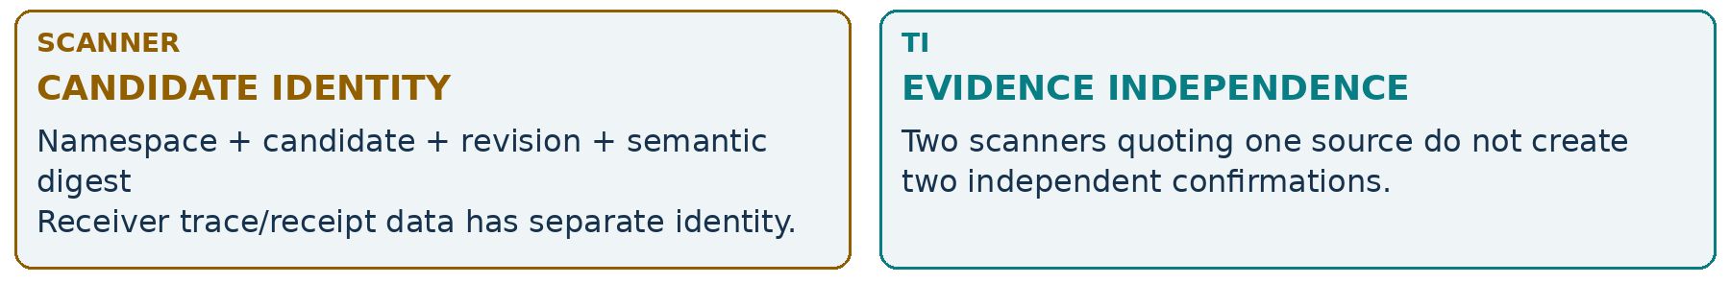
Figure 37. Idempotent delivery is not cross-source semantic collapse.
A shared instrument cluster may help navigation while preserving each source assertion. Canonical evidence admission separately decides rights, factual meaning and point-in-time availability. A changed nested expression is a candidate revision, not a mutable shared pointer. No deduplication step grants TM action authority.
READ WITH Ecosystem §3; source-authority provenance/contradiction architecture
IV • FUTURE INTELLIGENCE / FUTURE / TBD

Sector, qualification and forecasting
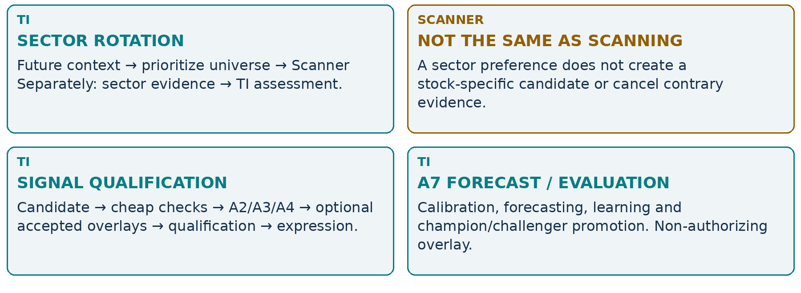
Figure 38. Separate future consumers, with no recursive search for a favorable answer.
Current A3.6 sector-context specialists are not a full Sector Rotation engine. Initial deterministic A6 does not require A7. Future calibrated evidence must be explicitly admitted and versioned; raw scanner confidence is not a substitute. Sector ordering relative to A7/A8 remains unresolved, and Signal Qualification follows its review unless explicitly reordered.
READ WITH Ecosystem §6; authoritative roadmap; TBD sector/qualification/forecasting notes
IV • EVOLUTION / CURRENT → FUTURE / TBD

A gated roadmap, not a wishful timeline
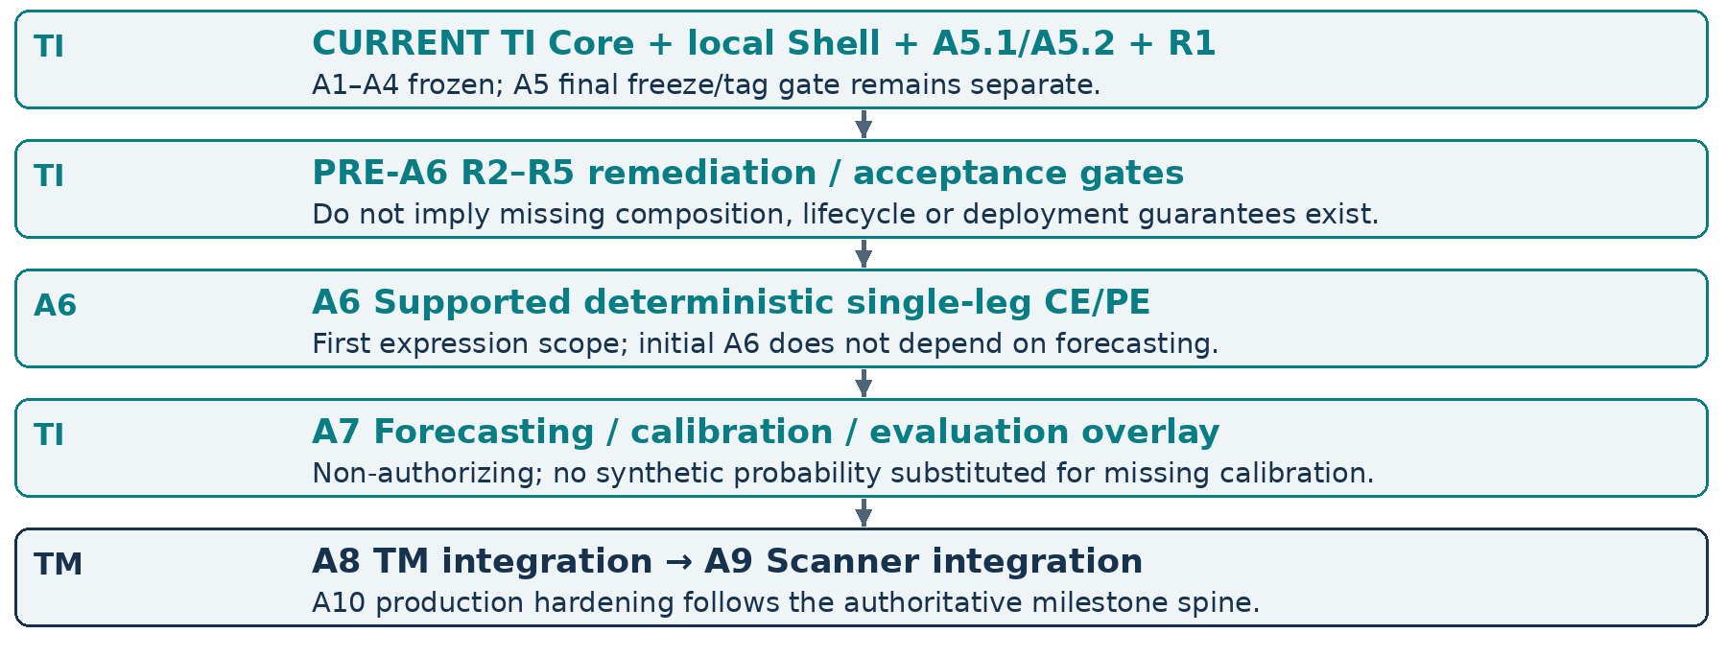
Figure 39. Normative milestone spine; this is not a delivery-date commitment.
Contract design may precede runtime integration. Monitoring runtime, Sheets/client integrations and a Web Cockpit each require separate admission, deployment and acceptance gates; this handbook does not assign them invented milestone numbers. Their dependency story is not permission to reorder the authoritative roadmap.
Sector Rotation’s placement relative to A7/A8 remains TBD; Signal Qualification follows that review unless explicitly reordered. The illustrative “scanner → monitoring → cockpit” journey explains dependencies, not a competing delivery sequence.
READ WITH TRADINGINTELLIGENCE_ROADMAP.md: current sequence; ecosystem §13
REFERENCE / ACCEPTED DESIGN / OPEN GATES

Boundaries to carry into implementation
Boundary still requiring acceptance | Do not infer
Source ingress authentication / published wire schemas | A payload source_id is authenticated; design field names are an implemented API
A6 eligibility, exposure sides and numeric policy | Every named stock has a supported option, or short-option authority exists
TM strategy, grants, action idempotency and reconciliation | TI support authorizes capital/quantity or a timeout means no fill
Fresh-input public binding / deployment / monitoring runtime | Captured replay acquires current facts or A5 hints start a daemon
Persistence, retention, cross-system export and R2–R5 | One shared database or complete captured composition already exists
Sheets / cockpit authentication, session and UI technology | A shared screen shares authority, or credentials belong in a spreadsheet
Sector Rotation / qualification / calibrated A7 evidence | Research ideas are current services or a raw score is a forecast

Memorable rules
Scanners propose. TI advises. TM authorizes. Brokers execute. Watchlist is organization; mandate is semantics. Shared evidence is not shared analysis state. Deduplicate evidence, not intent. Monitoring is intelligence orchestration, not execution. Broker truth outranks cached assumptions. Replay explains; replay never executes.
This thesis is a human-readable companion. Normative architecture remains in the authoritative Markdown architecture documents.
The handbook changes no runtime contract, enum, recommendation policy, authority boundary or package/schema version. Its mock objects and screens are teaching devices, not a new specification. When a simplification needs precision, follow the source map on the next page.
REFERENCE / REFERENCE

Source map & compact glossary
Topic | Authoritative repository reference
Ecosystem owner / object / state model | docs/TIAF_TRADING_ECOSYSTEM_ARCHITECTURE.md
TI boundary and deployment | docs/TIAF_SYSTEM_ARCHITECTURE.md  docs/TIAF_DEPLOYMENT_ARCHITECTURE.md
Mandates, clocks, sharing, scheduling | docs/TIAF_MONITORING_ARCHITECTURE.md
Replacement guarantees and required absence | docs/TIAF_PLUGGABILITY_ARCHITECTURE.md
Evidence meaning and contradiction | docs/TIAF_SOURCE_AUTHORITY_PROVENANCE_CONTRADICTION_ARCHITECTURE.md
Challenge / arbitration | docs/TIAF_A4_CHALLENGE_ARBITRATION_HIGHER_INTELLIGENCE_ARCHITECTURE.md
Single-position intelligence | docs/TIAF_A5_POSITION_INTELLIGENCE_ARCHITECTURE.md
Implementation truth, deferrals and order | docs/TIAF_CAPABILITY_MAP.md  docs/TIAF_DEFERRAL_REGISTER.md  docs/TRADINGINTELLIGENCE_ROADMAP.md
Narrative context | docs/TIAF_THESIS.md  TI_Intelligence_Hierarchy_Thesis.docx  TI_Monitoring_Architecture_Thesis.docx

Term | Read it as
PIT / as_of | Point-in-time availability / the explicit decision cutoff; not today’s knowledge.
Semantic fingerprint | Digest of declared meaning; not permission, freshness or an invented composition manifest.
OperationalPosition | TM’s reconciled managed lifecycle linked to broker truth, not a TI thesis.
MonitoringMandate | TI-admitted bounded intelligence work with separate subscriber intent.
CE / PE; A6 / A7 | Call / put; future supported expression / calibrated forecasting-evaluation overlay.

READ WITH Version snapshot: 13 September 2026, Asia/Kolkata. Future idea caches are context only.

