TradingWorkFlow (TWF)
Component Architecture
Status: Initial architecture-stage document — review before implementation freeze.

1. Purpose
This document decomposes TWF into frontend, backend, integration, persistence, and platform components. The goal is to make ownership, dependencies, and replacement seams explicit before coding.
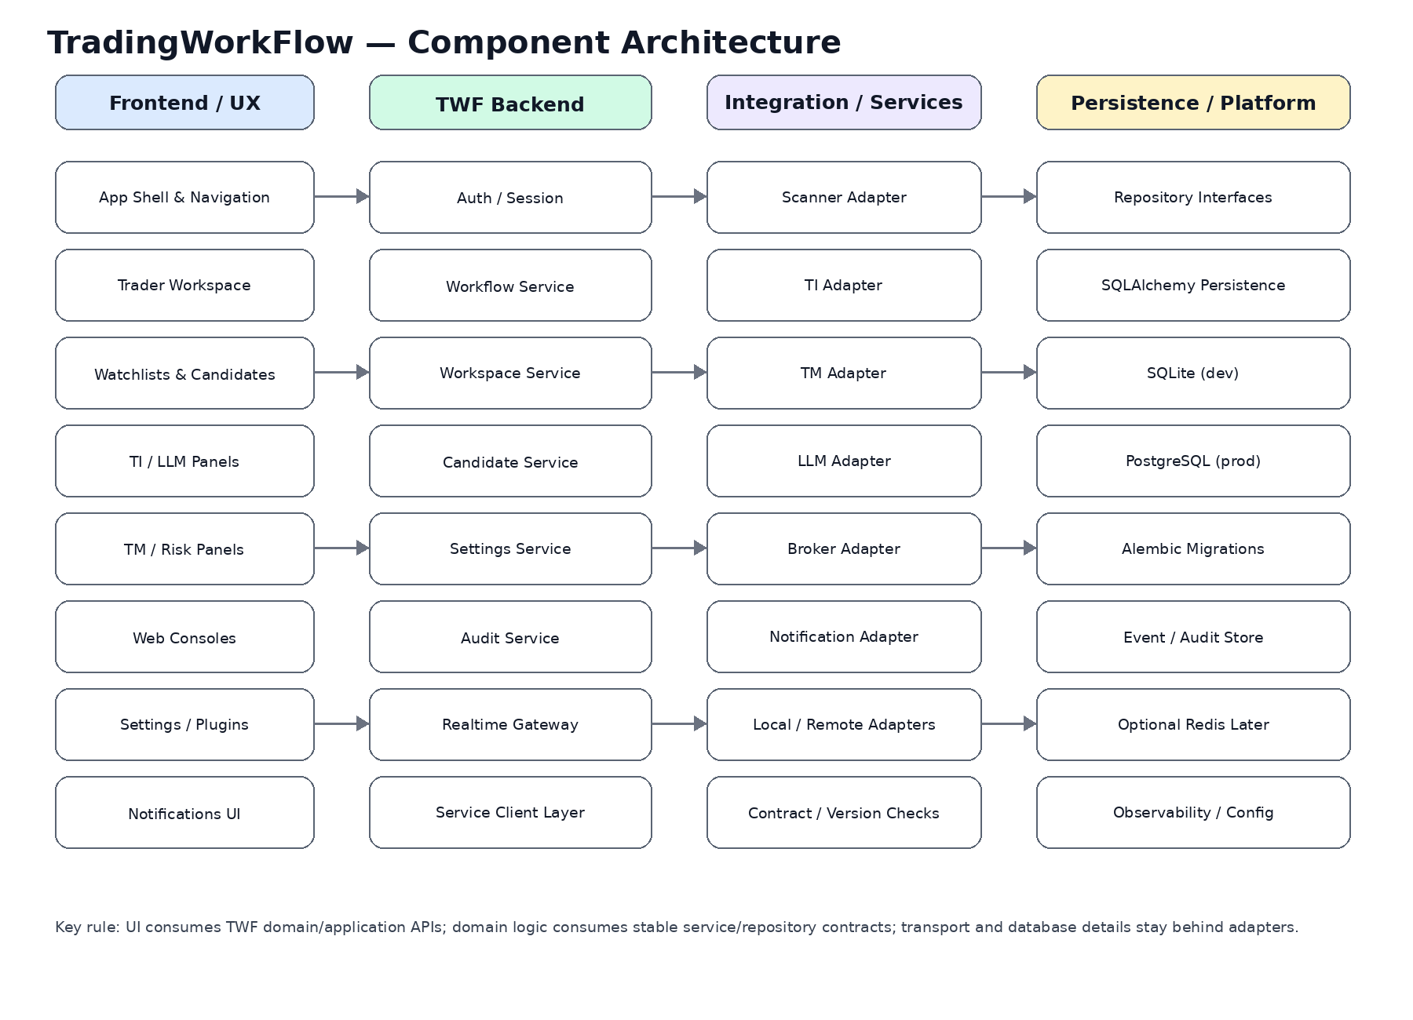

2. Frontend Components
Component | Responsibility
App Shell & Navigation | Persistent application frame, routing, global status
Trader Workspace | Selected instrument/candidate, panel composition, workflow context
Watchlists & Candidates | User-owned lists, candidate selection and filtering
TI / LLM Panels | Thesis, claims, horizons, evidence, producer identity
TM / Risk Panels | Risk, authority, position, adoption and monitoring state
Web Consoles | Reusable streamed operational/event views
Settings / Plugins | User preferences and service selection without authority leakage
Notification Center | Alerts, system status and workflow events

3. Backend Components
Component | Responsibility
Auth / Session | Authenticated user/session context
Workflow Service | Owns TWF workflow lifecycle and transitions
Workspace Service | Workspace, selected context and layouts
Candidate Service | TWF candidate references and lifecycle
Settings Service | Preferences and safe service configuration
Audit Service | Immutable/append-oriented workflow audit records
Realtime Gateway | Browser streaming/session channel
Service Client Layer | Stable logical clients for satellite systems

4. Integration Components
Adapter | Purpose
Scanner Adapter | Discovery/candidate ingestion
TI Adapter | IntelligenceResponse and provenance
TM Adapter | Risk/authority/position governance
LLM Adapter | Provider-neutral active LLM service
Broker Adapter | Only where needed; broker truth normally mediated by TM
Notification Adapter | Email/push/in-app providers
Local Adapter | Same-process/project implementation
Remote Adapter | HTTP/gRPC/future network implementation behind same semantics

5. Persistence Components
- Repository interfaces at application/domain boundary where replacement/testability benefits.
- SQLAlchemy persistence adapter.
- SQLite for initial development.
- PostgreSQL for production.
- Alembic migrations from day one.
- Audit/event persistence kept distinct from mutable user/workflow tables where useful.

6. Suggested Initial Domain Model
Entity / value object | Ownership
User | TWF
Workspace | TWF
Watchlist | TWF
Candidate | TWF reference/orchestration object
Workflow | TWF
WorkflowStep / Transition | TWF
ServiceConfiguration | TWF
UserPreference | TWF
Notification | TWF
AuditEvent | TWF
External Intelligence / Position references | Referenced, not duplicated as authority

7. Service Contract Pattern
TWF Application → Logical Service Client → LocalAdapter OR RemoteAdapter → Scanner / TI / TM / LLM / Broker
Transport, endpoint URLs, credentials and retry behavior must stay outside domain semantics. Equivalent local and remote adapters must preserve service/model/claim identity.

8. Realtime Component Model
- WebSocket for interactive/bidirectional streams and consoles.
- SSE where one-way streaming is sufficient.
- Explicit connection/reconnect/stale state.
- No event-bus platform until scaling evidence requires it.

9. Configuration Boundaries
Configuration class | Examples
User Preference | theme, layout, display defaults
Workspace Configuration | active watchlist, layout, active instrument
Service Configuration | TI/TM/scanner endpoints and capabilities
LLM Configuration | provider/model/prompt/tool/orchestration versions
Security Configuration | secrets, service authentication; never ordinary UI preferences
Trading Authority | TM-owned; not granted by TWF settings

10. Failure / Degradation Components
- Service health model
- Typed unavailable/timeout/version-mismatch errors
- Stale-data markers
- No silent provider failover without actual producer identity
- UI degradation state distinct from workflow state

11. Dependency Rules
- Frontend depends on TWF APIs/contracts, not satellite SDK internals.
- Domain/application layers do not import DB engines or provider SDKs.
- Integration adapters depend inward on stable contracts.
- TM state is referenced, not copied as a second authority.
- LLM provider SDKs remain behind provider-neutral adapter boundaries.

12. Pre-Coding Component Decisions Still Needed
- Exact frontend UI component library
- Charting/TradingView integration strategy
- Auth/session library/provider
- Frontend server-state library
- Service contract serialization/versioning conventions
- Background job boundary
- Repository/package structure

