TradingWorkFlow (TWF)
Deployment Architecture
Status: Initial architecture-stage document — review before implementation freeze.

1. Purpose
This document defines how the same logical TWF architecture can run locally during development and evolve into a secure, multi-user cloud product without changing business semantics.
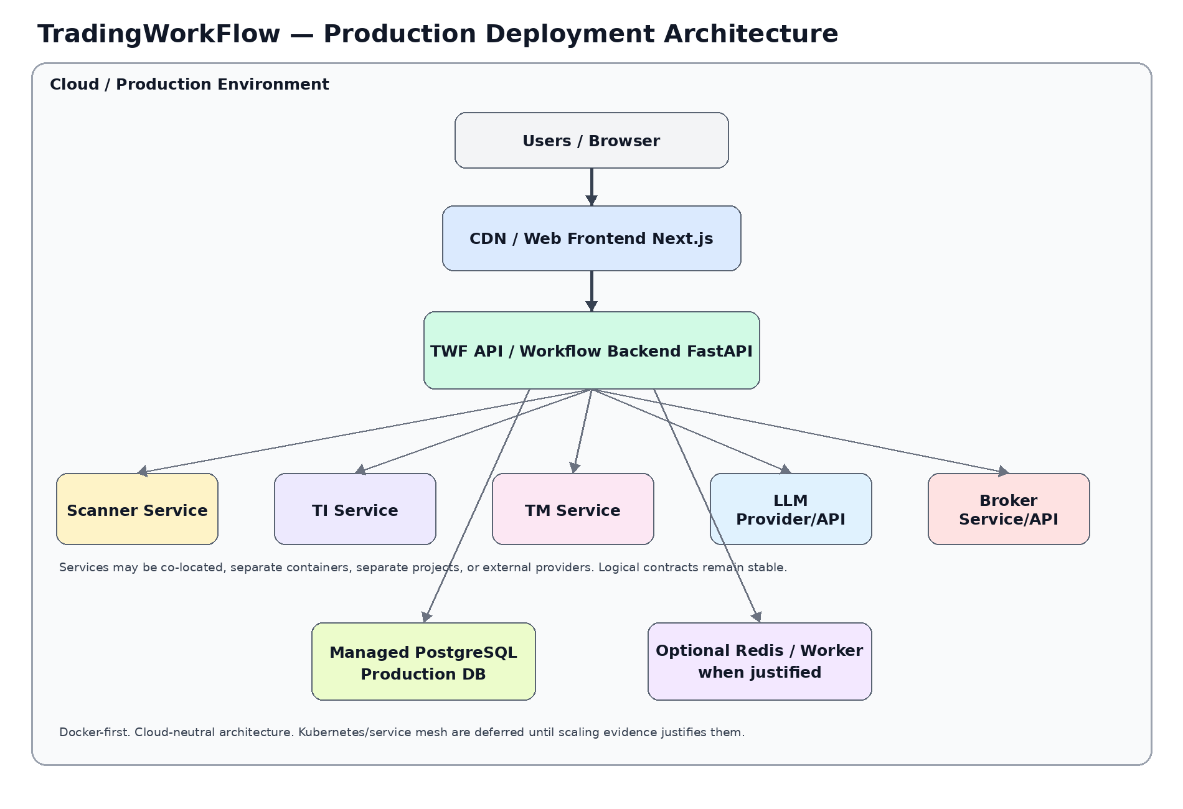

2. Deployment Principles
- Docker-first, cloud-neutral architecture.
- Logical services independent of physical location.
- Local and remote adapters share semantic contracts.
- SQLite is development-only by default; PostgreSQL is production target.
- No Kubernetes/service mesh until operational evidence justifies it.
- Multi-user ownership considered from first schema.
- Secrets are externalized from normal application data/configuration.

3. Development Topology
Browser → Next.js dev server → FastAPI dev backend → SQLite
↘ Local/Synthetic Scanner/TI/TM/LLM adapters
- Single developer machine friendly.
- Synthetic/local adapters permit workflow development even when satellite projects are unavailable.
- Real remote services can be enabled selectively through configuration.

4. Early Integrated Topology
Browser → TWF Web → TWF API → SQLite/PostgreSQL
├→ Scanner service
├→ TI service
├→ TM service
└→ LLM provider
Services may be local processes, remote projects, containers or hosted APIs. The TWF application should not change domain behavior based on placement.

5. Production Cloud Topology
Zone / component | Production direction
Edge/Web | TLS, CDN/reverse proxy, web frontend
Application | TWF FastAPI backend, horizontally scalable later
Database | Managed PostgreSQL
Cache/Worker | Redis/task worker only when justified
Satellite services | TI/TM/scanners local to cloud or remote
LLM | Provider-neutral external/internal service
Broker | Remote broker APIs; authority normally mediated by TM
Observability | Central logs, metrics, traces, health dashboards
Secrets | Cloud secret manager / secure environment injection

6. Multi-User / Subscription Deployment
- Every durable user-owned record carries explicit ownership scope.
- Authentication and application authorization are separate from broker/trading authority.
- Subscription/entitlement layer is additive; do not entangle billing logic with workflow domain.
- Rate/usage controls can be added at service/application boundary.

7. Database Evolution
Stage | Database | Requirements
Local development | SQLite | Migrations, portable types, realistic constraints
Integrated test | SQLite + PostgreSQL CI where practical | Catch portability/concurrency issues
Production | Managed PostgreSQL | Indexes, backups, PITR, connection pooling, monitoring

8. Realtime Deployment
- WebSocket/SSE connections terminate at TWF backend/realtime gateway.
- Multi-instance scaling later requires shared coordination only when needed.
- Redis/pub-sub should be introduced only when one-instance semantics no longer suffice.
- Reconnect/resume semantics must be explicit for trader UX.

9. Security Zones
Boundary | Rule
Browser ↔ TWF | Authenticated TLS session; no broker/provider secrets in browser
TWF ↔ Satellite service | Authenticated service call when remote; version/capability validation
TWF ↔ LLM provider | Provider credentials server-side only; actual provider/model recorded
TM ↔ Broker | Broker credentials and execution authority remain TM/broker concern
DB | Private network access in production; encrypted backups and least privilege

10. Availability and Degradation
Failure | Expected TWF behavior
TI unavailable | Show analysis unavailable/stale; do not fabricate advice
TM unavailable | Disable governed trade action; preserve read-only context
LLM unavailable | Show failure/fallback identity honestly; no silent masquerading
Scanner unavailable | Existing watchlists/workflows remain usable
Broker unavailable | TM/broker state marked unavailable; no fake execution success
DB unavailable | Fail closed for writes; preserve clear UX error state

11. Observability
- Correlation ID across browser → TWF → satellite calls.
- Workflow ID across trader journey.
- Service latency and error metrics.
- Structured audit logs for authority-sensitive transitions.
- Realtime connection state metrics.
- Model/service identity captured in relevant traces without secrets.

12. Backup / Recovery
- Database migration/version recorded.
- Production PostgreSQL backups and point-in-time recovery.
- User/workflow data recovery tested.
- TWF does not pretend it can reconstruct authoritative broker history if broker/TM records are unavailable.

13. Scaling Path
Single instance → multiple TWF app instances → shared PostgreSQL → optional Redis/worker → targeted service scaling
Scale only the components that show real pressure. Avoid premature distributed complexity.

14. Deployment Decisions Still Open
- Initial cloud provider
- Hosting model for Next.js
- Container runtime
- Managed PostgreSQL provider
- Secret manager
- Central observability tooling
- Worker/queue selection
- Subscription/billing provider
- Service authentication mechanism

15. Deployment Acceptance Gate Before Production
- PostgreSQL compatibility verified
- TLS/auth configured
- Secrets externalized
- Backups/recovery verified
- Service timeouts/degradation tested
- Audit logging enabled
- Observability dashboards defined
- Load/performance thresholds met
- Security review passed

