TradingWorkFlow (TWF)
Master Product Architecture
Status: Initial architecture-stage document — review before implementation freeze.

1. Purpose
This document is the master architectural view of TradingWorkFlow (TWF). It explains the major product components, their responsibilities, the end-to-end trader workflow, and the design rules that must hold as the system evolves.
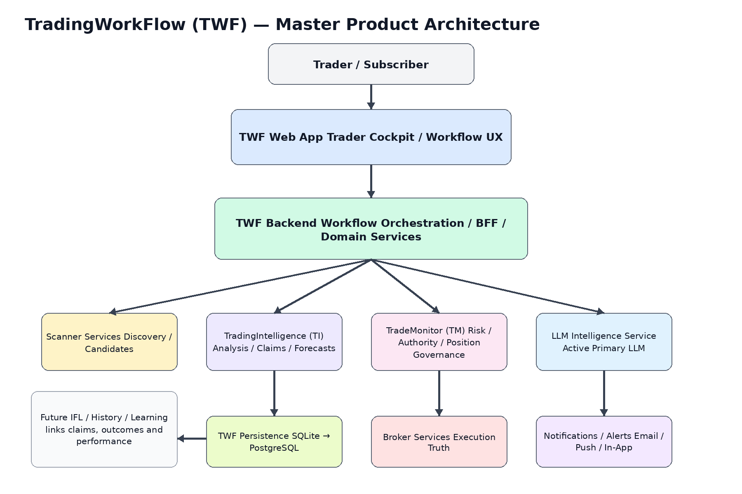

2. Product Positioning
TWF is a separate trader-facing product that composes specialist trading capabilities into one coherent web workflow. It is not merely a UI over TI/TM and it does not absorb their internal ownership responsibilities.
Component | Primary responsibility | Authority boundary
TWF | Trader workflow, orchestration, presentation, configuration, correlation | No independent trading authority
Scanner | Discovery and candidate proposal | No execution authority
TI | Assessment, explanation, claims, forecasts, advisory trade expression | Advisory only
LLM Service | Reasoning, synthesis, interpretation | No historical-truth or execution authority
TM | Risk, authority, ownership/adoption, execution supervision, position governance | Authoritative governance layer
Broker | Orders/fills/positions | Execution truth
Future IFL | Claim/outcome/performance feedback and learning coordination | No silent model mutation

3. Major Product Components
- Authentication and user/account boundary
- Workspace and trader session
- Watchlists and candidate context
- Scanner integration
- TradingIntelligence integration
- TradeMonitor integration
- Active primary LLM / Intelligence Service
- Candidate / trade workflow orchestration
- Orders / positions / monitoring views
- User settings and pluggable service configuration
- Reusable web consoles
- Notifications and alerts
- Audit/history and future IFL visibility

4. Minimal Complete Product
Login → Workspace → Watchlist/Scanner → Candidate → TI/LLM Analysis → Trader Review → TM Risk/Authority → Manual Approval → Execution/Adoption → Monitoring → History
The first miniature must be complete end to end even if some service integrations initially use synthetic/local adapters. Completeness of workflow is more important than breadth of advanced features.

5. Architectural Layers
Layer | Contains | Must not own
Experience | Web shell, panels, navigation, consoles, settings UI | TI/TM business authority
Application/Workflow | Workflow state, correlation, orchestration, user actions | Broker truth or model internals
Domain | User/workspace/candidate/workflow semantics | Transport or DB-specific behavior
Integration | Scanner/TI/TM/LLM/Broker adapters | Independent business decisions
Persistence | Repositories, migrations, audit persistence | Domain policy
Platform | Realtime, auth plumbing, config, observability | Trading logic

6. Core End-to-End Workflow
- Candidate is discovered or manually selected.
- TWF opens/creates a workflow context.
- TI and the active LLM produce structured intelligence and explanation.
- Trader reviews intelligence and any advisory trade expression.
- TWF hands the candidate to TM through a stable integration contract.
- TM evaluates broker truth, risk and authority.
- Trader manually approves in the initial miniature.
- TM coordinates execution/adoption and monitors the resulting position.
- TWF presents ongoing state and preserves workflow/audit lineage.
- Future IFL can later connect the original claims with outcomes and performance.

7. Data Ownership and Truth
State | Authoritative owner
TWF user/workspace/preferences | TWF
Scanner candidate evidence | Scanner / captured TWF reference
TI claims/provenance | TI / referenced by TWF
TM risk/authority/position ownership | TM
Broker order/fill/position truth | Broker / reconciled through TM
TWF workflow/audit lineage | TWF
Future claim outcome/performance memory | IFL / Evaluation layer

8. Key Architectural Invariants
- TWF is a separate product/repository.
- TWF is web-first and cloud/multi-user ready.
- Logical service contracts are independent of deployment location.
- One active primary top-tier LLM is normal runtime configuration, but provider identity remains replaceable.
- TI advises; TM governs; broker remains execution truth.
- Application/domain logic is database-neutral.
- SQLite is a development deployment choice, not a domain assumption.
- Historical/provenance identities survive service/model replacement.
- User preferences cannot silently change trading authority.
- The first implementation is miniature but complete end to end.
- Degraded service states are explicit in UX.
- Architecture grows through bounded milestones and acceptance gates.

9. Pre-Coding Architecture Gate
Coding should begin only after the following are accepted:
- Master Product Architecture
- Component Architecture
- Deployment Architecture
- UX Architecture
- Service Contract Architecture
- Data Architecture
- Security / Authentication Architecture
- Technology Decision Record
- Detailed Roadmap with milestone/target acceptance criteria

10. Explicit Non-Goals for Initial Miniature
- Autonomous trading
- Full subscription billing
- Full IFL self-learning runtime
- Every broker/scanner
- Kubernetes/service mesh
- High-frequency trading
- Complex distributed event platform
- Advanced mobile trading UX

11. Current Architecture Decision
Proceed architecture-first. TWF-0 should close the design gaps above before implementation scaffolding begins.

