TRADINGWORKFLOW (TWF)
TWF Opportunity Domain Architecture
Shared identities, lineage, lifecycle and ownership from discovery to managed outcomes
Version 0.1 • 28 Sep 2026
PROPOSED / RECONCILED / READY FOR REVIEW
Markdown is the normative repository source. This DOCX is the synchronized visual/reference companion.

Document map
Section | Topic
1 | Status and authority
2 | 1. Domain progression and authority
3 | 2. Identity and common record rules
4 | 3. Entity contracts
5 | 4. Evidence and relevance value objects
6 | 5. Episode lifecycle and temporal projection
7 | 6. Persistence and transitions
8 | 7. Cross-stage handoff and invalidation
9 | 8. Evolution from the older generic Candidate
10 | 9. Acceptance and open decisions

Status and authority
Version | Date | Status | Role and change
0.1 | 2026-09-28 | PROPOSED / RECONCILED / READY FOR REVIEW | Normative design proposal for identities, lineage, lifecycle and ownership across discovery and the future trading workflow

This document defines shared domain semantics. S&D architecture defines discovery policies and providers; the Sprint-2 plan limits implementation to DiscoveryCandidate. Later objects below are conceptual contracts, not implemented tables, endpoints or accepted satellite API schemas. The reconciliation record records baseline evidence and precedence. Broker V2 is accepted/frozen and unchanged.

1. Domain progression and authority
Figure 1. Opportunity-domain ladder from ScanMatch through evaluation.
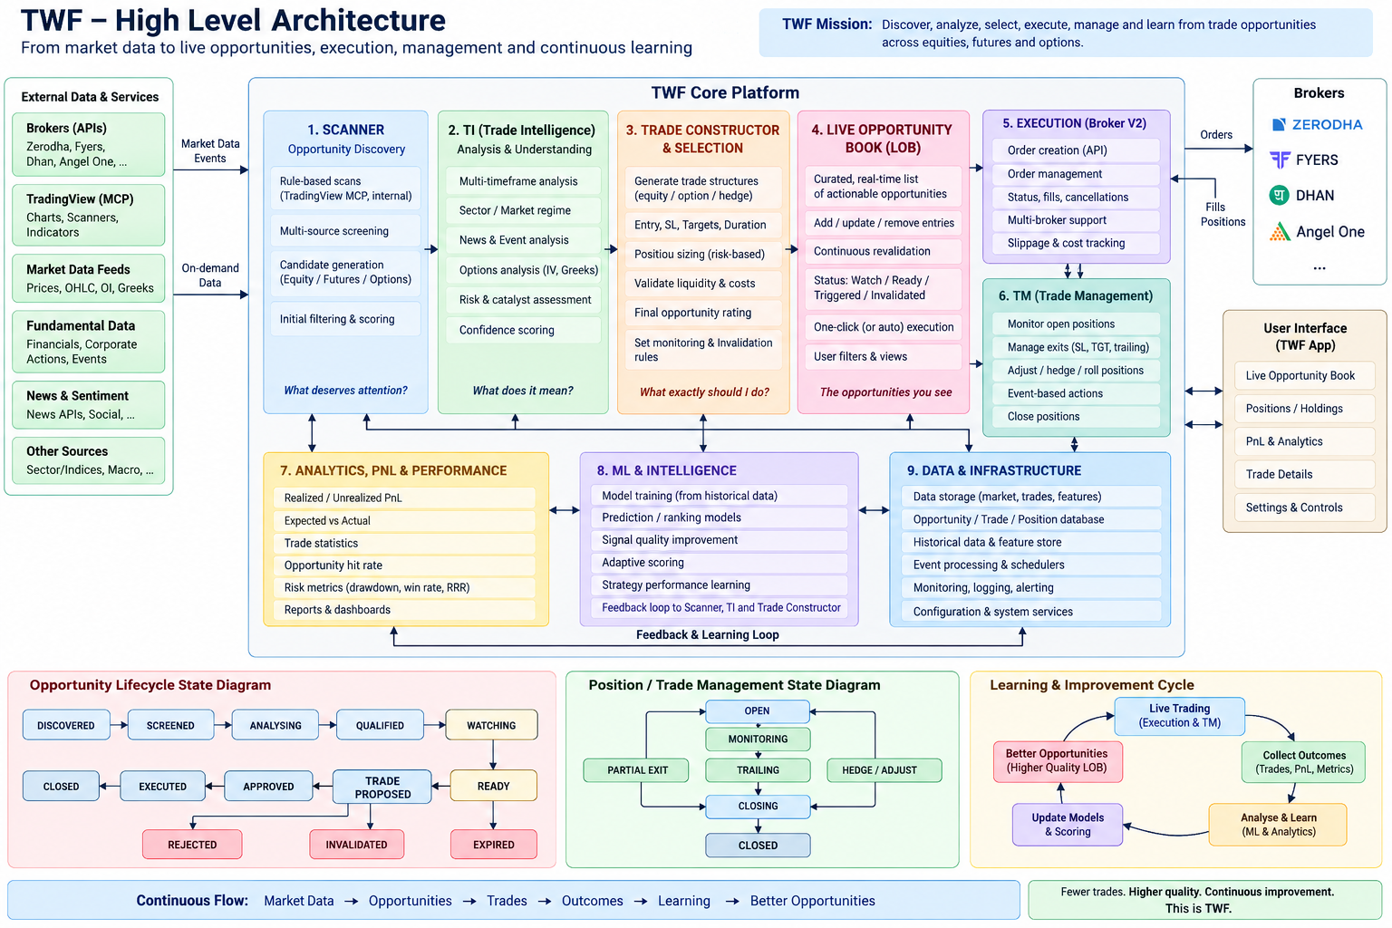
Figure 2. TWF end-to-end architecture vision.
An arrow conveys a possible relationship, not automatic conversion or authority. A trader may use Scan alone, never request TI, or never trade a candidate. Many matches produce no candidate; many candidates produce no qualified opportunity; one qualified opportunity can support alternative trade constructions. A manual Broker V2 order may have no discovery lineage. Do not invent a candidate for it.
TM-managed dispatch additionally requires TM assessment and approval before execution. The diagram's post-execution TM node describes supervision/adoption, not permission to delay risk governance until after a trade. Broker V2 manual execution retains its separate, explicitly enabled unmanaged authority path.
Boundary | Authority | What TWF may own | What it must not claim
Reference identity/data | Identified reference/market data producer | Stable IDs, source mappings, captured observations | That an ambiguous symbol is a universal security ID
Scan | ScanProvider's declared criteria evaluator | Definition revisions, runs, normalized matches | Ownership of a satellite's native algorithms
Discovery | TWF S&D evaluator and versioned policy | Intent, episode, snapshots, candidate projection, relevance | TI scientific confidence, profit probability, trade approval
TI | TI owns its claims/forecasts/thesis and their versions | Requests, immutable response references, future qualification decision record | Editing TI claims or replacing its scientific authority
Trade Construction | Future TWF construction workflow, within verified TI/TM contracts | Concrete proposals and alternatives | Execution permission or broker acceptance
LOB | Future TWF readiness/read-model workflow | Prepared-opportunity queue and validity projection | An order book, live-order ownership, automatic dispatch
Execution | Broker owns execution truth; TWF owns its request/audit | Existing order intent, idempotency, confirmation and reconciliation references | Acknowledgement means fill, or timeout means no execution
Managed trading | TM owns accepted managed scope | References and governed interaction UI | Silent manual fallback or implicit adoption
Evaluation | Named evaluator owns a versioned derived result | Captured datasets, labels, lineage, evaluation versions | Causality, calibrated probability or learnability from selected trades alone

2. Identity and common record rules
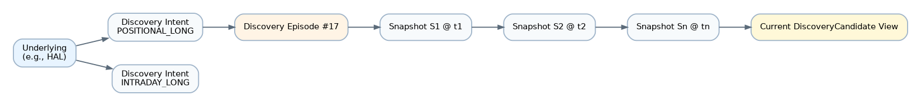
Figure 3. Stable underlying, discovery intents, episodes and snapshot lineage.
Every TWF-owned object has an opaque stable ID, authorized owner scope, schema version, creation timestamp and lineage references. Mutable aggregates also have revision/CAS control; immutable observations have capture IDs and content hashes. Never use display name, symbol alone, table position or relevance rank as identity. Personal user ownership is the Sprint-2 boundary. Workspace/tenant membership must be separately implemented and accepted before a shared scope is enabled.
External IDs retain producer namespace, producer version when relevant and native identifier; mappings have evidence/version and validity interval. An underlying can have multiple listings and derivative contracts. A venue-specific observation keeps its listing/contract basis. NSE and BSE prices do not become duplicate observations merely because both map to one underlying. Unresolved mappings stay source-scoped with an explicit ambiguity flag; cross-source underlying merge is forbidden until resolved. Broker-native execution identity is never replaced by a discovery ID. Later execution must resolve an exact eligible native contract.
The same underlying and trading intent may recur in a genuinely new episode. Different intents/horizons can coexist. Same-intent normal price fluctuations do not create a new episode. The observation basis, semantic intent/horizon fingerprint and policy series participate in the episode identity rule.
All timestamps use UTC instants plus explicit original venue/calendar/timezone metadata. Preserve observed_at, source_published_at when supplied, available_at where known, received_at, evaluated_at and recorded_at as distinct meanings. A missing source timestamp stays missing. Receipt time cannot assert market freshness. An evaluation records the actual information cutoff; future labels must not leak backward into the evidence used at nomination time.

3. Entity contracts

3.1 Underlying
- Purpose/owner: stable subject of analysis; TWF reference-identity registry
owns its mapping record, not the underlying market/security facts.
- Identity: underlying_id; versioned source mappings and listing relationships.
Unresolved source subjects have separate source-scoped IDs, not fabricated canonical IDs. An ISIN, symbol or provider token is evidence, not a universal key.
- Mutability/lifecycle: append reference revisions; ACTIVE, AMBIGUOUS,
RETIRED/SUPERSEDED mappings. A delisting preserves historical relationships.
- Authority/time/provenance: source namespace, mapping evidence, validity
interval, observed/received/recorded times, resolver version and corrections.
- Relationships: universe memberships and observations point here or to an
unresolved subject. Multiple intents, episodes, listings and contracts may follow; historical episode subject IDs are not destructively rewritten.

3.2 DiscoveryIntent
- Purpose/owner: TWF-owned definition of what attention is sought: direction,
objective, setup/thesis family and horizon, distinct from an execution instruction.
- Identity: intent_id plus immutable intent_revision and semantic fingerprint.
- Mutability/lifecycle: authorable DRAFT; validated ACTIVE revision; RETIRED.
Editing creates a revision; an episode pins the version it was evaluated under.
- Authority/time/provenance: user choice or saved profile, policy definitions,
created/activated/retired timestamps and actor/configuration revisions.
- Relationships: combines with subject and observation basis to form episodes;
future Opportunity retains this original context even if its own horizon differs.
HorizonSpec is a versioned value object: basis (elapsed, trading sessions, calendar or event-relative), minimum/maximum window, calendar and timezone where applicable, event anchor where applicable, and evaluation cadence expectation. Named presets select full values; they are not an exhaustive hard-coded enum. A 5-session horizon is not 5 calendar days. The existing Settings Foundation's default_horizon values 5d/15d lack these semantics; any migration needs explicit mapping/user confirmation, not reinterpretation of existing saved preferences.
An episode's OpportunityWindow contains an anchored start/end or a resolvable event-window rule and the resolved calendar revision. It is separate from evidence freshness, eventual order validity and eventual holding duration. Refresh does not slide the window forward. A changed objective or substantially changed horizon requires a new semantic intent/episode decision, not a rewritten past.

3.3 DiscoveryEpisode
- Purpose/owner: TWF-owned coherent run of a subject/intent thesis through time.
- Identity: episode_id; subject, observation basis, intent/horizon fingerprint,
owner and explicit policy-series key. At most one non-rejected episode per key.
- Mutability/lifecycle: revisioned head/decision aggregate; immutable observations
and transition events. NEW, CURRENT, DEFUNCT, EXPIRED, REJECTED; effective STALE projection defined below. New policy series is intentional, never accidental duplication.
- Authority/time/provenance: evaluator/policy revisions, initial evidence,
fixed opportunity window, opened/last-evaluated/expired/rejected timestamps, previous episode link and reason for opening. Record actor for manual dismissal.
- Relationships: contains S1…Sn and decision events, owns one candidate projection.
May point to prior terminal episode; later episodes cannot erase prior outcome.

3.4 Snapshot
- Purpose/owner: TWF-owned immutable capture of what was available for a decision.
- Identity: snapshot_id, episode sequence number and content hash; sequence
ordering is storage order, not permission to accept a late observation as newer data.
- Mutability/lifecycle: append-only; accepted, quarantined or superseded by a
separately recorded correction. Do not update payload, evidence, score or source times in place. Retention/deletion is separately audited, not a revised snapshot.
- Authority/time/provenance: original producers remain authoritative for raw
facts. Capture source mode, identities, observation/availability/receive/evaluation times, units, schema/profile/capability/policy versions, evidence references, market context, freshness, tolerance result, relevance and optional interpretation.
- Relationships: previous snapshot reference; correction can supersedes a
capture while preserving it. Every candidate display pins a head snapshot.
S1 establishes a provisional observation. S2…Sn establish evolution only with at least two comparable, distinct source observations using compatible identity, measurement basis, session and policy. Duplicate polls and replayed payloads do not satisfy this rule. Historical bars can support an initial indicator without constituting two separate S&D evaluations. Missing or non-comparable history produces UNKNOWN evolution, never fabricated improvement. Re-scoring past data under a new policy creates a labelled replay result, not a rewritten live snapshot.

3.5 ScanMatch
- Purpose/owner: normalized assertion that a subject matched a definition in
one scan run. Native match semantics belong to the ScanProvider.
- Identity: scan_match_id plus scan_run_id, provider observation key and
source-scoped/native subject identity; dedup lineage references all contributors.
- Mutability/lifecycle: immutable run result; valid, unresolved or quarantined
normalization outcome. Missing or partial provider responses remain distinguishable.
- Authority/time/provenance: criteria/version, actual applied filters, source
measurements/units and source timestamps, run capture time, provider/capability version, normalization version, source mode and completeness.
- Relationships: scan-only terminal output, or input to a discovery decision.
A match can be evaluated for several intents; it need not produce any candidate.

3.6 DiscoveryCandidate
- Purpose/owner: TWF S&D's attention-worthy subject for one intent/horizon/episode.
- Identity: candidate_id stable within episode_id; owner-scoped. It does not
reuse scan_match_id or eventual opportunity_id.
- Mutability/lifecycle: revisioned projection of immutable head snapshot and
transition history. Candidate effective lifecycle follows its episode; save/review markers are orthogonal user annotations and confer no trading approval.
- Authority/time/provenance: versioned deterministic nomination/relevance policy,
evidence/context/source lineage, head snapshot, evaluation cutoff, freshness, fixed opportunity window, optional separately labelled LLM interpretation.
- Relationships: derived from ScanMatch or another CandidateSource; references
subject/intent/episode/snapshots. Future explicit TI request references exact candidate revision and snapshot, not a moving mutable card.
A declined nomination is retained as a DiscoveryDecision with reason, input and policy references. It is not a REJECTED candidate if no candidate ever existed. The queue is a query projection, not the sole historical record.

3.7 Opportunity — future
- Purpose/owner: a qualified thesis worth constructing, beyond early discovery.
TWF owns the qualification workflow record; TI owns deeper analysis and claims.
- Identity: opportunity_id plus immutable qualification revision.
- Mutability/lifecycle: proposed ANALYSIS_PENDING, QUALIFIED, NEEDS_REVIEW,
INVALIDATED/EXPIRED/DECLINED states; exact public schema requires the future TI integration gate. Revised analysis yields a new decision revision.
- Authority/time/provenance: exact TI request/response/claim IDs and versions,
evidence as-of, analysis time, qualification policy/actor, decision/validity times. No invented universal probability threshold substitutes for TI's contract.
- Relationships: one or more explicit candidate/evidence references; separate
qualified horizon/thesis. Several trade constructions may follow. A returned TI response is not automatically a qualified opportunity.

3.8 TradeOpportunity — future
- Purpose/owner: future construction workflow's explicit proposed trade, with
structure, native/canonical mappings, direction, entry conditions, risk/exit proposal, duration, constraints and expected management mode.
- Identity: trade_opportunity_id and immutable construction revision;
alternative structures have distinct IDs with common opportunity lineage.
- Mutability/lifecycle: DRAFT, PREPARED, NEEDS_REVIEW, EXPIRED/WITHDRAWN conceptual
states. Edit after review creates a new revision and invalidates prior readiness.
- Authority/time/provenance: constructor/actor and policy, input qualification
revision, contract resolution, price/risk assumptions, prepared/as-of/valid-until times; TI claims and future TM assessments remain separate referenced authorities.
- Relationships: derives from Opportunity; can enter LOB; later creates a
distinct OrderIntent only after explicit authority/confirmation. Not itself an order.

3.9 LOBEntry — future
- Purpose/owner: future TWF Live Opportunity Book organizes prepared proposals
that are actionable under their current conditions. It is not a broker order book.
- Identity: lob_entry_id, linked exact trade-opportunity revision and owner.
- Mutability/lifecycle: revisioned projection with proposed WATCHING, READY,
PAUSED, STALE, EXPIRED/WITHDRAWN and DISPATCH_LINKED states. Readiness can be lost without deleting the underlying trade proposal or cancelling an existing order.
- Authority/time/provenance: condition evaluator, all input versions, evaluated
as-of, validity window and last verified checks. Readiness must be checked again under current account/capability/authority immediately before a new command.
- Relationships: links TradeOpportunity, future TM assessment where managed,
and any resulting OrderIntent. Multiple entries must not create duplicate dispatch. Concurrency/idempotency policy is a future execution gate, not implied by ranking.

3.10 ExecutedTrade / OrderIntent reference — existing broker foundation and future linkage
- Purpose/owner: reference to the accepted TWF order-intent/audit and broker's
authoritative orders, fills and positions. “ExecutedTrade” is a future analytical grouping; a successful submit is not sufficient to create a filled trade.
- Identity: existing TWF intent ID plus exact broker account/provider/order/fill
identifiers; do not redefine Broker V2's status enum or persisted intent semantics.
- Mutability/lifecycle: accepted Broker V2 reconciliation remains authoritative.
Unknown submission, pending order, rejected order, partial fill and complete fill stay distinct. Execution observations are captured with their original status.
- Authority/time/provenance: user confirmation, command owner, account policy,
idempotency reference, request/dispatch/acknowledgement/fill/as-of timestamps and provider lineage. Sensitive credentials/payloads never enter domain evidence.
- Relationships: optional future TradeOpportunity/LOB lineage; existing manual
orders need neither. Position adoption into TM is a separate explicit action.

3.11 ManagedPosition reference — future
- Purpose/owner: reference to a position TM has explicitly accepted into its
managed scope. TM owns managed lifecycle and policy; broker owns position/fill facts.
- Identity: verified TM service/managed-position ID and version, exact broker
account and adopted position/lot scope under the future committed public contract.
- Mutability/lifecycle: TWF stores observations and links; never locally invents
TM management states. Adoption, updates and termination follow TM's contract.
- Authority/time/provenance: adoption request/acceptance, ownership revision,
approved plan, TM observation/version/time and broker reconciliation as-of.
- Relationships: links execution references and, when present, prepared trade
lineage; produces management/outcome evidence. Manual execution alone is not adoption.

3.12 Outcome / Evaluation — future
- Purpose/owner: named evaluator's versioned assessment of discovery or trading
outcomes, including candidates never traded and matches never nominated.
- Identity: evaluation_id plus evaluator/version, subject episode or execution
reference, dataset/cutoff and label horizon. Distinguish research from live results.
- Mutability/lifecycle: PENDING_DATA, EVALUATED, INCOMPLETE, SUPERSEDED; corrections
and recalculations append new results. An evaluation cannot alter source snapshots.
- Authority/time/provenance: price/return source, corporate-action adjustment
basis, benchmark/calendar, information and evaluation cutoffs, method/configuration, availability and computed times. Missing future observations remain censored/unknown.
- Relationships: episode, declined decision, qualification or trade/position
references. Later reviewed ML/IFL can propose policies; no self-activation in Sprint 2.
Future labels include +1/+3/+5/+10-day returns with an explicit session/calendar basis, MFE/MAE, thesis validity, episode lifetime and rejection reason. Trade P&L, fees and execution quality are separate from hypothetical candidate returns. Avoid survivorship, selection and look-ahead bias; deduplicate dependent episodes and use temporal/underlying-separated validation. No asserted ML readiness if retention/licensing has removed the necessary observations.

4. Evidence and relevance value objects
EvidenceItem includes typed observation/feature/assertion, subject/observation basis, value and unit, source/source-version/native reference, source-mode, observed/available/received timestamps, quality/missingness, lineage/dependence key and transformation version. MarketContextSnapshot captures benchmark, sector where available, regime/session and its own freshness. A timestamp without a known observation basis is not sufficient evidence for a price-derived claim.
RelevanceAssessment captures policy version, intent/horizon, feature contributions, coverage, required-input result, score or null, band and reasons. It measures fit to the discovery policy. Example default bands on the displayed quantized score: LOW <= 0.60, MEDIUM > 0.60 and <= 0.90, HIGH > 0.90. These are configurable starting thresholds, not calibrated likelihoods. Required input missing means unscored; optional missing evidence cannot increase relevance through denominator shrinkage.
Interpretation stores actual LLM producer/model/prompt/configuration revision, input snapshot IDs, server-validated citations, generation time and grounding classification. GROUNDED, PARTIALLY_GROUNDED and CONTEXT_ONLY describe support from supplied evidence, not certainty. It has no score weight or transition authority in Sprint 2. A generated claim never becomes an authoritative raw observation.

5. Episode lifecycle and temporal projection
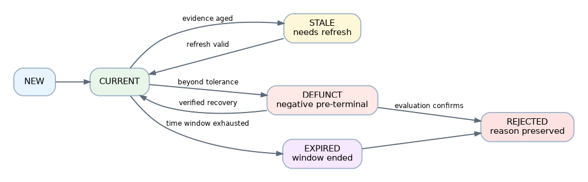
Figure 4. Discovery episode lifecycle semantics.
STALE is an effective display projection over CURRENT, not a competing durable thesis state. Freshness is also an orthogonal property on NEW/DEFUNCT. A read computes stale/expired at a captured as_of without writing on GET; explicit bounded evaluation/transition processing persists expiry/rejection events. Effective state precedence is REJECTED, EXPIRED, DEFUNCT, NEW, then CURRENT/STALE. This keeps an expired episode out of a current queue even when no background worker runs. The materialized head and GET projection must report their separate evaluation and projection timestamps.
Event | Permitted result | Invariant
Ordinary pullback inside multidimensional tolerance | Same episode, new snapshot | Price drawdown alone is not universal failure
Old/missing required data | STALE or provisional with freshness warning | Aging is not evidence of invalidity
Breach in structure, momentum, volatility, volume/context or thesis rule | DEFUNCT with reason/evidence | Pre-terminal; policy specifies confirmation/recovery criteria
Verified recovery | CURRENT, or NEW if comparability still insufficient | Same episode only before expiry/terminal rejection
Fixed opportunity window ends | EXPIRED | Refresh cannot extend it
Confirmation/dismissal/expiry closure | REJECTED with reason and actor/policy | Terminal, history preserved
New evidence after rejection | New episode if eligible | Link predecessor; no resurrection

Rejection reasons include DEFUNCT_CONFIRMED, EXPIRED, USER_DISMISSED and INSUFFICIENT_EVIDENCE with explicit policy/version. Stale evidence may lead to a separately reasoned insufficient-evidence rejection after a configured grace policy; it must not be recoded as a price/thesis failure. Out-of-order data, identity changes, concurrent refreshes and corrections require a versioned reconciliation decision, not last-write-wins.

6. Persistence and transitions
The proposed S&D repository owns logical aggregates, not a new database platform. Use the accepted SQLAlchemy/Alembic foundation and portable PostgreSQL production / isolated SQLite local/test behavior. No tables or migrations are created by this documentation task. Capture schema/data-retention decisions at the implementation gate.
- Persist snapshot, nomination/transition event and head CAS update atomically.
- Enforce active-episode uniqueness with database constraints plus bounded conflict
handling; no process-local lock is the only multi-worker protection.
- Provider/LLM network calls occur outside DB write transactions. Recheck owner,
profile revision, run generation and episode head before committing their output.
- Reject or separately retain obsolete responses; never let an old run replace a
newer head or reactivate cancelled work. Retry correlation survives restarts.
- Use explicit transactions; do not hide commits in repository/session dependencies.
- Keep evidence references and content hashes independent of short-lived caches.
A cache eviction is not historical deletion; a retention tombstone is not a fact.
- Licensed raw payload retention, normalized evidence and decision history may have
different limits. Deletion/tombstones and incomplete reproducibility must be visible.

7. Cross-stage handoff and invalidation
Figure 5. Future cross-stage handoff and execution/management boundary.
Each transition validates input version/freshness, actor permission, completeness, provenance, contract compatibility and correlation. Relevance alone cannot approve qualification. Qualification alone cannot establish construction suitability; construction alone cannot grant execution rights. Future gateways must define invalidation when an upstream snapshot changes, a qualification expires, a contract mapping changes, account capability is revoked or command ownership transfers. Previously executed orders are reconciled under the broker contract, not undone by changing a discovery candidate's status.
Future execution resolves one command owner. TM-managed accounts require the TM public-contract and ownership gate; unmanaged manual orders retain Broker V2 safeguards. Never silently fall back from TM to manual on error. S&D has no broker credentials, order endpoint, confirmation grant or permission to call an execution adapter.

8. Evolution from the older generic Candidate
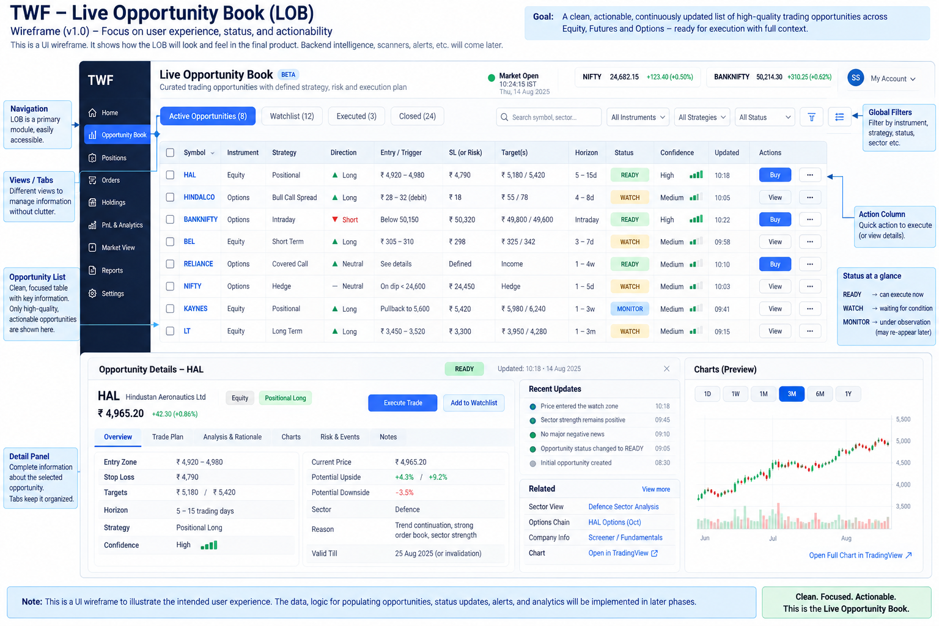
Figure 6. Future Live Opportunity Book surface illustrating the downstream role of prepared TradeOpportunities.
The TWF-0 “Candidate” was a broad workflow placeholder. It is not discarded or silently renamed in historical documents. For new work use the narrow stage:
Historical intent | New precise object | Required distinction
Instrument matched a scanner | ScanMatch | Criteria match may never deserve attention
Interesting subject to review | DiscoveryCandidate | Intent/horizon/evidence-relative, no trade recommendation
TI-supported qualified thesis | Opportunity | Separate analysis and qualification references
Fully proposed trade structure | TradeOpportunity | Exact structure/assumptions, still no execution authority
Actionable prepared item in a live queue | LOBEntry | Readiness projection, not broker order
Submitted/filled/managed trade | Existing OrderIntent/broker references; future ManagedPosition | Execution truth and managed authority remain external boundaries

There is no implemented generic candidate store to migrate in the inspected baseline. A later implementation must inspect actual schemas before introducing migration/backfill rules; ambiguous legacy records remain explicitly unclassified. Existing broker-native DTOs, IDs and frozen milestone records must not be renamed to fit this conceptual ladder. New public domain schemas need versioned publication, compatibility fixtures and the appropriate gate before consumer implementation.

9. Acceptance and open decisions
Domain acceptance must prove identity collision/ambiguity handling, same subject multiple intents, recurrence without resurrection, immutable snapshots, distinct observation counting, horizon/calendar boundaries, tolerance recovery, expiry, rejection reasons, null-vs-zero relevance, revision conflict/restart safety, owner isolation, retention honesty and absence of execution authority. See the Sprint-2 acceptance matrix.
Before production data acceptance, select reference/data/calendar sources and rights, initial instruments/horizon presets, fixed policy/tolerance parameters, limits/retention and reconciliation behavior under provider corrections. Future TI qualification, construction schema, LOB readiness and TM adoption require their own reviewed public contracts. These are explicit gates, not claims that those future systems have been implemented or accepted.

Publication note
This companion is derived from the reconciled normative Markdown source. Architecture status remains PROPOSED / RECONCILED / READY FOR REVIEW until the independent review gate records acceptance.

