TRADINGWORKFLOW (TWF)
TWF Product Vision & System Architecture
Reconciled product architecture including Broker V2, Scan & Discover, future LOB, TI/TM and learning loop
Version 0.1 • 28 Sep 2026
PROPOSED / RECONCILED / READY FOR REVIEW
Markdown is the normative repository source. This DOCX is the synchronized visual/reference companion.

Document map
Section | Topic
1 | Status
2 | 1. Purpose
3 | 2. North Star
4 | 3. Product Goals
5 | 4. Initial Non-Goals
6 | 5. Core Responsibility Model
7 | 6. System Context
8 | 7. Architectural Style
9 | 8. Proposed Technology Direction
10 | 9. Frontend Architecture Principles
11 | 10. Proposed UX Shell
12 | 11. Major Functional Areas
13 | 12. Workflow Model
14 | 13. TWF-Owned Domain Concepts
15 | 14. Database Architecture
16 | 15. Database Portability Rules
17 | 16. Multi-User / Subscription Architecture
18 | 17. Authentication Direction
19 | 18. LLM Architecture
20 | 19. Service Contract Model
21 | 20. Realtime Architecture
22 | 21. State Ownership
23 | 22. Configuration Model
24 | 23. Pluggability
25 | 24. Consoles
26 | 25. Auditability
27 | 26. Error / Degradation Model
28 | 27. Security Principles
29 | 28. Deployment Evolution
30 | 29. Testing Strategy
31 | 30. Observability
32 | 31. Architectural Invariants
33 | 32. Initial Documentation Set
34 | 33. Current Decision
35 | 34. Configuration and UX Reconciliation
36 | 35. Broker Workspace Reconciliation — 2026-09-26
37 | 36. Product progression and delivery reconciliation — 2026-09-28

> 2026-09-28 proposed extension: Product progression and delivery reconciliation. The accepted/historical basis below is retained; the appended dated revision governs the proposed S&D changes only. Status: PROPOSED / RECONCILED / READY FOR REVIEW, not accepted or implemented.

Status
Accepted TWF-0 product baseline, extended by configuration reconciliation on 2026-09-25

1. Purpose
TradingWorkFlow (TWF) is the trader-facing workflow application that unifies specialist trading systems into one coherent operating environment.
TWF integrates scanner/discovery systems, TradingIntelligence (TI), TradeMonitor (TM), LLM reasoning/synthesis, broker connectivity, alerts/notifications, future IFL feedback/learning, and other pluggable trading services.
TWF is a separate product and repository.

2. North Star
> Turn fragmented trading capabilities into a fast, explainable, governed, end-to-end trader workflow.
discover → understand → decide → approve → execute/adopt → monitor → review

3. Product Goals
TWF should:
- provide a fast, responsive web UX;
- integrate scanner, TI, TM and other services;
- support one active primary LLM while remaining provider-neutral;
- support local and remote service deployment;
- support SQLite initially and PostgreSQL later without domain redesign;
- support multiple users/subscriptions in production;
- preserve explicit authority boundaries;
- support console-style operational visibility;
- provide user-configurable settings and pluggable services;
- establish a miniature but end-to-end complete system before advanced expansion.

4. Initial Non-Goals
The first miniature does not require autonomous trading, full multi-tenant billing, full IFL learning runtime, every scanner/broker/asset class, Kubernetes/service mesh, HFT, or complex distributed event infrastructure.

5. Core Responsibility Model
Scanner = discover / propose
TI = assess / explain / forecast / advise
LLM = reason / synthesize / interpret
TM = govern / authorize / supervise / reconcile TM-managed workflows
Broker = execution truth
TWF = orchestrate / present / coordinate; bounded manual execution safety

6. System Context
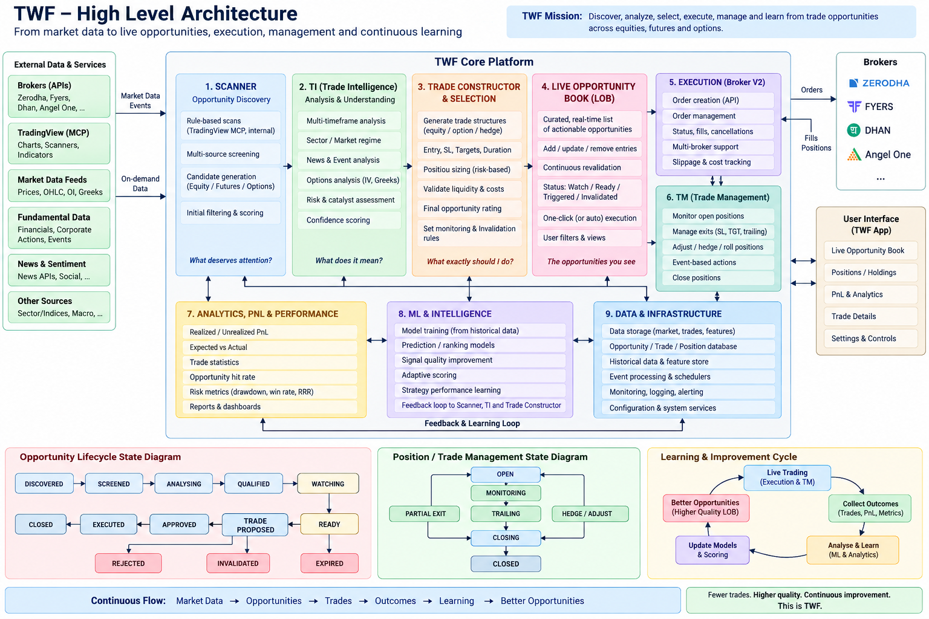
Figure 1. Updated TWF product architecture vision.
┌────────────────────┐
│ Trader │
└─────────┬──────────┘
│
▼
┌────────────────────┐
│ TWF Web │
│ Trader Cockpit │
└─────────┬──────────┘
│
▼
┌────────────────────┐
│ TWF API / │
│ Workflow Backend │
└─────────┬──────────┘
│
┌─────────────────────────┼──────────────────────────┐
│ │ │
▼ ▼ ▼
Scanner Service TI Service TM Service
│ │ │
└──────────────┬──────────┴──────────┬──────────────┘
│ │
▼ ▼
LLM Service Broker Service
│
▼
Future IFL / History

7. Architectural Style
Use a service-oriented modular architecture.
Logical service boundary = architectural requirement
Network/microservice boundary = deployment choice
A capability may run in-process or remotely through a stable contract.

8. Proposed Technology Direction
Subject to the Technology Decision Record:
- Frontend: Next.js + React + TypeScript
- Backend: FastAPI + Python
- Persistence: SQLAlchemy + Alembic
- Development DB: SQLite
- Production DB: PostgreSQL
- Realtime: WebSocket and/or SSE by use case
- Deployment: Docker-first, cloud-neutral
- Later optional infrastructure: Redis, task queue, object storage, centralized observability

9. Frontend Architecture Principles
- persistent application shell;
- responsive desktop-first layout;
- reusable panels;
- rapid instrument switching;
- minimal full-page reloads;
- explicit loading/stale/error states;
- keyboard-friendly actions where useful;
- service health visibility;
- authority/risk visibility;
- dense but readable trading UX.

10. Proposed UX Shell
┌─────────────────────────────────────────────────────────────────┐
│ User | Workspace | Broker | Market | Active LLM | Alerts │
├──────────────┬──────────────────────────────┬───────────────────┤
│ Watchlists │ Instrument / Candidate │ TI / LLM │
│ Scanners │ Chart / Thesis / Evidence │ Intelligence │
│ Alerts │ │ │
├──────────────┴──────────────────────────────┼───────────────────┤
│ Positions / Orders / TM │ Risk / Actions │
├─────────────────────────────────────────────┴───────────────────┤
│ Console / Events / Logs / Workflow History │
└─────────────────────────────────────────────────────────────────┘
Directional only; not frozen.

11. Major Functional Areas

Authentication / User
Login/logout, profile, user/workspace ownership, sessions, future subscription hooks.

Workspace
Persistent trader context, selected instrument, active watchlist, layout, active LLM and services.

Watchlists
User-owned lists and instrument selection.

Scanner
Scanner contract, candidate stream/results, filters/sort, candidate-to-workspace transition.

TI
Analysis request, IntelligenceResponse, claims, horizon, evidence, provenance, optional trade expression.

TM
Managed-trade risk, authority, adoption, execution supervision and reconciliation of broker observations. The broker remains execution truth. Manual Broker Workspace is a separate, explicitly unmanaged path; see section 35.

LLM
One active primary LLM configuration behind a provider-neutral service.

Consoles
Reusable event/log/command surfaces.

Settings / Plugins
User preferences, service endpoints, providers, layouts, feature toggles, separated from authority/security controls.

12. Workflow Model
Candidate discovered
↓
Candidate opened in workspace
↓
TI analysis requested
↓
LLM/TI synthesis displayed
↓
Trader reviews
↓
Trade expression / intent proposed
↓
Send to TM
↓
TM risk + authority assessment
↓
Trader approves
↓
Execution/adoption
↓
TM monitors
↓
Workflow closes
Correlation IDs should connect stages.

13. TWF-Owned Domain Concepts
Potential TWF-owned concepts:
- User
- Workspace
- Watchlist
- Candidate
- Workflow
- WorkflowStep
- ServiceConfiguration
- UserPreference
- Notification
- AuditEvent
TWF should reference rather than unnecessarily duplicate TI IntelligenceResponse, TM authoritative position/authority state, broker execution truth, and scanner-owned metadata.

14. Database Architecture
Application Services
↓
Repository Interfaces
↓
Persistence Adapters
↓
SQLAlchemy
/ \
SQLite PostgreSQL
Initial repositories may include UserRepository, WorkspaceRepository, WatchlistRepository, WorkflowRepository, SettingsRepository, and AuditRepository.

15. Database Portability Rules
- schema migrations from day one;
- avoid SQLite-specific SQL semantics;
- use portable types;
- explicit indexes/constraints;
- consistent timestamps;
- production acceptance should exercise PostgreSQL;
- domain identity should not rely casually on DB auto-increment semantics.

16. Multi-User / Subscription Architecture
Model ownership from the beginning:
User / Account
↓
Workspace
↓
owned resources
Capability-based subscription/entitlement hooks and account boundaries are defined now in configuration architecture v0.6. Commercial plans, quotas, billing and usage accounting remain later implementation scope.

17. Authentication Direction
Separate:
- user authentication;
- application authorization;
- trading authority;
- broker authorization.
TWF-1.4 implements local password authentication and server-owned revocable sessions. Production IdP, MFA and account recovery remain separate decisions; realm/account administration is not yet implemented.

18. LLM Architecture
TWF
↓
ActiveLLMConfiguration
↓
LLMService
↓
selected provider/model
Provider-neutral, one active primary LLM in normal runtime, actual producer identity preserved, and no authority to rewrite history/trading authority.

19. Service Contract Model
External capabilities should expose logical contracts with service identity, version, capabilities, health, and contract version. Endpoint/deployment details stay separate from semantic identity.
Each service may support LocalAdapter and RemoteAdapter implementations.

20. Realtime Architecture
Expected realtime sources include scanner events, orders, positions, broker state, alerts, TM monitoring, service health and console streams.
Use WebSocket where bidirectional interaction matters and SSE where one-way streaming is sufficient. Avoid distributed event infrastructure until justified.

21. State Ownership
Classify state as:
- durable TWF business state;
- service-authoritative state;
- UI/session state;
- streaming/transient state.
Do not copy external authoritative state into TWF as independently mutable truth.

22. Configuration Model
Runtime classes are Presentation, User/Workflow and System/Integration, with explicit permitted Platform/Account/User/Workspace/Workflow scopes and profile revisions. User/workspace/service configuration are ownership/use-case examples within that model. Bootstrap/security operations stay APS-owned; TM trading authority is outside ordinary settings. Section 34 and configuration architecture v0.6 govern the detailed separation.

23. Pluggability
Support pluggable scanners, LLM providers, brokers, TI/TM endpoints, notification providers and future analytics through explicit contracts/capabilities rather than arbitrary module loading.

24. Consoles
A reusable WebConsole should support timestamp, source/service, severity/state, correlation/workflow ID, message, structured metadata reference, filters and streaming. Command-enabled modes require explicit authority.

25. Auditability
Audit meaningful workflow transitions, such as candidate creation, TI analysis, TM handoff, risk rejection, trader approval, execution request, adoption and closure. TWF audit is not a replacement for service-owned histories.

26. Error / Degradation Model
Make scanner/TI/LLM/TM/broker unavailability, stale intelligence, stale positions, version mismatch and authorization failure visible. Never silently fallback in a way that changes authority or producer identity.

27. Security Principles
- least privilege;
- no secrets in browser code;
- no broker credentials in workflow records;
- encrypted transport in production;
- explicit remote-service authentication;
- audit authority transitions;
- separate login from trading authorization.

28. Deployment Evolution

Development
Frontend + backend + SQLite + local/mock service adapters.

Early Integration
Frontend + TWF backend + SQLite/PostgreSQL + local/remote TI/TM/scanners.

Production
Cloud frontend/backend, managed PostgreSQL, optional Redis/worker, remote services, observability and subscription infrastructure.
Docker before Kubernetes.

29. Testing Strategy
Frontend component/interaction tests, backend unit/repository/API/adapter tests, synthetic service integration tests, and browser E2E for login → candidate → TI → TM → monitoring.

30. Observability
Design for request correlation, workflow ID, service latency/health, structured logs, error rates and realtime connection state.

31. Architectural Invariants
- TWF is separate from TI/TM/scanners.
- Web-first and cloud-ready.
- Multi-user ownership is considered from the start.
- Satellite systems remain independent services.
- Local vs remote does not change semantics.
- TWF does not duplicate TM authority.
- TWF does not duplicate broker truth.
- LLM provider remains replaceable.
- One active primary LLM is normal operation.
- Database implementation is replaceable.
- SQLite-specific behavior stays out of application/domain logic.
- Durable-state ownership is explicit.
- External authoritative state is not silently copied as local truth.
- Workflow lineage is traceable.
- The first complete product checkpoint is the TWF-6 miniature; TWF-1 establishes its application foundation.
- User settings cannot silently grant trading authority.
- Degraded states are explicit.
- Service contracts are versioned.
- UI remains responsive under streaming updates.
- IFL can be added later without fundamental redesign.

32. Initial Documentation Set
Initial authoritative docs:
- TWF_HIGH_LEVEL_DISCUSSION_RECORD.md
- TWF_PRODUCT_VISION_AND_SYSTEM_ARCHITECTURE.md
- TWF_DETAILED_ROADMAP.md
- TWF_TECHNOLOGY_DECISION_RECORD.md
Specialist architecture and planning documents:
- TWF_UX_ARCHITECTURE.md
- TWF_SERVICE_CONTRACT_ARCHITECTURE.md
- TWF_DATA_ARCHITECTURE.md
- TWF_SECURITY_AUTH_ARCHITECTURE.md
- TWF_DEPLOYMENT_ARCHITECTURE.md
- TWF_CONFIGURATION_SETUP_CAPABILITY_ENTITLEMENT_PLUGGABILITY_ARCHITECTURE.md
- TWF_UX_BUCKET_ROADMAP.md
The detailed roadmap owns milestone/target sequencing; the documentation index maps current and historical implementation records.

33. Current Decision
TWF-0 and TWF-1 are accepted/frozen. Repository commit e3852d3 accepts TWF-1.6, and the existing annotated tag twf-1-application-foundation targets that commit with message TWF-1 Application Foundation accepted. TWF-1.0–1.6, including TWF-1.1A, are accepted. The earlier configuration review remains a historical planning gate. The Broker Workspace review reconciles stale status and recommends only the bounded BW-1 synthetic read-only target; it does not accept later runtime functionality.

34. Configuration and UX Reconciliation
This 2026-09-25 clarification extends the accepted TWF-0 product boundary. The configuration architecture v0.6 separates APS platform producers from ACS consumer tenants, COLD capability publication from HOT/WARM subscriber settings, and entitlement from permission and trading authority. The earlier settings categories are examples; canonical runtime classes are Presentation, User/Workflow and System/Integration, with explicit scopes and override policy. Platform bootstrap/security operations remain separate.
Capability registry/policy, entitlement, configuration/profile resolution, secret references, health and audit are logical backend responsibilities, not mandated microservices. Setup Center, ACS account administration and APS operations are distinct UX contexts. The master/component DOCX files remain TWF-0 reference snapshots; this clarification and the linked normative architectures govern subsequent configuration work.
The UX Bucket Roadmap tracks foundational, operational and mature UX across the functional milestones, with current delivery priority in the Detailed Roadmap. TWF-1.5 builds only the bounded personal settings foundation; TWF-1.6 supplies service-client foundations; TWF-2–6 grow the trader workflow. Later administration/subscription/IFL UX does not block early trading integration. Synthetic adapters accelerate UX while preserving Scanner/TI/TM/LLM contracts and authority boundaries.

35. Broker Workspace Reconciliation — 2026-09-26
Broker Workspace architecture v0.3 extends the accepted product direction: isolated rooms for N configured broker accounts, a read-only Unified Broker Control Room, broker-native execution identity and TWF Basic Execution Safety. Scanner, TI and LLM are optional later layers. The service diagram and section 12 describe the full intelligence/TM workflow, not a prerequisite for broker read-only utility.
The manual path is trader → TWF backend/BrokerClient → selected account adapter → broker, with explicit unmanaged status, authorization, revision-bound confirmation, durable command identity and recovery before any live submission. TM-managed accounts use trader → TWF → TM → broker; TWF never bypasses TM or falls back to direct execution. Initial TM coexistence is exclusive command ownership per broker account, with explicit reconciled handoff; read-only observations may coexist. Login, entitlement and broker authentication do not independently authorize a trade.
The 2026-09-26 priority was Broker Workspace → Basic Execution Safety → TM → Scanner → TI. The proposed S&D delivery update in section 36 supersedes that immediate scheduling order. Detailed Roadmap section 18 governs the bounded gates without renumbering existing milestones or declaring all UX-B1 complete. Synthetic read-only contracts/UI come first; secrets, real orders, trading safety, provider verification and recovery each retain a separate gate.

36. Product progression and delivery reconciliation — 2026-09-28
Figure 2. Evolved product progression and authority boundaries.
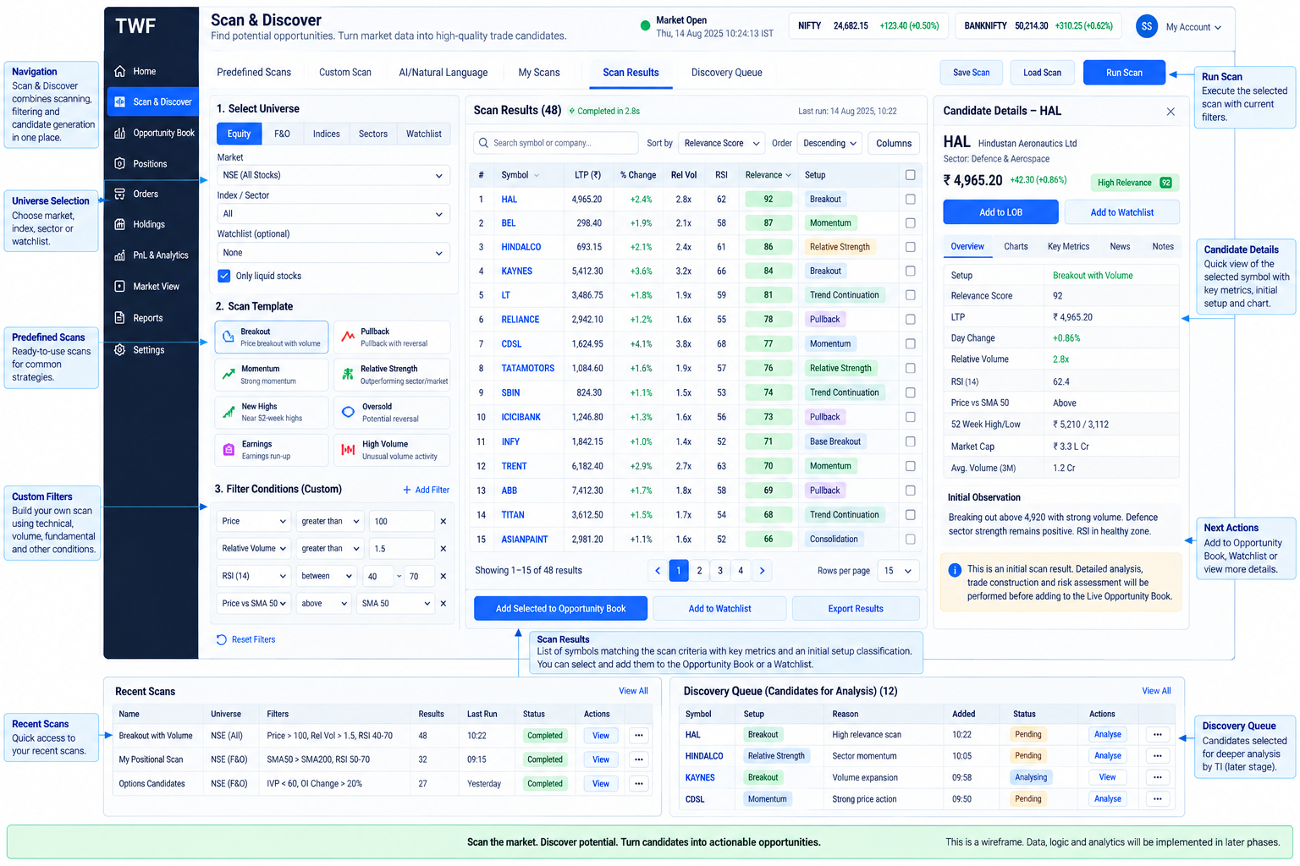
Figure 3. Scan & Discover target surface.
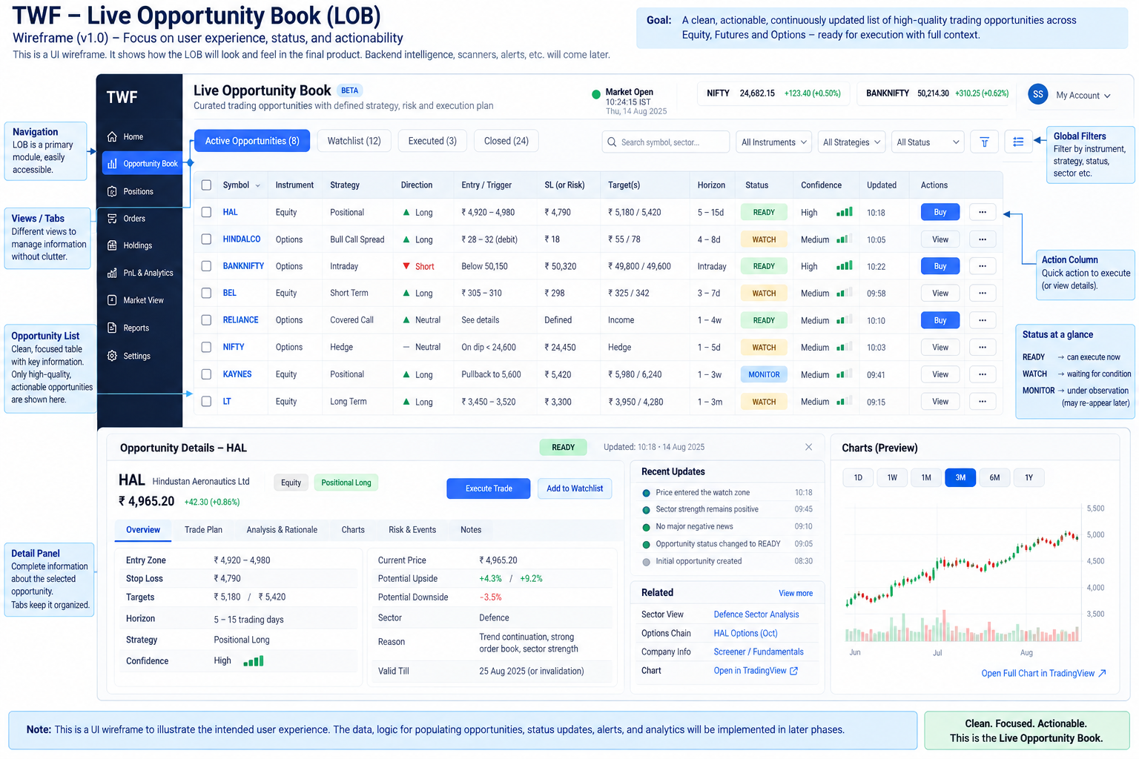
Figure 4. Future Live Opportunity Book target surface.
The next proposed independent product capability after accepted Broker V2 is Scan & Discover (Sprint 2). This delivery proposal supersedes the immediate TM-before-Scanner scheduling statement in section 35, not TM's authority or the existing TWF milestone IDs. The earlier sequence is retained as dated history.
This is a conceptual progression, not one implemented pipeline. Managed execution requires TM assessment/approval before dispatch and explicit adoption afterward; manual Broker V2 remains independently enabled and unmanaged. S&D grants neither.
Delivery state | Product meaning
Implemented / frozen | TWF-0/TWF-1 and Broker V1/V2; accepted manual order intent/preview/reconciliation and broker-native identity remain unchanged
Sprint-2 proposed | Scan-only and Scan + Discover, provider-neutral adapters, internal V0 scanner, verified TradingView MCP adapter, bounded market context, optional LLM Level-0, intent-relative DiscoveryCandidate, snapshots/history/settings/UX
Future target | TI qualification, Opportunity, construction, TradeOpportunity, LOB, TM-managed trading, outcome evaluation and governed ML/IFL

The older generic Candidate in sections 11–13 now has stage-specific semantics for new work. ScanMatch is a criteria match; DiscoveryCandidate is attention-worthy relative to intent/horizon/evidence; Opportunity is a qualified thesis; TradeOpportunity is a prepared structure; LOBEntry is its readiness projection. They are distinct objects with explicit lineage, not renamed statuses of one row.
TWF owns S&D orchestration/evaluation; external ScanProviders retain their native scan logic, TI its intelligence claims, TM its managed authority and brokers their execution truth. Discovery Relevance is not probability of profit. The internal scanner and approved independent data path keep S&D useful without TradingView; deterministic discovery works with LLM OFF. Bounded market intelligence belongs in Sprint 2 without replacing future TI. Future evaluation includes untraded episodes.
Read the S&D architecture, Opportunity domain and Sprint-2 delivery plan for the proposed normative contracts. Master/component DOCX files are historical and require regeneration after Markdown acceptance; no publication companion was edited here.

Revision history addition
Revision | Date | Status | Role / change
S&D reconciliation 1 | 2026-09-28 | PROPOSED / RECONCILED / READY FOR REVIEW | Normative design/planning extension: Product progression and delivery reconciliation; prior history and acceptance preserved

Publication note
This companion is derived from the reconciled normative Markdown source. Architecture status remains PROPOSED / RECONCILED / READY FOR REVIEW until the independent review gate records acceptance.

