TRADINGWORKFLOW (TWF)
TWF Scan & Discover Architecture
Provider-neutral scanning, discovery intelligence, temporal evidence and Sprint-2 boundaries
Version 0.1 • 28 Sep 2026
PROPOSED / RECONCILED / READY FOR REVIEW
Markdown is the normative repository source. This DOCX is the synchronized visual/reference companion.

Document map
Section | Topic
1 | Status and authority
2 | 1. Executive summary and user problem
3 | 2. Architecture principles
4 | 3. Scope, terminology and product context
5 | 4. System context and components
6 | 5. Three composable workflows
7 | 6. Identity, intent, horizon and episode model
8 | 7. Immutable snapshots and temporal provenance
9 | 8. Evidence and agreement
10 | 9. Market intelligence and candidate intelligence
11 | 10. Provider contracts and capability negotiation
12 | 11. TradingView MCP and other providers
13 | 12. Internal Scanner V0 and input data
14 | 13. Scan definitions, profiles and execution
15 | 14. Normalization, merge and deduplication
16 | 15. Discovery relevance and calibration
17 | 16. Freshness, horizon and after-market operation
18 | 17. Tolerance envelope and lifecycle
19 | 18. Optional LLM Level-0 and grounding
20 | 19. Persistence, transactions and future evaluation
21 | 20. Settings and authorization
22 | 21. Security and failure behavior
23 | 22. UX architecture and text wireframes
24 | 23. Use cases and sequences
25 | 24. Deployment and local/remote equivalence
26 | 25. Future handoffs and authority boundaries
27 | 26. FAQ
28 | 27. Risks, TBDs and acceptance

Status and authority
Version | Date | Status | Role and change
0.1 | 2026-09-28 | PROPOSED / RECONCILED / READY FOR REVIEW | Normative design proposal for Scan & Discover; separates scanning, discovery, evidence and optional interpretation

This is the designated Markdown authority for the proposed S&D subsystem, not an implementation or freeze claim. The Opportunity domain owns shared domain identities and cross-stage ownership; the Sprint-2 plan owns bounded delivery and gates. Their precedence and repository evidence are in the reconciliation record. The accepted Broker V2 baseline remains unchanged. No S&D runtime, real provider integration, TI qualification, LOB or TM adoption is claimed implemented here.

1. Executive summary and user problem
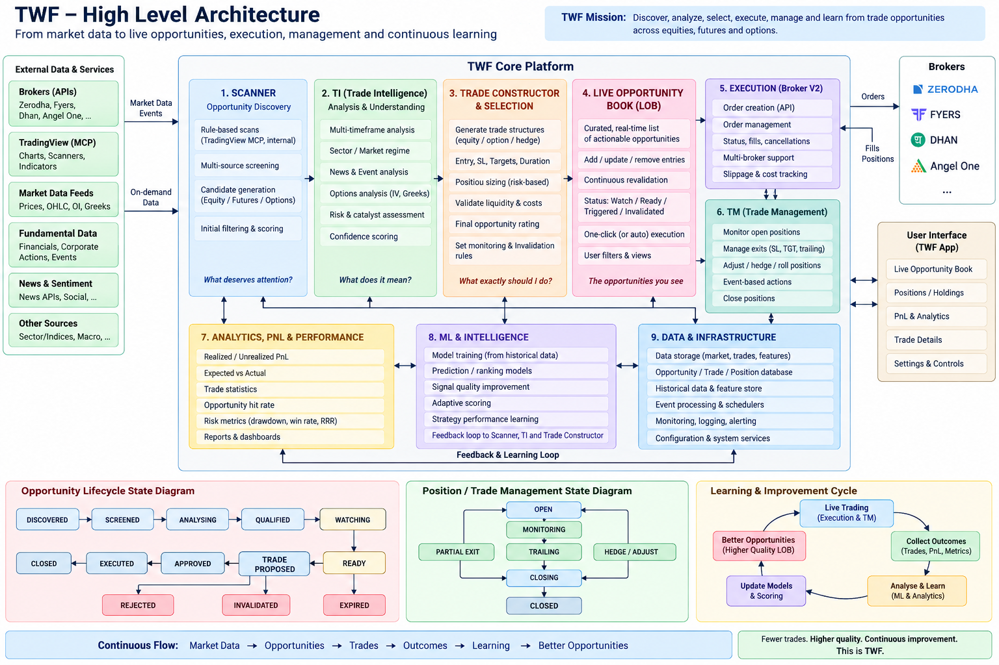
Figure 1. TWF end-to-end product vision: discovery through execution, management and learning.
S&D helps a trader answer: What deserves attention now, for this intent and horizon, and why? A scanner can return many matches without explaining whether they are timely, sufficiently supported or compatible with the market context. Discovery performs that separate assessment and may decline to nominate anything.
Scanner is a subsystem; opportunity discovery is its mission. A ScanMatch means criteria matched. A DiscoveryCandidate means something merits examination, not that it should be traded. S&D must be independently useful with no LLM, no TI/TM connection and no connected broker. It must remain usable without TradingView.
Sprint 2 delivers scan-only and Scan + Discover, bounded market context, evidence, intent-relative relevance, durable history and a finished discovery queue. It stops at DiscoveryCandidate. External candidate ingestion is a contract seam with synthetic acceptance coverage; production external/manual/agent feeds come later.

2. Architecture principles
- S&D has independent user value; deeper trading workflow is not a prerequisite.
- Scan and Discovery are separate, composable operations; scan-only is first class.
- Discovery accepts normalized candidate sources rather than one scanner's objects.
- Deterministic operation works with LLM OFF or disconnected.
- LLM Level-0 is optional explanation and qualitative interpretation.
- OpenAI, Anthropic/Claude and Google are possible hosted adapter families, not
mandated vendors or claims of verified integration.
- A LocalLLMAdapter is experimental/development-only unless separately accepted.
- One applied primary LLM configuration per authorized context is normal operation.
- Provider changes are explicit; failures never silently select a different producer.
- LLM content cannot masquerade as deterministic or current market evidence.
- Grounding is validated against supplied evidence, not an LLM's self-description.
- TradingView MCP is an important planned Sprint-2 adapter, not a domain dependency.
- A small internal scanner proves a genuine alternative execution path.
- Universe, scan, market context and candidate intelligence have separate contracts.
- Market intelligence is a first-class Discovery input, not deferred wholesale to TI.
- No provider, including a possible Tapetide adapter, is mandatory to the architecture.
- Identity, version, capabilities, health and actual data source survive normalization.
- Local and remote deployment preserve meaning, errors, lineage and ownership.
- Provider SDK/MCP payload types remain behind adapters.
- Every candidate is relative to intent, horizon, opportunity window and evidence.
- Temporal provenance and freshness are explicit; EOD is never labelled live.
- Snapshots are immutable and support a series, not a single overwritten row.
- Missing evidence is unknown, not zero, favorable, or an empty successful result.
- Correlated evidence is not counted repeatedly as independent agreement.
- Discovery Relevance is fit to policy, not probability of profit.
- Discovery may decline when required evidence is insufficient or incompatible.
- Terminal rejection is reasoned; a later setup creates a new episode.
- History includes untraded and dismissed candidates for future evaluation.
- Neither settings, LLM output nor a candidate grants trading authority.
- Contracts preserve future TI, construction, LOB, TM and ML seams without
implementing those systems or a premature microservice platform.

3. Scope, terminology and product context
Sprint 2 includes bounded scanning, normalization, market context, optional Level-0, DiscoveryCandidate lifecycle/evidence/history/settings and finished discovery UX. It excludes TI qualification, Opportunity/TradeOpportunity/LOB runtime, TM-managed integration, automatic execution, full alerts, high-frequency monitoring, production ML and autonomous agents. The later product progression below establishes handoff boundaries only; the delivery plan owns exact slices, initial data/profile gates and acceptance.
Term | Meaning | Does not mean
Universe | Versioned set of exact market/listing identities eligible for a run | Broker account or executable order routing
ScanDefinition | Typed criteria and required inputs | Arbitrary code or natural-language execution
ScanProfile | Owned, versioned configuration selecting definitions/providers/policies | Capability, entitlement or credentials
ScanMatch | Immutable report that specified criteria matched particular data | Recommendation or qualified opportunity
DiscoveryIntent | Direction, setup objective and horizon-relative attention purpose | Broker order side or execution permission
DiscoveryEpisode | One time-bounded investigation of a subject under an intent | Permanent state for a symbol
Snapshot | Immutable observation/evidence capture | An always-current quote
DiscoveryCandidate | Owned attention record with evidence and lifecycle | TradeOpportunity or authorized order
Level-0 | Optional grounded/context-labelled interpretation | TI deep intelligence or profit forecasting authority

These arrows show information flow, not automatic promotion or delegated trading authority. TM-managed execution also requires TM assessment before dispatch; post-execution TM adoption is explicit. Broker V2's separately enabled manual path remains available independently and unmanaged. S&D has no dispatch edge.

4. System context and components
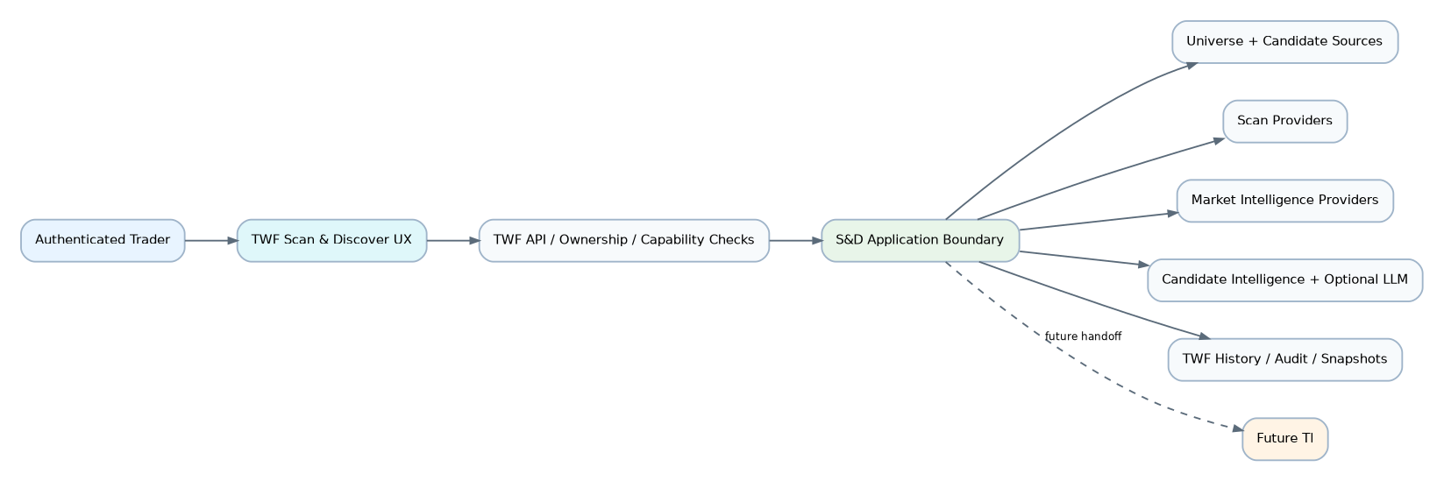
Figure 2. S&D system context.
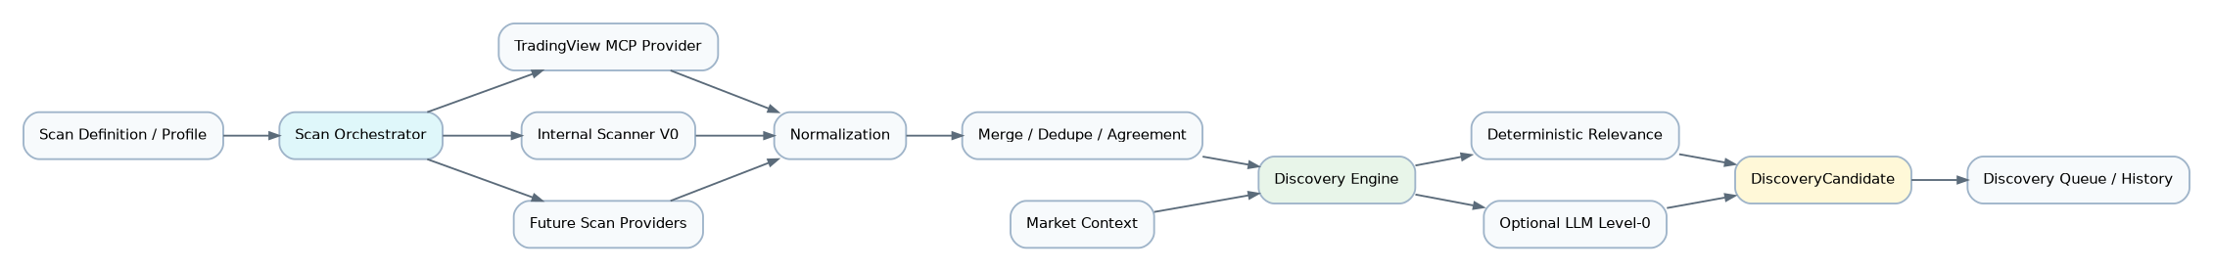
Figure 3. S&D logical component architecture.
These are logical responsibilities within the existing FastAPI application. Do not mandate separate services, queues or packages for every box. Domain contracts must not import HTTP/MCP, a provider SDK, SQLAlchemy or browser state. Application services own transactions; provider I/O runs outside DB transactions. The web app uses TWF APIs and the existing session/Origin boundary.

5. Three composable workflows
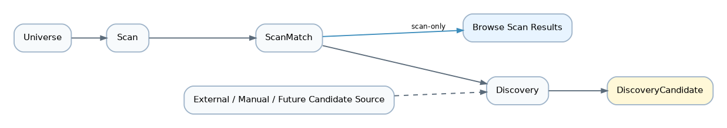
Figure 4. Scan-only, Scan + Discover, and external-source Discovery.

Scan only
No candidate, episode or LLM invocation is required just to scan. Empty complete results mean no matches; incomplete results show missing partitions and must not claim universe-wide absence.

Scan + Discover
Scan + Discover captures both operations under a parent correlation ID, retaining separate run statuses. A scan succeeding while discovery fails is not total success. A user can retry Discovery explicitly against the saved eligible input; new run identity and idempotency rules prevent duplicate episode creation.

Discovery from another source
A source nomination is not trusted evidence of fitness. Discovery applies the same evidence/decline rules and records the actual source. Sprint 2 proves this seam without shipping autonomous agents or an unrestricted import endpoint.

6. Identity, intent, horizon and episode model
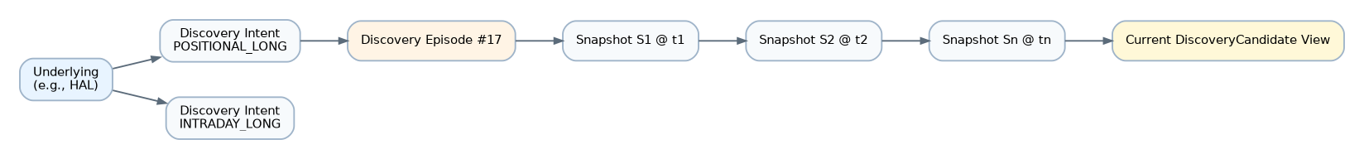
Figure 5. Underlying, discovery intent, episode and immutable snapshot series.
Use the domain identity rules. An Underlying denotes a stable analytical subject; an InstrumentRef denotes the exact listing/contract observed. Symbol alone is insufficient. Mapping has a version, evidence and status. Ambiguous mapping remains unresolved; show the source-qualified scan row but do not merge it into another subject's episode. Broker tokens are optional foreign references, never canonical identity. S&D identity cannot bypass later exact broker-native order resolution.
DiscoveryIntent contains direction/objective, setup family, HorizonSpec and policy series identity. Examples include INTRADAY_LONG, SWING_SHORT, POSITIONAL_LONG and MEDIUM_TERM_LONG; these are named presets, not a closed domain enum. Opposite directions and different horizons may coexist and are clearly labelled.
HorizonSpec is a versioned value object: basis (elapsed time, trading sessions, calendar interval, until event/expiry), minimum/maximum duration or count, calendar/venue/timezone, anchor rule, and optional event reference. It separates expected evaluation horizon from OpportunityWindow {opens_at, expires_at}. Examples: next 30 minutes; current session; 1–3, 1–5 or 1–15 trading sessions; 2–6 weeks; 1–3 months; explicit custom or event window. Trading days require a versioned calendar, not division by 24 hours. All persisted instants are aware UTC; exchange timezone and calendar remain explicit for display and calculations.
An episode pins its profile, definition, horizon/calendar, policy and comparison basis revisions. Define the active key as owner + subject + observation basis + intent/horizon semantic fingerprint + policy series. At most one non-rejected episode exists for that key; distinct intentional profiles/policy series may run in parallel and must be visibly distinguishable. Concurrent nomination uses a transactional uniqueness/CAS guard. New evidence appends to the same episode. Routine pullbacks do not create new episodes. A changed policy or basis requires an explicit new evaluation lineage, never reinterpretation of old snapshots.

7. Immutable snapshots and temporal provenance
Field group | Required semantics
Identity | Snapshot ID, owner, episode, subject, exact observed InstrumentRef and mapping revision
Time | observed_at / source_data_time describe the source observation; received_at, evaluated_at and recorded_at describe TWF receipt, decision and persistence; preserve source publication/availability, timeframe and session/calendar separately
Measurements | Price/currency/adjustment basis, technical values/formula versions, volume/liquidity, market/sector context; nullable with missing reasons
Source | Provider/service/model identity, dataset/revision, operation/run IDs, source observation IDs, upstream provenance, synthetic/live/EOD/delayed label
Policy | Profile/scan/ranking/tolerance/freshness versions and effective non-secret configuration digest
Reproducibility | Evidence references or licensed immutable captures, input digest, correction lineage and completeness

Never substitute receipt time for an unknown source time. Unknown or future source times fail required freshness checks; bounded clock-skew handling is a named policy, not silent timestamp rewriting. A provider response that arrives later can still describe old data. For a composite snapshot, freshness is evaluated per item and required category, not by the newest single item.
S1 may support a provisional candidate if static eligibility is satisfied. Claims about improvement or deterioration of this episode require at least two comparable observations. Historical bars can support an initial indicator/trend measurement, but bars supplied to one scan are not automatically two S&D observations. S2 must have distinct underlying source observations/times, same compatible units, adjustment basis and timeframe. Repeated polling of the same source sample is not evolution. Different cadences/bases remain separate comparison series. Corrections append new captures and supersession links; they never overwrite what was known.
Record source publication/availability when possible as well as capture time so future backtests cannot use information published after their decision cutoff. Late evidence cannot retroactively change a historical relevance or decision.

8. Evidence and agreement
EvidenceItem contains evidence_id, category, typed claim/value/unit, subject, support/oppose/neutral orientation, source reference, producer/version, source and capture times, applicable horizon, quality flags, completeness and upstream lineage. LLM evidence additionally carries verified grounding and input citation IDs. MissingEvidence contains category, reason and attempted provider; absence is not a zero-valued measurement. ConflictingEvidence links the disagreeing items and the incompatibility (direction, timestamp, units, methodology or subject).
The policy marks categories REQUIRED, OPTIONAL or NOT_APPLICABLE per intent. A missing required category prevents a current eligible attention result. Optional absence is visible and lowers coverage; it cannot silently improve the score. News/flows/breadth are not mandatory for every profile and may remain unavailable.
Agreement compares like-for-like claims only. Evidence sharing an upstream feed, same bar series, copied report or LLM summary forms one dependence group. Provider count is not independent vote count. Keep all sources visible; cap group influence and disclose unknown independence. Never average incompatible price adjustment bases, different listings or times into fictitious consensus. A useful result can be “Technically interesting; market environment unfavorable,” retaining both sides.

9. Market intelligence and candidate intelligence
Market context is bounded environmental evidence: benchmark direction/regime, NIFTY/BANKNIFTY where licensed data supports them, sector/industry strength, relative strength, volatility, breadth, session, institutional flow or event/news context. All carry source-data time, market calendar and methodology. S&D does not claim availability of any named vendor's API, dataset or redistribution rights.
Sprint 2 requires one useful deterministic market-context path: benchmark trend, volatility and session context from approved input bars/calendar. Sector relative strength is optional where an authoritative sector mapping and data exist. Flow, news and breadth are capability-gated optional enrichments, not fabricated zeros or mandatory new providers. If mandatory benchmark context is unavailable, show a decline or stale candidate, not a falsely complete market assessment.
MarketIntelligenceProvider returns market/sector observations; a CandidateIntelligenceProvider returns subject-specific annotations. LLM Level-0 can implement the latter via LLMService. Future TI deep intelligence remains a separate handoff with typed claims and scientific semantics; bounded context does not make S&D a TI replacement.

10. Provider contracts and capability negotiation
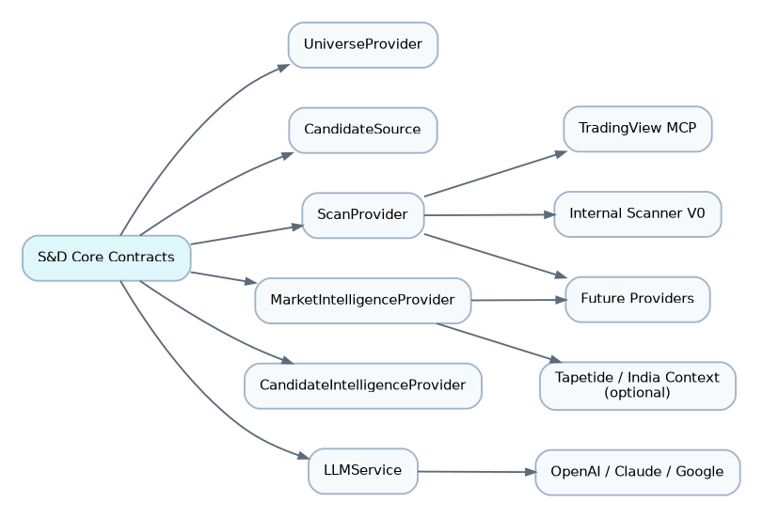
Figure 6. Provider-neutral pluggability model.
The six named families are logical protocols, not additions to the implemented foundation.health.v1 payload. Domain contract IDs such as sd.scan.v1 are proposed, separately versioned; exact wire schemas are a Sprint-2 contract gate. MarketDataReader is a supporting read port for internal calculations, not a new market-data warehouse or a reuse of ephemeral Broker V2 quote history.
Family | Bounded operation | Result and constraints
UniverseProvider | Resolve a versioned universe at an as-of cutoff | Exact identities, selection definition, membership revision, coverage and pagination
CandidateSource | Read nominated subjects since cursor/as-of | Input IDs, exact identity, intent hints, evidence references and source provenance; hints confer no eligibility
ScanProvider | Execute validated ScanRequest | ScanMatch batch, criteria revision, input times, completeness and typed unsupported fields
MarketIntelligenceProvider | Observe market/sector at requested basis and cutoff | Typed context observations, coverage, freshness and methodological limits
CandidateIntelligenceProvider | Annotate bounded subjects and evidence | Cited annotations, declared limitations and grounding where applicable
LLMService | Interpret an immutable bounded evidence packet | Structured interpretation or decline; provider/model/prompt/tool versions and citations
MarketDataReader | Read bars/observations for explicit identities/window | Timestamped licensed data, units, adjustment/session basis, gaps and provenance

Common metadata: provider/service ID and implementation version; supported contract versions; capability IDs and parameter schemas; allowed universes/exchanges/classes, timeframes/operators/indicators, data mode/delay, retention rights, limits and safe health/connection operations. Capability support, entitlement, configuration, enabled state, active binding, health and data freshness remain separate.
A run resolves an authorized applied profile revision, intersects its requirements with advertised capabilities and deployment policy, and pins the actual provider set. Unknown mandatory parameters/capabilities or breaking versions fail before execution. A preview explains unsupported combinations; adapters never silently drop filters. Optional enrichments can fail partially with explicit coverage.
Typed failures include INVALID_REQUEST, UNSUPPORTED_CAPABILITY, PROVIDER_UNAVAILABLE, TIMEOUT, AUTHENTICATION_FAILED, AUTHORIZATION_FAILED, RATE_LIMITED, STALE_DATA, CONTRACT_VERSION_MISMATCH, INVALID_RESPONSE, PROVENANCE_MISMATCH and CANCELLED. Errors carry safe retryability/operation correlation, not raw bodies, secrets or endpoints. Timeout covers the whole operation, streaming/decoding included, with bounded bytes, items, fan-out and pages. Health cannot promise fresh data.

11. TradingView MCP and other providers
TradingView MCP is planned as the rich scan adapter. The repository contains no accepted TradingView MCP server identity, release, authentication or tool schema. The name is a provider candidate, not proof of an official TradingView service. Before its live adapter gate, select and pin the actual server implementation, review its provenance/security, permitted read-only tools, schema, data access terms, costs, timestamps, completeness and rate limits. Record vendor evidence and contract fixtures. MCP transport is not itself a scanner domain contract.
The server-side adapter maps a typed ScanDefinition to a supported allowlisted tool request and validates its result. No provider-specific DSL or MCP session objects enter the core. Arbitrary tool discovery does not authorize invocation, and no order, shell, browser-login or credential-extraction tool is exposed to Discovery. A local subprocess, if used, must be operator-packaged and fixed; users cannot configure executable commands. A remote endpoint follows approved egress, authentication and TLS policy. No silent fallback to scraped/browser data.
If the adapter is unavailable, show that provider's failure. A user may explicitly select an eligible internal profile and start a new labelled run. A preconfigured multi-provider run can finish PARTIAL with surviving source identity; it must not pretend the missing provider participated. Tapetide/equivalent market context and future scanner/data vendors use the same admission gates; none is a hard dependency.

12. Internal Scanner V0 and input data
The bounded V0 computes a small deterministic subset over approved OHLCV bars: price/volume thresholds, SMA, relative volume and one simple close-above-prior-range breakout. Pin definitions: SMA uses N completed closes; relative volume compares the completed bar's volume with the mean of N prior comparable completed bars; breakout excludes the tested bar from its prior range. No intrabar/EOD comparison, look-ahead, zero-denominator division or implicit gap filling is allowed.
Required input validation covers ordering, duplicates, missing bars, exchange sessions, corporate-action adjustment, currency, nonfinite values and sufficient warm-up. Missing inputs yield unavailable measurements, not a fabricated match. Deterministic internal market context uses a similarly versioned benchmark SMA/trend and historical-return-volatility calculation, with its lookback, annualization/session convention and thresholds recorded in the policy.
EMA, RSI, ATR, momentum/crossovers, 52-week high/low and pullbacks are compatible future capabilities, not all mandatory V0 work. Their formulas/seeding and input coverage need independent contract fixtures before advertisement. Do not build a TradingView clone.
Fixture bars provide an offline, genuinely independent path in CI. A useful real V0 deployment additionally needs an approved non-TradingView data source or a licensed, operator-imported, versioned EOD dataset. An external data-source choice is an explicit delivery gate; a synthetic demo alone does not accept live S&D. Dataset import is bounded server/operator ingestion, not arbitrary user uploads or executable data. Reuse existing infrastructure only behind the new read port; do not persist Broker V2's ephemeral LTP batches as bar history.

13. Scan definitions, profiles and execution
ScanDefinition is immutable per revision: universe predicate, required timeframes, typed indicator parameters, bounded boolean/comparison expression tree, required data modes and completeness policy. Reject arbitrary expressions/code/SQL, unknown operators and excessive depth/width. Units are part of operands; explain validation failures before running. Natural language can only propose a draft definition for human review, never run a model-generated query directly.
ScanProfile selects definitions, universe revision, providers, intent presets, ranking/tolerance/freshness policies and optional enrichment. It is configuration under the existing settings architecture, not a second profile framework. Editing creates a new revision; runs pin the applied revision, not a mutable pointer.
A ScanRun records request ID/idempotency key, owner, revision set, source cutoff, actual providers, limits and status: QUEUED → RUNNING → SUCCEEDED / PARTIAL / FAILED / CANCELLED / INTERRUPTED. Persist before dispatch and use a bounded coordinator. Explicit cancellation aborts supported local/network work and fences late responses; it has no broker meaning. Completed partition captures are retained but cannot be misrepresented as a complete universe. Restart marks in-flight work INTERRUPTED and retains committed observations; retry is an explicit new attempt linked to the prior run, never an automatic paid-provider storm.
Sprint 2 uses user-triggered bounded batches and explicit Refresh, not an always-on scanner or high-frequency monitor. State/history must survive restart without requiring Redis, a distributed event bus or a scheduler. A single-process task runner is acceptable only with bounded concurrency and recoverable run state.

14. Normalization, merge and deduplication
Normalize units, exact identity, timestamps, source mode and criteria semantics before comparison. Preserve raw vendor IDs as namespaced references; retain safe source captures only where permitted. Unknown currency, adjustment basis, timeframe or mapping is explicit, not guessed from a ticker.
Idempotency removes repeated delivery of the same source observation using owner, provider, external observation ID/revision (or deterministic input digest), run attempt and exact instrument. It does not discard distinct timestamps or correction versions. Merge membership groups matches for the same resolved subject, intent, horizon and compatible observation basis; it links all evidence without replacing the original ScanMatch records. Cross-listing mapping can group an underlying in the UX but does not blend NSE/BSE price/volume or derivative and underlying data.
Different provider scores remain labelled raw measures. Only a versioned TWF relevance policy can compare normalized measures within a declared cohort. Provider refresh order cannot change tie-breaking or hide a negative observation. Pagination uses a stable run/snapshot revision and deterministic key; source pagination must be bounded before declaring run completeness.

15. Discovery relevance and calibration
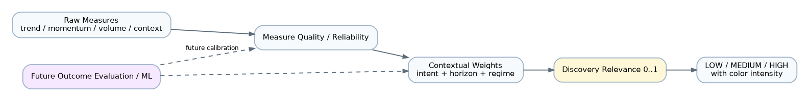
Figure 7. Relevance calibration pipeline; score is not probability of profit.
Display Discovery Relevance, a numeric 0–1 score plus named band and reasons. It means current fit to the configured intent/criteria/context, never success odds. A displayed 0.94 is not a 94% probability of profit. Scores across different intents, horizons or incompatible policy versions are not globally comparable.
For an initial transparent policy, approved raw measures map to fit values with documented monotonic transformations, units, direction and saturation. Weights, quality/reliability treatment, dependence-group caps, penalties and required coverage are versioned. A possible initial weighted fit uses the original total weight as denominator; optional missing evidence contributes no support and is reported as missing. Do not renormalize missing weights to inflate fit. Required missing/invalid evidence produces score=null, not LOW/0 by default. A genuinely evaluated zero fit is different from an unavailable score.
The policy must explain each contribution, opposing evidence, coverage and decline reason. LLM interpretation does not supply deterministic price/indicator measures or override eligibility/tolerance. Sprint-2 LLM output has zero ranking weight; qualitative annotations remain separately visible. Later learned weighting needs an explicit versioned validation gate, not an invisible live feedback update.
Illustrative initial bands are LOW [0, 0.60], MEDIUM (0.60, 0.90], HIGH (0.90, 1]. Use a documented decimal quantization (initially two places) before assigning the displayed band, so number and band agree. The original 0.60/0.61 example is not a gap in continuous domain values. Thresholds are profile/policy configuration, not permanent market truth. Rank within a comparable cohort by relevance, then required coverage and stable subject/episode ID; show stale/unscored results in separate groups rather than pretending they are current top picks.
Future calibration retains raw measures, available-at times, policy versions and all evaluated candidates including declines/non-trades. Test by time-separated out-of-sample cohorts and regime/horizon, preserving held-out results. No ML or automatic policy promotion is included in Sprint 2.

16. Freshness, horizon and after-market operation
Freshness is a policy evaluation over source-data times, required categories, timeframes and the exchange calendar. Freshness states are FRESH, STALE and UNKNOWN; source modes include LIVE_SNAPSHOT, DELAYED, EOD and SYNTHETIC. None is inferred merely because an HTTP request succeeded.
At market close, an EOD profile can assess the latest completed session for a multi-session horizon. The label says EOD/as-of session, not live. An intraday window expires at its captured session boundary even if price has not changed. Weekends/holidays use the pinned calendar and profile's next-session rule; do not invent a new market observation every calendar day. No provider bars or unknown calendar means explicit insufficient evidence, not a shifted hidden deadline.
Freshness TTL, relevant evaluation cadence, opportunity window and forecast horizon are different fields. Refreshing data does not extend a captured window. A new session/window requires an explicit new episode after the old episode is closed. Source refresh may be on demand; expiry/staleness are derived at read/evaluation time using an injected clock, so an idle process cannot keep old results “current.”

17. Tolerance envelope and lifecycle
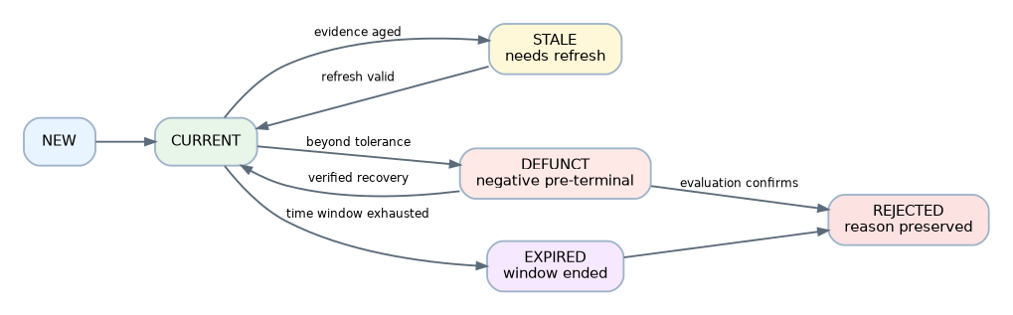
Figure 8. DiscoveryCandidate lifecycle, including STALE, DEFUNCT, EXPIRED and REJECTED.
The tolerance envelope pins rules for acceptable price drawdown, technical structure, momentum, volume/liquidity, sector context, market regime and time decay. Each dimension has a unit, direction, reference snapshot/basis, required evidence, threshold, persistence/hysteresis and recovery rule. Reference anchors are explicit; do not silently ratchet the baseline on every quote. Small normal pullbacks within the envelope append observations to the same episode.
Options-oriented IV, theta, days-to-expiry and spreads are future envelope dimensions. They are not inferred from underlying equity data or mandatory Sprint-2 features. An unavailable required dimension is unknown; it cannot prove deterioration or recovery. Material breach enters DEFUNCT pending evaluation, not automatic terminal rejection. Recovery requires sufficiently fresh, comparable evidence satisfying the pinned recovery rule before expiry/final rejection.
This diagram includes effective display states. Durable lifecycle is NEW, CURRENT, DEFUNCT, EXPIRED or REJECTED with append-only transitions; STALE is a freshness projection over an otherwise CURRENT episode, not a destructive rewrite. Freshness is also displayed for NEW/DEFUNCT states. Effective expiry is computed from the fixed window even before a bounded evaluator persists its transition. Read operations need not write to the DB. Precedence is REJECTED, then window EXPIRED, then DEFUNCT, then NEW, then CURRENT/STALE. Thus stale data never disguises a known tolerance breach, and REFRESH does not resurrect terminal history.
State | Meaning and permitted behavior
NEW | First evidence/provisional attention; no unsupported evolution claim; collect next comparable observation
CURRENT | Required evidence and relevance policy satisfied within window; review/save/refresh/dismiss
STALE | Refresh needed; not a negative thesis verdict; old score labelled historical and removed from current ranking
DEFUNCT | Material breach, pre-terminal; evaluate, request fresh evidence, recover under pinned rules or reject
EXPIRED | Temporal value exhausted; cannot recover by changing timestamps; record expiration evaluation then reject
REJECTED | Terminal with actor/policy, time and reason; preserve evidence and evaluations; no reopen mutation

Rejection reasons include DEFUNCT_CONFIRMED, EXPIRED, USER_DISMISSED, INSUFFICIENT_EVIDENCE and IDENTITY_INVALID. A discovery run can also decline a nomination without creating a candidate; retain a DecisionRecord with its input references and reason. Save/review markers are user workflow annotations, not eligibility overrides. Dismissal rejects the episode, never a trade cancellation. A subsequent distinct setup creates a new linked episode after duplicate/cooldown checks, not immediate recreation from the same dismissed source observation.

18. Optional LLM Level-0 and grounding
LLM OFF invokes no model and is fully useful. ON requires an eligible connected profile, applied provider/model revision, owner-authorized secret and explicit data-egress policy. Connect/disconnect, select model and activate profile are separate settings actions. Disconnect stops new calls and fences late responses; it does not erase historical interpretations or block deterministic Discovery. Only one primary binding is used for an operation; there is no hidden ensemble.
Level-0 can explain matches, summarize supporting/opposing evidence, describe setup characteristics, identify missing evidence, compare qualitatively and propose a structured scan draft for human validation. It can decline. It cannot execute tools outside a read-only allowlist, grant authority, promote into LOB, invent missing data, mutate snapshots or declare a probability of profit.
Grounding | Verification and user-facing meaning
GROUNDED | Every material factual market claim cites supplied, compatible evidence eligible under the current profile; interpretations are still labelled model inference, not guaranteed correctness
PARTIALLY_GROUNDED | Some claims have eligible evidence but others lack it or depend on stale/incompatible items; per-claim gaps are shown
CONTEXT_ONLY | No eligible deterministic market evidence supports the material claims; “LLM context only — not grounded in current deterministic market data”

EOD can be eligible for an EOD/positional profile but must retain its EOD source label. GROUNDED never implies tick-live data. The adapter's/model's claimed grounding cannot override server validation. Unknown citation IDs or malformed output are rejected or explicitly downgraded, not accepted as factual evidence. Unsupported numeric factual claims cannot fill typed deterministic fields.
Citation membership is necessary but not sufficient: verify cited subject, timestamp, measurement/unit and numeric value against the packet. Reject contradictory or unsupported factual assertions; keep qualitative interpretation explicitly labelled as model inference. If support cannot be validated, downgrade/decline rather than assign GROUNDED. This does not claim an automatic proof that arbitrary model prose is true, and no interpretation can write back to deterministic evidence.
Store interpretation ID, immutable input packet digest and evidence IDs, actual provider/model and available revision, prompt/template/tool/orchestration versions, generation and source times, grounding result and validation version, declared limitations/decline and bounded output. Do not claim reproducibility beyond a provider's disclosed model version. Keep private prompts/evidence access-controlled; operational logs store metadata, not raw prompts or responses. A model's hidden reasoning is not required or requested as audit evidence.

19. Persistence, transactions and future evaluation
State | Owner | Storage policy
Definition/profile/policy revisions | TWF configuration | Immutable versions plus authorized active binding
Scan/discovery runs and decisions | TWF S&D | Durable owner-scoped status, limits, completeness and correlation
Source observations/matches | External producer; TWF capture record | Immutable bounded licensed capture/reference, not vendor truth rewritten
Episodes, candidate projection, transitions | TWF S&D | Durable lifecycle; revision/CAS; immutable linked history
Snapshots/evidence/evaluations | TWF S&D capture/evaluation | Append-only, with explicit correction links and retention policy
LLM interpretation | Producer attribution; TWF capture | Separate from deterministic evidence and eligible ranking measures
TI response / TM position / broker order | External authoritative owner | Typed references and explicitly permitted snapshots only
Live Broker V2 quotes | Existing ephemeral overlay | No new persistence or S&D history inference

Use existing SQLAlchemy/Alembic foundations; do not create tables in this task. Sprint-2 migrations must specify foreign keys, owner-aware uniqueness, indexes, bounded JSON schemas and portable decimal/timestamp handling. Personal user ownership is supported first; sharing/workspace claims require implemented membership and ownership checks, not an invented tenant ID. Referenced snapshots must belong to the same authorized scope; exports, histories, caches and jobs enforce it too.
Commit run intent, release transaction, collect bounded I/O, then atomically append accepted captures/evaluation/transition under expected episode revision. Late or cancelled generation results cannot replace the current projection. Idempotency keys are scoped to owner/operation/request digest; same key with different inputs conflicts. Duplicate input does not duplicate a candidate. SQLite contention is bounded and sanitized; verify the same semantics with PostgreSQL concurrent writers.
Retention is class-specific and licensed: derived evaluation, audit metadata, raw captures and provider references have different permitted lifetimes. Immutable does not mean stored forever. Authorized retention/deletion records a tombstone and reproducibility limitation; no silent recreation of erased data from caches or backups. Legal/data-rights periods must be fixed before real-data acceptance. User records cannot promise indefinite vendor-data retention.
Future Outcome/Evaluation includes every eligible episode, not just executed ones: +1/+3/+5/+10 trading-session returns, favorable/adverse excursion, thesis validity, episode lifetime and rejection reason. Define basis, corporate actions, calendar, availability cutoff and missing/censored outcomes. These are hypothetical discovery outcomes, not realized broker P&L. Preserve TI claim evaluation and trade/execution quality as different targets. ML/IFL is future work, never an automatic ranking update or a background trading loop in Sprint 2.

20. Settings and authorization
Use configuration architecture classes, scopes, capability policy, secret references and desired/effective/applied revisions. Do not append arbitrary S&D keys to the finite accepted TWF-1.5 schema. Introduce separately versioned descriptors under the same logical settings boundary. 5d/15d legacy preferences may seed a new HorizonSpec only after the user sees and confirms the calendar/basis; their prior undefined day semantics are not silently reinterpreted or migrated.
Settings area | Class / initial authority | Behavior
General / result density | Presentation, personal user | HOT; no impact on eligibility or authority
Universe / scan profiles | User-workflow, personal user | Versioned selections; apply to new runs; allowed universe constrained by capability/data rights
Scan providers | System/integration; operator registration, authorized personal selection | WARM bind; only registered adapters; no arbitrary endpoints/code
Market-intelligence providers | System/integration | Same eligibility/secret/version rules; independent coverage requirements
Candidate-intelligence providers | System/integration | Optional bounded enrichment; cannot change execution rights
LLM | System/integration plus user selection | OFF/ON, connect/disconnect, select profile/model; one applied binding; egress consent and budgets
Discovery/ranking | User-workflow within platform policy | Typed weights/bands/intents; pinned revisions; no invisible historical reranking
Freshness/tolerance | User-workflow within safe bounds | Horizon/calendar-aware; cannot relabel unknown evidence as fresh
Persistence/retention | System/security/data-rights policy | Operator-controlled limits; user may choose less within legal policy, not exceed licensed retention
Experimental | Platform capability + environment | Local LLM and experimental measures unavailable in production unless separately accepted

Future WORKSPACE/ACCOUNT scopes use existing descriptor precedence only after verified ownership/membership exists. Security settings (destinations, TLS, secret material, deployment keys), platform capability installation and subscriber entitlement are not personal preferences. Read/configure/enable/apply/use permissions are distinct. A finite policy can gate initial capabilities without implementing commercial billing. Unknown grants deny use; revocation blocks new calls and fences late data while retaining authorized history under retention policy.

21. Security and failure behavior
Treat provider/MCP/news/LLM text as untrusted data, including embedded instructions. Do not follow source instructions, execute generated code, render unsanitized HTML or fetch arbitrary cited URLs. Server-owned tool/destination allowlists, bounded schema parsing and egress controls apply even when a model requests a tool. No browser cookie, broker token or unrelated portfolio/account data is sent to a scanner/LLM. Minimum evidence disclosure, licensing and per-provider data-egress approval precede hosted LLM calls. Secrets remain server-side behind authorized references; do not reuse broker tokens as scanner credentials.
Every read and mutation authenticates and checks owner, capability and current profile generation. Cookie-authenticated writes use the existing trusted Origin policy. Rate/cost budgets apply per owner/provider and operation; cancellation and timeouts fence results. Error/log fields are allowlisted correlation metadata; no raw responses, credentials, endpoints or private evidence blobs in logs.
Failure | Required behavior
Scan provider down/auth expired | Provider-specific safe error; no invented empty result or silent replacement
One selected provider fails | PARTIAL only if policy permits; show covered/missing universe partitions
Required market data stale/missing | Decline new nomination or show historical/stale candidate; no false current score
Optional context missing | Continue with explicit gap/coverage; never synthesize neutral evidence
LLM unavailable/OFF/budget exhausted | Deterministic results remain usable; interpretation unavailable/context labelled
Version/provenance mismatch | Reject payload; preserve last accepted historical record with stale/unknown status
Lost response / restart | Run INTERRUPTED/unknown completion metadata; inspect committed partitions; explicit bounded new attempt
Revoked profile/session | Block new work; cancel/fence in-flight results; never redirect to a different owner/provider

This read/analysis retry policy must never be reused for Broker V2 order dispatch. Its OrderIntent, unknown-submission and reconciliation behavior remain unchanged.

22. UX architecture and text wireframes
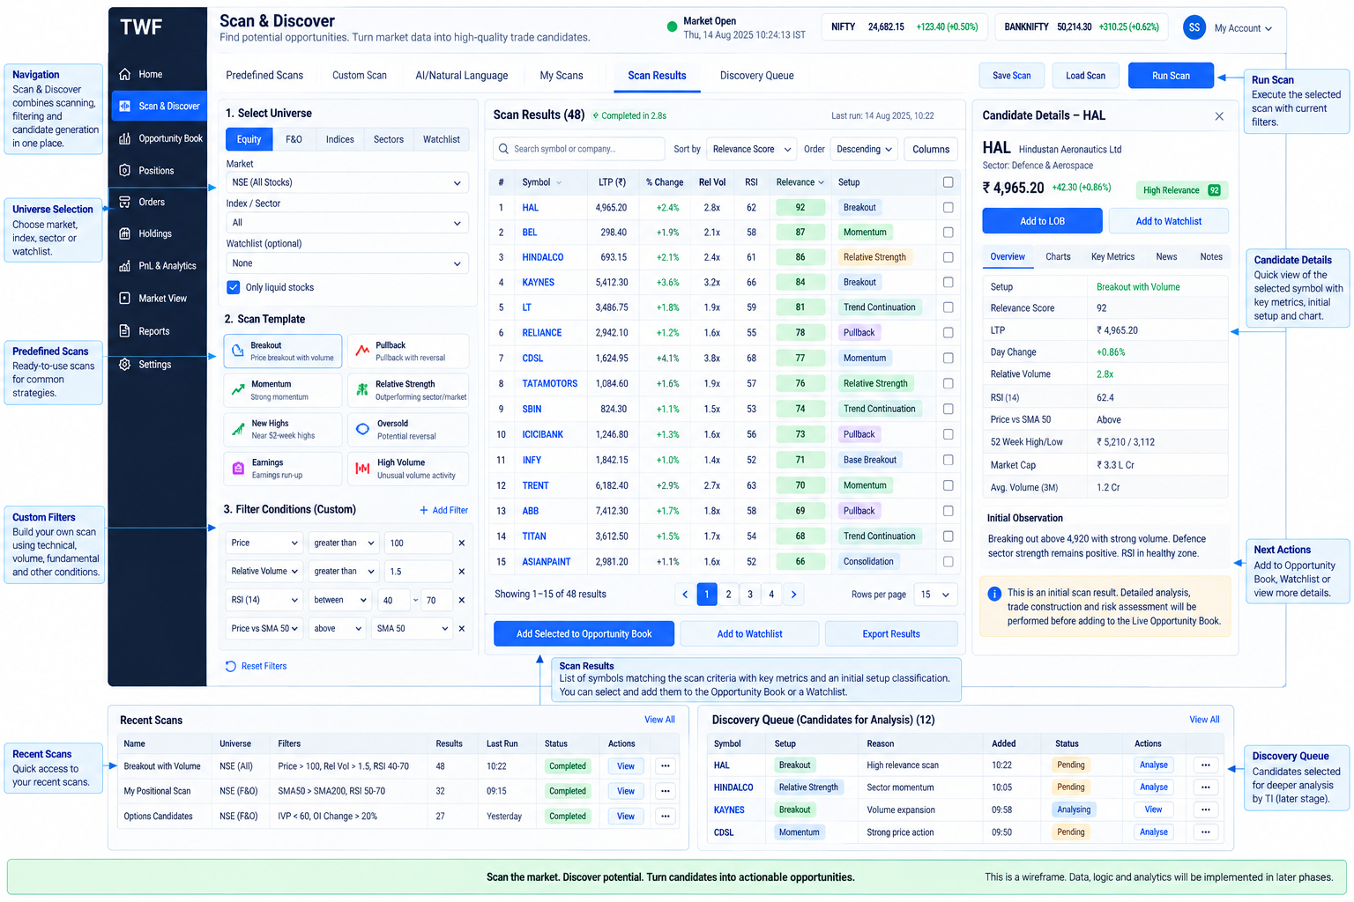
Figure 9. Scan & Discover product wireframe reference.
Provide three explicit entry actions: Scan, Discovery, Scan + Discover. Discovery can select a saved eligible scan/input batch; only the synthetic external source seam is required in Sprint 2. The queue is not an order ticket and contains no Buy/Sell, Confirm Order, automatic TI qualification or LOB promotion action.
Scan & Discover History Settings
Universe [owned selection] Profile [revision] Mode [Scan | Scan + Discover]
Provider badges and capabilities As-of/data mode LLM [OFF | applied model]
Validated filters / unsupported reasons Run Cancel run
Run status • coverage • observed/source times • provider failures
Matches | Discovery queue
Instrument + listing | Intent / horizon | Relevance + band | Freshness | Why now
Selected candidate: evidence / context / conflicts / gaps / snapshots / history
Actions: Save for review • Reviewed • Refresh evidence • Dismiss with reason
Candidate details
Exact subject/listing • intent • horizon • fixed opportunity window
Lifecycle + freshness separately • last evaluated and source-data timestamps
Discovery Relevance 0.74 MEDIUM • policy revision • coverage • not profit odds
Support / concerns / missing evidence • provider and upstream lineage
Market / sector context • EOD/delayed/live-snapshot labels
Optional interpretation: grounding badge + citations + actual model
Snapshot timeline S1 ... Sn • comparable delta • prior episode/rejection link
At desktop widths show results and evidence side by side; tablet uses a collapsible detail pane; mobile uses readable result cards and a dedicated detail view with back-navigation preserving filters. Ultrawide adds context/history without endless stretched prose. Use accepted theme tokens and eight shell states, keyboard-focus order, labelled inputs, semantic headings, live run-status announcements, accessible tables/cards, and number plus band/text rather than color alone. Do not add a docking/chart framework. Keep actions disabled with reasons for missing capability.
Scan history and Discovery history are distinct, owner-scoped and paginated. Failed/empty runs, partial coverage, LLM OFF and no previous snapshot have useful empty-state copy. A stale result remains inspectable with last-known labels and explicit Refresh; it does not disappear as though it never existed.

23. Use cases and sequences
Representative scenarios: EOD swing review without LLM; intraday candidates with stale benchmark context; technically positive but sector-negative results; repeated same-source observations; bounded pullback within tolerance; defunct recovery; expired episode followed by a new next-session setup; unavailable TradingView with explicit internal-profile selection; context-only LLM explanation; conflicting providers sharing a feed; dismissed candidates retained for future evaluation.

24. Deployment and local/remote equivalence
Local code receives typed context and runs under the same deadline/cancellation, ownership and result validation rules as remote code. No blocking provider work on the API event loop; choose a bounded executor for CPU-bound local indicators when measured. Network details are adapter-only. Remote authentication and egress must be reviewed before activation; health-only TWF-1.6 support is not sufficient.
Single-process/local deployment is the initial target. Multi-process admission, paid-provider quotas, job claims, revocation and cancellation require shared coordination before horizontal scaling; no process-local limiter is presented as cloud-wide enforcement. /ready stays application-only; S&D availability is a separate capability observation. No mandatory Redis, Kubernetes or worker fleet.

25. Future handoffs and authority boundaries
Figure 10. Future S&D-to-TI-to-LOB-to-Broker/TM handoff and feedback loop.
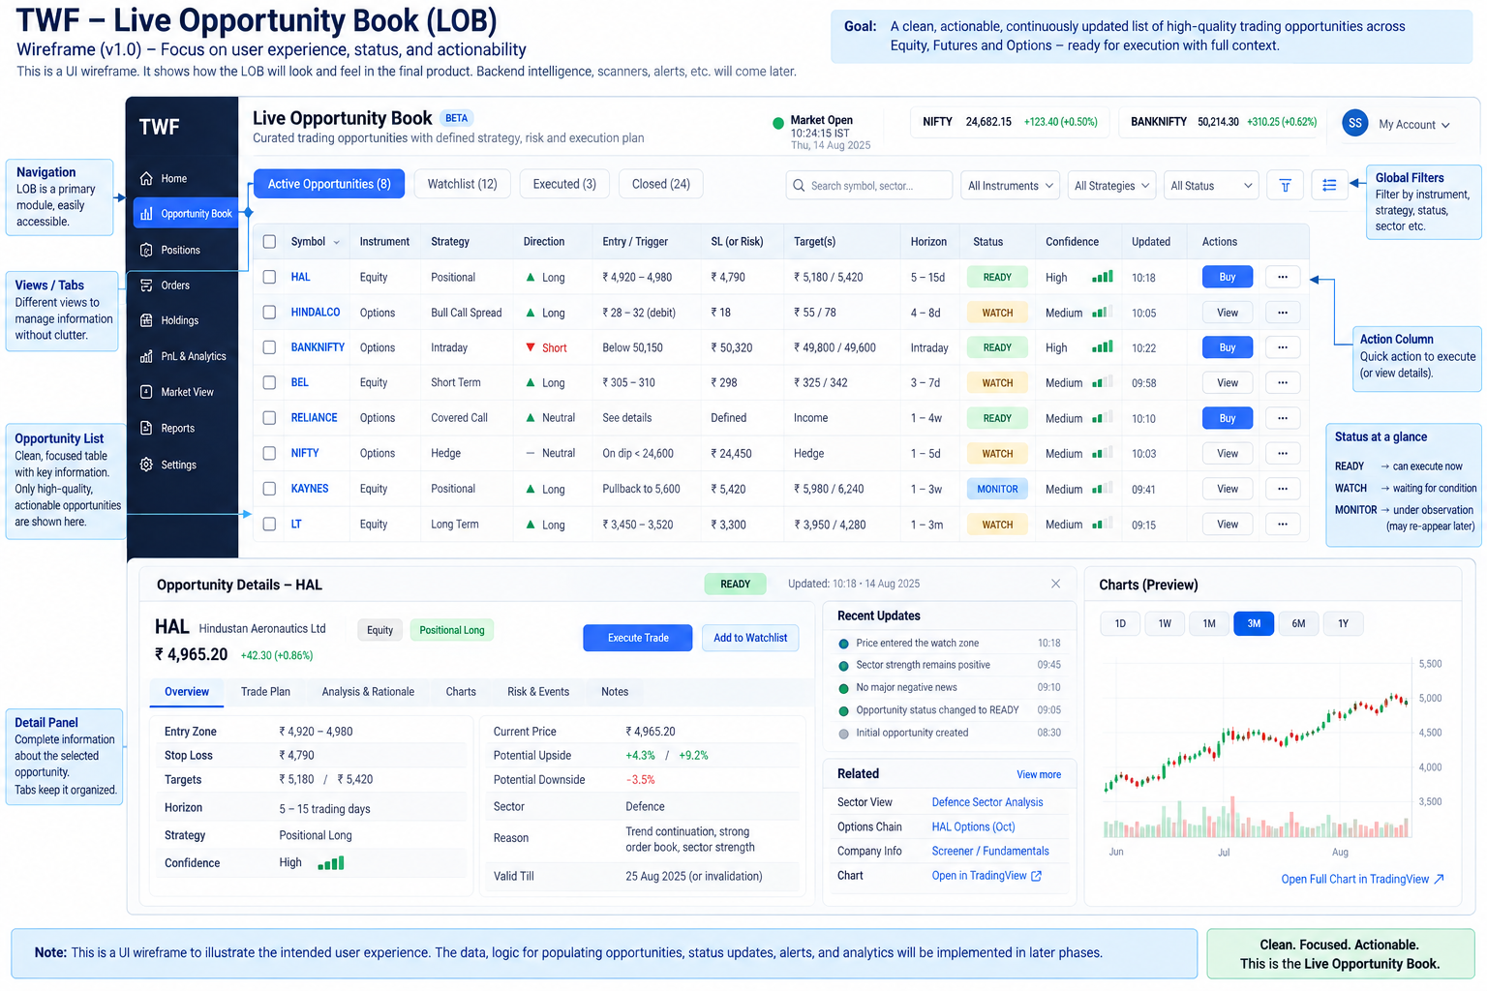
Figure 11. Future Live Opportunity Book wireframe reference (not Sprint-2 implementation scope).
The domain ladder does not cast one object into the next. TI response/claim IDs remain external authoritative references. Opportunity qualification links TI evidence and a versioned decision; it does not mutate TI claims. Construction adds exact structure, entry/risk/targets/duration/conditions and its own validity window. LOB later projects actionable prepared trades; disappearing from its current view is not deletion of lineage or cancellation of an existing order.
No S&D screen performs these future handoffs in Sprint 2. TM's committed public contract gate, exclusive account command ownership and explicit adoption remain. TM outage cannot enable a manual fallback. A manual trade is not automatically protected by SL/TP or TM simply because discovery evidence exists.

26. FAQ
Question | Answer
Why isn't every ScanMatch a candidate? | Matching criteria alone may lack timely context, sufficient evidence or intent-relative relevance. Discovery may decline.
Is a candidate a trade recommendation? | No. It means worth examining now; it has no constructed trade or authority.
Why split Scan and Discovery? | Scan tests criteria; Discovery evaluates attention-worthiness using intent/context and can accept other sources.
Can Scan be used alone? | Yes; matches and run history are useful without candidates or an LLM.
Can Discovery run without Scan? | Yes through CandidateSource; Sprint 2 proves this with a synthetic source, with real external feeds later.
Can S&D run without an LLM? | Yes; eligibility, relevance, snapshots and lifecycle are deterministic.
Can I replace the hosted LLM? | Yes through an explicit eligible profile/model rebind; actual old/new provenance remains.
Can S&D run without TradingView? | Yes through the internal scanner and approved independent data input; no silent provider substitution.
What if TradingView MCP is unavailable? | Its run fails or is explicitly partial; select the internal profile for a new run if desired.
Why build an internal scanner? | To prove replacement seams and provide a small native deterministic capability, not reproduce every vendor feature.
What is Level-0? | Optional explanation, comparison and evidence-gap identification, not deep TI qualification or execution.
What is grounded versus context-only? | Verified citations to eligible supplied evidence versus no such factual grounding; neither guarantees correctness.
Why market intelligence in S&D? | Attention-worthiness depends on current regime, sector/session and other available context.
How does this differ from TI? | S&D uses bounded contextual measures; TI owns deeper claims, forecasts, thesis and scientific evaluation.
Why can a candidate become STALE? | Required evidence aged; the thesis is not thereby invalidated.
What does DEFUNCT mean? | Material tolerance breach requiring a pre-terminal evaluation; verified recovery can occur before expiry/rejection.
What does EXPIRED mean? | The captured opportunity window has ended; a refreshed quote cannot extend it.
Why preserve rejection reason? | To explain terminal decisions and evaluate failures, dismissals and expirations separately later.
Can the same stock reappear? | Yes under another intent or a genuinely new episode after the prior one ends.
Why a new episode? | To preserve the old outcome instead of rewriting/resurrecting failed history.
Why immutable snapshots? | They preserve exactly what was observed and available at each decision.
Why at least two observations for evolution? | Change requires comparable distinct samples; S1 alone cannot establish improvement.
What does relevance mean? | Fit to this versioned intent/horizon/context policy, with coverage and reasons.
Is 0.94 a 94% chance of profit? | No. Relevance is not a calibrated return probability.
Why horizon-relative scores? | The same evidence can matter differently over minutes, sessions or months.
Can one underlying have several intents? | Yes; each has explicit horizon, basis and independent episode history.
What happens after market hours? | Use labelled completed-session evidence under an EOD policy; expire intraday windows honestly.
How does ML fit? | Later evaluate all candidates including non-trades and propose versioned calibrated policies; no live self-learning in Sprint 2.
How will LOB consume trades? | Future LOB references qualified, constructed TradeOpportunity revisions and derives readiness without granting authority.
Where does TI begin? | At an explicit deeper-analysis handoff carrying immutable Discovery evidence and exact horizon/identity.
Where does TM begin? | At managed-risk/authority assessment before managed execution or explicit adoption; never from a discovery score.

27. Risks, TBDs and acceptance
No unresolved ownership contradiction blocks this documentation proposal. These decisions still gate implementation/live acceptance: exact MCP server/tool contract; independent input data and retention rights; approved universe/identity/sector mapping; calendar and initial horizon presets; numeric limits/latency/cost budgets; initial ranking/tolerance thresholds and required coverage; hosted LLM provider/model and egress policy; production vault and operational retention. The Sprint-2 plan assigns decision gates rather than claiming these integrations already exist.
Acceptance must prove scan-only, Scan + Discover, synthetic external-source Discovery, no-LLM operation and TradingView-removed internal operation. It must exercise typed failures/capability mismatch, normalization/deduplication, correlated evidence, ranking determinism/missingness, immutable snapshot series, lifecycle and tolerance boundaries, horizon/calendar/after-market behavior, grounded/context-only LLM output, ownership/secret isolation, persistence/restart, responsive accessible UX and Broker V2 regression isolation. Use injected clocks and deterministic providers; acceptance must not depend solely on a live third-party service.
An independent architecture review must accept the three-document contract and close scope decisions before bounded coding begins. Documentation readiness is not provider acceptance, live deployment permission or a new milestone freeze.

Publication note
This companion is derived from the reconciled normative Markdown source. Architecture status remains PROPOSED / RECONCILED / READY FOR REVIEW until the independent review gate records acceptance.

