TRADINGWORKFLOW (TWF)
TWF Sprint-2 Scan & Discover Delivery Plan
Bounded implementation scope, gates, acceptance evidence and delivery slices
Version 0.1 • 28 Sep 2026
PROPOSED / RECONCILED / READY FOR REVIEW
Markdown is the normative repository source. This DOCX is the synchronized visual/reference companion.

Document map
Section | Topic
1 | Status and authority
2 | 1. Objective and starting point
3 | 2. Explicit scope
4 | 3. Baseline acceptance scenario and bounded configuration
5 | 4. Gate S2-0 — architecture and external-contract resolution
6 | 5. Delivery slices and acceptance evidence
7 | 6. Run, persistence and deployment boundary
8 | 7. UX acceptance journeys
9 | 8. Test and acceptance matrix
10 | 9. Validation and evidence required at implementation acceptance
11 | 10. Milestone mapping and final gate

Status and authority
Version | Date | Status | Role and change
0.1 | 2026-09-28 | PROPOSED / RECONCILED / READY FOR REVIEW | Normative delivery proposal with bounded slices, dependencies and acceptance gates; no runtime implementation authorized by this document alone

Read with the S&D architecture, Opportunity domain and reconciliation record. “Sprint 2” names this proposed delivery workstream, not a promised two-week estimate, not a renaming of TWF-2, and not a retrospective “Sprint 1” acceptance claim.

1. Objective and starting point
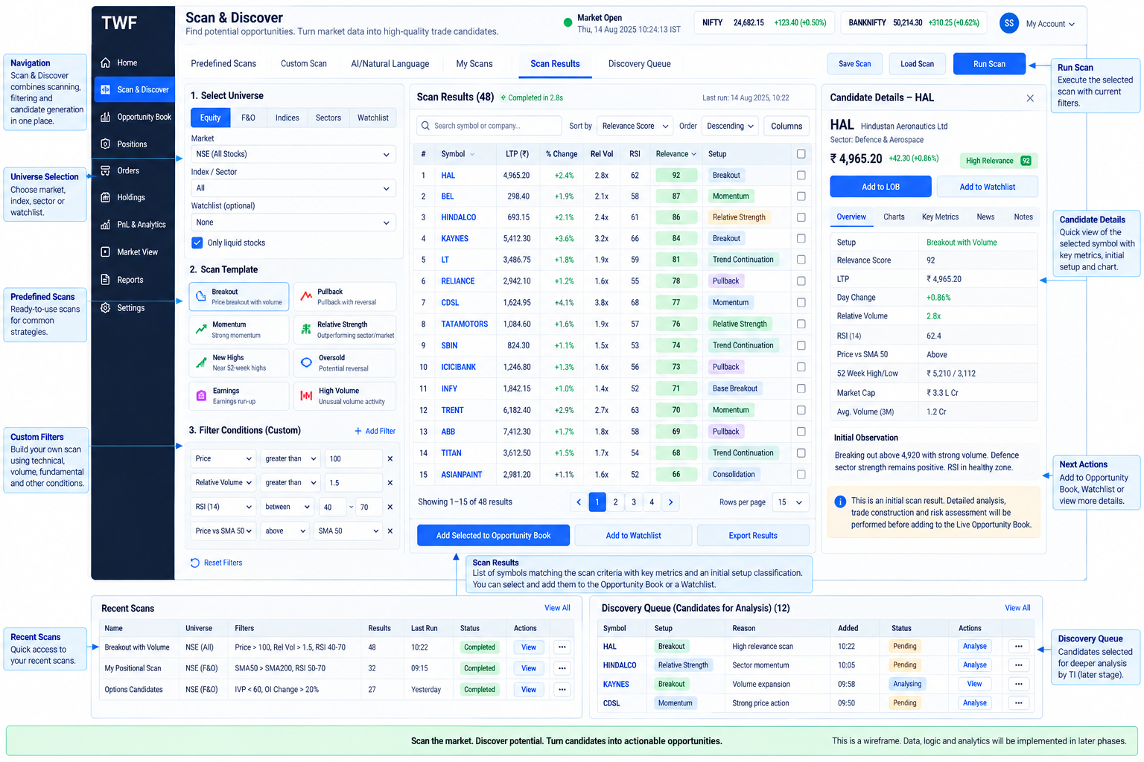
Figure 1. Sprint-2 target user surface: Scan & Discover.
Deliver an independently useful Scan & Discover system: a user can select an approved universe/profile, scan, inspect matches, optionally discover candidates, understand their evidence/context/freshness/relevance, refresh them and review history without TI, TM, an LLM or a broker connection. Broker V2 remains independently useful and unchanged. No trade can be submitted from S&D in this scope.
Repository reconnaissance at this proposal: main, 69a643e372c48a6d3d85ce57962ca05c38c4c3dc, clean before documentation edits, twf-broker-v2 at HEAD. TWF-0/TWF-1 and Broker V1/V2 acceptance are preserved. The accepted API, auth, SQLAlchemy/Alembic, frontend/theme, settings and service-client foundations are reusable. The current service-client implementation is health-only; it does not already provide scans, intelligence, MCP or LLM inference. Existing settings contain bounded personal preferences, not all proposed S&D configuration.

2. Explicit scope
In this delivery | Boundary
Provider-neutral S&D contracts | UniverseProvider, CandidateSource, ScanProvider, MarketIntelligenceProvider, CandidateIntelligenceProvider, LLMService; synthetic implementations prove seams
Scan definitions and profiles | Versioned bounded typed expression tree; capability validation before execution; no arbitrary code/SQL/provider tool text
Candidate-source seam | Internal normalized scan source and a synthetic external-source contract proof; production external/manual/agent ingestion remains later
TradingView MCP scan adapter | Important first external adapter, gated by verified service/tool/auth/data-rights contract; never mandatory for core startup or internal scans
TWF internal scanner V0 | Bounded price/volume, SMA trend, relative volume and breakout rules over an approved independent data input; not a TradingView clone
Normalization/merge/dedup | Typed identities, units/time semantics, lineage and uncertainty; no symbol-only merges or duplicate-source confidence inflation
Bounded market intelligence | Benchmark trend, historical-volatility/regime measure and venue/session context; optional sector context if supported; not full TI
Optional LLM Level-0 | Evidence-grounded explanations/comparisons/gap summaries; human-reviewed NL-to-definition drafts; one applied active binding; deterministic results unchanged with LLM OFF
Discovery | Intent/horizon, immutable snapshots, relevance, evidence, tolerance, freshness, recurrence and lifecycle
Durable history | Scan/discovery runs, outcomes/declined nominations, episodes, annotations and revisioned configuration references; restart and retention behavior
First-class settings | Existing settings/capability/security model extended with approved typed descriptors and bounded UI
Finished UX | Scan, Discovery and Scan + Discover; results, queue, details, evidence/history and settings; both themes and responsive layouts
Verification | Deterministic offline coverage, disposable DB/browser/container checks and explicitly authorized read-only provider smoke

Out: full TI/deep intelligence, Opportunity qualification, Trade Construction, LOB implementation, TM managed integration, broker order entry from discovery, automatic execution, alerts/notification platform, continuous/high-frequency monitoring, production ML ranking, autonomous agents and self-learning activation. Architectural hooks do not authorize endpoints/tables/UI for these later stages.

3. Baseline acceptance scenario and bounded configuration
The proposed initial product lane is listed cash-equity underlyings with an explicit reference listing, initially NSE/BSE subject to approved data rights and reliable identity/calendar coverage. A versioned completed-session swing profile (for example 1–5 trading sessions) provides meaningful deterministic use outside market hours. An intraday/current-session profile is enabled only when verified fresh-data and session-calendar capability is available. Do not describe EOD data as live.
This initial universe/profile selection is a proposal requiring S2-0 approval, not a claim about data already licensed or available. The core accepts extensible HorizonSpec values; synthetic contract tests cover session, elapsed, calendar and event windows regardless of initial live entitlements. Additional live assets or profiles require explicit capability/data acceptance, not new hard-coded domain types.
An internal scanner without an independent approved data source is not a completed provider-independent live product. A fixture-only demonstration satisfies contract checks but cannot close the final real-data delivery gate. The plan therefore requires the data-source choice before implementation of the corresponding adapter.
Pin a small initial definition set: a price/liquidity filter; a price-above-SMA trend filter; a relative-volume condition; and a breakout against a bounded prior window. Select exact window lengths, missing-bar rules, adjustment basis and numerical tolerances in S2-0/S2-2 fixtures. EMA/RSI/ATR/crossovers/52-week/pullback criteria are extension targets unless separately selected by replacing, not endlessly expanding, this bounded initial set. No universal “profitable” thresholds are asserted.
For a live adapter, complete a reviewed profile manifest with explicit limits: maximum universe size, result/page count, historical rows, concurrent calls, response bytes, total deadline, retry budget for safe reads, active runs per owner, LLM token/ cost cap, data-freshness thresholds, tolerance policy and retention classes. Missing limits fail capability activation; defaults may not silently mean unlimited. Exact operating values depend on the selected provider contract and deployment budget.

4. Gate S2-0 — architecture and external-contract resolution
This is the next gate, before runtime work. Review all three normative proposals and the reconciliation record independently. Resolve these implementation inputs:
Decision | Required evidence and owner | Blocked dependent work if unresolved
TradingView MCP service | Maintainer/repository/service URL, pinned version, auth, permitted tools and exact request/response schemas, capability and rate limits; integration owner verifies authoritative material | Real TV adapter; no assumption that a service branded TradingView is official or has a universal API
TV/data licensing | Rights to query, store, derive, display and send context to an LLM, including retention and redistribution; product/security owners record approval | Real data ingestion/retention/egress claims
Independent market data | Approved historical/current data producer independent of TV, calendar and benchmark coverage, correction/adjustment policy; data/integration owners | Live internal scanner and market-context acceptance
Reference identity | Initial universe/listing keys, mapping ambiguity behavior and canonicalization source; domain owner | Cross-provider identity merge beyond explicit exact mappings
Initial profiles | Universe, horizons/calendar, bounded scan set, market-context requirement, scoring features/weights, coverage, tolerance/freshness thresholds; product/domain owners | Reproducible live nomination and lifecycle acceptance
Optional hosted LLM | One permitted adapter/model binding, data-egress policy, budgets and grounding schema; security/integration owners | LLM-enabled production mode; LLM OFF remains valid
Retention/operations | Licensed capture rules, user deletion/tombstones, retention periods, limits and interrupted-run recovery; engineering/security owners | Production persistence/operational acceptance

No source/server or vendor-specific schema was verified in this documentation task. Do not invent a dependency or promise real integration from diagrams. If TV cannot be contracted, explicitly re-scope that slice through review; do not silently omit it and claim all Sprint-2 acceptance criteria passed. Likewise a missing LLM provider may leave deterministic S&D useful but must be reflected in feature acceptance.
Exit: reviewed architecture decisions, resolved gates for the next slice, approved implementation prompt, and explicit known limitations. Documentation readiness is not runtime GO or permission to contact paid/live providers with stored credentials.

5. Delivery slices and acceptance evidence
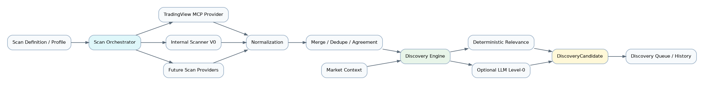
Figure 2. Delivery components and provider-neutral core.
Slices are dependency groups, not new permanent milestone IDs. Each needs a bounded implementation prompt, isolated tests and independent acceptance before claiming completion. Preserve prior accepted work rather than resetting its status.
Slice | Delivery | Dependencies | Acceptance evidence
S2-1 Domain and contracts | Shared subject/intent/horizon, typed evidence/run/result envelopes, provider manifests, capability/entitlement checks and deterministic synthetic fixtures | S2-0 core decisions | No scan-provider types in core; absent provider healthy app startup; schema/unknown-field/version/error/ownership tests; non-scan CandidateSource exercised
S2-2 Native scan and definitions | Universe resolution, approved independent data reader, versioned profiles, safe expressions, V0 scanner and bounded internal market context | S2-1 and data/calendar/profile gates | Known inputs yield expected matches/context; bad/missing/late data and unsupported criteria fail honestly; full scan-only without TV/LLM
S2-3 External adapter and normalization | Verified TradingView MCP adapter, local/remote contract parity, normalized results and merge/dedup with actual provenance | S2-1 and verified TV contract; S2-2 provides alternative | Adapter fixtures and authorized read-only smoke; TV unavailable scenario still permits explicit internal run; no silent fallback; schema/timeout/size/rate/security cases
S2-4 Discovery and history | Durable runs, episodes/S1…Sn, context/evidence, deterministic configurable relevance, tolerance/lifecycle, save/review/dismiss and history | S2-2; S2-3 exercises multi-provider inputs | No-LLM Scan + Discover; immutable history; same subject multiple intents and recurring episodes; concurrency/restart/isolation/retention tests
S2-5 Optional interpretation and settings | Existing configuration model extensions, one active hosted LLM binding, validated grounding, NL draft review, costs/egress safeguards | S2-4 and selected LLM/security gate | LLM OFF/failure leaves deterministic results usable; two interchangeable synthetic adapters; factual citation rejection, context-only UX and safe schema migration
S2-6 Finished UX and acceptance | Coherent Scan/Discovery/Scan + Discover screens, queue/details/history/settings, accessibility/responsiveness and release documentation | Prior slices with accepted required external gates | User journeys, negative/security tests, browser matrix, production/container build, review and explicit milestone decision

UI contracts and accessibility fixtures should be developed with each slice; S2-6 is integration/quality closure, not permission to leave unusable intermediate controls. S2-5 needs one real hosted binding when that feature is accepted, not three commercial integrations. Replaceability is demonstrated with contract fixtures; experimental local inference is not a production prerequisite.

6. Run, persistence and deployment boundary
Start within the existing modular FastAPI application and Next.js frontend. No separate scanner microservice, message broker, Redis, distributed scheduler or market-data warehouse is prescribed. Local in-process adapters and approved remote adapters have the same typed semantics. A future dedicated worker requires an operational decision, not an accidental framework side effect.
A user-triggered bounded run records QUEUED/RUNNING and terminal SUCCEEDED, PARTIAL, FAILED, CANCELLED or INTERRUPTED state. Restart reconciliation marks abandoned work interrupted; an explicit retry creates a linked attempt. Generation fencing rejects late responses. Provider I/O happens outside DB write transactions; snapshot/events/ head changes commit atomically under ownership/revision checks. No implicit perpetual background refresh is required. GET can compute time-based STALE/EXPIRED projections without mutating storage, while explicit bounded evaluation persists decisions.
Alembic owns schema evolution. Exercise disposable SQLite and PostgreSQL migrations, repeat upgrades and downgrade/re-upgrade as appropriate. Isolate tests from developer and production DBs; do not import live broker credentials. /ready retains accepted application-only meaning; provider/data degradation is a typed S&D result and UI state. No discovery failure should disable otherwise healthy Broker V2 access.

7. UX acceptance journeys
- Scan only: choose permitted universe/profile, inspect criteria and available
provider capabilities, run, see normalized matches with source/as-of/completeness, open a match and review run history. No candidate creation is forced.
- Scan + Discover, LLM OFF: run a profile, see eligible candidates or an explained
no-nomination result, relevance/coverage, intent/window, market context and evidence. No blank dependency panel implies TI/LLM is required.
- Discovery queue: filter by intent/horizon/relevance/freshness/status, save/review/
dismiss with clear consequences, inspect S1…Sn and transition reasons, refresh a selected candidate without silently extending its opportunity window.
- Temporal behavior: show provisional S1, genuine subsequent evolution, ordinary
pullback in the same episode, stale without invalidity, defunct recovery, expiry, rejection and a later new episode linked to history.
- Optional interpretation: distinguish GROUNDED/PARTIALLY_GROUNDED/CONTEXT_ONLY,
open actual input evidence citations, see missing/old context, disable/rebind LLM without changing deterministic scores. NL drafts require explicit review/validation.
- Provider failure/settings: unsupported criteria disabled with reason, revoked
entitlement cannot run, timeout/partial/empty separated, switch explicitly to an eligible internal profile, saved settings revision and applied revision visible.
Use existing theme tokens, eight surface-state primitives and keyboard/focus patterns. Review 390, 768, 1024, 1440, 1920 and 2560+ widths in both themes. Recompose result lists/detail panes; allow contained tabular overflow while preserving source identity and primary actions. Do not show fake dashboard metrics, invented probability or Buy/Sell/Send to LOB controls. Existing shell navigation placeholders are not evidence of implemented S&D. Specify final nav/route names during the UX implementation gate.

8. Test and acceptance matrix
Tests must verify failure behavior and invariants, not mirror implementation or rely on a real service being online. Use fixed clocks, controlled calendars, known units, source availability timestamps and seeded deterministic fixtures.
Category | Required regressions / meaningful oracle
Domain | Ambiguous symbols; listing vs underlying; owner collision; multiple intents; horizon basis/event/window semantics; no discovery execution authority
Scan definition | Typed operator/units/window validation; unsupported capability; bounded AST; no arbitrary expression execution; versioned drafts vs applied profile
Provider contracts | Local/remote/synthetic same envelope; actual source mode; capabilities vs health vs entitlement; missing vs empty vs partial; schema/version mismatch
Synthetic providers | Repeatable clocks/scenarios; delayed/partial/conflicting/malformed observations; external CandidateSource without scanning
TV MCP adapter | Pinned tool/schema fixtures; allowed tools only; auth redaction; total deadline including streaming/parsing; byte/page bounds; rate limit; no arbitrary URL/tool invocation
Internal scanner | Hand-checkable features, missing bars, zero volume/divisor, unadjusted vs adjusted basis, trading calendar, insufficient lookback, unavailable data; no TV dependency
Market context | Benchmark trend/volatility/session expected values; stale/missing benchmark; sector optional; incompatible context basis and provider conflict surfaced
Normalization | Decimal/units/time conversion; unknown IDs; future timestamps; exact native references preserved; correction and out-of-order handling
Dedup | Same observation replay not new evidence; cross-source syndicated lineage not independent confirmation; same underlying across listings not blindly collapsed
Relevance | Deterministic contributions, null vs zero, required-input refusal, optional missingness not inflation, dependence caps, exact band edges/display rounding, no-LLM invariance
Snapshot/history | Append-only/correction links, head CAS, two comparable distinct observations required; replays do not rewrite history; raw-retention limit shows incomplete reproducibility
Lifecycle/tolerance | Normal pullback, multidimensional breach, recovery, no timer-only defunct, stale projection, fixed expiry, reasoned terminal rejection, no resurrection/new episode linkage
LLM OFF | No inference call, credential requirement or missing-LLM failure; useful scans/context/candidates with same deterministic output
Grounded LLM | Valid eligible citations; fabricated/wrong-owner/stale citations fail validation; prompts untrusted; generated facts cannot fill raw evidence; no lifecycle/score control
Context-only LLM | Clear label and no current-fact presentation; no verified-grounded badge; qualitative output not substituted for missing measurements
Capability/config/security | Existing descriptor/scopes/apply semantics; stale revision conflict; provider rebind/secret rotation; owner denial; revocation checked at use; endpoint SSRF/egress and no secret leakage
Failure/degraded UX | Offline provider, timeout, cancelled run, partial data, invalid response, quota and stale cache; retain prior valid history with explicit age; no fabricated empty success
Persistence/restart | SQLite and PostgreSQL, concurrent nomination uniqueness, atomic snapshot+head, interrupted recovery, fencing, repeated retry correlation, non-mutating GET, isolated migrations
Frontend | Keyboard labels/focus, state primitives, filter ownership, pagination under dataset revision, view pinned to snapshot, responsive panes, theme contrast, safe rendering of untrusted text
Browser E2E | Scan-only and Scan + Discover with no LLM/TV; optional LLM grounding, lifecycle/history/settings, authentication/isolation; Chromium and WebKit where environment permits
Scope/regression | Broker V2 read/manual flow unchanged, no live orders submitted by tests, no TI/TM/LOB runtime claimed, dependency/secret/docs checks

Do not infer WebKit compatibility from Chromium. Recheck the known host/runtime limitation with an application-independent probe if it recurs; report an environmental block and residual uncertainty separately from a TWF defect. Never silently mark a browser passed when it did not execute.

9. Validation and evidence required at implementation acceptance
- Backend: pytest, Ruff lint/format, strict mypy, Python compilation, dependency
consistency/audit, OpenAPI/schema construction and contract snapshots.
- Database: disposable SQLite/PostgreSQL migrations and behavior, contention and
owner isolation, restart recovery, no production auto-migration.
- Frontend: type-check, lint, unit/interaction tests, Prettier, production build,
deterministic browser suites and representative rendered UX checks.
- Operations: Compose validation, clean relevant image builds, app health/readiness,
bounded run/provider smoke and interruption recovery; no unintended remote writes.
- Documentation/security: links, architecture/contract/settings accuracy, secret and
dependency review, clean diff checks, recorded limitations and exact test counts.
Counts from earlier Broker V2 validation are historical evidence, not acceptance of future S&D. Tests for this documentation-only task are structural/link/diagram/ consistency and scope checks; runtime suites are not rerun to imply nonexistent S&D implementation passed them.

10. Milestone mapping and final gate
Figure 3. Sprint-2 boundary and future handoff path.
Sprint 2 contributes to TWF-3 scanning/discovery and the bounded TWF-2.3 candidate workspace, with extensions of TWF-1.5 settings/TWF-1.6 client seams. It does not reopen those frozen foundations or mark all TWF-2/TWF-3 complete. LLM Level-0 is a bounded early interpretation slice, not acceptance of TWF-4 TI/deep intelligence. It advances UX-B2's independent discovery usefulness, not full UX-B2 or UX-B3 closure. TWF-5 managed authority, TWF-6 complete workflow and TWF-7–10 keep separate gates.
The join means final external-provider scope must be reviewed; discovery development and deterministic use do not wait on TV runtime availability. Implementation may parallelize independent slices after contracts are fixed, without weakening gates.
Final review must independently demonstrate: useful scan-only and Scan + Discover; viable internal path with no TV and no LLM; truthful source/freshness/grounding; immutable lineage and correct lifecycle; configurable deterministic relevance; provider replacement and safe failure; finished responsive UX; isolation and operational recovery; and zero expansion into trade authority or later-stage runtime.
Current decision: documentation is ready for independent architecture review. Sprint-2 runtime is not started by this task, not accepted, and not frozen. The next step is S2-0 review and recorded provider/data/policy resolutions, followed by a separately authorized bounded implementation prompt.

Publication note
This companion is derived from the reconciled normative Markdown source. Architecture status remains PROPOSED / RECONCILED / READY FOR REVIEW until the independent review gate records acceptance.

