TradingWorkFlow (TWF)
Configuration, Setup, Capability, Entitlement & Pluggability Architecture
Version 0.5 — Authoritative architecture proposed for acceptance before TWF-1.5

Core invariant:
Every capability advertised by the deployed TWF release already exists in the Platform Capability Catalog.
Subscription/user activation is runtime-safe and never requires shutting down TWF.

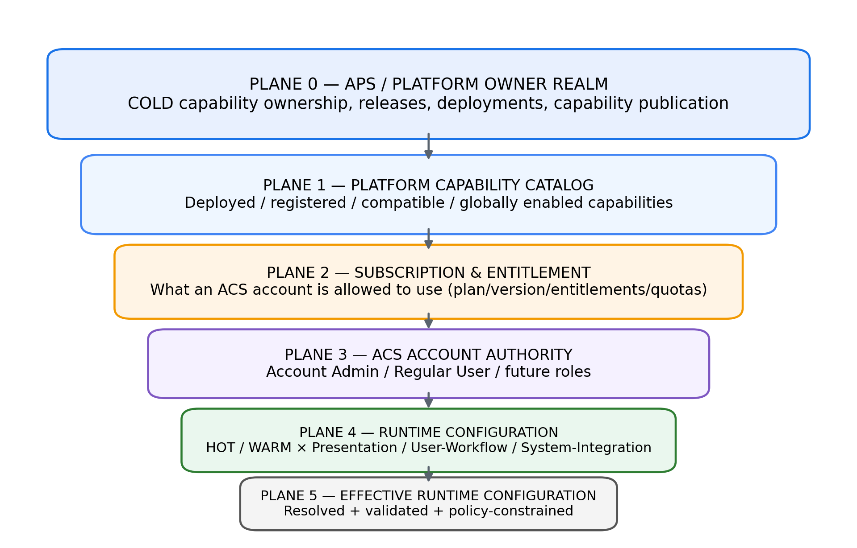
Figure 1 — Master configuration and capability planes

1. Executive Summary
TWF configuration is a multi-plane SaaS architecture rather than a flat Settings page. APS/platform ownership governs product capabilities and deployment; subscription governs what ACS accounts may use; roles govern what principals may change; HOT/WARM settings govern subscriber runtime behaviour; effective configuration is derived through scope, policy, entitlement, authorization, validation and health.
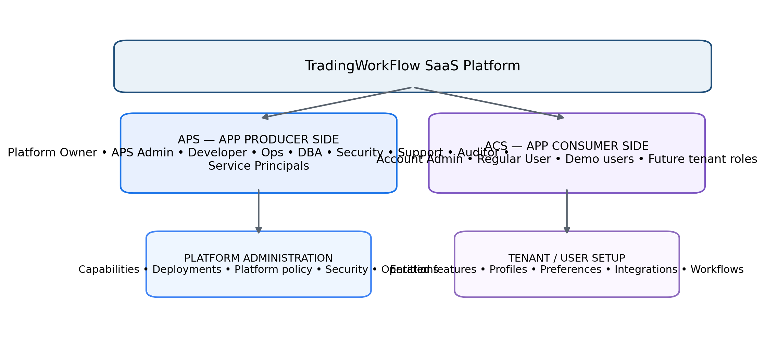
Figure 2 — APS and ACS as separate security and administration realms

2. Architectural Dimensions
Dimension | Question | Representative values
Realm | Which side of the product is acting? | APS / ACS
Principal type | What kind of actor? | Human, Service, Demo
Role / privilege | What may the actor change? | Platform Owner, APS Admin, Developer, Account Admin, Regular
Capability | What can the deployed platform do? | LLM, Scanner, TI, TM, Broker, Notifications
Entitlement | What may an ACS account use? | Plan grants, quotas
Setting class | What kind of runtime setting? | Presentation, User/Workflow, System/Integration
Mutability | How does change take effect? | HOT, WARM; COLD only in platform plane
Scope | Where does value apply? | Account, User, Workspace, Workflow
Secret ownership | Who owns credentials? | Platform, Account, User

3. APS / ACS Realms and Account Types
APS (App Producer Side) and ACS (App Consumer Side) are first-class security realms. Platform workers are not merely special subscribers; customer administrators are not platform operators.
ACC_TYPE | Realm | Purpose | Default production authority
APS_USER | APS | Human platform worker | Role-dependent
APS_SERVICE | APS | CI/CD, backup, monitor, workers | Narrow machine scope
APS_DEMO | APS | Internal demo/training | No production-changing authority
ACS_USER | ACS | Customer-side human | Role + entitlement
ACS_DEMO | ACS | Trial/demo consumer | No live trading authority by default

4. APS Roles, Privileges and Separation of Duties
APS role | Primary responsibility | Role grant | COLD publication | ACS data by default
PLATFORM_OWNER | Ultimate platform/product authority | Yes | Yes | No blanket daily access
APS_ADMIN | APS users, roles, privileges | Yes, bounded | No | No
DEVELOPER | Build/maintain software | No | No | No
RELEASE_OPERATOR | Execute approved releases | No | Approved execution only | No
SERVICE_OPERATOR | Operate services | No | No | Operational telemetry
DB_ADMIN | Database maintenance | No | No | Scoped/job-based
SECURITY_ADMIN | Secrets/trust/security config | No | No | No ordinary business access
SUPPORT | Customer issue diagnosis | No | No | Controlled support session only
AUDITOR | Read audit/compliance evidence | No | No | Read-only scoped

APS_ADMIN is deliberately not a universal super-admin. It administers APS identity/role assignments. Platform Owner retains owner-level authority; operational roles perform their job-specific actions under least privilege.
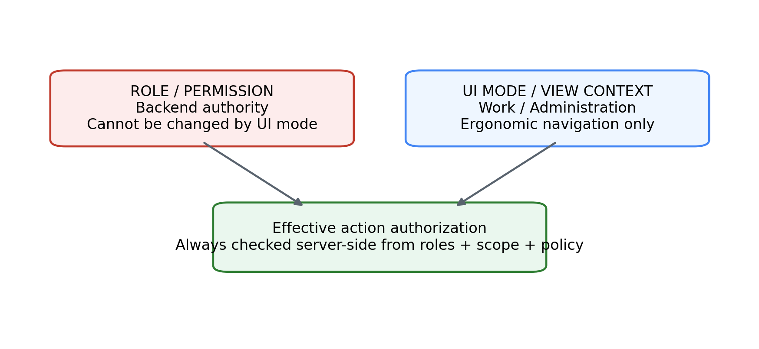
Figure 3 — UI Work/Admin mode is not a privilege elevation mechanism

5. ACS Roles
ACS role | Purpose | Account settings | Personal settings | Platform install
ACCOUNT_ADMIN | Manage account-level configuration; users later | Yes within entitlement/policy | Yes | No
REGULAR_USER | Use TWF and configure own experience | No by default | Yes | No

Future ACS roles such as Analyst, Trader, Risk Manager, Read Only and Team Manager are reserved but intentionally TBD.

6. Platform Bootstrap and COLD Capability Ownership
- Bootstrap configuration (environment, DB, platform key material, secret-store bootstrap, trusted origins, base observability) exists outside ordinary ACS Setup.
- COLD changes alter what the TWF platform is capable of providing.
- COLD capability publication is APS/platform-owner controlled.
- COLD does not imply subscriber-visible downtime; rolling/blue-green deployment is the production direction.
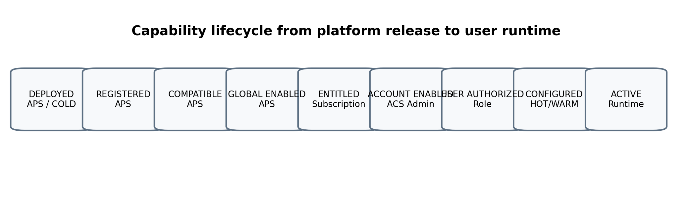
Figure 4 — Capability lifecycle from platform deployment to active user configuration

7. Platform Capability Catalog
The Platform Capability Catalog is the authoritative deployed feature surface. Everything TWF advertises for the current release must already exist here before subscribers need it.
Capability metadata | Purpose
capability_id | Stable feature/provider identity, e.g. llm.anthropic
feature family | LLM / scanner / broker / TI / TM / notifications
version / contract | Compatibility and rollout
config schema | Schema-driven settings UI
secret requirements | Credential references
mutability | HOT/WARM runtime behaviour
health/test connection | Operational qualification
entitlement key | Subscription mapping
rollout state | Internal/beta/general enablement

8. Subscription and Entitlement Architecture
Subscription is architecturally included now because it affects capability visibility, quotas, account administration and settings. Commercial pricing and final bundles remain TBD.
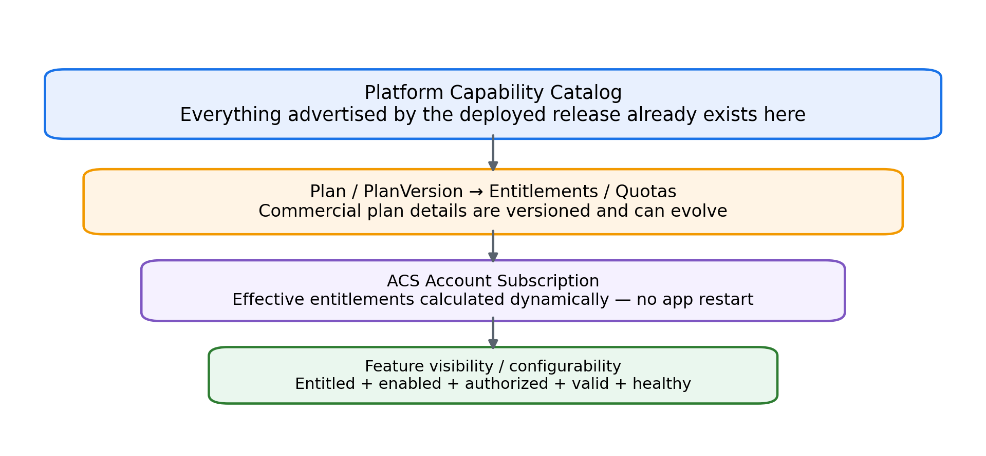
Figure 5 — Capability catalog to subscription entitlement to runtime feature visibility
Concept | Responsibility
PlanDefinition | Commercial product family
PlanVersion | Immutable/versioned snapshot of plan rights
EntitlementDefinition | Stable capability/limit key
PlanEntitlement | Grants capability/limit to a plan version
UsageQuota | Optional limit semantics
AccountSubscription | Which plan/version an ACS account currently holds
Effective entitlement | Resolved rights used by capability checks

The fundamental separation is: subscription answers WHAT the account may use; role/privilege answers WHAT the actor may change. Premium/PRO never implies admin authority.

9. HOT / WARM / COLD Model
Class | Who sees/uses it | Meaning | Examples
HOT | ACS runtime | Immediate runtime change | Theme, layout, active profile, filters, notifications
WARM | ACS runtime / admin | Controlled reconnect/rebind; no TWF shutdown | Change endpoint, credentials, broker/service binding
COLD | APS/platform | Deployment/capability publication | New adapter code, new TWF release, core API capability

10. The Three Runtime Setting Classes
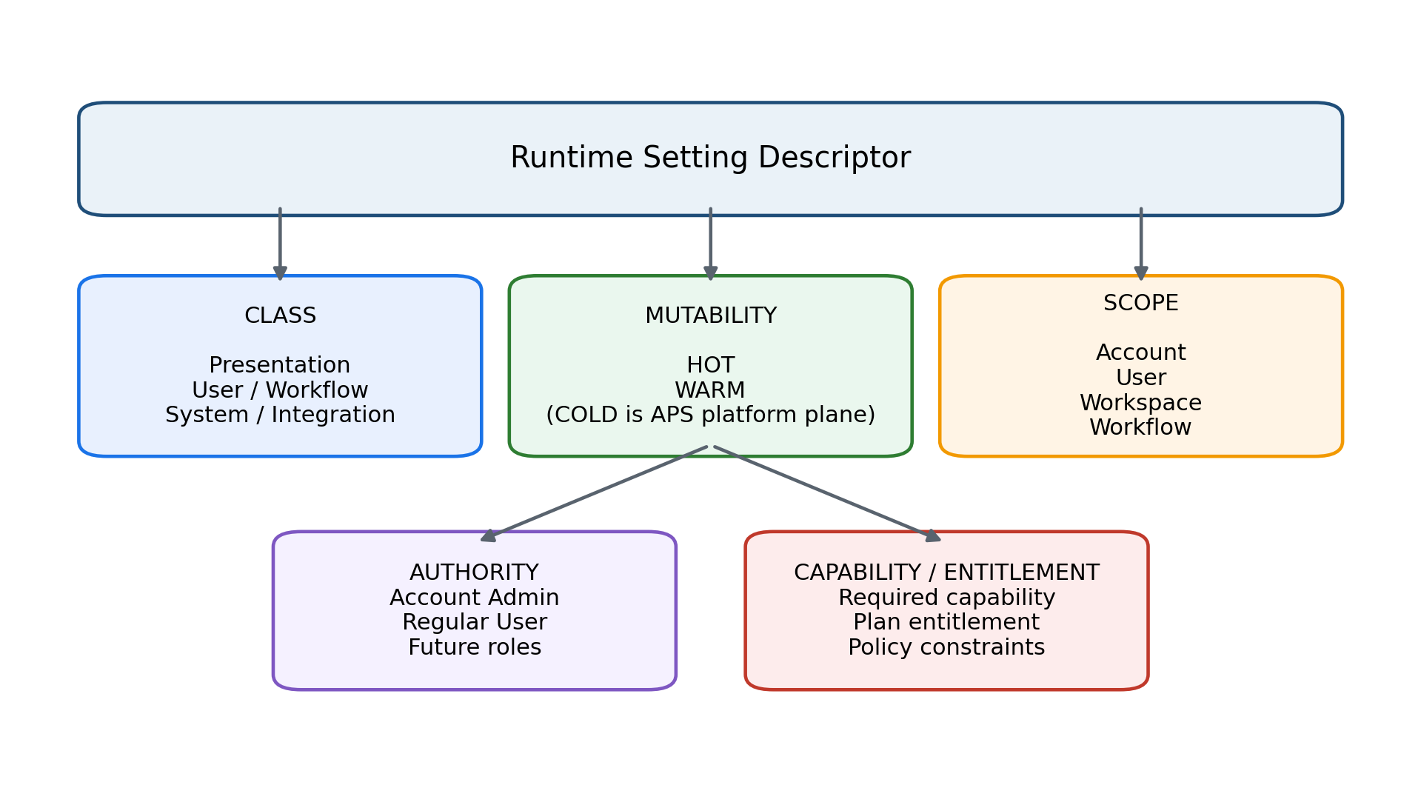
Figure 6 — Setting class, mutability, scope, authority and capability are independent dimensions
Setting class | Purpose | Examples | Typical mutability
Presentation | How TWF looks/feels | Theme, font, density, table/chart presentation | HOT
User / Workflow | How the trader works | Defaults, active profiles, watchlist, notifications, panel visibility | HOT
System / Integration | Subscriber-visible service/integration setup | LLM/TI/TM/scanner/broker profiles, timeouts, fallbacks | HOT / WARM

11. Scopes, Policy and Effective Configuration
Runtime values may exist at Account, User, Workspace and Workflow scopes. Platform defaults and constraints exist above them. A setting definition explicitly declares legal scopes.
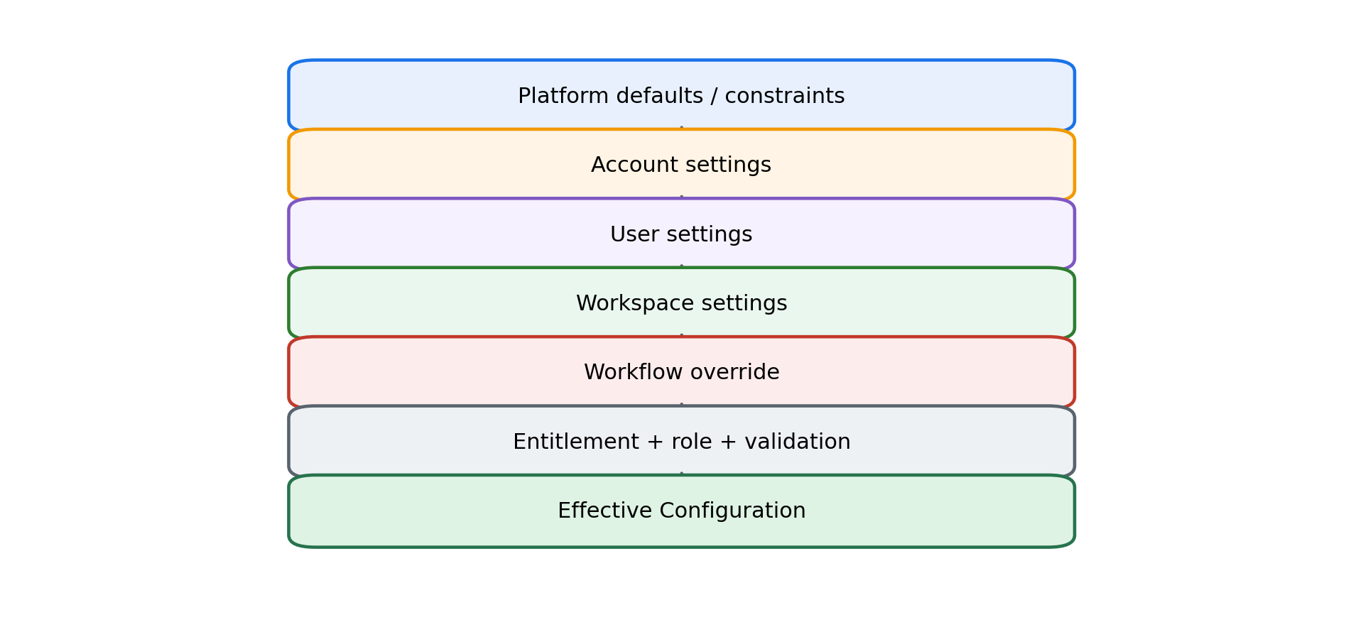
Figure 7 — Effective configuration resolution with precedence and policy gates
Setting | Allowed scope examples
Theme | User, Workspace
Active LLM profile | User, Workspace, optionally Workflow
Account provider credential | Account only
Production database | Platform only; not ACS setting

12. Profiles, States and Activation
Profiles are named reusable configuration instances such as “Primary Trading Reasoner”, “Intraday Momentum”, “Positional Equity”, or “Zerodha Primary”. The architecture does not hard-limit the number stored; the UX may limit pinned/favorite profiles.
Layer | Representative states
Platform capability | DEPLOYED, REGISTERED, COMPATIBLE, GLOBALLY_ENABLED/DISABLED, DEGRADED, UNAVAILABLE
Account capability | ENTITLED/NOT_ENTITLED, ENABLED/DISABLED
Profile | DRAFT, CONFIGURED, VALIDATED, ACTIVE, INACTIVE, INVALID

13. Secrets
Secrets are separate from ordinary settings. Profiles contain secret references rather than raw credentials.
Secret ownership | Example
PLATFORM_MANAGED | TWF-managed provider credential supplied as part of platform service
ACCOUNT_MANAGED | Enterprise/customer BYOK or shared account connection
USER_MANAGED | Personal user API credential if later supported

14. Plugin / Provider Manifests and Schema-Driven Setup
- Explicit registration is preferred over arbitrary runtime code discovery.
- A provider manifest declares identity/version, capabilities, config schema, secret schema, defaults, validation, health/test-connection support, mutability and compatibility.
- TWF can use the schema to render setup forms and avoid provider-specific if/else UI everywhere.
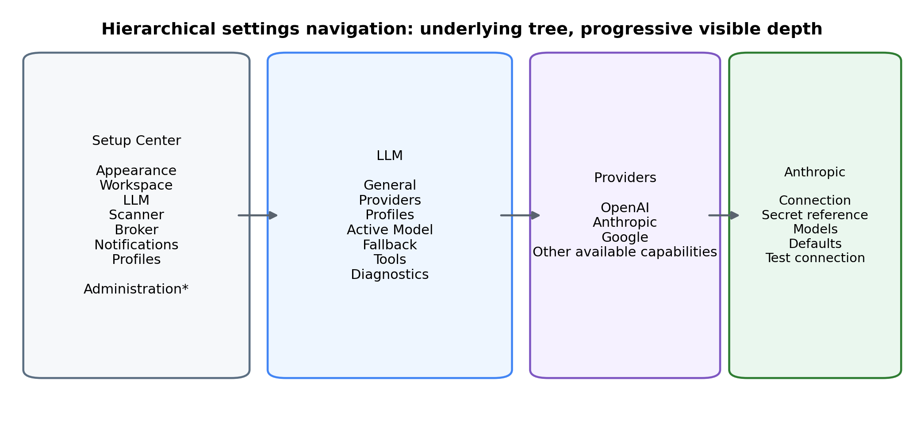
Figure 8 — Hierarchical Setup Center navigation inspired by the original matrix concept

15. Setup Center, Administration and Platform Administration
Surface | Audience | Representative contents
Setup | ACS Regular + Admin | Appearance, Workspace, LLM, Scanner, Broker, Notifications, Profiles
Administration | ACS Account Admin | Users later, enabled capabilities, shared profiles, connections, account secrets/defaults
Platform Administration | APS authorized roles | Capability catalog, releases, services, platform policy/secrets, DB/ops, security, support, audit

16. Logical Component Architecture
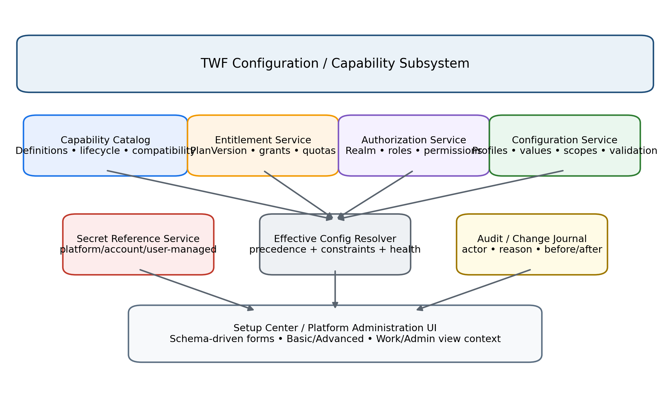
Figure 9 — Configuration/capability subsystem components
These are logical responsibilities; they need not become separate microservices. TWF-1.5 should implement only the minimal subset needed for Settings Foundation.

17. Representative Use Cases
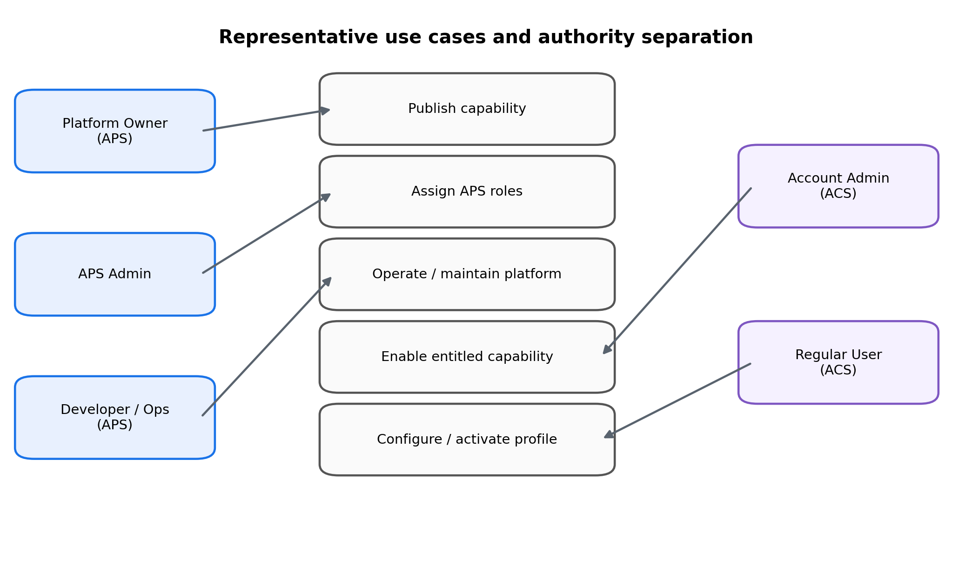
Figure 10 — Representative APS/ACS use cases and authority separation

17.1 Publish a New Capability
Platform Owner approves
→ Developer builds
→ Release Operator deploys approved release
→ compatibility / health validation
→ register capability
→ internal/beta enablement
→ subscription entitlement may reference it

17.2 Subscription Upgrade
Plan/version changes
→ entitlements recomputed
→ new capability becomes visible
→ Account Admin optionally enables shared capability
→ user configures profile
→ active runtime selection
(NO restart / NO redeploy)

17.3 APS Role Assignment
Platform Owner grants APS_ADMIN
→ APS_ADMIN grants bounded job roles to APS users
→ backend authorization checks role/scope
→ changes audited
→ APS_ADMIN cannot self-elevate to PLATFORM_OWNER

17.4 Support Access
Support ticket / reason
→ controlled support-access session
→ target account + scope + time limit
→ optional customer consent
→ audited access
→ session expires

18. Demo Accounts and Service Principals
Identity | Use | Guardrails
APS_DEMO | Internal product demo/training | No production-changing authority; no prod secrets
ACS_DEMO | Trial/demo consumer experience | Synthetic/paper environment by default; no live broker execution
APS_SERVICE | CI/CD, backup, monitor, scheduler, workers | Machine identity, narrow permissions, rotated secrets, no shared human credential

19. Roles, Modes, Subscription and Settings — Summary
Concept | Example | Controls
Realm | APS / ACS | Security/administration world
Principal type | APS_USER, APS_SERVICE, APS_DEMO, ACS_USER, ACS_DEMO | Nature/purpose of identity
Role | APS_ADMIN, DEVELOPER, ACCOUNT_ADMIN, REGULAR_USER | Permission/authority
UI mode | Work / Administration | Navigation context only
Subscription | Plan/version | ACS capability entitlement
Mutability | HOT / WARM / COLD | How change takes effect
Setting class | Presentation / User-Workflow / System-Integration | Functional category
Scope | Account/User/Workspace/Workflow | Where value applies

20. Authority / Responsibility Matrix
Action | Owner | APS Admin | Developer | Release/Ops | ACS Admin | ACS Regular
Approve new COLD capability | Yes | No | No | No | No | No
Assign APS roles | Yes | Yes, bounded | No | No | No | No
Develop feature | Optional | No | Yes | No | No | No
Execute approved release | Optional | No | No | Yes | No | No
Enable entitled account capability | No | No | No | No | Yes | No
Configure shared account profile | No | No | No | No | Yes | No
Configure personal profile | No | No | No | No | Yes | Yes
Change personal appearance/workspace | No | No | No | No | Yes | Yes

21. Capability Usability Formula
Usable =
PlatformCapabilityAvailable
AND Compatible
AND GloballyEnabled
AND SubscriptionEntitled
AND AccountEnabled
AND UserAuthorized
AND ConfigurationValid
AND SecretAvailable
AND RuntimeHealthy
Active = Usable AND SelectedForCurrentScope

22. TWF-1.5 Guidance
TWF-1.5 should implement the representative settings foundation, not the entire SaaS control plane.
- Typed setting definition with class, allowed scopes, HOT/WARM mutability and validation.
- User-scoped Presentation and User/Workflow settings.
- Account/user role hooks only as required by the current login model.
- Profile foundation and activation binding.
- Effective-resolution logic for implemented scopes.
- Capability requirement hook and default entitlement interface.
- SecretReference type without cloud-vault implementation.
- Setup Center foundation UI.
- Audit/change metadata for settings changes.

23. Security and Operational Invariants
- APS and ACS remain separate realms.
- Subscription tier never grants APS privileges.
- Premium/PRO never implies Account Admin.
- UI mode never elevates backend permission.
- Developer does not automatically gain production/customer access.
- APS Admin administers roles; it is not a universal operator.
- True COLD capability publication remains platform-owner controlled.
- Subscriber-visible changes never require TWF restart.
- Secrets are separate from ordinary settings.
- Demo identities cannot accidentally obtain live trading authority.
- Everything advertised by a deployed release already exists in the capability catalog.
- COLD changes use platform deployment with zero/minimal-downtime techniques.

24. Subscription Commitments and Deferred Commercial Decisions
Architecture now commits to versioned plans, capability-based entitlements, quota hooks, dynamic upgrades, role/entitlement separation and future grandfathering/migration support. Pricing, final plan names, billing provider, exact bundles, overage and promotional policy remain TBD.

25. Architecture Decisions Frozen in Principle
- One authoritative configuration/capability architecture.
- APS/ACS realm separation.
- COLD belongs to platform-owner/deployment plane; ACS runtime uses HOT/WARM.
- Capability Catalog precedes subscription and configuration.
- Subscription controls capability entitlement, not authority.
- Roles/privileges are independent of subscription.
- Work/Admin mode is UX context only.
- Three runtime setting classes remain: Presentation, User/Workflow, System/Integration.
- Scopes: Account, User, Workspace, Workflow.
- Profiles and secret references are first-class.
- Settings UI is hierarchical and capability-driven.
- Effective configuration is resolved through precedence, policy, entitlement, authorization, validation and health.

26. Remaining TBDs
- Final plan names/pricing/bundles/quotas.
- Billing provider and trial/overage policy.
- Detailed future APS and ACS role taxonomies.
- Break-glass owner mechanics.
- Support-access consent policy.
- Secret-manager implementation.
- Dynamic remote capability registration policy.
- Schema-driven form engine implementation.
- Profile sharing/import/export/templates.
- Feature-flag implementation/provider.
- Admin-console routing/deployment boundary.

27. Next Engineering Gate
Independent architecture review
→ reconcile findings
→ update docs/roadmap if accepted
→ derive bounded TWF-1.5 implementation prompt
→ DO NOT implement full subscription/billing/platform-admin in TWF-1.5

Recommended independent review model: GPT-6 Astra Extra High, because this architecture affects SaaS authorization, subscriptions, settings schema, secrets, pluggability and administration.

