TradingWorkFlow
TWF Order Domain & Lifecycle Architecture
OE-1 — Canonical Model, Lifecycle, Persistence & Relationships
Design for Implementation
Version 0.1 | 14 October 2026
Execution principle
No TWF subsystem may initiate a broker order except through the governed TWF execution path.

1. Executive Summary
OE-1 defines the canonical TWF Order domain before TWF introduces its durable execution queue. A TWF Order is a broker-neutral trading intent owned by TWF. It represents what TWF wants to trade, why it wants to trade, and the exact instrument and request semantics, while remaining independent of any single broker implementation.
The architecture deliberately separates intent from execution. Manual trading, Watchlists, Scanner, Discovery, strategies, agents, and future webhooks all create or request TWF Orders. Those orders will later enter TWF Queue (OE-3), pass governance and authority checks, and only then reach Broker V2 (OE-4). Broker truth remains authoritative for broker acceptance, fills, rejections, cancellations, and reconciliation.
OE-1 does not move the New Order UI, implement Queue, or redesign the ticket. It defines the constitution that those later capabilities must obey.

1.1 Objectives
- Define a broker-neutral TWF Order entity and immutable identity.
- Support Equity, Futures and Options with exact canonical instrument identity.
- Define lifecycle states, legal transitions and invariants.
- Persist orders and their state/audit history durably.
- Capture provenance so every order can be traced to its source.
- Create a future-safe model for SL, TP, max loss/profit, conditional execution, automation and multi-leg relationships without implementing those features yet.

1.2 Non-goals for OE-1
- No New Order UI migration yet (planned for OE-2).
- No execution queue implementation yet (planned for OE-3).
- No Queue → Broker bridge yet (planned for OE-4).
- No TWF Position or Alert lifecycle implementation yet.
- No advanced SL/TP/trailing/conditional execution engine in V1.
- No direct integration from Scanner, Watchlist, webhook, strategy or agent to broker execution.

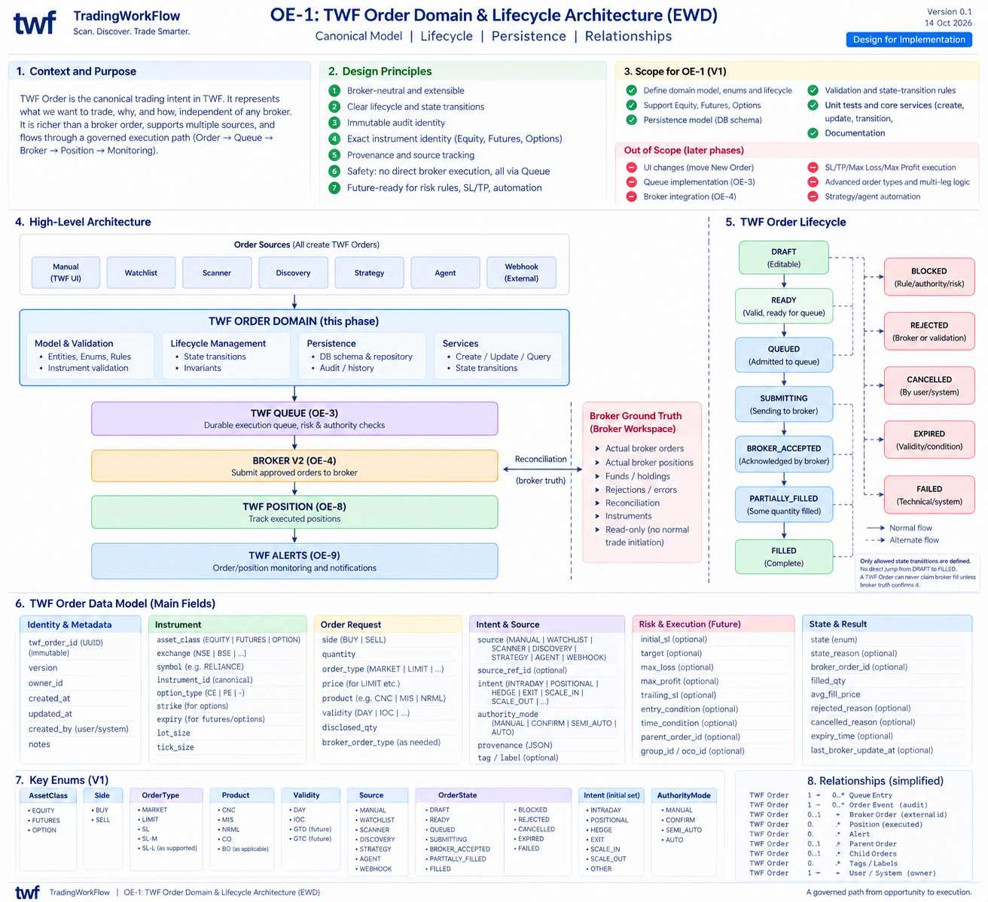
Figure 1 — TWF Order Domain & Lifecycle Architecture (EWD).

2. Architectural Principles
Broker-neutral domain. TWF Order is not a Zerodha, Dhan, Fyers or other broker order DTO. Broker mapping happens only at the execution boundary.
Exact instrument identity. Equity, Futures and Options must resolve to canonical, unambiguous instrument identity. Plain display symbols are insufficient for derivative execution.
Intent is not execution. Creating a TWF Order does not mean it was queued, submitted, accepted or filled.
Broker truth is authoritative. TWF may request execution, but broker acceptance/fill/rejection/cancellation states must come from Broker V2/reconciliation truth.
Governed path only. No subsystem may bypass TWF Order → TWF Queue → governed execution → Broker V2.
Durable auditability. Order identity, lifecycle transitions and provenance must survive process restarts.
Safe extensibility. The V1 model must leave room for future SL/TP, max loss/profit, trailing, conditional orders, parent/child relations and automated authority.
Explicit provenance. A manual action, Watchlist, Scanner run, DiscoveryCandidate, strategy, agent or webhook must remain identifiable as the source of the order.

3. TWF Order Lifecycle
The lifecycle intentionally distinguishes TWF validation, queue admission, broker submission and broker execution. The exact state names may be adjusted during implementation, but the semantic boundaries are normative.
State | Meaning | Authority / Truth Source
DRAFT | Editable TWF trading intent. Not eligible for execution. | TWF / initiating user or subsystem
READY | Valid and complete enough for queue admission. | TWF validation
QUEUED | Durably admitted to TWF Queue. | TWF Queue (OE-3)
SUBMITTING | Queue has begun broker submission. | TWF Queue / Broker bridge
BROKER_ACCEPTED | Broker acknowledged the order request. | Broker truth
PARTIALLY_FILLED | Broker confirms some quantity filled. | Broker truth / reconciliation
FILLED | Broker confirms complete fill. | Broker truth / reconciliation
BLOCKED | Cannot progress because rule, risk, authority or dependency blocks it. | TWF governance
REJECTED | Order cannot proceed due validation or broker rejection; reason required. | TWF or broker truth, distinguished by reason/source
CANCELLED | Order intentionally cancelled by permitted actor/system. | TWF and/or broker reconciliation
EXPIRED | Order validity/condition/time window ended before completion. | TWF policy or broker truth
FAILED | Technical/system failure prevents progress; distinct from broker rejection. | TWF execution infrastructure

3.1 Lifecycle invariants
- No direct transition from DRAFT to FILLED.
- BROKER_ACCEPTED, PARTIALLY_FILLED and FILLED cannot be asserted without broker truth.
- QUEUED means durable admission, not merely an in-memory list membership.
- REJECTED is semantically different from FAILED: rejection is a business/broker decision; failure is a technical/system condition.
- Every terminal or exceptional state must preserve a reason and transition history.
- A TWF Order is never silently rewritten to look as if a different source created it.

4. Canonical TWF Order Data Model
The following model is the architectural target. OE-1 implementation should persist the bounded V1 subset required for OE-2/OE-3 while keeping the schema extensible.
Dimension | Representative fields | V1 expectation
Identity & metadata | twf_order_id, version, owner_id, created_at, updated_at, created_by, notes | Required core identity and ownership
Instrument | asset_class, exchange, canonical instrument_id, symbol, option_type, strike, expiry, lot_size, tick_size | Exact identity required; derivative fields only where applicable
Order request | side, quantity, order_type, limit/trigger price, product, validity, disclosed_qty | Support current proven broker order forms first
Intent & source | source, source_ref_id, intent/horizon, authority_mode, provenance, tags | Source required; richer intent fields may be optional in V1
Risk & execution (future) | initial_sl, target, max_loss, max_profit, trailing_sl, entry_condition, time_condition, parent/group/OCO refs | Architecturally reserved; not active execution features in OE-1
State & result | state, state_reason, broker_order_id, filled_qty, avg_fill_price, reject/cancel reason, expiry_time, last_broker_update_at | State/history foundation required; broker results populated only from later bridge/reconciliation

5. Key Domain Types and Enums
Type | Initial values / notes
AssetClass | EQUITY, FUTURES, OPTION
Side | BUY, SELL
OrderType | MARKET, LIMIT and currently supported order forms; trigger/SL variants can be added without broker coupling
Source | MANUAL, WATCHLIST, SCANNER, DISCOVERY, STRATEGY, AGENT, WEBHOOK
Intent | INTRADAY, POSITIONAL, HEDGE, EXIT, SCALE_IN, SCALE_OUT, OTHER — extensible and not all mandatory in V1
AuthorityMode | MANUAL, CONFIRM_REQUIRED, SEMI_AUTO, AUTO — advanced modes may remain inactive initially
OrderState | DRAFT, READY, QUEUED, SUBMITTING, BROKER_ACCEPTED, PARTIALLY_FILLED, FILLED, BLOCKED, REJECTED, CANCELLED, EXPIRED, FAILED

6. Source and Provenance Model
A central value of TWF Orders is that execution can be traced back to its originating workflow. Provenance must be explicit and durable, not reconstructed later from logs.
Source | Example provenance
MANUAL | User, UI location, originating workspace, optional notes
WATCHLIST | Watchlist id/name, selected row/instrument, timestamp
SCANNER | Scanner mode, run id, template id, filters, exact evidence snapshot/reference
DISCOVERY | DiscoveryCandidate id, lifecycle state, evidence/context references
STRATEGY | Strategy id/version, signal id, parameters
AGENT | Agent/service id, policy/version, decision reference
WEBHOOK | External integration id, signed request/event id, received timestamp
Source provenance never grants execution authority by itself. All sources converge on the same governed Order → Queue → Broker path.

7. Relationships
Relationship | Cardinality / meaning
TWF Order → Queue Entry | 1 → 0..n over lifecycle/history; active queue semantics finalized in OE-3
TWF Order → Order Event | 1 → n immutable/auditable transition and operational events
TWF Order → Broker Order | 0..1+ external broker identifiers depending later amendment/retry design; must remain explicit
TWF Order → Position | 0..1+ executed position linkage finalized in OE-8
TWF Order → Alert | 0..n monitoring/operational alerts finalized in OE-9
TWF Order → Parent/Children | Optional future relationship for scale, hedge, multi-leg or conditional workflows
TWF Order → Owner | Exactly one owner/account scope

8. Persistence, Events and Audit
OE-1 should establish persistence that is sufficient to recover TWF Orders and reconstruct their lifecycle after restart. State transitions should be auditable rather than merely overwriting the current-state row without history.
- Current-state record. Fast access to the latest canonical order state and request.
- Immutable order/event history. Transition, actor/subsystem, timestamp, reason and relevant correlation identifiers.
- Idempotency/correlation hooks. Reserve stable identifiers for later Queue and Broker submission deduplication.
- No secret material. Order persistence must not contain broker credentials or access tokens.
- Owner scoping. Every query/update must respect current TWF ownership/account boundaries.

8.1 Minimum event examples
Event | Example purpose
ORDER_CREATED | Canonical TWF Order created from a source.
ORDER_UPDATED | Editable DRAFT fields changed; changes captured with actor/timestamp.
ORDER_VALIDATED | Order passes/fails readiness validation.
STATE_TRANSITIONED | Lifecycle state transition with from/to/reason.
PROVENANCE_ATTACHED | Source/evidence reference associated with the order.

9. Validation and State Transition Rules
Validation in OE-1 is domain validation, not live broker validation. Broker-specific capability checks belong to the execution bridge, although OE-1 should preserve enough canonical information to perform those checks later.
- Quantity must be positive and compatible with the canonical instrument constraints known to TWF.
- Derivative orders require exact expiry/strike/option type as applicable.
- A LIMIT order requires a valid limit price; unsupported combinations must be rejected explicitly.
- Instrument identity cannot be silently changed after an order leaves editable DRAFT without explicit lifecycle semantics.
- Only allowed state transitions are accepted; invalid transitions return typed errors.
- Terminal-state mutation must be tightly controlled and auditable.
- Every rejection/failure/cancellation must preserve a machine-readable category plus human-readable reason where useful.

10. OE-1 Domain Services
OE-1 should expose a small set of application/domain services that later OE phases can reuse rather than allowing callers to manipulate database rows directly.
Service capability | Responsibility
CreateOrder | Create canonical TWF Order from validated broker-neutral request and source provenance.
GetOrder / ListOrders | Owner-scoped retrieval.
UpdateDraftOrder | Modify only fields that are legal while editable.
ValidateForReadiness | Check whether order is complete and valid enough to become READY.
TransitionOrder | Apply one legal lifecycle transition atomically with audit event.
Attach/QueryProvenance | Persist and retrieve originating workflow references.
OrderHistory | Return chronological immutable transition/event history.

11. Boundary with Broker V2
Broker V2 remains the broker-facing authority and ground-truth adapter. OE-1 must not move broker submission logic into the TWF Order entity or repository.
- TWF Order is broker-neutral and can exist before any broker is selected/connected.
- Broker-specific symbol/token mapping is an execution concern, not the canonical order identity itself.
- Broker order ids are results/references, not the identity of the TWF Order.
- The Broker workspace remains the faithful view of actual broker orders, positions, holdings, funds, errors and reconciliation.
- Normal future TWF trade initiation will move to TWF Orders, but OE-1 does not remove the current Broker New Order UI.

12. Relationship to the OE Roadmap
Phase | Dependency on OE-1
OE-2 — Existing New Order → TWF Order | Uses OE-1 contracts/services to create a TWF Order instead of directly initiating a broker order.
OE-3 — TWF Queue Foundation | Admits READY TWF Orders durably and governs progression.
OE-4 — Queue → Broker V2 | Maps approved queued orders to exact Broker V2 submissions.
OE-5 — Broker Reconciliation | Updates TWF state from broker truth.
OE-6 — TWF Orders Workspace | Presents TWF Orders and lifecycle to the operator.
OE-7 — Audit / Logging | Builds richer operational/trade audit on top of OE-1 event foundation.
OE-8 — TWF Positions | Links executed/adopted trades to richer managed positions.
OE-9 — TWF Alerts | Monitors Orders/Queue/Positions.
OE-10+ | Adds advanced order semantics, external intake and hardening.

13. OE-1 Acceptance Criteria
- A canonical TWF Order can be created for Equity, Futures and Options without embedding broker-specific DTO semantics.
- Exact canonical instrument identity is preserved and derivative identity is unambiguous.
- Source/provenance is durably attached and owner-scoped.
- Lifecycle transitions are typed, validated and audited; illegal transitions are rejected.
- Broker-truth-only states cannot be asserted by ordinary TWF callers.
- Current state and transition history survive restart/persistence round trips.
- No runtime path introduced by OE-1 can directly submit to a broker.
- The model is extensible for later SL/TP/max-loss/max-profit/trailing/conditional/parent-child capabilities without implementing them in V1.
- Automated tests cover valid/invalid transitions, persistence, provenance, instrument validation and broker-truth invariants.
- Architecture documentation and README status remain consistent with implemented capability.

14. Decisions to Settle During OE-1 Implementation
- Exact canonical field representation for instruments and whether to reference an existing instrument identity/value object.
- Whether TWF Order uses optimistic versioning and how concurrent draft updates are rejected.
- Whether order events are append-only rows, an existing ledger abstraction, or another repository-native mechanism.
- Precise transition matrix for cancellation/expiry/failure from intermediate states.
- Which order types/products/validity values belong in V1 versus future extensions.
- How broker-neutral product/validity fields map to broker capabilities later without polluting the canonical model.
- How source_ref/provenance references existing Scanner/Watchlist entities without hard coupling domain packages.

15. Architectural Bottom Line
OE-1 creates the stable domain boundary that lets every future TWF capability request a trade without receiving direct broker authority.
Once OE-1 is accepted, OE-2 can safely reuse the current proven Select Instrument → Ticket → Preview experience and have it create a TWF Order. OE-3 can then introduce the durable execution queue. This sequence deliberately proves the foundation before advanced trade-management features are added.

