Lifelong Version-controlled Code Generation

PURPOSE OF PROJECT
The primary goal of this project is to develop a lifelong (continual learning) mechanism for large language models to enable version-controlled code generation.
At eBay, we frequently face the challenge of maintaining legacy code while integrating the latest technologies, necessitating solutions that can bridge this gap. By addressing the challenges of understanding and generating code compatible with both legacy systems and the latest software updates, we aim to enhance the efficiency, automation, and relevance of code generation in the software development process. This will empower developers to maintain and refactor legacy codebases effectively while ensuring that LLMs remain up-to-date with evolving dependencies and APIs.

ENGAGEMENT STRUCTURE
University | Monash University, Australia
Principal Investigator / Professor / Researcher | Professor Reza Haffari  (further info in Appendix A)
Sponsor | <ebay VP name>
Submitted by | Ramesh Periyathambi
Subject Area | Machine Learning
Initiative / Customer Problem Alignment | Horizontal work that impacts: Payment 2.0, Ads, CS Tech, etc.
Nature of collaboration (research help or specific deliverable / outcome) | Research Help (Research gift + DATA USE AND RESEARCH AGREEMENT with students)
Amount requested | <in USD>
Duration of the collaboration | 12 Months

GOALS
The primary goal of this project is to address the challenges posed by legacy code maintenance and the rapid evolution of programming languages, libraries, and APIs. As the first step, we will implement the best existing methods to establish an initial proof-of-concept model. Subsequently, we will investigate various approaches to achieve optimal results. To this end, we pursue two complementary strategies to mitigate risks:
- Designing innovative and effective algorithms that enable LLMs to comprehend and generate code compliant with specific versions, including outdated or legacy systems.
- Developing continual learning techniques that allow LLMs to swiftly adapt to new versions of dependencies and APIs, ensuring they remain up-to-date and relevant in code generation tasks.
This proposal significantly benefits from our existing expertise in building a comprehensive dataset, VersiCode [5], which is designed to address the challenges posed by version-controlled code generation. Further, it builds on our research on continual learning with deep-learning and LLMs [2,3,4].

APPROACHES
Approach 1: Evolving Knowledge Graph-enhanced Controlled Code Generation
This approach integrates long-context code completion with knowledge graphs to improve code retrieval efficiency. By constructing a code knowledge graph, we overcome the limitations of retrieval-based generation, which often suffers from low efficiency, especially in handling large codebases with billions of lines of code. The knowledge graph acts as a middle ground between long-context retrieval and retrieval-augmented generation (RAG), addressing the issues of query misalignment and cross-modal retrieval between natural language queries and code snippets.
Code Knowledge Graph
We construct a knowledge graph (KG) [1] using Abstract Syntax Trees (ASTs) to extract API and dependency information from the source code packages in Java and Python. This is particularly suitable to eBay’s technical environment which is mainly in Java. This method strips away syntactic and implementation details, preserving only the structural relationships between components, as shown in Fig-1. The following properties characterize the knowledge graph:
- Simplicity: Each library version forms a distinct sub-graph composed of triplets, such as "pytorch-lightning 1.0.3, contains, mae."
- Scalability: The graph can scale by incorporating additional libraries, functions, and versions while maintaining a coherent structure. We plan to automatically integrate future libraries and versions without manual intervention.
- Modularity: Each version of a library will be modular, allowing for quick version-to-version comparison without needing to reprocess the entire graph.
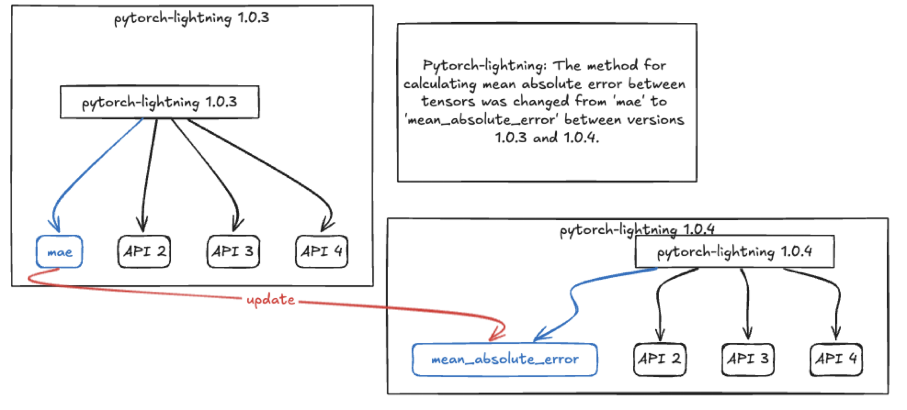
Fig.1 An example of a code knowledge graph
Knowledge Graph-enhanced Code Generation
We will serialize the knowledge graph and provide it as input to the LLM to assist in code generation [7,8]. The knowledge graph will serve as contextual information to guide the model in version-aware code completion and migration tasks [5]; specifically:
- Version-specific code completion: The LLM will leverage the knowledge graph to generate code tailored to a particular library version, ensuring compatibility with its specific APIs.
- Version-aware code migration: The knowledge graph will enable the model to identify deprecated functions and suggest alternatives when migrating code between different versions.
Hybrid Semantic-Experience Knowledge for Evolving Code Agent
In addition to semantic knowledge (e.g., API names and relationships), the knowledge graph will be augmented with experience-based knowledge drawn from user interactions and preferences:
- Semantic knowledge: Core information about APIs and code structures across different versions will be embedded in the knowledge graph.
- Experience-based knowledge: User preferences, such as frequently used APIs or personalized code snippets, will be integrated into the graph, allowing the LLM to offer more tailored and context-aware code suggestions.
This combination of semantic and experiential data will make the code generation process more accurate and efficient.
Approach 2: Contrastive Continual Learning for Version-controlled Code Generation
This second approach focuses on embedding version-specific knowledge directly into the LLM’s parameters through continual learning, improving inference speed by reducing reliance on external knowledge graphs. This approach also addresses the challenge of preventing catastrophic forgetting—where new information causes the model to lose track of older knowledge.
Knowledge-enhanced Data Selection
We will analyze the differences between versions by parsing code diffs and identifying key changes in APIs and functions. These differences will be used to isolate relevant information for training the model on updated versions while retaining the knowledge of older versions. By focusing on the alignment between different versions, the model will learn to adapt to new changes while preserving past knowledge.
For example, when updating from one version to another, specific code snippets and API changes will serve as anchors for retraining the model. These code snippets will guide the learning process to focus on the elements that have changed, ensuring that the model can handle both old and new versions seamlessly.
Contrastive Continual Learning
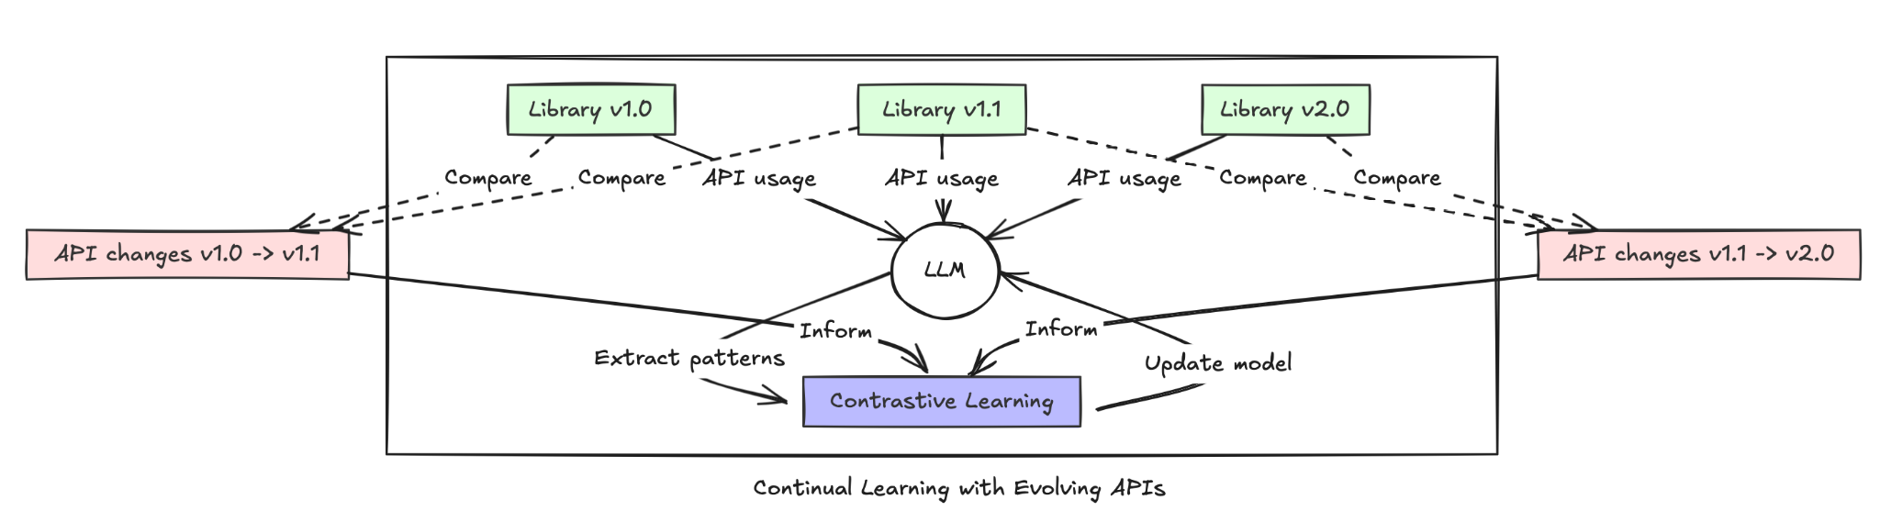
Fig.2 Framework for Leveraging Code Knowledge Graph in Continual Learning for Evolving APIs
Contrastive continual learning [6] will be employed to ensure that the model efficiently accumulates new knowledge while preventing it from forgetting older knowledge. This approach uses contrastive learning techniques to compare code snippets from different versions and learn the relationships between them, as shown in Fig 2. By focusing on the differences and similarities between versions, the model can retain version-specific knowledge and improve its ability to generalize across different versions.
To ensure that the model maintains the balance between learning new information and retaining past knowledge, a replay memory will be used [2]. This memory stores examples from previous versions, allowing the model to reference these examples during training on new versions. The replay memory will be used to reinforce older knowledge during continual learning, helping to mitigate catastrophic forgetting.
Preventing Catastrophic Forgetting
To further prevent catastrophic forgetting, we will use techniques such as replay memory and selective weight regularization [3,4]. The replay memory will store a subset of examples from previous tasks (i.e., older versions), which the model can revisit during training to retain knowledge of those tasks. Additionally, weight regularization techniques will be applied to ensure that the most important parameters for older tasks are preserved during training on new tasks.
By combining contrastive continual learning with memory-based mechanisms, the model will be able to continuously adapt to new versions while maintaining the knowledge needed to handle legacy systems. This allows for version-controlled code generation that remains efficient and up-to-date without losing track of past knowledge.
Data
In our previous work, we curated a comprehensive dataset, VersiCode [5], which is designed to address the challenges posed by version-controlled code generation. This dataset is sourced from platforms such as Stack Overflow and GitHub, containing rich metadata that includes version-specific code snippets, functionality descriptions, and dependency information across various versions of libraries. VersiCode supports two primary tasks: Version-constrained Code Completion and Version-constrained Code Editing, with further subdivisions into token, line, and block-level generation tasks. The dataset focuses on ensuring backward compatibility by tracking when new features are introduced or deprecated, making it ideal for evaluating the continual learning capabilities of large language models in the context of version-specific code generation​.
Personnel and Budget
The personnel and budget are covered in Appendices A and B, respectively.

IMPACT and EXPECTED PRODUCT/OUTPUT
At eBay, keeping software up-to-date while maintaining older, legacy code is a big challenge. Developers spend a lot of time ensuring new code works with old systems, which slows down progress and increases costs. This project aims to create a system that uses large language models (LLMs) to generate code that works with both new and old versions of software, automatically adapting to changes in libraries and APIs. By implementing continual learning, the model will remember older versions while staying updated with new ones.
Expected outcomes include:
- An LLM that can generate code compatible with both current and older software versions.
- A system that helps developers update and migrate code between different versions of libraries.
- Tools to reduce the manual effort required to maintain legacy code, saving time and costs.
Overall, this project will make it easier and faster for developers at eBay to update software without breaking older systems, reducing development costs and increasing efficiency.
Deliverables:
- Proof-of-Concept (PoC) models and algorithms: eBay GitHub repository
1.1 Evolving Knowledge Graph-enhanced Controlled Code Generation (7th month)
1.2 Contrastive continual learning for evolving APIs (12th month)
- Reports: One report every 6 months summarizing progress, key achievements, and future directions
- Publications: Academic publications and presentations based on research outcomes throughout the project

REFERENCES
[1] Pan, Shirui, et al. "Unifying large language models and knowledge graphs: A roadmap." IEEE Transactions on Knowledge and Data Engineering. 2024.
[2] Wu, Tongtong, et al. "Continual learning for large language models: A survey." arXiv preprint arXiv:2402.01364. 2024.
[3] Wu, Tongtong, et al. "Pretrained language model in continual learning: A comparative study." International Conference on Learning Representations 2022. OpenReview, 2022.
[4] Wu, Tongtong, et al. "Curriculum-meta learning for order-robust continual relation extraction." Proceedings of the AAAI conference on artificial intelligence. Vol. 35. No. 12. 2021.
[5] Wu, Tongtong, et al. "VersiCode: Towards Version-controllable Code Generation." arXiv preprint arXiv:2406.07411. 2024.
[6] Chen, Shuai, et al. "Exemplar-based Continual Learning via Contrastive Learning." IEEE Transactions on Artificial Intelligence. 2024.
[7] Zhang, Zejun, et al. "Refactoring to Pythonic Idioms: A Hybrid Knowledge-Driven Approach Leveraging Large Language Models." Proceedings of FSE. 2024.
[8] Su, Yanqi, et al. "Enhancing exploratory testing by large language model and knowledge graph." Proceedings of ICSE. 2024.
Appendix A -- Personnel
Principal Investigator: Prof Gholamreza (Reza) Haffari is the Director of the Vision and Language Group in the Department of Data Science and Artificial Intelligence, Monash University, Australia. He is an Australian Research Council Future Fellow in Artificial Intelligence. Reza’s expertise lies in GenAI & LLMs, particularly neuro-symbolic AI for low-level perception and high level reasoning, knowledge graphs and questions answering, multi-agent systems, large multimodal models (covering text, vision, speech, code), lifelong learning, and active learning with human in the loop.
He has received ​Australian Research Council Future Fellowship Award (2019-2024), Google Faculty Research Awards (2018 and 2019), ​Amazon Research Award (2019), Australian Research Council Discovery Project Grants (2016-2019, 2019-2022), NVIDIA Faculty GPU Award (2017-2019), ​National ICT Australia Grant (2014-2015), Honorable Mention Best Paper Award at EACL (2021), and the ​Best Paper Awards in Australiasian Language Technology Workshop (2016, 2018, 2020) for his research on deep learning and machine learning.
Prof Haffari has extensively published in top venues of NLP and ML communities, including ACL, NAACL, EMNLP, EACL, ICML, UAI, and NIPS. He has been the Machine Learning Area Chair in the International Joint Conference on NLP, Co-Organiser of the “​Deep Learning Approaches for Low-Resource NLP​” at ACL and EMNLP, Program Committee Co-Chair of ALTAW. Annually, he serves as the program committee member of the top NLP/ML venues, including ACL, EMNLP, NIPS, and ICML. He is a standing reviewer for Transactions of the ACL (TACL) in 2018-2022, and annually serves as the program committee member of top ML and NLP venues, including ACL, EMNLP, and ICML.
Postdoctoral Fellow: Dr Tongtong Wu is currently a Research Fellow at Monash University, with a jointly supervised Ph.D. from Southeast University and Monash University. His main research interests include the continual learning of large language models, natural language processing, and knowledge graphs. He has published over ten papers at conferences such as ICLR, ACL, EMNLP, etc. As a principal researcher, he has long served as a member of the program committee for major conferences in the fields of machine learning and natural language processing, including ICML, ICLR, NeurIPS, ACL ARR, ACM MM, AAAI, etc.
Appendix B -- Breakdown of the requested budget
The project is planned to run for 12 months, with the timeline depending on the preferred option chosen by eBay. Based on two research components, the project is divided into two phases: Phase 1 will cover months 0–7, and Phase 2 will cover months 8–12.
Professor Haffari's in-kind contribution, valued at 0.03 FTE (full-time equivalent), equates to USD 17,500. This contribution is not charged to eBay.
The requested budget will fund a full-time postdoctoral researcher for one year. This position costs AUD 158,000, which converts to USD 110,600 at a stable exchange rate of 0.7, factoring in potential currency fluctuations.
According to the phase divisions, the estimated budget for Phase 1 is approximately AUD 92,000 (USD 64,516.7), and for Phase 2, it is approximately AUD 66,000 (USD 46,083.3).

Code and data are available at: https://github.com/wutong8023/VersiCode

