Endless – 2D Terrain Generator (1.1)

# Quickstart

1. Go to *Component->Endless 2D Terrain->Create Terrain*

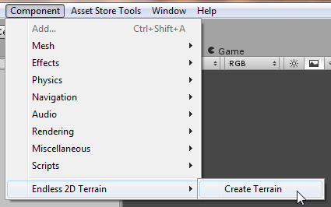

1. Select the *Endless 2D Terrain* game object in the hierarchy.



1. Adjust the settings in the Terrain Displayer script to generate the style of terrain you want. All settings have a brief rollover description describing what they do.

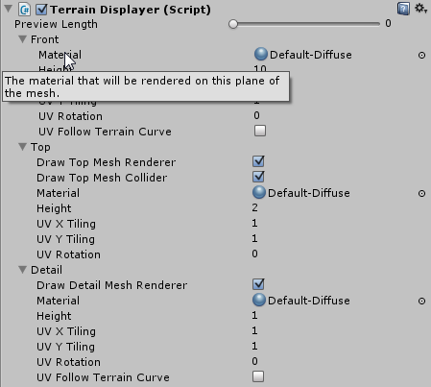

1. Terrain is generated based on the assumption that the camera moves to the right (in a positive x direction). To see terrain generation in action, attach the script *Chase Camera* to your main camera. This will move the camera to the right, and you can see the terrain being generated as needed.

For a real game, your camera would follow your character. Demos are available for this case as well (see below).

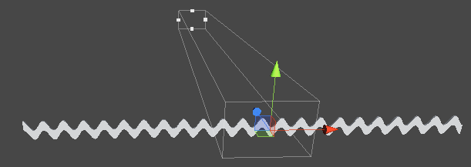

# Demos

To view some example with a background, prefab placement, and applied textures, browse to the *Scenes* folder under the main *Endless2DTerrain* folder and select a scene. There are sample scenes for Orthographic and Perspective cameras.

All scenes include a basic character controller that the camera follows.

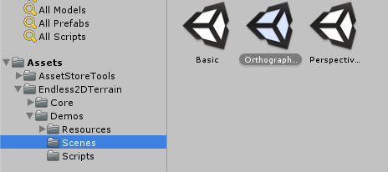

# Terrain Generation Rules

The terrain is generated based off rules entered in the editor on the right hand side of the screen.

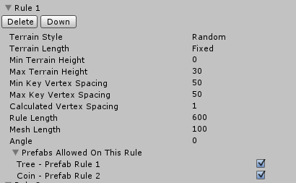

**Terrain Style**

*Random* – Terrain points are randomly generated between the *Min Terrain Height* and the *Max Terrain Height.*

*Repeated* – Terrain points alternated between the *Min Terrain Height*  and the *Max Terrain Height*, which creates hills

**Terrain Length**

*Fixed –* You will move to the next terrain rule (if there is one) after the *Rule Length* number of units have been generated.

*Infinite* – You will never move to the next terrain rule. Terrain will continue to be generated according to this rule.

**Min Terrain Height**

The minimum height for terrain generation. Setting the min and max terrain height to the same value will create flat terrain.

**Max Terrain Height**

The maximum height for terrain generation. Setting the min and max terrain height to the same value will create flat terrain.

**Key Vertex Spacing**

The farther apart your key vertices are, the smoother your terrain will be. The closer they are, the more hilly your terrain will be.

Set the min and max key vertex spacing to the same value for more consistent terrain. Setting these to different values can result in terrain that alternates between smooth and hilly.

**Calculated Vertex Spacing**

Calculated verticies are the points calculated between your key verticies. The more of these you have, the smoother the terrain will be. The less you have, the more jagged the terrain will be. Setting this to 1 is a good default.

**Rule Length**

How long your rule will run for.

**Mesh Length**

The size of each mesh piece within this rule.

**Angle**

The angle the terrain will be generated at.

**Prefabs Allowed On This Rule**

When you add prefab generation rules, you may only want prefabs to generate on certain rules and not others. Checking the checkbox by a prefab name allows the prefab to generate in a given rule. By default these are all checked.

## Prefab Generation Rules

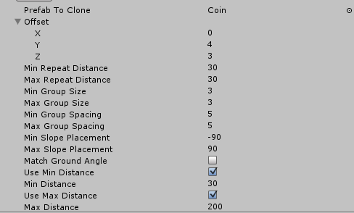

**Prefab To Clone**

The prefab that will be cloned along the generated terrain when the rule criteria is met.

**Offset**

The x,y,z offset amount from the default prefab positioning along the terrain.

**Min Repeat Distance**

The minimum distance before the prefab will be generated again.

**Max Repeat Distance**

The maximum distance before the prefab will be generated again.

**Min Group Size**

This is used of you want multiple prefabs cloned each time a prefab would be generated. For example, if you wanted clumps of tree or bushes to all be generated at the same spot, you can set a group size.

**Max Group Size**

The max number of prefabs to clone in a group.

**Min Group Spacing**

The minimum spacing between cloned prefabs in a group.

**Max Group Spacing**

The maximum spacing between cloned prefabs in a group.

**Min Slope Placement**

Prefabs will only be placed on slopes that are greater than this number. Setting this number to -90 means the prefabs will be placed on all downhill slopes. Setting it to 0 means they will be placed on no downhill slopes. Anything between will place the prefabs only on downhill slopes greater than that number.

**Max Slope Placement**

Same as min slope placement, but applies to uphill slopes.

**Match Ground Angle**

Check if you want the prefabs to be rotated to match the angle of the slope they are on.

**Use Min Distance**

Check this to enter a min distance value. Prefabs will only be generated after the min distance has been reached. Uncheck if you want min distance to be ignored.

**Use Max Distance**

Check this to enter a max distance value. Prefabs will only be generated until the max distance has been reached. Uncheck if you want max distance to be ignored.

## Mesh Settings

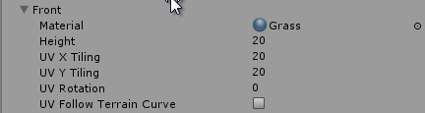

**Material**

The material you want displayed on the mesh.

**Height**

The height of the mesh.

**UV X Tiling**

The tiling in the x direction of the mesh. Higher numbers will create tighter tiling.

**UV Y Tiling**

The tiling in the y direction of the mesh. Higher numbers will create tighter tiling.

**UV Rotation**

The rotation of the UV mapping for this plane.

**UV Follow Terrain Curve**

Check to make the uv mapping follow the curve of the terrain. Can cause some distortion, especially on steep hills.

## Contact Info

Neil Meredith – [neilcmeredith@gmail.com](mailto:neilcmeredith@gmail.com)

Support thread- <http://forum.unity3d.com/threads/207138-Endless-2D-Terrain-Generator>