# CHANDANA CH

Computer Science & Engineering PES University Bangalore, India

[spoorthikalkunte@gmail.com](mailto:spoorthikalkunte@gmail.com)

# CHAITHRA

Computer Science & Engineering PES University Bangalore, India

[sahanarao2902@gmail.com](mailto:sahanarao2902@gmail.com)

# VEENA GARAG

Computer Science & Engineering PES University Bangalore, India

[thrupthi2804@gmail.com](mailto:thrupthi2804@gmail.com)

*Abstract*— Human resource managers in firms are having restless nights due to the serious issue of employee turnover that has emerged in many nations. Talent acquisition and retention have become increasingly difficult in recent years. Today's professionals are reported to be constantly on the go, and loyalty and dedication have fallen to the wayside and are little valued by either the individual or the organization. In the current study, an effort has been made to ascertain whether opportunities for professional success and achieving promotions result in the development of a more motivated workforce. It makes use of various regression model t make out the scenario that is if the employee performance have impact on employee promotion.

***Index Terms*—** **Employee performance, Expectancy theory, Promotion, Employee Retention, Organizational Adherence.**

1. INTRODUCTION

This report provides employee promotion prediction using classification algorithms. Promotions are also an important aspect of a worker’s career and life, affecting other facts of the work experience.They constitute an important aspect of workers’ labor mobility, most often carrying substantial wage increases and can have a significant impact on other job characteristics such as responsibilities and subsequent job attachment. Firms can use promotions as a reward for highly productive workers, creating an incentive for workers to exert greater effort. Promotions will only be an effective mechanism for eliciting greater effort if workers place significant value on the promotion itself. Otherwise, firms would simply use pay increases to reward effort and productivity.Workers may valuepromotions because they carry an increase in job amenities such as a bigger office or spending accountor because they enjoy the

acknowledgement of work well done and the ego boost that comes with a promotion. Some workers might enjoy the increase in authority over co-workers that often accompanies a promotion. Given all of the dimensions in which promotions can affect workers’ careers and compensation, relatively little attention has been paid to the importance of promotions as a determinant of job satisfaction.

Efforts to improve employee performance are not easy, and therefore there is a need for employee motivation by career development, one of which is by promoting positions.Job promotion provides an important role for every employee, even a dream that is always waiting for. If there is an opportunity for employees to be promoted based on the principles of fairness and objectivity, employees will be motivated to work harder, be more enthusiastic, discipline, and achieve work so that organizational goals can be optimally achieved. Organizations need high-performing employees, at the same time employees need feedback on their performance as a guide for their actions in the future.

We are using the stored data of promotion cycle from the previous year, which consists of details of all the employees in the company working last year and also if they got promoted or not, but every time this process gets delayed due to so many details available for each employee - it gets difficult to compare and decide.

We utilize the stored data to make a model, that will predict if a person is eligible for promotion or not.

1. REVIEW OF LITERATURE

In [1] This paper is basically is based on analysis of employee promotion which is influenced by various features.

Reviewing the idea of promotion in relation to the public sector provides an explanation of the different types of promotions that the public is familiar with in the nation, the importance of employee promotions, and the procedures used, such as the requirements, criteria, and difficulties encountered during this process.

The definition of promotion is the progression of an employee from low-status duties to higher-status duties with a greater remuneration in an organisation. The promotion is seen as a token of appreciation from the organisation or business for the employee's efforts and as recognition that they are a valuable member of the team.

The idea of public service is that promotion depends on the budget that is accommodated for the promotion process.This is not the case in Namibia as most employees in the public organisation claim that the promotion is based on who you know and not what you know. In other words, it is believed that in order to be promoted one need to invest in tnterpersonal relationships with the right circle of people rather than putting more effort into putting one's knowledge to us

In [2] Promotion within a firm or organisation is affected by a lack of openness in the employee promotion process and the availability of incomplete or limited information.

Even if a person possesses the requisite professional credentials, they may find themselves locked on a job for a period of 10 to 15 years, as happened to one of the few interviewers I spoke with. The management must create and implement a personnel policy that is efficient and contains little to no corruption. Due to a lack of institutional support and qualified staff at the time of implementation, the government of Namibia has not yet adopted a performance appraisal system.

In [3] The human resources department should handle the promotion process with help from the line managers. Armstrong (1984) claimed that the procedures for promotions required notifications on personnel development so that positions were made clear and advertised within the internal organisation for qualified applicants from the internal organisation, but this is not the case in the current generational era.

Older employees are given lower ranks or have slower industry growth than new hires, depending on the organisation. According to Armstrong, applicants for advancement should not be excluded based on their age, race, sex, or marital status. The workplace environment must permit assessment of the extent to which individuals can carry out their responsibilities effectively; this process entails evaluating the outcomes and evaluating the physical, intellectual, professional, and managerial potential.

In [4] The authors examine the factors that contribute to and have an impact on promotions among young employees using data from the National Longitudinal Survey of Youth. The majority of "promotions," as they

were referred to by employees, consisted just of an upgrade to the post in question. Normally, the promotion was only given to one candidate. Men and white people were more likely to be promoted than women and black people or Hispanic people. Two of the most significant predictors of promotion were receiving company training and having received a prior promotion. Increased pay, training, supervisory responsibility, and greater job satisfaction were all effects of promotion. There is minimal proof that a promotion affected work attachment in a significant way.

This study provides a more in-depth research of employee promotion decisions, focusing on how firm size, gender, and business cycle stages affect these decisions. Using data from Portugal, we discover that all enterprises' chances of promotion decrease during periods of unfavourable macroeconomic conditions. According to the "glass cliff" theory, women are more likely to be promoted within large companies when the economy is weak. However, women are less likely to receive promotions at small and medium-sized businesses (SMEs), where total promotion rates are less impacted by poor economic conditions. Our findings highlight the significance of firm and market heterogeneity in promotion and, more crucially, they distinguish between various types of gender discrimination. In large companies, women are actually given more responsibility for the consequences of market instability.

The success of employee promotion in an organisation or firm has formalities that, according to the research, are not adaptable enough to modifications in line with the current era that we are in. The evaluations must be methodical, streamlined, and permissive of an employer-employee discussion in order to eliminate an abuse that the majority of employees commit, which puts pressure on the managers both directly and indirectly for the promotion.

III. METHODOLOGY

A).DATASET

B)PREPROCESSING

Data in the file comprises 54808 rows(Observations) and 13columns(features). The majority of real-world datasets are not flawless;Consequently, missing values have been created.at the time of data entry. Missing values are therefore filled, information is filtered as necessary, and erroneous information is deleted. This preprocessing of data helps in rendering highly precise values and the analytical power are also increased.

1. DATA CLEANING AND VISUALIZATION

To analyse the data set much better, it is required to

Perform exploratory analysis in order to understand

the features much better.

* + The dataset consists of 54,808 rows(observations) and 13 columns (features),8 of which are numeric.
  + This data set do not contain missing values.

There are various features that influence the promotion of an employee.

**1.Univariate Analysis**

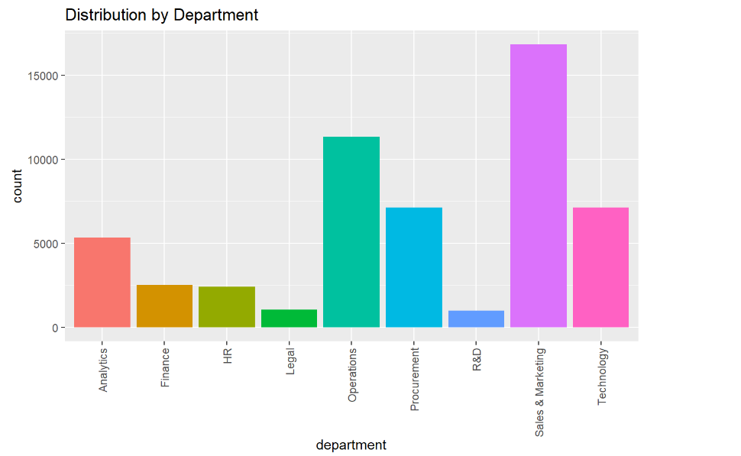

Based on the bar plot above, we can see that the Sales & Marketing department is the department with the most employees.

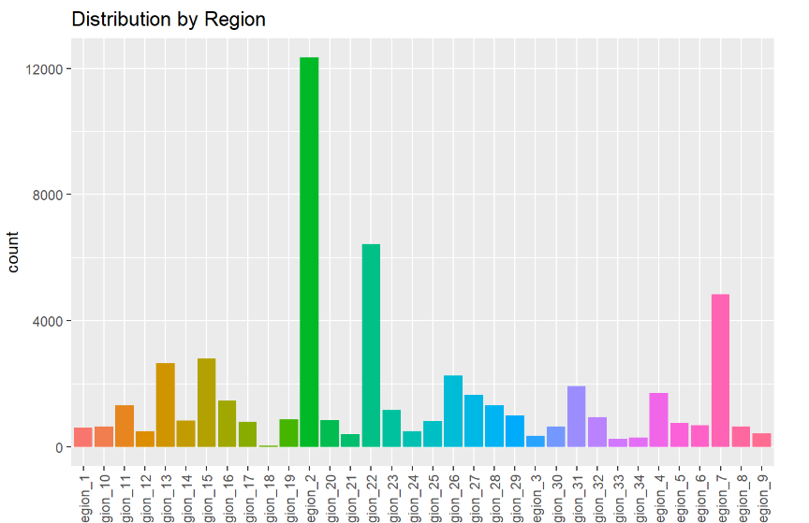

Based on the bar plot above, we can see that the most employees are in region 2.

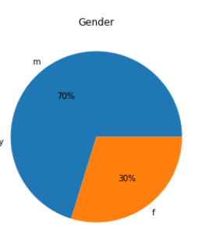

From the above pie chart it can be seen that most of the employees are male

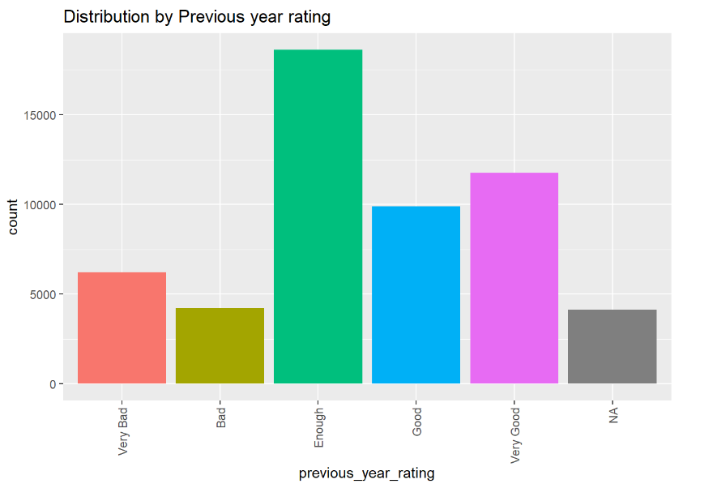

We can see that the most employees rating in 3 rating.

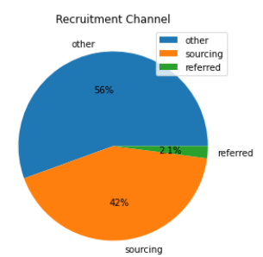

Based on above plot , we can see that the most recruitment channel is other channel.

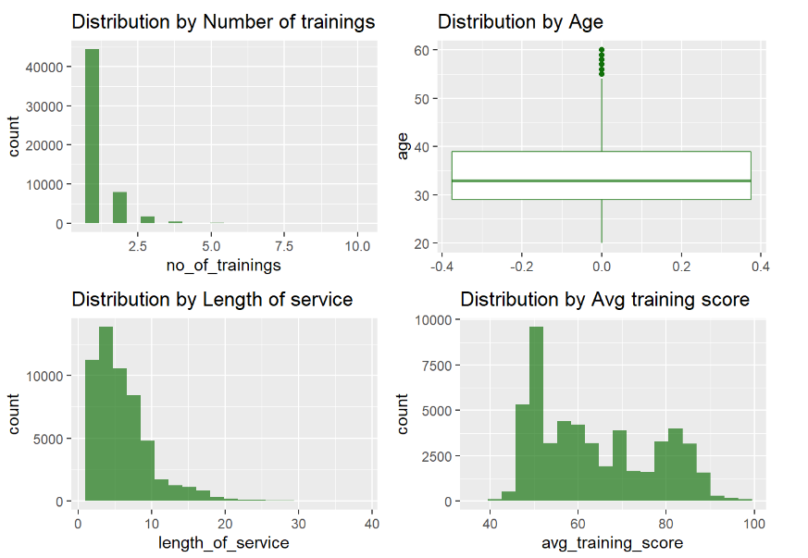

We can see that the gender variable contains outliers from the histogram plot and boxplot shown above. The majority of employees only participate in one training, and the majority of training scores are 50. Then, many employees at the company work there for between one and ten years.

## 2.Bivariate Analysis

Plot distribution of gender and is_promoted using bar plot.

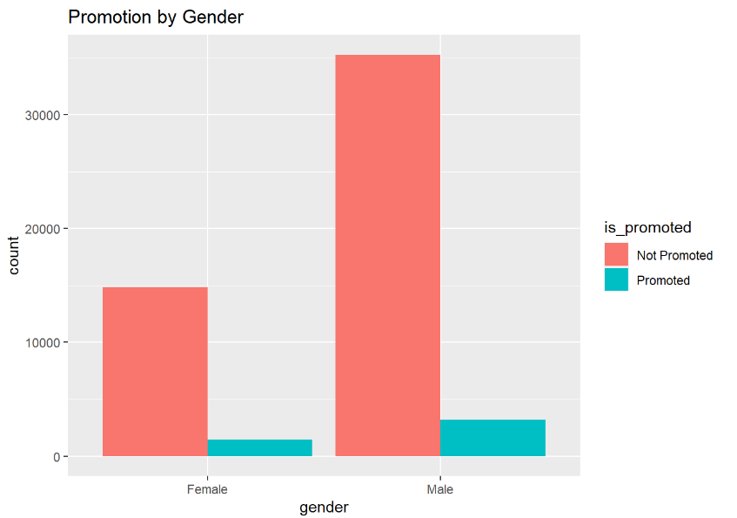

As shown by the bar plot above,male employees are promoted more frequently than female employees Additionally, there are still more male employees than female employees who do not receive promotions.

Plot distribution of awards_won and is_promoted using bar plot.

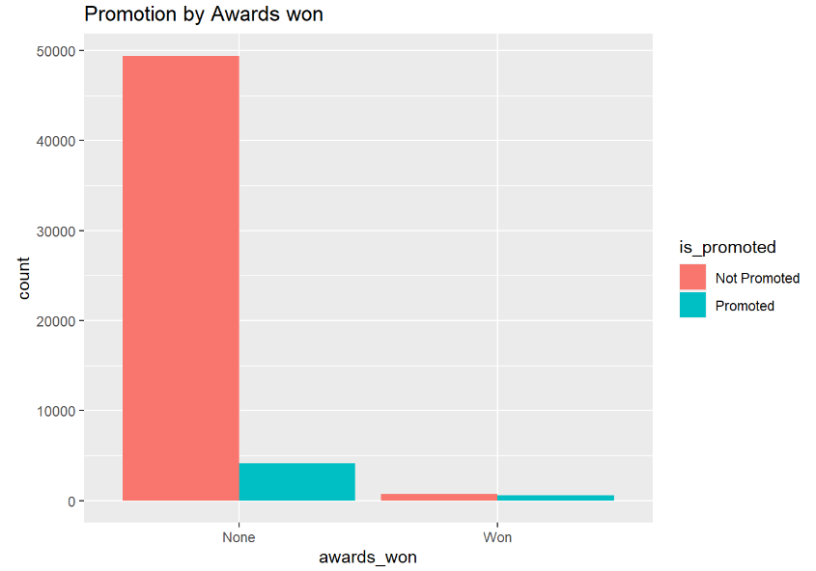

Based on the above bar plot,we can see that employees who have not received awards are promoted more than employees who have received awards.

Plot distribution of previous_year_rating

and is_promoted using bar plot.

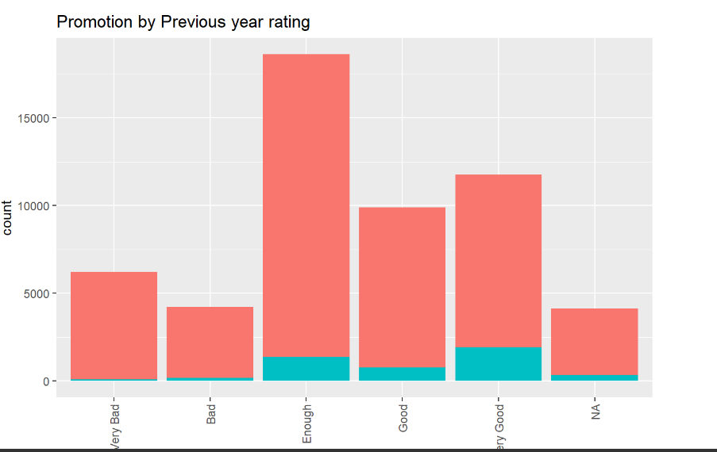

Based on the bar plot above, we can see that employees who get enough rating, good rating, and very good rating are more likely to be promoted.

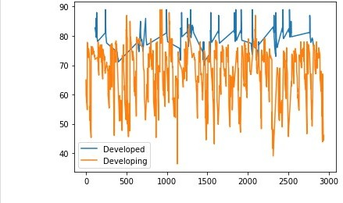

Fig. 2. life expectancy with developed,developing countries

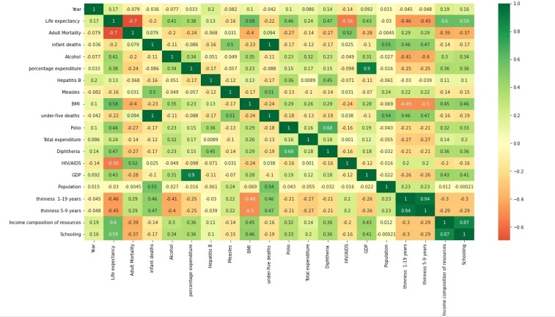

Fig. 3. Heat map

1. PROBLEM STATEMENT AND PROPOSED SOLUTION After performing the initial preprocessing and data

visualization techniques, the areas which will need focus and can potentially yield answers have become more clear. The problem statement involves measuring the effects of health, socio economic and demographic factors on global life expectancy, and analysing why and in what arena one country performs better than the other. We believe [2] would help us make a good start, with exploring the variables and their correlations using univariate and bivariate analysis and using models like multiple regression to model the features. Following which we could make use of Lasso regression for important feature selection to build a model to predict life expectancy. We would also like to make analysis country wise, possibly by capitalising on the countries for which more data is available, and perform a comparative study. We would also like to figure out the countries with low life expectancy and intend to suggest them the fields (like immunization,schooling etc) they have to improve or focus on in order to improve the LE of their countrymen from our analysis. Cluster analysis would help us in finding groups and coming up with different solutions to improve the LE of different groups of countries. We would like to perform further analysis on the dataset to get to know more insights, and to get a more structured representation which could help us understand the dependencies of features better.

1. ACKNOWLEDGEMENT

We would like to express our heartfelt gratitude to our Data Analytics Course Professor Dr.Gowri Srinivasa and the entire Data Analytics team including Teaching Assistants and Assistant professors at PES University, for guiding us along the way, and providing multiple resources to learn from and understand and make sense of the project and the underlying work needed.

REFERENCES

1. Mondal MN, Shitan M. Impact of Socio-Health Factors on Life Ex- pectancy in the Low and Lower Middle Income Countries. Iran J Public Health. 2013 Dec;42(12):1354-62. PMID: 26060637; PMCID: PMC4441932.
2. Y. Wang, ”The Greatest Factors Affecting Life Expectancy: A Re- search based on Different Continents and Countries,” 2021 3rd In- ternational Conference on Machine Learning, Big Data and Busi- ness Intelligence (MLBDBI), 2021, pp. 531-541, doi: 10.1109/MLB- DBI54094.2021.00107.
3. Licher S, Heshmatollah A, van der Willik KD, Stricker BHC, Ruiter R, de Roos EW, Lahousse L, Koudstaal PJ, Hofman A, Fani L, Brusselle GGO, Bos D, Arshi B, Kavousi M, Leening MJG, Ikram MK, Ikram MA. Lifetime risk and multimorbidity of non-communicable diseases and disease-free life expectancy in the general population: A population-based cohort study. PLoS Med. 2019 Feb 4;16(2):e1002741. doi: 10.1371/jour- nal.pmed.1002741. PMID: 30716101; PMCID: PMC6361416.
4. Paramita, S.A., Yamazaki, C. Koyama, H. Determinants of life ex- pectancy and clustering of provinces to improve life expectancy: an ecological study in Indonesia. BMC Public Health 20, 351 (2020)