MAC

11. go https://202.175.115.246:444

2. 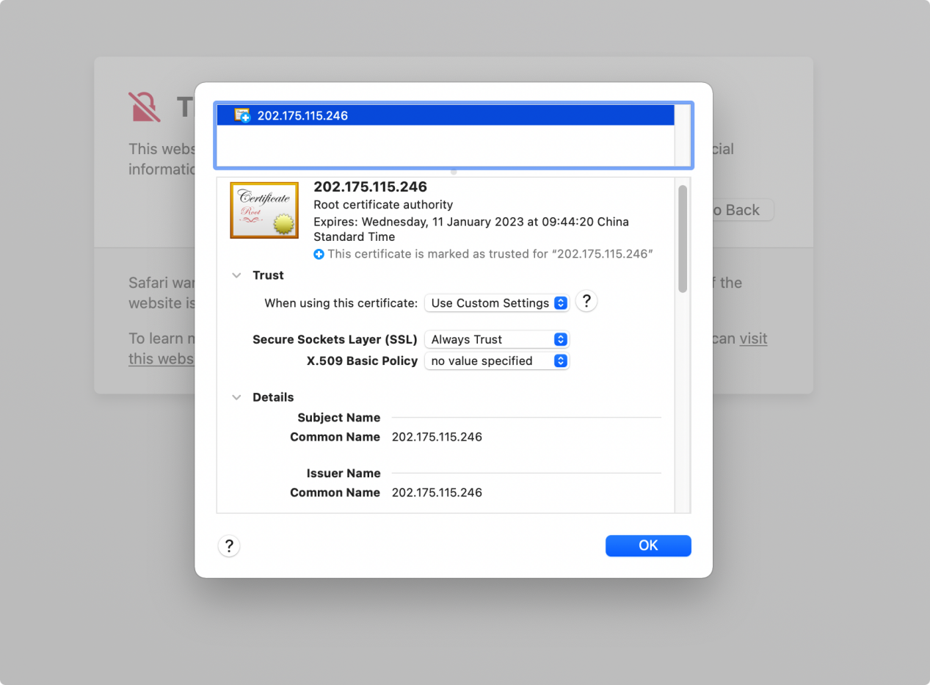

3. ok

或者，在CHROME下載憑證

去lanuchpad 找 keychain

