SMS與alert說明

內容

儀器故障檢測

門檻值檢測

其他

冷暖天氣提示

Alert

SMS Server

Alert Server

另外兩個系統

註解

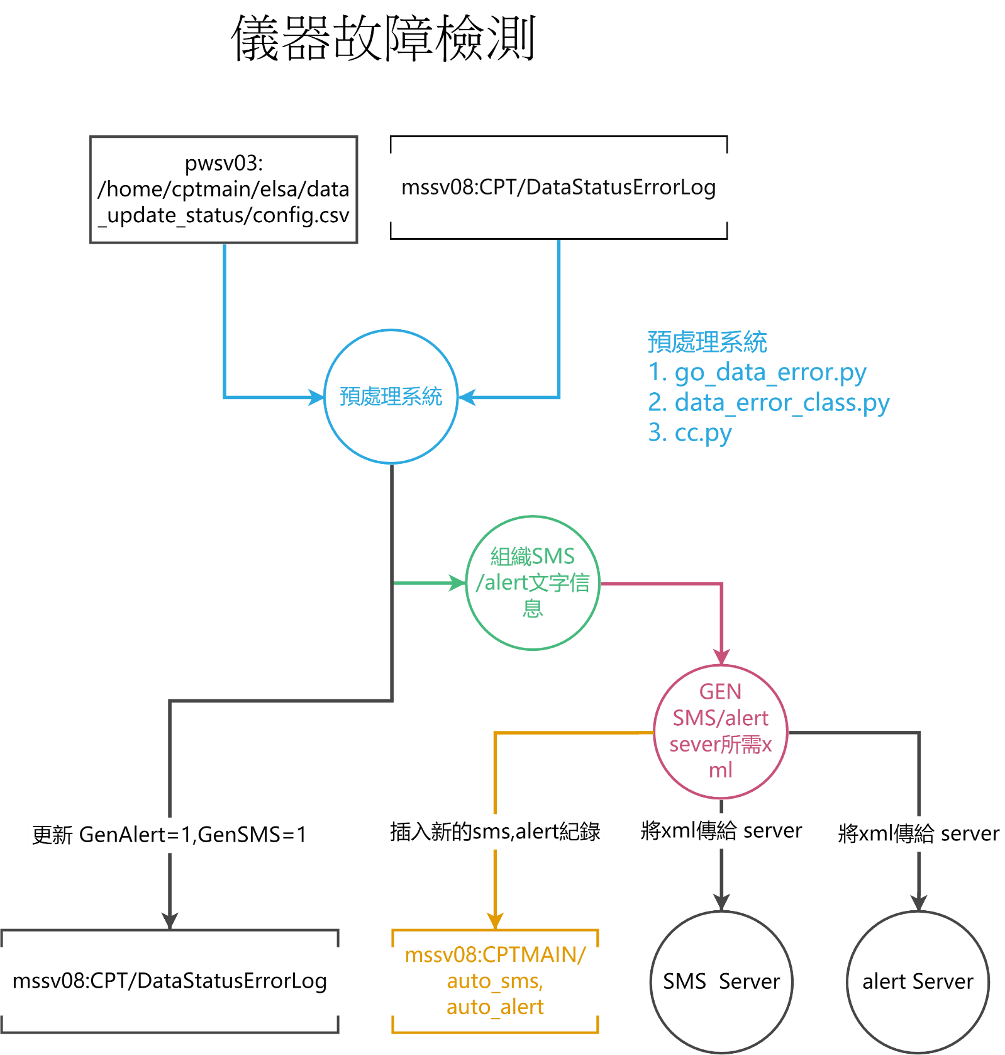

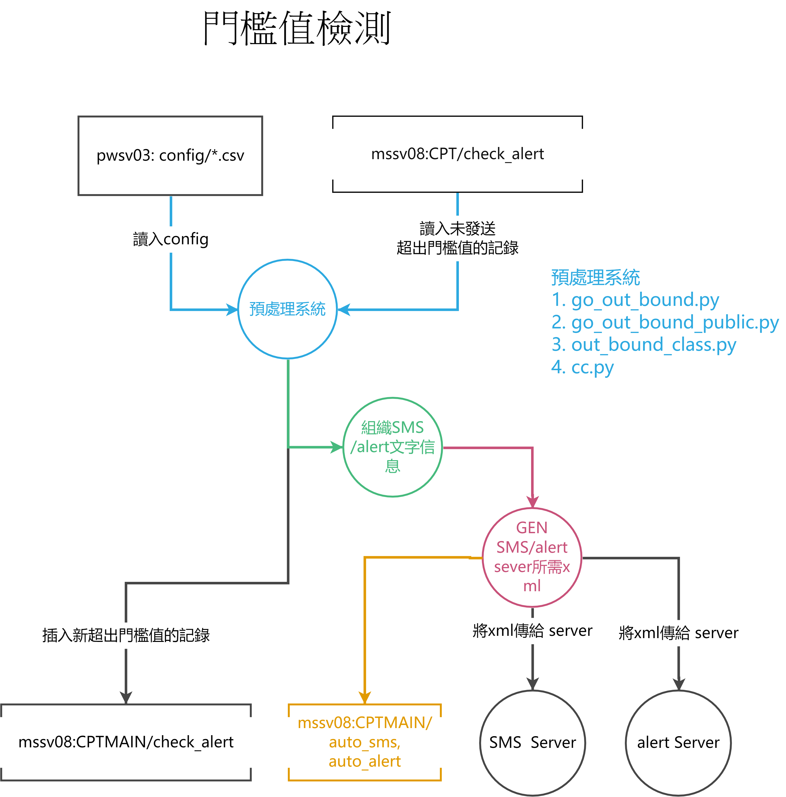

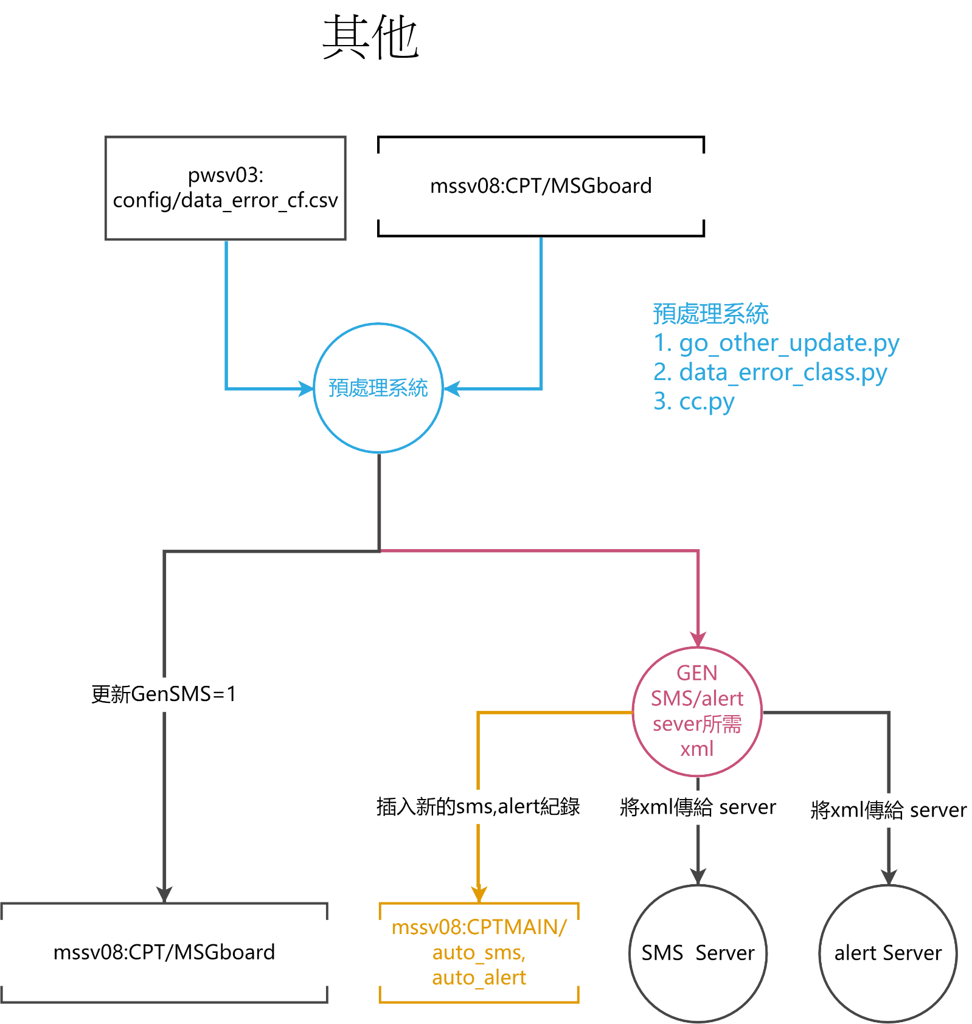

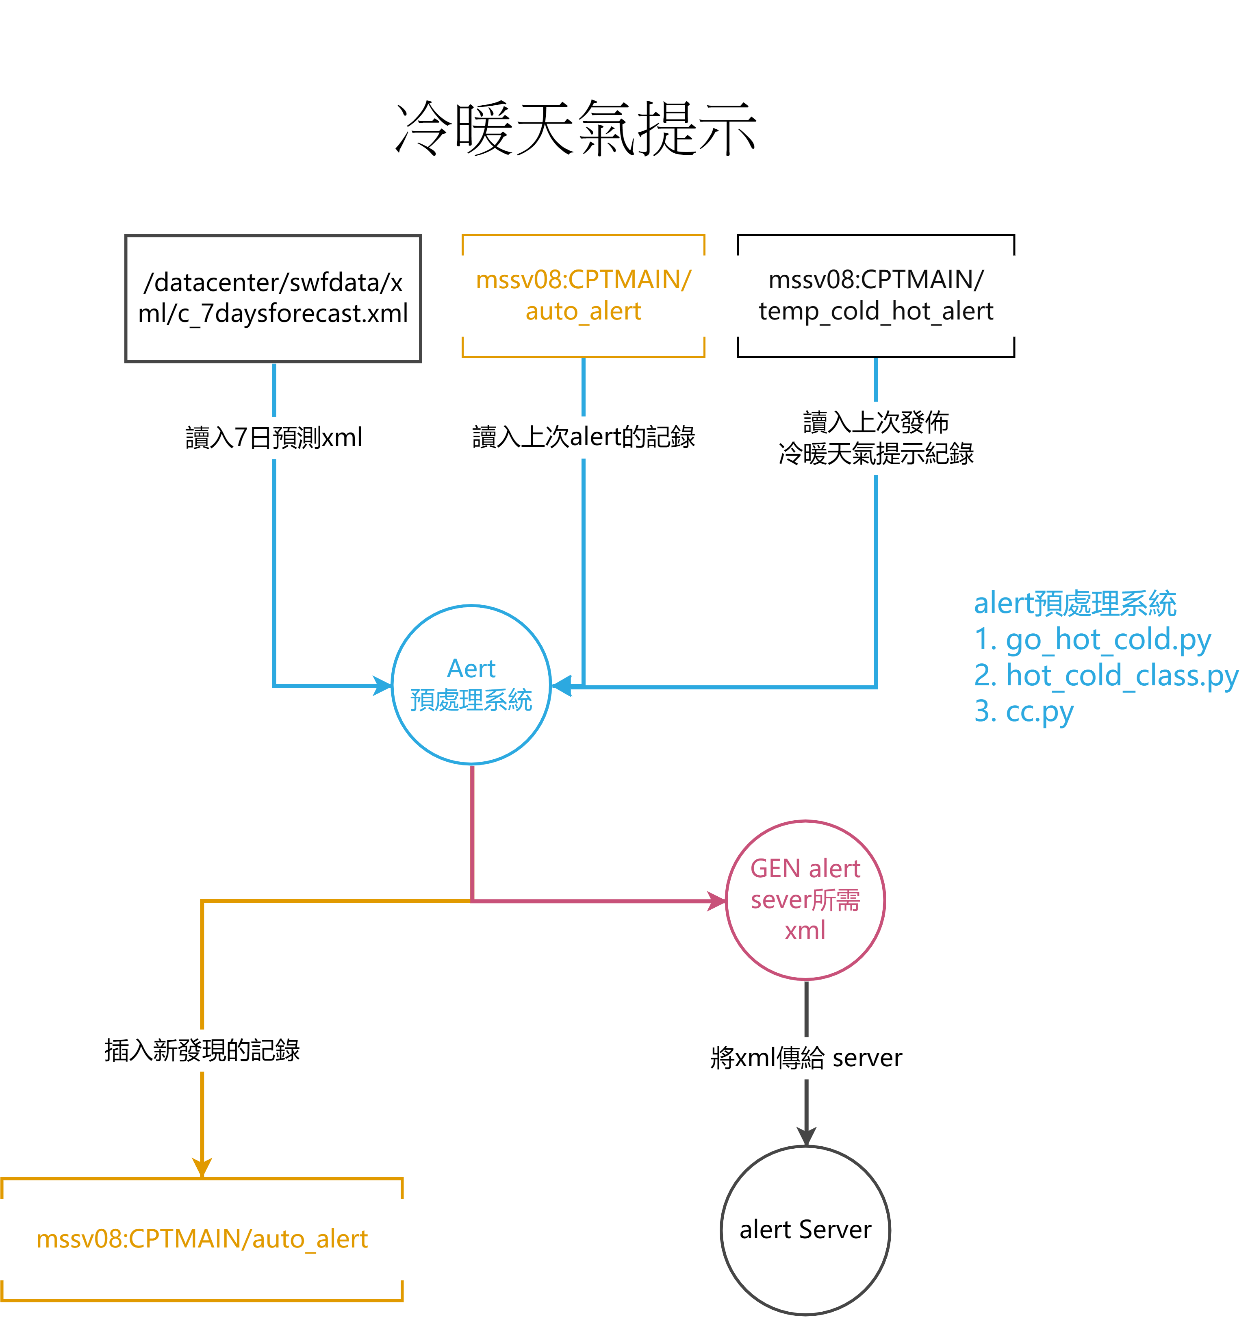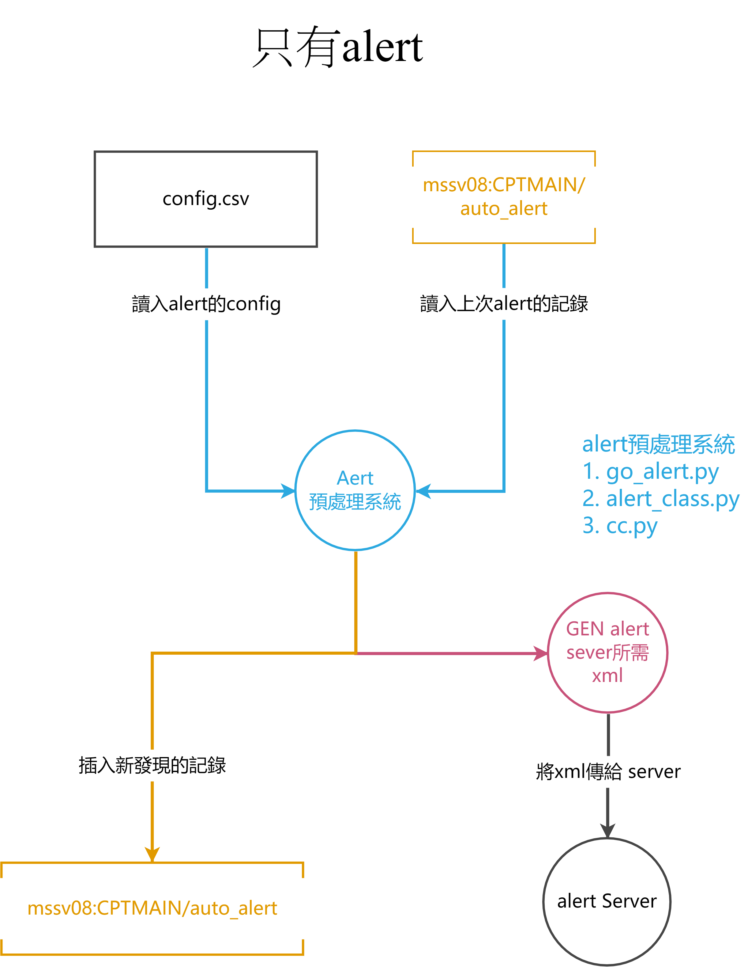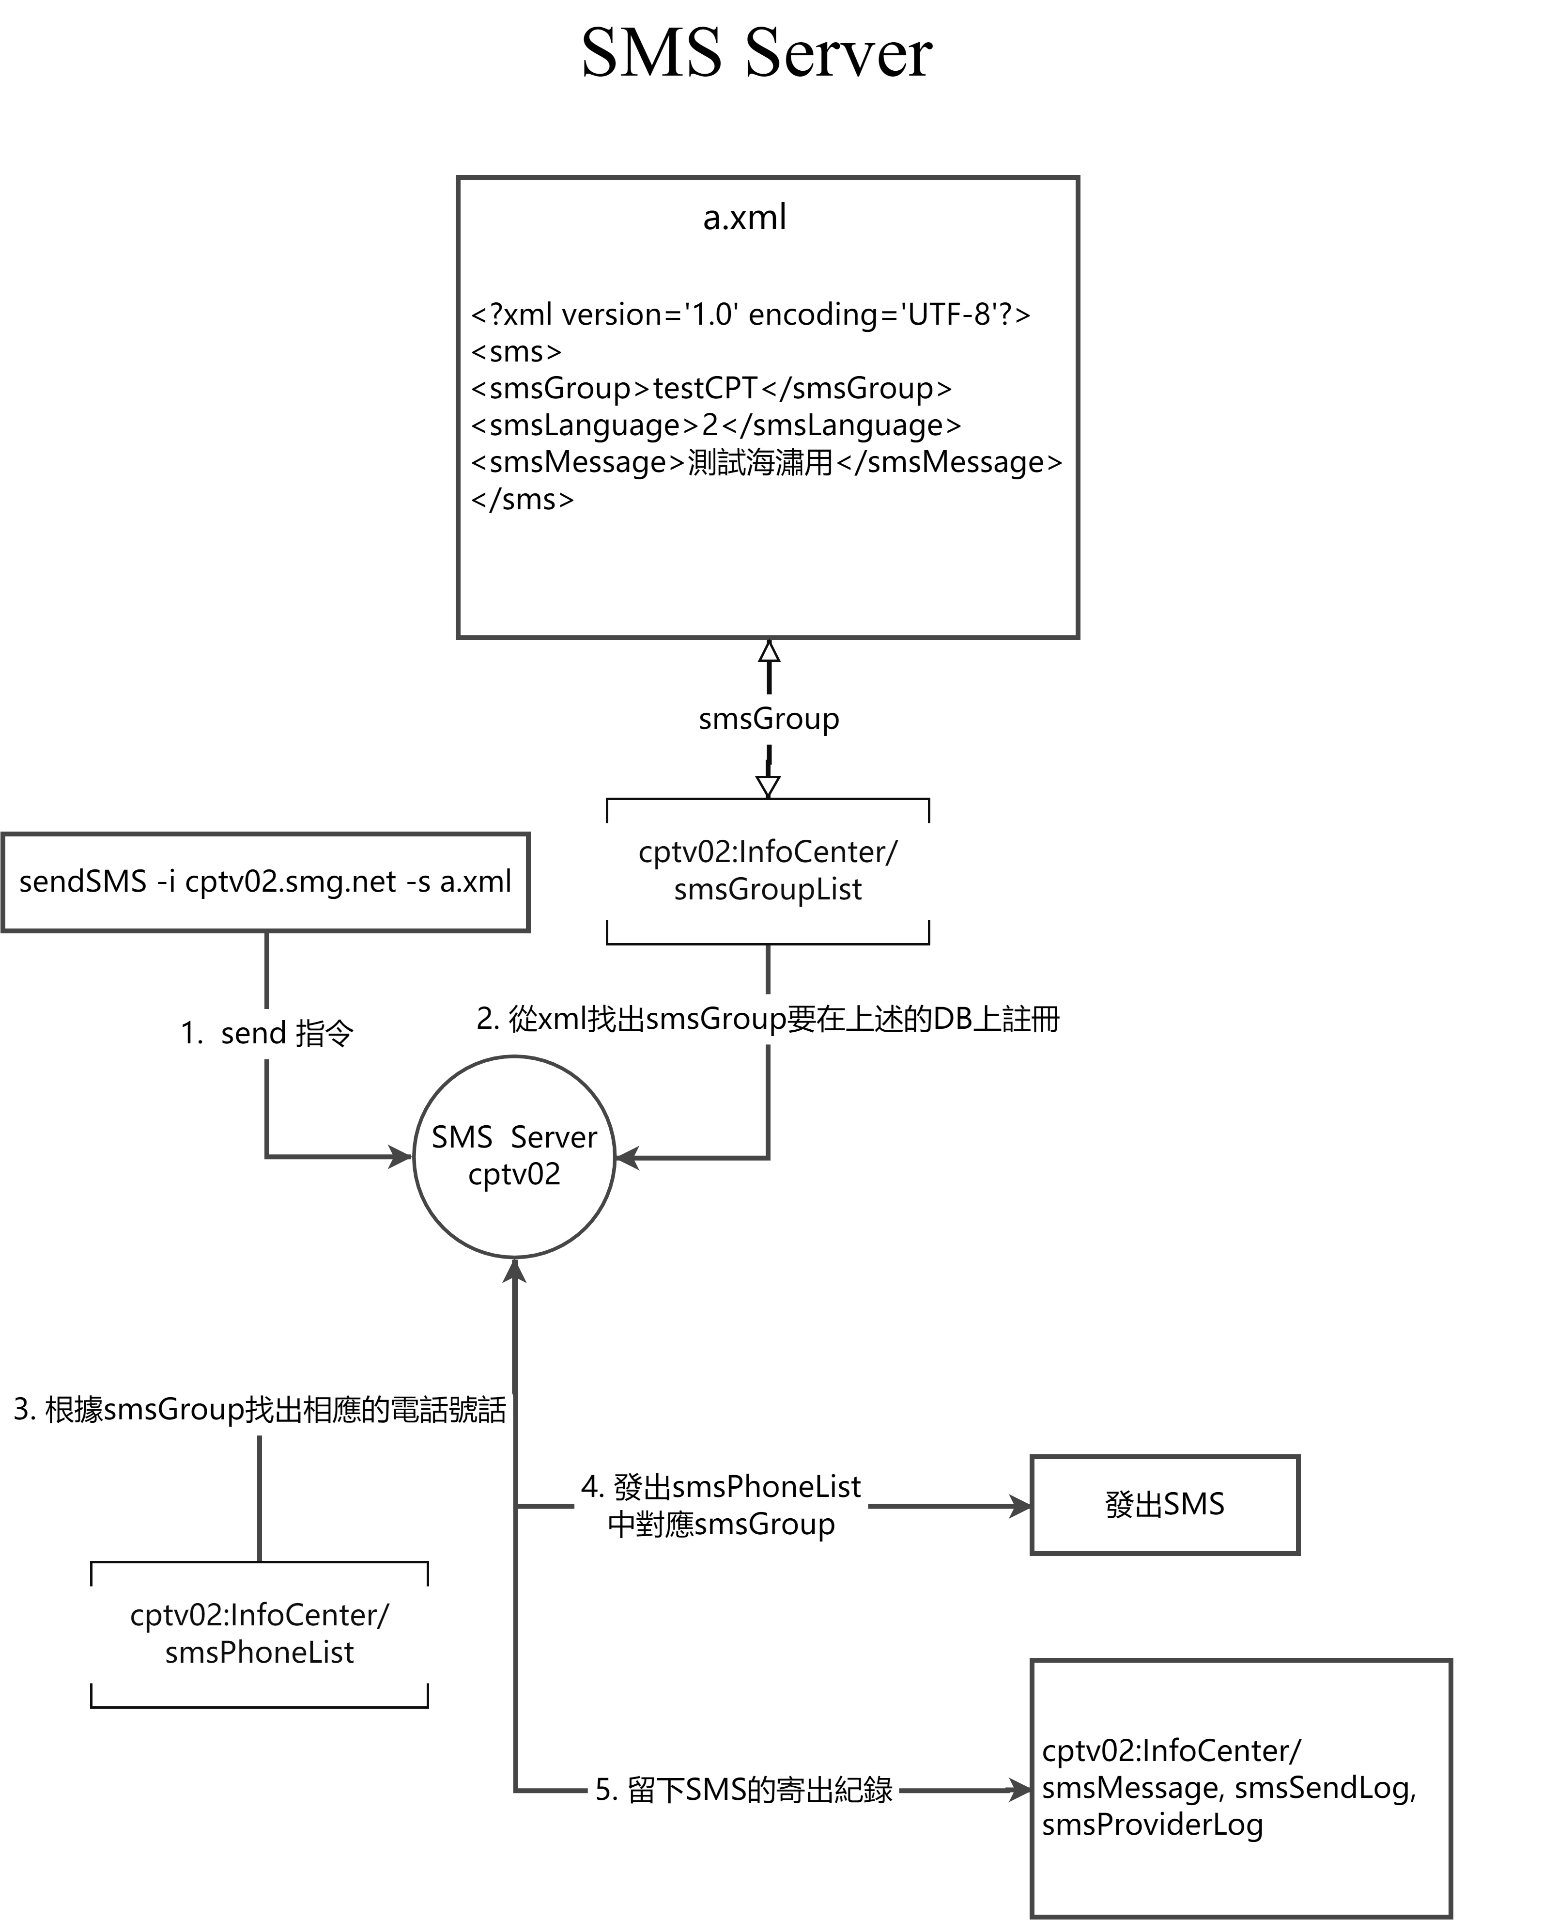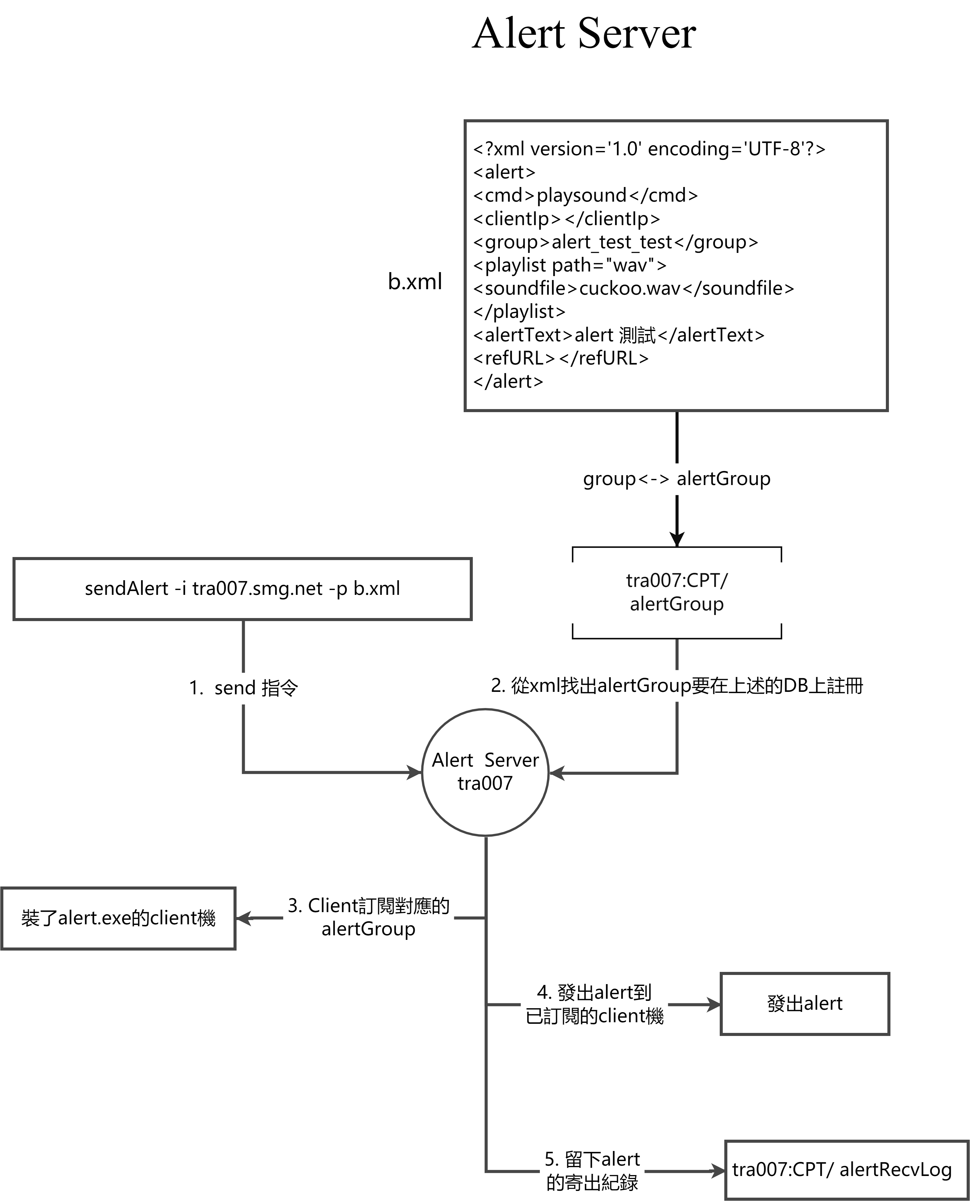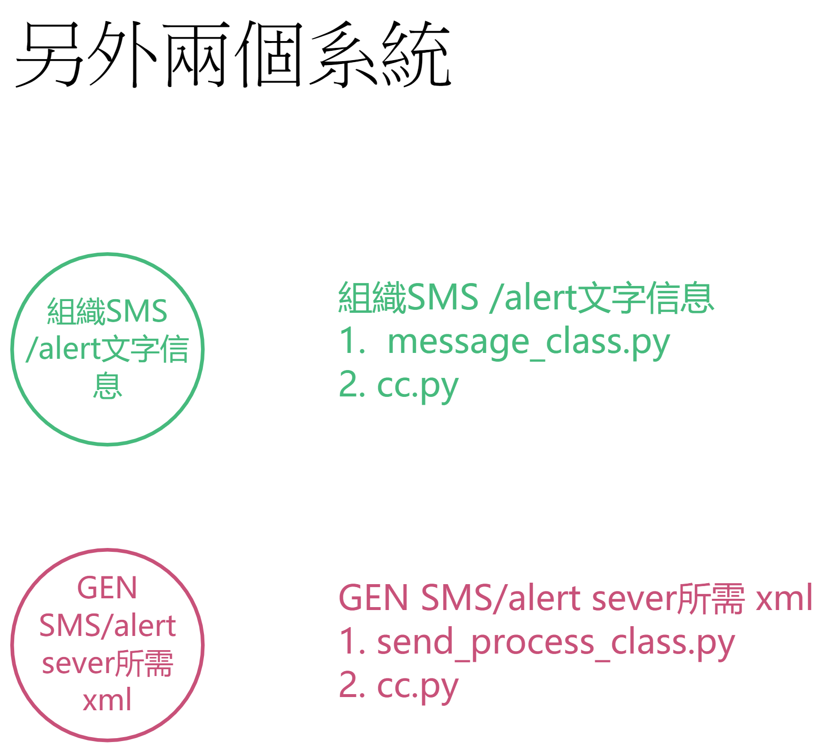

註解

位置： pwsv03: /home/cptmain/elsa/data_update_status/

1. Sms Server

指令: sendSMS -i cptv02.smg.net -s a.xml

a.xml 樣本

<?xml version='1.0' encoding='UTF-8'?>

<sms>

<smsGroup>testCPT</smsGroup>

<smsLanguage>2</smsLanguage>

<smsMessage>測試海潚用</smsMessage>

</sms>

1. Alert Server

指令: sendAlert -i tra007.smg.net -p b.xml

b.xml 樣本

<?xml version='1.0' encoding='UTF-8'?>

<alert>

<cmd>playsound</cmd>

<clientIp></clientIp>

<group>alert_test_test</group>

<playlist path="wav">

<soundfile>cuckoo.wav</soundfile>

</playlist>

<alertText>alert 測試</alertText>

<refURL></refURL>

</alert>

全文完