Rebel-Scrum

Milestone 2
github:
https://github.com/chda6313/3308SemesterProject_Sp2017

We will be using Trello as our project tracking tool. We have a board of long term goals labeled critical features. We have a backlog of user stories that are smaller tasks than the critical features. these tasks are color coded with the critical feature they are a part of. These tasks will be assigned due dates to define which sprint they will be a part of. We currently have due dates assigned for some tasks up until Mar21.

Our Trello page can be found here:
https://trello.com/b/Ym1fhDAI/big-picture-stories

We will be conducting three two-week sprints, assigning tasks from our backlog as we go. We will have weekly standup meetings instead of daily, because we are having trouble scheduling meetings when we can all be there.

Trello Screenshot:

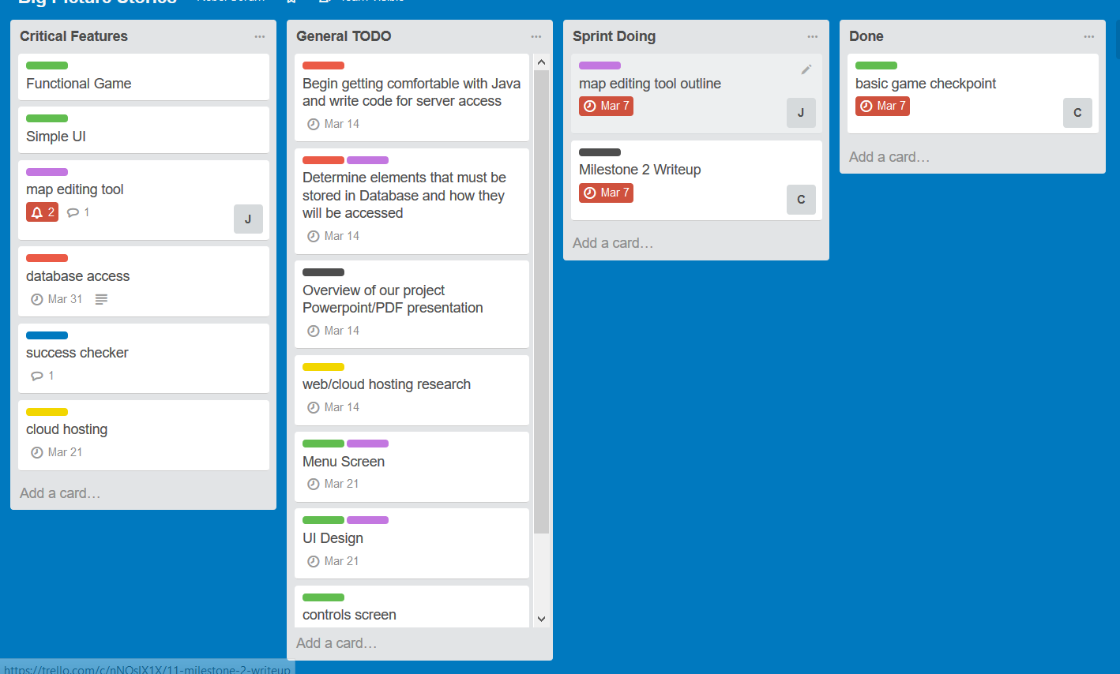

Sprint Retrospective:

--Things we did well:

-we made a good first step towards our goal
-good vision / respect for each other

--Things to work on:

-communication and attendance of meetings
-further familiarization with JS and database stuff
-using trello more consistently for task managment
-more smaller user stories

