1. Use “LabDb” database and table “Product”, Create an index page with four links (Show product; Add new product; update product; delete product)

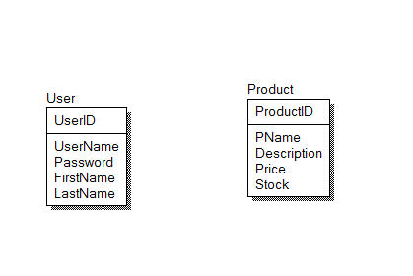

2. When the first two links (Show, Add) clicked, the relevant page will display and each function will be performed like the “CRUD” example from lecture notes.