**This lab is designed for two weeks work and worth 9% of lab assessment.**

1. Continue Lab 7, when the last two links (Update, Delete) clicked, the relevant page will display and each function will be performed like the “CRUD” example from lecture notes. Make sure the “confirmation” performed at delete function.
2. In the “add new” and “update” forms, add the mechanism to make sure the value of “price” is number.

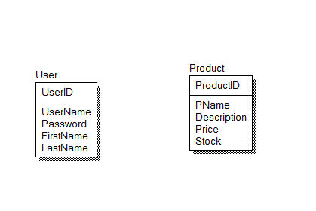

1. Create a three PHP pages address book mini system similar like the example of the lecture, to allow users login using user name and password stored in database, assign a session id and check the session id when enter the address information. If the user is trying to bypass the login page, send it back to very first page.