

Tribhuvan University
Faculty of Humanities and Social Sciences

A PROJECT REPORT
On
“Online Appointment Management System"
Submitted to
Department of Humanities & Social Science
Greenfield National College

In partial fulfillment of the requirements for the Bachelor’s Degree in Computer Application

Submitted by
Sachita Kapri
Reg. No: 6-2-717-15-2021

Under the Supervision of: Babita Rimal

Tribhuvan University
Faculty of Humanities and Social Sciences
Greenfield National College

Supervisor’s Recommendation

I hereby recommend that this project prepared under my supervision by Sachita Kapri “Online Appointment Management System” in partial fulfillment of the requirements for the degree of Bachelor of Computer Application is recommended for the final evaluation.

-----------------------
SIGNATURE
Babita Rimal
SUPERVISOR
BCA Department

Tribhuvan University
Faculty of Humanities and Social Sciences
Greenfield National College

LETTER OF APPROVAL
This is to certify that this project prepared by Sachita Kapri entitled “Online Appointment Management System” in partial fulfillment of the requirements for the degree of Bachelor in Computer Application has been evaluated. In our opinion it is satisfactory in the scope and quality as a project for the required degree.
…………………………….  Signature of Supervisor  Miss.Babita Rimal  Greenfield National College | …………………………  Signature of Program Coordinator  Mr. Ganesh Kumar Updhaya  Program Coordinator Greenfield National College
……………  Signature  Internal Examiner | ……………  Signature  External Examiner

Table Of Contents

LETTER OF APPROVAL 1
Acknowledgement 3
Abstract 4
List Of Figures 7
CHAPTER 1: INTRODUCTION 1
1.1 Introduction 1
1.3 Objectives of the Project 1
1.4 Scope of the Project 1
2.3 Problem Analysis 4
2.12 Findings 11
1.5 Methodology/Procedure 1
1.7 Project Framework 2
CHAPTER 2: BACKGROUND AND STUDY
2.1 Background study
2.2 Literature review
CHAPTER 3: SYSTEM ANALYSIS AND DESIGN
2.1 System Analysis 4
2.4 Feasibility Analysis 5
2.4.1 Economical Analysis 5
2.4.2 Software Analysis 5
2.3.1 Design and Development Problem 4
2.4.3 Data Conversion 5
2.4.4 Operational Feasibility 5
2.5 Use case Diagram 6
2.6 Sequence Diagram 6
2.7 Activity Diagram 8
2.9 ER Diagram 9
2.10 Gantt Chart 10
CHAPTER 4: IMPLEMENTATION AND TESTING
1.8 Data and Information 2
1.9 Primary Source of Data 2
1.10 Secondary Source of Data 2
1.11 Tools Used 2
1.12 Testing 3
1.12.1 Unit Testing 3
1.12.2 Integration Testing 3
1.12.3 System Testing 3
CHAPTER 5: CONCLUSION AND FUTURE RECOMMENDATIONS
2.12.1 Application’s Output 11
2.12.1.1 Backend 11

REFERENCE
APPENDICES
SUPERVISIOR LOG SHEET

Acknowledgement
I truly acknowledge the cooperation and help made by my supervisor Miss.Babita Rimal, who gave me the golden opportunity to do this wonderful project on the topic of “Online Appointment Management System” which also helped me in doing a lot of research and I came to know about so many new tools and technologies.

I would like to express my special gratitude and thanks to my Program Coordinator Mr. Ganesh Kumar Upadhyaya for his support and help for my educational development and mainly for the completion of this Project.

I am highly indebted to Greenfield National College for their guidance and constant supervision as well as for providing necessary information regarding the Project and support in the completion.

I would also like to express my gratitude towards library of Greenfield National College for their kind co-operation and encouragement which help me in completion of this project.

I would also like to thank my parents and friends whose silent help led me in finalizing this project within the limited time frame.

In the end, I would also like to thank Tribhuvan University for giving me this opportunity via the course of Computer Application to help me understand the project ethics at this early stage and helped me to evaluate my knowledge and expand it a little more.

Yours Sincerely
Sachita Kapri

Abstract
This project presents the development of an Online Appointment Management System that helps users book and manage appointments through a computerized system. The system is designed to reduce manual appointment handling, avoid scheduling confusion, and make appointment information easier to manage. It provides a simple connection between service providers and users by allowing appointment details to be stored and managed in one place. The project focuses on improving the efficiency, organization, and convenience of appointment management.

Appointment management is an important activity for organizations and service providers where users need to select a suitable date and time. Manual appointment systems may require phone calls, registers, or direct visits and can take more time. An Online Appointment Management System provides a computerized method to store user, service provider, appointment, date, and time information.

CHAPTER 1: INTRODUCTION

1.1 Introduction
Online Appointment Management System is the farmer system where they can plan, monitor and analyze the activity of the service providers production system. It manages farmer operation with one system and organizes data in one place. It helps smart service providers become even smarter. This creates in partnership with growers and users. It inspires farmer to produce and users to consume fresh goods.
Online Appointment Management System System will make better connection among Service Providers and Users ensure quality food. Standardize and increase efficiency of appointment management process.

1.3 Objectives of the Project
The specific objectives of the project include:
- To provide qualitative foods to the users.
- Implementing an automated/online appointment management system.
- To inspire farmer to produce quality goods and supply to the users.
- Eco-friendly farming system.

1.4 Scope of the Project
It is focused on studying the existing system of appointment management in and to make sure that the peoples are getting quality fresh goods. This is also will produce:
- Less effort and less labor intensive, as the primary cost and focus primary on creating, managing, and running a secure quality food supply.
- Increasing number of users as individuals will find it easier and more convenient to buy goods.
- Easy management.

1.5 Methodology/Procedure
- For the development of the project, the database can be designed using phpMyAdmin and MySQL. The back end can be developed using basic PHP and the front end can use HTML and CSS. XAMPP can be used as the local development environment.

- Software methodologies are concerned with the process of creating software – not so much the technical side but the organizational aspects. Several software development approaches have been used since the origin of information technology.

1.7 Project Framework
A framework is a standardized set of concepts, practices, and criteria for dealing with a common type of problem, which can be used as a reference to help us approach and resolve new problems of a similar nature.
The aim of framework is to provide a common structure so that developers don’t have to redo it from scratch and can reuse the code provided. In this way, frameworks allow us to cut out much of the work and save a lot of time

1.8 Data and Information
Data collection plays an important role in a projects succession and also it plays an inevitable role in the timely completion of the project. The data in the project includes contact information of the clients and their respective feedback's/complaints which is stored in a database. To assure safety, only the admin has proper access to the information provided by the clients.

1.9 Primary Source of Data
Primary data are the first-hand data. The necessary information was collected from day-to-day observation, problems, instructions of supervisor. Queries and personal discussion with the staff of the organization.
- Observation of working environment
- Informal discussion and interaction with the staff of the library department

1.10 Secondary Source of Data
The Secondary sources of data were collected in order to achieve the real and fact data as far as available. The major sources of secondary data are as follows:
- Annual reports of the concerned organization
- Related websites

1.11 Tools Used
- Xampp:
  - Apache:
    - (Application Server) Apache , often referred to as Server, is an open-source Java Servlet Container developed by the Apache Software Foundation.
  - MySQL Server:
    - It handles larege databases much faster than existing solutions.
    - It consists of multi-threaded SQL server that supports different back ends, several different client programs and libraries, administrative tools, and application programming interfaces (APIs)
    - Its connectivity, speed, and security make MySQL Server highly suited for accessing databases on the Internet.
- Sublime Text 3.1.1- Sublime Text is a sophisticated text editor for code, markup and prose. You'll love the slick user interface, extraordinary features and amazing performance.
- Web browsers: Google Chrome, Mozilla Firefox, Opera and Internet Explorer.
- Git Hub: GitHub Inc. is a web-based hosting service for version control using Git. It is mostly used for computer code. It offers all of the distributed version control and source code management functionality of Git as well as adding its own features.

1.12 Testing
Testing is evaluation of the software against requirements gathered from users and system specifications. Testing identifies important defects, flaws, or an error in the application code that must be fixed .It also assesses the feature of a system. Testing assesses the quality of the product.

1.12.1 Unit Testing
Unit testing refers to the testing certain functions and areas of the code. It gives the ability to verify that all the functions work as expected. Eventually, it helps to identify failures in the algorithms as well as logic to help improve the quality of the code that composes a certain function.

1.12.2 Integration Testing
Integration testing is basically a logical extension of unit testing. In simple words, two tested units are combined into a component and the interface between them is tested. It identifies problems that occur when different units are combined The different modules of this project have undergone integration testing while being merged.

1.12.3 System Testing
System testing tests the behavior of whole system as defined by the scope of the development project. It might include tests based on risks as well as requirement specifications, business process, use cases or other high level descriptions of system behavior, interactions with the operating systems and system resources. It is most often the final test performed to verify that the system meets the specification and its objectives. System testing has been performed at the completion of each feature and is still taking place to make improvements on the existing system.

CHAPTER 2: BACKGROUND AND STUDY

2.1 System Analysis
System Analysis is a detailed study of the various operations performed by a system and their relationships within and outside of the system. Here the key question is- why all problems exist in the present system? What must be done to solve the problem? Analysis begins when a user or manager begins a study of the program using existing system. During analysis, data collected on the various files, decision points and transactions handled by the present system. The commonly used tools in the system are Data Flow Diagram etc. Training, experience and common sense are required for collection of relevant information needed to develop the system. The success of the system depends largely on how clearly the problem is defined, thoroughly investigated and properly carried out through the choice of solution. A good analysis model should provide not only the mechanisms of problem understanding but also the frame work of the solution. Thus it should be studied thoroughly by collecting data about the system. Then the proposed system should be analyzed thoroughly in accordance with the needs. System analysis can be categorized into four parts.
- System planning and initial investigation
- Information Gathering
- Applying analysis tools for structured analysis
- Feasibility study
- Cost/ Benefit analysis.
In our existing system the recording of user’s information is done manually, So taking more time for searching the information of the users. Another major disadvantage is that preparing the list of members that viewed any user’s information takes more time. So, after conducting the feasibility study I decided to make the appointment management System to be computerized.

2.3 Problem Analysis
It is related to accessing detailed information about users, service providers, and appointments. The project is initiated with simple requirements such as user registration, service provider information, appointment booking, appointment status, and appointment management. Some problems related to designing and developing this project are discussed below:

2.3.1 Design and Development Problem
- Problem in running XAMPP.
- To debug the error during the development.
- To show a relationship between entity.
- Minor error with database table.

2.4 Feasibility Analysis
A feasibility analysis is conducted once the problem is clearly understood. The purpose of the study is to determine whether the problem is worth solving. It is an analysis and evaluation of a proposed project to determine if it is technically feasible, feasible with the estimated cost and profitable.

2.4.1 Economical Analysis
The economic feasibility of a system is used to evaluate the benefits achieved from and the costs incurred for the project or system. This is done by a process called cost benefit analysis. It provides tangible and intangible benefits like reduction in cost, more flexibility, faster activities, proper database management, etc.
The application is a medium-scale application and is economically feasible to develop. It can be developed using commonly available software tools such as XAMPP, PHP, MySQL, HTML, and CSS. Therefore, the development cost can be kept low while providing useful benefits.

2.4.2 Software Analysis
- Consumes a long-time for development of web application.
- Research and analysis cost to determine the actual need in real world.
- Implementation of application in the server and cost associated with the space in server.

2.4.3 Data Conversion
Another activity associated with implementing this web application is data conversion. Existing appointment records, if available, should be transferred and backed up so that important information is not lost while implementing the new system.

2.4.4 Operational Feasibility
The system is operationally feasible because normal users and service providers with basic computer skills can operate it. The system is designed with simple functions for registration, appointment booking, viewing appointment details, and managing appointment status.

2.5 Use case Diagram

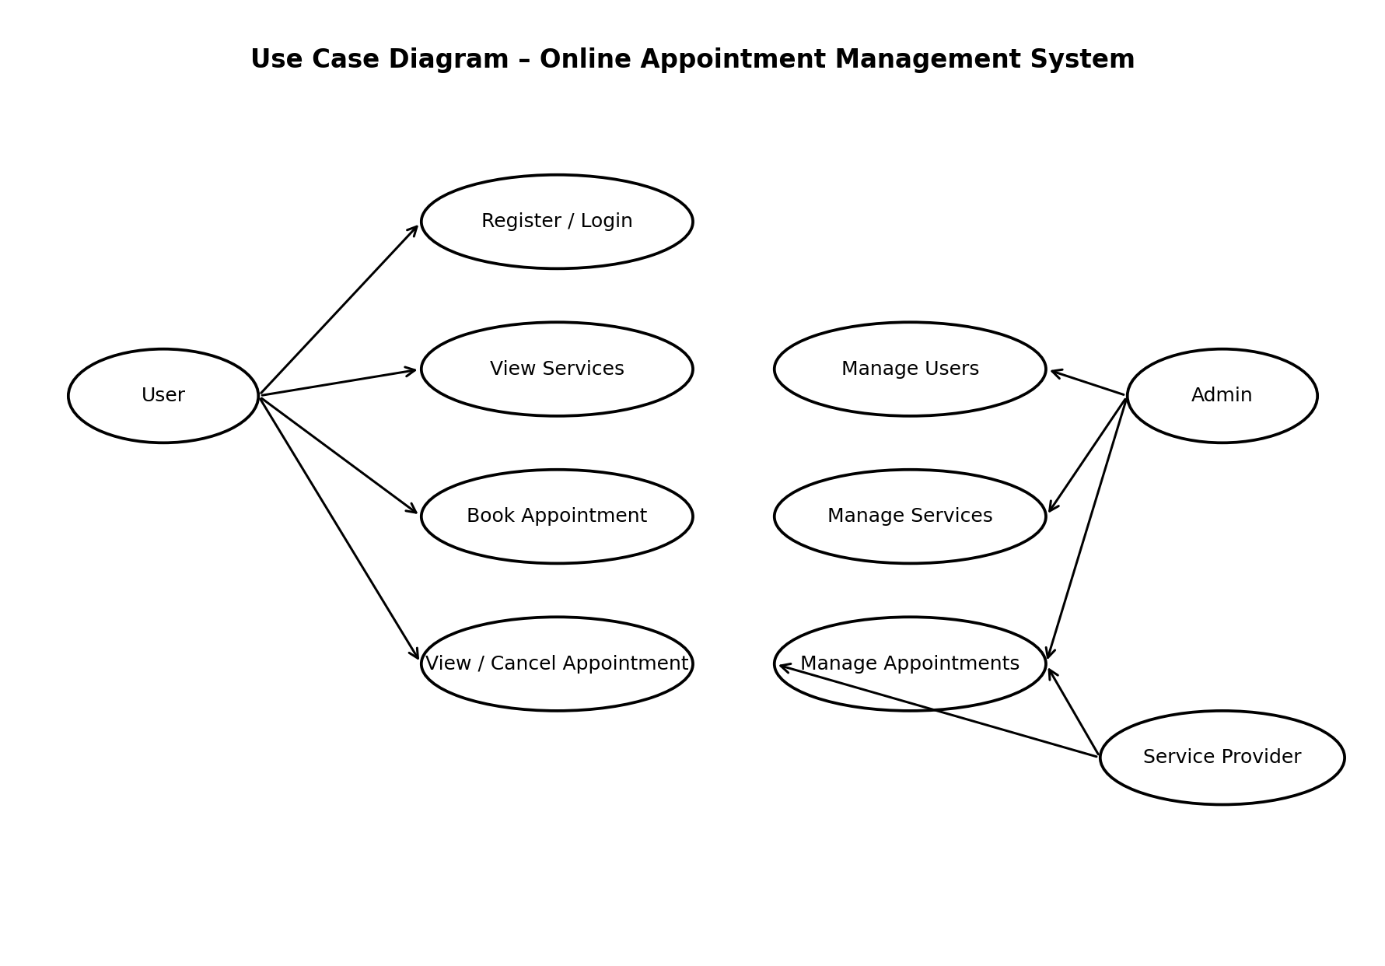
Figure 1: Use Case Diagram
Above figure represents the Use Case Diagram of the Online Appointment Management System. It shows the interaction between the user, service provider, and administrator and the major functions performed by them.

2.6 Sequence Diagram
A sequence diagram is a type of interaction diagram because it describes how—and in what order—a group of objects works together. A sequence diagram specifically focuses on lifelines, or the processes and objects that live simultaneously, and the messages exchanged between them to perform a function before the lifeline ends.

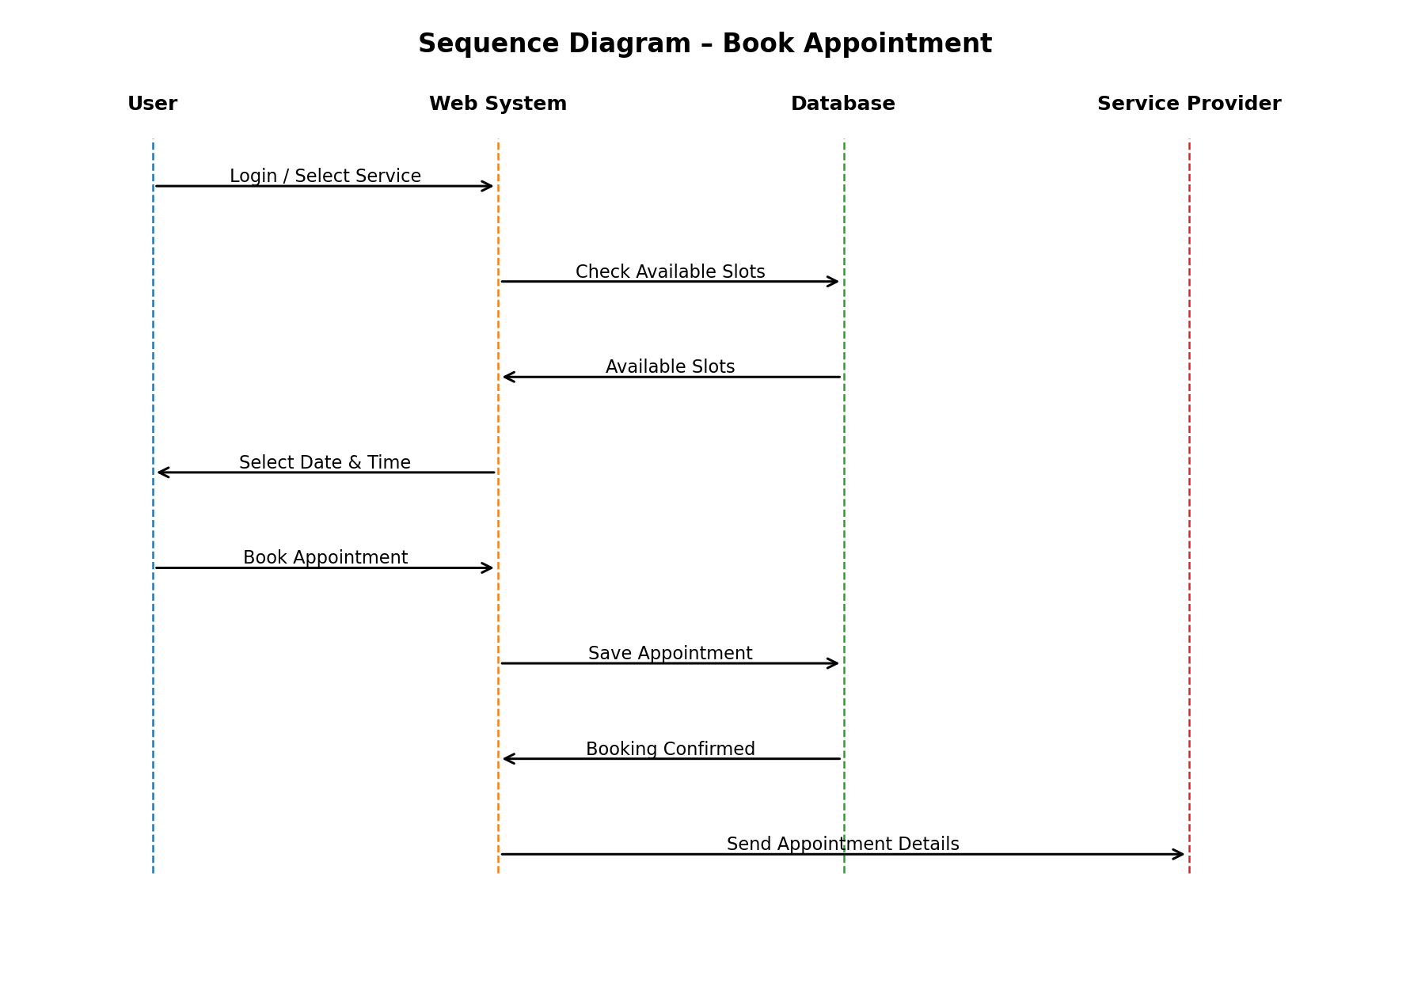
Figure 2:Sequence Diagram
Above figure represents the Sequence Diagram of the Online Appointment Management System. It shows the order of messages exchanged between the user, system, database, and service provider during appointment booking.

2.7 Activity Diagram

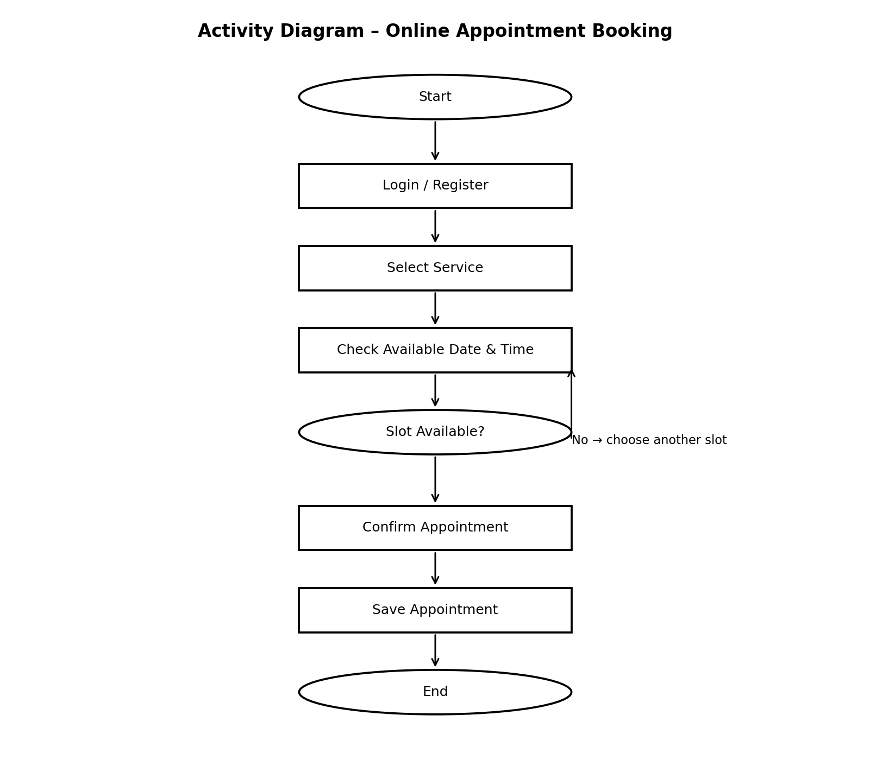
Figure 3: Activity Diagram

Above diagram describes the flow of control of a system. The flow can be sequential, concurrent or branched showing the overall functions of the system.

2.9 ER Diagram

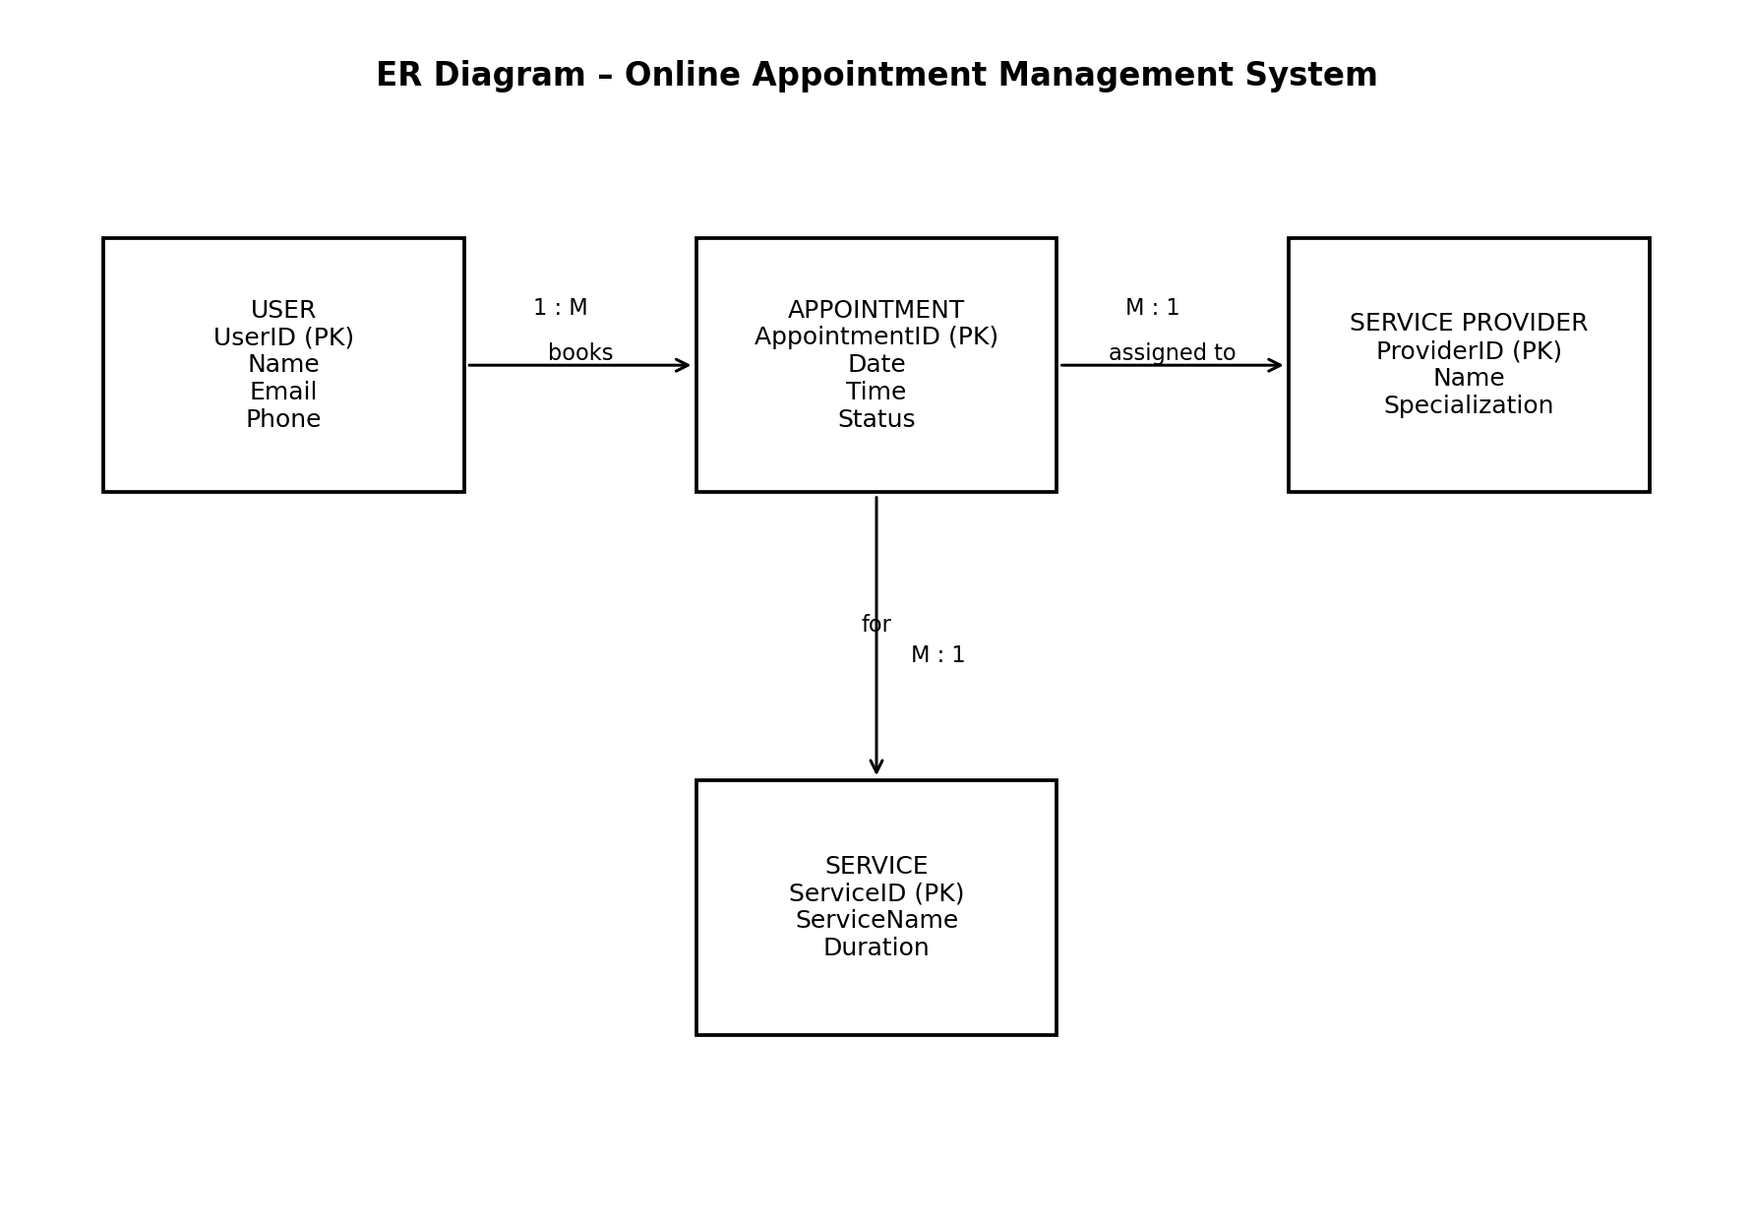
Figure 4: ER Diagram

ER diagram show all the relationships between entity sets stored in the database. It illustrates the logical structure of the database. It helps to visualize how data is connected in general ways.

2.10 Gantt Chart

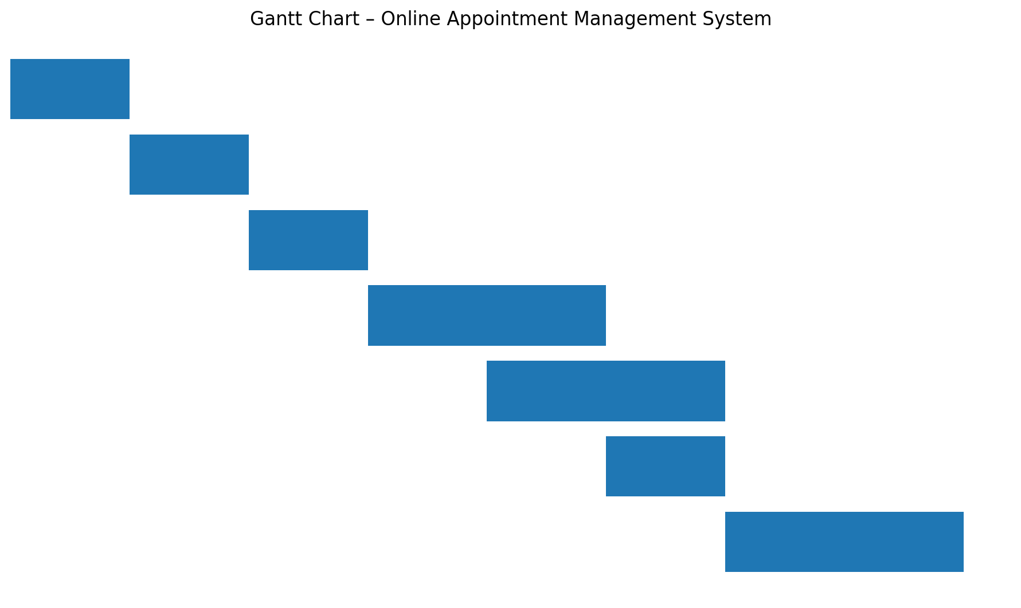
Figure 5: Gantt Chart
A Gantt chart illustrates how the project will run. It communicates with the client and shows them the expected date of project completion. It helps you assess how long a project should take, determine the resources needed, and plan the order in which you'll complete task.

2.12 Findings
After a series of testing and debugging, the project was ready for demonstration and is expected to achieve its main objectives. The system provides an easier way to create, manage, and track appointments.

2.12.1 Application’s Output

2.12.1.1 Backend

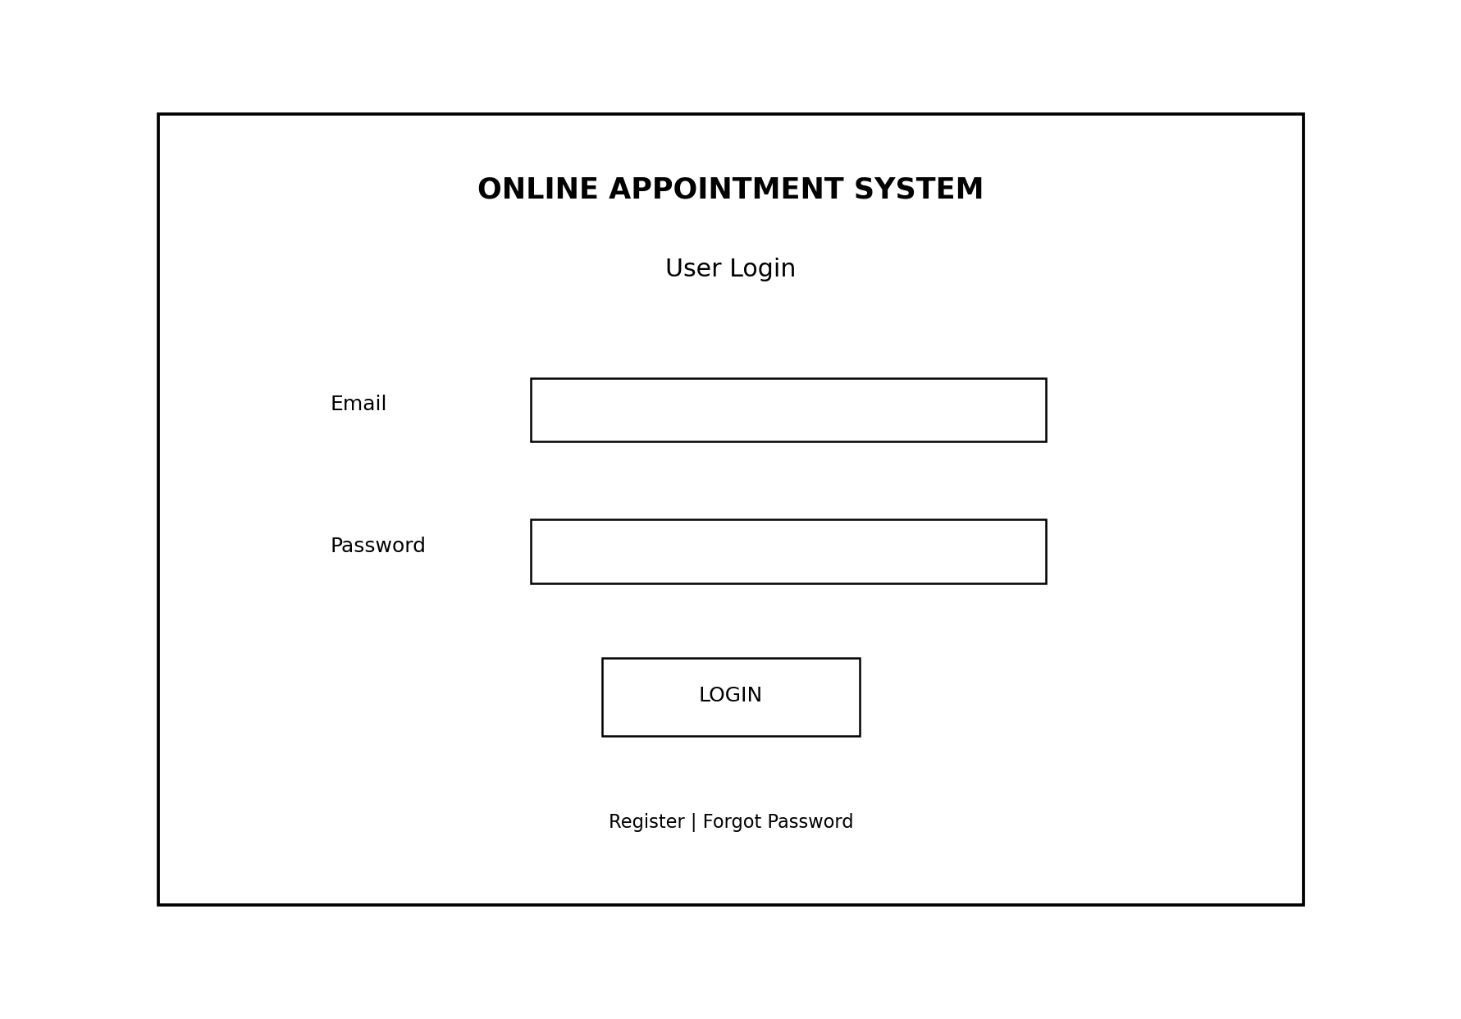
Figure 6: Admin Login

CHAPTER 3: CONCLUSION AND SUMMARY

3.1.Conclusion

Overall, this project has demonstrated the usefulness of an Online Appointment Management System for reducing manual appointment work and organizing appointment information. The system can make booking, scheduling, and status management easier. In the future, additional features such as SMS or email notifications, online payment, calendar integration, and mobile support can be added.

