HDL Digital Design (Graduate Level)

Spring 2024

HOMEWORK

REPORT

Must do self-checking before submission:

Compress all files described in the problem into one zip file.

All files can be compiled under ModelSim environment.

All port declarations comply with I/O port specifications.

Organize files according to File Hierarchy Requirement

No waveform files or project file in deliverables

Student name: 蔡承哲

Student ID: Q36111150

1. Your simulation result on the terminal (Transcript) .

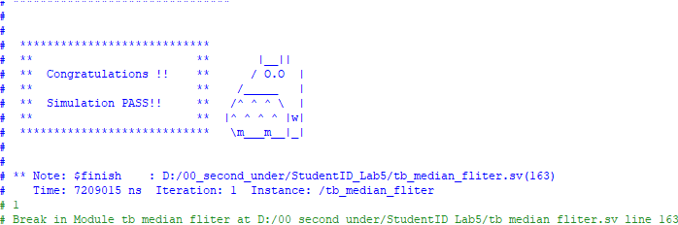

1. Explain the result by waveform.

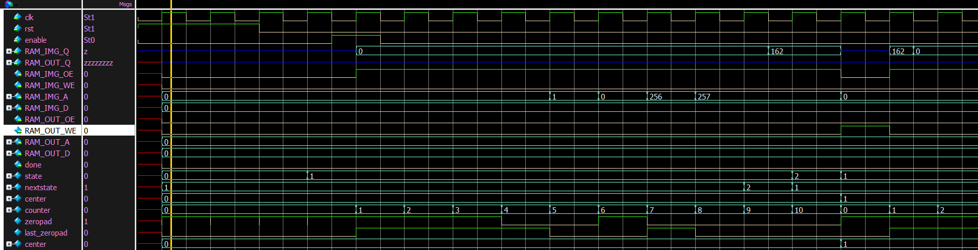

利用counter來記數，依序讀取local window裡的9個pixel。Center為圖片的最 左上角，直到移動到最右下角的pixel就代表結束整過流程。

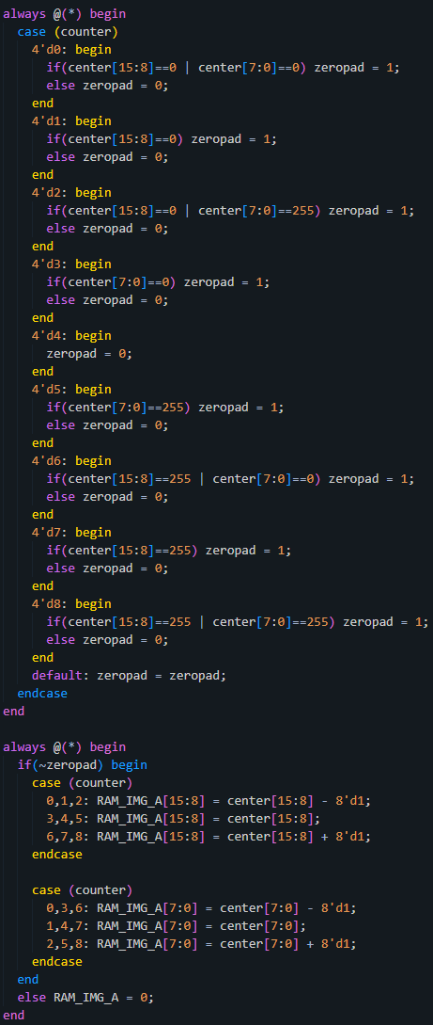

利用這兩個always block來判斷是否需要zero padding，並輸出required address。

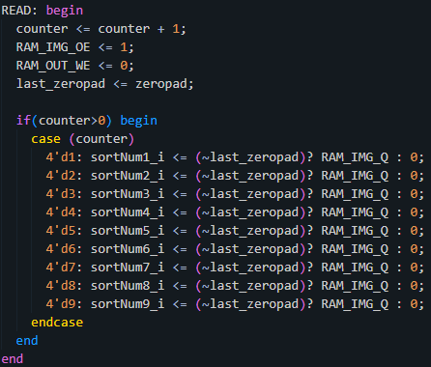

這裡就是把剛剛判斷zero pad flag當作條件，判斷放進reg sort的值是0還是RAM_IMG_Q。

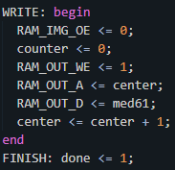

排序的部分就利用Lab2的方式，接著就把找到的median寫出去，並center = center + 1，移動到下一個新pixel，然後就依序反覆上述操作直到結束。

1. Draw the flowchart for your Finite State Machine (FSM).



1. At last, please write the lesson you learned from Lab5.

更精確的控制FSM以及zero padding。