Dissertation

Sergio Pérez-Limón

3/10/2023

Table of contents

# Preface

This is a Quarto book.

To learn more about Quarto books visit <https://quarto.org/docs/books>.

# 1. Introduction

This is a book created from markdown and executable code.

See Knuth (1984) for additional discussion of literate programming.

# 2. Estimate mosaic metrics MAGIC

There are a few questions that we can make out of the MAGIC population:

* Is there any residual populations structure in the MAGIC population?
* Can we improve the parenta haplotype call in the MAGIC population if we increae the number of markers?
  + How does the choromosomic mosaic looks in the MAGIC population?
  + What’s the median and maximum chromosomic chunk size in the MAGIC population?
  + What’s the median and maximum “same genotype” chunk in a pairwise comparison of the MAGIC parents?
  + What is the minimal number of markers that we need to obtain information similar to the total of 8.2 M markers?

Logic: We hypothesize that most of the NAs or mistakes in the call of the parent in the MAGIC populations are because {qtl2} can’t tell apart one parent from the other with enough confidence (with $α=0.5$) because the marker density is not enough to tell a parent from the other. In this case, increasing the number of markers between each chunk will help us only if the maximun size of the chunks with “same genotype” in the parents information is smaller than the recombination chunk size in the MAGIC population. IN other words, we’re adding more relevant information in each of these chunks that would allow us to differentiate one parent from the other.

Loading libraries

library(tidyverse)

── Attaching packages ─────────────────────────────────────── tidyverse 1.3.2 ──  
✔ ggplot2 3.4.1 ✔ purrr 1.0.1   
✔ tibble 3.1.8 ✔ dplyr 1.0.10  
✔ tidyr 1.3.0 ✔ stringr 1.5.0   
✔ readr 2.1.3 ✔ forcats 0.5.2

Warning: package 'ggplot2' was built under R version 4.2.2

Warning: package 'tidyr' was built under R version 4.2.2

Warning: package 'readr' was built under R version 4.2.2

Warning: package 'purrr' was built under R version 4.2.2

Warning: package 'dplyr' was built under R version 4.2.2

Warning: package 'stringr' was built under R version 4.2.2

Warning: package 'forcats' was built under R version 4.2.2

── Conflicts ────────────────────────────────────────── tidyverse_conflicts() ──  
✖ dplyr::filter() masks stats::filter()  
✖ dplyr::lag() masks stats::lag()

library(furrr)

Warning: package 'furrr' was built under R version 4.2.2

Loading required package: future

Warning: package 'future' was built under R version 4.2.2

plan(multisession)  
library(arrow)

Warning: package 'arrow' was built under R version 4.2.2

Attaching package: 'arrow'  
  
The following object is masked from 'package:utils':  
  
 timestamp

library(tidymodels)

── Attaching packages ────────────────────────────────────── tidymodels 1.0.0 ──  
✔ broom 1.0.3 ✔ rsample 1.1.1   
✔ dials 1.1.0 ✔ tune 1.0.1   
✔ infer 1.0.4 ✔ workflows 1.1.2   
✔ modeldata 1.1.0 ✔ workflowsets 1.0.0   
✔ parsnip 1.0.3.9000 ✔ yardstick 1.1.0   
✔ recipes 1.0.4

Warning: package 'broom' was built under R version 4.2.2

Warning: package 'dials' was built under R version 4.2.2

Warning: package 'infer' was built under R version 4.2.2

Warning: package 'modeldata' was built under R version 4.2.2

Warning: package 'recipes' was built under R version 4.2.2

Warning: package 'rsample' was built under R version 4.2.2

Warning: package 'tune' was built under R version 4.2.2

Warning: package 'workflows' was built under R version 4.2.2

Warning: package 'yardstick' was built under R version 4.2.2

── Conflicts ───────────────────────────────────────── tidymodels_conflicts() ──  
✖ scales::discard() masks purrr::discard()  
✖ dplyr::filter() masks stats::filter()  
✖ recipes::fixed() masks stringr::fixed()  
✖ dplyr::lag() masks stats::lag()  
✖ yardstick::spec() masks readr::spec()  
✖ recipes::step() masks stats::step()  
• Search for functions across packages at https://www.tidymodels.org/find/

library(qtl2)

Warning: package 'qtl2' was built under R version 4.2.2

Attaching package: 'qtl2'  
  
The following object is masked from 'package:readr':  
  
 read_csv

library(tidymodels)  
library(finetune)

Warning: package 'finetune' was built under R version 4.2.2

library(reshape2)

Attaching package: 'reshape2'  
  
The following object is masked from 'package:tidyr':  
  
 smiths

library(tidymodels)

Clean CrossObject: Remove weid markers and individuals based on their total number of recombinations and LODerror

MEMA_DATA <-   
 read_cross2(  
 "C:/Users/sergi/Documents/SAWERS LAB/MAGIC/genetic_mapping/MEMA_CTRL_wo_weird.yaml"  
 )

Warning in drop_incomplete_markers(output): Omitting 4738 markers that are not  
in both genotypes and maps

Warning in check_cross2(output): Physical map out of order on chr 1, 2, 3, 4,  
5, 6, 7, 8, 9, 10

snp.info.founders <- readr::read_csv(  
 "C:/Users/sergi/Documents/SAWERS LAB/MAGIC/genetic_mapping/snp.info.founders.csv"  
 ) %>%  
 filter(!is.na(snp))

Rows: 19654 Columns: 4  
── Column specification ────────────────────────────────────────────────────────  
Delimiter: ","  
chr (1): snp  
dbl (3): chr, pos, sdp  
  
ℹ Use `spec()` to retrieve the full column specification for this data.  
ℹ Specify the column types or set `show_col_types = FALSE` to quiet this message.

# recombinations #  
######################################################################################  
  
genmap_MEMA <- MEMA_DATA$gmap  
  
# Estimate genotype probabilities  
set.seed(100)  
genoprob_MEMA <-  
 calc_genoprob(  
 cross = MEMA_DATA,   
 map = genmap_MEMA,   
 error_prob=0.002) %>%  
 clean_genoprob ()  
  
# Estimate the genotypes with maximum marginal probabilities  
set.seed(100)  
geno_maxprob_MEMA <-   
 maxmarg(  
 probs = genoprob_MEMA,  
 minprob = 0.95  
 ) #assigns founder code to each marker/pos  
  
# Estimate the genotypes with maximum marginal probabilities with letters  
set.seed(100)  
geno_maxprob_letters_MEMA <- maxmarg(  
 probs= genoprob_MEMA,  
 minprob = 0.95,  
 return_char = TRUE  
 )

Estimate the error lod probability for any marker for any family. Positive LOD scores suggest that there might be a mistake in the genotype probability. I’m estimating the proportion of genotype calls in each marker whose errorLOD > 0 and estimate the top 5 percentile values of the proportion distribution and remove the markers whose proportion belong to this group.

# Calculate genotyping error LOD scores  
set.seed(100)  
errorlod_MEMA <-   
 calc_errorlod(  
 cross = MEMA_DATA,   
 probs = genoprob_MEMA  
 )  
  
errorlod_MEMA <- do.call("cbind", errorlod_MEMA)  
  
# matrix to df  
errorlod_MEMA_df <-   
 errorlod_MEMA %>%  
 as_tibble(rownames = "family")  
  
# Estimate the proportion of LODerror > 0 in every marker  
errorlod_MEMA_prop_marker <-   
 errorlod_MEMA_df %>%  
 pivot_longer(-family) %>%  
 filter(!is.infinite(value)) %>%  
 group_by(name) %>%  
 summarise(prop = sum(value >= 0)/dim(errorlod_MEMA_df)[1])  
  
errorlod_MEMA_prop_marker

# A tibble: 14,176 × 2  
 name prop  
 <chr> <dbl>  
 1 1_100088401 0.125  
 2 1_100224800 0.115  
 3 1_100225275 0.135  
 4 1_100229005 0.11   
 5 1_100344399 0.13   
 6 1_100344420 0.13   
 7 1_100344944 0.145  
 8 1_100384962 0.13   
 9 1_100385294 0.16   
10 1_100388059 0.135  
# … with 14,166 more rows

# Estimate the 95 percentile of the LODerror proportion distribution   
errorlod_95_perc <- quantile(errorlod_MEMA_prop_marker$prop, 0.95)  
  
errorlod_95_perc

95%   
0.2

# Remove all the markers with prop >=0.2  
  
errorlod_MEMA_prop_marker %>%  
 ggplot(data =., aes(x = prop)) +  
 geom_density(linewidth = 1) +  
 xlab("Proportion of LODerror > 0 per marker") +  
 geom_vline(  
 aes(xintercept = errorlod_95_perc),   
 color = "red",   
 linetype = "dashed",   
 linewidth = 1  
 ) +  
 theme(  
 panel.background = element_rect(fill = "white", colour = "grey50"),   
 text = element_text(size = 12),  
 legend.position = "top"   
 )

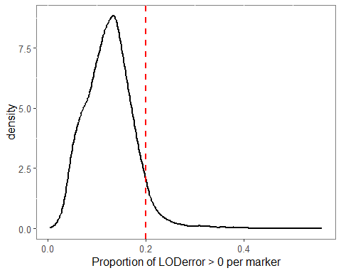

# Select markers in the 95 percentile to remove  
errorlod_marker_remove <- errorlod_MEMA_prop_marker %>%  
 filter(prop >= errorlod_95_perc) %>%  
 .$name  
  
#############################################  
# Count number of recombinations per family #  
#############################################  
  
# Estimate the total number of recombinations per family  
set.seed(100)  
n_recomb_family_MEMA <-   
 count_xo(geno = geno_maxprob_MEMA) %>%  
 as_tibble(rownames = "family") %>%  
 pivot_longer(-family) %>%  
 group_by(family) %>%  
 summarise(n_recomb = sum(value)) %>%  
 arrange(desc(n_recomb))   
  
# Identify outliers in the distribution of genomewide recombination events  
n_recomb_family_MEMA %>%  
 ggplot(data =., aes(y = n_recomb)) +  
 geom_boxplot() +  
 theme(  
 panel.background = element_rect(fill = "white", colour = "grey50"),   
 text = element_text(size = 12),  
 plot.title = element_text(hjust = 0.5)  
 ) +  
 ggtitle("Distribution of number of genome-wide number of recombinations per family")

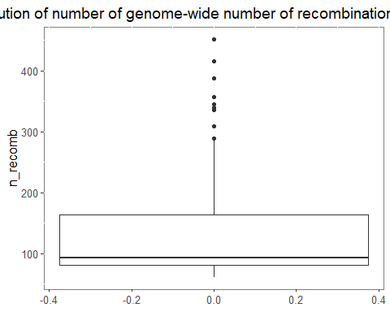

# Outliers total number of recomb  
outliers_lots_recomb_MEMA <-   
 boxplot(n_recomb_family_MEMA$n_recomb, plot = F)$out  
  
# non outlier families  
family_normal_recomb <-   
 n_recomb_family_MEMA %>%  
 filter(! n_recomb %in% outliers_lots_recomb_MEMA) %>%  
 .$family   
  
MEMA_DATA_wo_weird <-   
 MEMA_DATA %>%  
 drop_markers(errorlod_marker_remove) %>%  
 subset(x =., ind = family_normal_recomb)

Is there any population structure in the MEMA population?

Approach: I’m going to estimate the kinship matrix using the overall option and a decomposition of eigenvalues of the same matrix and detect population structure.

# Estimate genotype probabilities  
set.seed(100)  
genoprob_wo_weird_MEMA <-  
 calc_genoprob(  
 cross = MEMA_DATA_wo_weird,   
 map = genmap_MEMA,   
 error_prob=0.002) %>%  
 clean_genoprob ()  
  
# Estimate Allele probabilities  
set.seed(100)  
allele_prob_MEMA <-   
 genoprob_to_alleleprob(genoprob_wo_weird_MEMA)  
  
# Estimate kinship matrix   
set.seed(100)  
kinship_wo_weird_MEMA <- calc_kinship(  
 probs = allele_prob_MEMA,  
 type = "overall"  
 )  
  
# Estimate the eigenvalue decomposition of the kinship matrix  
set.seed(100)  
eigen_kinship_MEMA <-   
 decomp_kinship(kinship_wo_weird_MEMA)  
  
# correlation matrix of the kinship matrix  
set.seed(100)  
corr_kindhip_MEMA <-   
 scale_kinship (kinship_wo_weird_MEMA)  
  
# Pairwise correlation of families  
pairwise_geno_corr_MEMA <- corr_kindhip_MEMA %>%  
 as_tibble(rownames = "family") %>%  
 pivot_longer(-family) %>%  
 filter(family != name) %>%  
 mutate(code = map2_chr(  
 .x = family,  
 .y = name,  
 .f = ~ paste0(.x, .y) %>% str_split("") %>% unlist() %>% sort() %>% paste(collapse = "")  
 )) %>%  
 group_by(code) %>%  
 filter(row_number() == 1) %>%  
 ungroup() %>%  
 select(-code)   
  
# Estimate 99 percentile of pairwise correlation  
geno_corr_99_perc <- quantile(pairwise_geno_corr_MEMA$value, 0.99)  
  
geno_corr_99_perc

99%   
0.2882856

# plot the distribution of the pairwise correlation between families   
pairwise_geno_corr_MEMA %>%  
 ggplot(data =., aes(x = value)) +  
 geom_density(linewidth = 1) +  
 xlab("Pairwise kinship between families (vertical line = 99 percentile)") +  
 geom_vline(  
 aes(xintercept = geno_corr_99_perc),   
 color = "red",   
 linetype = "dashed",   
 linewidth = 1  
 ) +  
 theme(  
 panel.background = element_rect(fill = "white", colour = "grey50"),   
 text = element_text(size = 12),  
 legend.position = "top"   
 )

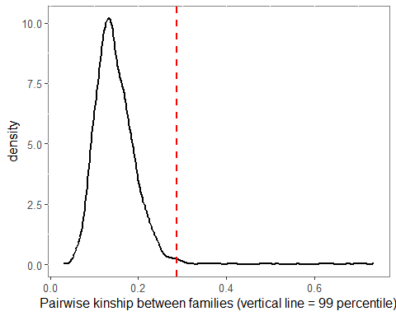

# Identify family pairwise correlation values in the 99 percentile  
familyes_high_corr <-   
 pairwise_geno_corr_MEMA %>%  
 filter(value >= geno_corr_99_perc) %>%  
 arrange(desc(value))  
  
familyes_high_corr

# A tibble: 27 × 3  
 family name value  
 <chr> <chr> <dbl>  
 1 MEMA210 MEMA211 0.736  
 2 MEMA245 MEMA244 0.714  
 3 MEMA162 MEMA163 0.695  
 4 MEMA128 MEMA127 0.675  
 5 MEMA307 MEMA308 0.638  
 6 MEMA033 MEMA034 0.631  
 7 MEMA133 MEMA132 0.612  
 8 MEMA055 MEMA054 0.563  
 9 MEMA252 MEMA253 0.517  
10 MEMA168 MEMA078 0.496  
# … with 17 more rows

# Select families to drop that are in the 99th percentile but doesn't have a phenotype in the TC experiment  
  
genotyped_fam_MEMA <-   
 MEMA_DATA_wo_weird$geno$`1` %>% rownames()  
  
families_no_pheno <-   
 MEMA_DATA_wo_weird$pheno %>%  
 rownames() %>%  
 setdiff(genotyped_fam_MEMA, .)  
  
families_no_pheno_high_corr <-   
 familyes_high_corr %>%  
 rowid_to_column() %>%  
 rename(cor = value) %>%  
 pivot_longer(c(family, name)) %>%  
 count(value) %>%  
 arrange(desc(n)) %>%  
 filter(value %in% families_no_pheno) %>%  
 .$value  
  
# Drop families with high correlation and not phenotyped: c("MEMA163", "MEMA210", "MEMA252")  
  
MEMA_DATA_wo_weird2 <- MEMA_DATA_wo_weird %>%  
 subset(ind = setdiff(genotyped_fam_MEMA, families_no_pheno_high_corr))

In the absence of population structure we can expect a correlation between families of 1/8. Any significant deviation from this number would imply that there is residual population structure in the population. The distribution of the pairwise correlation values for the MEMA family is right skewed with a median value of ~ 0.14, close to 0.125 (1/8) expected. This value is inflated a little bit by weird families that have a lot of correlation. We hypothesize that the high correlation values for these families (for instance families MEMA210-MEMA211; cor = 0.736) was the result of either mistakes in the development of families: Someone mistakenly grabbed seed from an incorrect envelope that was planted and generated a very closely relted family, or it could also be the result of mistakes in collecting tissue from plants for genotyping. Nevertheless, the results show that the median pairwise correlation doesn’t deviate that much from the expected under the hypothesis of no population structure, so we can conclude that there is a reduced population structure in the MEMA pop. We’re going to remove highly correlated individuals for whom we don’t have phenotypic data.

# 3. What is the size of the recombination chunks in the MEMA population?

# Estimate genotype probabilities  
set.seed(100)  
genoprob_wo_weird2_MEMA <-  
 calc_genoprob(  
 cross = MEMA_DATA_wo_weird2,   
 map = genmap_MEMA,   
 error_prob=0.002) %>%  
 clean_genoprob ()  
  
# Estimate Allele probabilities  
set.seed(100)  
geno__wo_weird2_MEMA <-   
 maxmarg(  
 probs = genoprob_wo_weird2_MEMA,  
 minprob = 0.95  
 )  
  
# Guess the phase of each family in each chromosome  
phase_MEMA <- guess_phase(MEMA_DATA_wo_weird2, geno__wo_weird2_MEMA)  
  
# genetic map  
genmap_MEMA <-   
 MEMA_DATA_wo_weird2$gmap %>%  
 map_df(.x = ., .f = ~ .x %>% enframe(name = "marker", value = "g_pos"))  
  
# markers at the end of each chromosome  
genmap_chr_end <-   
 genmap_MEMA %>%  
 separate(marker, into = c("chr", "p_pos"), sep = "_", remove = F) %>%  
 mutate(  
 chr = as.integer(chr),  
 p_pos = as.integer(p_pos)  
 ) %>%  
 arrange(chr, p_pos) %>%  
 group_by(chr) %>%  
 filter(row_number() == max(row_number())) %>%  
 mutate(p_pos = p_pos/1e6) %>%  
 ungroup() %>%  
 rename(chr_end = p_pos)  
   
  
# Identify the recombination breakpoints in the MEMA population  
set.seed(100)  
recomb_location_MEMA <-   
 locate_xo(phase_MEMA, map = MEMA_DATA_wo_weird2$gmap) %>%  
 map_df(  
 .x = .,  
 .f = ~ map_df(  
 .x = .,  
 .f = ~ enframe(.x, name = NULL, value = "location"),  
 .id = "family"  
 ),  
 .id = "chr"  
 ) %>%  
 mutate(marker = find_marker(MEMA_DATA$gmap, chr = chr, pos = location)) %>%  
 mutate(chr = as.integer(chr))  
  
# Estimate the size of the recombination chunks in the MEMA population  
recomb_chunk_size_MEMA <-   
 recomb_location_MEMA %>%  
 group_by(family, chr) %>%  
 nest() %>%  
 mutate(data = map(  
 .x = data,   
 .f = ~ .x %>% add_row(location = NA, marker = NA)  
 )) %>%  
 ungroup() %>%  
 unnest(c(data), keep_empty = T) %>%  
 group_by(family, chr) %>%  
 mutate(  
 pos = gsub("^\\d{1,2}_", "", marker) %>% as.integer() %>% "/"(1e6),  
 chr = as.integer(chr)  
 ) %>%  
 mutate(  
 start = lag(pos, default = 0),  
 end = pos  
 ) %>%  
 left_join(genmap_chr_end %>% select(-marker), by = "chr") %>%  
 mutate(end = ifelse(is.na(pos), chr_end, end)) %>%  
 select(family, chr, location, marker, start, end) %>%  
 ungroup() %>%  
 mutate(chunk_size = end - start) %>%  
 mutate(  
 p_pos_start = find_marker(MEMA_DATA$gmap, chr = chr, pos = start),  
 p_pos_end = find_marker(MEMA_DATA$gmap, chr = chr, pos = end)) %>%  
 mutate(  
 across(contains("p_pos"), ~ gsub("\\d{1,2}_", "", .) %>% as.integer() %>% "/"(1e6))  
 ) %>%  
 mutate(p_chunk_size = p_pos_end - p_pos_start) %>%  
 filter(chunk_size > 0 & p_chunk_size > 0)  
  
recomb_chunk_size_MEMA

# A tibble: 22,217 × 10  
 family chr location marker start end chunk…¹ p_pos…² p_pos…³ p_chu…⁴  
 <chr> <int> <dbl> <chr> <dbl> <dbl> <dbl> <dbl> <dbl> <dbl>  
 1 MEMA156 1 14.0 1_7987929 0 7.99 7.99 1.74 4.91 3.17   
 2 MEMA156 1 34.1 1_18969916 7.99 19.0 11.0 4.91 11.3 6.40   
 3 MEMA156 1 65.8 1_42129633 19.0 42.1 23.2 11.3 23.6 12.3   
 4 MEMA156 1 97.8 1_71985242 42.1 72.0 29.9 23.6 50.5 26.9   
 5 MEMA156 1 98.6 1_72903601 72.0 72.9 0.918 50.5 53.8 3.24   
 6 MEMA156 1 99.4 1_74159005 72.9 74.2 1.26 53.8 54.8 1.01   
 7 MEMA156 1 101. 1_78116605 74.2 78.1 3.96 54.8 57.4 2.69   
 8 MEMA156 1 104. 1_80559358 78.1 80.6 2.44 57.4 58.3 0.826  
 9 MEMA156 1 105. 1_81673169 80.6 81.7 1.11 58.3 59.0 0.751  
10 MEMA156 1 105. 1_82472265 81.7 82.5 0.799 59.0 59.4 0.420  
# … with 22,207 more rows, and abbreviated variable names ¹​chunk_size,  
# ²​p_pos_start, ³​p_pos_end, ⁴​p_chunk_size

recomb_med_max_size <-   
 recomb_chunk_size_MEMA %>%  
 summarise(  
 min_chunk_size = min(chunk_size),  
 median_chunk_size = median(chunk_size),  
 max_chunk_size = max(chunk_size)  
 )  
  
recomb_med_max_size

# A tibble: 1 × 3  
 min_chunk_size median_chunk_size max_chunk_size  
 <dbl> <dbl> <dbl>  
1 0.0180 6.43 249.

recomb_chunk_size_MEMA %>%  
 ggplot(data =., aes(x = chunk_size)) +  
 geom_density(linewidth = 1) +  
 xlab("Recombination chunk size (cM)") +  
 geom_vline(  
 data = recomb_med_max_size,   
 aes(xintercept = median_chunk_size),  
 color = "red",  
 linetype = "dashed",  
 linewidth = 1  
 ) +  
 theme(  
 panel.background = element_rect(fill = "white", colour = "grey50"),   
 text = element_text(size = 12),  
 legend.position = "top"   
 ) +  
 ggtitle("Distribution of the recombination chunk sizes in the MEMA population")

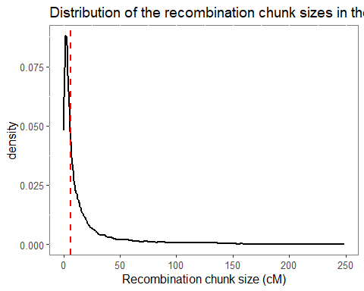

recomb_med_max_p_size <-   
 recomb_chunk_size_MEMA %>%  
 summarise(  
 min_chunk_size_p = min(p_chunk_size),  
 median_chunk_size_p = median(p_chunk_size),  
 max_chunk_size_p = max(p_chunk_size)  
 )  
  
recomb_med_max_p_size

# A tibble: 1 × 3  
 min_chunk_size_p median_chunk_size_p max_chunk_size_p  
 <dbl> <dbl> <dbl>  
1 0.00000800 4.20 235.

recomb_chunk_size_MEMA %>%  
 ggplot(data =., aes(x = p_chunk_size)) +  
 geom_density(linewidth = 1) +  
 xlab("Recombination chunk size (cM)") +  
 geom_vline(  
 data = recomb_med_max_p_size,  
 aes(xintercept = median_chunk_size_p),  
 color = "red",  
 linetype = "dashed",  
 linewidth = 1  
 ) +  
 theme(  
 panel.background = element_rect(fill = "white", colour = "grey50"),   
 text = element_text(size = 12),  
 legend.position = "top"   
 ) +  
 ggtitle("Distribution of the recombination chunk sizes in the MEMA population")

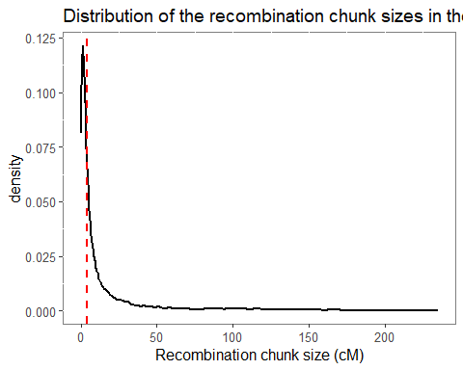

The median recombination chunk size is ~ 4.20 MB, but they can go from almos 0 to >200 MB. It is kinda weird. The most probable thing is that those very small chunks are just mistakes in the haplotype calling and therefore the chunks are very small. Is also worth to mention that the missing information in the parentall haplotype calls seems to be located when one haplotype ends to when the other starts, so it seems that with this marker density (~ 14K markers), rqtl2 can’t confidently assign a parental haplotype in these transition regions.

# 4. What is the average size of the “same genotype” chunks in the parental magic haplotype?

We hypothesize that rqtl2 is having trouble in calling parental haplotypes with confidence because there are chromosomic chunks where two or more parents have the same genotype, and with the actual marker density rqtl2 cannot tell apart one from the other. So we want to assess if including a greater number of markers (that come from WGS) can reduce the size of this chunks, therefore becoming easier to identify one parent from the other. In the other hand, it might be the case that even with a greater marker density the chunks stay about the same size, so including a genotype strategy to increase the marker density in the MEMA families will not be helpfull at all.

# Import CHIP data  
  
mema_par_hap_raw <-   
 read_delim(  
 "C:/Users/sergi/Documents/SAWERS LAB/MAGIC/mosaic_estimates/gen_mosaic_estimates/magic_parents_HAPMAP.txt",  
 delim = "\t",   
 escape_double = FALSE,   
 trim_ws = TRUE  
 )

Rows: 23645 Columns: 19  
── Column specification ────────────────────────────────────────────────────────  
Delimiter: "\t"  
chr (11): rs#, alleles, strand, m_zc, m_nt, m_rv, m_gd, m_tb, m_mu, m_ja, m_pt  
dbl (2): chrom, pos  
lgl (6): assembly#, center, protLSID, assayLSID, panelLSID, QCcode  
  
ℹ Use `spec()` to retrieve the full column specification for this data.  
ℹ Specify the column types or set `show_col_types = FALSE` to quiet this message.

colnames_WGS_data <- arrow::open_dataset(  
 sources = "C:/Users/sergi/Documents/SAWERS LAB/MAGIC/mosaic_estimates/gen_mosaic_estimates/parents_WGS_hap.parquet"  
 )$schema$names  
  
parent_chip_MEMA <- c("GD", "JL", "MS", "NT", "PT", "RV", "TB", "ZC")  
  
  
mema_par_hap <-   
 mema_par_hap_raw %>%  
 select(marker = `rs#`, chrom, pos, contains("m_")) %>%  
 select(marker:pos, sort(names(.))) %>%  
 rename_with(.cols = contains("m_"), ~ c("GD", "JL", "MS", "NT", "PT", "RV", "TB", "ZC")) %>%  
 pivot_longer(-c(marker:pos), names_to = "parental", values_to = "geno")  
  
chip_parent_comp_mema <-   
 crossing(p1 = parent_chip_MEMA, p2 = parent_chip_MEMA) %>%  
 filter(p1 != p2) %>%  
 mutate(code = map2_chr(  
 .x = p1,  
 .y = p2,  
 .f = ~ paste0(.x, .y) %>% str_split("") %>% unlist() %>% sort() %>% paste(collapse = "")  
 )) %>%  
 group_by(code) %>%  
 filter(row_number() == 1) %>%  
 ungroup() %>%  
 select(-code) %>%  
 left_join(mema_par_hap %>% rename(geno1 = geno), by = c("p1" = "parental")) %>%  
 left_join(mema_par_hap %>% rename(geno2 = geno), by = c("p2" = "parental", "marker", "chrom", "pos"))   
  
chip_parent_chunk_info <-   
 chip_parent_comp_mema %>%  
 mutate(comp_group = paste(p1, p2, sep ="-")) %>%  
 select(-c(p1, p2)) %>%  
 group_by(comp_group) %>%  
 nest() %>%  
 mutate(chunk_info = future_map(  
 .x = data,  
 .f = ~ .x %>%  
 group_by(chrom) %>%  
 rowid_to_column() %>%  
 filter(geno1 == geno2) %>%  
 mutate(  
 dif_inicio = lead(rowid) - rowid,  
 dif_final = lag(dif_inicio)  
 ) %>%  
 filter(dif_inicio == 1 | dif_final == 1) %>%  
 mutate(block = ifelse(dif_inicio == 1, NA, rowid)) %>%  
 fill(block, .direction = "up") %>%  
 group_by(block) %>%  
 mutate(chunck_n_marker = n()) %>%  
 filter(rowid == min(rowid) | rowid == max(rowid)) %>%  
 group_by(chrom, block) %>%  
 summarise(  
 chunck_n_marker = first(chunck_n_marker),  
 chunk_size = diff(pos),  
 chunck_name = paste(first(rowid), last(rowid), sep = "-"),  
 spans = paste(round(first(pos)/1e6, 2), round(last(pos)/1e6, 2), sep ="-")  
 ) %>%  
 ungroup()  
 ))

`summarise()` has grouped output by 'chrom', 'block'. You can override using  
the `.groups` argument.  
`summarise()` has grouped output by 'chrom', 'block'. You can override using  
the `.groups` argument.  
`summarise()` has grouped output by 'chrom', 'block'. You can override using  
the `.groups` argument.  
`summarise()` has grouped output by 'chrom', 'block'. You can override using  
the `.groups` argument.  
`summarise()` has grouped output by 'chrom', 'block'. You can override using  
the `.groups` argument.  
`summarise()` has grouped output by 'chrom', 'block'. You can override using  
the `.groups` argument.  
`summarise()` has grouped output by 'chrom', 'block'. You can override using  
the `.groups` argument.  
`summarise()` has grouped output by 'chrom', 'block'. You can override using  
the `.groups` argument.  
`summarise()` has grouped output by 'chrom', 'block'. You can override using  
the `.groups` argument.  
`summarise()` has grouped output by 'chrom', 'block'. You can override using  
the `.groups` argument.  
`summarise()` has grouped output by 'chrom', 'block'. You can override using  
the `.groups` argument.  
`summarise()` has grouped output by 'chrom', 'block'. You can override using  
the `.groups` argument.  
`summarise()` has grouped output by 'chrom', 'block'. You can override using  
the `.groups` argument.  
`summarise()` has grouped output by 'chrom', 'block'. You can override using  
the `.groups` argument.  
`summarise()` has grouped output by 'chrom', 'block'. You can override using  
the `.groups` argument.  
`summarise()` has grouped output by 'chrom', 'block'. You can override using  
the `.groups` argument.  
`summarise()` has grouped output by 'chrom', 'block'. You can override using  
the `.groups` argument.  
`summarise()` has grouped output by 'chrom', 'block'. You can override using  
the `.groups` argument.  
`summarise()` has grouped output by 'chrom', 'block'. You can override using  
the `.groups` argument.  
`summarise()` has grouped output by 'chrom', 'block'. You can override using  
the `.groups` argument.  
`summarise()` has grouped output by 'chrom', 'block'. You can override using  
the `.groups` argument.  
`summarise()` has grouped output by 'chrom', 'block'. You can override using  
the `.groups` argument.  
`summarise()` has grouped output by 'chrom', 'block'. You can override using  
the `.groups` argument.  
`summarise()` has grouped output by 'chrom', 'block'. You can override using  
the `.groups` argument.  
`summarise()` has grouped output by 'chrom', 'block'. You can override using  
the `.groups` argument.  
`summarise()` has grouped output by 'chrom', 'block'. You can override using  
the `.groups` argument.  
`summarise()` has grouped output by 'chrom', 'block'. You can override using  
the `.groups` argument.  
`summarise()` has grouped output by 'chrom', 'block'. You can override using  
the `.groups` argument.

chip_parent_chunk_info_pre <-   
 chip_parent_chunk_info %>%  
 select(comp_group, chunk_info) %>%  
 ungroup() %>%  
 unnest(chunk_info) %>%  
 mutate(chunk_size = round(chunk_size/1e6, 2)) %>%  
 filter(chunk_size != 0)  
  
chip_parent_chunk_info_pre %>%  
 group_by(comp_group) %>%  
 summarise(  
 med_size = median(chunk_size),  
 max_size = max(chunk_size)  
 ) %>%  
 summarise(  
 med_size = median(med_size),  
 max_size = median(max_size)  
 )

# A tibble: 1 × 2  
 med_size max_size  
 <dbl> <dbl>  
1 0.19 12.1

chip_parent_chunk_mema_label <- chip_parent_chunk_info_pre %>%  
 group_by(comp_group) %>%  
 summarise(  
 label = sapply(c("min", "max", "median"), do.call, list(x = chunk_size)) %>%  
 round(., 2) %>%  
 paste(names(.), ., sep = " = ") %>%  
 paste(., collapse = "\n"),  
 y = 1000,  
 chunk_size = 10  
 )  
  
chip_parent_chunk_info_pre %>%  
 ggplot(data =., aes(x = chunk_size, fill = comp_group )) +  
 geom_histogram(color = "black", linewidth = 0.75, bins = 30) +  
 geom_vline(  
 data = . %>% group_by(comp_group ) %>% summarise(chunk_size = median(chunk_size)),  
 aes(xintercept = chunk_size),  
 linetype = "dashed",  
 linewidth = 0.75  
 ) +  
 geom_text(  
 data = chip_parent_chunk_mema_label,  
 aes(label = label, x = chunk_size, y = y, hjust = "bottom"),  
 ) +  
 facet_wrap(. ~ comp_group, scales = "free_y") +  
 xlab("Chunk size (MB)") +  
 theme(   
 legend.position = "none",  
 panel.grid.major.x = element_blank(),  
 panel.grid.minor.x = element_blank(),  
 ) +   
 ggtitle('Distribution of "runs of identical sequence" for pairwise combination of MEMA parents using ~20K markers')

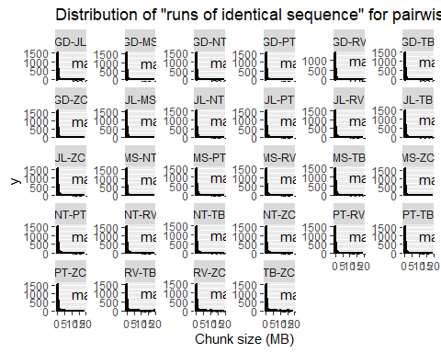

In general the maximum size of the “same genotype” chunks seems to be 8-16 MB depending on the pairwise cross that is being analyzed. We expect to see a reduction in the size by using WGS (higher marker density)

wgs_mema_parquet_source <-   
 "C:/Users/sergi/Documents/SAWERS LAB/MAGIC/mosaic_estimates/gen_mosaic_estimates/parents_WGS_hap.parquet"  
  
colnames_WGS_data <-   
 arrow::open_dataset(sources = wgs_mema_parquet_source)$schema$names  
  
WGS_parents_raw <-  
 colnames_WGS_data[-c(1:11)] %>%  
 crossing(p1 =., p2 = .) %>%  
 filter(p1 != p2) %>%  
 mutate(code = map2_chr(  
 .x = p1,  
 .y = p2,  
 .f = ~ paste0(.x, .y) %>% str_split("") %>% unlist() %>% sort() %>% paste(collapse = "")  
 )) %>%  
 group_by(code) %>%  
 filter(row_number() == 1) %>%  
 ungroup() %>%  
 select(-code) %>%  
 mutate(  
 cols = map2(  
 .x = p1,  
 .y = p2,  
 .f = ~ c(colnames_WGS_data[c(1, 3, 4)], .x, .y)  
 )) %>%  
 mutate(comp_group_label = paste0(p1, "_", p2))  
  
  
downsize_scheme <- tibble(  
 n_marker = c(5000, 10000, 20000, 50000, 100000, 500000, 1e6, 3e6, 5e6, 8125930),  
 code = c("5k", "10k", "20k", "50K", "100K", "500K", "1M", "3M", "5M", "8.2M")  
 ) %>%  
 mutate(prop = n_marker/8125930)   
  
# for (j in 10) {  
#   
# for (i in 1:dim(WGS_parents_raw)[1]) {  
#   
# wgs_data_pre <- read_parquet(file = "parents_WGS_hap.parquet", col_select = all_of(WGS_parents_raw$cols[[i]])) %>%  
# rename_with(~c("marker", "chrom", "pos", "geno1", "geno2"))  
#   
# if (j == dim(downsize_scheme)[1]) {  
#   
# wgs_magic_chunks_data_pre <- wgs_data_pre  
#   
# } else {  
#   
# set.seed(100)  
# wgs_data_split <- initial_split(wgs_data_pre, prop = downsize_scheme$prop[j], strata = chrom)  
# wgs_magic_chunks_data_pre <- training(wgs_data_split)  
#   
# }  
#   
# wgs_magic_chunks <-   
# wgs_magic_chunks_data_pre %>%  
# group_by(chrom) %>%  
# rowid_to_column() %>%  
# filter(geno1 == geno2) %>%  
# mutate(  
# dif_inicio = lead(rowid) - rowid,  
# dif_final = lag(dif_inicio)  
# ) %>%  
# filter(dif_inicio == 1 | dif_final == 1) %>%  
# mutate(block = ifelse(dif_inicio == 1, NA, rowid)) %>%  
# fill(block, .direction = "up") %>%  
# group_by(block) %>%  
# mutate(chunck_n_marker = n()) %>%  
# filter(rowid == min(rowid) | rowid == max(rowid)) %>%  
# group_by(chrom, block) %>%  
# summarise(  
# chunck_n_marker = first(chunck_n_marker),  
# chunk_size = diff(pos),  
# chunck_name = paste(first(rowid), last(rowid), sep = "-"),  
# spans = paste(round(first(pos)/1e6, 2), round(last(pos)/1e6, 2), sep ="-")  
# ) %>%  
# ungroup() %>%  
# mutate(chunk_size = round(chunk_size/1e6, 2)) %>%  
# filter(chunk_size > 0)   
#   
# SINK <- paste0(WGS_parents_raw$comp_group_label[i], "_", downsize_scheme$code[j], "_chunk_info.parquet")  
#   
# write_parquet(wgs_magic_chunks, sink = SINK)  
#   
# rm(wgs_data_pre, wgs_data_split, wgs_magic_chunks_data_pre, wgs_magic_chunks, SINK)  
# gc()  
#   
# }  
# }  
  
parents_mema_gws_all_data <-  
 WGS_parents_raw %>%  
 select(comp_group_label) %>%  
 mutate(ds = list(downsize_scheme)) %>%  
 unnest(ds) %>%  
 mutate(file = paste0(  
 "C:/Users/sergi/Documents/SAWERS LAB/MAGIC/mosaic_estimates/gen_mosaic_estimates/",  
 comp_group_label,   
 "_", code,  
 "_chunk_info.parquet")) %>%  
 mutate(data = map(  
 .x = file,  
 .f = ~ read_parquet(.x)  
 ))  
  
WGS_parents_chunk_sizes <-   
 parents_mema_gws_all_data %>%  
 unnest(data) %>%  
 group_by(comp_group_label, n_marker) %>%  
 summarise(  
 min_chunk_size = min(chunk_size),  
 med_chunk_size = median(chunk_size),  
 max_chunk_size = max(chunk_size),  
 code = first(code)  
 )

`summarise()` has grouped output by 'comp_group_label'. You can override using  
the `.groups` argument.

WGS_parents_chunk_sizes %>%   
 group_by(n_marker, code) %>%  
 pivot_longer(contains("chunk_size")) %>%  
 ungroup() %>%  
 filter(name != "min_chunk_size") %>%  
 group_by(code, name) %>%  
 filter(value == min(value) | value == max(value)) %>%  
 ungroup() %>%  
 select(-comp_group_label) %>%  
 distinct() %>%  
 arrange(n_marker, name) %>%  
 group_by(n_marker, code, name) %>%  
 summarise(interval = paste(value, collapse = " - ")) %>%  
 pivot_wider(names_from = name, values_from = interval)

`summarise()` has grouped output by 'n_marker', 'code'. You can override using  
the `.groups` argument.

# A tibble: 10 × 4  
# Groups: n_marker, code [10]  
 n_marker code max_chunk_size med_chunk_size  
 <dbl> <chr> <chr> <chr>   
 1 5000 5k 28.76 - 66.82 0.93 - 2.02   
 2 10000 10k 21.82 - 56.12 0.51 - 1.01   
 3 20000 20k 10.53 - 41.29 0.26 - 0.55   
 4 50000 50K 7.57 - 22.21 0.13 - 0.23   
 5 100000 100K 5.35 - 19.09 0.08 - 0.13   
 6 500000 500K 2.46 - 7.87 0.03 - 0.05   
 7 1000000 1M 2.38 - 5.83 0.03   
 8 3000000 3M 5.49 - 1.19 0.02   
 9 5000000 5M 5.33 - 1 0.02   
10 8125930 8.2M 0.56 - 4.13 0.01 - 0.02

WGS_parents_med_chunk_sizes_plot <-   
 WGS_parents_chunk_sizes %>%  
 mutate(  
 code = as_factor(code)) %>%   
 ggplot(  
 data =.,   
 aes(x = n_marker, y = med_chunk_size, color = comp_group_label, group = comp_group_label)  
 ) +  
 geom_line(linewidth = 0.75) +  
 scale_x_continuous(  
 breaks = unique(WGS_parents_chunk_sizes$n_marker),  
 labels = unique(WGS_parents_chunk_sizes$code)  
 ) +  
 xlab("Number of markers") +  
 ylab("Median chunk size (MB)") +  
 ggtitle('Reduction in "same genotype chunk" size when marker density is increased') +  
 theme(  
 panel.background = element_rect(fill = "white", colour = "grey50"),   
 text = element_text(size = 12),  
 axis.text.x = element_text(angle = 90, vjust = 0.5, hjust = 0),  
 legend.title = element_blank(),  
 plot.title = element_text(hjust = 0.5)  
 )   
  
WGS_parents_med_chunk_sizes_plot

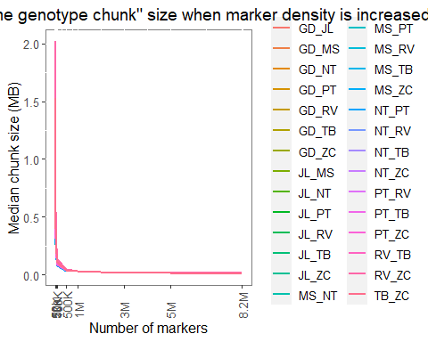

WGS_parents_med_chunk_sizes_plot +  
 scale_x_log10(  
 breaks = unique(WGS_parents_chunk_sizes$n_marker),  
 labels = unique(WGS_parents_chunk_sizes$code)  
 )

Scale for x is already present.  
Adding another scale for x, which will replace the existing scale.

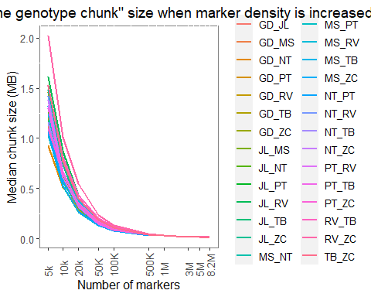

WGS_parents_max_chunk_sizes_plot <-  
 WGS_parents_chunk_sizes %>%  
 mutate(  
 code = as_factor(code)) %>%   
 ggplot(  
 data =.,   
 aes(x = n_marker, y = max_chunk_size, color = comp_group_label, group = comp_group_label)  
 ) +  
 geom_line(linewidth = 0.75) +  
 scale_x_continuous(  
 breaks = unique(WGS_parents_chunk_sizes$n_marker),  
 labels = unique(WGS_parents_chunk_sizes$code)  
 ) +  
 xlab("Number of markers") +  
 ylab("Maximum chunk size (MB)") +  
 ggtitle('Reduction in "same genotype chunk" size when marker density is increased') +  
 theme(  
 panel.background = element_rect(fill = "white", colour = "grey50"),   
 text = element_text(size = 12),  
 axis.text.x = element_text(angle = 90, vjust = 0.5, hjust = 0),  
 legend.title = element_blank(),  
 plot.title = element_text(hjust = 0.5)  
 )   
  
WGS_parents_max_chunk_sizes_plot

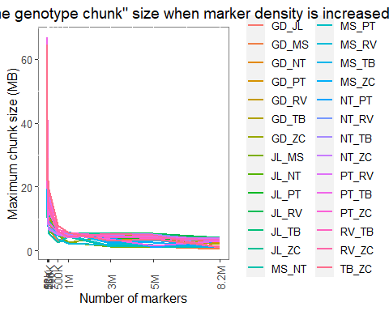

WGS_parents_max_chunk_sizes_plot +  
 scale_x_log10(  
 breaks = unique(WGS_parents_chunk_sizes$n_marker),  
 labels = unique(WGS_parents_chunk_sizes$code)  
 )

Scale for x is already present.  
Adding another scale for x, which will replace the existing scale.

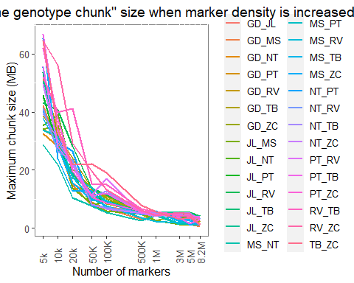

dif_chunk_size_par <-   
 WGS_parents_chunk_sizes %>%  
 group_by(comp_group_label) %>%  
 mutate(  
 dif_med = med_chunk_size - lead(med_chunk_size),  
 dif_max = max_chunk_size - lead(max_chunk_size),  
 code2 = lead(code),  
 code2 = paste0(code, "-", code2)  
 ) %>%  
 filter(!is.na(dif_med)) %>%  
 mutate(code2 = as_factor(code2))   
  
dif_chunk_size_par %>%  
 ggplot(  
 data =.,   
 aes(x = code2, y = dif_med, color = comp_group_label, group = comp_group_label)) +  
 geom_line() +  
 xlab(NULL) +  
 ylab("Median chunk size (MB)") +  
 ggtitle('Difference in the median chunk size as the number of markers is increased') +  
 theme(  
 panel.background = element_rect(fill = "white", colour = "grey50"),   
 text = element_text(size = 12),  
 axis.text.x = element_text(angle = 90, vjust = 0.5, hjust = 0),  
 legend.title = element_blank(),  
 plot.title = element_text(hjust = 0.5)  
 )

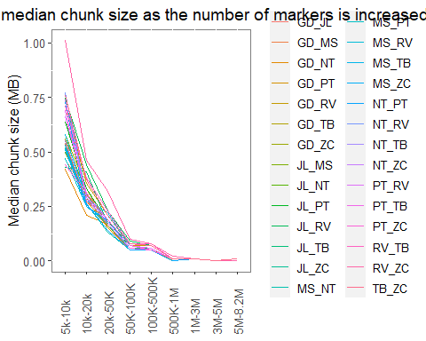

dif_chunk_size_par %>%  
 ggplot(  
 data =.,   
 aes(x = code2, y = dif_max, color = comp_group_label, group = comp_group_label)) +  
 geom_line() +  
 xlab(NULL) +  
 ylab("Median chunk size (MB)") +  
 ggtitle('Difference in the maximum chunk size as the number of markers is increased') +  
 theme(  
 panel.background = element_rect(fill = "white", colour = "grey50"),   
 text = element_text(size = 12),  
 axis.text.x = element_text(angle = 90, vjust = 0.5, hjust = 0),  
 legend.title = element_blank(),  
 plot.title = element_text(hjust = 0.5)  
 )

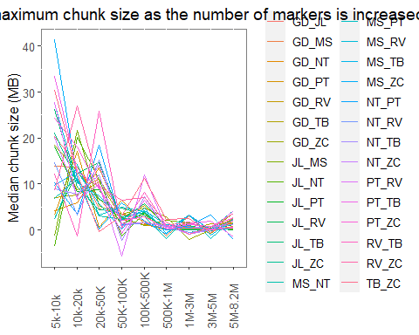

We hypothesize that the big amount of missing information in the assignment of a parental haplotypes for markers in the MEMA population is because at the actual marker density (~ 15K markers) rqtl2 cannot differentiate between any parent with a 95% of confidence, thus generating missing information. This leads us to think that is because there are genomic regions in the parents that have “identical genotype (IBD?)”, making difficult or impossible for qtl2 to differentiate one parent from the other. So we think that if we can reduce the size of this “same genotype” regions by identifying polymorphic markers across each pair of parents, we can give more information to rqtl2 to assign a parental haplotype and reduce the number of misscalling.

The question here is: how big are this regions? and If we increase the genome-wide marker density, can we reduce the size of this regions? Can we add more information with more markers? How many markers do we need to add more information and reduce the size of the “same genotype chunks”?

To answer these questions we assess the size of the “same genotype” regions in each pairwise combination of the parents of the MEMA population by using the 50K CHIP marker data (~ 15K SNPs) and WGS data (~8.2M SNPs). We use a “down-scale” simulation with the WGS data, where we randomly sampled markers across the genome with the same proportion of markers per chromosome as the original dataset, to assess if we can observe a gradient of how much information we acquire (in terms of reduction of the size of the same genotype chunks) as we increase the marker density. We selected 5000, 10,000, 20,000, 100,000, 1,000,000, 3,000,000, 5,000,000 and 8,200,000 markers to answer this question.

For the CHIP dataset, the same chunk genotype median and max size can go from 0.17-0.24 MB and 5.09-19 MB respectively. For WGS data, we can observe that an increase of the number of markers leads to the reduction of the median and max same genotype chunk size, for instance, with 50,000 markers we get a median chunk size from 0.13 - 0.23 MB and max size of 7.57 - 22.21 MB, and as we increase the marker density we observe a reduction in these values. So we can conclude that more dense marker data increases the information on the parents of the MEMA population. So it is worth to find a genotyping way that can increase the density of markers, like skim sequencing + imputation.

# 5. 2023_Highland_experiment_design

Sergio Perez-Limon

Here I use the FieldHub app to design the field evaluation of the CML F2:3 population, for the Highlands we’re using a p-rep design (more info: 10.1198/108571106X154443). In total there are going to be 210 genotypes of the HI73 and HI93 populations, 320 from the HI79 and Hermes as a CHECK evaluated in two locations. For this experimental design, 70 genotypes of each biparental population are going to be replicated, and the rest (140, 140 and 250 respectively) are going as single reps. The families are selected based on the phc BLUP value. It is important to note that we’re only removing a few families based on this, so there is not an important bias/selection towards the best genotypes, but it might help us to select families that are going to survive. We select the families that are going to be repeated randomly. Check is repeated 50 times. The ecperiment is designed for a 25 columns x 40 rows experiment.

There is an augmented block design for Ameca, a possible “no stress” environment where we can have a baseline to compare the performance of the highland site. Here, the experiment is composed of a 53 block per repetition, and 2 replications, with the same genotypes as the p-rep design. Each genotype is present only once per replication and is not repeated across block either.

Loading libraries

library(FielDHub)  
library(googlesheets4)

Warning: package 'googlesheets4' was built under R version 4.2.2

library(googledrive)

Attaching package: 'googledrive'

The following objects are masked from 'package:googlesheets4':  
  
 request_generate, request_make

library(tidyverse)

── Attaching packages ─────────────────────────────────────── tidyverse 1.3.2  
──

✔ ggplot2 3.4.1 ✔ purrr 1.0.1   
✔ tibble 3.1.8 ✔ dplyr 1.0.10  
✔ tidyr 1.3.0 ✔ stringr 1.5.0   
✔ readr 2.1.3 ✔ forcats 0.5.2

Warning: package 'ggplot2' was built under R version 4.2.2

Warning: package 'tidyr' was built under R version 4.2.2

Warning: package 'readr' was built under R version 4.2.2

Warning: package 'purrr' was built under R version 4.2.2

Warning: package 'dplyr' was built under R version 4.2.2

Warning: package 'stringr' was built under R version 4.2.2

Warning: package 'forcats' was built under R version 4.2.2

── Conflicts ────────────────────────────────────────── tidyverse_conflicts() ──  
✖ dplyr::filter() masks stats::filter()  
✖ dplyr::lag() masks stats::lag()  
✖ googledrive::request_generate() masks googlesheets4::request_generate()  
✖ googledrive::request_make() masks googlesheets4::request_make()

library(lme4)

Warning: package 'lme4' was built under R version 4.2.2

Loading required package: Matrix

Warning: package 'Matrix' was built under R version 4.2.2

Attaching package: 'Matrix'  
  
The following objects are masked from 'package:tidyr':  
  
 expand, pack, unpack

gs4_auth("checo.spl@gmail.com")

Import available genotypes and genotype information

data_url <- "https://docs.google.com/spreadsheets/d/14yHP2kqQZQ-wp0IdiUgeUeQIeqorQed3-m-xcwFu_Ko/edit#gid=723581705"  
  
genotypes_data_raw <-   
 data_url %>%  
 as_id() %>%  
 range_read(sheet = "Genetic Stocks")

Auto-refreshing stale OAuth token.

✔ Reading from "CML457_459_Populations".

✔ Range ''Genetic Stocks''.

families_url <- "https://docs.google.com/spreadsheets/d/1Mix1vFbJkeLhC3psHaOxxJscgPXsiizt-unjrE1Arbs/edit#gid=497667827"  
  
seed_availability_url <- "https://docs.google.com/spreadsheets/d/14yHP2kqQZQ-wp0IdiUgeUeQIeqorQed3-m-xcwFu_Ko/edit#gid=723581705"  
  
# Import raw data for families  
families_data_raw <- families_url %>%  
 as_id %>%  
 range_read(ss =., sheet = "UNISEM21A", skip = 1)

✔ Reading from "21_NCS_PSU_LANGEBIO_FIELDS".

✔ Range ''UNISEM21A'!2:10000000'.

New names:  
• `` -> `...16`  
• `` -> `...18`

seed_available <- seed_availability_url %>%  
 as_id() %>%  
 range_read(ss =., sheet = "Genetic Stocks")

✔ Reading from "CML457_459_Populations".  
✔ Range ''Genetic Stocks''.

packing_seed_info_url <- "https://docs.google.com/spreadsheets/d/14yHP2kqQZQ-wp0IdiUgeUeQIeqorQed3-m-xcwFu_Ko/edit#gid=2014961217"  
  
# packing seed info  
  
packing_seed_info <-   
 packing_seed_info_url %>%  
 as_id() %>%  
 range_read(ss =., sheet = "seed_packing_2022")

✔ Reading from "CML457_459_Populations".  
✔ Range ''seed_packing_2022''.

packing_seed_info_unique <-   
 packing_seed_info %>%  
 select(familia, F2_Parent, sobre_UNISEM) %>%  
 unique() %>%  
 rename(`Female genotype` = familia, `Female parent` = sobre_UNISEM)

Highland site p-rep design

# Genotypes available for planting  
  
available_genos <-   
 genotypes_data_raw %>%  
 select(family = Family_ID, pop = Population_ID, use = `Use_23 (798)`) %>%  
 filter(use == 1)  
  
# select families based on the best BLUP values  
cml_pops_raw_data <-   
 data_url %>%  
 as_id() %>%  
 range_read("22_Highland_Raw_data_tidy") %>%  
 mutate(phc = as.double(phc))

✔ Reading from "CML457_459_Populations".

✔ Range ''22_Highland_Raw_data_tidy''.

cml_phc_example <-  
 cml_pops_raw_data %>%  
 select(location, family, phc, nblock) %>%  
 mutate(across(c(location, family), ~ as_factor(.))) %>%  
 mutate(phc = ifelse(phc > 2 | phc == 0, NA_real_, phc)) %>%  
 filter(family != "HERMES")  
  
set.seed(100)  
phc_BLUP_example <-   
 lmer(  
 phc ~ location + (1|family) + (1|location:nblock), data = cml_phc_example  
 ) %>%  
 ranef() %>%  
 .$family %>%  
 as_tibble(rownames = "family") %>%  
 rename(BLUP = `(Intercept)`)  
  
# Best families available based on the BLUP value  
prospect_families <-   
 phc_BLUP_example %>%  
 semi_join(available_genos) %>%  
 mutate(pop = gsub("-\\d+$", "", family)) %>%  
 arrange(pop, desc(BLUP)) %>%  
 group_by(pop) %>%  
 mutate(id = row_number()) %>%  
 filter(  
 (pop == "HI73" & id %in% c(1:210)) |   
 (pop == "HI93" & id %in% c(1:210)) |  
 (pop == "HI79" & id %in% c(1:320))  
 ) %>%  
 ungroup() %>%  
 rename(phc_BLUP = BLUP)

Joining, by = "family"

# p-rep eperimental design using FieldHub  
  
highland_2023_prep_design <-   
 partially_replicated(  
 nrows = 40,   
 ncols = 25,  
 repGens = c(530, 210, 1),  
 repUnits = c(1, 2, 50),  
 planter = "serpentine",  
 l = 2,  
 seed = 100,  
 locationNames = c("site1", "site2")  
 )

Warning message:   
 Since plotNumber was missing, it was set up to default value of: 1001 2001

# Extracting the fieldbook from the experimental design  
high23_fieldbook <-   
 highland_2023_prep_design$fieldBook %>%  
 as_tibble() %>%  
 rename_with(~tolower(.))  
  
# Selecting rep families by random and randomizing families within each pop  
set.seed(100)  
high_exp_data <-  
 prospect_families %>%  
 group_by(pop) %>%  
 slice_sample(prop = 1) %>%  
 mutate(id2 = row_number()) %>%  
 ungroup() %>%  
 select(family, pop, id2) %>%  
 add_row(family = "CHECK", id2 = NA, .before = 1) %>%  
 mutate(  
 rep = case_when(  
 is.na(id2) ~ 50,  
 id2 %in% c(1:70) ~ 2,  
 T ~ 1  
 )) %>%  
 arrange(desc(rep), pop, id2) %>%  
 mutate(id = row_number())  
  
treatment_family <-   
 high23_fieldbook %>%  
 count(location, treatment) %>%  
 mutate(id = gsub("G", "", treatment) %>% as.integer()) %>%  
 rename(rep = n) %>%  
 arrange(id) %>%  
 left_join(high_exp_data) %>%  
 select(treatment, family, pop) %>%  
 distinct() %>%  
 mutate(pop = ifelse(is.na(pop), "CHECK", pop))

Joining, by = c("rep", "id")

high23_fieldbook_family <-   
 high23_fieldbook %>%  
 left_join(treatment_family)

Joining, by = "treatment"

high23_fieldbook_family

# A tibble: 2,000 × 12  
 id expt location year plot row column checks entry treatment family   
 <int> <chr> <chr> <chr> <dbl> <int> <int> <chr> <dbl> <chr> <chr>   
 1 1 Expt1 SITE1 2023 1001 1 1 186 186 G186 HI93-271  
 2 2 Expt1 SITE1 2023 1002 1 2 0 574 G574 HI79-370  
 3 3 Expt1 SITE1 2023 1003 1 3 0 218 G218 HI73-028  
 4 4 Expt1 SITE1 2023 1004 1 4 0 508 G508 HI79-280  
 5 5 Expt1 SITE1 2023 1005 1 5 0 567 G567 HI79-306  
 6 6 Expt1 SITE1 2023 1006 1 6 115 115 G115 HI79-286  
 7 7 Expt1 SITE1 2023 1007 1 7 0 444 G444 HI79-321  
 8 8 Expt1 SITE1 2023 1008 1 8 0 384 G384 HI79-191  
 9 9 Expt1 SITE1 2023 1009 1 9 1 1 G1 CHECK   
10 10 Expt1 SITE1 2023 1010 1 10 0 482 G482 HI79-104  
# … with 1,990 more rows, and 1 more variable: pop <chr>

high23_fieldbook_family %>%  
 ggplot(data =., aes(x = row, y = column)) +  
 geom_tile(  
 aes(fill = pop),  
 color = "black") +  
 facet_grid(. ~ location)

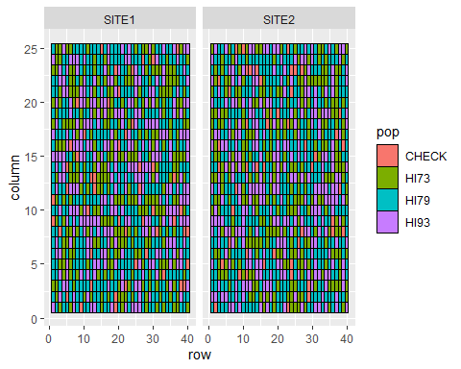

data_spreadsheet <-  
 high23_fieldbook_family %>%  
 select(  
 `CML23-` = plot, Description = pop, `Female genotype` = family,   
 row_design = row, column_design = column, checks) %>%  
 mutate(  
 `Origin (Package)` = "LANGEBIO",  
 `Packed?` = " ",  
 `Who/What` = "AL/JL",  
 `Male parent` = "x sib",  
 `Male genotype` = "x sib",  
 `Number/Selection` = "14K",  
 rep = case_when(  
 checks == 0 ~ 1,  
 Description == "CHECK" ~ 50,  
 T ~ 2  
 )  
 ) %>%  
 left_join(packing_seed_info_unique) %>%  
 select(  
 `CML23-`, `Origin (Package)`:`Who/What`, Description, `Female parent`,   
 `Male parent`, `Female genotype`, `Male genotype`, `Number/Selection`,  
 row_design, column_design, rep  
 ) %>%  
 mutate(across(contains("Female"), ~ ifelse(is.na(.), "HERMES", .)))

Joining, by = "Female genotype"

write_csv(data_spreadsheet, "23_highland_experiment_spreadsheet.csv")

Ameca augmented complete block design

prospect_families %>%  
 count(pop) %>%  
 mutate(prop = n/sum(n)) %>%  
 mutate(a = prop*24)

# A tibble: 3 × 4  
 pop n prop a  
 <chr> <int> <dbl> <dbl>  
1 HI73 210 0.284 6.81  
2 HI79 320 0.432 10.4   
3 HI93 210 0.284 6.81

prospect_families %>% dim %>% .[[1]]

[1] 740

Ameca_RCBD <- RCBD_augmented(  
 lines = prospect_families %>% dim %>% .[[1]],  
 planter = "serpentine",  
 checks = 1,  
 b = 53,   
 repsExpt = 2,   
 l = 1,  
 random = TRUE,  
 locationNames = c("Ameca"),  
 seed = 100,   
 )  
  
# 57, 53, 50, 47, 44  
  
Ameca_fieldbook <- Ameca_RCBD$fieldBook %>%  
 as_tibble() %>%  
 rename_with( ~ tolower(.))  
  
Ameca_fieldbook %>%  
 filter(treatment != "CH1") %>%  
 count(block) %>%  
 mutate(nn = n/2) %>%  
 count(nn)

# A tibble: 1 × 2  
 nn n  
 <dbl> <int>  
1 14 53

prospect_families %>%  
 count(pop) %>%   
 mutate(prop = n/sum(n)) %>%  
 mutate(a = prop*14)

# A tibble: 3 × 4  
 pop n prop a  
 <chr> <int> <dbl> <dbl>  
1 HI73 210 0.284 3.97  
2 HI79 320 0.432 6.05  
3 HI93 210 0.284 3.97

# Per block: 4 HI73/HI93; 6 HI79  
  
set.seed(100)  
Ameca_fieldbook_pops <-   
 Ameca_fieldbook %>%  
 mutate(rep = ifelse(id < 796, 1, 2)) %>%  
 group_by(rep, block) %>%  
 mutate(rowid = row_number()) %>%  
 slice_sample(prop = 1) %>%  
 mutate(  
 type = ifelse(treatment == "CH1", "check", "family"),  
 type = factor(type, levels = c("check", "family"))  
 ) %>%  
 ungroup() %>%  
 arrange(rep, block, type) %>%  
 mutate(what = rep(c("HERMES", rep("HI73", 4), rep("HI79", 6), rep("HI93", 4)), 106)) %>%  
 filter(treatment != "Filler")  
  
Ameca_fieldbook_pops %>%  
 count(rep, what)

# A tibble: 8 × 3  
 rep what n  
 <dbl> <chr> <int>  
1 1 HERMES 53  
2 1 HI73 211  
3 1 HI79 317  
4 1 HI93 212  
5 2 HERMES 53  
6 2 HI73 211  
7 2 HI79 318  
8 2 HI93 211

# Need 420 HI73/HI93; 640 HI79  
  
set.seed(100)  
extra_family_replacement <-   
 Ameca_fieldbook_pops %>%  
 filter(what %in% c("HI93", "HI73")) %>%  
 group_by(rep, what) %>%  
 slice_sample(n = 3) %>%  
 filter(  
 (rep == 1 & what == "HI73" & row_number() == 1) |  
 (rep == 1 & what == "HI93" & row_number() %in% c(1:2)) |  
 (rep == 2 & what == "HI73" & row_number() %in% c(1)) |  
 (rep == 2 & what == "HI93" & row_number() %in% c(1))  
 ) %>%  
 mutate(what = "HI79")  
  
  
set.seed(100)  
Ameca_fieldbook_pops_family <- Ameca_fieldbook_pops %>%  
 anti_join(extra_family_replacement, by = c("rep", "plot")) %>%  
 bind_rows(extra_family_replacement) %>%  
 arrange(rep, what) %>%  
 group_by(rep, what) %>%  
 slice_sample(prop = 1) %>%  
 mutate(id2 = row_number()) %>%  
 left_join(prospect_families %>% select(-phc_BLUP), by = c("what" = "pop", "id2" = "id")) %>%  
 mutate(family = ifelse(what == "HERMES", "HERMES", family)) %>%  
 ungroup()  
  
Ameca_fieldbook_pops_family %>%  
 arrange(id) %>%  
 select(id, plot:block, rep, treatment, pop = what, family)

# A tibble: 1,586 × 10  
 id plot row column checks block rep treatment pop family   
 <int> <dbl> <int> <int> <chr> <dbl> <dbl> <chr> <chr> <chr>   
 1 1 101 1 1 0 1 1 G658 HI93 HI93-179  
 2 2 102 1 2 1 1 1 CH1 HERMES HERMES   
 3 3 103 1 3 0 1 1 G205 HI73 HI73-092  
 4 4 104 1 4 0 1 1 G133 HI93 HI93-233  
 5 5 105 1 5 0 1 1 G641 HI93 HI93-108  
 6 6 106 1 6 0 1 1 G321 HI73 HI73-137  
 7 7 107 1 7 0 1 1 G418 HI73 HI73-220  
 8 8 108 1 8 0 1 1 G44 HI79 HI79-162  
 9 9 109 1 9 0 1 1 G636 HI79 HI79-268  
10 10 110 1 10 0 1 1 G391 HI73 HI73-248  
# … with 1,576 more rows

Ameca_fieldbook_pops_family %>%  
 select(id, plot:block, rep, treatment, pop = what, family) %>%  
 ggplot(data =., aes(x = column, y = row, fill = pop)) +  
 geom_tile(color = "black")

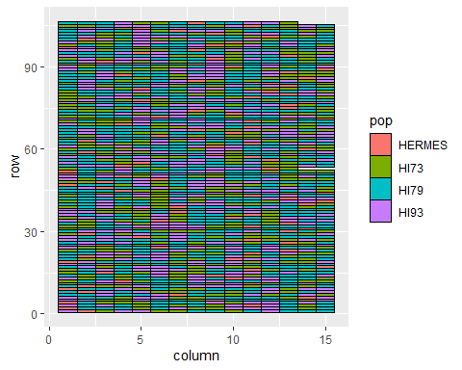

Ameca_data_spreadsheet <-  
 Ameca_fieldbook_pops_family %>%  
 arrange(id) %>%  
 mutate(`CML23-` = id + 4000) %>%  
 select(  
 `CML23-`, Description = what, `Female genotype` = family,   
 row_design = row, column_design = column, checks, rep, block) %>%  
 mutate(  
 `Origin (Package)` = "LANGEBIO",  
 `Packed?` = " ",  
 `Who/What` = "AL/JL",  
 `Male parent` = "x sib",  
 `Male genotype` = "x sib",  
 `Number/Selection` = "14K"  
 ) %>%  
 left_join(packing_seed_info_unique) %>%  
 select(  
 `CML23-`, `Origin (Package)`:`Who/What`, Description, `Female parent`,   
 `Male parent`, `Female genotype`, `Male genotype`, `Number/Selection`,  
 row_design, column_design, rep, block  
 ) %>%  
 mutate(across(contains("Female"), ~ ifelse(is.na(.), "HERMES", .)))

Joining, by = "Female genotype"

write_csv(Ameca_data_spreadsheet, "Ameca_data_spreadsheet.csv")

# 6. PT

Sergio Pérez-Limón

Quarto enables you to weave together content and executable code into a finished document. To learn more about Quarto see <https://quarto.org>.

## 6.1 Running Code

When you click the **Render** button a document will be generated that includes both content and the output of embedded code. You can embed code like this:

1 + 1

[1] 2

You can add options to executable code like this

[1] 4

The echo: false option disables the printing of code (only output is displayed).

# 7. AMF

Sergio Pérez-Limón

Quarto enables you to weave together content and executable code into a finished document. To learn more about Quarto see <https://quarto.org>.

## 7.1 Running Code

When you click the **Render** button a document will be generated that includes both content and the output of embedded code. You can embed code like this:

1 + 1

[1] 2

You can add options to executable code like this

[1] 4

The echo: false option disables the printing of code (only output is displayed).

# 8. Summary

In summary, this book has no content whatsoever.

# References

Knuth, Donald E. 1984. “Literate Programming.” *Comput. J.* 27 (2): 97–111. <https://doi.org/10.1093/comjnl/27.2.97>.